实验四：PIN二极管特性仿真

姓名： 何衍宁 ；
时间： 2025/11/12 ;

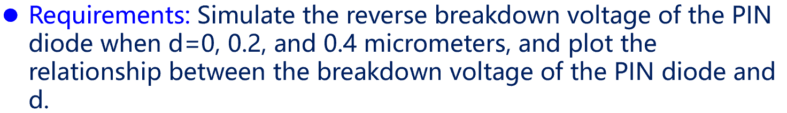
模拟当 d=0、0.2 和 0.4 μm时的PIN二极管的反向击穿电压，并绘制PIN二极管的击穿电压与 d 之间的关系图。

1 d=0μm
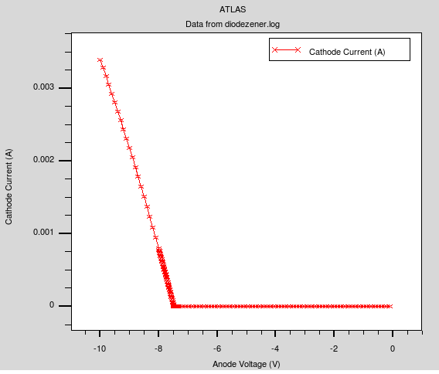

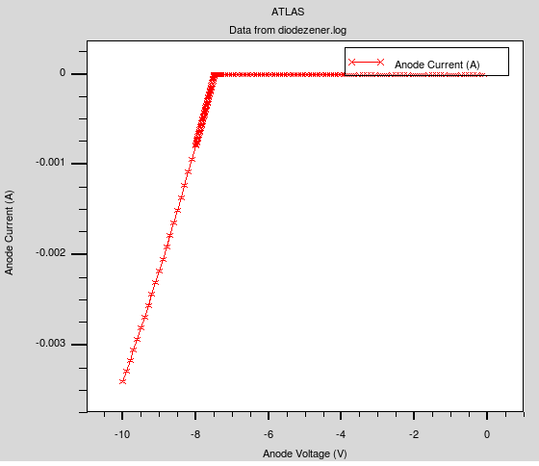
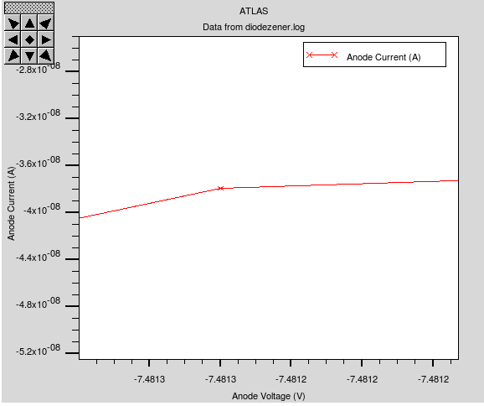
从图中可知，击穿电压：U=-7.4813V
运行代码：
go atlas

mesh
x.mesh location=0.0 spac=0.1
x.mes location=1.0 spac=0.1
y.mesh location=0 spac=0.1
y.mesh location=0.9 spac=0.001
y.mesh location=1.8 spac=0.1

region num = 1 y.min = 0 y.max = 0.9 material = silicon
#region num = 2 y.min = 0.9 y.max = 2.9 material = silicon
region num = 3 y.min = 0.9 y.max = 1.8 material = silicon

electrode name=anode top
electrode name=cathode bottom

doping region = 1 p.type uniform conc = 1e18
doping region = 2 n.type uniform conc = 5e10
doping region = 3 n.type uniform conc = 1e18

output con.band val.band QFN QFP
models bipolar bbt.std print
impact selb
method newton trap maxtrap=30 \
climit=1e-4

solve init
log outfile=diodezener.log
solve vanode=-0.1 vstep=-0.1 vfinal=-7.2 name=anode
solve vanode=-7.3 vstep=-0.01 vfinal=-8.0 name=anode
solve vanode=-8.0 vstep=-0.1 vfinal=-10 name=anode

tonyplot diodezener.log
quit

2 d=0.2μm
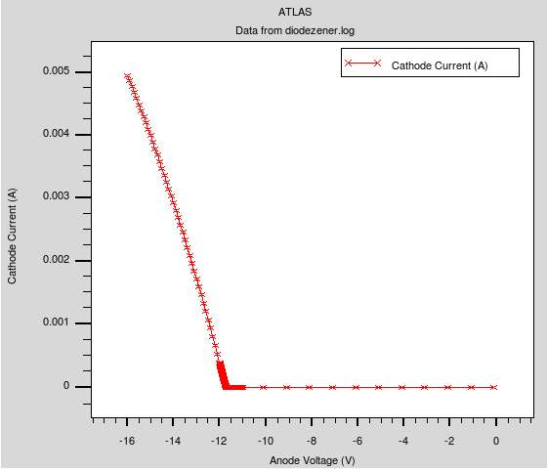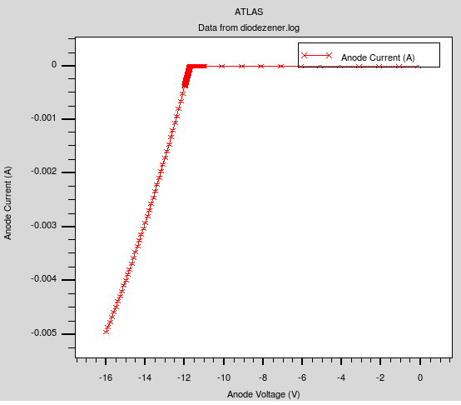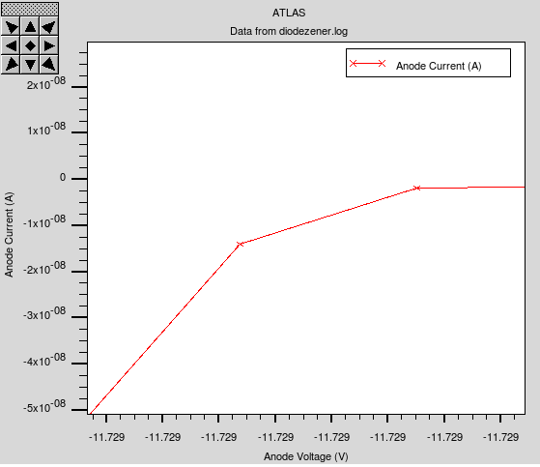
从图中可知，击穿电压：U=-11.729V
运行代码：
go atlas

mesh
x.mesh location=0.0 spac=0.1
x.mes location=1.0 spac=0.1
y.mesh location=0 spac=0.1
y.mesh location=0.9 spac=0.005
y.mesh location=1.1 spac=0.005
y.mesh location=2.0 spac=0.1

region num = 1 y.min = 0 y.max = 0.9 material = silicon
region num = 2 y.min = 0.9 y.max = 1.1 material = silicon
region num = 3 y.min = 1.1 y.max = 2.0 material = silicon

electrode name=anode top
electrode name=cathode bottom

doping region = 1 p.type uniform conc = 1e18
doping region = 2 n.type uniform conc = 5e10
doping region = 3 n.type uniform conc = 1e18

output con.band val.band QFN QFP
models bipolar bbt.std print
impact selb
method newton trap maxtrap=30 \
climit=1e-4

solve init
log outfile=diodezener.log
solve vanode=-0.1 vstep=-1 vfinal=-10 name=anode
solve vanode=-11 vstep=-0.001 vfinal=-12 name=anode
solve vanode=-12 vstep=-0.1 vfinal=-16 name=anode

tonyplot diodezener.log
quit

3 d=0.4μm
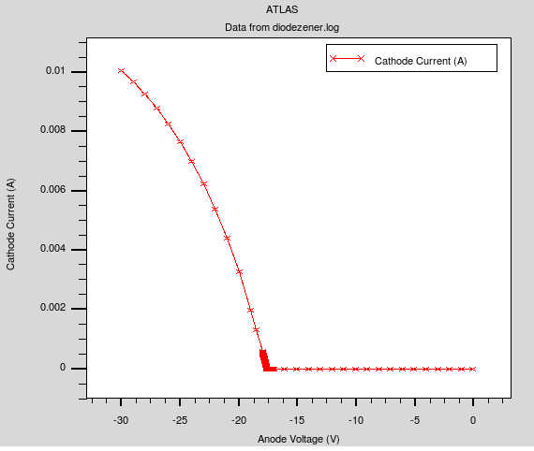
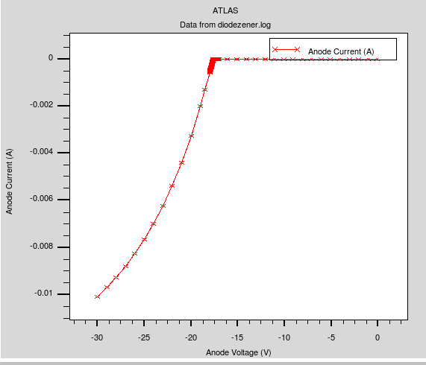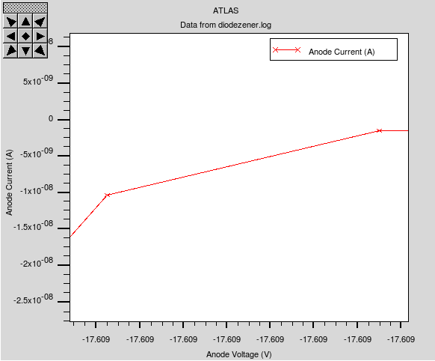
从图中可知，击穿电压：U=-17.609V
运行代码：
go atlas

mesh
x.mesh location=0.0 spac=0.1
x.mes location=1.0 spac=0.1
y.mesh location=0 spac=0.1
y.mesh location=0.9 spac=0.005
y.mesh location=1.3 spac=0.005
y.mesh location=2.2 spac=0.1

region num = 1 y.min = 0 y.max = 0.9 material = silicon
region num = 2 y.min = 0.9 y.max = 1.3 material = silicon
region num = 3 y.min = 1.3 y.max = 2.2 material = silicon

electrode name=anode top
electrode name=cathode bottom

doping region = 1 p.type uniform conc = 1e18
doping region = 2 n.type uniform conc = 5e10
doping region = 3 n.type uniform conc = 1e18

output con.band val.band QFN QFP
models bipolar bbt.std print
impact selb
method newton trap maxtrap=30 \
climit=1e-4

solve init
log outfile=diodezener.log
solve vanode=-0.1 vstep=-1 vfinal=-17 name=anode
solve vanode=-17 vstep=-0.001 vfinal=-18 name=anode
solve vanode=-18 vstep=-1 vfinal=-30 name=anode

tonyplot diodezener.log
quit

4 PIN二极管的击穿电压与d之间的关系
实验数据记录如下：
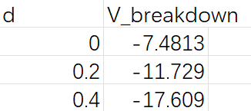
绘制如图：
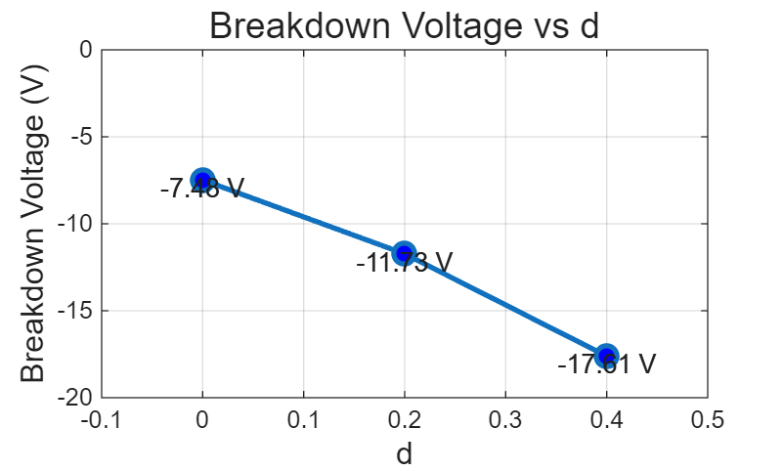
击穿电压取正值时：
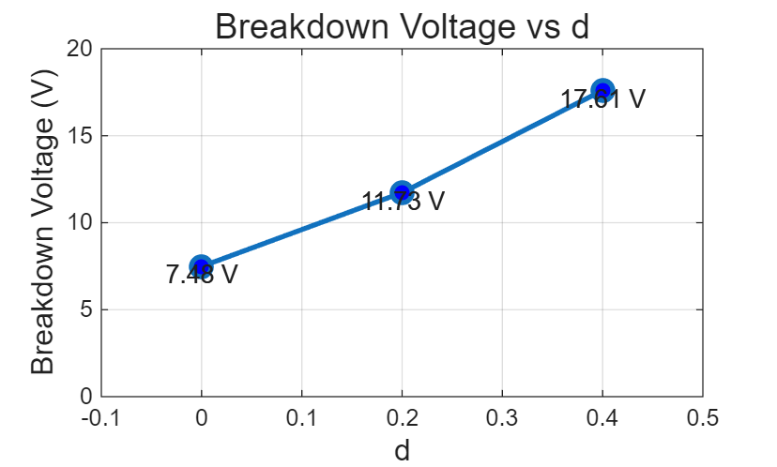
因为PIN二极管的I层几乎无掺杂，电场在其中近似均匀分布，
击穿时满足$E_{c}=V_{br}/d$,
所以击穿电压$V_{br}=E_{C}⋅d$，与I层宽度d近似成线性关系。

