实验三：PN结工艺仿真

姓名：肖诺言 ；
时间：2025年3月29日;

- 用工艺仿真器制作一个如下图所示结构的PN结，并用器件仿真器仿真出其伏安特性。
- 给出所设计PN结的结构图；
- 给出所设计PN结的掺杂浓度分布图（含结深分布曲线和所定义的电极名称）；
- 给出PN结中间位置的结深；
- 仿真PN结的正反向特性，反向特性需包含击穿特性（仿真齐纳击穿）

（1）
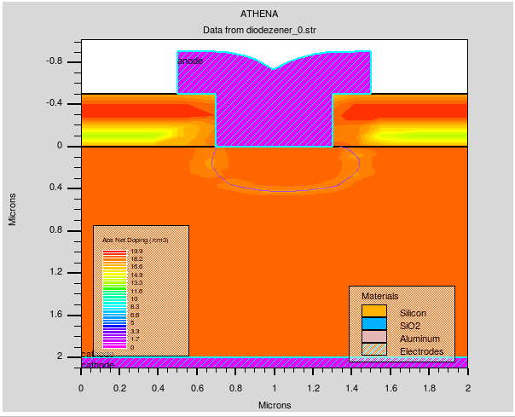
设计的PN结的代码如下：
go athena
line x loc=0.00 spac=0.2
line x loc=1 spac=0.1
line x loc=1.1 spac=0.02
line x loc=2 spac=0.25
line y loc=0.00 spac=0.02
line y loc=0.2 spac=0.1
line y loc=0.4 spac=0.02
line y loc=2 spac=0.5

init silicon c.phos=9.0e18 orientation=100
deposit oxide thick=0.50 divisions=5
etch oxide start x = 0.7 y = 0
etch continue x = 0.7 y = -0.5
etch continue x = 1.3 y = -0.5
etch done x = 1.3 y = 0
implant boron dose=1.0e15 energy=50 pearson tilt=7 rotation=0
method fermi compress
diffus time=30 temp=1000 nitro press=1.00
deposit aluminum thick = 0.4 div = 5
etch aluminum p1.x = 0.5 left
etch aluminum p1.x = 1.5 right
structure flip.y
deposit aluminum thick = 0.1 div = 5
structure flip.y
electrode x = 0.05 name = anode
electrode x = 0.05 y = 2.05 name = cathode
electrode name=anode x=1.0
electrode name=cathode backside
structure outf=diodezener_0.str
extract name="xj" xj silicon mat.occno=1 x.val=1
tonyplot diodezener_0.str
quit

go atlas
models bipolar bbt.std print
impact selb
method newton trap maxtrap=10
climit=1e-4
solve init
log outfile=diodezener.log
solve vanode=-0.25 vstep=-0.25 vfinal=-10 name=anode
tonyplot diodezener.log
quit
（2）
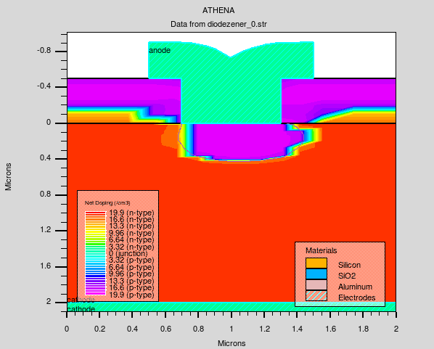
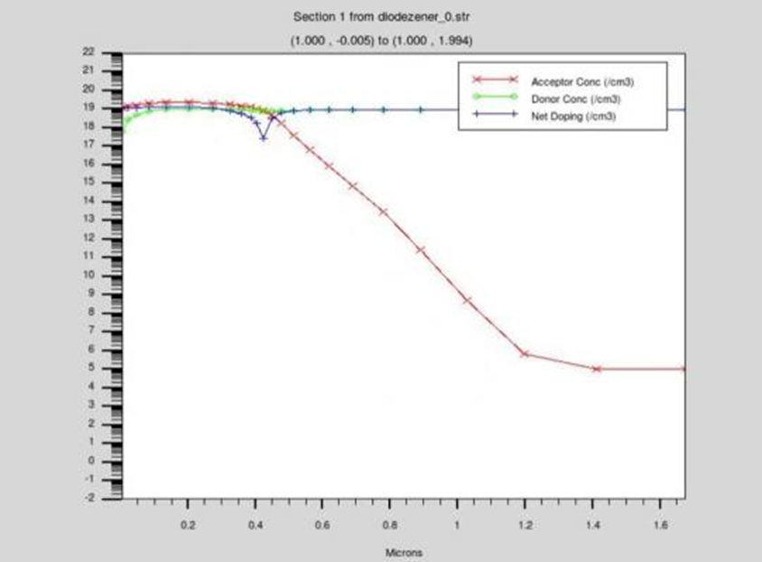
- PN结中间位置的结深0.437618 um

对于正向：
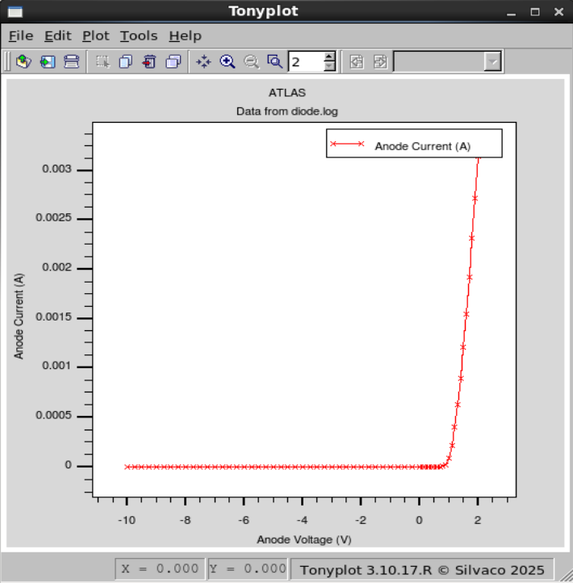
实现代码：
go atlas
mesh
x.mesh location=0.0 spac=0.1
x.mesh location=1.0 spac=0.1
y.mesh location=0 spac=0.1
y.mesh location=5 spac=0.001
y.mesh location=10 spac=0.1
region num=1 silicon
electrode name=anode top
electrode name=cathode bottom
doping uniform conc=1e18 n.type
doping uniform conc=2e18 p.type y.bottom=5.0
output con.band val.band QFN QFP
models conmob fldmob bgn srh auger
solve init
method newton
log outfile = diode.log
solve vanode=-10 vstep=0.25 vfinal=-0.25 name=anode
solve vanode = 0 vstep = 0.1 vfinal = 2 name = anode
tonyplot diode.log
quit

对于反向：
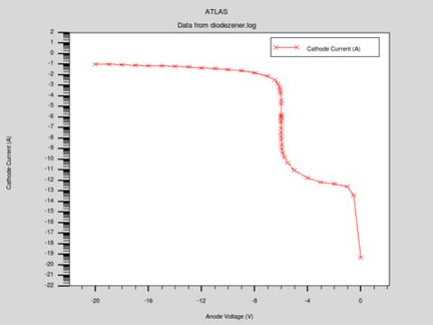
在反向偏压逐步增大的过程中，当电压接近击穿阈值时，电流会急剧上升。这一陡峭的斜率对应齐纳击穿现象，表明高掺杂PN结在强电场下发生隧穿效应，导致反向电流迅速增大。
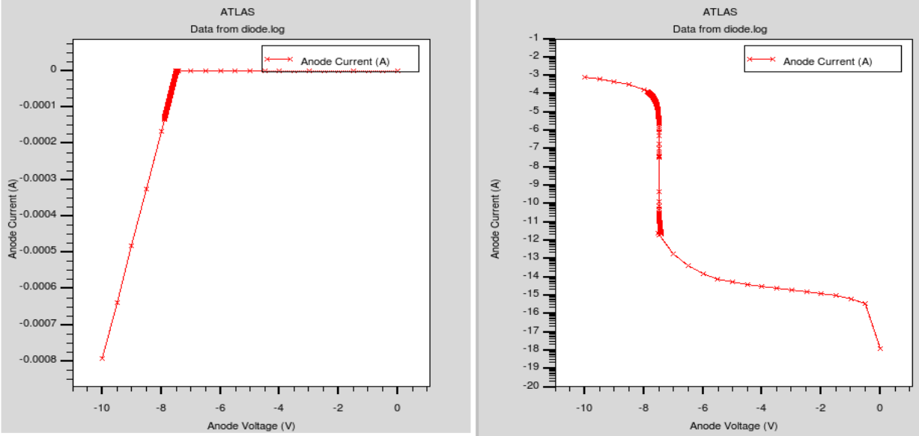
击穿时耗尽层内的电场分布或碰撞电离速率。在高反向偏压下，耗尽层电场强度极高，触发隧穿效应。

实现代码：
go athena
line x loc=0.00 spac=0.2
line x loc=1 spac=0.1
line x loc=1.1 spac=0.02
line x loc=2 spac=0.25
line y loc=0.00 spac=0.02
line y loc=0.2 spac=0.1
line y loc=0.4 spac=0.02
line y loc=2 spac=0.5
init silicon c.phos=9.0e18 orientation=100
deposit oxide thick=0.50 divisions=5
etch oxide left p1.x=1
implant boron dose=1.0e15 energy=50 pearson tilt=7 rotation=0
method fermi compress
diffus time=30 temp=1000 nitro press=1.00
etch oxide all
deposit alum thickness=0.2 div=3
etch alum right p1.x=1.0
electrode name=anode x=0.0
electrode name=cathode backside
structure outf=diodezener_0.str
go atlas
models bipolar bbt.std print
impact selb
method newton trap maxtrap=10 climit=1e-4
solve init
log outfile=diodezener.log
solve vanode=0 vstep=-1 vfinal=-20 name=anode
tonyplot diodezener.log
quit

