实验四：PIN二极管特性仿真
姓名：肖诺言；
时间：4月24日;

模拟当 d=0、0.2 和 0.3 微米时的PIN二极管的反向击穿电压，并绘制PIN二极管的击穿电压与 d 之间的关系图。

（1）d=0微米
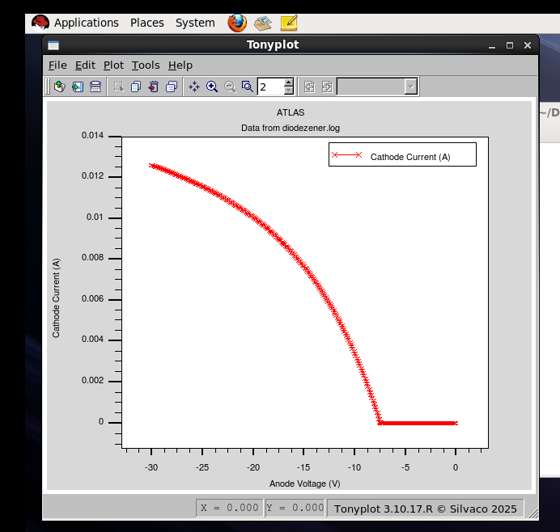
击穿电压U=-7.49V
运行代码：
go atlas
mesh
x.mesh location=0.0 spac=0.1
x.mes location=1.0 spac=0.1
y.mesh location=0 spac=0.1
y.mesh location=0.9 spac=0.005
y.mesh location=1.8 spac=0.1
region num = 1 y.min = 0 y.max = 0.9 material = silicon
region num = 3 y.min = 0.9 y.max = 1.8 material = silicon
electrode name=anode top
electrode name=cathode bottom
doping region = 1 p.type uniform conc = 1e18
doping region = 3 n.type uniform conc = 1e18
output con.band val.band QFN QFP
models bipolar bbt.std print
impact selb
method newton trap maxtrap=30 \
climit=1e-4
solve init
log outfile=diodezener.log
solve vanode=-0.1 vstep=-0.1 vfinal=-30 name=anode
tonyplot diodezener.log
quit

（2）d=0.2微米
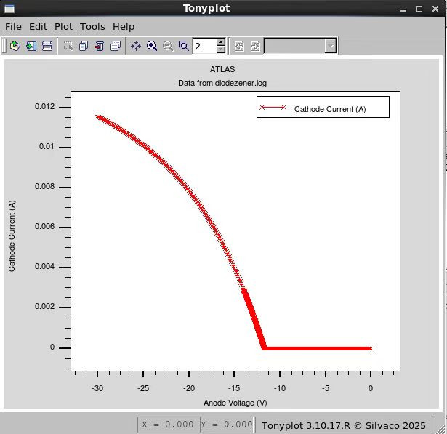
击穿电压U=-11.83V
运行代码：
go atlas
mesh
x.mesh location=0.0 spac=0.1
x.mes location=1.0 spac=0.1
y.mesh location=0 spac=0.1
y.mesh location=0.9 spac=0.005
y.mesh location=1.1 spac=0.005
y.mesh location=2.0 spac=0.1
region num = 1 y.min = 0 y.max = 0.9 material = silicon
region num = 2 y.min = 0.9 y.max = 1.1 material = silicon
region num = 3 y.min = 1.1 y.max = 2.0 material = silicon
electrode name=anode top
electrode name=cathode bottom
doping region = 1 p.type uniform conc = 1e18
doping region = 2 n.type uniform conc = 5e10
doping region = 3 n.type uniform conc = 1e18
output con.band val.band QFN QFP
models bipolar bbt.std print
impact selb
method newton trap maxtrap=30 \
climit=1e-4
solve init
log outfile=diodezener.log
solve vanode=-0.1 vstep=-0.1 vfinal=-13 name=anode
solve vanode=-9 vstep=-0.005 vfinal=-14 name=anode
solve vanode=-14 vstep=-0.1 vfinal=-26 name=anode
tonyplot diodezener.log
quit

（3）d=0.3微米
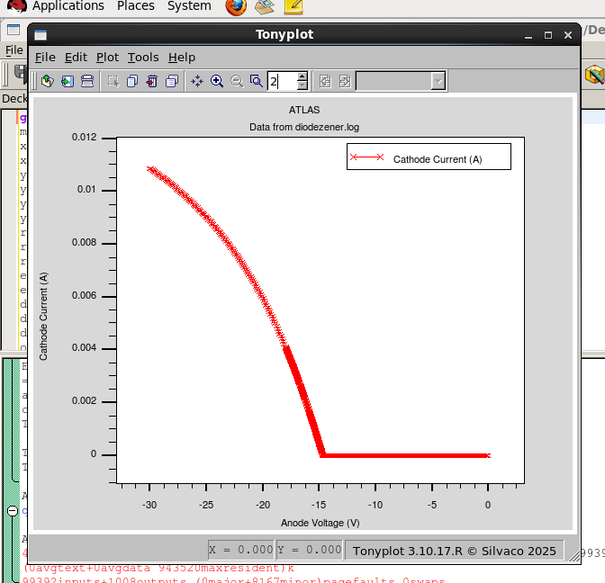
击穿电压U=-14.98V
运行代码：
go atlas
mesh
x.mesh location=0.0 spac=0.1
x.mes location=1.0 spac=0.1
y.mesh location=0 spac=0.1
y.mesh location=0.9 spac=0.005
y.mesh location=1.2 spac=0.005
y.mesh location=2.1 spac=0.1
region num = 1 y.min = 0 y.max = 0.9 material = silicon
region num = 2 y.min = 0.9 y.max = 1.2 material = silicon
region num = 3 y.min = 1.2 y.max = 2.1 material = silicon
electrode name=anode top
electrode name=cathode bottom
doping region = 1 p.type uniform conc = 1e18
doping region = 2 n.type uniform conc = 5e10
doping region = 3 n.type uniform conc = 1e18
output con.band val.band QFN QFP
models bipolar bbt.std print
impact selb
method newton trap maxtrap=30 \
climit=1e-4
solve init
log outfile=diodezener.log
solve vanode=-0.1 vstep=-0.1 vfinal=-13 name=anode
solve vanode=-13 vstep=-0.005 vfinal=-18 name=anode
solve vanode=-18 vstep=-0.1 vfinal=-30 name=anode
tonyplot diodezener.log
quit

