设计的LPF的频率响应：
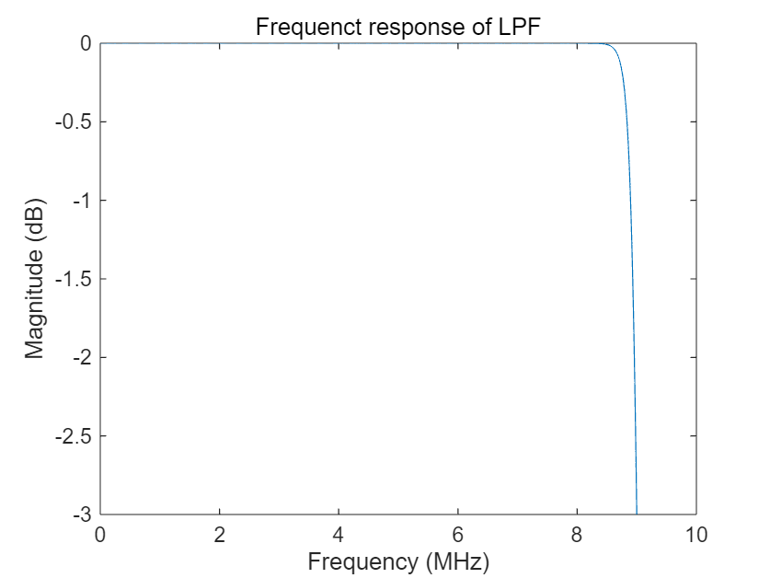
代码如下：
addpath('data');
load(sprintf('data\\data_%d.mat', 1));
bandwidth = 9e6;
[b, a] = butter(20, bandwidth/(0.5*f_s));
[H,f_H] = freqz(b,a,4096,f_s);
figure;
plot(f_H*1e-6,20*log10(abs(H)));
xlabel('Frequency (MHz)');
ylabel('Magnitude (dB)');
ylim([-3,0]);
title('Frequenct response of LPF');

