Data1
监测信号的时域图/频域图：
1、时域图局部图（虚部）+完整频域图
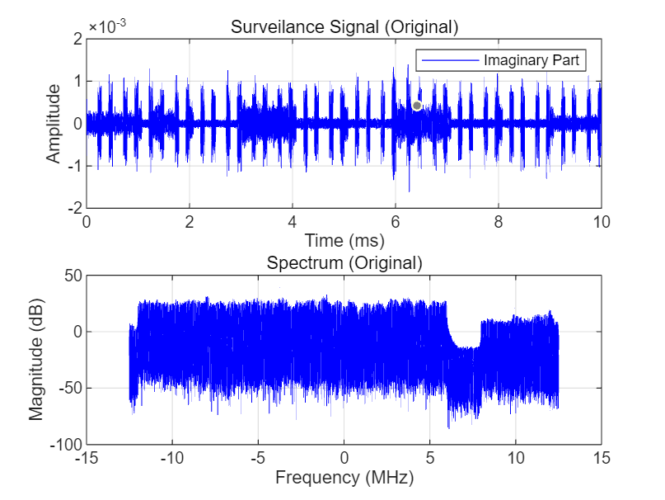

2、完整时域图+完整频域图
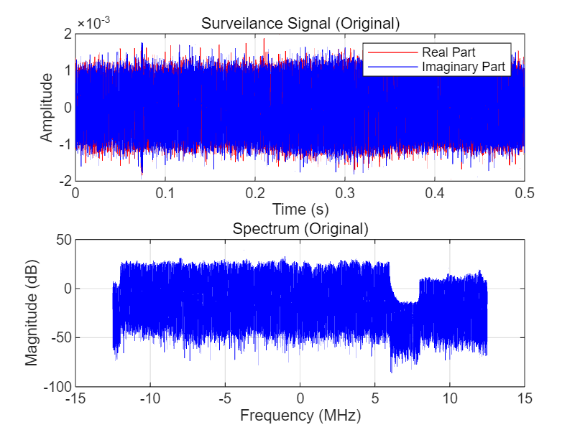

经过频移处理的监测信号时域图/频域图:
- 时域图局部图（虚部）+完整频域图
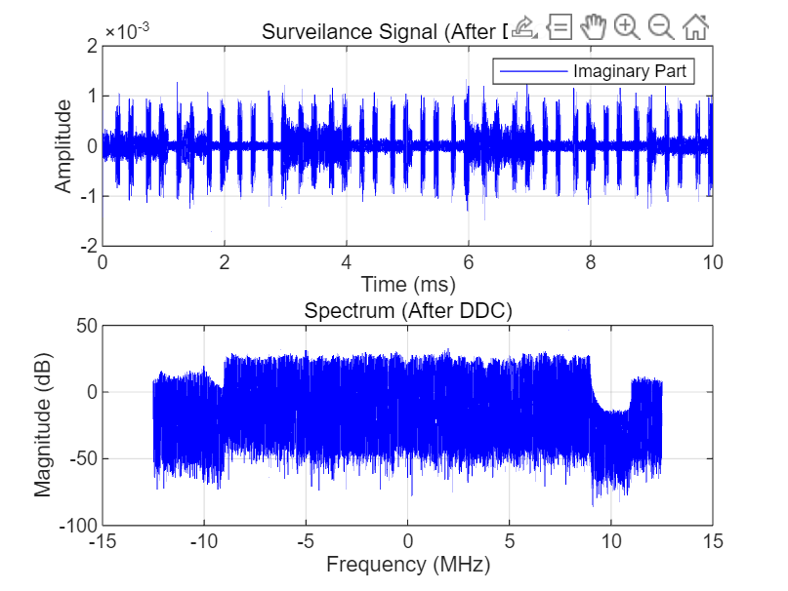

2、完整时域图+完整频域图
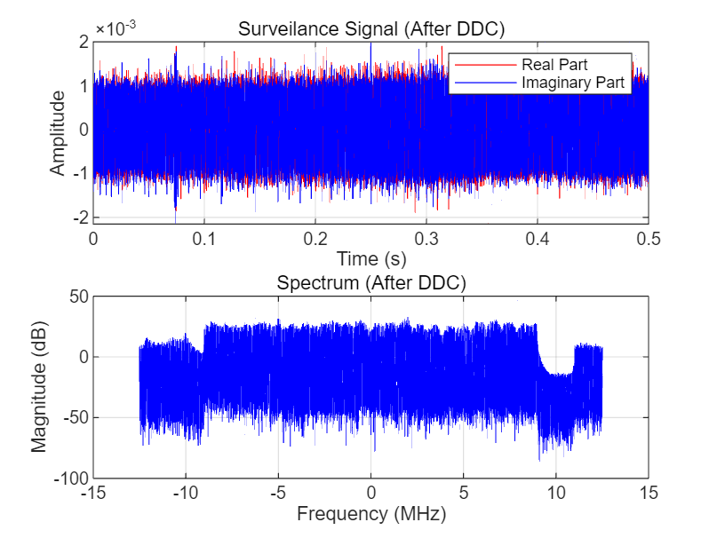

经过低通滤波器处理的监测信号时域图/频域图：
- 时域图局部图（虚部）+完整频域图
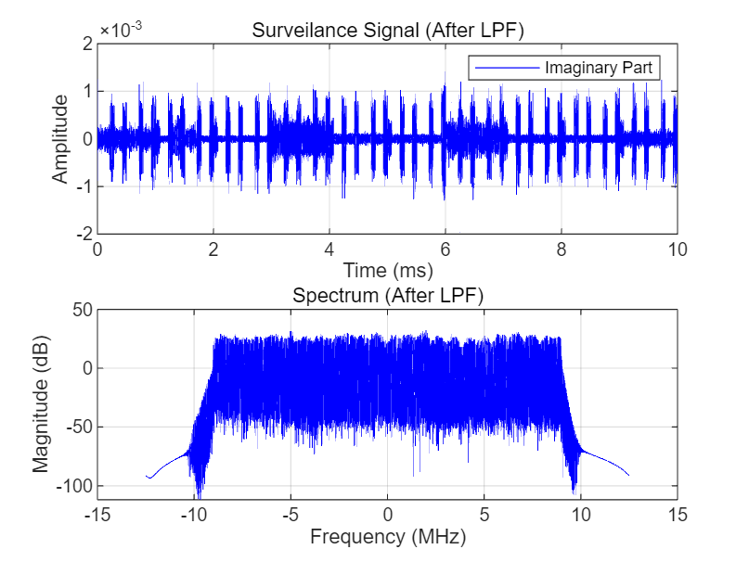
2、完整时域图+完整频域图
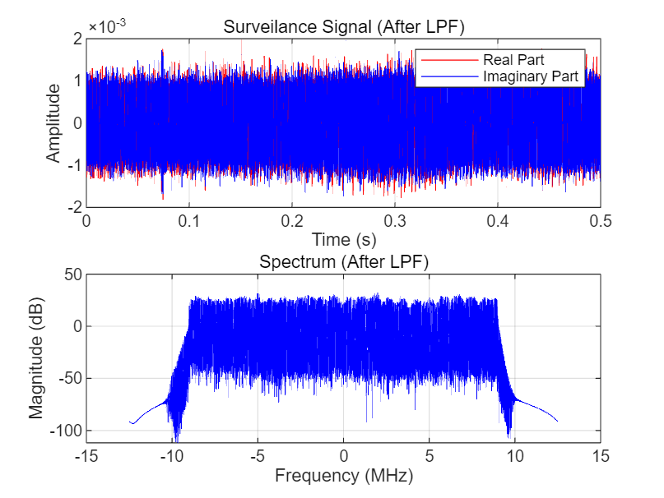

代码：
Surveil
function out = surveil(n)

% 加载数据

addpath('data');

load(sprintf('data\\data_%d.mat', n));

% 参数设置

bandwidth = 9e6;

ts = 1/f_s;

duration_plot = 0.5;

t_axis_plot = 0:1/f_s: duration_plot-1/f_s;

N = length(seq_sur);

f = (-N/2:N/2-1)*(f_s/N)/1e6;

% 初始信号频域

seq_sur_f = 20*log10(abs(fftshift(fft(seq_sur))));

% DDC

f_ddc = -3*1e6;

seq_sur_ddc_t = seq_sur .* exp(-1i*2*pi*f_ddc*(0:N-1)/f_s);

seq_sur_ddc_f = 20*log10(abs(fftshift(fft(seq_sur_ddc_t))));

% LPF

[b, a] = butter(20, bandwidth/(0.5*f_s));

seq_sur_lpf_t = filter(b, a, seq_sur_ddc_t);

seq_sur_lpf_f = 20*log10(abs(fftshift(fft(seq_sur_lpf_t))));

% 输出

out = seq_sur_lpf_f;

% 绘图 - 初始信号

figure;

subplot(2,1,1);

%plot(t_axis_plot, real(seq_sur), 'r');

%hold on;

plot(t_axis_plot*1000, imag(seq_sur), 'b');

grid on;

xlim([0,10]);

ylim([-2e-3,2e-3]);

xlabel('Time (ms)');

ylabel('Amplitude');

legend('Imaginary Part');

title('Surveilance Signal (Original)');

subplot(2,1,2);

plot(f, seq_sur_f, 'b');

grid on;

xlabel('Frequency (MHz)');

ylabel('Magnitude (dB)');

title('Spectrum (Original)');

% 绘图 - DDC

figure;

subplot(2,1,1);

%plot(t_axis_plot, real(seq_sur_ddc_t), 'r');

%hold on;

plot(t_axis_plot*1000, imag(seq_sur_ddc_t), 'b');

grid on;

xlim([0,10]);

ylim([-2e-3,2e-3]);

xlabel('Time (ms)');

ylabel('Amplitude');

legend('Imaginary Part');

title('Surveilance Signal (After DDC)');

subplot(2,1,2);

plot(f, seq_sur_ddc_f, 'b');

grid on;

xlabel('Frequency (MHz)');

ylabel('Magnitude (dB)');

title('Spectrum (After DDC)');

% 绘图 - LPF

figure;

subplot(2,1,1);

%plot(t_axis_plot, real(seq_sur_lpf_t), 'r');

%hold on;

plot(t_axis_plot*1000, imag(seq_sur_lpf_t), 'b');

grid on;

xlim([0,10]);

ylim([-2e-3,2e-3]);

xlabel('Time (ms)');

ylabel('Amplitude');

legend( 'Imaginary Part');

title('Surveilance Signal (After LPF)');

subplot(2,1,2);

plot(f, seq_sur_lpf_f, 'b');

grid on;

xlabel('Frequency (MHz)');

ylabel('Magnitude (dB)');

title('Spectrum (After LPF)');

end

surveilri
function out = surveilri(n)

% 加载数据

addpath('data');

load(sprintf('data\\data_%d.mat', n));

% 参数设置

bandwidth = 9e6;

ts = 1/f_s;

duration_plot = 0.5;

t_axis_plot = 0:1/f_s: duration_plot-1/f_s;

N = length(seq_sur);

f = (-N/2:N/2-1)*(f_s/N)/1e6;

% 初始信号频域

seq_sur_f = 20*log10(abs(fftshift(fft(seq_sur))));

% DDC

f_ddc = -3*1e6;

seq_sur_ddc_t = seq_sur .* exp(-1i*2*pi*f_ddc*(0:N-1)/f_s);

seq_sur_ddc_f = 20*log10(abs(fftshift(fft(seq_sur_ddc_t))));

% LPF

[b, a] = butter(20, bandwidth/(0.5*f_s));

seq_sur_lpf_t = filter(b, a, seq_sur_ddc_t);

seq_sur_lpf_f = 20*log10(abs(fftshift(fft(seq_sur_lpf_t))));

% 输出

out = seq_sur_lpf_f;

% 绘图 - 初始信号

figure;

subplot(2,1,1);

plot(t_axis_plot, real(seq_sur), 'r');

hold on;

plot(t_axis_plot, imag(seq_sur), 'b');

grid on;

xlabel('Time (s)');

ylabel('Amplitude');

legend('Real Part','Imaginary Part');

title('Surveilance Signal (Original)');

subplot(2,1,2);

plot(f, seq_sur_f, 'b');

grid on;

xlabel('Frequency (MHz)');

ylabel('Magnitude (dB)');

title('Spectrum (Original)');

% 绘图 - DDC

figure;

subplot(2,1,1);

plot(t_axis_plot, real(seq_sur_ddc_t), 'r');

hold on;

plot(t_axis_plot, imag(seq_sur_ddc_t), 'b');

grid on;

xlabel('Time (s)');

ylabel('Amplitude');

legend('Real Part','Imaginary Part');

title('Surveilance Signal (After DDC)');

subplot(2,1,2);

plot(f, seq_sur_ddc_f, 'b');

grid on;

xlabel('Frequency (MHz)');

ylabel('Magnitude (dB)');

title('Spectrum (After DDC)');

% 绘图 - LPF

figure;

subplot(2,1,1);

plot(t_axis_plot, real(seq_sur_lpf_t), 'r');

hold on;

plot(t_axis_plot, imag(seq_sur_lpf_t), 'b');

grid on;

xlabel('Time (s)');

ylabel('Amplitude');

legend('Real Part', 'Imaginary Part');

title('Surveilance Signal (After LPF)');

subplot(2,1,2);

plot(f, seq_sur_lpf_f, 'b');

grid on;

xlabel('Frequency (MHz)');

ylabel('Magnitude (dB)');

title('Spectrum (After LPF)');

end

