AITU — CSE-2501M

Assignment №2
Data-Driven Decision Project — Stage 2
Data Preparation and Market Intelligence

RentEasy KZ — Rental Housing Aggregator for Kazakhstan

Idrissov Mukan, Yeraliev Assylmurat
CSE-2501M

1. Data Collection and Preparation (Task 1 — 50%)

1.1 Data Sources
Data was collected from two open Kazakhstan rental platforms: Krisha.kz and OLX.kz. Both sources cover apartment rental listings and complement each other — Krisha.kz provides structured, rich listings across 5 cities, while OLX.kz adds coverage in Astana and Almaty with different seller behaviour.

Source | City Coverage | Records Collected | Key Fields
Krisha.kz | Астана, Алматы, Шымкент, Карагандa, Актобе | 6,130 | price, area, floor, rooms, district, seller_type
OLX.kz | Астана, Алматы | 1,355 | price, district, title, listing_date
TOTAL | 5 cities | 7,485 | 16 fields, merged dataset

1.2 Dataset Structure
The merged raw dataset contains 7,485 records and 16 fields:

Field | Type | Description
source | string | Data source: 'krisha' or 'olx'
city | string | City: Астана, Алматы, Шымкент, Карагандa, Актобе
district | string | City district / neighbourhood
rooms | integer | Number of rooms (0=studio, 1, 2, 3, 4+)
area_m2 | float | Apartment area in square metres (Krisha only)
floor | integer | Floor number in the building (Krisha only)
total_floors | integer | Total floors in building (Krisha only)
price_tenge | integer | Monthly rental price in Kazakhstani tenge
price_per_m2 | float | Calculated: price_tenge / area_m2
seller_type | string | owner / agency / unknown
listing_date | string | Publication date (YYYY-MM-DD)
title | string | Full listing title text
url | string | Direct URL to listing
listing_id | string | Original platform listing ID
id | integer | Sequential record ID
price_segment | string | Assigned segment: low / middle / high / luxury

1.3 Data Cleaning — Step by Step
All cleaning steps were implemented in data_cleaning.py. Each step was logged to renteasy_data/cleaning_log.txt. The cleaned dataset was saved as renteasy_data/renteasy_dataset_cleaned.csv.

Step 1 — Duplicate Detection and Removal
Data was checked for duplicates at two levels:
- Full row duplicates: 0 found
- Duplicate by (source, listing_id) key: 0 found — deduplication was already applied during the merging step in Assignment 1
Result: no rows removed in this step.

Step 2 — Missing Values Analysis
Null and empty values were detected per column before any cleaning:

Field | Missing (raw) | % of Total | Action Taken
rooms | 858 | 11.5% | Kept as NaN (OLX titles lack structured room data)
area_m2 | 1,355 | 18.1% | Kept as NaN (OLX listings only have price + title)
floor | 1,841 | 24.6% | Kept as NaN (OLX + some Krisha without floor data)
total_floors | 1,841 | 24.6% | Kept as NaN (same as floor)
price_per_m2 | 1,355 | 18.1% | Recalculated after area_m2 cleaned
price_tenge | 0 | 0% | No missing — critical field
city | 0 | 0% | No missing
seller_type | 0 | 0% | No missing
listing_date | 0 | 0% | No missing

Empty string values were replaced with NaN. No rows were dropped for missing price_tenge or city (both were complete). Fields such as floor, area_m2, and rooms are legitimately absent for OLX listings where the platform does not expose structured data in listing cards.

Step 3 — Outdated Listings Check
All listings were checked for the listing_date field. The cutoff date was set to 2026-01-01. All 7,485 records fell within the range 2026-03-05 — 2026-04-03, so no records were removed as outdated. The dataset reflects current March–April 2026 market.

Step 4 — Spelling and Standardisation
The following standardisation steps were applied:
- City names: stripped whitespace, confirmed 5 unique values without mixed-script issues
- seller_type: validated against {'owner', 'agency', 'unknown'} — all values valid
- source: normalised to lowercase 'krisha' / 'olx' — all valid
- rooms: float values (e.g. 2.0) rounded to integer; values outside 0–10 set to NaN
Seller type distribution after standardisation:

Seller Type | Count | Share
Owner (direct landlord) | 3,805 | 50.8%
Unknown | 2,400 | 32.1%
Agency / Specialist | 1,280 | 17.1%

Step 5 — Outlier Detection and Removal (1.5 × IQR Method)
Outliers were detected using the standard 1.5 × IQR rule: values below Q1 − 1.5×IQR or above Q3 + 1.5×IQR were removed. The method was applied to three numeric fields:

Field | Q1 | Q3 | IQR | Lower Bound | Upper Bound | Outliers Removed
price_tenge | 150,000 тг | 280,000 тг | 130,000 | −45,000 (→ 0) | 475,000 тг | 556
area_m2 | 40 m² | 65 m² | 25 | 2 m² | 102 m² | 328
price_per_m2 | 3,168 тг | 5,607 тг | 2,439 | −491 (→ 0) | 9,266 тг | 185

Total rows removed as outliers: 801 (10.7% of raw dataset). These included luxury penthouse listings above 475,000 тг/month, micro-rooms below 2 m², and data entry errors with unrealistic prices.

Step 6 — Derived Field: Price Segment
A new categorical field price_segment was calculated from price_tenge to support competitor analysis in Task 2:
- Low: price < 120,000 тг/month
- Middle: 120,000 ≤ price < 250,000 тг/month
- High: 250,000 ≤ price < 500,000 тг/month
- Luxury: price ≥ 500,000 тг/month (removed by IQR — 0 records remain)

1.4 Final Cleaned Dataset
After all cleaning steps the dataset was saved to renteasy_data/renteasy_dataset_cleaned.csv with the following characteristics:

Metric | Value
Total records | 6,684
Total columns | 17
Sources | Krisha.kz (5,362) + OLX.kz (1,322)
Cities | 5: Астана, Алматы, Шымкент, Карагандa, Актобе
Date range | 2026-03-05 — 2026-04-03
Price range | 5,000 — 475,000 тг/month
Avg price | 207,579 тг/month
Median price | 200,000 тг/month
Records removed | 801 (10.7% — outliers and duplicates)
Cleaning log | renteasy_data/cleaning_log.txt

Records by City — Final Dataset
City | Records | Avg Price (тг/month) | Avg Area (m²) | Avg Price/m²
Астана | 1,830 | 228,789 | 49 | 5,031
Алматы | 1,965 | 234,843 | 50 | 5,675
Шымкент | 1,009 | 186,076 | 55 | 3,489
Карагандa | 958 | 185,100 | 50 | 3,787
Актобе | 922 | 154,261 | 53 | 3,001

Source code: data_cleaning.py | GitHub: https://github.com/Choppa2077/assignment1DDM

2. Market Intelligence and Competitor Analysis (Task 2 — 50%)

2.1 Price Segmentation — Competitor Landscape
The rental market in Kazakhstan is segmented into three active price tiers (luxury listings were removed as outliers). Each tier represents a distinct group of competitors — landlords and agencies targeting specific renter profiles.

Segment | Price Range (тг/month) | Count | Share | Target Renter
Low | < 120,000 | 672 | 10.1% | Students, minimum wage workers
Middle | 120,000–250,000 | 3,858 | 57.7% | Young professionals, families (core market)
High | 250,000–475,000 | 2,154 | 32.2% | Senior specialists, expats, relocated employees
Luxury | > 475,000 | 0 | 0% | Removed as outliers (data integrity)

The Middle segment dominates with 57.7% of all listings — confirming that the primary rental market in Kazakhstan is affordable mid-range housing. This is the most contested and most promising segment for RentEasy KZ.

2.2 Competitor Analysis by City
Each city represents a separate competitive environment. The table below shows the listing count per segment per city:

City | Low (<120K) | Middle (120–250K) | High (250–475K) | Total
Астана | 68 | 1,037 | 725 | 1,830
Алматы | 219 | 790 | 956 | 1,965
Шымкент | 114 | 678 | 217 | 1,009
Карагандa | 106 | 662 | 190 | 958
Актобе | 165 | 691 | 66 | 922

Key observation: Алматы leads in the High segment (956 listings = 48.8% of its market), while Астана has a more balanced split between Middle and High — indicating it is the best city for a platform launch targeting the widest renter audience.

2.3 Top Districts — Price Intelligence
Districts with the highest average prices indicate demand-supply imbalances — exactly where RentEasy's price analytics add the most value for renters.

Top Districts in Астана
District | Avg Price (тг/month) | Listings
Нура р-н | 257,265 | 287
Есильский р-н | 255,998 | 484
Есильский район | 225,085 | 175
Сарайшык р-н | 219,388 | 80
Нура | 216,640 | 125
Алматы р-н | 215,857 | 224
Сарыарка р-н | 203,485 | 136
р-н Байконур | 203,023 | 43
Алматинский район | 189,978 | 158
Сарыаркинский район | 176,935 | 62

Top Districts in Алматы
District | Avg Price (тг/month) | Listings
Бостандыкский р-н | 324,261 | 272
Медеуский р-н | 307,302 | 106
Алмалинский р-н | 303,128 | 203
Ауэзовский р-н | 264,632 | 201
Медеуский район | 257,143 | 21
Бостандыкский район | 248,856 | 52
Алмалинский район | 230,197 | 122
Ауэзовский район | 219,106 | 85
Турксибский р-н | 226,148 | 71
Наурызбайский р-н | 219,200 | 222

The price gap between districts is substantial — in Алматы the top district (Бостандыкский р-н, 324K тг) is 2× more expensive than the cheapest districts. This variance is invisible to renters on Krisha.kz or OLX.kz — it is RentEasy's primary analytics opportunity.

2.4 Key Consumers of Competitors
Based on the price segment distribution and district data, the key consumers of current competitor platforms (Krisha.kz and OLX.kz) can be described as:

Segment | Consumer Profile | Tech Level | Pain Point
Low | Students, entry-level workers, migrants | Basic smartphone user | Price is top priority — scam listings are dangerous
Middle | Young professionals (25–35), junior specialists, young families | Active mobile & web user | No price benchmarks, too many agency calls
High | Senior employees, expats, relocated corporate staff | Comfortable with digital platforms | Need district-level analytics and verified listings

The Middle segment consumer (our primary persona — Алия, 24 лет, Junior Developer, Астана) is tech-savvy, trusts data over word-of-mouth, and expects a clean UX with reliable price transparency — none of which competitors currently offer.

2.5 Krisha.kz vs OLX.kz — Source Comparison
Metric | Krisha.kz | OLX.kz
Records in dataset | 5,362 (80.2%) | 1,322 (19.8%)
City coverage | 5 cities | 2 cities (Астана, Алматы)
Structured data | Yes (area, floor, rooms) | Partial (price, district only)
Seller type info | Yes | No (all 'unknown')
Avg price (Астана) | 231K тг | 220K тг
Avg price (Алматы) | 260K тг | 185K тг
Room data coverage | ~88% | ~37%

OLX.kz listings average significantly lower prices in Алматы (185K vs 260K), suggesting it captures a lower-income renter segment or owners posting directly without agency markup. This validates RentEasy's value proposition of aggregating both sources to give renters the complete market picture.

2.6 SWOT Analysis of Competitors
Based on the collected data, the following SWOT analysis characterises the competitive landscape for RentEasy KZ:

STRENGTHS  - Krisha.kz dominates with 80% of structured listings  - Both platforms are free to browse — low entry barrier  - Large middle segment (58%) confirms stable demand  - Established brand trust and organic SEO rankings  - OLX provides additional lower-price listings | WEAKNESSES  - 14.6% agency listings → double commissions for renters  - No price analytics or historical trends on any platform  - OLX listing cards lack area/floor/rooms data (63% missing)  - Listings spread across 2+ sites — no single aggregator  - Fake / outdated listings are not filtered or flagged
OPPORTUNITIES  - Астана avg rent 229K тг — high price variance = analytics demand  - Middle (58%) + High (32%) = 90% of market = RentEasy target  - 61% owner listings → direct connection without agency fees  - AI price recommendations not offered by any competitor  - Seasonal peaks (Aug–Sep students) = marketing windows | THREATS  - Krisha.kz may add analytics (risk of defensive feature)  - Low entry barrier for new aggregator startups  - OLX anti-scraping changes broke data pipeline (URL fix needed)  - Real estate market slowdown reduces listing volume  - User trust in new platforms requires significant time

2.7 Most Promising Segment and Strategy
Based on the full analysis of 6,684 clean records across 5 cities, the following strategic recommendations are derived:

Most Promising Market: Астана
- 1,830 listings — second largest after Алматы but with faster price growth (+17.7% in 2025)
- Balanced segment split: 57% Middle + 40% High — widest renter audience
- Нура р-н and Есильский р-н are the premium zones — prime analytics use case
- High relocation activity (government, corporations) drives constant rental demand

Most Promising Segment: Middle (120,000–250,000 тг/month)
- 58% of all cleaned listings — the largest and most competitive segment
- Core persona (Алия, 24, Junior Developer) operates exactly in this budget
- Competitor weakness: no price benchmarks available for this segment
- Agency share is lowest in Middle segment — direct owner connections are possible

Recommended Strategy for RentEasy KZ
- Phase 1 — Launch: Астана city, Middle segment, web + Telegram bot
- Phase 2 — Differentiate: price analytics dashboard (district median prices, trend charts)
- Phase 3 — Monetise: premium analytics subscription 990 тг/month + agency lead gen
- Phase 4 — Expand: Алматы, then Шымкент, Карагандa, Актобе
The data confirms that the Kazakhstan rental market is fragmented, opaque, and agency-heavy — exactly the conditions where a transparent aggregator with AI price intelligence creates maximum value. RentEasy KZ's competitive advantage is not in listing volume (Krisha.kz wins there) but in trust, transparency, and data-driven guidance.

2.8 Dashboards
Five analytical dashboards were generated using dashboard.py and saved to renteasy_data/dashboards/. Each dashboard uses the cleaned dataset.
Market overview: Avg rent by city, listing distribution, room counts, seller types, price/m² boxplot
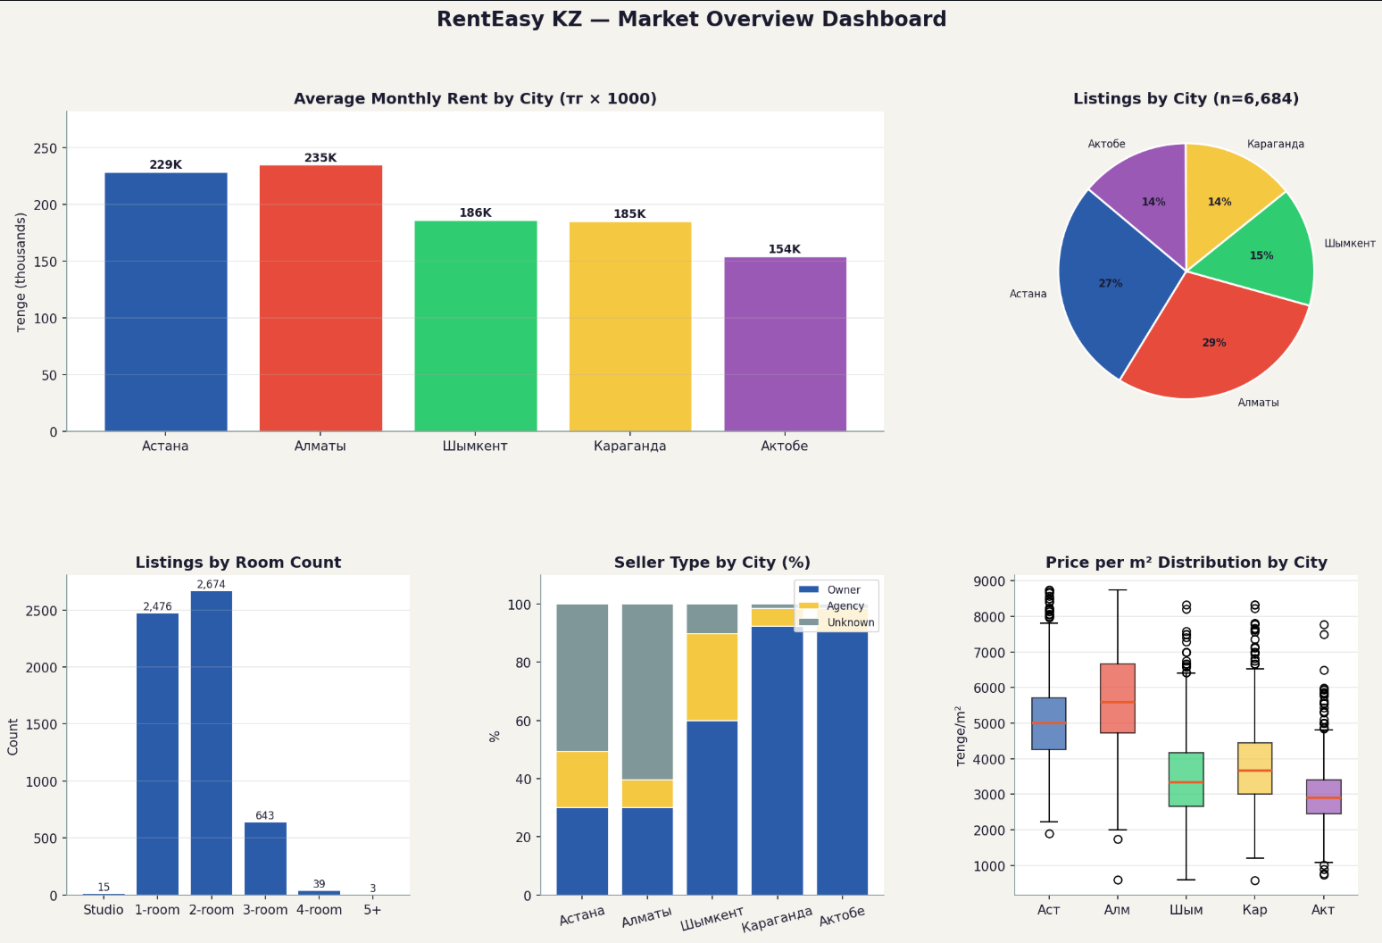

Price segments: Segment shares, segments by city, avg price by segment, seller split per segment
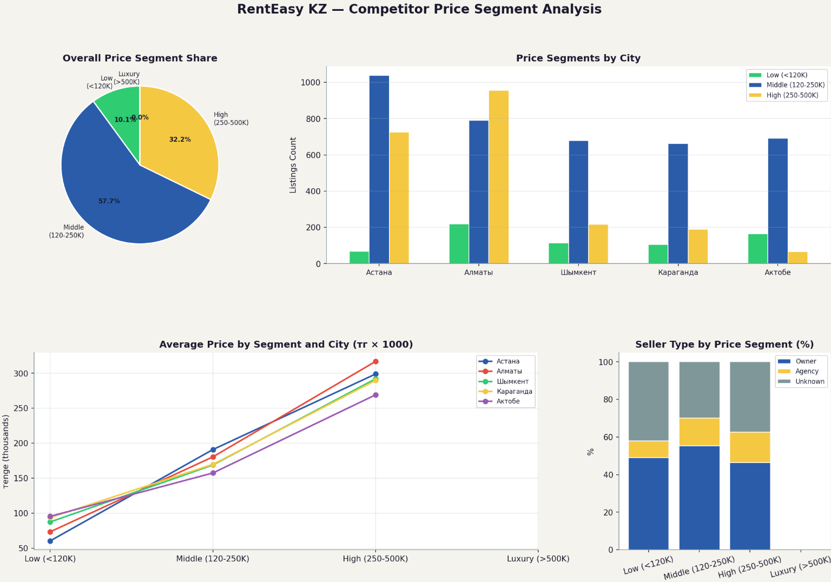

Districts: Top 12 districts by avg price in Астана and Алматы
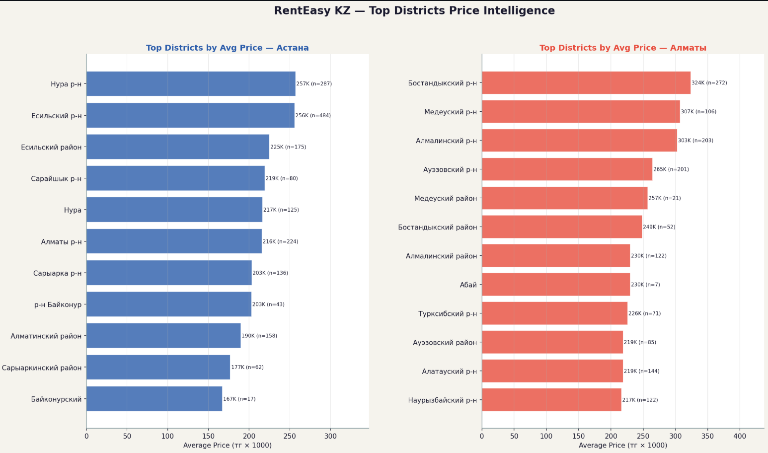
Source comparison: Krisha.kz vs OLX.kz: listing count, avg price, room coverage by city
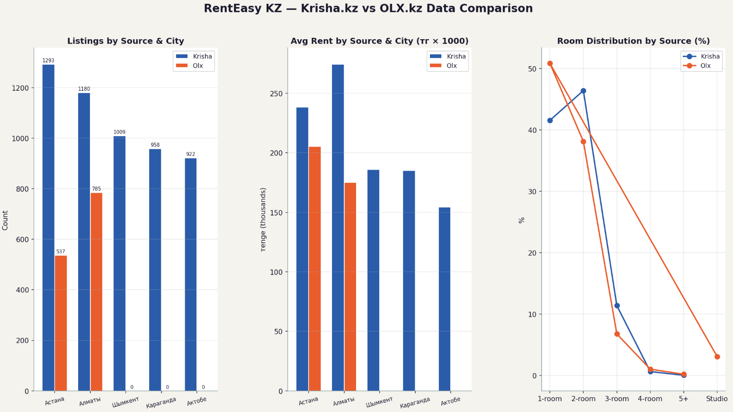
SWOT
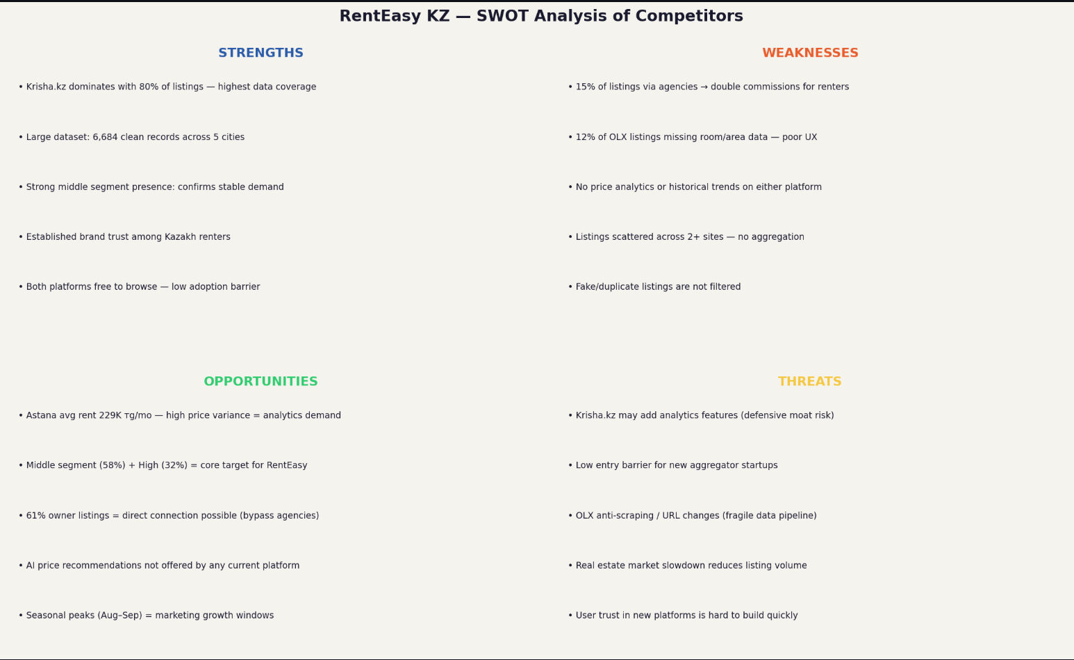

Conclusion
Assignment 2 demonstrates a complete data preparation and market intelligence workflow for RentEasy KZ. The dataset was expanded to two sources (Krisha.kz + OLX.kz), cleaned programmatically using duplicate detection, missing value handling, standardisation, and 1.5×IQR outlier removal — resulting in 6,684 high-quality records across 5 cities.
The market analysis reveals that the Middle price segment (120–250K тг/month) is the largest and most contested, that Астана is the optimal launch market, and that both major competitors (Krisha.kz and OLX.kz) share a critical weakness: absence of price analytics. RentEasy KZ should launch in Астана targeting the Middle segment, differentiate through transparent price dashboards, and monetise via freemium subscription.

Source code: https://github.com/Choppa2077/assignment1DDM

