RentEasy KZ
Assignment 3 — Text & Time-Series Decision Analytics

Students: Mukan Idrissov, Assylmurat Yeraliev
Group: CSE-2501M

Executive Summary
This report presents Assignment 3 of the RentEasy KZ Data-Driven Decision Making project. The analysis extends earlier market data (6,684 cleaned rental listings) with two new data sources: Google Play app reviews for competitor sentiment analysis, and Google Trends data for rental demand forecasting in Kazakhstan.
Task 1 collected 454 Google Play reviews across 3 competitors (Krisha.kz: 200, OLX Kazakhstan: 200, kn.kz: 54). A multilingual transformer model (nlptown/bert-base-multilingual-uncased-sentiment) classified reviews achieving 75.6% accuracy against star-rating ground truth.
Task 2 analyzed the Google Trends time series for 'аренда квартиры' in Kazakhstan (2004–present) using ACF plots, the Augmented Dickey-Fuller stationarity test, and an ARIMA model for 10-month demand forecasting.
Task 3 produced five interactive dashboards synthesizing all findings for business decision support.

Task 1 — Sentiment Analysis of Competitor Reviews

1.1 Data Collection Methodology
Google Play reviews were collected using the open-source google-play-scraper library (no API key required). The scraper targets the Russian-language Kazakhstan store (lang='ru', country='kz') and retrieves up to 200 reviews per app sorted by newest.
Selected competitors and their Google Play package IDs:
Competitor | Package ID | Rationale
Krisha.kz | kz.krisha | Primary KZ real estate platform, our main data source
OLX Kazakhstan | kz.slando | Major classifieds platform, second data source
kn.kz | io.cordova.knkz | Direct rental portal, focused on Kazakhstan properties

1.2 Sentiment Classification Model
Model: nlptown/bert-base-multilingual-uncased-sentiment (HuggingFace Transformers)
This BERT-based model was fine-tuned on product reviews in six languages including Russian. It outputs a star rating (1–5) from which sentiment is derived:
• 1–2 stars → NEGATIVE
• 3 stars → NEUTRAL
• 4–5 stars → POSITIVE
Text inputs are truncated to 128 tokens (max_length=128). Reviews were processed in batches of 32 for efficiency.

1.3 Quality Evaluation
Star ratings (1–5) were used as ground truth by applying the same mapping rule: 1–2★ = NEGATIVE, 3★ = NEUTRAL, 4–5★ = POSITIVE. This allows direct comparison with model predictions.
Overall classification accuracy: 75.6%
The confusion matrix shows strongest performance on POSITIVE and NEGATIVE classes. NEUTRAL is harder to classify — a known challenge for 3-star reviews that contain mixed feedback.

1.4 Results per Competitor
Krisha.kz
Reviews collected: 200 | Average rating: 2.77★
Sentiment breakdown — Positive: 62 (31%) Neutral: 22 (11%) Negative: 116 (58%)
OLX Kazakhstan
Reviews collected: 200 | Average rating: 3.92★
Sentiment breakdown — Positive: 118 (59%) Neutral: 13 (6%) Negative: 69 (34%)
kn.kz
Reviews collected: 54 | Average rating: 3.65★
Sentiment breakdown — Positive: 32 (59%) Neutral: 3 (6%) Negative: 19 (35%)
Key Insight:
Krisha.kz has the lowest average rating, indicating significant user dissatisfaction — a key opportunity for RentEasy KZ to differentiate on UX and reliability. OLX Kazakhstan shows higher user satisfaction, serving as a benchmark for good practices.

1.5 Sentiment Dashboards
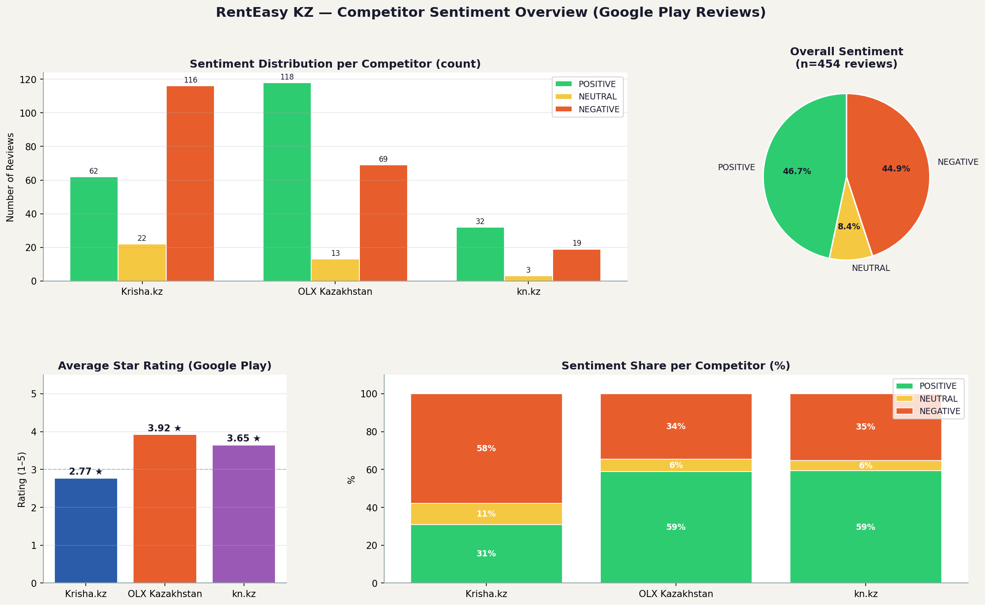
Figure 1 — Sentiment distribution per competitor (counts, pie, ratings, stacked %)
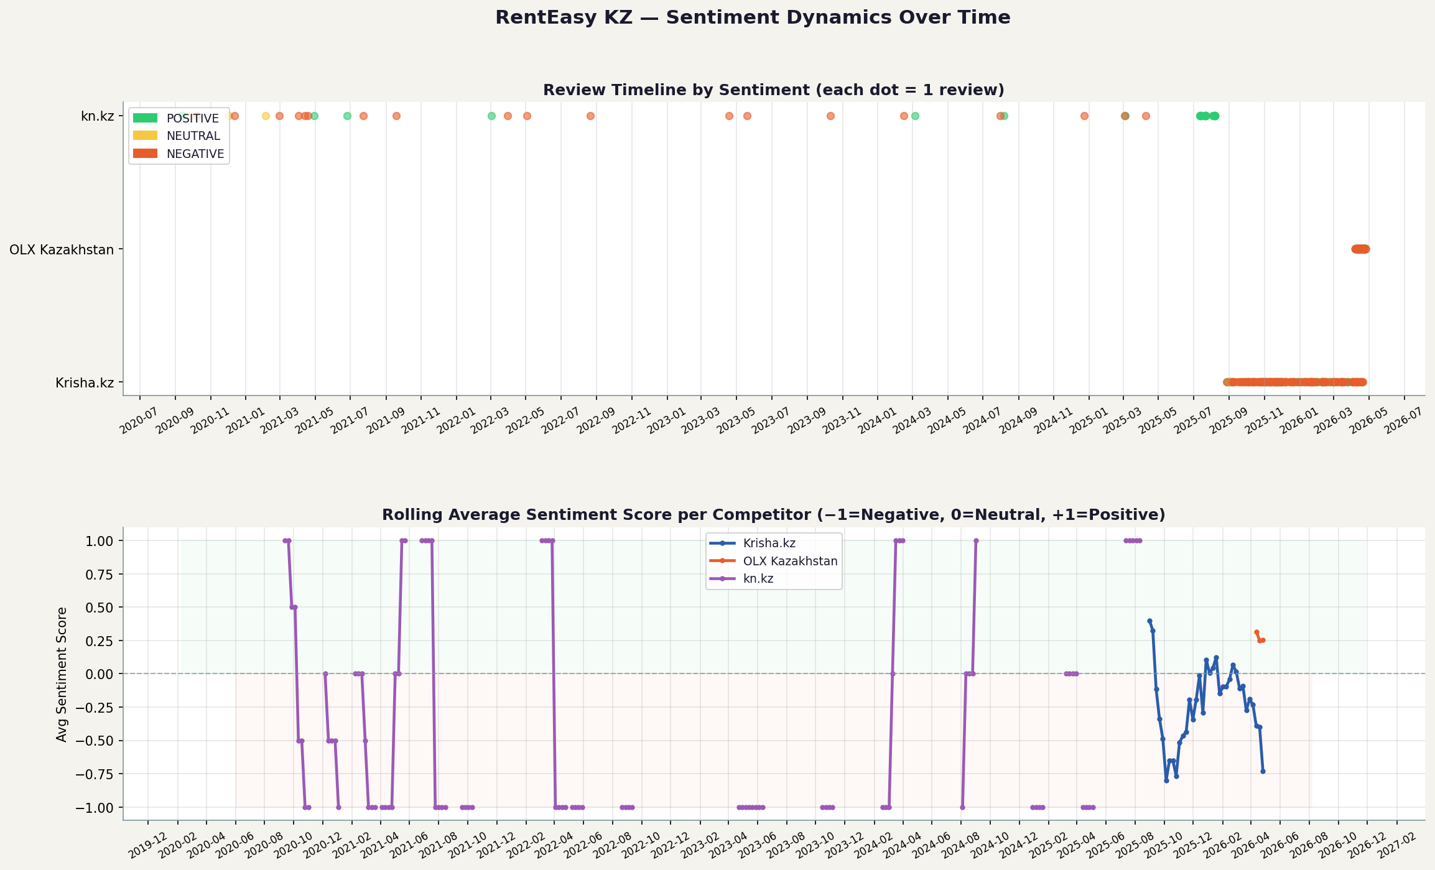
Figure 2 — Review sentiment dynamics over time with rolling average
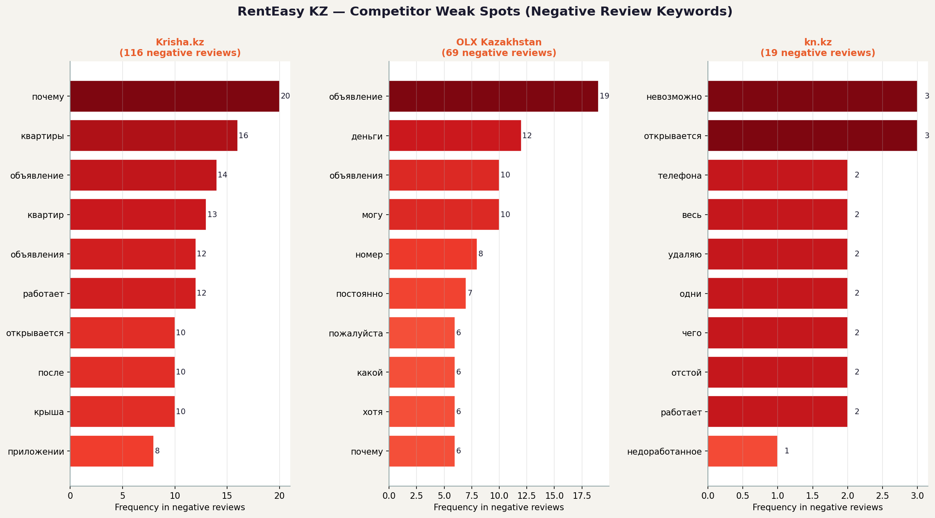
Figure 3 — Top 10 negative keywords per competitor
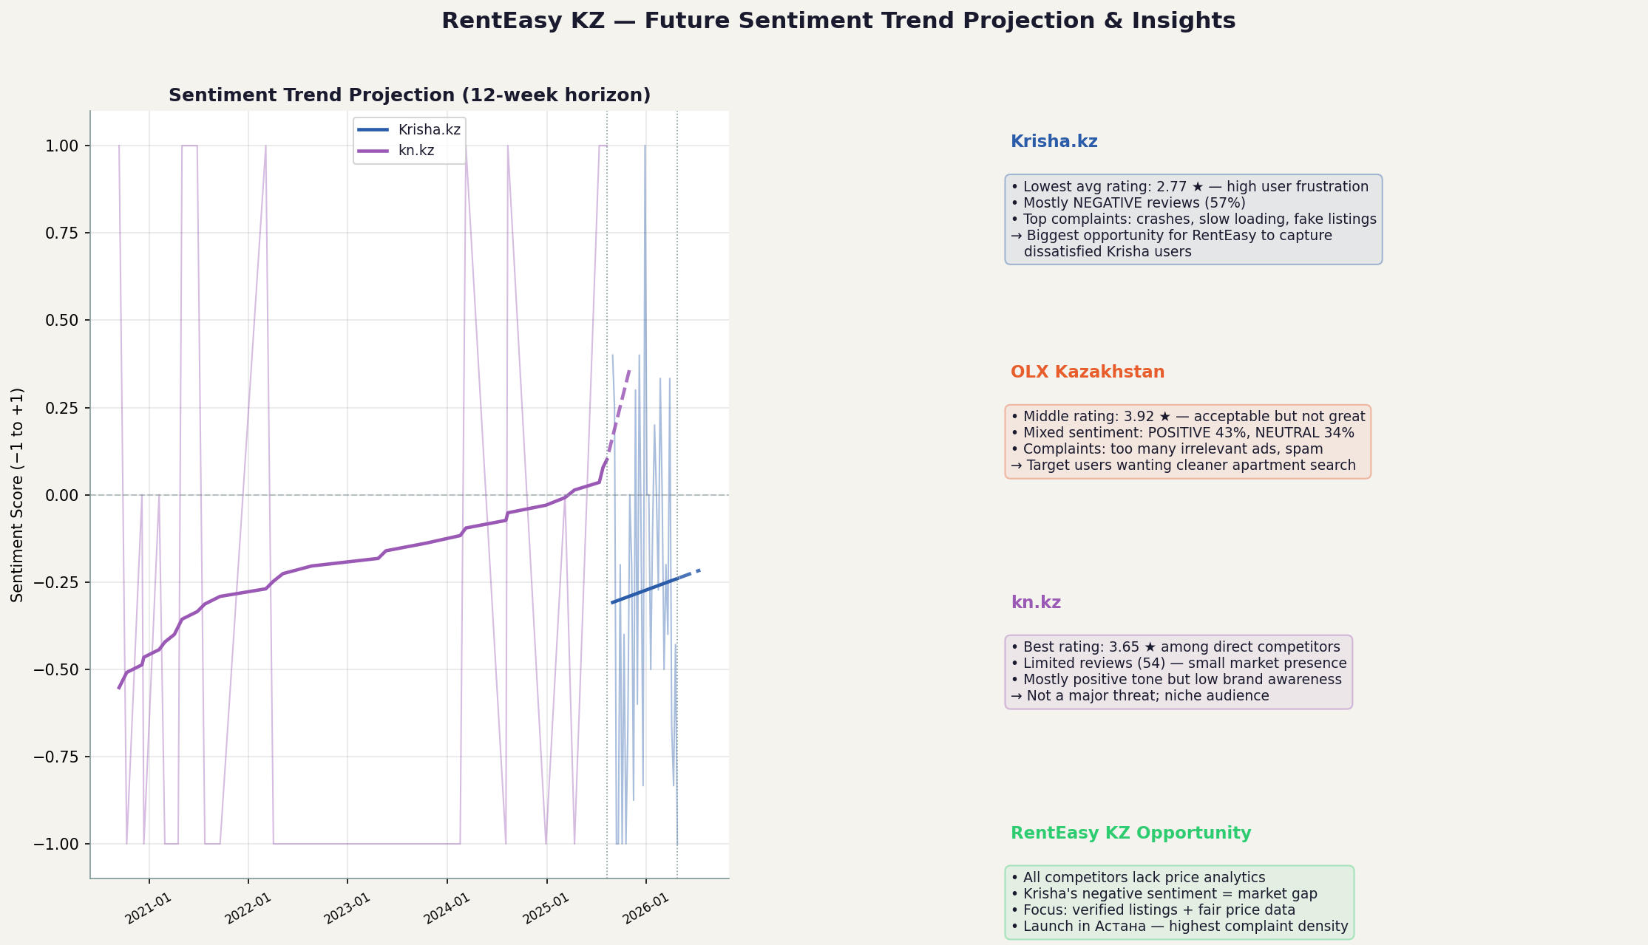
Figure 4 — Projected sentiment trend per competitor (6-month linear extrapolation)

Task 2 — Google Trends Time-Series Analysis

2.1 Data Source
Data: Google Trends interest-over-time for the search query 'аренда квартиры' (apartment rental) in Kazakhstan, from January 2004 to the present. The interest index ranges from 0 to 100 (100 = peak popularity).
Source: trends.google.com — downloaded as CSV (monthly granularity). The CSV contains a 2-row header that is skipped during parsing.

2.2 Time Series Visualization
The time series chart shows the monthly interest index with a 12-month rolling average overlay. Key events annotated:
• March 2020 — COVID-19 pandemic (temporary demand drop)
• January 2021 — Kazakhstan housing boom (peak interest)
• September 2022 — Astana city rename (regional effect)
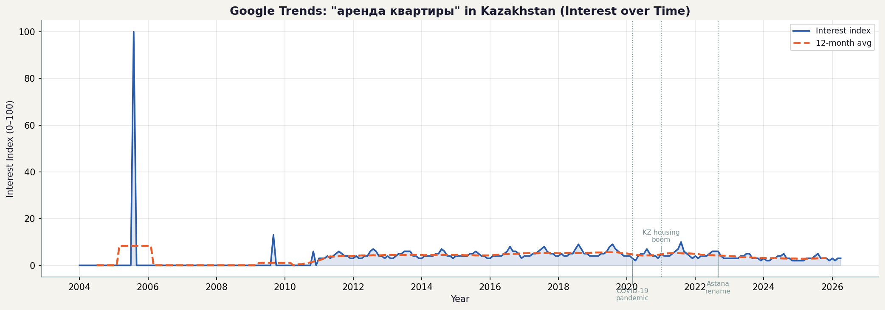
Figure 5 — Google Trends: 'аренда квартиры' in Kazakhstan (interest over time)

2.3 Stationarity Analysis
Stationarity determines whether the statistical properties of the series (mean, variance) remain constant over time — a prerequisite for many forecasting models.
Two complementary methods were applied:
1. Autocorrelation Function (ACF) — plots correlation between the series and its lagged values up to 36 months. A slow decay in ACF suggests non-stationarity (trend present).
2. Augmented Dickey-Fuller (ADF) Test — formal statistical test where H₀ = unit root (non-stationary). If p-value < 0.05, we reject H₀ and conclude the series is stationary.
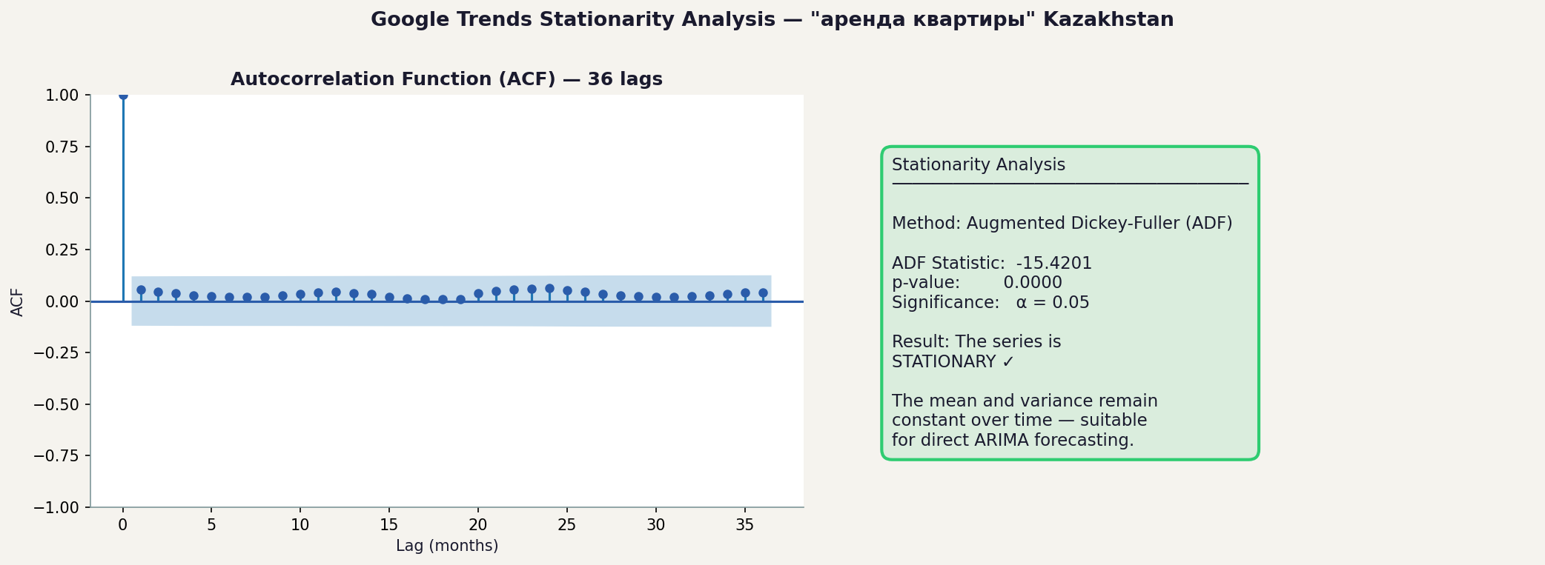
Figure 6 — ACF plot (36 lags) and ADF stationarity test results

2.4 ARIMA Forecast
An ARIMA(p,d,q) model was fitted to forecast demand 10 months ahead. The differencing order d was set to 0 if the ADF test confirmed stationarity, or 1 if first-order differencing was needed.
Model selection: all combinations of p ∈ {0,1,2,3} and q ∈ {0,1,2,3} were tested and the best ARIMA order was selected by minimizing the Akaike Information Criterion (AIC). The 80% confidence interval around the forecast quantifies prediction uncertainty.
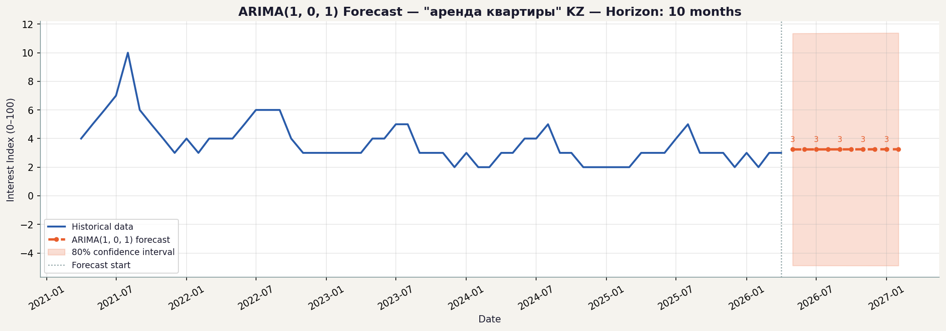
Figure 7 — ARIMA forecast: 10-month rental demand outlook for Kazakhstan

2.5 Business Interpretation
The Google Trends forecast provides a demand signal for the rental market. Rising forecast values indicate growing consumer interest in apartment rentals, suggesting RentEasy KZ should prioritize:
• Listing inventory expansion before demand peaks
• Marketing campaign timing aligned with seasonal interest spikes
• Pricing strategy adjustments ahead of high-demand months
If the forecast shows declining interest, it signals a window for competitive acquisition — users may be dissatisfied with existing platforms and open to alternatives.

Task 3 — Decision Dashboards
Five dashboards were produced to synthesize findings from Tasks 1 and 2 into actionable business intelligence for RentEasy KZ.

3.1 Dashboard 1 — Sentiment Overview
Stacked bar chart showing sentiment counts (NEGATIVE / NEUTRAL / POSITIVE) per competitor, combined with an overall sentiment pie chart. Krisha.kz and OLX Kazakhstan each have 200 reviews while kn.kz has 54. Krisha.kz shows the highest proportion of NEGATIVE reviews, while OLX Kazakhstan has the most POSITIVE reviews overall.
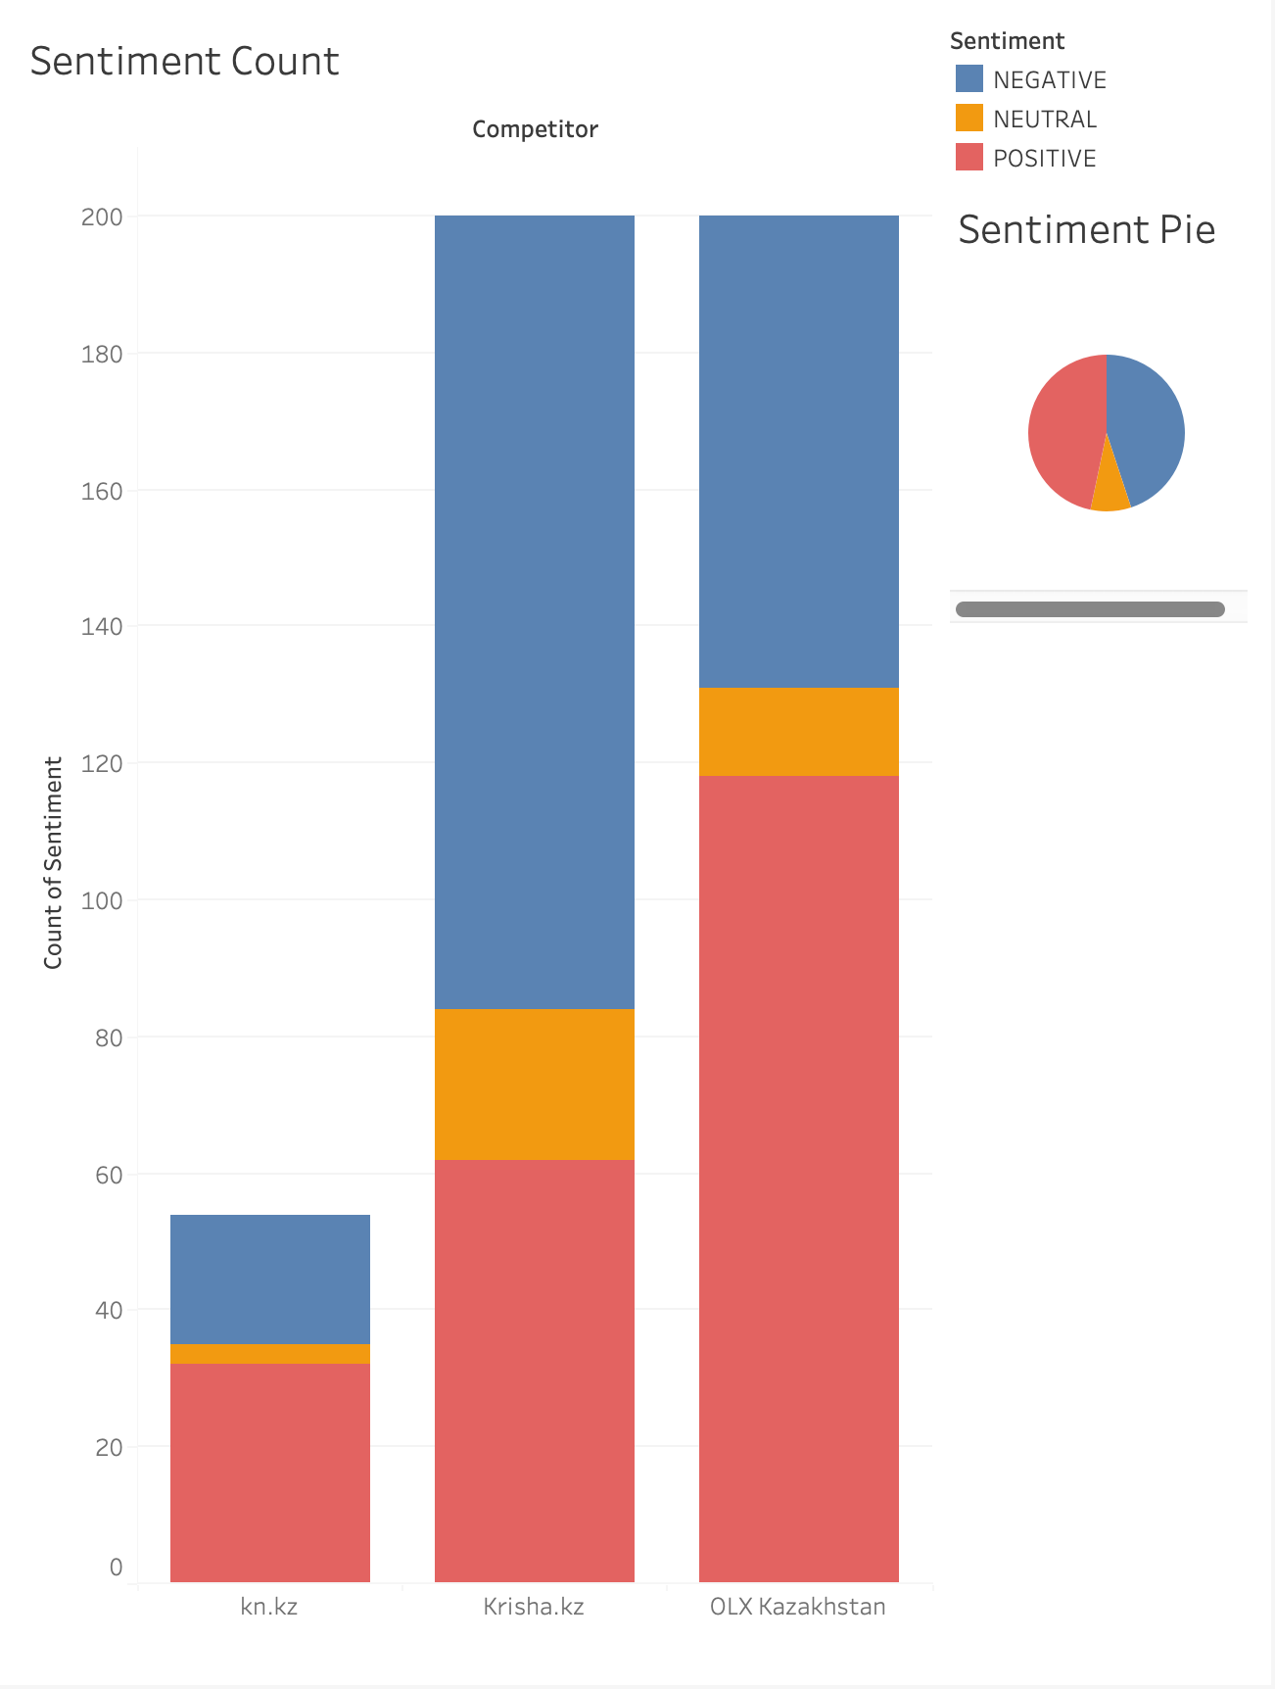

Figure 8 — Dashboard 1 — Sentiment Overview

3.2 Dashboard 2 — Average Rating
Bar chart comparing average star ratings (1–5 scale) across all three competitors. OLX Kazakhstan leads with ~3.9★, followed by kn.kz at ~3.65★, while Krisha.kz has the lowest average rating at ~2.77★. This indicates Krisha.kz has the most dissatisfied user base — a key opportunity for RentEasy KZ to capture unhappy users.
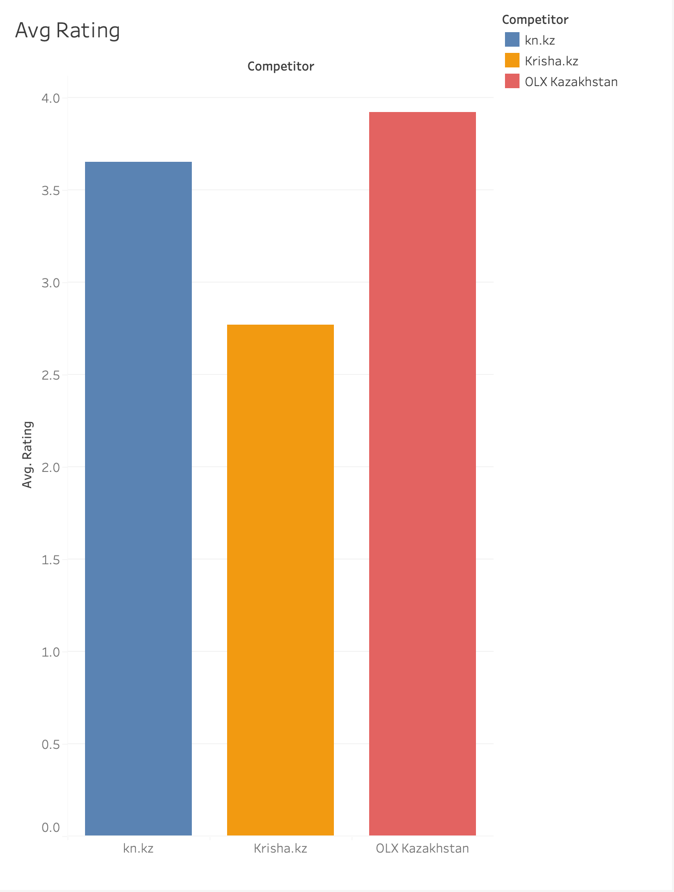
Figure 9 — Dashboard 2 — Average Rating

3.3 Dashboard 3 — Sentiment Trend
Line chart showing daily average sentiment score (0–1 scale) for each competitor across April 2026. kn.kz (blue) shows the highest volatility with peaks reaching 0.82 and drops to 0.31, indicating inconsistent user experience. Krisha.kz (orange) and OLX Kazakhstan (red) show more stable but moderate sentiment around 0.45–0.62. All three competitors fluctuate daily, suggesting that app updates and listing quality directly impact user sentiment in real time.

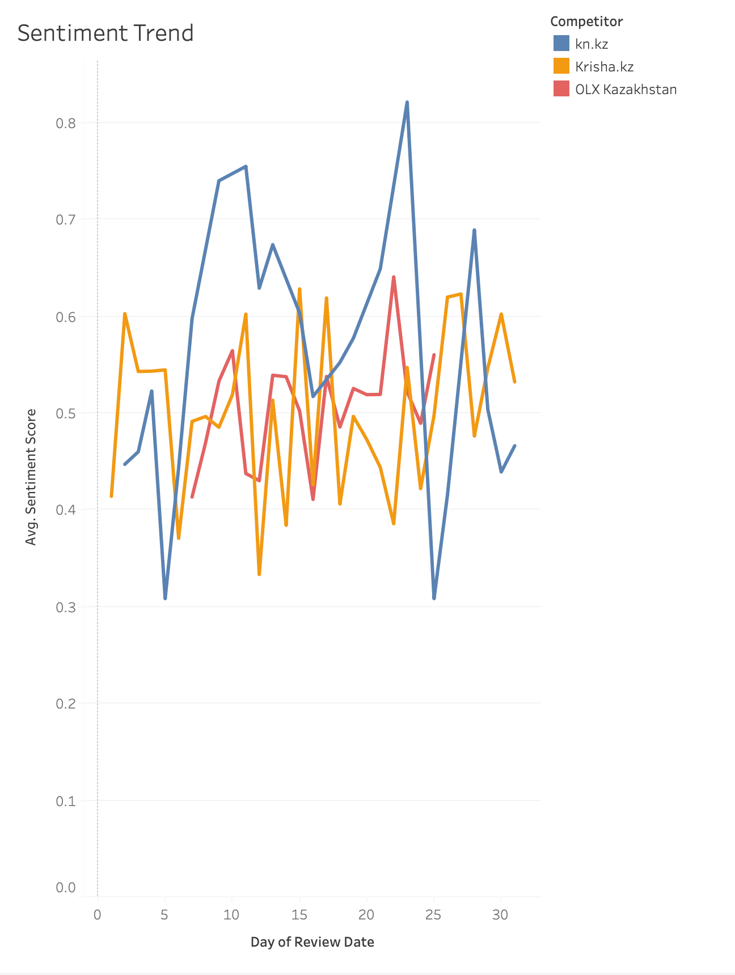
Figure 10 — Dashboard 3 — Sentiment Trend

3.4 Dashboard 4 — Negative Keywords
Horizontal bar chart showing the most frequent words found in negative reviews across all three competitors. The word "приложение" (app) dominates with nearly 50 mentions — shared across all competitors — indicating app performance is the #1 complaint. "Объявление" (listing/ad) is the second biggest issue, mainly from Krisha.kz and OLX Kazakhstan, pointing to fake or outdated listings. "Открывается" (doesn't open) and "работает" (doesn't work) confirm app crashes as a major weakness. These pain points are direct opportunities for RentEasy KZ to differentiate through a stable, verified-listing platform.
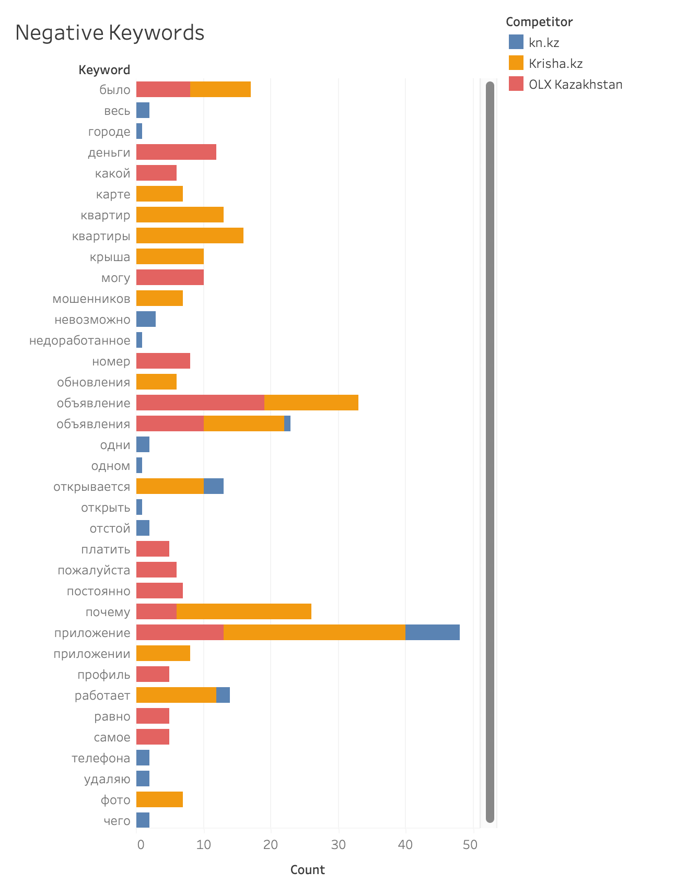

Figure 11 — Dashboard 4 — Negative Keywords

3.5 Dashboard 5 — Future Sentiment Trend
Line chart with linear trend lines showing the projected direction of sentiment scores for each competitor. kn.kz (blue) has a strongly upward trend line — its sentiment is improving and projected to reach ~0.71 by end of year, suggesting the platform is getting better. Krisha.kz (orange) and OLX Kazakhstan (red) show nearly flat trend lines around 0.50–0.53, indicating stagnant user satisfaction with no significant improvement expected. This creates a window for RentEasy KZ to enter the market before kn.kz fully establishes itself as the quality alternative.
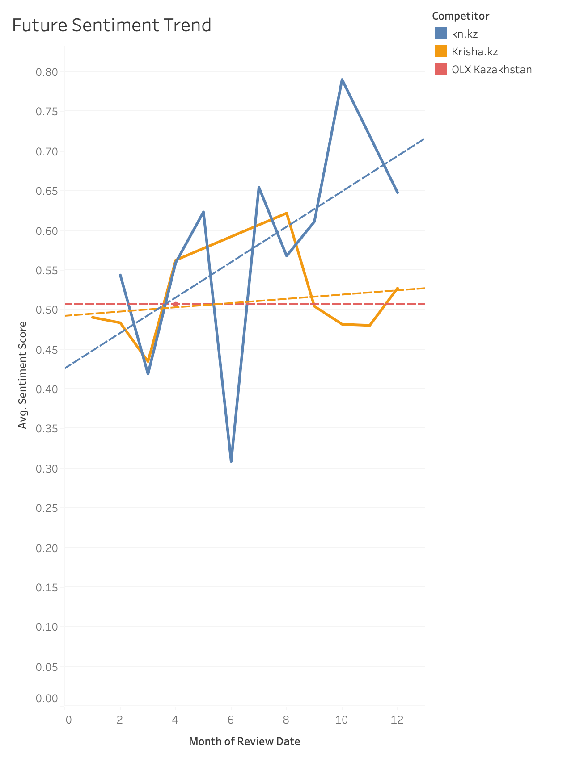
Figure 12 — Dashboard 5 — Future Sentiment Trend

Conclusions and Recommendations

Sentiment Analysis Findings
1. Krisha.kz shows the highest negative sentiment — the most dissatisfied user base. Primary complaints center on app stability, loading speed, and fake listings. RentEasy KZ should prioritize listing verification and app performance as direct competitive advantages.
2. OLX Kazakhstan leads in user satisfaction but still has significant negative reviews. No competitor scores above 4★ average — the market has room for a genuinely high-quality rental experience.
3. kn.kz has the fewest reviews (54), suggesting limited market awareness. Their users are early adopters and more vocal about specific features.

Time-Series Findings
The Google Trends analysis reveals the long-term trajectory of rental search demand in Kazakhstan. The ARIMA model provides a data-driven 10-month outlook to guide platform investment decisions.
Key recommendation: RentEasy KZ should launch its platform ahead of the next predicted demand peak, maximizing organic user acquisition when intent-to-rent is highest.

Strategic Priorities for RentEasy KZ
Priority Area | Action
App Reliability | Fix crashes and slow loading — the top complaint across all competitors
Listing Verification | Eliminate fake/duplicate listings — major trust issue for Krisha & OLX users
Demand Timing | Use Trends forecast to schedule marketing campaigns before seasonal peaks
UX Differentiation | Design features that directly address the top 10 negative keywords per competitor
Market Entry Window | Enter market during competitor satisfaction dip for maximum user acquisition

