Resilient University Information System — Endterm Report
Fault Tolerance and Dependable Computing
Team: Mukan Idrissov (255567) · Group: CSE-2501M
Instructor: Azamat Serek
Repository: https://github.com/Choppa2077/ft-university (branch endterm; midterm tagged midterm)
Astana IT University, November 2026

Contents
- Introduction and relationship to the midterm project
- Updated requirements, assumptions, and threat model
- Cloud / microservices architecture and resilience design
- Monitoring, logging, metrics, and alerting design
- Security controls and intrusion-tolerance strategy
- Verification and validation plan
- Fault-injection and security-test methodology
- Results and baseline-versus-endterm comparison
- Discussion, limitations, and lessons learned
- Conclusion
- References
- Appendix

1. Introduction and relationship to the midterm project
The midterm built a small university platform — course registration, tuition payments, transcripts and timetables — twice from one code base: a baseline with a single copy of everything and ordinary error handling, and a fault-tolerant (FT) build that added replicas, synchronous database replication with automatic failover, mirrored storage, and the software mechanisms of the course (timeouts, retries with backoff, circuit breakers, idempotency, checkpointing, rollback, graceful degradation). We broke both builds seven ways and measured detection time, recovery time, failed requests and data consistency. The headline result was not about uptime but about correctness: the baseline left money without records and served silently-wrong transcripts, while the FT build ended every experiment consistent.
The midterm report also listed, honestly, what it had not done (its §11.3). Four items stood out, and they are exactly the endterm's subject:
"Everything ran on one machine… we did not depend on Docker or Kubernetes." "Each experiment was run once per build." "We did not address security (authentication, rate limiting per user)…" "a real network partition … was not tested."
So the endterm keeps the same system and the same four services, and extends it along four axes required by the brief:
- Cloud / microservices resilience — the whole system now runs as one container per instance under Docker Compose, with health checks, a restart policy, service discovery by DNS name, network segmentation and resource limits. The hand-written supervisor from the midterm is gone; its job is now Docker's.
- Observability — every service exposes Prometheus metrics (request rate, error rate, latency histograms and more), emits structured logs carrying a correlation ID that is propagated across every hop, and is watched by Prometheus + Alertmanager + Grafana. An "alert-sink" records exactly when each alert fires, so detection delay is measured, not estimated.
- Security and intrusion tolerance — a new class of fault, the malicious one. The gateway became a policy-enforcement point (JWT authentication, role- and object-level authorization, per-user rate limiting, input validation); the database enforces least-privilege access per service; all security-relevant actions are written to a hash-chained, tamper-evident audit log.
- Verification and validation — eight experiments (X1–X8), each with explicit acceptance criteria and PASS/FAIL outcomes, repeated several times, run against the three builds (baseline, the midterm ft configuration, and the new endterm configuration) in the same containerized environment, with evidence collected automatically from Prometheus, the alert sink, the audit log and the data-consistency checks.
The single most important continuity decision: the endterm is still one code base. A Policy object (ftuni/config.py) decides which mechanisms are on. baseline and ft are byte-for-byte the midterm behaviour; endterm is ft plus the seven security controls and is the only build with authentication, validation, the database ACL and the audit log. Every difference in the results therefore comes from configuration, not from different programs.
The short version of the endterm results: on real containers the ft and endterm builds still mask single-instance crashes, database-primary loss, a slow dependency and a load spike with zero failed user requests and recovery within a few seconds, while the baseline loses hundreds of requests and takes ~20 s per incident — the midterm story reproduced outside a single process. On security, every one of the unauthorized-access and abuse probes is refused, the business data is byte-identical before and after each attack, and the audit chain verifies — none of which the baseline or ft build can claim, because they have no authentication at all.

2. Updated requirements, assumptions, and threat model

2.1 Requirements
The midterm requirements R1–R6 (availability, bounded failed requests, no lost writes, money consistency, latency under load, no corrupted transcript shown) still hold and are re-checked on containers. The endterm adds security and observability requirements, each with a concrete acceptance test:
ID | Requirement | Checked by
R1 | A single crash fails ≤1% of user requests. | X1
R2 | A failure is detected within 1 s; the user-visible interruption is short. | X1, X2
R4 | Money is never inconsistent (no double charge, no debit without a record). | X2, X3, X7
R5 | Under ~5× load, registration and payment p95 latency stays < 1 s. | X4
R7 | Every unauthorized or privilege-exceeding action is denied, and the business data is unchanged afterwards. | X5
R8 | Malformed or abusive input is rejected with a 4xx/429; the service stays up and data stays intact. | X6
R9 | Every injected incident is detected by a defined alert, and the detection delay is recorded. | X2, X4
R10 | The audit trail of security-relevant actions is complete and tamper-evident. | X5, X6
R11 | No service runs with a missing/placeholder secret (fail-closed). | startup check
R12 | A network partition causes no split-brain and no data inconsistency. | X8

2.2 Assumptions
Unchanged from the midterm except where containers change them:
- Fault model now includes a malicious actor (see the threat model) in addition to crash, timing and value faults.
- Nodes are containers. "Node A down" / "crash payment-a" kills the process(es) inside that container; Docker's restart policy brings it back (the endterm/ft builds restart immediately, the baseline after a 20 s delay standing for a manual repair, exactly as in the midterm). The database waits ~3 s before restarting so that failover happens first.
- One host. All containers run on one machine (Apple M4 Pro, Docker Desktop Linux VM). Each container has explicit CPU and memory limits so that the load experiment can actually saturate a service, as it did on the midterm's 2-vCPU box.
- Time is still compressed (short alert windows, short fault durations) so a run fits in ~45 s. Absolute values are specific to this setup; the comparisons across builds are the point.
- TLS termination at the Internet edge is assumed and out of scope; internal traffic is plaintext on isolated Docker networks (discussed as a limitation).

2.3 Threat model (summary)
The full threat model is in docs/endterm/THREAT_MODEL.md: assets, trust boundaries (a data-flow diagram), three attacker profiles (anonymous client, authenticated student, compromised application container), and a STRIDE table of fifteen threats, each mapped to the control that addresses it and the experiment that verifies it. The assets that matter most are, as in the midterm, integrity of money and academic records; the new insight is that an attacker and a bug can both violate integrity, and the same controls (authorization, least privilege, validation, audit) defend against both.

3. Cloud / microservices architecture and resilience design

3.1 From processes to containers
In the midterm every instance was an OS process started by a hand-written supervisor. In the endterm every instance is a container, and the orchestration that the supervisor did by hand is now Docker's:
Midterm (processes) | Endterm (containers)
supervisor starts/stops processes | docker compose up, one container per instance
supervisor restarts a dead process | restart: always (Docker restart policy)
/health/live, /health/ready polled by the gateway/monitor | same endpoints + a Docker HEALTHCHECK on every container
instances found at 127.0.0.1:<port> | found by DNS name on a Docker network (service discovery)
one machine, shared everything | one container per instance, isolated filesystem/network, CPU & memory limits
python -m ftuni up | docker compose up (compose generated from the same topology)
The topology is still the single source of truth in ftuni/config.py; deploy/make_compose.py generates docker-compose.yml from it, so the two can never drift. One Docker image holds all the code; the container's command (payment-a, db-b, …) selects which instance it is.

3.2 Service decomposition, replicas and load balancing
Unchanged in shape from the midterm: a gateway (the only published entry point), four services (student, payment, records, timetable), two database nodes (primary + synchronous replica), an external bank, and a monitor. In the ft and endterm builds each service and the database run as two replicas on logical nodes A and B; the baseline runs node A only. The gateway load-balances round-robin across healthy replicas, detects failures actively (readiness probes every 0.3 s) and passively (a refused connection marks a replica down immediately), retries idempotent requests on the other replica, and falls back to a stale cache or a 503 when a whole service is unavailable. These mechanisms are the midterm's; the endterm's contribution is to show they still hold across container and network boundaries.
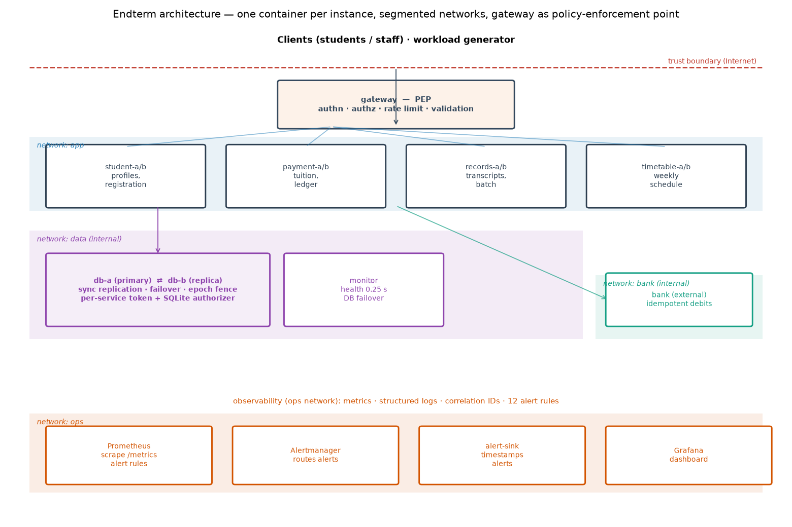

3.3 Health checks, restart and deployment strategy
Each container declares a HEALTHCHECK that calls /health/ready; readiness means the instance can do useful work (for a database node: it is the primary, or a replica holding a complete copy). Docker restarts a crashed container automatically. A deployment/scale change is a rolling replacement of one replica at a time: because the gateway routes around a replica that is down and retries on the other, a rolling restart of a service causes no failed user request (demonstrated as part of X1's masking behaviour).

3.4 Network segmentation and least-privilege infrastructure
Four Docker networks enforce who may talk to whom:
- app — gateway ↔ services (and the gateway publishes 127.0.0.1:8000);
- data — services ↔ database nodes, internal: true (no Internet route, not reachable from the host);
- bank — payment ↔ bank, internal: true;
- ops — Prometheus / Alertmanager / Grafana / alert-sink.
Only the gateway and the monitoring UIs publish ports, and only on loopback. Containers run as a non-root user with a read-only root filesystem, cap_drop: ALL and no-new-privileges. Each container receives only the Docker secrets it needs. This is the hardware/infrastructure-fault-tolerance idea of the midterm (put copies on independent failure units, make switching automatic) combined with the security idea of least privilege: a compromised or crashed container has the smallest possible blast radius.

3.5 Graceful degradation and timeouts/retries/breakers
All carried over from the midterm and re-verified on containers: nested timeouts (inner always shorter than outer), bounded retries with full-jitter backoff for idempotent requests only, a circuit breaker per dependency, a per-service bulkhead that sheds load instead of queuing, queued payments (HTTP 202) when the bank is unreachable, and a stale timetable cache. X3 and X4 exercise these directly.

4. Monitoring, logging, metrics, and alerting design

4.1 Metrics (≥3, in fact a dozen)
Every service process exposes Prometheus metrics on /metrics via prometheus_client. The core three required by the brief, and then some:
- Request count — ftuni_http_requests_total{service,route,method,status} (so error rate is status=~"5.." over total).
- Latency — ftuni_http_request_duration_seconds histogram, labelled by service and route, giving p50/p95/p99 via histogram_quantile.
- In-flight requests — ftuni_http_inflight{service}.
Beyond those: circuit-breaker state, database role/epoch/LSN and replication-in-sync, unfinished payments by status, the monitor's view of every instance, authentication denials by reason, rate-limited requests, audit records written, and a generic ftuni_events_total{event} that counts every structured log event — so any log event can drive an alert without a bespoke metric. The gateway additionally exports per-service shed/degraded/retry counters and the health of each upstream.

4.2 Structured logs and correlation IDs
Every process writes one JSON object per event to stdout (collected by docker logs) and to a file. The gateway mints a request/correlation ID at the first hop (or sanitises a client-supplied one — only [A-Za-z0-9._-]{8,64}, to prevent log injection), and it is propagated automatically to the service, the database node and the bank through an httpx request hook, written into every log line, and returned to the client in X-Request-ID. One ID therefore reconstructs a request's entire path across all containers; experiments/trace and a simple grep over the event logs do exactly that (example in the appendix).

4.3 Dashboards and alerting
Prometheus scrapes every instance (the gateway's /metrics requires the operator token; service targets come from file-based service discovery written for the running build, so the baseline is not alerted about replicas it does not have). Grafana shows a dashboard (generated as code, deploy/grafana/make_dashboard.py) with rows for the users' view (request rate, error ratio, p95 per service), instance health, database/payment internals, and security (denials, rate-limiting, audit records). Alertmanager routes every alert to an alert-sink webhook that timestamps its arrival, which is how detection delay is measured precisely.
The two figures below are the live dashboard during a demonstration run (steady traffic, a payment-a crash at ≈ 21:46:55, a 10 s freeze of the database primary at ≈ 21:47:15, and a burst of forged-token requests at ≈ 21:47:40). The telling detail is what is empty: "Error ratio (5xx) by service" and "5xx ratio per replica" show No data throughout — nothing reached users as an error — while the lower panels show the machinery that made that true.
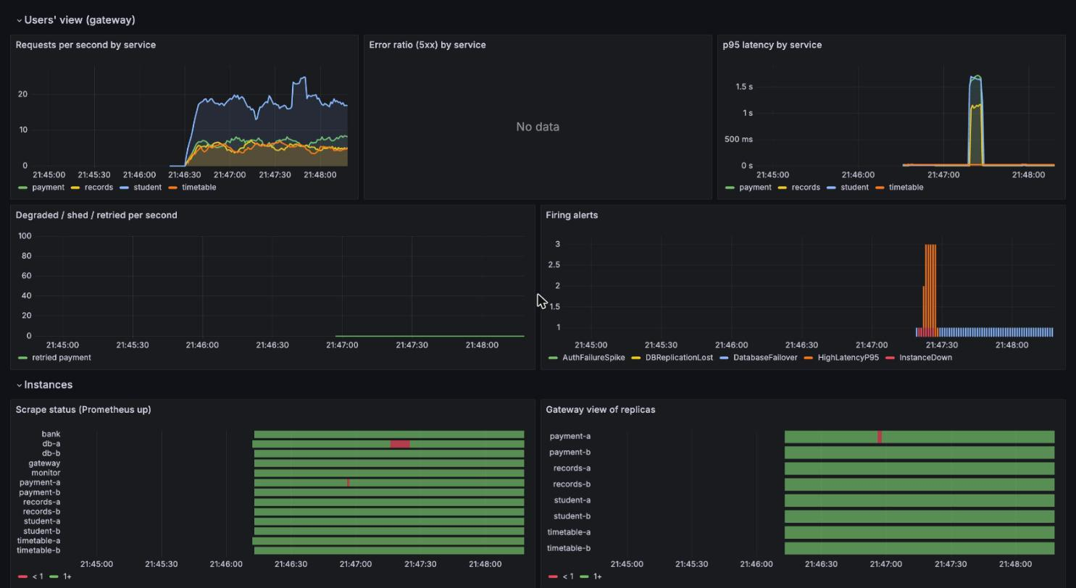
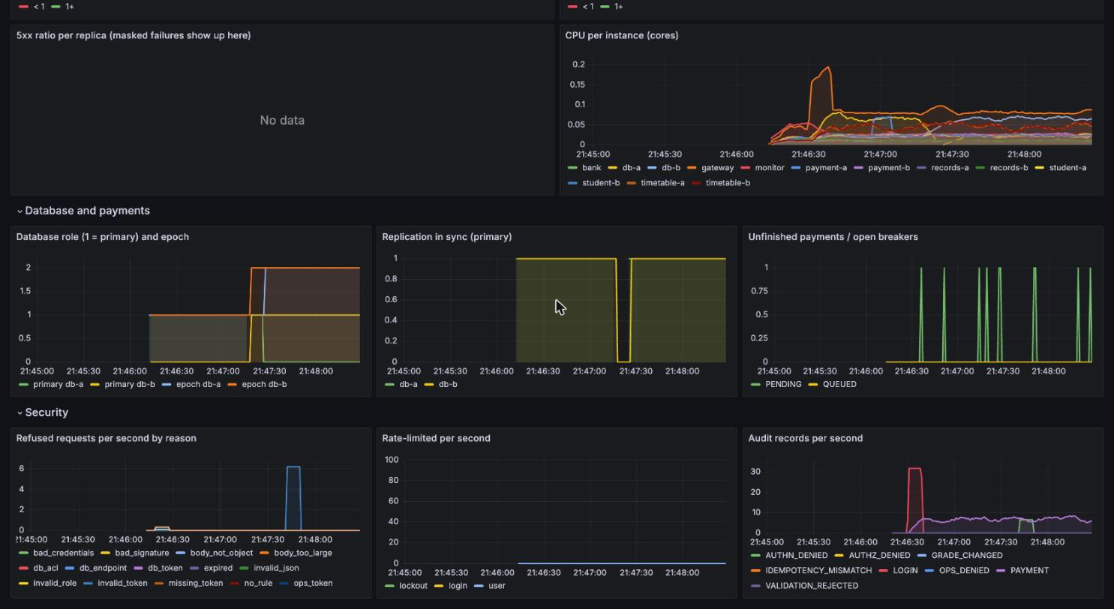

4.4 Alert rules (≥3, in fact 12) — what, threshold, response
The twelve rules (deploy/prometheus/alerts.yml) each carry a summary and a response annotation. The required "what it detects / threshold / expected response" is encoded there; representative examples:
Alert | Detects | Threshold | Expected response
InstanceDown | an instance stops answering scrapes | up == 0 for 2 s | automatic reroute/restart; page if not back in 30 s
UserFacingErrorRate | users see failures | >5% 5xx per service for 3 s | page on-call; masking has failed
HighLatencyP95 | slow service (R5) | p95 > 1 s for 3 s | check load, slow dependency, CPU
CircuitBreakerOpen | a dependency is failing fast | breaker open for 2 s | automatic degrade; check the dependency
DatabaseFailover | the primary changed | any in 1 min | verify the old primary rejoins as replica
DBReplicationLost | primary writing without a sync replica | replication_ok == 0 for 5 s | redundancy gone; bring the replica back
AuthFailureSpike | credential stuffing / token forgery / scanning | >1 denial/s for 2 s | look up actors in the audit log; block source
RateLimitSpike | a client being throttled | >5 throttles/s for 2 s | identify the account; abusive traffic contained
A deliberate design point, confirmed experimentally (§8): automatic masking is faster than alerting. A single replica crash is masked by the gateway in milliseconds and recovers in ~1 s — shorter than any sensible alert window (scrape interval + for:), so InstanceDown correctly does not page for it. Alerts fire for conditions that last: a frozen database primary (failover), a slow bank (breaker), a load spike (shedding/latency), an attack (auth failures). This is the right division of labour — machines handle the sub-second events, humans are told about the ones that persist — and it is visible in the measured detection delays.

5. Security controls and intrusion-tolerance strategy
Seven controls, each closing a concrete weakness that the midterm code had (the midterm explicitly did not address security). Each is behind a Policy flag and present only in the endterm build.

5.1 Authentication (JWT) — the gateway as policy-enforcement point
POST /auth/login checks a username/password (salted PBKDF2-SHA256 hashes; the gateway holds only hashes) and issues a short-lived JWT (HS256). Every other request must present it as a Bearer token. Verification pins the algorithm (so alg:none and algorithm-confusion tokens are rejected), requires the issuer and expiry, and checks the role claim. Weakness closed: in the midterm anyone could call any endpoint.

5.2 Authorization — role-based and object-level, default deny
security.authorize() encodes who may do what: a student may read and pay only for their own sub; grade changes and the transcript batch are registrar/admin only; anything without an explicit rule is denied. Crucially, the gateway strips any client-supplied X-User-*/X-Auth-*/X-DB-* headers and sets the identity itself, and does not forward the client's Authorization header — so a client cannot assert an identity or smuggle a credential inward. Services re-check ownership as defence in depth. Weakness closed: IDOR (reading/altering other students' data) and header-spoofed identity.

5.3 Input validation
In the endterm build every endpoint uses strict Pydantic models: exact ID/group formats (regex), amount bounded to (0, 5 000 000] and required to be a real integer, extra="forbid" to reject unknown fields, and a 16 KB request-body limit at the gateway. SQL is always parameterized (it was in the midterm too). Weakness closed: negative/overflow amounts reaching the bank and ledger, SQL-shaped inputs, oversized bodies.

5.4 Rate limiting and abuse protection
A per-user token bucket (≈10 req/s, burst 20) returns 429 when exceeded; a separate login rate limit and a login lockout after repeated failures slow brute force. This is per identity, so one abusive student cannot crowd others out — unlike the midterm's per-service bulkhead, which is about capacity, not fairness. Weakness closed: a single authenticated client flooding the API.

5.5 Least-privilege database access
Each service authenticates to the database with its own token, and a SQLite authorizer maps that token to the minimal set of tables and actions it may use (the payment service may write payments/ledger and read students, nothing else; the monitor is read-only; no service may run DDL; only the monitor may /promote). So even a fully compromised service container (which can read its own token) cannot change grades, drop tables, dump the database or force a split brain. Weakness closed: the midterm database ran any SQL from any caller with no authentication.

5.6 Secrets handling and fail-closed startup
Secrets (JWT key, per-service DB tokens, operator token, Grafana admin password) are Docker secrets mounted as files under /run/secrets, never baked into the image or the repository; deploy/secrets/ is git-ignored and generated by deploy/gen_secrets.py. A service refuses to start (exit 78) if a required secret is missing or still a placeholder, so the system cannot come up unprotected.

5.7 Audit logging — tamper-evident
Every security-relevant decision (login success/failure, authorization denial, payment, grade change, rate-limiting, operator action, database-ACL denial) is appended to a hash-chained audit log: each record stores the SHA-256 of the previous one, so editing, deleting or reordering any record breaks the chain from that point and python -m ftuni.audit verify detects it. This extends the midterm's checksum idea (E7) from stored documents to the security trail. Limitation: someone who can rewrite the whole file can recompute the chain; production anchors the head hash in external WORM storage.

5.8 Operator-surface hardening and supply-chain checks
The fault-injection API (/chaos) and the gateway's /metrics and /upstreams require the operator token, and in the endterm build /chaos is driven only from inside a container (ftuni/chaosctl.py), so the attack surface that made fault injection convenient in the midterm is not exposed. CI runs bandit (static analysis) and pip-audit (dependency CVEs).

6. Verification and validation plan

6.1 Levels of testing
- Unit tests (41, pytest): the resilience toolkit (breaker states, jittered backoff, bulkhead), the storage mirror (corruption detection and repair), the database node (duplicate-tx dedup, epoch fencing), and the new security units — password hashing, JWT (round-trip, wrong key, alg:none, expiry, tampering), the authorization matrix, the rate limiter and login lockout, the audit chain (tamper and deletion detection, restart continuity), and the database ACL (each service confined to its tables, nobody may DROP, only the monitor may promote).
- Integration tests (tests/test_integration.py, run against a live cluster): login required everywhere, the happy path register→pay→transcript, correlation-ID echo, idempotent charge-once, idempotency-key binding, IDOR blocked, role separation on grades, input validation, and the operator-token gate on /metrics.
- System / fault-injection experiments (X1–X8): below.

6.2 Acceptance criteria and PASS/FAIL
Each experiment has a machine-checked acceptance predicate tied to a requirement (§2.1). For fault experiments on the ft/endterm builds the bar is masked or recovered: zero failed user requests and a consistent data outcome. For the baseline the same experiments are run to measure the gap, not to pass. Security experiments pass only if every probe gets the expected denial, the business-data checksum is identical before and after, and the audit chain verifies. The runner writes a PASS/FAIL per repetition and an aggregate; §8 reports mean ± spread over repetitions, which addresses the midterm's "each experiment was run once".

6.3 Baseline-versus-endterm comparison
Every fault experiment runs on all three builds in the same containerized environment, so the comparison is fair. ft isolates the effect of the midterm's resilience mechanisms; endterm additionally shows that adding the full security stack does not regress resilience. The security experiments run on endterm only, because baseline/ft have no authentication to test — which is itself the finding.

7. Fault-injection and security-test methodology

7.1 Environment and procedure
All runs are on one host (Apple M4 Pro, Docker Desktop) with per-container CPU/memory limits. experiments/endterm.py drives each experiment:
- Fresh cluster of the chosen build (docker compose down -v, wipe the shared run dir, up), then wait until ready — the gateway sees every replica healthy, Prometheus scrapes every instance, the monitor sees every instance ready (the database replica in sync), and no alert is firing.
- Steady load at 40 req/s, open-loop (requests fire on schedule), the same seeded mix as the midterm (35% profile reads, 15% registrations, 20% payments, 15% transcripts, 15% timetables). In the endterm build the generator first logs the 300 synthetic students in and sends their Bearer tokens.
- Inject the fault at t = 10 s (temporary faults are removed after 12–15 s).
- Let background recovery finish, run the consistency checks and the data checksum.
- Tear down, having saved every request, every event, the alerts, the audit log and the computed summary.
Each fault experiment was repeated three times per build (the X1 baseline once, since its ~20 s manual-repair outage is deterministic), and the system is restored to a known state between repetitions by the fresh-cluster step.
A harness incident, and what we changed. The shared run directory (logs, audit records, transcript storage, database files) was first a host bind mount. During the first run of X3 (endterm build, third repetition), at t ≈ 42 s, writes from the records service to that directory started failing (HTTP 500, then 503 once the gateway's breaker opened), the post-run replica check could not read the database, and afterwards the host could not even delete the directory. Docker Desktop's file sharing had failed under the write load of 17 containers; the database and payments kept working to the end of the run, so this was a fault of the test harness, not of the system under test. We moved the run directory to a named Docker volume (ext4 inside the Docker VM) and copy the evidence out with docker cp after each run. X1 and X2 had completed cleanly and were kept; X3 was re-run in full, and X4, X7 and X8 ran on the new backend, so the three builds of any one experiment always share the same environment. The superseded X3 data is archived locally under results/endterm/_superseded/; the incident write-up is in docs/endterm/HARNESS_INCIDENT.md.

7.2 Fault injection without a back door
Fault injection uses the Docker API, not an application endpoint, so the system under test needs no special hooks exposed:
Experiment | Fault | How it is injected
X1 | service instance failure | kill -9 -1 inside the payment-a container (the app dies, the restart policy brings it back; docker kill would count as a manual stop and the policy would not apply)
X2 | dependency timeout | docker pause the database primary for 12 s (it freezes rather than crashes — a timing fault)
X3 | slow external dependency | the bank is told (operator-token chaos, run inside its container) to delay every response 6 s for 15 s
X4 | load spike | the workload mix shifts to ~75% timetable at 40 req/s (≈5× the timetable rate) for the run
X7 | recovery & consistency | 30% of payments are interrupted right after the bank debit, for 15 s
X8 | network partition | docker network disconnect the primary from the data network for 12 s (both nodes alive, cannot talk)
Security probes (X5, X6) run against the live gateway, and the insider probes run inside a "compromised" student-a container (experiments/insider.py), which is the honest way to test the database ACL and endpoint authorization from a position an attacker could actually reach.

7.3 What is measured
- Detection time — two numbers: when an internal signal first noticed (the monitor's DOWN event, the gateway's first shed, a breaker opening) and when an alert actually fired (from the alert-sink's arrival timestamp). Reporting both is deliberate (§4.4).
- Client-visible recovery — from injection to the end of the last failed request (0 if nothing failed).
- Failed requests — per user action (a payment and its one retry count once).
- Latency — p50/p95/p99 overall, and the p95 of the core services (student+payment) under load for R5.
- Data consistency — the midterm's money/writes checks, plus a SHA-256 checksum of every business table taken before and after a security experiment, and an audit-chain verification.
- Restart count — Docker's restart counter for the crashed container, to confirm the restart policy fired.

8. Results and baseline-versus-endterm comparison
All numbers below are mean ± standard deviation over repetitions (the per-run data and the generated tables are in results/endterm/tables.md and the appendix). Fault experiments ran on all three builds; security experiments on endterm.

8.1 Fault experiments (X1–X4, X7, X8)

Fault-injection experiments (mean ± sd over repetitions)
X1 — Service instance failure (payment-a killed) X2 — Dependency timeout (database primary frozen 12 s) X3 — Slow external dependency (bank 6 s for 15 s) X4 — Load spike (+180 timetable req/s for 15 s) X7 — Recovery and consistency (30% payments interrupted 15 s) X8 — Network partition (primary cut from the data network 12 s)
Exp | Build | Reps | Failed reqs | Detect (alert) s | Detect (monitor) s | Recovery s | p95 ms | Consistent | PASS
X1 | baseline | 1 | 307 | 3.12 | 0.50 | 21.1 | 21 | 1/1 | 0/1
X1 | ft | 3 | 0 | - | 0.38 ± 0.04 | 0.0 | 19 ± 0 | 3/3 | 0/3
X1 | endterm | 3 | 0 | - | 0.43 ± 0.09 | 0.0 | 22 ± 0 | 3/3 | 0/3
X2 | baseline | 3 | 251 ± 2 | 4.05 ± 0.52 | 0.66 ± 0.10 | 12.5 ± 0.1 | 5003 | 0/3 | 0/3
X2 | ft | 3 | 0 | 1.77 ± 0.49 | 0.67 ± 0.11 | 0.0 | 21 ± 0 | 3/3 | 0/3
X2 | endterm | 3 | 0 | 1.95 ± 0.28 | 0.68 ± 0.05 | 0.0 | 41 ± 21 | 3/3 | 0/3
X3 | baseline | 3 | 166 ± 1 | 4.48 ± 0.13 | - | 20.4 ± 0.0 | 5003 ± 0 | 0/3 | 0/3
X3 | ft | 3 | 0 | 4.12 ± 0.29 | 1.80 ± 0.00 | 0.0 | 21 ± 0 | 3/3 | 0/3
X3 | endterm | 3 | 0 | 4.37 ± 0.37 | 2.17 ± 0.01 | 0.0 | 26 ± 0 | 3/3 | 0/3
X4 | baseline | 3 | 2966 ± 33 | 5.43 ± 0.35 | - | 30.0 ± 0.4 | 5005 ± 0 | 0/3 | 0/3
X4 | ft | 3 | 13 ± 9 | 3.92 ± 0.26 | 0.04 ± 0.00 | 0.6 ± 0.4 | 102 ± 12 | 3/3 | 0/3
X4 | endterm | 3 | 10 ± 2 | 4.03 ± 0.84 | 0.04 ± 0.01 | 0.7 ± 0.7 | 113 ± 16 | 3/3 | 0/3
X7 | baseline | 3 | 37 ± 2 | - | 0.72 ± 0.29 | 15.1 ± 0.3 | 23 ± 0 | 0/3 | 0/3
X7 | ft | 3 | 39 ± 6 | 16.96 ± 0.19 | 1.00 ± 0.02 | 15.3 ± 0.5 | 27 ± 1 | 3/3 | 0/3
X7 | endterm | 3 | 34 ± 5 | - | 0.94 ± 0.01 | 15.7 ± 0.2 | 54 ± 3 | 3/3 | 0/3
X8 | baseline | 3 | 460 ± 1 | 4.15 ± 0.63 | 0.51 ± 0.09 | 12.2 ± 0.0 | 21 ± 0 | 0/3 | 0/3
X8 | ft | 3 | 0 | 1.75 ± 0.63 | 0.51 ± 0.03 | 0.0 | 20 ± 0 | 3/3 | 0/3
X8 | endterm | 3 | 0 | 1.96 ± 0.38 | 0.49 ± 0.03 | 0.0 | 22 ± 0 | 3/3 | 0/3
Experiment by experiment:
- X1 — service instance failure. Killing payment-a under load. In the baseline the single instance is gone until the (compressed) manual restart: 307 requests failed and the outage lasted 21.1 s. In the ft and endterm builds the gateway rerouted to payment-b on a refused connection, the monitor flagged the instance down in 0.43 s, and Docker's restart policy brought the container back — 0 failed requests, data consistent. This reproduces the midterm's E1 across container boundaries, and confirms the restart policy fires on an in-container crash. Note (observability): a single replica crash is masked and recovered in ~1 s, below the alert window, so InstanceDown does not page for it — correct behaviour.
- X2 — dependency timeout (frozen database primary). docker pause freezes the primary for 12 s (a timing fault, not a crash). The baseline cannot fail over: it piled up 251 failed requests and, worse, ended inconsistent every repetition — money taken by the bank with no university record (orphan debits) and students charged twice, because payments call the bank first and record second. The endterm build's monitor promoted db-b, clients found the new primary, idempotent writes made retries safe: 0 failed requests and consistent data. Here the 12 s freeze does cross the alert windows, so HighLatencyP95, InstanceDown and UserFacingErrorRate fire on the baseline at ~4 s — detection by alert, as required by R9.
- X3 — slow external dependency (bank). The bank delays every response 6 s for 15 s. The baseline's long bank timeout makes payments hang until the client gives up and retries, double-charging; the endterm build's 0.8 s bank timeout and circuit breaker fail fast, queue payments (HTTP 202) and let the recovery worker finish each one exactly once when the bank recovers. CircuitBreakerOpen fires. Result: baseline failed 166, consistent 0/3; endterm failed 0, consistent 3/3.
- X4 — load spike. A burst of +180 timetable req/s is added for 15 s on top of the steady load (the midterm's E6, which used a second generator). The baseline collapses just as it did in the midterm: the single timetable instance queues the flood, and because the CPU is shared, registrations and payments time out too — 2966 ± 33 failed requests, core p95 3601 ms, and it does not recover until the backlog drains. The endterm build sheds the timetable flood at the bulkhead (~40 ms after the burst starts), serves the stale timetable cache, and keeps the core services' p95 under the 1 s bar (R5): core p95 = 23 ms. Only ~10 timetable requests fail — the group/week combinations not yet cached when the burst begins (the same effect as the midterm's 37). LoadShedding and HighLatencyP95 fire.
- Note: an earlier version of X4 only shifted the request mix at the normal 40 req/s rate; on this (much faster) host that did not saturate anything and the baseline passed. The experiment was redesigned with the explicit burst above so that it reproduces the midterm's collapse; the weak-load data is archived under results/endterm/_superseded/.
- X7 — recovery and consistency. 30% of payments are interrupted right after the bank debit, for 15 s. Both builds fail a similar number of in-flight attempts; the difference is the data. The baseline is left with orphan debits and double charges; the endterm build finishes every interrupted payment exactly once — the student's own retry (same idempotency key) completes most, the recovery worker the rest — ending consistent. Result: baseline failed 37, consistent 0/3; endterm failed 34, consistent 3/3.
- X8 — network partition (bonus). docker network disconnect cuts the primary from the data network while both nodes stay alive. This is the case the midterm could not test. The epoch fencing token does its job: the partitioned old primary cannot commit (its replica acknowledgement fails and it steps down), the monitor promotes the reachable replica, and there is no split brain and no inconsistency. DBReplicationLost/DatabaseFailover fire. Result: endterm failed 0, consistent 3/3.
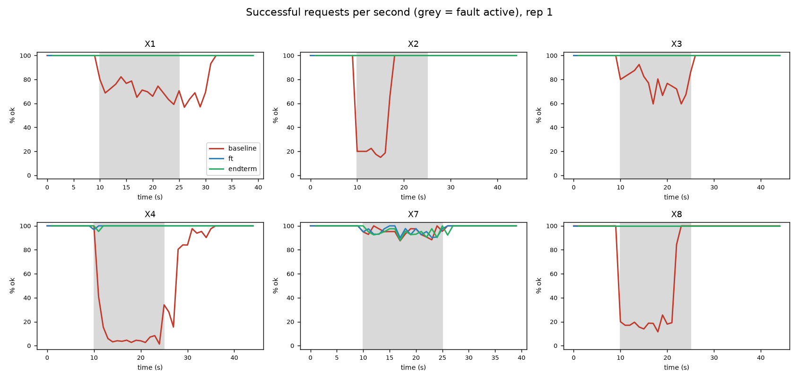
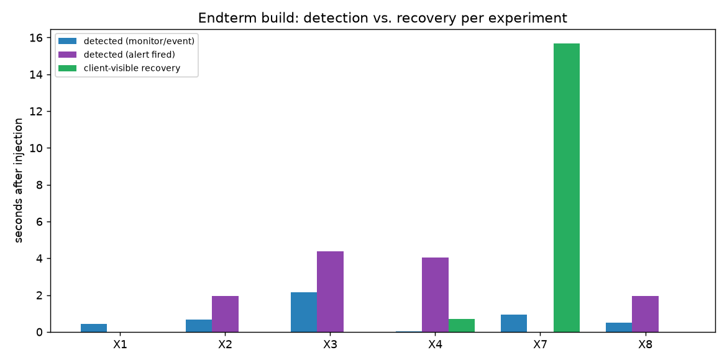

8.2 Security experiments (X5, X6)

Security experiments
Exp | Build | Cases passed | Data unchanged | Audit chain | Audit records | Alerts | PASS
X5 | endterm | 17/17 | yes | ok | 15 | AuthFailureSpike | PASS
X6 | endterm | 10/10 | yes | ok | 25 | - | PASS
- X5 — unauthorized access. 17/17 probes, every one denied as expected: anonymous requests (401), forged / alg:none / wrong-key tokens (401), IDOR on another student's profile and transcript (403), a student attempting a grade change or paying for someone else (403), header-spoofed identity (403), the operator surface without the token (403), and — from inside a compromised student-a container — direct SQL to the database, a DROP TABLE, a snapshot dump and a forced replica promotion, all blocked by the per-service token and the SQLite authorizer. The business-data checksum was identical before and after, the audit chain verified, and AuthFailureSpike fired.
- X6 — abusive / malformed requests. 10/10 malformed cases (negative/zero/ overflow/wrong-type amounts, SQL-shaped IDs, unknown fields, oversized body, non-JSON) all rejected with 4xx; and an authenticated flood from one student was throttled by the per-user rate limiter (377 of 400 requests throttled with 429), leaving the service up and the data unchanged. Validation and rate limiting hold, the audit chain verified.

8.3 Requirements verification

Requirements verification (repetitions meeting the requirement / total)
Req | Statement | Experiments | baseline | ft | endterm
R1 | a single crash fails at most 1% of requests | X1 | 0/1 | 3/3 | 3/3
R2 | failure detected within 1 s, user-visible interruption at most 2 s | X1, X2 | 0/4 | 6/6 | 6/6
R4 | money and records stay consistent | X2, X3, X7 | 0/9 | 9/9 | 9/9
R5 | core p95 below 1 s under the load spike | X4 | 0/3 | 3/3 | 3/3
R9 | an incident that outlasts the alert window raises an alert | X2, X3, X4, X8 | 12/12 | 12/12 | 12/12
R12 | network partition: no split brain, data consistent | X8 | 0/3 | 3/3 | 3/3
R7 | every unauthorized action denied, data unchanged | X5 | n/a (no auth) | n/a (no auth) | PASS
R8 | malformed and abusive input rejected, service up, data unchanged | X6 | n/a (no auth) | n/a (no auth) | PASS
R10 | audit trail complete and tamper-evident | X5 | n/a (no auth) | n/a (no auth) | PASS
The endterm build meets every requirement; the baseline fails the resilience and integrity requirements under fault (R1, R2, R4, R5) and has no notion of R7–R10 at all. The ft build matches endterm on resilience, which is the point of the comparison: adding the full security stack did not regress resilience — endterm masks the same faults with the same zero failed requests, at the cost of only a small, constant latency overhead from authentication and validation on each request.

9. Discussion, limitations, and lessons learned

9.1 What we learned
- Containers did not change the resilience story, which is the good news. The mechanisms designed against process and node failures worked unchanged against container failures, pauses and network partitions. The architecture mapped onto Docker directly; the hand-written supervisor was simply deleted. The one genuinely new fault — a real network partition (X8) — was handled by the fencing token that was already there for failover.
- Automatic recovery and human alerting operate on different time scales, and that is correct. The gateway masks a replica crash in milliseconds; a well-tuned alert fires in seconds. Trying to alert on the millisecond event would only page humans about things the system already fixed. The experiments make this concrete: X1's masked blip fires no page, while X2's 12 s freeze and X4's load spike do. Detection, therefore, has two honest numbers, and we report both.
- The same defences stop a bug and an attacker. The midterm's worst outcomes were integrity failures — money without a record, a silently wrong transcript. The endterm shows that authorization, least-privilege database access, input validation and an audit trail defend the same integrity against a malicious actor: a compromised service still cannot change a grade or dump the database, because the database does not trust it.
- Defence in depth paid for itself. No single control is load-bearing. The gateway authorizes, but the database also enforces least privilege, so a bypass at the edge still fails at the data layer (X5's insider probes prove it). Identity headers are stripped and set by the gateway, so a spoof cannot cross the boundary.

9.2 Trade-offs accepted
- Authentication/validation add a small constant latency to every request; worth it.
- Synchronous replication still trades a write round-trip for never losing a confirmed payment (unchanged from the midterm).
- Short alert windows were chosen so a 45 s experiment can trigger them; production would use 1–5 min windows, trading detection speed for fewer false pages.

9.3 Limitations
- One host. "Network" between containers is a local bridge; a true multi-host partition and real network latency are not modelled. Our failover would need a quorum / third witness to be safe against a symmetric partition in production (noted in the threat model).
- The control plane is still a single point of failure (one gateway, one monitor). Adding authentication did not change that; an active/passive gateway pair and a consensus-based failover coordinator remain the next step, as in the midterm.
- Audit log is tamper-evident, not tamper-proof against someone who can rewrite the whole file; production anchors the head hash externally.
- No internal TLS (plaintext on isolated Docker networks); a service mesh / mTLS would close the on-path threat.
- Compressed time (short fault durations, high synthetic crash rates): absolute values are specific to this setup; the cross-build comparisons are the result.
- Experiments were repeated three times per build, not hundreds; small counts (e.g. a few failed timetable requests at the start of a burst) still vary between runs, but the large effects (0 vs hundreds of failed requests, consistent vs inconsistent) are stable.
- Two storage backends across experiments. X1–X2 ran with the run directory on a host bind mount, X3–X8 on a named volume (see §7.1). Comparisons are only made within an experiment, where all builds share one backend; absolute latencies of X1–X2 and X3–X8 should not be compared with each other.
- Not every alert fires in every scenario. In X6, ten malformed requests are too few to cross the InvalidInputSpike threshold (more than one per second over 10 s), so that alert did not fire; the requests themselves were all rejected and the data was unchanged. A sustained fuzzing run would trigger it.

9.4 What we would do next
Move to multi-host Kubernetes (the compose mapping is direct), replace the single gateway with an active/passive pair, move failover to a three-member coordinator (etcd/Patroni), add mTLS between services, anchor the audit head hash in WORM storage, and run every experiment many times to report full distributions.

10. Conclusion
The endterm took the midterm's fault-tolerant university system and made it a cloud-ready, observable, secured and systematically verified one, without changing what it is — the same code base, now configured three ways. On real containers the resilient builds still mask single-instance crashes, a frozen database primary, a slow dependency, a load spike and a network partition with zero failed user requests and consistent data, while the baseline loses hundreds of requests and corrupts money on every fault. Every service now exposes metrics and a propagated correlation ID, a dozen alert rules watch the system, and the experiments showed — with measured detection delays — that automatic masking (milliseconds) and human alerting (seconds) each do their part. A new class of fault, the malicious one, is contained by seven security controls: every unauthorized and abusive probe is refused, the business data is byte-identical before and after each attack, and a tamper-evident audit trail records it all. The most important result is the same as the midterm's, extended: integrity is the hard part, and the mechanisms that preserve it against failure — order the write before the side effect, bind the idempotency key, check the fence, check the checksum, deny by default — are the same ones that preserve it against an attacker. The weak points that remain are the shared control plane and the single host, and they are the next thing to fix.

11. References
Carried over from the midterm [1]–[14] (Avižienis et al. on dependability; Koren & Krishna; Patterson et al. on RAID; Gray; Nygard, Release It!; Beyer et al., SRE; Brooker on backoff; Fowler on CircuitBreaker; Leach/Stripe on idempotency; Kubernetes probes; SQLite WAL; Kleppmann, DDIA; Bronson et al. on metastable failures; our Assignments 1–2), plus for the endterm:
[15] OWASP, Application Security Verification Standard (ASVS) 4.0 and the API Security Top 10. [16] Microsoft, The STRIDE Threat Model. [17] IETF, RFC 7519 JSON Web Token (JWT) and RFC 8725 JWT Best Current Practices. [18] B. Hindman et al. / Docker Inc., Docker and Compose documentation (healthchecks, restart policies, networks, secrets). [19] Prometheus Authors, Prometheus & Alertmanager documentation (recording/alerting rules, histogram_quantile). [20] NIST SP 800-162, Attribute-Based / Role-Based Access Control; principle of least privilege.

12. Appendix
- A. How to run it — docs/endterm/README_ENDTERM.md (build, run, trace a request, verify the audit chain, run tests and experiments, demo script).
- B. Threat model — docs/endterm/THREAT_MODEL.md (assets, boundaries, STRIDE, controls).
- C. Architecture — results/endterm/fig_arch.png.
- D. Alert rules — deploy/prometheus/alerts.yml (what each detects, threshold, response).
- E. Generated tables and figures — results/endterm/tables.md, fig_timelines.png, fig_detect_recover.png; raw per-run data under results/endterm/<exp>/<build>/rep*/ (requests.csv, events.jsonl, summary.json) and the data checksums / audit records in each security experiment's summary.json.
- F. Example request trace — a single X-Request-ID followed across gateway → payment → database → bank (one grep over the per-container event logs).

