MIDTERM PROJECT
Fault-Tolerant University Information System
Fault Tolerance and Dependable Computing
Team: Mukan Idrissov (255567), Assylmurat Yeraliyev (255574)
Group: CSE-2501M
Instructor: Azamat Serek
Repository: https://github.com/Choppa2077/ft-university
Astana IT University, October 2026

Contents
1. Introduction and project motivation
2. System requirements and assumptions
3. Dependability and fault model
4. Reliability and failure analysis
5. System architecture
6. Hardware fault-tolerance design
7. Software fault-tolerance design
8. Implementation
9. Experimental methodology
10. Results and comparison
11. Discussion and limitations
12. Conclusion
13. References
14. Appendix

1. Introduction and project motivation
In Assignment 1 we analysed a synthetic AITU student portal on paper. Its incident log showed 96.25% availability over one month, and most of the 27 hours of downtime came from a database failover that somebody had to do by hand. The block diagram also showed that the load balancer and the campus network were single points of failure. In Assignment 2 we wrote retry and checkpoint logic for a payment batch, but it ran in one Python process and the faults were simulated with if-statements. For the midterm we wanted to put these two pieces together and see whether the mechanisms still work when real processes die, a real database primary disappears and requests keep arriving the whole time.
So we built a small university platform with the four services students actually hit during registration week: profiles and course registration, tuition payments, transcripts, and timetables. We built it twice from the same code. The baseline has one copy of everything and the kind of error handling a first version usually has. The fault-tolerant (FT) build runs every service on two nodes, replicates the database with automatic failover, mirrors stored documents, and adds the software mechanisms from the course: timeouts, retries with backoff, circuit breakers, idempotency keys, checkpointing, rollback and graceful degradation. Then we broke both builds in the same seven ways and measured detection time, recovery time, failed requests and, which turned out to matter most for a payment system, whether the data was still correct afterwards.
The short version of the results: in the four experiments where something simply died (an application process, the database primary, a whole node) or got very slow (the bank), the FT build did not fail a single user request, while the baseline lost between 76 and 844 user requests per experiment and needed about 20 seconds of "manual" repair each time. The bigger surprise was the data. When the baseline's database was down for 20 seconds, the bank recorded 408 debits but the university recorded only 149 payments, and 133 students were charged twice because they pressed "Pay" again. The FT build finished every experiment with consistent data.

2. System requirements and assumptions

2.1 What the system does
Component | What it does | State
Student service | Student profile, course registration | students, enrollments (database)
Payment service | Tuition payments through the bank, payment status | payments, ledger (database)
Records service | Transcripts with GPA, end-of-term batch that renders all transcripts | grades (database), documents on disk
Timetable service | Builds the weekly timetable of a group (CPU-heavy, about 24 ms per request) | none, computed
Bank (external) | Debits a student's account; a repeated key returns the first debit | its own database
Database | SQLite behind a small HTTP API; primary and replica in the FT build | all university data
Gateway, monitor, supervisor | Entry point and load balancer; health monitoring and DB failover; process restarts | none

The brief asks for a baseline, at least five failure scenarios, at least three independent services, at least two hardware-level and four software-level mechanisms. We have seven scenarios (E1 to E7, plus a variant E5b), four services plus the bank, three infrastructure mechanisms (service replication with load balancing, database replication with failover, mirrored storage with checksums) and eight software mechanisms (Section 7).

2.2 Dependability requirements
We set these targets so that "better" had a concrete meaning:
ID | Requirement | Checked by
R1 | A crash of any single application process, database node or whole application node fails at most 1% of user requests. | E1, E2, E4
R2 | Such a failure is detected within 1 s, and the interruption users can see lasts at most 2 s. | E1, E2, E4
R3 | No acknowledged write is lost: a registration or payment confirmed to the user exists afterwards. | all
R4 | Money is never inconsistent: no student is charged twice for one payment and no bank debit exists without a payment record. | E2, E3, E5
R5 | With about five times the normal traffic, registration and payments keep p95 latency under 1 s; the timetable may be served stale. | E6
R6 | A corrupted stored transcript is never shown to a user. | E7

2.3 Assumptions
- Fault types. Processes and nodes fail by crashing (they disappear). The bank can become slow (timing fault). Stored files can be silently corrupted (value fault). We do not model Byzantine behaviour, attacks or bugs that hit both replicas the same way.
- Nodes are logical. All processes run on one machine (2 vCPU, 8 GB RAM, Linux). "Node A down" kills every process that belongs to node A at the same moment. We chose not to depend on Docker or Kubernetes so that the system and every experiment run with a plain Python install on any laptop, including during the demonstration; a small supervisor process plays the part Kubernetes or systemd would play (Section 8.3).
- Compressed time. In the baseline a crashed process is restarted after 20 s. This stands for an operator noticing the problem and restarting it by hand. A real repair at night takes far longer, so if anything the baseline numbers are optimistic.
- Control node. The gateway, monitor and supervisor are not failed in the experiments. They are a known single point of failure and are discussed in Section 6.5.
- The bank is external. We cannot replicate it, but like real payment providers it accepts an idempotency key and returns the original debit if the same key comes again.
- Users behave the same in both builds. If a payment fails or times out (client timeout 5 s), the student presses Pay once more after 1 s. The FT client library sends an Idempotency-Key header and reuses it on the retry; the baseline has no such thing.
- Load. 40 requests per second: 35% profile reads, 15% registrations, 20% payments, 15% transcripts, 15% timetables. It is a scaled-down busy registration hour, small enough to run on one machine.

3. Dependability and fault model
We use the vocabulary of Avizienis et al. [1]. A fault is the cause (a process is killed), an error is the wrong internal state it creates (requests in flight are lost, the database is unreachable), and a failure is what the user sees (an HTTP 502, a double charge). Thinking in these three steps was useful because each mechanism we built stops the chain at a different link: health checks and failover act on the error before it becomes a failure, idempotency makes a retried request harmless, a checksum turns an invisible value error into a detected one.
The dependability attributes we care about are not equally important for every service. For registration and payments during registration week, availability is the main one. For payments and transcripts, integrity matters even more: an unavailable payment page is annoying, a wrong transcript or a double charge is a real problem for a student. Maintainability shows up as MTTR, and reliability as "a long batch job finishes without starting over".
ID | Fault (class) | Error inside the system | Failure without protection | Where the FT build breaks the chain
F1 | Application process crash (crash) | Instance stops accepting connections, in-flight requests lost | 502 for every request routed to that instance | Gateway retries on the other replica, health check removes it, supervisor restarts it
F2 | Database primary crash (crash) | No reads or writes possible; a payment already sent to the bank cannot be recorded | All database requests fail; money taken without a record | Monitor promotes the synchronous replica; clients find the new primary; idempotent writes
F3 | Bank answers after 6 s (timing, transient) | Payment requests pile up waiting | Payments time out, the student retries and is charged twice | 0.8 s timeout, retries with the same key, circuit breaker, payment queued (HTTP 202)
F4 | Whole node lost (correlated crash of 5 processes) | F1 and F2 at the same time | Complete outage | Replicas on the other node, DB failover
F5 | Transaction interrupted after the bank debit (crash mid-operation) | Debit exists, payment row missing or stuck | Money without a record, and a retry charges again | PENDING checkpoint before the bank call, roll-forward by the retry or by the recovery worker
F6 | Traffic burst, about 5x (overload) | Queues grow, CPU saturated | Timeouts in every service | Load shedding per service, stale timetable cache, two replicas
F7 | Silent corruption of stored transcripts (value) | Wrong bytes on disk | Wrong GPA shown, or an error | SHA-256 check, read from the mirror, repair

Not covered: network partitions between individual services (we only cut whole nodes), Byzantine or malicious components, common-mode software bugs, clock problems and security. Section 11 comes back to what this means for the results.

4. Reliability and failure analysis

4.1 Metrics and how we measured them
MTTF is the total up time divided by the number of failures, MTTR is the total down time divided by the number of failures, MTBF = MTTF + MTTR, availability A = up time / observed time, and the failure rate is λ = failures / up time. We measured these at two levels.
- Component level: from the monitor's log. A component is down from its first failed health check (checks every 0.25 s) until the check that sees it ready again.
- Service and system level: from the client's log. Time is cut into 1-second windows. A service is down in a window if fewer than half of its requests succeeded; down windows closer than 2 s are merged into one outage. The system is up only while all four services are up.
To get enough failures in a reasonable time we ran a soak test: 540 s of steady traffic (20 requests/s) per build, while a script killed application-node processes at random. Each process had an exponentially distributed time to failure with a mean of 240 s for services and 480 s for database nodes. The random schedule is seeded per process, so node A's processes crashed at the same moments in both builds; the FT build additionally lost node B processes. In total 15 crashes hit the baseline and 30 hit the FT build (a few planned kills found the process already down). This is compressed time, so the absolute MTTF values say nothing about real hardware; the comparison between builds is what matters.

4.2 Component level
Component | Build | Copies | Failures | MTTF | MTTR | MTBF | A | λ (1/h)
db | baseline | 1 | 2 | 249.3 s | 20.66 s | 270.0 s | 92.35% | 14.4
db | FT | 2 | 2 | 536.5 s | 3.52 s | 540.0 s | 99.35% | 6.7
student | baseline | 1 | 5 | 87.4 s | 20.57 s | 108.0 s | 80.95% | 41.2
student | FT | 2 | 12 | 88.4 s | 1.56 s | 90.0 s | 98.26% | 40.7
payment | baseline | 1 | 4 | 114.5 s | 20.52 s | 135.0 s | 84.80% | 31.4
payment | FT | 2 | 6 | 178.4 s | 1.60 s | 180.0 s | 99.11% | 20.2
records | baseline | 1 | 2 | 249.5 s | 20.53 s | 270.0 s | 92.40% | 14.4
records | FT | 2 | 6 | 178.4 s | 1.64 s | 180.0 s | 99.09% | 20.2
timetable | baseline | 1 | 2 | 249.5 s | 20.52 s | 270.0 s | 92.40% | 14.4
timetable | FT | 2 | 4 | 268.5 s | 1.52 s | 270.0 s | 99.44% | 13.4
Table 4.1 Measured per-component metrics in the soak test (compressed time; λ per hour of compressed time).
The difference that matters here is MTTR. A crashed service process in the baseline stayed down for 20.5 to 20.6 s, which is our 20 s "operator" plus the start-up time. In the FT build the supervisor restarts it after 1 s, so a service replica was back after 1.52 to 1.64 s. The database node takes longer (3.52 s on average) because it is restarted after 3 s on purpose, so that the failover decision happens before the old primary comes back, and then it has to copy a snapshot from the new primary. Per-process availability in the FT build is therefore above 98.2% even though its processes crashed at the same rate as in the baseline.

4.3 System level, and how it compares to the block-diagram prediction
Service | Build | Outages | MTTF | MTTR | A (time) | Requests OK
student | baseline | 6 | 69.7 s | 20.5 s | 77.26% | 77.31%
student | FT | 1 | 540.0 s | 1.0 s | 99.82% | 99.87%
payment | baseline | 5 | 87.4 s | 20.8 s | 80.78% | 69.03%
payment | FT | 0 | no outage | - | 100.00% | 100.00%
records | baseline | 4 | 124.2 s | 11.0 s | 91.87% | 90.52%
records | FT | 0 | no outage | - | 100.00% | 100.00%
timetable | baseline | 2 | 250.0 s | 20.5 s | 92.42% | 92.14%
timetable | FT | 0 | no outage | - | 100.00% | 100.00%
system | baseline | 9 | 36.8 s | 23.3 s | 61.18% | 79.36%
system | FT | 1 | 540.0 s | 1.0 s | 99.82% | 99.94%
Table 4.2 What users experienced during the soak test (1-second windows, see 4.1).
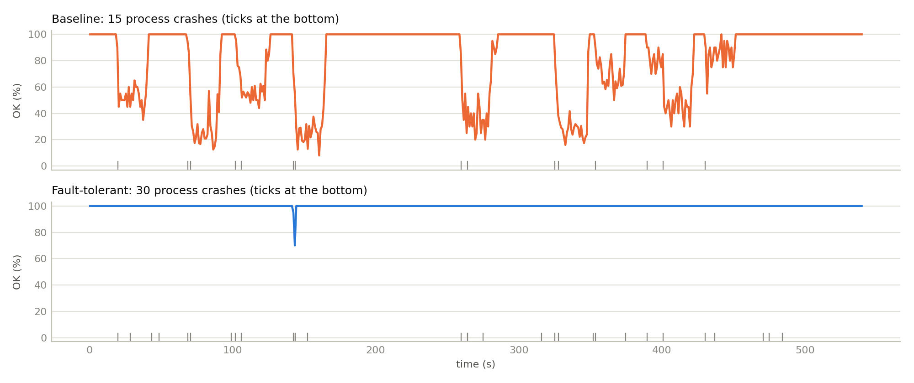
Figure 4.1 Share of successful requests per second during the soak test. Ticks at the bottom mark process crashes.
To compare with theory we used the reliability block diagram in Figure 4.2. In the baseline every service and the database are in series, so the system is up only when all five are up. In the FT build each service and the database are a parallel pair; the gateway is left out of both because it was never failed.
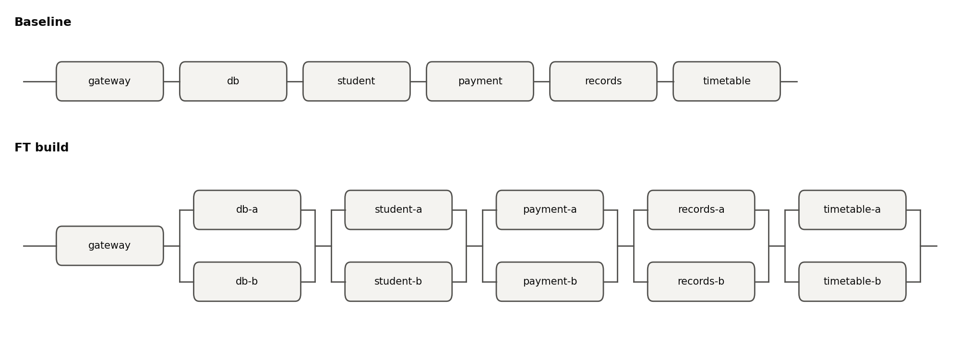
Figure 4.2 Reliability block diagrams of the two builds.
With the measured component availabilities A_{i} the prediction is A = Π A_{i} for the baseline and A = Π (1 − (1 − A_{i})²) for the FT build. That gives 54.1% and 99.95%. We measured 61.2% and 99.82%.
For the baseline the measurement is better than the prediction. The series formula assumes independent failures spread evenly in time, but with only 15 crashes our failures happened to overlap (for example student-a and records-a around t = 260 s, db-a and payment-a around t = 325 s), and when two components are down at the same time the system only loses that time once. Also the records service kept serving transcripts that were already stored on disk while the database was down, so it was not a pure series element.
For the FT build the measurement (99.82% of the time, 99.94% of requests) is below the prediction (99.95%), and all of the difference comes from one second. student-a crashed at 142.4 s and student-b at 142.9 s, before student-a had finished restarting, so for about a second there was no student service at all and 7 requests failed. The other 28 crashes, including a database failover at 143.8 s, did not fail a single request. The RBD formula does contain this case, as the (1 − A)² term, but it treats it as a tiny average. In a real run it is a rare event that either happens or does not, and when it happens it is visible. This is the kind of failure redundancy alone cannot remove; only faster restarts or a third replica make it shorter or rarer.

4.4 Fault tree: "a student cannot pay tuition"
The same structure seen from the failure side. Minimal cut sets are the smallest sets of components whose failure together causes the top event:
Order | Baseline cut sets | FT cut sets
1 | {gateway}, {payment}, {database}, {bank} | {gateway} (the bank is no longer a cut set: when it is down, payments are accepted as QUEUED and finished later)
2 | - | {payment-a, payment-b}, {db-a, db-b}, {node A, node B}, {monitor, DB primary}

The {monitor, DB primary} pair is worth a note: if the monitor is down when the database primary dies, nobody promotes the replica. That is a common-cause path we introduced by having one failover controller. The gateway is still an order-1 cut set in both builds, the same lesson Assignment 1 gave us about the load balancer.

4.5 What these numbers would mean at real failure rates
As an illustration only, assume each process fails once every 30 days on average (MTTF = 720 h). With a manual repair of 1 hour the baseline gets A = 0.99861 per component and 0.9931 for five components in series, about 60.6 hours of downtime per year. With an automatic restart of about 3 s and two replicas, the FT formula gives a number so close to 1 that it is meaningless. In practice the availability of the FT build would be limited by the things this formula does not contain: the gateway, the monitor, the bank, network problems, deployments and bugs that hit both replicas. So the main conclusion of this section is that redundancy moved the weak points from the services to the shared parts around them.

5. System architecture
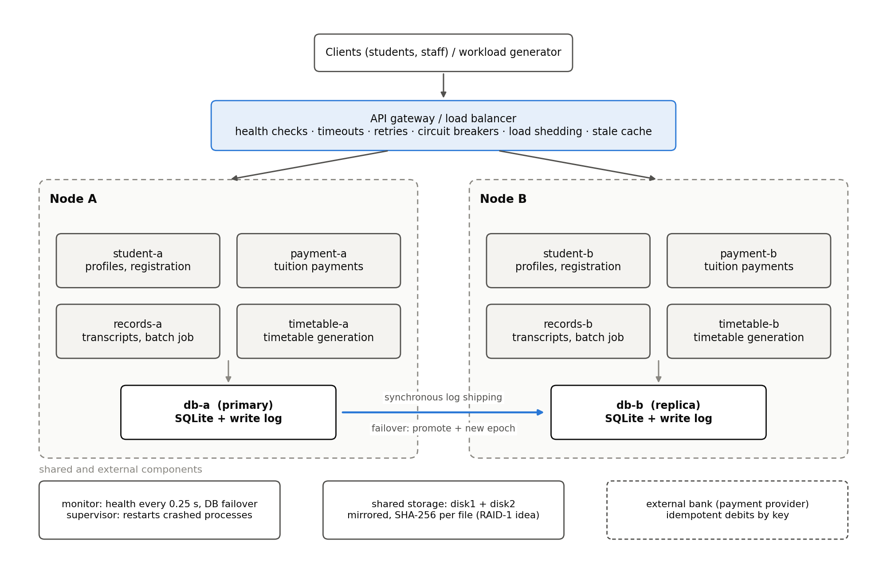
Figure 5.1 Architecture of the FT build. The baseline is node A only, without db-b, disk2 and the FT features of the gateway.
Every box is a separate operating-system process with its own port. Node A and node B each run one replica of every service and one database node. The control node runs the gateway (the only entry point for clients), the monitor and the supervisor. The bank is outside our system. Transcripts are stored on a volume made of two directories, disk1 and disk2, that both records replicas can reach.
Instance | Node | Port | Role
gateway | control | 8000 | load balancer, health checks, retries, breakers, shedding, stale cache
monitor | control | 8001 | health of everything every 0.25 s, database failover
supervisor | control | 8009 | starts processes, restarts crashed ones, fault-injection API
bank | external | 8002 | payment provider, idempotent by key
db-a / db-b | A / B | 8110 / 8210 | database primary / synchronous replica (roles can swap)
student-a / -b | A / B | 8120 / 8220 | student service replicas
payment-a / -b | A / B | 8130 / 8230 | payment service replicas
records-a / -b | A / B | 8140 / 8240 | records service replicas
timetable-a / -b | A / B | 8150 / 8250 | timetable service replicas

A payment in the FT build, step by step: the client sends POST /payments with an Idempotency-Key. The gateway picks a healthy payment replica (round-robin). The payment service checks whether it already knows this key; if not, it writes a PENDING row to the database (this is the checkpoint). The database primary assigns the write a log sequence number, ships it to the replica and commits only after the replica has applied it. Then the payment service calls the bank with the same key, and finally writes COMPLETED plus a ledger row in one transaction. If anything breaks in the middle, the PENDING row and the key are what allow the system to finish the payment exactly once.

6. Hardware fault-tolerance design
We did not have real servers to unplug, so the infrastructure mechanisms are implemented at process level. The logic is the same as with physical machines: put copies of everything on independent failure units and make switching between them automatic.

6.1 Replicated application instances and load balancing
Each service runs as two instances on different nodes. The gateway keeps a pool per service and sends requests round-robin to the instances it considers healthy. It finds out about failures in two ways: actively, by calling /health/ready on every instance every 0.3 s (two failures in a row mark it down, one success brings it back), and passively, when a connection is refused, which marks the instance down immediately. In the node-failure experiment the passive path removed all four node-A services within 25 ms, long before the next active check. If every instance of a service looks unhealthy, the gateway still tries them ("panic mode") instead of refusing everything, because health checks can be wrong too.
The supervisor provides self-healing: when a process exits, it is started again after 1 s (database nodes after 3 s). In the baseline the same supervisor waits 20 s, our stand-in for manual repair. This mirrors a Kubernetes Deployment with two replicas, readiness and liveness probes and restartPolicy Always (Section 8.3).

6.2 Database replication and automatic failover
The database is the hardest part, because unlike the services it has state. We wrote a small database node around SQLite (WAL mode). Writes only go to the primary. Every write transaction gets a log sequence number (LSN) and is stored, together with its SQL, in a _log table. Before committing, the primary ships the entry to the replica and waits for its acknowledgement. So when a client gets "OK" for a write, the write already exists on both nodes. This is synchronous replication, and it is why no acknowledged write was lost in any failover.
If the replica is unreachable, the primary marks it "lagging" and carries on alone rather than blocking all writes; a background loop ships the backlog when the replica is back. This is a deliberate availability-over-durability choice for that one situation, and the monitor knows about it: it will not promote a replica if the primary's last reported replica state was not "sync", because such a replica might be missing confirmed payments.
Failover is done by the monitor. When the primary has failed three health checks in a row (0.5 to 0.75 s) and the replica is healthy and in sync, the monitor writes a new epoch number and the new primary's name to a small registry file and calls /promote on the replica. The epoch is a fencing token [12]: every write carries the highest epoch the client has seen, a node with a lower epoch refuses it, and a primary that tries to replicate into a node with a higher epoch rolls back its write and steps down. Without this, an old primary that comes back quickly could accept writes the rest of the system never sees (split brain).
A database node that restarts reads the registry. If it is no longer the primary, it throws its local data away and copies a full snapshot from the current primary, then follows the log from there. This is the same idea as rebuilding a PostgreSQL standby from a base backup. The snapshot endpoint is also our backup mechanism: the same consistent copy can be taken at any time and stored elsewhere.

6.3 Storage redundancy: RAID-1 with checksums, and ECC
Transcripts are documents, not database rows, so they need their own protection. Every transcript is written to two directories that stand for two disks, together with its SHA-256 hash (RAID level 1, mirroring [3]). A read verifies the hash. If the copy on disk1 is missing or does not match, the copy on disk2 is checked and served, and disk1 is rewritten from it. A scrub endpoint checks every document on both disks, which is what a RAID controller does in the background.
ECC memory works on the same principle one level lower: extra bits stored next to the data let the memory controller detect and correct single-bit errors (SECDED Hamming codes) before the CPU uses the value. We could not inject memory faults, so ECC is documented rather than demonstrated. What experiment E7 shows is the part that matters to the user: without redundancy and a checksum, corrupted data is served as if it were correct.

6.4 Backup infrastructure
Besides the snapshot endpoint, the bank keeps its own record of every debit, and the reconciliation loop in the payment service compares the two. In a real deployment the snapshot would be shipped to a third location daily, so that a mistake replicated to both database nodes (for example a wrong UPDATE) can still be undone. Replication protects against hardware loss, not against bad writes.

6.5 Single points of failure that remain
The gateway is the obvious one, and Assignment 1 already told us to fix it with an active/passive pair and a virtual IP (VRRP/keepalived). The monitor is a single failover controller; production systems use a consensus-based coordinator (etcd, ZooKeeper, Patroni) for this. The supervisor and the storage volume are shared. And all "nodes" are one physical machine, so a real power cut would take everything down. We kept these out of the experiments on purpose and list them here so the results are read correctly: the FT build tolerates failures of application nodes, not of the control plane.

7. Software fault-tolerance design
The brief asks for at least four mechanisms. We implemented eight, and most of them depend on each other: retries are only safe because of idempotency, rollback is only possible because of the checkpoint, and graceful degradation is what the circuit breaker falls back to.

7.1 Timeouts
Every call across a process boundary has a timeout, and the timeouts are nested so that the inner one always expires before the outer one: the bank call times out after 0.8 s; three attempts plus backoff fit inside the gateway's 4.5 s timeout for payments; that fits inside the client's 5 s. In the baseline the gateway waits 30 s and the payment service waits 30 s for the bank, which is roughly what you get with library defaults. Experiment E3 shows what this costs: requests do not fail fast, they hang until the user gives up and tries again.
Call | Baseline | FT | Why this value
client to gateway | 5 s | 5 s | a person waiting for a page
gateway to student / records / timetable | 30 s | 2.5 / 3.0 / 1.5 s | longer than a database failover (about 0.5 to 1 s), shorter than the client
gateway to payment | 30 s | 4.5 s | must cover 3 bank attempts
payment to bank | 30 s | 0.8 s, 2 retries | normal bank answer is a few ms
service to database | 10 s | 1 s per try, 4 s deadline | failover takes about 0.5 s

7.2 Retry with exponential backoff and jitter
Retries happen in three places: the gateway retries a failed or timed-out request once on the other replica; the payment service retries the bank twice; the database client keeps retrying until its 4 s deadline while it looks for the new primary. All of them wait a random time between 0 and base × 2^attempt ("full jitter" [7]), so that many clients that failed at the same moment do not all come back at the same moment.
Only idempotent requests are retried: GET requests, and POST requests that carry an Idempotency-Key. A POST without a key is retried only if the connection was refused, because then the request provably never reached the server. This rule is the difference between a retry that helps and a retry that charges a student twice.

7.3 Circuit breaker
The payment service has a breaker in front of the bank and the gateway has one per service. After 5 consecutive failures (8 at the gateway) the breaker opens and calls fail immediately instead of waiting for timeouts. After 3 s (2 s at the gateway) it lets one trial call through; success closes it, failure opens it again. In E3 the payment breaker opened 1.8 s after the bank slowed down and closed 1.5 s after the bank recovered (Appendix C).

7.4 Idempotent processing and duplicate-request detection
There are three layers. The client sends an Idempotency-Key with every payment and reuses it on retries; the payment service looks the key up before doing anything, and a known key returns or finishes the original payment instead of creating a new one (logged as DUPLICATE_REQUEST). The bank receives the same key, so even if our service calls it twice, the student is debited once. And every database write carries a tx_id; the database node remembers applied tx_ids in its log, so a write retried after a timeout is not applied twice. Registrations are idempotent by design (INSERT OR IGNORE on the student and course).

7.5 Checkpointing
For payments, the checkpoint is the PENDING row written before the bank is called. It records the intention, so that whoever looks at the payment later knows a debit might exist. For the end-of-term transcript batch, the job writes its position to the database every 10 transcripts and holds a 3 s lease. If the owner dies, the lease expires and any records replica takes the job over and continues from the last checkpoint. This is the same idea as in Assignment 2, moved into a shared, replicated database so that it survives the loss of a node.

7.6 Rollback and recovery
A recovery worker in every payment replica looks every second for payments that have been PENDING or QUEUED for more than 2 s, which means the request that created them is gone. The rules are simple and we tried to make them easy to defend:
- Debit exists at the bank: roll forward. The money has already moved, so the only correct action is to finish the bookkeeping: COMPLETED plus ledger row, in one transaction.
- No debit and the intent is older than 10 s: roll back. The client has given up; we must not start moving money on behalf of someone who is gone. The payment becomes FAILED.
- A debit appears for a payment that was rolled back: compensate. This can happen if a slow request reaches the bank just after the rollback. The service refunds the debit, and a reconciliation loop checks recently failed payments against the bank as a second line of defence.
- QUEUED payments: roll forward when the bank is back. The student was told the payment was accepted, so it must eventually complete.
Database-level rollback comes for free: a write transaction that is interrupted by a crash is never committed, and a write that the replica refuses because of a newer epoch is explicitly rolled back.

7.7 Health checks
Every process exposes /health/live (the process answers) and /health/ready (it can do useful work). For a database node, ready means it is the primary, or a replica that holds a complete copy. We deliberately did not make service readiness depend on the database: if it did, a database failover would make every service replica "not ready" at the same moment, and the gateway would take the whole system out of rotation for a problem the database client handles on its own.

7.8 Graceful degradation
When something is broken we prefer giving a reduced answer to giving no answer. Payments are accepted as QUEUED (HTTP 202) when the bank is unreachable and finished later. The gateway caches the last good timetable for every group and week and serves it, marked with an X-Degraded header, when the timetable service is overloaded or its breaker is open. And each service has an in-flight limit at the gateway (a bulkhead: 6 concurrent timetable requests, 48 payments, 64 student requests); a request over the limit is shed immediately instead of queueing. That last one is what kept registrations and payments fast in E6 while the timetable was flooded.

7.9 Service replication
Covered in Section 6.1. It is listed here too because without a second copy, most of the mechanisms above would only turn a crash into a faster error.

8. Implementation

8.1 Technology
Python 3.11, FastAPI with Uvicorn for every service, httpx for HTTP calls, SQLite in WAL mode for storage, matplotlib for figures and pytest for unit tests. The whole system is about 2,100 lines of Python in the ftuni package, plus about 1,300 lines of experiment tooling. Everything runs on a laptop with pip install -r requirements.txt; no Docker or cloud services are needed.

8.2 One code base, two builds
The baseline and the FT build are the same code. A Policy object in ftuni/config.py decides how many replicas exist and which mechanisms are on, so every difference in the results comes from the mechanisms and not from two different programs:
BASELINE = Policy(name="baseline", gw_timeout={"*": 30.0}) # all mechanisms off
FT = Policy(name="ft",
gw_timeout={"student": 2.5, "payment": 4.5, "records": 3.0, "timetable": 1.5},
gw_retries=2, health_checks=True, breaker=True, load_shedding=True, degrade=True,
db_failover=True, db_timeout=1.0, db_deadline=4.0,
idempotency=True, bank_timeout=0.8, bank_retries=2, recovery_worker=True,
mirror_storage=True, checkpointing=True, restart_delay=1.0, db_restart_delay=3.0)

Directory | Contents
ftuni/ | gateway.py, monitor.py, supervisor.py, dbnode.py (database node), dbclient.py, resilience.py (backoff, breaker, bulkhead), storage.py (mirrored store), common.py (logging, chaos hooks, health endpoints)
ftuni/services/ | student.py, payment.py, records.py, timetable.py, bank.py
experiments/ | workload.py (load generator), run_experiments.py (E1-E7), soak.py, consistency.py, demo.py, analyze.py
tests/ | 12 unit tests: breaker states, backoff, bulkhead, mirror repair, database deduplication and fencing
results/ | every request and every event of every run, summaries, figures

8.3 How this maps to Kubernetes
Because we wanted everything to run with a plain Python install, we wrote the orchestration part ourselves instead of using Docker and Kubernetes. The mapping is direct, which is why we think the results carry over:
Kubernetes | Our implementation
Deployment with replicas: 2, anti-affinity across nodes | two instances per service, one on node A and one on node B
livenessProbe / readinessProbe | /health/live and /health/ready, polled by the gateway (0.3 s) and the monitor (0.25 s)
restartPolicy: Always (kubelet) | supervisor restarts an exited process after 1 s
Service + kube-proxy | gateway pool with round-robin over ready instances
Node failure | supervisor kills every process of a node and keeps them down for the given time
StatefulSet + operator (e.g. Patroni for PostgreSQL) | dbnode.py + monitor.py failover

8.4 Problems we ran into
A few things did not work the first time, and some of them taught us more than the parts that did:
- The first payment returned 307 instead of 201. The gateway route was /{service}/{path}, so /payments (with nothing after it) did not match and FastAPI answered with a redirect. A second route for the bare service path fixed it.
- Split brain in the failover code. While reviewing the database node we noticed that an old primary which came back quickly could still accept a write after the replica had been promoted. The write would be acknowledged and then lost when the old primary resynchronised. We added the rule from 6.2: if the replica answers "stale epoch" during replication, the primary rolls the write back and steps down.
- Timeouts in the wrong order. We first gave the gateway a 1.5 s timeout for student requests. A database failover plus the client finding the new primary can take about a second, and the gateway would have given up on requests that were about to succeed. We raised it to 2.5 s and made the rule "inner timeouts are always shorter than outer ones" explicit (7.1).
- A rollback can race with a late debit. If the recovery worker rolls back a payment at the same moment a slow request reaches the bank, there is money without a payment. We added the compensation path (refund) and the reconciliation loop for this case.
- The timetable generator was too slow. The first version needed about 50 ms per request, which left too little CPU for the other services on our two-CPU machine. We halved the search iterations (about 24 ms per request), so that only the overload experiment saturates it.

9. Experimental methodology

9.1 Environment and procedure
All runs were on one Linux machine with 2 virtual CPUs and 8 GB of RAM, Python 3.11.15. Every experiment run follows the same steps, done by experiments/run_experiments.py:
- start a fresh cluster of the chosen build (data directory wiped, database seeded with 300 students, 40 courses and 3,600 grades) and wait until every process is ready;
- send the standard workload for 40 s (45 s for E4) at 40 requests/s, open loop: requests are sent on schedule whether or not earlier ones have finished;
- inject the fault at t = 10 s, and remove it again after 15 s where the fault is temporary (E3, E5);
- wait for background recovery (3 s, or 12 to 14 s for the payment experiments, which is longer than the 10 s rollback rule), then run the consistency checks;
- stop the cluster and save every request (requests.csv) and every event from every process (events.jsonl).
Both builds get exactly the same workload because the request generator is seeded.

9.2 Fault injection
Exp. | Fault | How it is injected
E1 | Application crash | SIGKILL to student-a through the supervisor API
E2 | Database failure | SIGKILL to the current database primary
E3 | Service timeout | bank chaos switch: every response delayed by 6 s after the debit is done, health checks included; removed after 15 s
E4 | Node failure | supervisor kills all five node-A processes and keeps the node down for 20 s
E5 | Interrupted transaction | payment chaos switch: 30% of payments abort right after the bank debit, for 15 s
E5b | Interrupted record operation | transcript batch for 300 students started on records-a, SIGKILL when it reaches 150
E6 | High load | second load generator adds 150 timetable requests/s for 15 s (about 4.75x the normal total)
E7 | Corrupted data | 30 stored transcripts changed on disk1: in 25 the GPA digit changes (still valid JSON), 5 get garbage bytes

9.3 What we measured
- Detection time: from the injection to the first event that shows the system noticed: the monitor's DOWN event for crashes and the slow bank, the gateway's first shed request for overload, and for interrupted payments the moment each one was picked up again.
- Client-visible recovery time: from the injection to the end of the last failed request. If nothing failed, it is 0.
- Redundancy restored: from the injection until the failed component is healthy again (FT: back in the pool or back in sync).
- Failed requests: counted per user action. A payment and its retry are one action, which fails only if both attempts fail. We also count degraded answers (queued payments, stale timetables) and requests that succeeded only thanks to a retry.
- Data consistency: money (every live bank debit belongs to exactly one completed payment; no student intent charged twice; ledger matches payments), no payment left PENDING or QUEUED, every acknowledged payment and registration present, and in the FT build primary and replica identical.

10. Results and comparison

10.1 Summary table
Exp. | Failure | Build | Detection | Recovery | Failed requests | Result
E1 | Application crash | baseline | 0.44 s | 20.5 s | 429 / 1600 | consistent
E1 | Application crash | FT | 0.41 s | 0 s (masked) | 0 / 1600 | consistent
E2 | Database failure | baseline | 0.29 s | 20.6 s | 666 / 1600 | 259 debits without a payment, 133 students charged twice
E2 | Database failure | FT | 0.27 s | 0 s (masked) | 0 / 1600 | consistent
E3 | Bank timeout | baseline | 0.74 s | 19.9 s | 76 / 1600 | 119 students charged twice
E3 | Bank timeout | FT | 0.54 s | 0 s (masked) | 0 / 1600 | consistent; 134 degraded answers
E4 | Node failure | baseline | 0.24 s | 21.2 s | 844 / 1800 | consistent
E4 | Node failure | FT | 0.44 s | 0 s (masked) | 0 / 1800 | consistent
E5 | Interrupted transactions | baseline | not detected | never: debits stay without a record | 8 / 1600 | 53 debits without a payment, 45 students charged twice
E5 | Interrupted transactions | FT | 1.08 s (per payment) | each payment finished in 1.08 s on average (max 1.90 s) | 10 / 1600 | consistent
E6 | High load | baseline | no mechanism | not within the run | 3154 / 3850 | 16 students charged twice
E6 | High load | FT | 0.04 s | 4.2 s | 37 / 3850 | consistent; 1664 degraded answers
Table 10.1 Failure experiments. Failed requests are user actions (a payment and its retry count once).
Exp. | Build | What happened
E5b | baseline | killed at transcript 151; operator restarted the job after 20.6 s, from zero; 451 transcripts rendered for 300 students (151 twice); finished after 30.8 s
E5b | FT | killed at transcript 150; records-a took the job over after 3.55 s from checkpoint 150; 2 transcripts rendered twice; finished after 10.8 s
E7 | baseline | 25 of 300 transcripts served with a wrong GPA and no error (e.g. S0007: 1.46 instead of 2.46); 5 answered with an error
E7 | FT | all 30 corrupted files detected on read and repaired from disk2; 300 of 300 answers correct; a scrub afterwards found nothing left to fix
Table 10.2 Batch job and storage experiments.
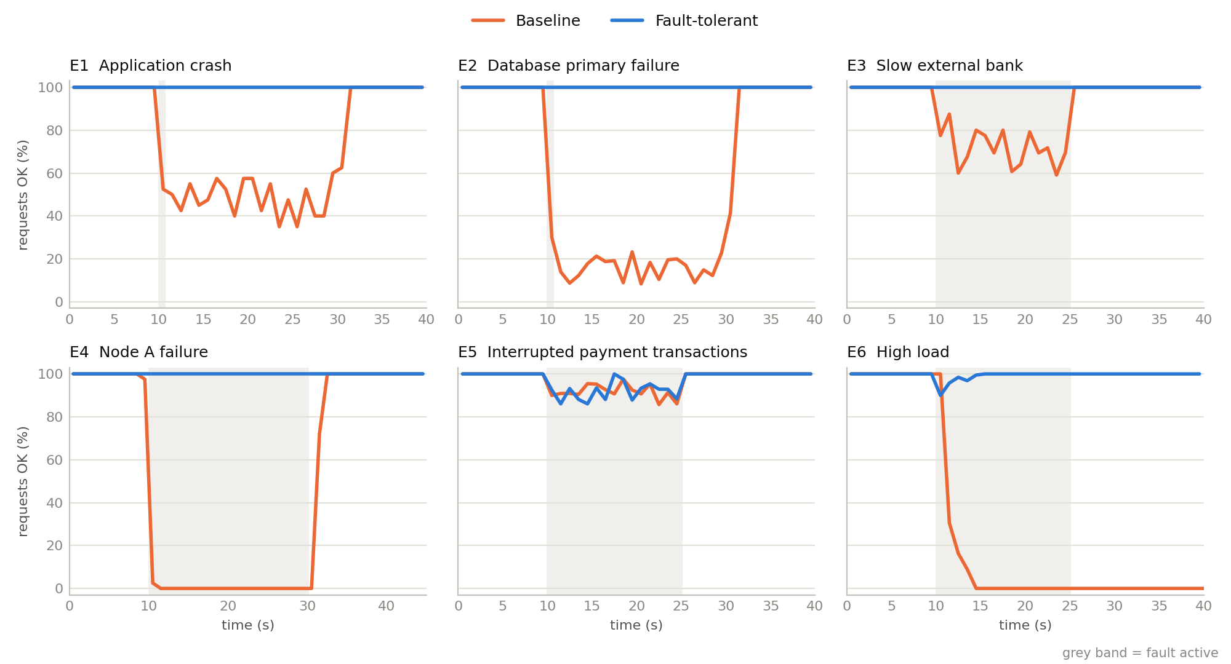
Figure 10.1 Share of successful requests per second (all request types). Grey band: fault active.

10.2 Experiment by experiment
E1, application crash. In the baseline every profile and registration request failed until the "operator" restarted student-a: 429 of 1600 requests failed and users saw the outage for 20.5 s. In the FT build the gateway got a refused connection on the next request to student-a, marked it down and sent the request to student-b; the monitor flagged it 0.41 s after the kill. Not one request failed, and student-a was back 1.97 s after the crash.
E2, database failure. This is the experiment that changed how we look at the baseline. Availability was bad, as expected (666 of 1600 requests failed during 20.6 s). But the payment service calls the bank first and writes to the database second, so during the outage every payment took the money and then failed to record it. At the end the bank had 408 debits and the university only 149 payments: 259 debits worth 54 890 000 KZT have no record anywhere, and 133 students paid twice because their retry was a brand-new payment. In the FT build the monitor saw the primary down after 0.27 s and promoted db-b 0.53 s after the crash; all six database clients had switched by 0.59 s (Appendix C). Requests that arrived in that window waited inside the database client's retry loop, so no request failed. db-a was restarted 3 s later, copied a 397 KB snapshot from db-b and was a synchronous replica again 3.5 s after the crash. Primary and replica were identical at the end (LSN 784).
E3, slow bank. The baseline waits up to 30 s for the bank but the student gives up after 5 s, so every payment in the window timed out (195 timeouts). The bank still processed each request and the payment service still recorded it 6 s later. So every student who tried again paid twice: 119 double charges. 76 of these students saw both of their attempts fail and were still charged twice; the other 43 saw the second attempt succeed. In the FT build the first payments took up to 1.7 s (attempts of 0.8 s each), then the circuit breaker opened 1.8 s after the slowdown started and payments were accepted immediately as QUEUED without calling the bank. 134 payments were queued. The breaker tried the bank every 3 s, closed 1.5 s after the bank was healthy again, and the recovery workers finished every queued payment with exactly one debit each, because the retries reused the key.
E4, node failure. Node A held the database primary and one replica of every service. In the baseline this is a complete outage: 844 of 1800 requests failed and it lasted 21.2 s (20 s node down plus start-up). In the FT build the gateway marked all four node-A services down within 25 ms from refused connections, the monitor promoted db-b after 0.69 s, and again no request failed; the only visible effect was p99 latency going up to 380 ms. When node A came back its processes started, db-a joined as a replica and the gateway put the node back into rotation, 22.0 s after the failure.
E5, interrupted payments. For 15 s, 30% of payments were aborted right after the bank had taken the money. Both builds failed a similar number of attempts (53 and 53), and the timeline in Figure 10.1 looks almost the same. The difference is entirely in the data. The baseline was left with 53 debits without a payment (12 830 000 KZT) and 45 students charged twice. In the FT build the 53 interruptions hit 43 payments. 33 of them were finished by the student's own retry: the same key led the service to the PENDING row, the bank returned the existing debit and the payment was completed. The other 10 were unlucky twice (both attempts aborted) and were completed by the recovery worker, because the debit existed. On average a payment was finished 1.08 s after its interruption, at most 1.90 s. No orphans, no double charges. One remark: those 10 students still saw an error message although their payment went through a second later. A real interface should show "payment is being processed" there.
E6, high load. The baseline collapsed. The single timetable process queued every request, the gateway's 30 s timeout let the queue grow, and because everything shares the CPU, registrations and payments timed out as well: 3154 of 3850 requests failed and the median latency was 5.06 s. It did not recover when the burst ended at t = 25 s, because the backlog kept the CPU busy until the end of the run. This is a small example of what Bronson et al. call a metastable failure [13]. The FT gateway started shedding timetable requests 40 ms after the burst began. 1664 timetable requests were answered from the stale cache. 37 failed, all in the first four seconds of the burst: they asked for group and week combinations the gateway had not cached yet, so there was nothing to fall back to. Registrations and payments were not affected; their p95 latency stayed below 100 ms (Figure 10.2).
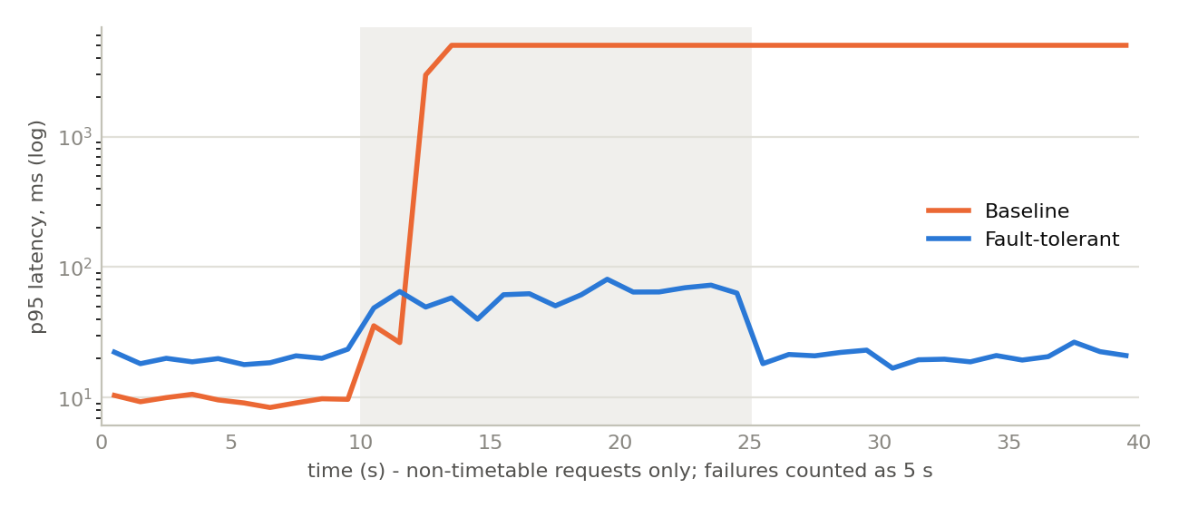
Figure 10.2 E6: p95 latency of registration, profile, payment and transcript requests (timetable excluded). Failed requests counted as 5 s.
E5b, interrupted batch job. The baseline kept its progress only in memory, so after the crash the operator had to start the job again from the first student: 151 transcripts were rendered twice and the job took 30.8 s instead of about 7. In the FT build the lease of the dead owner ran out, records-a (already restarted by the supervisor) claimed the job 3.55 s after the crash and continued from transcript 150. Only the 2 transcripts rendered after the last checkpoint were done twice.
E7, silent corruption. The worst result of the baseline in our opinion, because nothing looks wrong: 25 students received a transcript with a GPA one point lower than the real one, with HTTP 200, and only the 5 files with garbage bytes produced an error. The FT build detected all 30 corrupted files on the first read, served the copy from disk2 and repaired disk1.

10.3 Did we meet the requirements?
Req. | Baseline | FT build
R1 ≤1% failed requests on a single crash | not met (27%, 42%, 47% in E1, E2, E4) | met (0 failed requests in E1, E2, E4)
R2 detection ≤1 s, interruption ≤2 s | detection yes (the monitor runs in both builds), interruption about 20 s | met (detection 0.27 s to 0.44 s, no visible interruption)
R3 no lost acknowledged writes | met (it fails loudly instead) | met
R4 money consistent | not met in E2, E3, E5, E6 | met in every experiment
R5 p95 < 1 s for core services under 5x load | not met (p50 5.06 s) | met (below 100 ms)
R6 no corrupted transcript shown | not met (25 wrong) | met (0 wrong)

The cost of all this in normal operation is small but real. Before the faults, the FT build's median latency was about 2 ms higher than the baseline's (8.3 ms against 6.4 ms in E1), because synchronous replication adds a network round trip to every write, and the health checks add a constant trickle of requests.

11. Discussion and limitations

11.1 What we learned
The first thing is that availability and correctness are different problems, and the second one is worse. We expected the baseline to have outages, and it did. We did not expect that a 20-second database outage would leave 259 payments with money taken and nothing recorded. The order of operations in a perfectly normal-looking handler (charge the card, then save the record) turned an availability problem into a financial one. The fix was not a bigger server but a different order: record the intent first, then call the bank with a key, then finish.
The second is that retries need idempotency, always. In E3 and E5 the student's second click caused the double charges, not the fault itself. In the FT build the same second click is what completed most interrupted payments. The only difference is a header with a key.
Third, redundancy without fast detection is not worth much, and fast detection without fencing is dangerous. Passive detection in the gateway (a refused connection) reacted in about 20 ms, faster than any polling interval we could afford. For the database, the 0.5 s failover was the easy part; making sure the old primary cannot accept writes afterwards took more thought.
Fourth, under overload the protection has to come from saying no. The baseline did not lack capacity in E6 so much as it lacked a limit: it accepted work it could not finish, and that work kept it busy after the burst was over. Shedding and a stale cache cost us 37 failed timetable requests and kept everything else normal.

11.2 Trade-offs we accepted
- Synchronous replication adds latency to every write and, if the replica is slow but not dead, slows writes down. We let the primary continue alone when the replica is unreachable and blocked automatic failover in that state, trading a bit of availability for never losing a confirmed payment.
- Queued payments are eventually consistent: for a few seconds a student sees "accepted" rather than "paid".
- A stale timetable may be out of date. For a timetable that is acceptable; for grades it would not be, which is why transcripts are never served from a cache that could be stale.

11.3 Limitations
- Everything ran on one machine. Network delay between "nodes" was a loopback call, CPU was shared, and a real network partition (both nodes alive but unable to talk) was not tested. Our failover would need a quorum or a third witness to handle that safely.
- The control plane (gateway, monitor, supervisor) was never failed. It is the remaining single point of failure (6.5).
- Time was compressed: manual repair is 20 s and crash rates in the soak test are far higher than real ones. Absolute MTTF values are not meaningful outside this setup; the comparisons are.
- Each experiment was run once per build. The effects are large compared to run-to-run noise (0 vs hundreds of failed requests), but small numbers such as "37 failed timetable requests" would vary between runs.
- SQLite with our own replication is a teaching implementation, not PostgreSQL with Patroni. The log grows without bound and a replica always resynchronises with a full snapshot.
- We did not address security (authentication, rate limiting per user), which in a real portal is also a dependability issue.

11.4 What we would do next
Run the same experiments on real containers with Kubernetes (the mapping in 8.3 is direct), replace the single gateway with an active/passive pair, move failover decisions to a three-member coordinator, add network-partition tests, and repeat every experiment several times to report spread instead of single values.

12. Conclusion
We built a small university information system in a baseline and a fault-tolerant version from the same code and measured both under seven kinds of failure. For crash and timing faults of single processes, the database primary and a whole node, the FT build masked the failure completely: 0 failed user requests in E1 to E4, detection within 0.27 s to 0.54 s, and redundancy restored within a few seconds without anyone touching it. The baseline lost up to 47% of requests in the same experiments and needed about 20 s of manual repair each time. Under overload the FT build kept registrations and payments under 100 ms while the baseline collapsed and did not recover by itself.
The most important result for us is about data, not uptime. The baseline produced debits without payment records and double charges in four of the six main experiments and silently served 25 wrong transcripts; the FT build ended every experiment with consistent money, a replica identical to the primary and correct documents. The mechanisms that made this possible were not the expensive ones. They were an idempotency key, a row written before the bank call, a checksum, and a rule about which node may accept writes. The remaining weak points are the shared components around the replicated ones, the gateway and the failover controller, and they are the next thing to fix.

13. References
[1] A. Avižienis, J.-C. Laprie, B. Randell and C. Landwehr, "Basic concepts and taxonomy of dependable and secure computing," IEEE Transactions on Dependable and Secure Computing, vol. 1, no. 1, pp. 11-33, 2004.
[2] I. Koren and C. M. Krishna, Fault-Tolerant Systems, 2nd ed. Morgan Kaufmann, 2020.
[3] D. A. Patterson, G. Gibson and R. H. Katz, "A case for redundant arrays of inexpensive disks (RAID)," in Proc. ACM SIGMOD, 1988, pp. 109-116.
[4] J. Gray, "Why do computers stop and what can be done about it?" Tandem Computers, Technical Report 85.7, 1985.
[5] M. T. Nygard, Release It! Design and Deploy Production-Ready Software, 2nd ed. Pragmatic Bookshelf, 2018.
[6] B. Beyer, C. Jones, J. Petoff and N. R. Murphy (eds.), Site Reliability Engineering: How Google Runs Production Systems. O'Reilly, 2016.
[7] M. Brooker, "Exponential backoff and jitter," AWS Architecture Blog, 2015.
[8] M. Fowler, "CircuitBreaker," martinfowler.com, 2014.
[9] B. Leach, "Designing robust and predictable APIs with idempotency," Stripe Blog, 2017.
[10] Kubernetes Documentation, "Configure liveness, readiness and startup probes," kubernetes.io.
[11] SQLite Documentation, "Write-ahead logging," sqlite.org/wal.html.
[12] M. Kleppmann, Designing Data-Intensive Applications. O'Reilly, 2017 (chapters 5 and 8: replication, fencing tokens).
[13] N. Bronson, A. Aghayev, A. Charapko and T. Zhu, "Metastable failures in distributed systems," in Proc. HotOS '21, 2021.
[14] M. Idrissov and A. Yeraliyev, Assignment 1 (reliability metrics, RBD, FMEA, FTA) and Assignment 2 (software fault-tolerant design), Fault Tolerance course, AITU, 2026.

14. Appendix

A. How to run it
pip install -r requirements.txt
python -m ftuni up --mode ft # or --mode baseline; Ctrl+C stops everything
python -m experiments.demo db # live demo: crash | db | node | bank | payment | load
python -m ftuni status # processes, monitor view, current DB primary

python -m experiments.run_experiments # E1-E7 in both builds, results/ (about 20 min)
python -m experiments.soak --mode both # soak test (about 20 min)
python -m experiments.analyze # tables, reliability numbers, figures
python -m pytest -q tests # 12 unit tests

For the demonstration we run the demo script against the FT build for three scenarios (db, node, payment) and, for contrast, the db scenario against the baseline. The script prints one line per second with successful and failed requests and the events the system logged, and finishes with the consistency check.

B. Configuration differences
Setting | Baseline | FT
replicas per service / database nodes | 1 / 1 | 2 / 2 (nodes A and B)
gateway retries, health checks, breaker, shedding, stale cache | off | on
database client | one node, 10 s timeout | failover, 1 s per try, 4 s deadline
payment: idempotency key, bank timeout, retries, recovery worker | no, 30 s, 0, no | yes, 0.8 s, 2, yes
transcript storage | one disk, no checksum | two disks, SHA-256
batch job progress | in memory | checkpoint in the database every 10 items, 3 s lease
restart after crash | 20 s (operator) | 1 s, database 3 s

C. Log excerpts
E2, FT build: database primary killed at t = 10.004 s (times are seconds since the start of the load).
10.004 supervisor SIGNAL db-a SIGKILL
10.277 monitor DOWN db-a (first failed check at 10.016)
10.533 db-b PROMOTED epoch 2, lsn 202
10.534 monitor DB_FAILOVER db-a -> db-b, epoch 2
10.534 student-a DB_SWITCHED primary = db-b
10.589 records-b DB_SWITCHED primary = db-b (last of six clients)
13.050 supervisor RESTART db-a after 3.01 s
13.516 db-b SNAPSHOT_SERVED lsn 262, 397312 bytes
13.524 db-a RESYNCED from db-b, lsn 262, epoch 2
13.568 db-b REPLICA_IN_SYNC lsn 264

E3, FT build: bank slowed down at t = 10.005 s, healed at t = 25.008 s.
10.545 monitor DOWN bank
11.838 payment-a BREAKER bank: closed -> open
15.039 payment-a BREAKER bank: open -> half_open (trial call)
15.840 payment-a BREAKER bank: half_open -> open (trial timed out)
... (trial every 3 s)
25.179 monitor UP bank after 15.1 s
26.540 payment-a BREAKER bank: half_open -> closed

E5, FT build: one interrupted payment followed through the logs.
10.062 payment-a TX_INTERRUPTED key 77e7... after_debit (bank already has the debit)
11.069 payment-b DUPLICATE_REQUEST key 77e7... (student retries, same key)
11.078 payment-b PAYMENT_COMPLETED key 77e7... client_retry (bank replays the debit)

D. Raw data
results/<experiment>_<build>/requests.csv has one line per request (start and end time, status, replica, gateway attempts, degraded flag). events.jsonl has every event from every process with a timestamp. summary.json has the computed numbers, including all consistency checks. results/soak_<build>/ has the same for the soak test, and results/reliability.json the derived reliability metrics.

