**EXCELENCIA**

**STRING COMPARISON EXERCISE**

**Language :** Python Programming.

**Environment used:** Idle(Python).

**PSEUDO CODE**:

1. Initialize an empty list strings to store the input strings.
2. Take user input for the number of strings to compare (count).
3. Validate the user input to ensure that count is between 2 and 5.
4. If the user input is invalid, prompt the user to enter another value or exit the program.
5. Take user input to choose whether to compare the strings by vowels or consonants (comparison_type).
6. Validate the user input to ensure that comparison_type is either "Vowels" or "Consonants".
7. If the user input is invalid, prompt the user to enter either "Vowels" or "Consonants".
8. For each string in the range of count, take user input for the string and validate that it only contains alphabetic characters.
9. Convert each input string to uppercase and append it to the strings list.
10. Initialize a list of counts to store the count of each alphabet in each string, and a list of positions to store the positions where the vowels or consonants occur in each string.
11. Create a string of all vowels and another string of all consonants.
12. Based on the user's choice of comparison_type, set the variable letters to either the vowels or consonants string.
13. For each string in the range of count, iterate through each character and:

a. Check if the character is an alphabet

b. Check if the uppercase version of the character is in the letters string

c. If so, increment the count of that character in the counts list, and append its position to the positions list. Print the string comparison results based on the user's choice of comparison_type.

**CODE OUTPUT:**

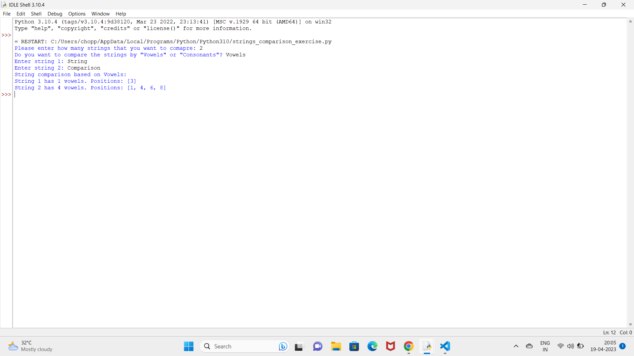

**Fig 1: The output of the string_comparison code**

Two strings were taken to comparison.Choosing whether to compare by vowels or consonants. If Vowels is selected then it will display how many vowels present in the string and their position(i.e, Indices

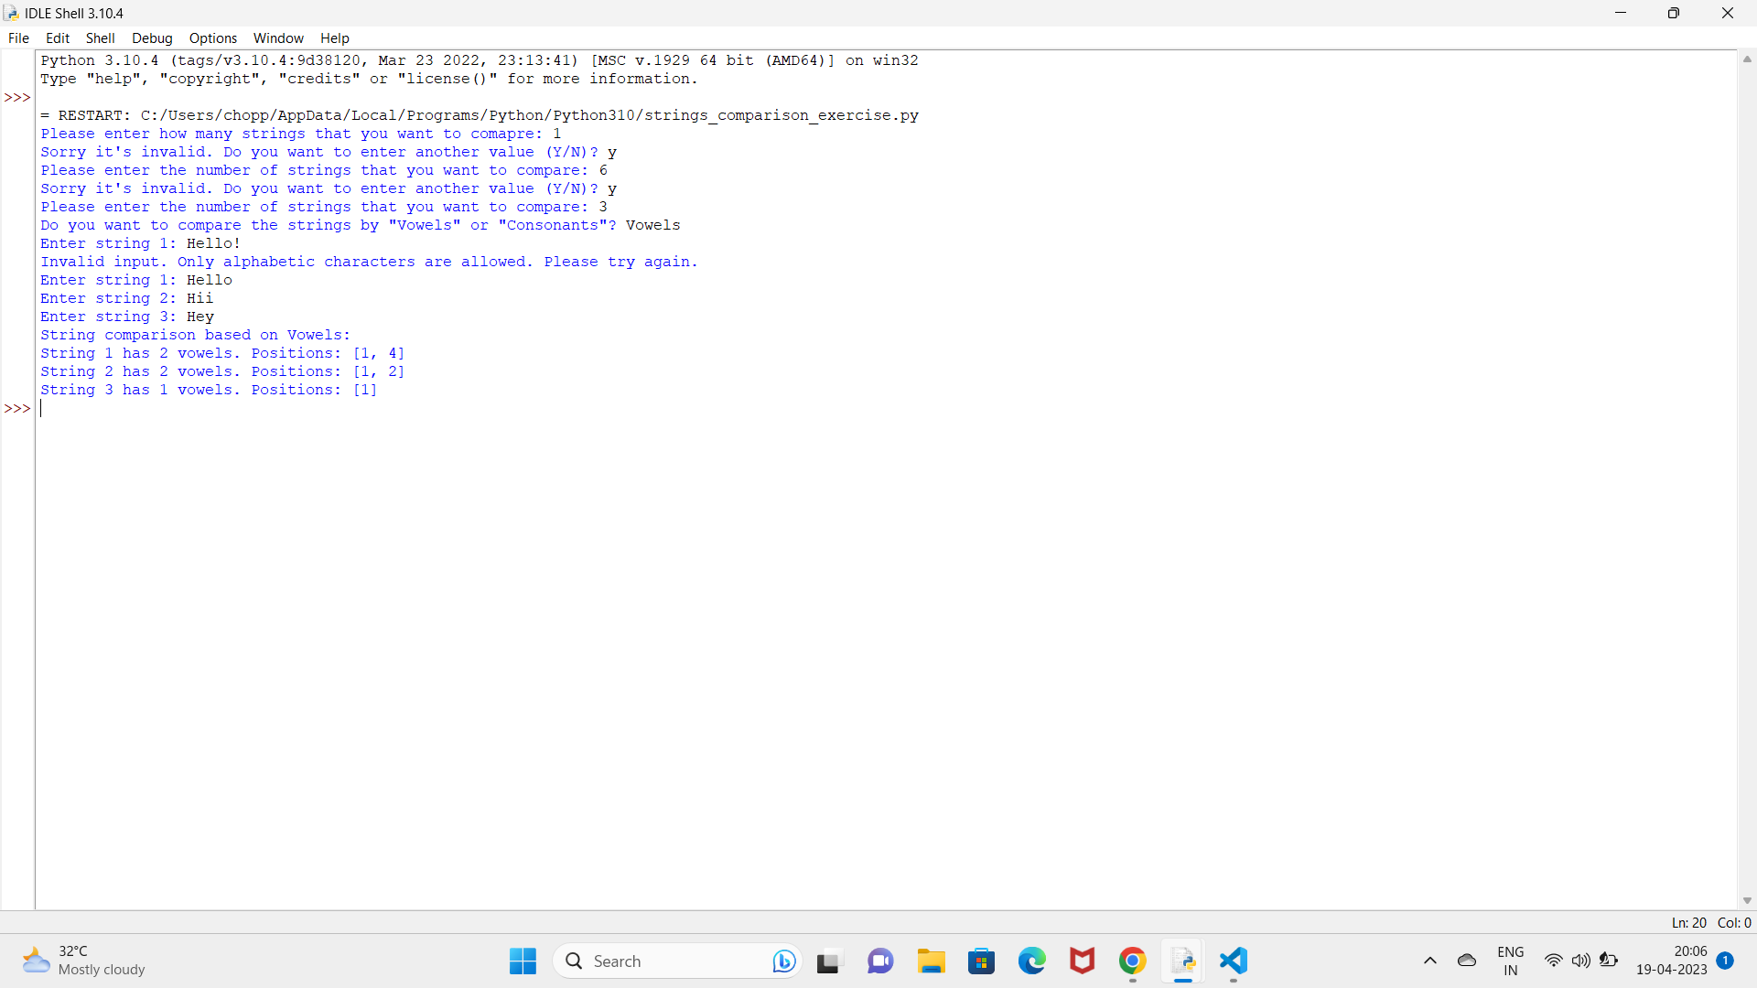**Fig 2 :Output of the code when other characters were given as input to compare.**

If string length is less than 2 and greater than 5 then it will display **“Sorry it’s invalid. Do you want to enter another value(y/n)”**While giving the input if any characters(!,@,$,*,_,-…) are given then it will display message like **”Only Alphabetic characters are allowed.Please try again.”**

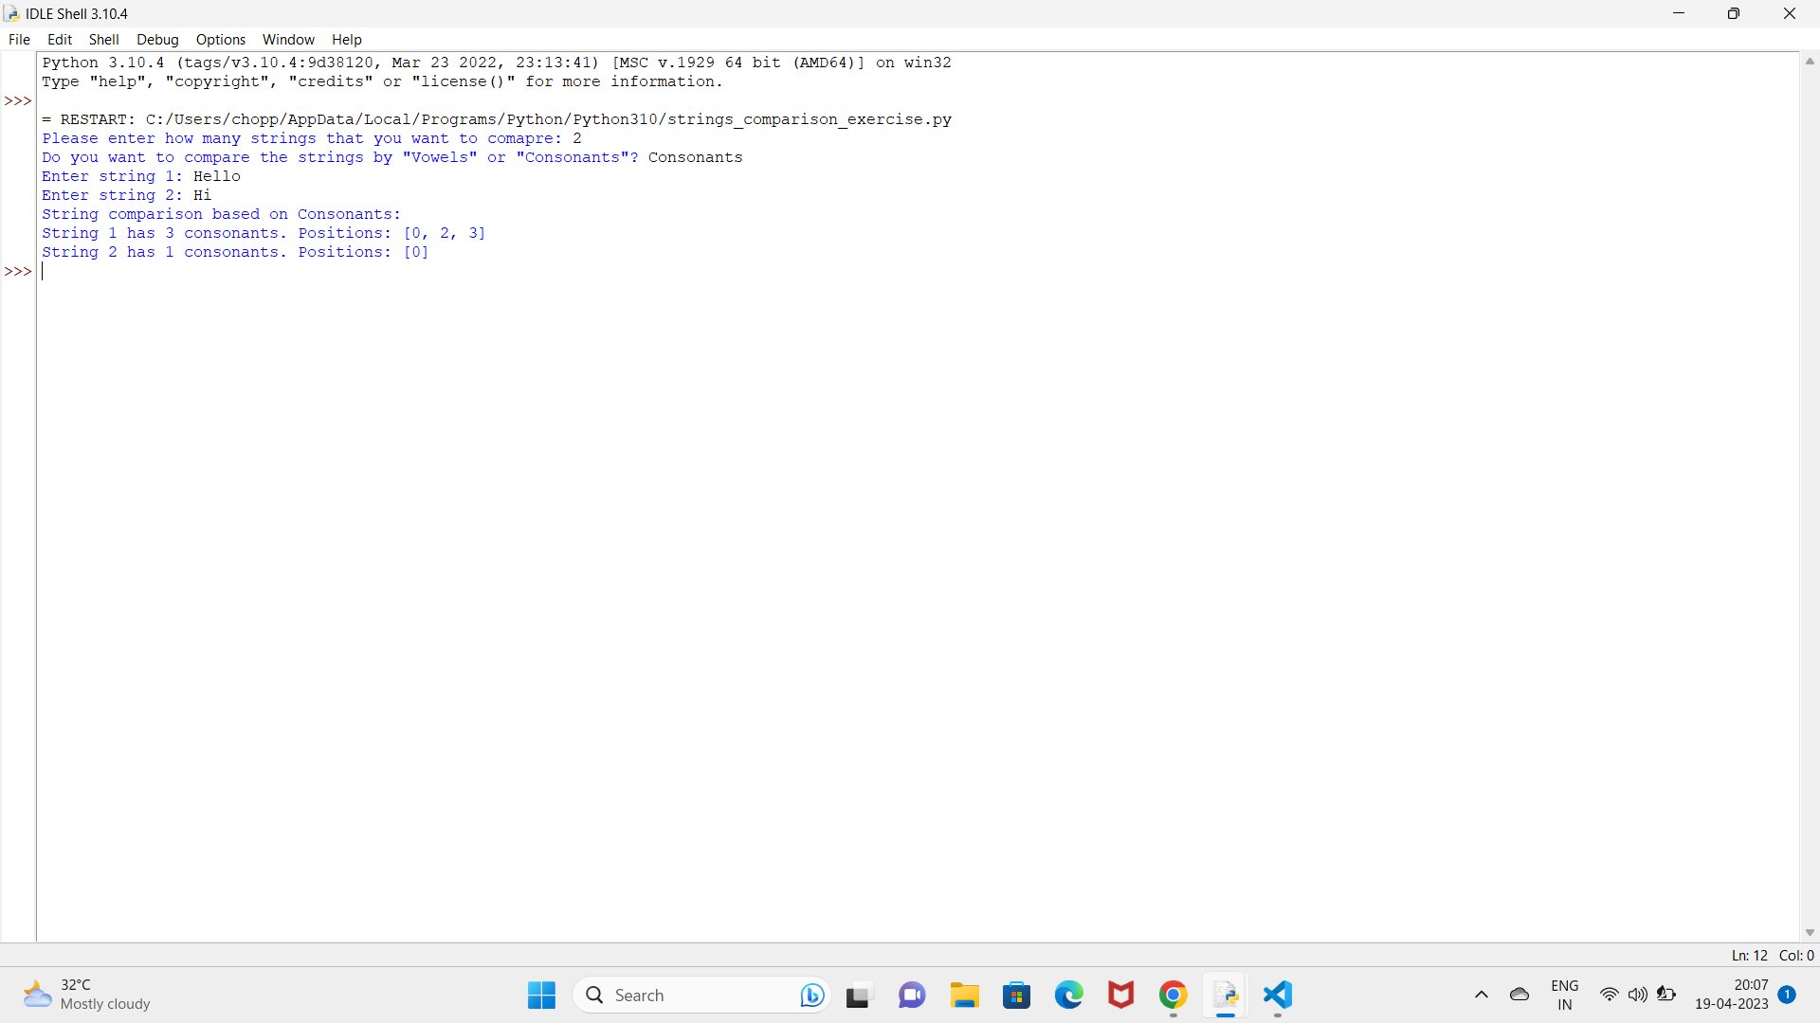

**Fig 3: Output of the code when consonants is taken to compare strings.**

Output of the code when strings are compared by consonants. It compares and displays the count of consonants and their position(i.e, indices).