AI DOCUMENT SEARCH (RAG)

Technologies Used:
Python
Streamlit
Pypdf
Sentence Transformers
ChromaDB
Ollama
RAG

Why it is Used?

Streamlit - interface
Pypdf – extract text from pdf
Sentence Transformers – convert text into embedding
ChromaDB – storing and searching doc embeddings
Ollama – communicate with our local AI model
RAG
Python-dotenv – manage environment variables

Architecture:
PDF PyPDF text chunks sentence Transformers embeddings chromaDB retrieval Ollama LLM Answer Streamlit UI

STEPS :

Step -1:
Create a folder
Name : AI _document_search
Open folder in VS Code
Step -2 :
Create a virtual environment
Command: python -m venv env
Where env is the name of the name of the environment
Activate the environment
Step -3:
For installing we will use “pip” – it means python’s package installer
Install all the libraries
Command: pip install streamlit pypdf chromadb sentence-transformers ollama
Why to install these many packges?
Because these libraries have their own dependencies
Now Install python-dotenv
Command: pip install python-dotenv
Verify the installation :
Command: pip list
Step – 4:
Installing ollama
Ollama: it allows us to run AI models locally on our computer/laptop instead of sending every question to an online AI API/

FLOW:
Pdf find relevant information send information to LLM Ollama + Llama generate answer

Why we are using Ollama ?
Normally , if we wanted an LLM in our application, we’d use an API such as:
App Internet AI API LLM Answer
With Ollama:
App Ollama LLM running on our Computer Answer

Download Ollama
Website: Download Ollama on Windows
Open a New Terminal:
After installation , close our existing VS Code terminal and open a new terminal
Why??
Because installing a program can update our windows environment variables (PATH) , and a new terminal ensures it sees the newly installed command.
Check Ollama installation :
Command : ollama –version
STEP -5:
Download and test the AI model
Downloading – Llama 3.2
Ollama is the software that runs AI models

Downloading the Llama 3.2
Open a new terminal
Command : ollama pull llama3.2
What is pull ?
It is similar to downloading a package
ollama pull llama3.2 find llama 3.2 download the model store it locally

Why are we downloading a model ?
Our chatbot needs an LLM to generate natural-language answers.
Check if the model exists:
Command: ollama list
This means – show me all the AI models currently installed in Ollama
Run the model:
Command: ollama run llama3.2
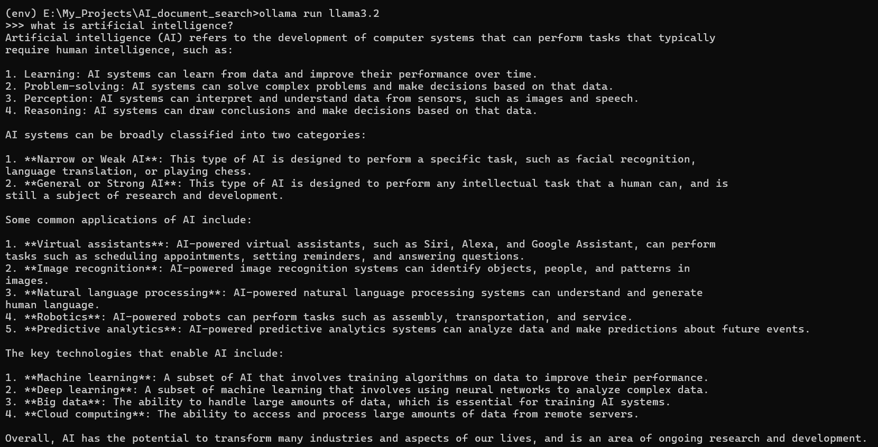

STEP – 6:
Create the project Structure

AI_document_search/
|
| env/
|
| data/
| documents/
|
| src/
|
| app.py
|
| requirements.txt

Why?

If we are putting everything into one python file:
That would become difficult to understand and maintain
Instead, we’ll separate responsibilities
PDF processing pdf_loader.py
Text chunking chunker.py
Embeddings embeddings.py
Vector database vector_store.py
RAG logic rag.py
User interface app.py
This is called separation of concerns
Create 3 folders –
- Data
- Inside data create documents
- Src

Why src?
Src stands for source
It’s a common convention for storing the application’s Python source code
Create app.py file
Why app.py?
This will be the main entry point of our application
When we run,
Command: streamlit run app.py
Streamlit will start our chatbot application
Flow: app.py Main application Connects all the components

Create requirements.txt file
What is requirements.txt?
This is a very useful file in python projects
It records the Python packages that the project needs
To install all the packages we used in the project, just run the command –
Command: pip install -r requirements.txt
This makes our project reproducible.

We don’t put env in Github .
Why?
Because env contains the installed Python environment and can become very large.
We’ll eventually create a .gitignore and add env/
So Git doesn’t upload it

STEP – 7:
Create requirements.txt
Add packages to the requirement.txt

streamlit
pypdf
chromadb
sentence-transformers
ollama
python-dotenv

and save it by using ctrl+S

requirements.txt is basically a list of the Python packages required to run our project

if we want to write every installed package and its exact version , including dependencies then
run this command: pip freeze > requirements.txt
that’s useful for reproducibility

STEP - 8 :
Add a PDF to the project

Upload any pdf in the documents floder and name it as sample.pdf

STEP -9 :
Read the PDF using Python
Goal : Take sample.pdf extracts its text remember which page text came from
What we are building?
We are creating :
Src/pdf_loader.py
This file will be responsible for loading PDF files and extracting their text.

Flow: sample.pdf pyPDF Extract text Page 1 -> text, page 2 -> text , …
Create a file in src
Name: pdf_loader.py
And add this code
from pypdf import PdfReader

def load_pdf(file_path):
reader = PdfReader(file_path)

pages = []

for page_number, page in enumerate(reader.pages):
text = page.extract_text()

if text:
pages.append({
"text": text,
"page": page_number + 1
})

return pages
Code explanation:
pdfReader -allows Python to open and read a PDF
load_pdf – load a PDF and return its pages and text
file_path – location of the PDF
reader=PdfReader(file_path) – open this PDF so Python can read its contents
enumerate() – gives us both position/number + item

TESTING :
Create a file in the main project folder
Name: test_pdf.py
And write this code
from src.pdf_loader import load_pdf

pages = load_pdf("data/documents/sample.pdf")

for page in pages:
print("PAGE:", page["page"])
print(page["text"][:500])
print("----------------")

Running command: python test_pdf.py

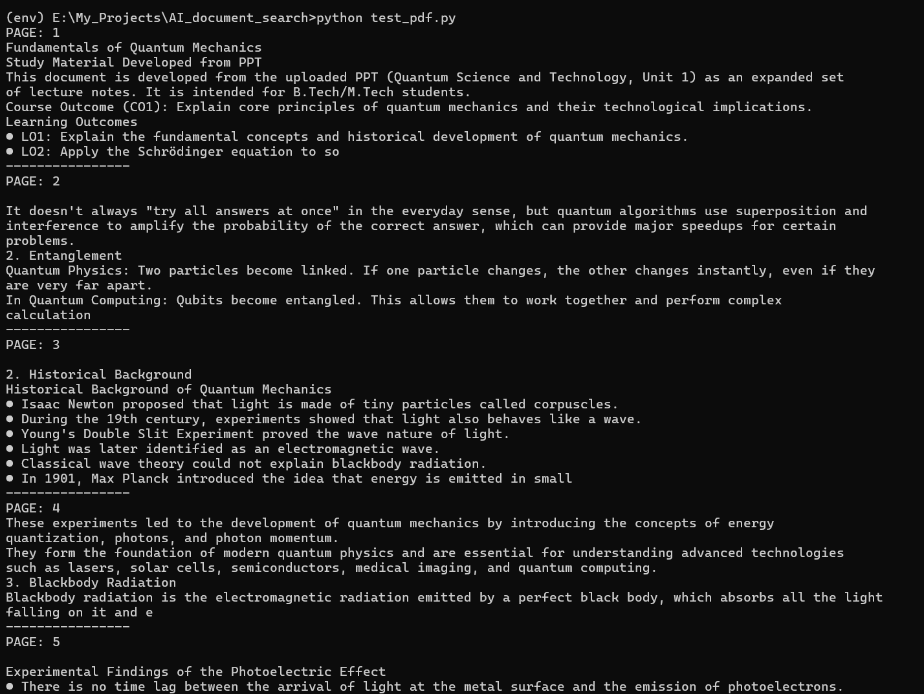

STEP -10:
Test PDF Extraction
Check test_pdf.py
Run the test
Command: python test_pdf.py

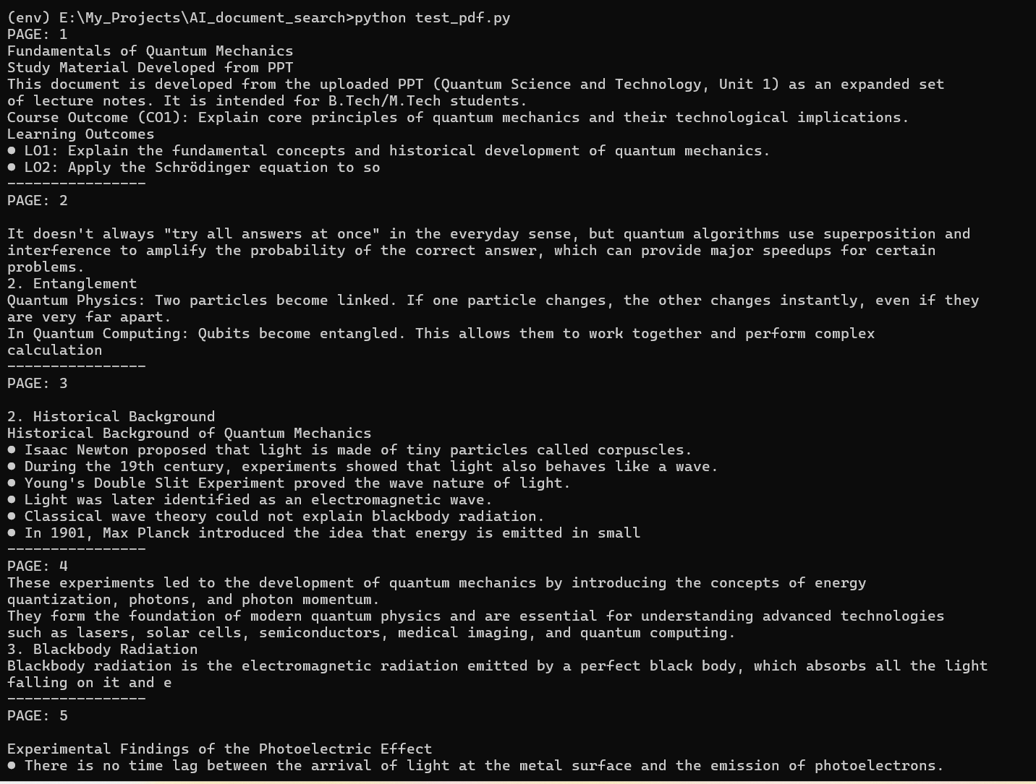
STEP – 11:
Text Chunking
A chunk is simply a smaller piece of text.
Create chunker.py in src folder
And write this code

def create_chunks(pages, chunk_size=500, overlap=50):
chunks = []

for page in pages:
text = page["text"]
page_number = page["page"]

start = 0

while start < len(text):
end = start + chunk_size

chunk_text = text[start:end]

chunks.append({
"text": chunk_text,
"page": page_number
})

start += chunk_size - overlap

return chunks

create a file named test_chunker.py in the project folder
and write this code
from src.pdf_loader import load_pdf
from src.chunker import create_chunks

pages = load_pdf("data/documents/sample.pdf")

chunks = create_chunks(pages)

print("Total pages:", len(pages))
print("Total chunks:", len(chunks))

for i, chunk in enumerate(chunks[:5]):
print("\nCHUNK:", i + 1)
print("PAGE:", chunk["page"])
print(chunk["text"])
print("----------------")

Run command: python test_chunker.py

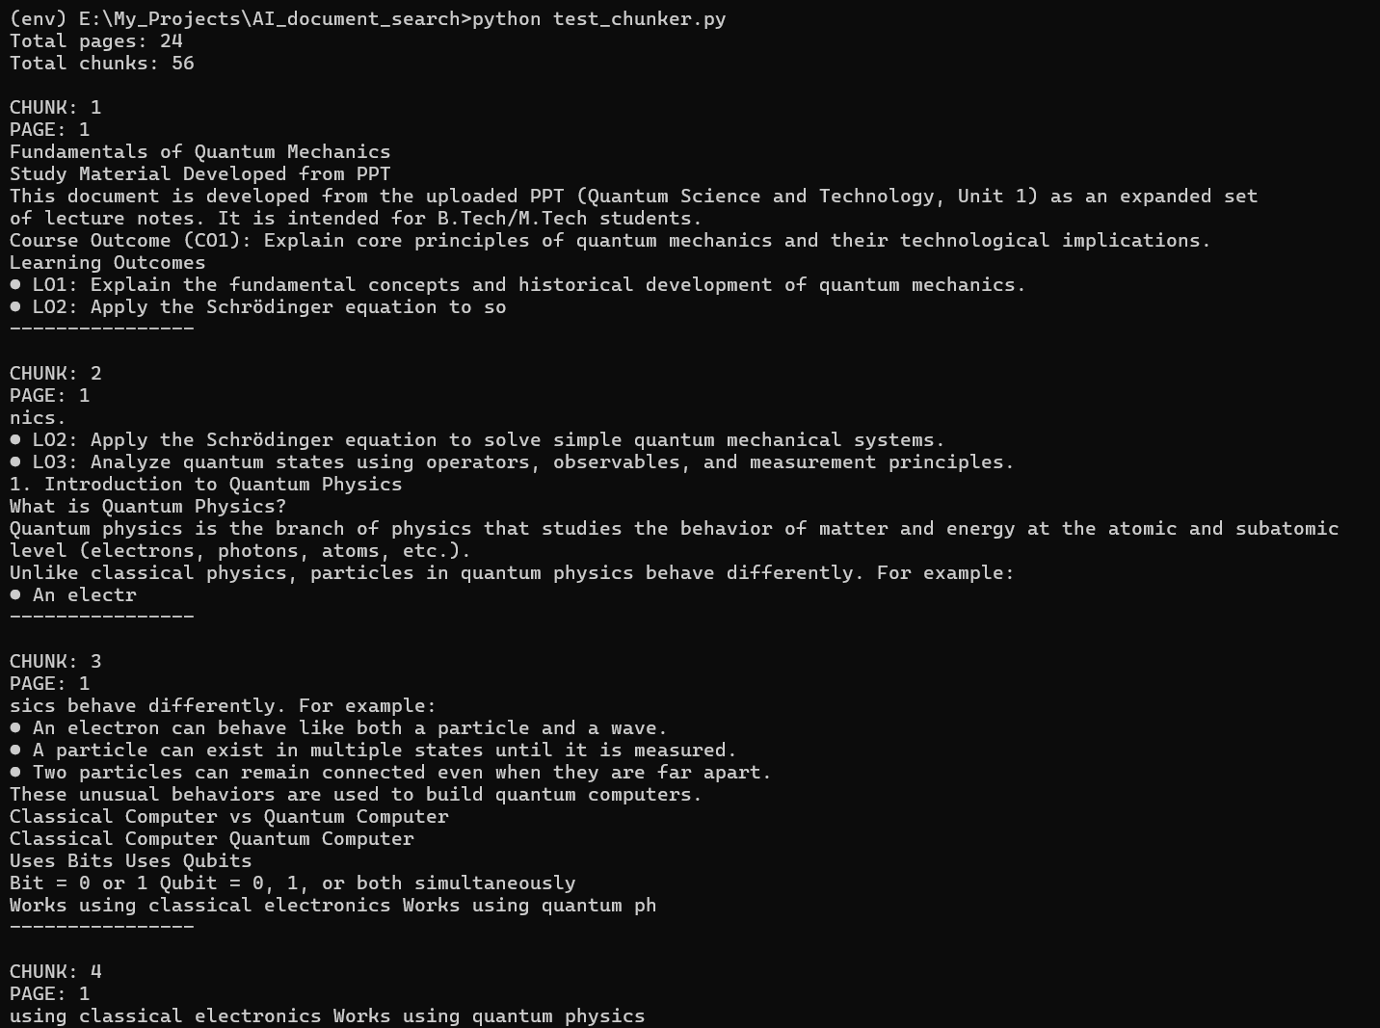
STEP – 12:
Create Embeddings
In src folder create a file named embeddings.py
And paste this code
from sentence_transformers import SentenceTransformer

model = SentenceTransformer("all-MiniLM-L6-v2")

def create_embeddings(texts):
embeddings = model.encode(texts)
return embeddings

test the embedding model:
in the main project folder create a file – test_embeddings.py
and paste this code
from src.embeddings import create_embeddings

texts = [
"What is machine learning?",
"Machine learning allows computers to learn from data.",
"The capital of France is Paris."
]

embeddings = create_embeddings(texts)

print("Number of texts:", len(texts))
print("Number of embeddings:", len(embeddings))
print("Embedding size:", len(embeddings[0]))
print("First embedding:")
print(embeddings[0])

and run the test
command: python test_embeddings.py
output:

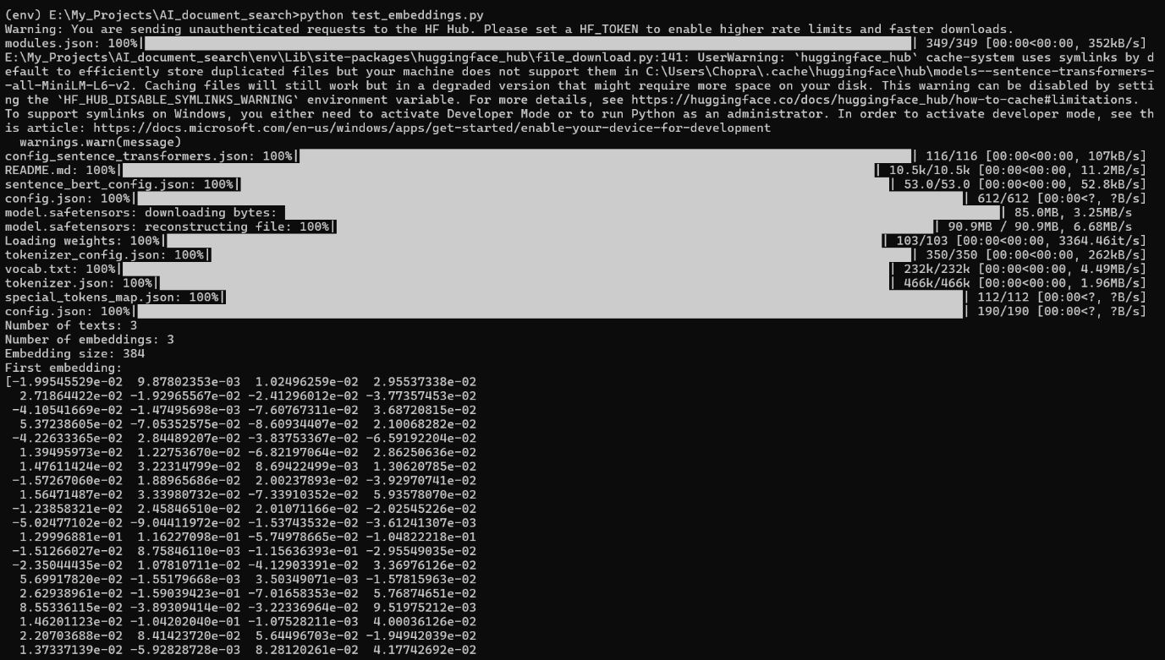
Embeddings: it allows us to convert document chunks and user queries into vectors so that we can find semantically similar information during retrieval.

STEP – 13:
Store embeddings in ChromaDB
ChromaDB is a vector database
It store those vectors along with the information they came from
Inside src folder create a file named vector_store.py
And paste this code
import chromadb

client = chromadb.PersistentClient(path="chroma_db")

collection = client.get_or_create_collection(
name="documents"
)

def add_documents(chunks, embeddings):
ids = []
documents = []
metadatas = []

for i, chunk in enumerate(chunks):
ids.append(str(i))
documents.append(chunk["text"])
metadatas.append({
"page": chunk["page"]
})

collection.add(
ids=ids,
documents=documents,
embeddings=embeddings.tolist(),
metadatas=metadatas
)

For testing create a file named test_vector_store.py in the main project folder and write this code
from src.pdf_loader import load_pdf
from src.chunker import create_chunks
from src.embeddings import create_embeddings
from src.vector_store import add_documents

pages = load_pdf("data/documents/sample.pdf")

chunks = create_chunks(pages)

texts = [chunk["text"] for chunk in chunks]

embeddings = create_embeddings(texts)

add_documents(chunks, embeddings)

print("Total pages:", len(pages))
print("Total chunks:", len(chunks))
print("Embeddings created:", len(embeddings))
print("Documents stored in ChromaDB successfully!")

run the test :
command: python test_vector_store.py
output:

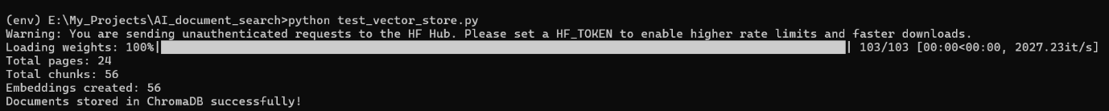
STEP – 14:
Question Answering

This is the actual RAG retrieval + question – answering part
RAG : Retrieval – Augmented Generation
- Retrieval – find the relevant information from our document
- Generation – give that information to Llama and ask it to generate an answer

Create a file in src folder names rag.py and write this code
import chromadb
from src.embeddings import create_embeddings
import ollama

client = chromadb.PersistentClient(path="chroma_db")

collection = client.get_or_create_collection(
name="documents"
)

def ask_question(question, n_results=3):

# 1. Convert the question into an embedding
question_embedding = create_embeddings([question])[0]

# 2. Search ChromaDB for similar chunks
results = collection.query(
query_embeddings=[question_embedding.tolist()],
n_results=n_results
)

# 3. Get the retrieved chunks
documents = results["documents"][0]
metadatas = results["metadatas"][0]

# 4. Combine the chunks into context
context = ""

for document, metadata in zip(documents, metadatas):
context += f"\nPage {metadata['page']}:\n{document}\n"

# 5. Create the prompt for Llama
prompt = f"""
You are a helpful document assistant.

Answer the question using only the information provided in the context.

If the answer is not present in the context, say:
"I could not find the answer in the document."

Context:
{context}

Question:
{question}

Answer:
"""

# 6. Send the prompt to Llama
response = ollama.chat(
model="llama3.2",
messages=[
{
"role": "user",
"content": prompt
}
]
)

answer = response["message"]["content"]

return answer, metadatas

Test our RAG system :
Create a new file in main project folder names test_rag.py and add this code

from src.rag import ask_question

question = "What is quantum mechanics?"

answer, sources = ask_question(question)

print("\nANSWER:")
print(answer)

print("\nSOURCE PAGES:")

for source in sources:
print("Page:", source["page"])

Run it:
Python test_rag.py

STEP – 15 :
Build the Streamlit.py

In the app.py file add this code

import streamlit as st

from src.rag import ask_question

# Page configuration
st.set_page_config(
page_title="AI Document Search",
page_icon="📚",
layout="centered"
)

# Title
st.title("📚 AI Document Search")

st.write(
"Ask questions about your document using AI."
)

# PDF uploader
uploaded_file = st.file_uploader(
"📄 Upload a PDF",
type=["pdf"]
)

# Question input
question = st.text_input(
"❓ Ask a question",
placeholder="What is quantum mechanics?"
)

# Ask button
if st.button("Ask"):

if not question:
st.warning("Please enter a question.")

else:
with st.spinner("Searching document and generating answer..."):

answer, sources = ask_question(question)

st.subheader("🤖 Answer")

st.write(answer)

st.subheader("📑 Sources")

for source in sources:
st.write(f"Page {source['page']}")

Run the application using the command
- streamlit run app.py

STEP – 16 :
Connect PDF Upload ChromaDB
Modify app.py file

import streamlit as st

from src.pdf_loader import load_pdf
from src.chunker import create_chunks
from src.embeddings import create_embeddings
from src.vector_store import add_documents
from src.rag import ask_question

# Page configuration
st.set_page_config(
page_title="AI Document Search",
page_icon="📚",
layout="centered"
)

# Title
st.title("📚 AI Document Search")

st.write(
"Upload a PDF and ask questions about its content using AI."
)

# PDF uploader
uploaded_file = st.file_uploader(
"📄 Upload a PDF",
type=["pdf"]
)

# Process uploaded PDF
if uploaded_file is not None:

with st.spinner("Processing your PDF..."):

# Save uploaded PDF temporarily
pdf_path = "data/documents/uploaded.pdf"

with open(pdf_path, "wb") as file:
file.write(uploaded_file.getbuffer())

# 1. Extract text from PDF
pages = load_pdf(pdf_path)

# 2. Split text into chunks
chunks = create_chunks(pages)

# 3. Create embeddings
texts = [chunk["text"] for chunk in chunks]

embeddings = create_embeddings(texts)

# 4. Store chunks and embeddings in ChromaDB
add_documents(chunks, embeddings)

st.success("✅ PDF processed successfully!")

# Question input
question = st.text_input(
"❓ Ask a question",
placeholder="What is quantum mechanics?"
)

# Ask button
if st.button("Ask"):

if not question:
st.warning("Please enter a question.")

elif uploaded_file is None:
st.warning("Please upload a PDF first.")

else:

with st.spinner(
"Searching document and generating answer..."
):

answer, sources = ask_question(question)

st.subheader("🤖 Answer")

st.write(answer)

st.subheader("📑 Sources")

for source in sources:
st.write(f"Page {source['page']}")

now again test it
command: streamlit run app.py

