Custom CSV Parser in Python

Submitted by: Konakalla Chopra Lakshmi Sathvika
Roll Number: 23A91A6127
Date: December 2025
Task Title:
Implement a Custom CSV Parser from Scratch in Python
GitHub Repository: https://github.com/Chopra-14/custom-csv-parser-python

Section 1: Detailed Documentation
In this part of the project, I mainly focused on understanding how a CSV reader and writer actually work under the hood instead of just using the built-in csv module. I first set up my project folder, created a virtual environment, and made all the required Python files so that everything stayed organised. After that, I started working on the reader logic by reading the file character by character and deciding what each character meant based on whether it was inside quotes or outside. Once the reader started working properly for different kinds of lines, I moved on to building the writer, where I made sure that fields with commas, quotes, or newlines were handled correctly by escaping and quoting them. After completing both reader and writer, I wrote a benchmark script to compare the performance of my custom implementation with Python’s csv module on a large test dataset. Finally, I tested everything multiple times, captured screenshots, and pushed the full project to GitHub as a complete solution.
- I created the main folder and files first.
I started by creating a separate folder for this task so that all my work stayed in one place. Inside that folder, I created files like custom_csv.py, benchmark.py, README.md, and requirements.txt so that the code, tests, and documentation were clearly separated.
- I set up a virtual environment to keep things clean.
I used python -m venv venv to create a virtual environment and then activated it. This helped me make sure that any Python packages or versions I used for this project would not interfere with other projects on my system.
- I wrote the reader class by reading characters one by one.
I began implementing CustomCsvReader so that it reads the file character by character instead of splitting by commas directly. This gave me full control over how each character should be treated, especially in tricky situations like quotes and newlines.
- I used a simple state idea to track quoted fields.
Inside the reader, I used a boolean flag (like in_quotes) to keep track of whether the current position is inside a quoted field or not. This helped the code decide if a comma should be treated as a separator between columns or just as a normal character inside a value.
- I handled commas inside quotes.
Normally, a comma means a new column, but if the comma appears inside double quotes, it is part of the data itself. I added logic so that when in_quotes is True, the reader does not split on commas and simply adds them to the current field value.
- I handled newline characters inside quotes.
Some CSV fields can spread across multiple lines when they are enclosed in quotes. I made sure that if the reader sees a newline while still inside quotes, it continues reading into the same field instead of treating it as the end of the row.
- I created the writer class to escape quotes properly.
For CustomCsvWriter, I wrote logic that goes through each field, converts it to a string, and checks if it contains quotes. If it does, it replaces each " with "" so that the quote is treated correctly by CSV readers and does not break the file format.
- I tested the code with different CSV samples.
After writing the reader and writer, I created different small CSV examples with commas, quotes, and newlines. I ran my custom reader on them and compared the results with Python’s csv.reader to make sure the output matched exactly.
- I built the benchmark script to compare performance.
I then wrote benchmark.py to generate a large dataset with 10,000 rows and 5 columns, and used timeit to measure how long it took for both the standard csv module and my custom reader/writer to read and write the file. This gave me a clear comparison of speed.
- I pushed everything to GitHub at the end.
Once I was satisfied with the functionality and the benchmark results, I staged all my files using git add ., created a commit with a meaningful message, and pushed the code to my GitHub repository. This completed the project and made it easy to share and submit.

Section 2: Challenges I Faced
This project had several parts where I struggled, especially while building the reader because CSV rules have many edge cases. Understanding how quoted fields behave and writing a state machine from scratch was not easy at first. Another challenge was handling newlines inside quotes because it required careful character-level thinking. Writing the benchmark also needed testing and debugging to ensure the results were accurate. But solving these issues helped me understand how parsing works on a deeper level. Understanding the actual CSV format beyond simple comma splitting.
- Handling cases where commas appear inside quoted fields.
- Managing escaped double quotes like "" without breaking the field.
- Dealing with newline characters that appear inside quotes instead of ending a row.
- Writing logic that works line by line without loading the whole file.
- Ensuring the reader stops and returns rows correctly using __next__.
- Formatting fields in the writer so that quotes and commas were handled safely.
- Testing different tricky CSV samples until everything matched the standard module.
- Creating the benchmark in a way that gave fair and consistent results.
- Maintaining code readability while handling many small conditions.

Section 3: What I Learned Technically
While doing this project, I learned a lot about file parsing, state machines, escaping rules, Python classes, iterators, and performance testing. I also understood how much work goes into something that seems simple like reading a CSV file. This project helped me build confidence in writing low-level logic and managing edge cases properly.
- How CSV formatting actually works following RFC 4180 rules.
- Building a state machine using simple booleans to control parsing flow.
- Writing efficient character-by-character parsing logic.
- Understanding when and why fields must be wrapped in quotes.
- How to escape internal quotes inside a field using "".
- Implementing custom iterators using __iter__ and __next__.
- Writing clean code using helper functions like _escape_field.
- Generating synthetic data for benchmarking purposes.
- Measuring performance using Python’s timeit module.
- Comparing pure Python code with built-in C-optimized modules.

Section 4: Technical Summary
This project involved building a complete CSV reader and writer from scratch using Python. The reader works as an iterator and processes the file character by character, while the writer escapes quotes and adds them when needed. The benchmark compares this implementation with Python’s csv module on a large dataset. The goal was not to be faster but to understand how CSV handling actually works internally. The reader uses a simple state mechanism.
- A reader class that streams CSV rows one at a time.
- A writer class that safely escapes and formats fields.
- Handling commas, quotes, escaped quotes, and newlines.
- Using a state machine to detect quoted fields.
- Processing files without loading them entirely into memory.
- Benchmarking reader and writer performance.
- Testing with multiple sample CSV formats.
- Following CSV rules described in RFC 4180.
- Using \r\n for correct CSV line endings.
- Documenting everything clearly in a README and DOCX.

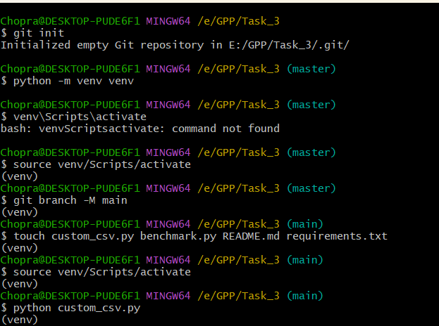
Section 5: Screen Shots
Screenshot 1: Git initialization and virtual environment setup.
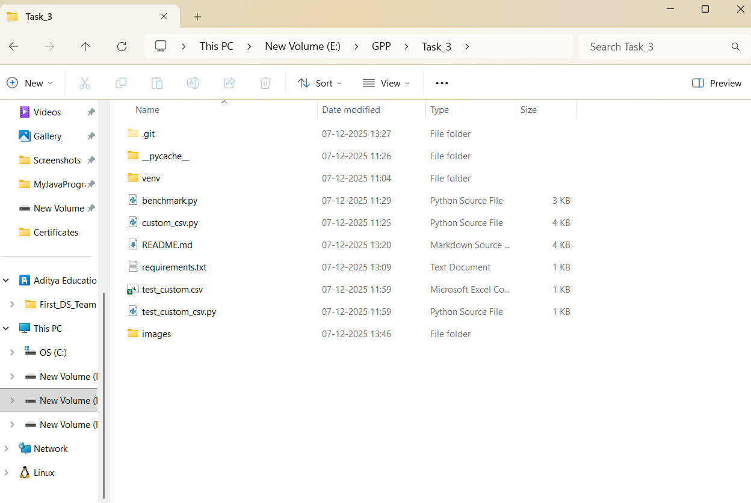

Screenshot 2: Project folder structure.

Screenshot 3: CustomCsvReader core parsing logic.
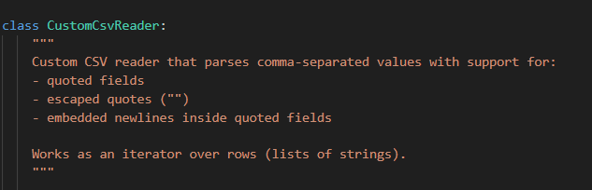
Screenshot 4: CustomCsvWriter class definition.
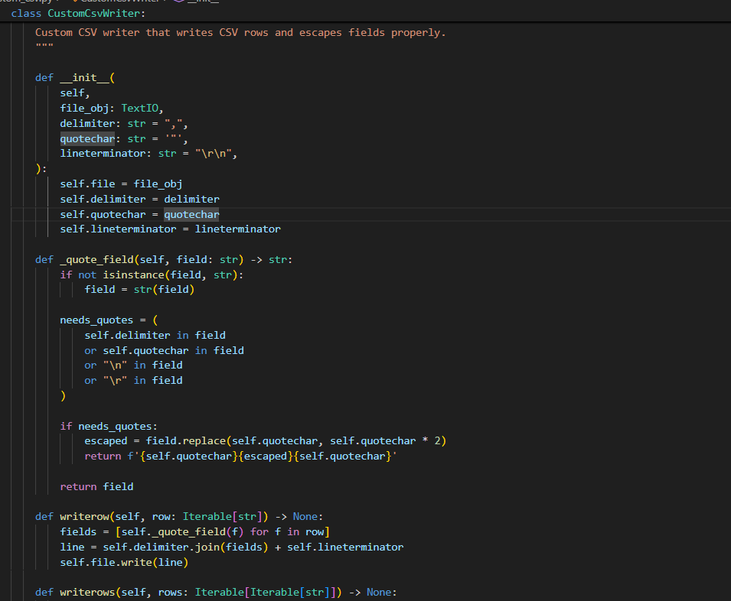
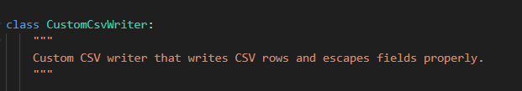
Screenshot 5: CustomCsvWriter escaping & quoting logic.
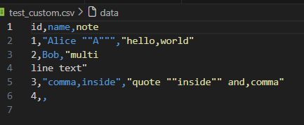
Screenshot 6: Sample test CSV file.
Screenshot 7: Reader output comparison with standard csv module.
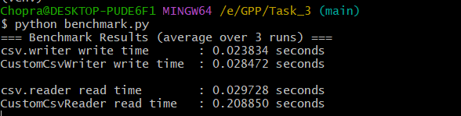

Screenshot 8: Benchmark results.

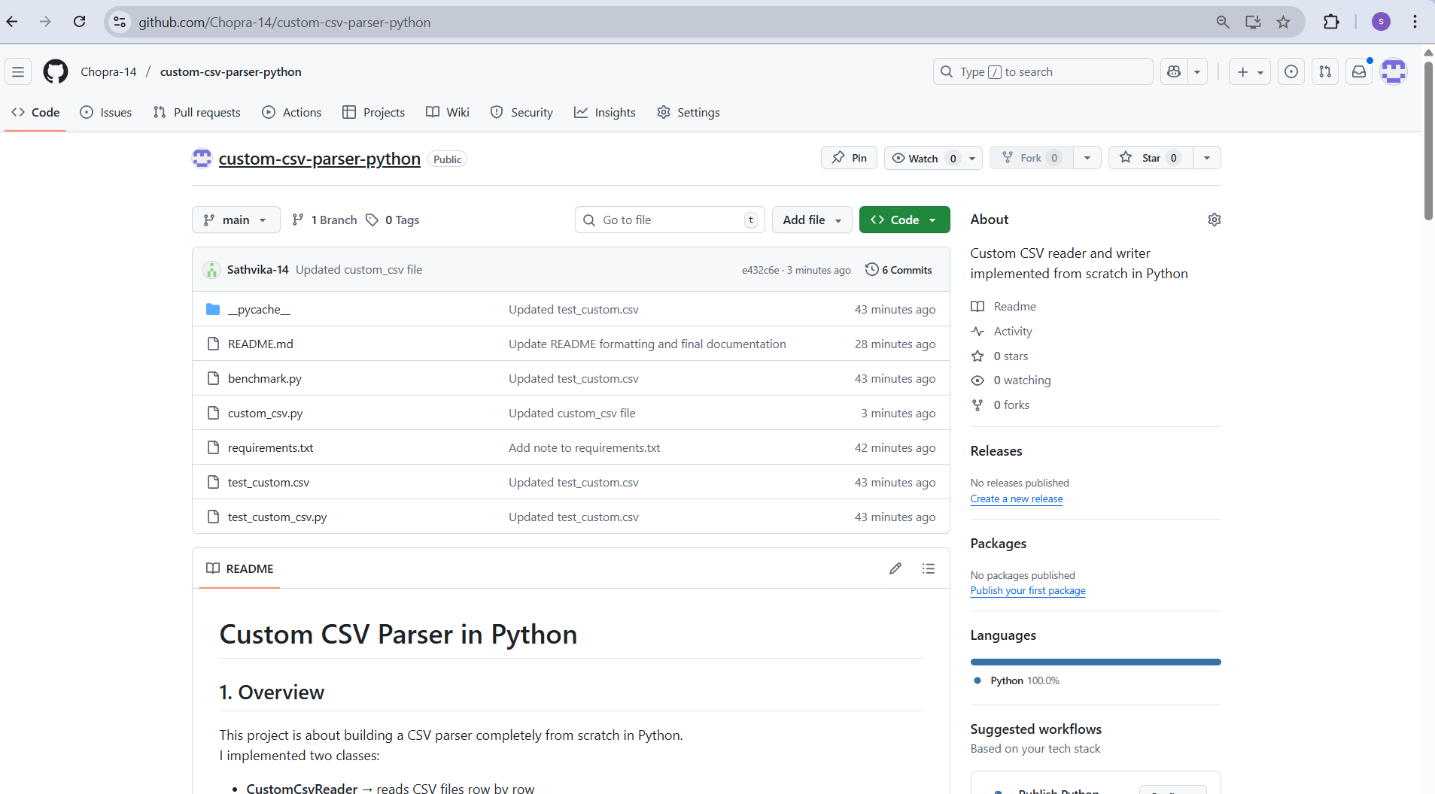

Screenshot 9: GitHub repository overview.

Section 6: Conclusion
Overall, this project helped me understand how CSV parsing works internally and made me appreciate the complexity behind simple-looking functions like csv.reader. I learned how to manage edge cases, write clean parsing logic, handle file streaming, and compare performance using benchmarks. Completing this project from scratch improved my confidence in Python and in understanding low-level data processing tasks.I understood the importance of careful parsing.
- I understood CSV rules in depth.
- I implemented a complete reader and writer manually.
- I handled multiple complex edge cases.
- I built a working state machine for parsing.
- I compared performance with the real csv module.
- I learned how to escape quotes properly.
- I improved my debugging and testing skills.
- I documented my project clearly.
- I pushed a clean and organized repository.
- I gained confidence in writing core logic from scratch.

