Business Template

Global Wardrobe



Content

Content 1
1 BUSINESS DESCRIPTION 2
1.1 BUSINESS BACKGROUND 2
1.2 PROBLEMS BECAUSE OF POOR DATA MANAGEMENT 2
1.3 BENEFITS FROM IMPLEMENTING A DATA WAREHOUSE 3
1.4 DATASETS DESCRIPTION 3
First Dataset: Local Sales (USA Market) 3
Second Dataset: International Sales (Global Market) 4
1.5 GRAIN / DIM / FACT 4
Task 2: BUSINESS TEMPLATE – Grain 5
4-Step Process: 5
Why This Grain Was Selected: 5
Fact Table 6
Time Table 7
Product Table 7
Buyer Table 7
Branch Table 8
Geography Table 8
Shipping Table (International Only) 9
2 BUSINESS LAYER 3NF 9
Model Photos 10
3 BUSINESS LAYER DIMENSIONAL MODEL 11
Fact Table: 11
Script 11
Defining Metrics: 12
Script of calculated measure 12
Metric/Description/Formula 12
4 LOGICAL SCHEME 13
5 DATA FLOW 13
6 FACT TABLE PARTITIONING STRATEGY 14

_{Confidential} 2
Introduction to DWH and ETL Business Template

1 BUSINESS DESCRIPTION

1.1 BUSINESS BACKGROUND
"Global Wardrobe" represents a dynamic retail enterprise specializing in clothing and accessories. The company strategically operates across the United States' domestic market and international territories, encompassing European and Asian regions. Its diverse product portfolio spans clothing lines, decorative ornaments, and complementary accessories, designed to satisfy varied consumer preferences and emerging fashion trends. Through analysis of sales data from multiple markets, the organization aims to optimize inventory management, refine pricing strategies, and elevate overall customer satisfaction.

1.2 PROBLEMS BECAUSE OF POOR DATA MANAGEMENT
Poor data management doesn’t let us do successful business because of Limited insights into the market. There are not any Inconsistent pricing strategies and Inadequate tracking of shipping types. Difficulty in understanding customer behavior, resulting in missed opportunities for targeted marketing.

1.3 BENEFITS FROM IMPLEMENTING A DATA WAREHOUSE
Data Warehouse Benefits for Global Wardrobe:
Comprehensive market insights, optimized cost tracking, advanced customer segmentation, precise revenue trend analysis, and centralized operational data management. This strategic implementation enables more informed decision-making, targeted marketing, and enhanced business performance across local and international markets.

1.4 DATASETS DESCRIPTION
US Sales Snapshot: Tracks domestic market performance.
Global Sales Overview: Captures international transactions with shipping specifics.
Distinct Characteristics:
- Local Data: Pinpoints Location and State within US boundaries.
- International Data: Captures Country, City, Shipping_Type, and Shipping_Cost.

Common Ground:
- Unified metrics across Product_ID, Buyer_ID, Sales_Price bridging local and global datasets.

First Dataset: Local Sales (USA Market)
The dataset contains information about sales within the United States, covering various cities and states.
- Product Information:
  - Product ID: Unique identifier for each product.
  - Product Category: The category of the product (e.g., Clothing, Ornaments, Accessories).
- Sales Information:
  - Order ID: Unique identifier for each order.
  - Order Date: The date when the order was placed.
  - Sales Price: The actual selling price of the product.
  - Revenue: The total income generated from the sale.
  - Product Cost: The cost of producing or sourcing the product.
  - Profit: Revenue minus product cost.
- Customer Information:
  - Buyer ID: Unique identifier for each buyer.
  - Buyer Gender: The gender of the buyer (Male or Female).
  - Buyer Age: The age of the buyer.
- Geographical Information:
  - Location: City where the order was placed.
  - State: State where the order was placed.
- Branch Information:
  - Branch ID: Unique identifier for each branch.
  - Branch Manager: Name of the branch manager.
- Supplier Information:
  - Supplier Name: The name of the supplier for the product.
  - Supplier Country: The country where the supplier is located.
  - Supplier Rating: The rating of the supplier (1 to 5 scale).

Second Dataset: International Sales (Global Market)
The dataset provides detailed information about sales across Europe and Asia.
- Product Information:
  - Product ID: Unique identifier for each product.
  - Product Category: The category of the product (e.g., Clothing, Ornaments, Accessories).
- Sales Information:
  - Order ID: Unique identifier for each order.
  - Order Date: The date when the order was placed.
  - Sales Price: The actual selling price of the product.
  - Revenue: The total income generated from the sale.
  - Product Cost: The cost of producing or sourcing the product.
  - Profit: Revenue minus product cost.
  - Shipping Type: Mode of shipping for the product (Air or Sea).
  - Shipping Cost: The cost of shipping the product.
- Customer Information:
  - Buyer ID: Unique identifier for each buyer.
  - Buyer Gender: The gender of the buyer (Male or Female).
  - Buyer Age: The age of the buyer.
- Geographical Information:
  - Country: The country where the order was placed.
  - City: The city where the order was placed.
- Branch Information:
  - Branch ID: Unique identifier for each branch.
  - Branch Manager: Name of the branch manager.
- Supplier Information:
  - Supplier Name: The name of the supplier for the product.
  - Supplier Country: The country where the supplier is located.
  - Supplier Rating: The rating of the supplier (1 to 5 scale).

1.5 GRAIN / DIM / FACT
Grain:
- The level of detail in the fact table:
  - One row per Order_ID, representing a single transaction.
Dimensions (DIM):
- Date Dimension: Contains details about Order_Date (e.g., year, month, day).
- Product Dimension: Includes Product_ID, Product_Category, and Product_Name.
- Customer Dimension: Includes Buyer_ID, Buyer_Gender, and Buyer_Age.
- Geography Dimension: Includes Location, State (Local), Country, City (International).
- Supplier Dimension: Includes Supplier_Name, Supplier_Country, and Supplier_Rating.
- Branch Dimension: Includes Branch_ID and Branch_Manager.
Fact Table:
- Sales_Price, Revenue, Product_Cost, Profit, and Shipping_Cost (for international).

Task 2: BUSINESS TEMPLATE – Grain
The local dataset captures US market sales, with each row representing a single product sale. It includes dimensions like Time (transaction date), Product (category, name, supplier), Buyer (age, gender), and Branch (ID, manager), along with financial facts such as Sales_Price, Revenue, Product_Cost, and Profit.
The international dataset focuses on global transactions, adding a Shipping Dimension (mode and cost) to similar dimensions and facts as the local dataset. Both datasets are granular, complete, and aligned with the project’s requirements for detailed analysis.

4-Step Process:
- Select a Business Process:

Tracking sales and profitability across local and international markets.
- This includes analyzing total revenue, profit margins, product costs, and shipping expenses.
- The dataset supports measuring sales performance by region, product category, and buyer behavior.
- Determine the Grain:
Each row in the fact table represents one per individual product sale transaction.
- Each row uniquely identifies an Order_ID combined with a Product_ID, ensuring accurate tracking of revenue and costs.
- Reason for this grain: This level of detail allows for maximum flexibility when aggregating data for different reporting needs.
- Identify the Dimensions:
- Time Dimension: Provides the date and time context for each sale.
- Product Dimension: Contains details about the product sold.
- Buyer Dimension: Includes demographic details about the buyer.
- Branch Dimension: Describes the branch handling the sale.
- Location Dimension: Provides geographical context (local vs. international).
- Identify the Facts:
- Sales_Price: Price at which the product was sold.
- Revenue: Total income generated.
- Product_Cost: Cost of producing/acquiring the product.
- Profit: Net profit from the sale.

Why This Grain Was Selected:
- Analytical Depth: Capturing data at the transaction level provides the most detailed insights for analysis
- Scalability: The grain aligns with future requirements for aggregating data across dimensions.
- Flexibility: high-level and detailed reporting

Fact Table
Measurable metrics for each transaction

Column name | Description | Data Type
Order_ID | Unique ID for each transaction | Int
Date_ID | Foreign key to the Time dimension | Int
Product_ID | Foreign key to the Product dimension | Int
Buyer_ID | Foreign key to the Buyer dimension | Int
Branch_ID | Foreign key to the Branch dimension | Int
Location_ID | Foreign key to the Geography dimension | Int
Shipping_ID | Foreign key to the Shipping dimension | Int
Sales_Price | Price at which the product was sold | Float
Revenue | Total revenue from the sale | Float
Product_Cost | Cost of acquiring/producing the product | Float
Profit | Net profit from the sale | Float
Shipping_Cost | Cost of shipping (if applicable) | Float

Example with filled data

Order_ID | Date_ID | Product_ID | Buyer_ID | Branch_ID | Location_ID | Sales_Price | Revenue | Product_Cost | Profit | Shipping_Cost
1 | 1 | 1 | 1 | 1 | 1 | 63.00 | 247.86 | 113.87 | 135.81 | 1000
2 | 2 | 2 | 2 | 2 | 2 | 30.15 | 207.41 | 74.90 | 38.98 | 1200

Time Table
Tracks temporal details of transactions
Column name | Description | Data Type
Date_ID | Unique ID for each date | Int
Order_Date | Date of the transaction | Text
Year | Year of the transaction | Int
Month | Month of the transaction | Int
Day | Day of the transaction | Int

Date_ID | Order_Date | Year | Month | Day
1 | 2022-01-01 | 2022 | 1 | 1
2 | 2022-01-02 | 2022 | 1 | 2

Product Table
Stores product-related details.
Column name | Description | Data Type
Product_ID | Unique ID for each product | Int
Product_Name | Name of the product | Text
Product_Category | Category of the product | Text
Supplier_Name | Name of the supplier | Text
Supplier_Country | Country of the supplier | Text

Product_ID | Product_Name | Product_Category | Supplier_Name | Supplier_Country
1 | T-Shirt | Clothing | Velvet Supply Co. | Germany
2 | Necklace | Ornaments | Urban Threads Inc. | India

Buyer Table
Contains buyer demographic information
Column name | Description | Data Type
Buyer_ID | Unique ID for each buyer | Int
Buyer_Gender | Gender of the buyer | Text
Buyer_Age | Age of the buyer | Int

Buyer_ID | Buyer_Gender | Buyer_Age
1 | Male | 35
2 | Female | 28

Branch Table
Provides details about the sales branch

Column name | Description | Data Type
Branch_ID | Unique ID for each branch | Int
Branch_Location | Location of the branch | Text
Branch_Manager | Name of the branch manager | Text

Branch_ID | Branch_Location | Branch_Manager
1 | Chicago | John
2 | Miami | Lisa

Geography Table
Stores geographic information for transactions

Column name | Description | Data Type
Location_ID | Unique ID for each location | Int
Country | Country of the transaction | Text
State | State of the transaction | Text
City | City of the transaction | Text

Location_ID | Country | State | City
1 | USA | IL | Chicago
2 | USA | FL | Miami

Shipping Table (International Only)
Tracks shipping-related details for international sales

Column name | Description | Data Type
Shipping_ID | Unique ID for each shipping entry | Int
Shipping_Type | Type of shipping | Text
Shipping_Cost | Cost of shipping | Float
Shipping_ID | Shipping_Type | Shipping_Cost
1 | Air | 5000.00
2 | Sea | 2000.00

2 BUSINESS LAYER 3NF
Step 1: Understanding Business Requirements
Analyze datasets to determine key business entities and their relationships.
Identify core business processes: sales transactions, supplier relationships, buyer demographics.
Define granularity: each row in a fact table = single sales transaction.
Step 2: Identifying and Normalizing Entities
Applied 3NF principles for data consistency and reduced redundancy:
CE_GEO: Stores unique geographical data.
CE_SUPPLIER: Stores supplier information.
CE_BUYER: Stores buyer data.
CE_BRANCH: Links sales branches to geographical data. (SCD1)
CE_PRODUCT_SCD: Tracks product attributes and history (SCD2).

Step 3: Primary & Foreign Keys
Each table includes:
Surrogate Keys: Unique identifiers (e.g., PRODUCT_ID, SUPPLIER_ID).
Natural Keys: Real-world identifiers (e.g., PRODUCT_SRC_ID, SUPPLIER_SRC_ID).
Example relationships:
SUPPLIER_ID links products to suppliers.
GEO_ID links branches to locations.
Step 4: Handling SCD2
The CE_PRODUCT_SCD table includes:
START_DT and END_DT: Track record validity periods.
IS_ACTIVE: Indicates current active record.
TA_INSERT_DT and TA_UPDATE_DT: Audit timestamps.
Ensures historical accuracy of product changes over time.
Step 5: Implementing SOURCE_TRIPLET for Data Lineage
SOURCE_SYSTEM, SOURCE_ENTITY, and SOURCE_ID ensure full traceability:
SOURCE_SYSTEM: Origin of the data (e.g., SA_LOCAL or SA_GLOBAL).
SOURCE_ENTITY: The staging table (e.g., SRC_LOCAL_SALES).
SOURCE_ID: The original natural key in the source system.

Model Photos

Old Model:
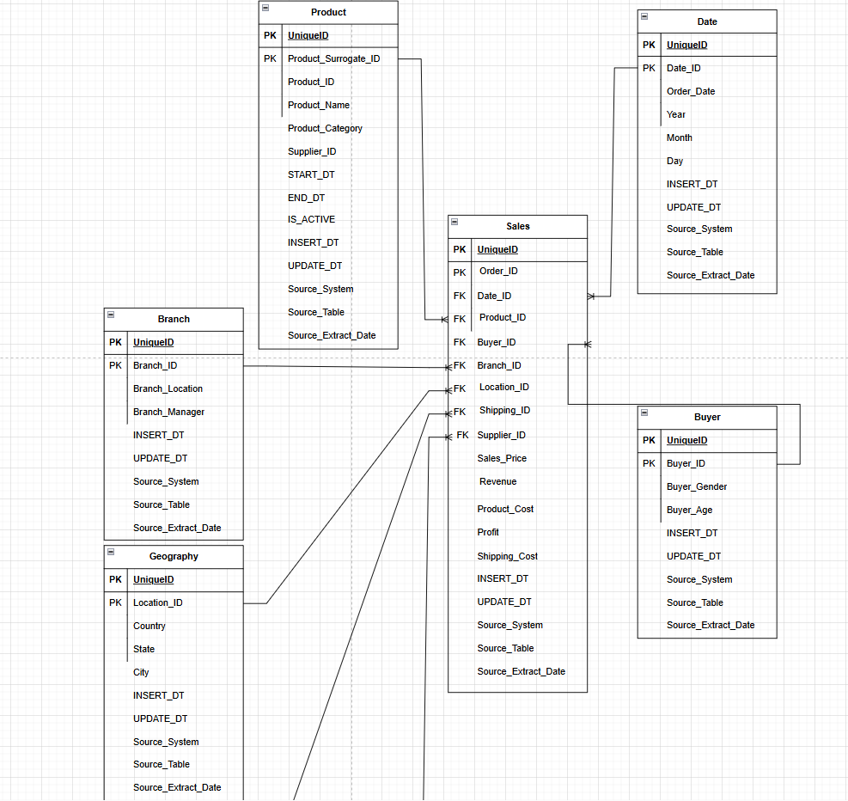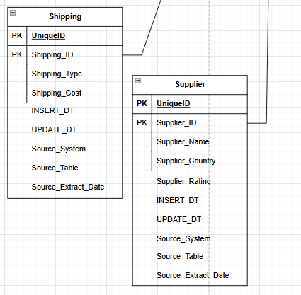

New Model Before Dimensional Model:
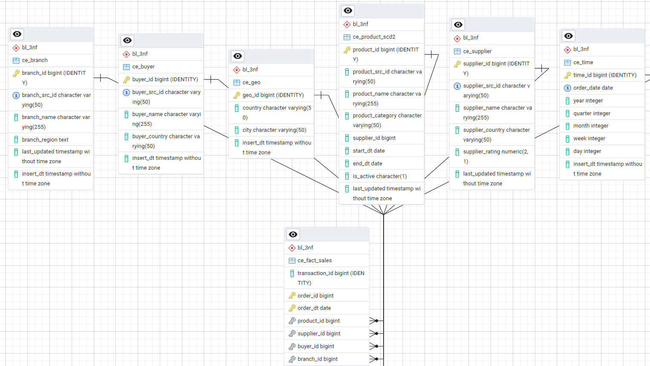

3 BUSINESS LAYER DIMENSIONAL MODEL

Fact Table:
- BL_DM.DWH_DIM_PRODUCT: Product details, SCD2 applied.
- BL_DM.DWH_DIM_SUPPLIER: Supplier details.
- BL_DM.DWH_DIM_BUYER: Buyer details.
- BL_DM.DWH_DIM_GEO: Geographic details.
- BL_DM.DWH_DIM_BRANCH: Stores branch details with GEO_ID.
- BL_DM.DWH_DIM_TIME: Stores transaction dates.
These IDs are surrogate IDs and if there is source ID like in Products, then there is both IDs.

Script Of Creation
- -- Geographic Dimension Table
- CREATE TABLE bl_dm.dwh_dim_geo (
- geo_id BIGINT PRIMARY KEY,
- country VARCHAR(50) NOT NULL DEFAULT 'N/A',
- city VARCHAR(50) NOT NULL DEFAULT 'N/A',
- insert_dt TIMESTAMP DEFAULT CURRENT_TIMESTAMP
- );

- -- Supplier Dimension Table
- CREATE TABLE bl_dm.dwh_dim_supplier (
- supplier_id BIGINT PRIMARY KEY,
- supplier_name VARCHAR(255) NOT NULL DEFAULT 'N/A',
- supplier_country VARCHAR(50) NOT NULL DEFAULT 'N/A',
- supplier_rating DECIMAL(2,1) CHECK (supplier_rating BETWEEN 1.0 AND 5.0) DEFAULT 0.0,
- insert_dt TIMESTAMP DEFAULT CURRENT_TIMESTAMP
- );

- -- Buyer Dimension Table
- CREATE TABLE bl_dm.dwh_dim_buyer (
- buyer_id BIGINT PRIMARY KEY,
- buyer_name VARCHAR(255) NOT NULL DEFAULT 'N/A',
- buyer_country VARCHAR(50) DEFAULT 'N/A',
- insert_dt TIMESTAMP DEFAULT CURRENT_TIMESTAMP
- );

- -- Branch Dimension Table (SCD1)
- CREATE TABLE bl_dm.dwh_dim_branch (
- branch_id BIGINT PRIMARY KEY,
- branch_name VARCHAR(255) NOT NULL DEFAULT 'N/A',
- branch_region TEXT NOT NULL DEFAULT 'N/A',
- insert_dt TIMESTAMP DEFAULT CURRENT_TIMESTAMP
- );

- -- ✅ Product Dimension Table (SCD2)
- CREATE TABLE bl_dm.dwh_dim_product (
- product_id BIGINT PRIMARY KEY,
- product_name VARCHAR(255) NOT NULL DEFAULT 'N/A',
- product_category VARCHAR(50) NOT NULL DEFAULT 'N/A',
- supplier_id BIGINT NOT NULL,
- insert_dt TIMESTAMP DEFAULT CURRENT_TIMESTAMP,
- FOREIGN KEY (supplier_id) REFERENCES bl_dm.dwh_dim_supplier(supplier_id)
- );

- -- Time Dimension Table
- CREATE TABLE bl_dm.dwh_dim_time (
- time_id BIGINT PRIMARY KEY,
- order_date DATE UNIQUE NOT NULL,
- year INT NOT NULL DEFAULT 2000,
- quarter INT NOT NULL DEFAULT 1,
- month INT NOT NULL DEFAULT 1,
- week INT NOT NULL DEFAULT 1,
- day INT NOT NULL DEFAULT 1,
- insert_dt TIMESTAMP DEFAULT CURRENT_TIMESTAMP
- );

- CREATE TABLE bl_dm.dwh_fact_sales (
- fact_id BIGINT GENERATED ALWAYS AS IDENTITY,
- order_id BIGINT NOT NULL,
- order_dt DATE NOT NULL,
- product_id BIGINT NOT NULL,
- supplier_id BIGINT NOT NULL,
- buyer_id BIGINT NOT NULL,
- branch_id BIGINT NOT NULL,
- geo_id BIGINT NOT NULL,
- time_id BIGINT NOT NULL,
- sales_price DECIMAL(10,2) NOT NULL DEFAULT 0.00,
- revenue DECIMAL(10,2) NOT NULL DEFAULT 0.00,
- product_cost DECIMAL(10,2) NOT NULL DEFAULT 0.00,
- profit DECIMAL(10,2) NOT NULL DEFAULT 0.00,
- insert_dt TIMESTAMP DEFAULT CURRENT_TIMESTAMP,
- source_system VARCHAR(50) NOT NULL DEFAULT 'N/A',
- source_entity VARCHAR(50) NOT NULL DEFAULT 'N/A',
- source_id VARCHAR(50) NOT NULL DEFAULT 'N/A',
- shipping_type TEXT DEFAULT 'N/A',
- shipping_cost DECIMAL(10,2) DEFAULT 0.00,
- PRIMARY KEY (order_id, order_dt),
- FOREIGN KEY (product_id) REFERENCES bl_dm.dwh_dim_product(product_id),
- FOREIGN KEY (supplier_id) REFERENCES bl_dm.dwh_dim_supplier(supplier_id),
- FOREIGN KEY (buyer_id) REFERENCES bl_dm.dwh_dim_buyer(buyer_id),
- FOREIGN KEY (branch_id) REFERENCES bl_dm.dwh_dim_branch(branch_id),
- FOREIGN KEY (geo_id) REFERENCES bl_dm.dwh_dim_geo(geo_id),
- FOREIGN KEY (time_id) REFERENCES bl_dm.dwh_dim_time(time_id)
- ) PARTITION BY RANGE (order_dt);

- CREATE MATERIALIZED VIEW IF NOT EXISTS bl_dm.mv_fact_sales AS
- SELECT
- order_id, order_dt, product_id, supplier_id, buyer_id, branch_id, geo_id, time_id,
- sales_price, revenue, product_cost, profit, shipping_type, shipping_cost, insert_dt,
- source_system, source_entity, source_id
- FROM bl_dm.dwh_fact_sales
- WHERE insert_dt >= (SELECT COALESCE(MAX(insert_dt), '1900-01-01') FROM bl_dm.dwh_fact_sales) - INTERVAL '1 day';

- CREATE UNIQUE INDEX IF NOT EXISTS idx_mv_fact_sales_unique
- ON bl_dm.mv_fact_sales (order_id, order_dt);

- CREATE INDEX IF NOT EXISTS idx_fact_sales_order ON bl_dm.dwh_fact_sales (order_id, order_dt);
- CREATE INDEX IF NOT EXISTS idx_ce_fact_sales_order ON bl_3nf.ce_fact_sales (order_id, order_dt);

Defining Metrics:
In the Fact Table Sales_Price, Revenue
Add one calculated metric to the Fact Table - Profit_Margin = Profit / Revenue

Script of calculated measure
- ALTER TABLE BL_DM.DWH_FACT_SALES DROP COLUMN PROFIT_MARGIN;
- ALTER TABLE BL_DM.DWH_FACT_SALES
- ADD COLUMN PROFIT_MARGIN NUMERIC(5,2);
- UPDATE BL_DM.DWH_FACT_SALES
- SET PROFIT_MARGIN = PROFIT / NULLIF(REVENUE, 0);

Metric/Description/Formula

Metric Name | Description | Formula/Definition
Sales_Price | The price at which the product was sold | Direct value
Revenue | Total revenue from the sale | Sales_Price * Quantity
Product_Cost | Cost of acquiring/producing the product | Direct value
Profit | Net profit from the sale | Revenue - Product_Cost
Profit_Margin | Percentage of profit relative to revenue | Profit / Revenue

4 LOGICAL SCHEME

Data Source
The data warehouse receives data from two primary sources:
- SRC_LOCAL_SALES: Raw sales transactions from local regions.
- SRC_INTERNATIONAL_SALES: Raw sales transactions from international regions.

Staging Area
The staging area serves several key purposes:

- Keeps raw data separate until it's cleaned up
- Gets rid of duplicate records
- Makes sure data formats match (consistent data types and naming)
- Provides a checkpoint to review data quality

Raw data can't go straight into 3NF tables because:

- 3NF needs clean, structured data
- Duplicates and broken references would mess up data integrity
- Tracking changes over time (SCD2) and applying business rules require processing the data first

Script for External Table/Deduplication
- -- Enable Foreign Data Wrapper for reading external CSV files
- CREATE EXTENSION IF NOT EXISTS file_fdw;

- -- Server for Local Sales CSV
- CREATE SERVER IF NOT EXISTS local_sales_server
- FOREIGN DATA WRAPPER file_fdw;

- -- Server for International Sales CSV
- CREATE SERVER IF NOT EXISTS global_sales_server
- FOREIGN DATA WRAPPER file_fdw;

- -- Source Table for Local Sales
- CREATE TABLE IF NOT EXISTS sa_local.src_local_sales (
- order_src_id INT PRIMARY KEY,
- order_dt DATE NOT NULL,
- location TEXT,
- state TEXT,
- product_src_id INT,
- product_category TEXT,
- supplier_name TEXT,
- supplier_country TEXT,
- supplier_rating DECIMAL(2,1),
- buyer_src_id INT,
- branch_src_id INT,
- sales_price DECIMAL(10,2),
- revenue DECIMAL(10,2),
- product_cost DECIMAL(10,2),
- profit DECIMAL(10,2),
- insert_dt TIMESTAMP DEFAULT NOW()
- );

- -- Incremental Load for Local Sales (Final Fixed Version)
- CREATE OR REPLACE PROCEDURE sa_local.incremental_load_local_sales()
- LANGUAGE plpgsql
- AS $$
- DECLARE
- v_last_order_date DATE;
- v_new_max_date DATE;
- v_inserted_count INT := 0;
- BEGIN
- -- Get last successfully loaded `order_dt`
- SELECT COALESCE(last_order_date, '1900-01-01') INTO v_last_order_date
- FROM bl_log.incremental_load_log
- WHERE table_name = 'sa_local.src_local_sales'
- FOR UPDATE;

- -- Insert Only New `order_dt` Values, Avoiding Duplicate `order_src_id`
- WITH inserted_data AS (
- INSERT INTO sa_local.src_local_sales
- SELECT DISTINCT ON (order_src_id) *
- FROM sa_local.ext_local_sales
- WHERE order_dt > v_last_order_date
- ON CONFLICT (order_src_id) DO UPDATE
- SET order_dt = EXCLUDED.order_dt -- Ensures updated order_dt is inserted
- RETURNING order_src_id
- )
- SELECT COUNT(*) INTO v_inserted_count FROM inserted_data;

- -- Update last order date only if new rows were inserted
- IF v_inserted_count > 0 THEN
- SELECT MAX(order_dt) INTO v_new_max_date FROM sa_local.src_local_sales;
- ELSE
- v_new_max_date := v_last_order_date;
- END IF;

- -- Update Log Table
- UPDATE bl_log.incremental_load_log
- SET last_order_date = v_new_max_date,
- inserted_rows = v_inserted_count,
- status = 'SUCCESS',
- error_message = NULL
- WHERE table_name = 'sa_local.src_local_sales';

- EXCEPTION
- WHEN OTHERS THEN
- -- Log Failure
- UPDATE bl_log.incremental_load_log
- SET status = 'FAILED', error_message = SQLERRM
- WHERE table_name = 'sa_local.src_local_sales';
- END;
- $$;

- -- Master Procedure to Execute Both Incremental Loads
- CREATE OR REPLACE PROCEDURE bl_log.master_incremental_load()
- LANGUAGE plpgsql
- AS $$
- BEGIN
- CALL sa_local.incremental_load_local_sales();
- CALL sa_global.incremental_load_international_sales();
- END;
- $$;
- -- Source Table for International Sales
- CREATE TABLE IF NOT EXISTS sa_global.src_international_sales (
- order_src_id INT PRIMARY KEY,
- order_dt DATE NOT NULL,
- country TEXT,
- city TEXT,
- product_src_id INT,
- product_category TEXT,
- supplier_name TEXT,
- supplier_country TEXT,
- supplier_rating DECIMAL(2,1),
- buyer_src_id INT,
- branch_src_id INT,
- sales_price DECIMAL(10,2),
- revenue DECIMAL(10,2),
- product_cost DECIMAL(10,2),
- profit DECIMAL(10,2),
- shipping_type TEXT,
- shipping_cost DECIMAL(10,2),
- insert_dt TIMESTAMP DEFAULT NOW()
- );

- -- Incremental Load for International Sales (Final Fixed Version)
- CREATE OR REPLACE PROCEDURE sa_global.incremental_load_international_sales()
- LANGUAGE plpgsql
- AS $$
- DECLARE
- v_last_order_date DATE;
- v_new_max_date DATE;
- v_inserted_count INT := 0;
- BEGIN
- -- Get last successfully loaded `order_dt`
- SELECT COALESCE(last_order_date, '1900-01-01') INTO v_last_order_date
- FROM bl_log.incremental_load_log
- WHERE table_name = 'sa_global.src_international_sales'
- FOR UPDATE;

- -- Insert Only New `order_dt` Values, Avoiding Duplicate `order_src_id`
- WITH inserted_data AS (
- INSERT INTO sa_global.src_international_sales
- SELECT DISTINCT ON (order_src_id) *
- FROM sa_global.ext_international_sales
- WHERE order_dt > v_last_order_date
- ON CONFLICT (order_src_id) DO UPDATE
- SET order_dt = EXCLUDED.order_dt -- Ensures updated order_dt is inserted
- RETURNING order_src_id
- )
- SELECT COUNT(*) INTO v_inserted_count FROM inserted_data;

- -- Update last order date only if new rows were inserted
- IF v_inserted_count > 0 THEN
- SELECT MAX(order_dt) INTO v_new_max_date FROM sa_global.src_international_sales;
- ELSE
- v_new_max_date := v_last_order_date;
- END IF;

- -- Update Log Table
- UPDATE bl_log.incremental_load_log
- SET last_order_date = v_new_max_date,
- inserted_rows = v_inserted_count,
- status = 'SUCCESS',
- error_message = NULL
- WHERE table_name = 'sa_global.src_international_sales';

- EXCEPTION
- WHEN OTHERS THEN
- -- Log Failure
- UPDATE bl_log.incremental_load_log
- SET status = 'FAILED', error_message = SQLERRM
- WHERE table_name = 'sa_global.src_international_sales';
- END;
- $$;

- -- Master Procedure to Execute Both Incremental Loads
- CREATE OR REPLACE PROCEDURE bl_log.master_incremental_load()
- LANGUAGE plpgsql
- AS $$
- BEGIN
- CALL sa_local.incremental_load_local_sales();
- CALL sa_global.incremental_load_international_sales();
- END;
- $$;

- -- Execute the Master Procedure
- CALL bl_log.master_incremental_load();

- -- Execute the Master Procedure
- CALL bl_log.master_incremental_load();

- DELETE FROM SA_LOCAL.SRC_LOCAL_SALES a
- WHERE EXISTS (
- SELECT 1 FROM SA_LOCAL.SRC_LOCAL_SALES b
- WHERE a.ORDER_SRC_ID = b.ORDER_SRC_ID
- AND a.ORDER_DT > b.ORDER_DT
- );

- DELETE FROM SA_GLOBAL.SRC_INTERNATIONAL_SALES a
- WHERE EXISTS (
- SELECT 1 FROM SA_GLOBAL.SRC_INTERNATIONAL_SALES b
- WHERE a.ORDER_SRC_ID = b.ORDER_SRC_ID
- AND a.ORDER_DT > b.ORDER_DT
- );

- -- Verify Deduplication

- SELECT ORDER_SRC_ID, COUNT(*)
- FROM SA_LOCAL.SRC_LOCAL_SALES
- GROUP BY ORDER_SRC_ID
- HAVING COUNT(*) > 1;

- SELECT ORDER_SRC_ID, COUNT(*)
- FROM SA_GLOBAL.SRC_INTERNATIONAL_SALES
- GROUP BY ORDER_SRC_ID
- HAVING COUNT(*) > 1;

3NF Relational Layer
The 3NF layer stores normalized data:
- Fact Table: CE_FACT_SALES
- Dimension Tables:
  - CE_GEO: Geographical data.
  - CE_SUPPLIER: Supplier details.
  - CE_BUYER: Buyer details.
  - CE_BRANCH: Branch information.
  - CE_PRODUCT_SCD: Slowly changing dimension for products.

Star Schema
The denormalized star schema for reporting
- Fact Table: DWH_FACT_SALES
- Dimension Tables:
  - DWH_DIM_PRODUCT
  - DWH_DIM_SUPPLIER
  - DWH_DIM_BUYER
  - DWH_DIM_GEO
  - DWH_DIM_TIME

ETL Process
- Extract: Data is pulled from source systems (SA_LOCAL and SA_GLOBAL).
- Transform: Staging tables clean, deduplicate, and standardize the data.
- Load: Data is normalized into 3NF tables and transformed into the star schema for reporting.

5 DATA FLOW

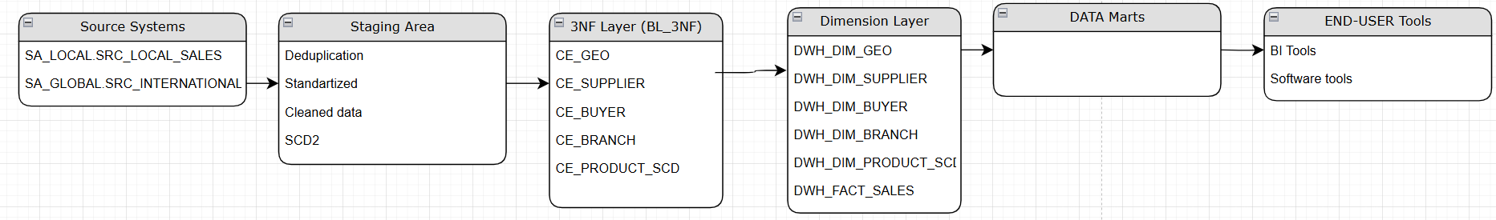

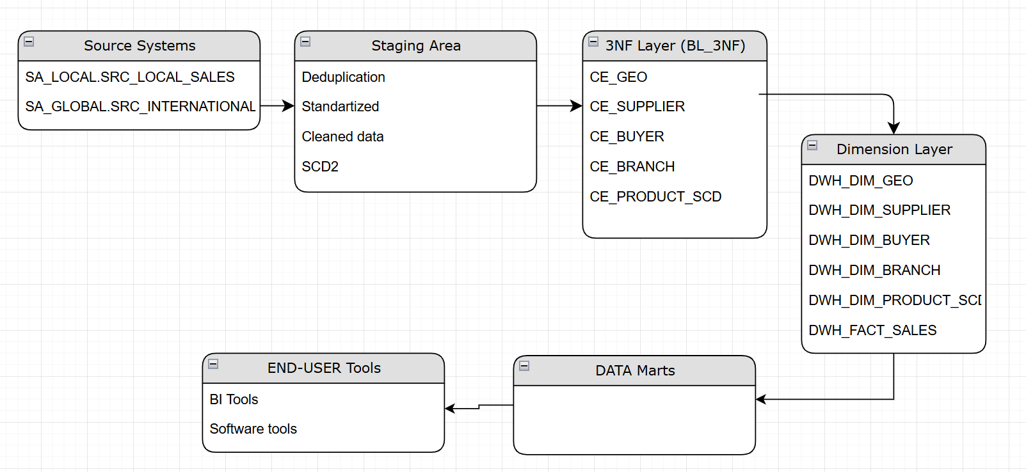

6 FACT TABLE PARTITIONING STRATEGY
Partitioning by Date:
- The fact table is partitioned based on the Order_Date, ensuring efficient data storage and retrieval. The partitioning strategy follows a three-month interval, meaning each partition contains data for a specific quarter.
  - Partition: dwh_fact_sales_2024_Q1 → Covers January to March 2024
  - Partition: dwh_fact_sales_2024_Q2 → Covers April to June 2024

Advantages:
- Improved Query Performance – Queries targeting a specific date range scan only relevant partitions.
- Faster Data Loading & Maintenance – Incremental loads and deletions operate on smaller partitions instead of the full table.
- Efficient Storage Management – Old partitions can be archived or dropped without affecting recent data.
So, This strategy optimizes the performance of analytical queries while maintaining scalability and manageability.

_{Confidential} 4

