3/23/2026 – 3/29/2026
OLED Display Visualization Progress Report
Timothy Kareng

3/22/2026
Brainstorm:
- Have a countdown appear on screen for when we play along
- A start button?
- Progress bar?
- Record circle pulser display?
- Aux port to hear the song while playing?
- Use a 2.42 inch oled LCD display

3/23/2026
Adafruit 5” 800x480 HDMI Backpack (+ AR1100 Touch Controller) PWM-able Backlight
- It has micro usb port and a hdmi port
- NOT really an OLED LCD display
- Acts more like a monitor than a screen that is programmable
- The display gets pretty hot after connecting the power straight from my laptop to screen
  - Maybe need a lower voltage power source
  - Backlight is PWM-able
    - So you can lower brightness
- If we do Jetson + HDMI display
  - This is easier for the display, but heavier for the overall system.
    - a Python app with a GUI toolkit such as PyQt or Tkinter
    - or a Fullscreen local webpage served by a small app
    - or a simple OpenCV / Pygame style visualization
  - Pros:
    - Not limited to the tools used to make a OLED display work
    - Directly connected to Jetson, so communication is local
    - Bigger display with more pixels with colors (not just 1 color)
    - Easier to debug
    - Could make companion app connect easier with hardware
  - Cons:
    - Probably needs more power
    - UI can be developed faster
    - Heavier
    - Could come with OS/software issues compared to a simple microcontroller
  - Concern: How easy will it be to connect a button/switch to the jetson so that we can switch modes and other options on our device?
    - NVIDIA’s jetson-gpio repo includes event detection and PWM samples, which is a good sign for straightforward input handling.
    - library specifically to read and control those pins with an API similar to Raspberry Pi GPIO.
    - Shouldn’t be a problem then
- If we do Microcontroller + OLED/LCD display
  - Pros:
    - Less power usage
    - Smaller and cheaper
    - Can use SPI and I2C
    - Less software complexity
  - Cons:
    - Microcontroller needs communication with Jetson to work
    - Will probably have to have a smaller UI design unless we find a bigger screen
    - Less room for graphics

Start Experimenting with the Display without the Jetson
- Use your computer as a stand-in for the Jetson
- Develop a fullscreen application prototype of the Chordsense UI
- Feed it some chords to re-enact how the user will see it
- Determine what should be on the UI, what buttons should be there
- Determine what looks good in a distance and what looks clear
- Use your keyboard to model the button pressing on the device itself
- Can use Python GUI to make the display
  - https://pyuibuilder.com/
  - Can I use rust with this?
    - Yes your can use the RUST GUI: egui

3/24/2026

Experimenting with RUST gui using eframe and egui
- I just have simple text to represent each mode
- Only concern is that when I use the keyboard button to change modes, I need to click the window to get the button to work
  - This shouldn’t be a problem with the jetson GPIO pins since they are directly communicating to software.
- Sense mode:

- Rt-sense mode:
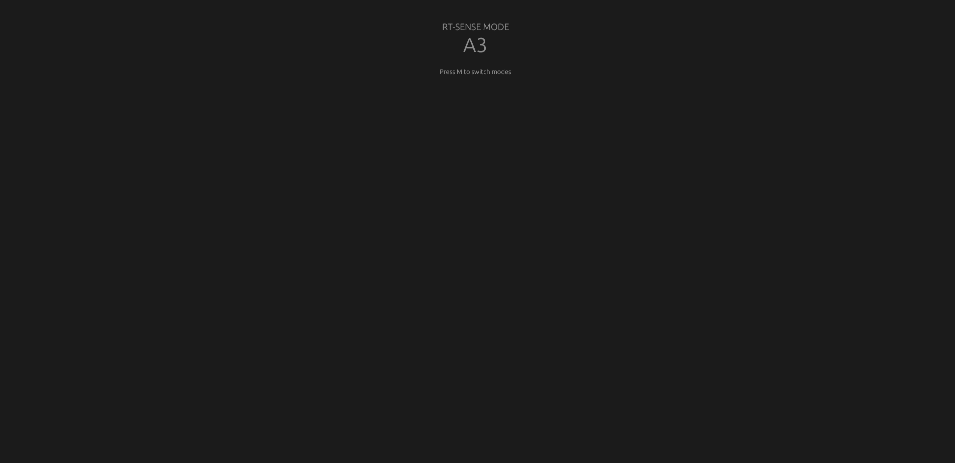
- Record mode:


