SID Factory II
User Manual

Last updated 2026-03-14

Editor coded by Thomas Egeskov Petersen
Mac version by Michel de Bree
ASID implementation by Thomas Jansson
Manual written by Jens-Christian Huus

Contents
Contents 2
Introduction 4
Noteworthy features 4
The Basics 5
Editor 5
Options 6
Tracks 6
Song list 8
Bookmarks 9
Visualizers 9
Tables 10
Commands 11
Instruments 11
Wave 12
Pulse 12
Filter 12
Arp 12
Init 12
HR 13
Tempo 13
Multiple songs 14
Changing drivers 14
Changing the settings 15
Converting 15
Packing 16
ASID 17
Controls 18
Startup 18
Files 18
Playing 18
Tracks 19
Order list 19
Sequences 20
Tables 20
Options 21
Song list 21
Bookmarks 21

Introduction
SID Factory II is a cross-platform music editor for editing SID music that can be played on a Commodore 64. The project was started by Thomas Egeskov Petersen (also known as Laxity) with the ambition of combining the emulation of MOS6510 code and SID sound with an editing environment that will provide close to full consistency between the work in progress and the final product.
It is the modern successor to the native C64 editor from 2006.
The editor has been compiled for Windows and Mac under GNU General Public License v2.
As a cross-platform editor, SID Factory II joins the fierce competition of other cross-platform editors such as GoatTracker 2 and CheeseCutter. SID Factory II works in much the same manner as these editors by using SDL and a text interface, hitting hotkeys for notes, and typing hexadecimal values for instruments, commands, and support tables.

Noteworthy features
If you are already quite familiar with the latest C64 editors, you may be wondering what is so special about SID Factory II. Here is what we consider unique about it.
- It packs the sequences in real time as you edit them. This means that what you hear is pretty much what you get. Less nasty surprises when packing the tune in the end.
- Because the sequences are packed in real time, they can be extremely long. The cap is currently 1024 rows, as long as the data in it can be packed below 256 bytes.
- The song list on the left side gives a strong overview of the sequences, with spaced distances to align everything correctly. You can also edit descriptions and copy ranges of sequences.
- The driver system is modular and there is already a wide selection of drivers available, some of which are designed to take up little memory while missing out on features.
- You can have up to eight different bookmarks, all defined and managed in the small table in the bottom left corner of the window.
- Multi-song support for making game tracks. You can loop songs and stop jingles. All songs share the same sequences and instruments.
- The standard driver 11 (loaded as you start the editor) features both 12-bit pulse and filter control as well as a separate arpeggio table for chords only.
- The colors of the editor and the key definitions used can be modified in a configuration file to fit how you want the editor to look as well as the keys you are most comfortable with.
- The editor can convert from MOD (Amiga), SNG (GoatTracker 2) and CT (CheeseCutter) when loading a tune as always
- You can use hardware that supports the ASID protocol (e.g. TherapSID or USBSID-Pico). Press F1 in the startup screen to select the MIDI device you wish to use.
- You can play on real SIDs with a USBSID-Pico board connected over USB, without MIDI. Every SID write is sent with its exact cycle timing, and you can use more than one board at the same time.
- Driver 11 also comes in versions for 2, 3 or 4 SID chips, with three tracks for every SID.
- The reSID emulation can play in stereo, with the panning of the SID file format v5, and packed tunes can be saved as SID v5 files.
Of course, the editor and its drivers also have all the modern features you would expect these days, such as table index hotkeys, muting channels, both instruments and commands at the same time, adjustable hard restart, pulse and filter programs, inserting the next unused sequence, and a whole lot more.

The Basics
Let us take you on a brief tour through the editor and show the areas. To make this easier, start out by loading a tune. Hit F10, enter the music folder, and open an SF2 file. (This is the file extension SID Factory II uses for its source tunes.)
TIP: When a confirmation dialog box pops up, you can also hit y or n to select.
SF2 files are actually PRG files in disguise. You can open e.g. the VICE emulator and drag-and-drop an SF2 file there. It even has a small interrupt driver. Just type SYS4093 and your source tune should play, showing the rastertime it uses.

Editor
You should now have returned to the editor with data all over the place. SID veterans may immediately recognize the order list and sequence tracks in the middle as well as the tables in the right side.
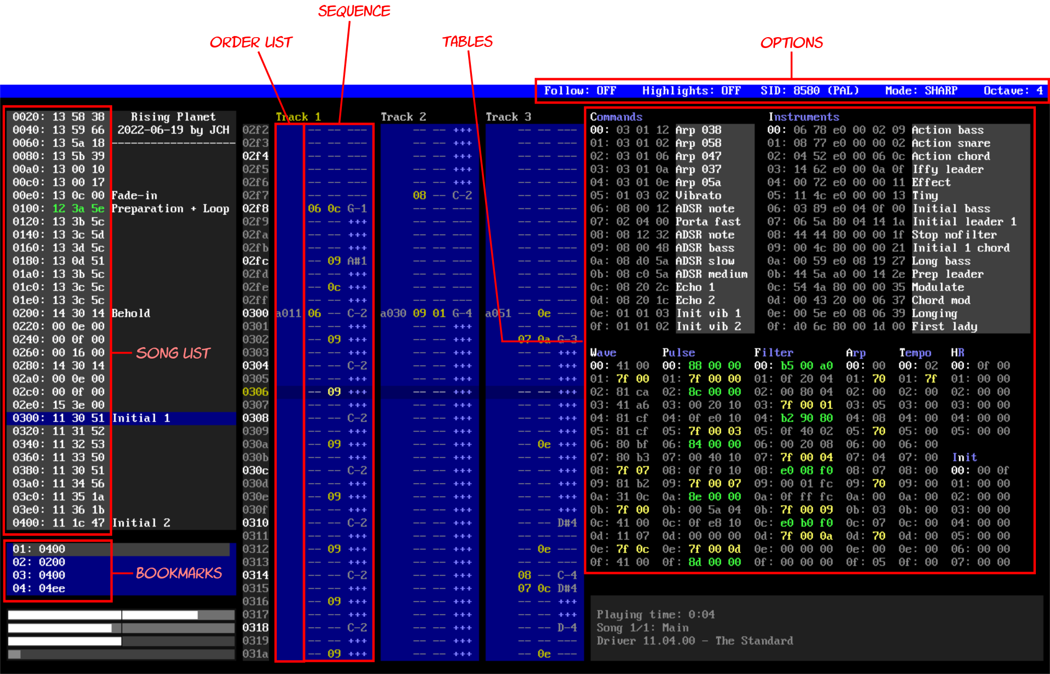

In the left side, the song list provides an overview of the entire song. It shows the sequences numbers, and you can even copy and paste a range. You can also use it to go to and play from specific locations.
Just below it, the bookmarks make it possible to add a marker that you can later go back to or even play from. You can have up to eight different bookmarks in a song.
Each of the three channels has an order list with transposition and sequence number, and the latter is then displayed as the sequence next to it. The sequence edits instruments, commands and notes.
The tables in the right side of the editor are tied to the driver version currently loaded. They may change their layout, sizes and meaning when another driver version is loaded. When starting SID Factory II, the default driver 11 is on the luxurious side with plenty of effects and commands available. If you hit the F12 key now, the window expands with a hotkey overlay that also explains these tables.

Options
There are a few option flags in the right side of the status bar in the top of the editor. Some of these have hotkeys, but most of them can be left-clicked too.
You can choose between the 6581 or 8580 SID chip, sharp or flat notes (e.g. D#4 or Eb4 shown in the sequence) and you can toggle Highlights on or off. The latter turns notes and values green in the sequence whenever the instrument or command matches what is selected in their tables.
TIP: You can also use F9 to toggle 6581/8580, and Shift+F9 to toggle PAL/NTSC.
The Output field shows where the music plays: reSID, ASID or USBSID. The Pan field shows where every SID plays in the stereo output of reSID (see Stereo below).

Tracks
The core of the editor is the three blue tracks for the SID voices. Click on any one and you can use the Enter key to toggle between the order list entry and its contents. The entry has the format XXYY, where XX is transpose and YY the sequence number. XX is usually A0 as the default. Type e.g. 94 for one octave lower, or AC for one octave higher.
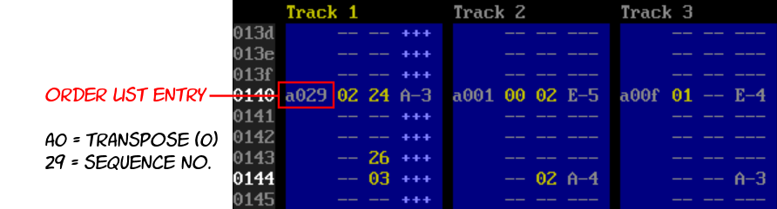
SID Factory II uses the same contiguous sequence stacking system as JCH’s original native C64 editor did. CheeseCutter also uses this. It means that all the sequences in each voice can be at various lengths independently from the neighbor tracks. The sequences are simply stacked on top of each other, like a game of perfect Tetris.
Only, the bottom sequences won’t magically disappear, of course.
The first column to the left is the instrument number, and the second is the command. You can also toggle tie note on or off with Shift+Enter. A ** in the instrument column indicates that the note is tied, which means that the effects of the note will not restart. This can be useful when using portamento.
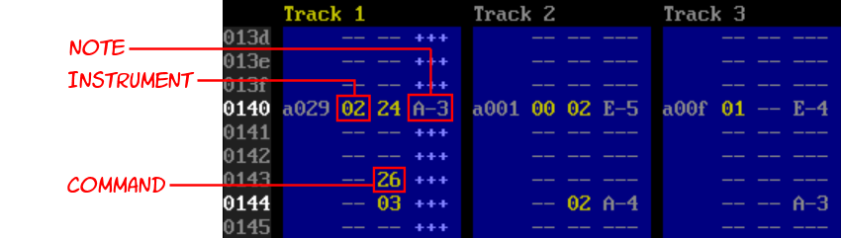
Notes are entered in the right-most column by hitting one of the many standard letter and number keys on the keyboard. They match the keys on a piano like this:
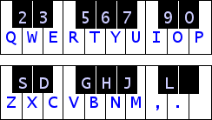
You can replace with --- (gate off) with Space or with +++ (gate on) with Shift+Space. SID Factory II thus adheres to the same gate on/off system that JCH’s C64 editor did. This is different from how GoatTracker and CheeseCutter handles it. The SID chip uses an ADSR envelope to control the amplitude of each voice. If there are +++ below the note, the amplitude is attacked, decayed and sustained. Changing to --- later releases it.
Using this gate system can sometimes be more work than the simpler gate off indicator used by most other modern C64 editors, but it does have its advantages. You have more control over continuous gating on and off during the lifetime of a note, and it’s visually logical.
TIP: You can “fill” upwards with Ctrl+Shift+Up, downwards with Ctrl+Shift+Down.
SID Factory II is normally silent as you type in notes. However, if you hold down Shift while typing the notes, you can hear the currently chosen instrument playing. This also temporarily stops all editing, making it suitable for quickly testing a melody or an instrument. If you want to be able to hear the instrument as you type in the notes, click the Caps Lock key first.
Use F3 to decrease the octave or F4 to increase the octave of the note you are typing. It is also possible to transpose all of the notes in the entire sequence directly. To transpose it one semitone, use Shift+F3 and Shift+F4; for one octave use Ctrl+F3 and Ctrl+F4 (Shift+Cmd+F3 and Shift+Cmd+F4 in macOS).
Deleting and inserting in a sequence moves the notes up or down, but it does not change the length of the sequence. If you want to do that too, you need to hold down Ctrl as well.
It’s also possible to mark and copy parts of a sequence. Simply hold down Shift and move up or down to start marking an area. You can even mark across boundaries, into another sequence. Hit Ctrl+C to copy the marked area, then move to another place (even in another track) and then hit Ctrl+V to overwrite the area. If you want to insert instead, hit Ctrl+Shift+V.
TIP: Hit F5 to prepare a new sequence with many lines, or Shift+F5 to insert lines.
Hit Enter again to return to the sequence number. You can also insert and delete here too, and you can hit Ctrl+F to insert the next unused sequence where old data is ignored. (If you want the next truly empty unused sequence, hit Ctrl+Shift+F instead.)
To mute and unmute channels, use Ctrl+1, Ctrl+2 or Ctrl+3. With a multi SID driver, use Ctrl+4 to Ctrl+9 and Ctrl+Shift+1 to Ctrl+Shift+3 for track 4 to 12.

Song list
While inserting and deleting sequence positions or inside the sequences themselves, you may have noticed that things changed in the gray box in the left side of the editor. This is the song list overview. It shows the same sequence numbers as in the tracks, only without the transpositions and contents. This condenses it down for a nice overview of the entire song.

You can click anywhere to browse a line up and down, home and end, or use page up/down. Clicking a line (or using Enter) will go to that spot in the song. Double-clicking (or using Ctrl+Enter) will go to that spot and play from there.
It’s also possible to copy and paste several sequences in a row. Hold down Shift and move the cursor to mark several sequences, copy with Ctrl+C, then paste the range elsewhere with Ctrl+V. This will always insert the range thereby making the order list longer.
NOTE: Left click an empty spot next to sequence numbers to edit a description.

Bookmarks
The small blue box towards the bottom left corner is the list of bookmarks.
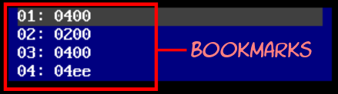
You can define up to eight different bookmarks in a song. Each bookmark is selected from Alt+1 to Alt+8. To set a bookmark, hit Ctrl+M anywhere in the song – even in the middle of sequences. The row number is added as the bookmark number. You can now return to that spot with Ctrl+G.
But more importantly, you can now also play from that spot with F2.

Visualizers
Below the box with bookmarks, in the bottom left corner, there’s a column of horizontal bars.

The top three bars with the same colors represent the pulse values. When the pulse registers of the SID chip are changed each frame, it produces pulsating and this is represented by these bars shrinking or growing as the music plays. Each of the three voices have their own individual pulse registers, and the width of each register is 12 bits, which is a range from 0 to 4095.
However, the pulsating is not unique all the way.
It sounds thinnest at 0 and becomes more pronounced as you approach halfway, i.e. 2048. Then, as the pulsating grows from 2049 to 4095, it diminishes again. It’s exactly as if you were going backwards from 2048 to 0. In other words, 0 and 4095, 10 and 4085, 1000 and 3095 all sound the same. This is the reason the bars have a center line. It indicates this is where the pulse is most pronounced.
The bottom (darker gray) bar shows the filtering of the SID chip. Its single register is 11 bits and goes from 0 to 2047. Unlike the pulse registers, it doesn’t repeat itself – all of the 2048 bits there are unique. Unfortunately, there is only one filter register for the entire SID chip, although you can at least control which voices you want to be affected by the filtering. In fact, this can be seen in the pulse bars.
The pulse bars represent voice one to three from top to bottom, and the background color of these bars change whenever filtering is turned on for that voice. Note that the filtering is not directly tied to the pulsating, it’s just a visual detail to help you know what voices are currently being filtered.
With a driver for more than one SID, there is a column of bars for every SID.
In the image above, you can see that the gray color of the bottom filter bar is visible as the background color on voice one and two. This indicates that those voices are currently filtered while the third is not. How to control this depends on the player. In the default player, you can turn it on and off for voices either in the filter table or by setting flags in the instrument table.
You can see where, when you press F12 to open the help overlay.
Observing the bars is not only useful when adjusting the pulse and filter programming of the player, it also makes it clear when the left or right boundary is crossed. If you’re composing for the older 6581 SID chip, crossing a boundary may produce an audible click. This is something you would want to avoid.

Tables
Each driver available to SID Factory II has a text file in a sub folder called documentation, explaining all the tables. You can also just hit F12 to open an overlay with this information.
Actually navigating the tables is as simple as using the cursor keys, tab across the tracks and tables, or clicking a table to enter that position in it. You can also page up/down or use the mouse wheel to scroll it. Numpad + and Numpad - changes the current instrument (Cmd+Up and Cmd+Down in macOS), and Ctrl+Numpad + and Ctrl+Numpad - the command (Shift+Cmd+Up and Shift+Cmd+Down in macOS).
TIP: First time you hit End (Fn+Right in macOS) it goes to the end of the used data.
You can edit the descriptions for individual commands and instruments. Simple hit Enter and edit it, then hit Enter again to accept, or Esc to undo your typing.
Some table bytes may have one or more bits for controlling minor details. For example, the standard driver 11 has a byte with flags in an instrument row. Normally you would have to add the bit values together in your head, like e.g. 80 and 40 is C0, but you don’t have to do that in SID Factory II. It has a bit selector built in. Just hit Shift+Enter on that value, and you can set the bits with the Space key as you cursor up and down. Then hit Enter to accept, or Esc to cancel.
You can use Ctrl+Enter to go to a table index pointer. This is used not only in instruments but also in commands. For example, the standard driver 11 has index pointers for pulse, filter and wave tables. Hit Ctrl+Enter on any of these to enter that spot in one of those tables. If a command also uses an index pointer to a table, Ctrl+Enter works there too.
SID Factory II is normally silent in the tables. However, if you hold down Shift while typing notes, you can hear the currently chosen instrument playing. This also temporarily stops all table input, making it suitable for quickly testing a melody or an instrument. You can repeatedly play the latest shifted note in the tables by pressing Space. If you use Ctrl+Space you will also apply the current command effect.

Commands
This is the table that is referred to from the middle numeric column in the sequences. Because of this it is not possible to insert and delete in it.
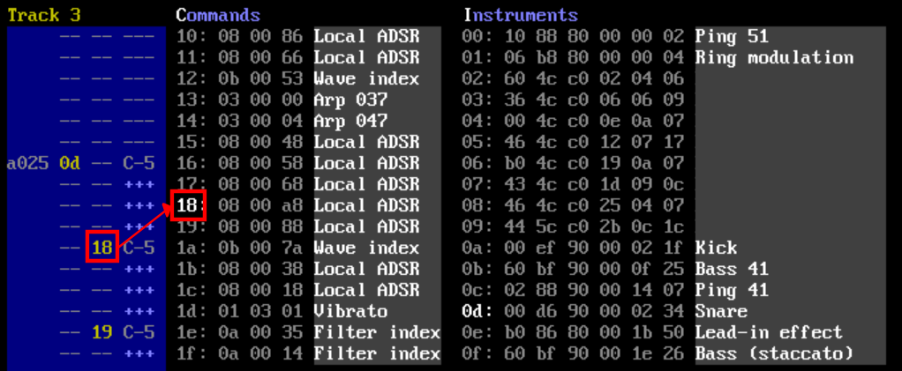
If you hit F12 to open an expanded overlay, you can see a list of the commands offered by the currently loaded driver. Look for the magenta color.

Instruments
The instruments are referred to from the left numeric column in the sequences – and just like with the commands, it is thus not possible to insert and delete in it.
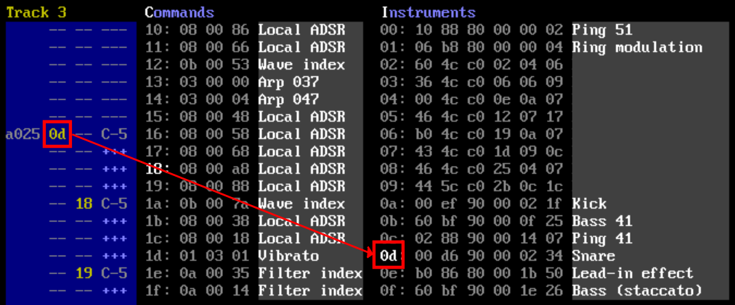
The number of bytes and their purpose depends on the currently loaded driver, but typically at least the ADSR can be edited here. If there are support tables for e.g. waveforms, pulse or filter, there may also be index pointer bytes to rows in them. As mentioned before, you can jump to a row in one of these tables by placing the cursor on the index pointer value and then hit Ctrl+Enter.

Wave
If the driver offers a wave table, it usually sets the waveform in the left column, and the semitones add value in the right. For example, 11 0c means use the triangle waveform and play it one octave higher than what the note in the sequence states. However, if you add 80 to the right value, it will be a static note chosen directly from the table of frequency values. This is great for e.g. drums.
A left value of 7f expects the right value to be an absolute pointer to a different row. For example, 7f 02 means that it should wrap back to the third row in the table.
The above rules are common but might change when a different driver is loaded.

Pulse
If the driver offers a pulse table, it is used to define the range and speeds of which the pulse travels to produce the swooping effects of waveform 41 as well as a few combined waveforms. Hit F12 to open an expanded overlay that explains the commands in this table. Look for the pink color.
In some drivers, a simpler pulsating effect is defined in one or two bytes in the instrument.

Filter
If the driver offers a filter table, it is also used to define the range and speeds. Unlike pulse, the filter in the SID chip is a global effect that can then be applied to one or more channels using a bit mask. This bit mask consists of three bits, for values 1, 2 and 4.
By combining these you can choose any combination of channels.
For example, 1+2 = 3 adds the filter effect to the first two channels, 4 only to the third channel, while 1+2+4 = 7 to all three channels. Typically, this bitmask is one of several settings in this table along with the filter cutoff start value and the resonance, but it depends on how the driver is written. Hit F12 to open an expanded overlay that explains the commands in the table. Look for the orange color.
Note that some of the drivers available don’t even have any filter capabilities at all.

Arp
Some drivers have an arpeggio table that is separate from the wave table. This is primarily used to make arpeggio chords, typically referred to from the command table. The values are added as semitones to the note in the sequence. A value in the command may even set the speed of the arpeggio. Hit F12 to open an expanded overlay that explains the table. Look for the green color.
In the default driver that loads when SID Factory II starts (driver 11) the arpeggio only affects the values in the wave table where semitone add values are set to 00. Other add values ignore the arpeggio.

Init
If the init table is present in the current driver, it points to a tempo table row and sets the main volume with 00 0f (the latter is the loudest volume possible in the SID chip). Multiple entries here are used for multi-songs. If you hit F12 to open the overlay, you can find its details in the box outlined in white.

HR
Most drivers utilize something called hard restart. In fact, most modern players on the C64 have some version of this technique. So, what is this?
The ADSR for each channel defines the Attack, Decay, Sustain and Release of a note. How it increases in volume and then decays to a steady level as long as the note is gated on, which corresponds to holding down a piano key. As soon as you gate off – release the piano key – the release fades out the note. The ASDR is typically defined in the instrument table and can also be changed with commands.
While ADSR is one of the best features of the SID chip, it is not perfect. If you were to, say, play a sequence full of smaller note durations, each kept gated on until the next note, then played it repeatedly without enabling hard restart in the instrument, you would probably hear the ADSR kind of stumble here and there. Of course, this depends on what values you put into the ADSR registers, and some values may also alleviate it, but it’s easy to keep running into this problem. The renowned C64 composer Martin Galway called this “the school band effect” which is as apt a description as any.
Hard restart was invented to defeat this ADSR bug.
The hard restart prevention works by gating off and resetting the ADSR values a few frames before the next note triggers. How to design hard restart in a player varies a lot depending on the creator, but in SID Factory II, most drivers that use it triggers the effect exactly two frames before. Say you trigger a note and keep it gated on with +++ rows for a few rows, adding up to a total of 15 frames. The note is first triggered with the ADSR defined in the instrument. After 13 of its 15 frames have passed, the hard restart takes over. It gates off and applies a different set of ADSR. Depending on this new set of ADSR, it may cut off the remainder of the note, making it sound a tiny bit staccato. However, this also stabilizes the ADSR and makes sure the next note always triggers perfectly. No more stumbling.
Defining this new ADSR is where the HR table comes in. In the default driver that loads when SID Factory II starts (driver 11) you can enable hard restart with a flag in the instrument and point to an ADSR value in the HR table. This is typically 0F 00 which brings the note down fast. There is usually no reason to change this, but as you become more proficient with composing, you may want to experiment. You can also leave it as is for most instruments and create a second ADSR set that you point to from another instrument. If you hit F12 to open the overlay, you can find the details in the cyan box with flags.

Tempo
If the current driver supports a tempo table, this is where the pace of the song is defined. In the default driver that loads when SID Factory II starts (driver 11) the accompanying init table points to it.
A value in the tempo table defines the number of frames one row (or the smallest possible note) in a sequence lasts. Frames is the fastest possible update of the driver and is typically 50 times a second on PAL and 60 times a second on NTSC.
Smaller values mean a faster tune. Depending on whether the driver uses hard restart and how this is set up, there may be a minimum value that works well with the driver. Usually this is 02, but if you are using a driver that doesn’t have hard restart (or uses a tight model of it) it may be smaller. The table won’t prevent you from trying small values, however, and sometimes they may work in a chain.
You may have a chain of tempo values until the wrap byte 7f restarts it. Every time the driver exhausts a tempo value, it will count down on the next one. This makes it possible to make funky shuffle rhythms or e.g. 2½ speeds. Sometimes it can also be handy to match the speed of a real song you’re covering.

Multiple songs
Press the F7 key at any time to show a dialog box where you can manage multiple songs. You can select, rename, move, add, or delete songs. This is especially useful when making music for a game.
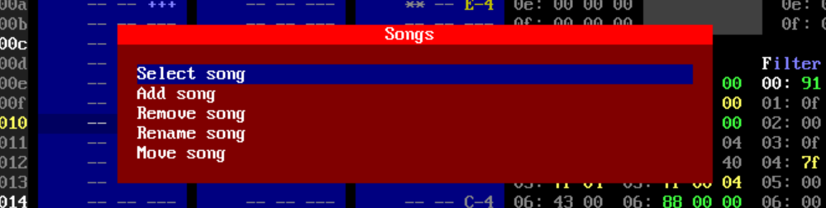
After having selected a song, the gray information box in the bottom right corner should show you what is currently being edited.
Individual songs have their own bookmarks, and you can set a different speed and volume in the Init table. However, all songs do share the same sequences and table data.
The end of a song can have a loop (the default) or an end marker. With the cursor on the loop marker, you can change it to end by hitting Ctrl+L. Hit it again to toggle back to loop with the loop point set to the beginning of the song. You can also just set a loop point somewhere earlier with Ctrl+L too.

Changing drivers
Starting from scratch with a different driver is as simple as hitting F10, browsing to the folder with drivers (you can go back to a parent folder with Backspace) and loading it.
Loading a different driver will change the layout of tables on the right side of the window. Different drivers have different capabilities. Some have much fewer tables but make up for it by being tiny.
TIP: To study the rastertime, drag-and-drop an SF2 file into VICE and type SYS4093.
In each build archive, there is a sub folder called documentation where the details of each driver are listed and what the values in each table mean. You can also just hit F12 to open an overlay.
Currently, the following drivers are available for SID Factory II:
- Driver 11 – this is the standard driver loaded as the default. It is the luxury driver with the most features and table data.
- Driver 12 – this is an extremely simple driver that can only do the most basic effects.
- Driver 13 – this is a driver that emulates the sound of Rob Hubbard’s driver. If you load the demo song for it, you may recognize some of the instruments.
- Driver 14 – this is an experimental version of the standard driver that allows for a short duration of gate off, but also has a greater chance of instability.
- Driver 15 – this tiny driver (mark I) is a slightly expanded version of driver 12 with a few more effects, but it also uses more of the zero page area.
- Driver 16 – this tiny driver (mark II) is like driver 15 but with no commands at all.
- Driver 11 with 2, 3 or 4 SIDs - driver 11.05 for multiple SID chips, with three tracks per SID (see Multi SID below).
It is also possible to change the driver in an existing source tune. To do this, first load the driver with F10, then hit Ctrl+F10 to import your source tune on top of it. This will probably only be useful for sub versions of the same major version driver. You could import a driver 11 tune into driver 12, but you would then have to overhaul the tables.

Multi SID
The drivers sf2driver11_05_2sid.prg, sf2driver11_05_3sid.prg and sf2driver11_05_4sid.prg are driver 11.05 for 2, 3 or 4 SID chips. Every SID has three tracks of its own: tracks 1 to 3 play on the first SID, tracks 4 to 6 on the second, 7 to 9 on the third and 10 to 12 on the fourth. The SIDs are placed at $D400, $D420, $D440 and $D460.
Instruments, commands and all the other tables are shared by all SIDs. Every SID has its own filter, filter program and main volume.
When you load a multi SID driver or tune, the window widens to make room for the extra tracks. It narrows again when you load a tune with fewer SIDs. Press Ctrl+F12 to step through the window widths for 1, 2, 3 and 4 SIDs; widths too narrow for the loaded driver are skipped. The window fades out and in like with F12. Changing the width stops playback and clears the undo history.
Use Ctrl+1 to Ctrl+9 to mute and unmute track 1 to 9, and Ctrl+Shift+1, Ctrl+Shift+2 and Ctrl+Shift+3 for track 10 to 12.
reSID emulates every SID and mixes them. USBSID-Pico plays every SID of the tune on its own SID chip, and ASID sends every SID to the MIDI device (see ASID and USBSID-Pico below).
TIP: The SIDs are added up. If a loud tune distorts, lower Sound.Output.Gain in your user.ini (0.5 for 2 SIDs and 0.25 for 4 SIDs are always safe). With 3 or 4 SIDs on the 6581 model, a slow computer may need a larger Sound.Buffer.Size, for example 1024.
NOTE: The flight recorder and the WAV recording only hold the first SID.

Stereo
The reSID emulation can play every SID on the left, in the center or on the right. Every tune stores its own stereo panning, saved in the SF2 file.
For a multi SID tune, the panning uses the layouts and modes of the SID file format v5. The layout is Standard, L/C/R, Center first or Fully centered, the mode is Direct, Reverse, Group or Spread. A single SID tune plays in the center, on the left or on the right.
Ctrl+F9 cycles the layout (for a single SID tune: the position), Ctrl+Shift+F9 cycles the mode. You can also left click the Pan field in the status bar for the layout, or Ctrl+click it for the mode. The field shows where every SID plays.
Tunes without a stored panning play their SIDs alternating left and right. Fully centered gives the mono mix. The output switches to stereo only while a SID plays on the left or the right.
NOTE: Older versions of SID Factory II can load tunes with a stored panning, they ignore it.

Changing the settings
You can change various settings in an INI file. If you load the config.ini file (located in the same directory where the executable file resides) you will find comments describing how to make persistent changes to be placed in a secondary user.ini file. The documentation that comes with the distribution contains a template called user.default.ini. You can use this as a starting point by renaming it to user.ini. On macOS and linux, your user.ini file should be placed in the folder ~/.config/sidfactory2/
INI files for the color schemes are location in the color_schemes sub directory and can be selected by specifying a numeric value for an entry in the config.ini file. Again, refer to that file for more information about selecting a persistent color scheme.
NOTE: A proper dialog box for the settings will be added in a future version of SF2.
You are welcome to try defining a new color scheme too. The rules are quite simple – copy and rename one of the INI files in the color_schemes sub directory, edit it, and change the hexadecimal RGB values there. You can create all new variable names and use them instead of values by prefixing them with a colon. Remember to also add new ColorScheme.Name and .Filename lines in config.ini too.
If you manage to create a nice color scheme, consider sending it to us for future inclusion.
Note: Custom color schemes are not supported on macOS yet.

Converting
SID Factory II also have the ability to convert from song formats made in other popular editors. Just hit F10 as usual and load MOD (4-voice music from Amiga), SNG (GoatTracker 2) or CT (CheeseCutter) to convert it to the latest sub version of driver 11.
Since the cat is out of the bag, we might as well also tell you that you can load source tunes from JCH’s old NewPlayer 20.G4. It will be converted into a special driver that works almost exactly like it.
TIP: You can download a ZIP file with a ton of NP20 source tunes at our web site.
A console will tell you about the conversion process. It’s not guaranteed that the conversion process will succeed. Some of the editors mentioned above have room for more instruments than SID Factory II does, and it’s also possible that the conversion into additional commands might overflow. If this happens you will have to simplify the tune in the original editor.

Packing
When you are finally done with your song, hit F6 to open the list of utilities.
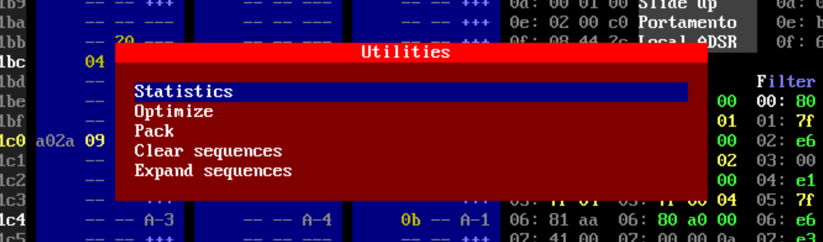
You can pack your song immediately using the dedicated menu item, but perhaps you should consider optimizing it first. This will remove unused instruments, commands and sequences while moving things closer together, taking up less memory.
NOTE: Currently, SID Factory II actually does not optimize the song when packing!
Although you can optimize if you are running out of both commands and instruments fast, we recommend waiting until packing the song, if you can. The reason for this is that the tidying of tables may change a lot of the instrument and command numbers you are used to for that song. The song should of course not break, but it can be a little confusing to learn that the bass drum on 15 is now 11 and the wave command on 1A is now 14.
When selecting the packer option, you are first asked where you would like to place the tune in memory, and you can also change the zero page addresses used. Both the range and the size will then be reported.
And now comes the important part.
If you type a filename without an extension, it will save to a PRG file as the default. But if you want to save it as a SID file, you have to specify the .sid extension too. Now SID Factory II asks for the title, author and copyright strings, and then saves a SID file.
When you save a multi SID tune as a SID file, the dialog also asks for the file format and the stereo panning. PSID v3/v4 holds up to 3 SIDs, the SID file format v5 holds all 4 SIDs, the panning and the play time of every song. A 4 SID tune is always saved as SID v5. The panning you choose is stored in the tune and is also used by reSID.
The play time of a song is found by playing it until every track starts over or the song stops. A song that does not end within 99:59 is saved without play times.

ASID
SID Factory II supports real hardware that can use the ASID protocol. To connect to a MIDI device, press the F1 key while looking at the startup screen, i.e. the one where credits are shown. (Make sure you have not chosen the setting where the startup screen is skipped.)
This will show a small dialog list for choosing the MIDI output device.
While in the main editor itself, you can click the Output field in the top bar (or press the Alt+O key) to toggle the output between reSID, ASID and USBSID.
With a multi SID driver, ASID sends the second, third and fourth SID with the multi SID messages of the ASID protocol. The hardware needs to support these to play more than one SID.
To learn more about ASID, please go to: https://github.com/thomasj/asid-protocol

USBSID-Pico
SID Factory II can play directly on a USBSID-Pico board over USB, without MIDI. Every SID write is sent with its exact cycle distance to the previous one, and the board replays that timing.
Connect the board before starting SID Factory II. While in the main editor, click the Output field in the top bar (or press Alt+O) to cycle between reSID, ASID and USBSID. Outputs that are not available are skipped. The board clock follows the PAL or NTSC setting of the tune.
In the startup screen, press F3 to choose the SID chips on the board(s) to play on. A single SID tune plays on every chosen SID, a multi SID tune plays every SID of the tune on its own SID chip. With more than one board connected, a dialog lets you choose the board(s) to use, and F2 opens it again. In both dialogs, Space marks an entry and Enter confirms.
To use the same boards and SIDs every time, set Playback.USBSID.Boards and Playback.USBSID.SIDs in your user.ini. The serial numbers of the boards are written to the log at startup. Set Playback.USBSID.AllSIDs to 1 to play on every SID of the boards. Playback.USBSID.LeadTime is the time in milliseconds the board plays behind the editor (30 by default).
NOTE: On Windows, the "USBSID-Pico Data" interface of the board needs the WinUSB driver, which you can install with Zadig. On Linux, your user needs access to the USB device; the USBSID-Pico documentation has a udev rule for this.
To learn more about USBSID-Pico, please go to: https://github.com/LouDnl/USBSID-Pico

Controls
SID Factory II generally respects the logical use of keys such as Tab and Shift+Tab for next and previous input focus, Home and End (Fn+Left and Fn+Right in macOS) for start or end of input focus, etc.
You can also undo and redo virtually anything with Ctrl+Z and Ctrl+Y (or Ctrl+X) keys.
You can toggle an expanded version of the editor with a surrounding overlay using F12. This shows all the most important keys along with detailed information about the table values for the current driver.
Press Ctrl+F12 to step the window width through the widths for 1, 2, 3 and 4 SIDs.
Press Alt+Enter to toggle fullscreen mode.

Startup
This is where you can see the credits. (This can be set to be automatically skipped in the settings, but if you do, you won’t be able to select a MIDI output device.)
- F1 selects the MIDI output device for the ASID protocol (this requires external hardware).
- F2 selects the USBSID-Pico board(s) to use, if more than one board is connected.
- F3 selects the SID chips on the USBSID-Pico board(s) to play on.
- F10 loads an SF2 file or a different driver.
- Space enters the main editor.

Files
- F10 loads an SF2 file or a different driver.
- F10 to convert from another format (MOD, SNG from GoatTracker 2, or CT from CheeseCutter).
- F10, then load a specific driver, then hit Ctrl+F10 and load an SF2 file to add that driver to it.
- F11 saves your song as a specific SF2 file.
- Ctrl+S quick saves your song to the latest loaded or saved SF2 file.
- F6 then select Pack to save as a PRG file.
- F6 then select Pack and add extension .sid to save as a SID file.
While in any file dialog:
- Tab to toggle between browser or filename.
- Hit A to Z to jump to the files starting with this letter. Repeating also works.
- Delete to remove a file in a folder.
- Backspace for browsing to a parent folder.
- Enter to select a file.

Playing
SID Factory II does not have a separate function key for stopping, they all work as toggle keys. This cut down on function keys for other purposes. However, Esc will also stop a tune.
- F1 plays from the start of the entire song.
- F2 plays from the currently selected bookmark (see below about these).
- Shift+F2 plays from the top of the sequence you are currently editing.
- Ctrl+F2 (Cmd+F2 in macOS) plays from the current cursor position.
- Ctrl+P toggles follow-play on and off.
- Hold the key below Esc (Minus in macOS) for fast forward. Include Shift to go even faster.

Tracks
These are the general keys that work when you are editing an order list or a sequence.
- Enter toggles between editing the order list or the sequence itself.
- Tab and Shift+Tab for next or previous track (order list or sequence).
- Home or End (Fn+Left or Fn+Right in macOS) for the absolute start or end of the entire song.
- Ctrl+1, Ctrl+2 or Ctrl+3 turns voice tracks on or off.
- Ctrl+4 to Ctrl+9 and Ctrl+Shift+1 to Ctrl+Shift+3 turn track 4 to 12 on or off (multi SID drivers).
- Shift+Up/Down in a sequence to mark an area, then Ctrl+C to copy the contents.
- Ctrl+V to paste a previously marked area in a sequence, overwriting an area of the same size.
- Ctrl+Shift+V to paste a previously marked area, inserting it to make the sequence longer.
- Ctrl+L sets the song loop position (the order list values then turn green). It also toggles between loop and end marker when the cursor is at the end of a song.
- Shift+F3 and Shift+F4 to decrease and increase the sequence itself by one semitone.
- Ctrl+F3 and Ctrl+F4 (Shift+Cmd+F3 and Shift+Cmd+F4 in macOS) to decrease and increase the sequence itself by one octave.
- Alt+Up and Alt+Down to decrease and increase the white intervals.
- Alt+Shift+Up and Alt+Shift+Down to “roll” the white intervals up or down.

Order list
This is where you edit the transpose value and the sequence number itself in a blue track voice.
As soon as you start typing hexadecimal digits, the XXYY word turns white and you must press Enter to accept or Esc to cancel (cursor up or down is prohibited until this is done).
- Insert and Delete (Shift+Backspace and Backspace in macOS) to insert and delete order list entries. Backspace also works in Windows for deleting the previous entry.
- Ctrl+C and Ctrl+V will copy and paste the entire sequence.
- Ctrl+F to insert the next unused sequence (whether it has data in it is ignored).
- Ctrl+Shift+F to insert the next unused empty sequence.
- Ctrl+D to duplicate and replace the currently edited sequence.
- Ctrl+Shift+D to duplicate and append a sequence after the currently edited one.

Sequences
Notes are entered in the right-most column by hitting one of the many standard letters and number keys on the keyboard. They match the keys on a piano like this:
If you hold down Shift while doing so, editing is temporarily paused and you can play with the current instrument. To both edit and play it, toggle the Caps Lock key on.
- Ctrl+Left and Ctrl+Right (Cmd+Left and Cmd+Right in macOS) move between the three columns in the sequence.
- Insert and Delete (Shift+Backspace and Backspace in macOS) to insert and delete without altering the size of the sequence. Backspace also works in Windows for deleting the previous row without altering the size of the sequence.
- Ctrl+Insert and Ctrl+Delete (Ctrl+Shift+Backspace and Ctrl+Backspace in macOS) to insert and delete while also altering the size of the sequence. Ctrl+Backspace also works in Windows for deleting the previous row while also altering the size of the sequence.
- Space to erase an instrument or command value, or for a --- (gate off) event.
- Shift+Space for a +++ (gate on) event.
- Shift+Enter toggles a ** (tie note) on and off.
- Ctrl+Space erases an entire row (i.e. the instrument, command and note).
- Ctrl+I adds the value for the current instrument (hit it again to remove it).
- Ctrl+O adds the value for the current command (hit it again to remove it).
- F3 and F4 to decrease and increase the octave for notes being typed in.
- F5 resizes a sequence to a specific number of rows (preserves data unless truncated).
- Shift+F5 inserts a specific number of rows at the exact cursor position.
- Ctrl+B splits a sequence. The existing upper part is resized while the lower part is new.

Tables
- Alt+[Letter] to jump to or from that table. Use the highlighted letter in the table name.
- Tab or Shift+Tab for next or previous table.
- Home (Fn+Left in macOS) for the absolute top of the table.
- End (Fn+Right in macOS) for the end of actual data in the table. Hit it again for jumping to the absolute bottom of the table.
- Enter in commands or instruments to edit a description. Hit Enter to accept or Esc to undo.
- Shift+Enter on a value to edit bits. Use up/down, Space to toggle bits, then Enter or Esc.
- Ctrl+Enter on a table index pointer value jumps to that spot in the relevant table.
- Insert and Delete (Shift+Backspace and Backspace in macOS) to insert and delete rows (except in commands and instruments because of being referred to from sequences).
- Space plays the last instrument you played while holding down Shift and hitting letter keys.
- Ctrl+Space works as Space but also applies the effect of the current command.
- Numpad + and Numpad (Cmd+Up and Cmd+Down in macOS) – changes the instrument.
- Ctrl+Numpad + and Ctrl+Numpad (Shift+Cmd+Up and Shift+Cmd+Down in macOS) – changes the command.
- Ctrl+U to toggle between lower- and upper-case hex values in all tables.

Options
You can left click most options in the status bar, except PAL/NTSC. Use left- and right-click on the octave field to increase and decrease it (or use F3 and F4 directly).
- F9 toggles between the 6581 or 8580 SID chip models.
- Shift+F9 toggles between PAL and NTSC.
- Shift+F7 reloads the settings
- Ctrl+F7 selects the next color scheme
- Alt+O toggles the output between reSID, ASID and USBSID-Pico (only the ones that are available).
- Ctrl+F9 cycles the stereo panning layout (single SID: the position).
- Ctrl+Shift+F9 cycles the stereo panning mode of a multi SID tune.
- Ctrl+F12 steps the window width through the widths for 1, 2, 3 and 4 SIDs.
- F6 opens the utilities menu.
- F7 opens the songs menu.

Song list
This is the gray box located in the left side of the SID Factory II.
- Enter (or left click) a row jumps to that spot in the song. If you cursor to an empty description spot, it will start editing the text for it (you can also use left click for this).
- Ctrl+Enter (or double-click) a row jumps to that spot in the song and plays from it.
- Home (Fn+Left in macOS) for jumping to the top without scrolling the list. Hit it again for jumping to the absolute top.
- End (Fn+Right in macOS) for jumping to the bottom without scrolling the list. Hit it again for jumping to the absolute bottom.
- Shift+Up/Down in mark a range of sequences, then Ctrl+C to copy the range.
- Ctrl+V to insert a previously marked range thereby making the order list longer.

Bookmarks
- Alt+1 to Alt+8 selects one of the eight bookmark slots.
- Ctrl+M stores the current track position in the current bookmark slot.
- Ctrl+G goes to the position indicated by the current bookmark slot.
- F2 plays from the position indicated by the current bookmark slot.
- Enter (or left click) a row jumps to that spot in the song.
- Ctrl+Enter (or double-click) a row jumps to that spot in the song and plays from it.
- Home or End (Fn+Left or Fn+Right in macOS) for the start or end of the list.

We hope you'll have a lot of fun composing. Enjoy! =)
- The SF2 Team

