SID Factory II  
User Manual

Last updated 2021-01-17

Editor coded by Thomas Egeskov Petersen  
Mac version by Michel de Bree  
Manual written by Jens-Christian Huus

Contents

Introduction 3

Noteworthy features 3

The Basics 4

Editor 4

Options 5

Tracks 5

Song list 7

Bookmarks 8

Tables 8

Commands 9

Instruments 9

Wave 10

Pulse 10

Filter 10

Arp 10

Init 11

HR 11

Tempo 12

Changing drivers 12

Changing the settings 13

Converting 13

Packing 13

Controls 15

Files 15

Playing 15

Tracks 15

Order list 16

Sequences 16

Tables 17

Options 17

Song list 18

Bookmarks 18

# Introduction

[SID Factory II](http://deepsid.chordian.net/?player=122&type=player&search=sidfactory_ii) is a cross-platform music editor for editing SID music that can be played on a Commodore 64. The project was started by Thomas Egeskov Petersen (also known as Laxity) with the ambition of combining the emulation of MOS6510 code and SID sound with an editing environment that will provide close to full consistency between the work in progress and the final product.

It is the modern successor to the [native C64 editor](http://deepsid.chordian.net/?player=45&type=player&search=sidfactory) from 2006.

The editor has been compiled for Windows and Mac under GNU General Public License v2.

Please note that the editor is in **BETA** and may still be missing essential features.

As a cross-platform editor, SID Factory II joins the fierce competition of other cross-platform editors such as [GoatTracker 2](http://deepsid.chordian.net/?player=1&type=player&search=goattracker_v2.x) and [CheeseCutter](http://deepsid.chordian.net/?player=4&type=player&search=cheesecutter_2.x). SID Factory II works in much the same manner as these editors by using [SDL](https://www.libsdl.org/) and a text interface, hitting hotkeys for notes, and typing hexadecimal values for instruments, commands, and support tables.

## Noteworthy features

If you are already quite familiar with the latest C64 editors, you may be wondering what is so special about SID Factory II. Here is what we consider unique about it.

* It packs the sequences in real time as you edit them. This means that what you hear is pretty much what you get. Less nasty surprises when packing the tune in the end.
* Because the sequences are packed in real time, they can be extremely long. The cap is currently 1024 rows, as long as the data in it can be packed below 256 bytes.
* The song list in the left side gives a strong overview of the sequences, with spaced distances to align everything correctly. Descriptions are planned for the empty void.
* The driver system is modular and there is already a wide selection of drivers available, some of which are designed to take up little memory while missing out on features.
* You can have up to eight different bookmarks, all defined and managed in the small table in the bottom left corner of the window.
* The standard driver 11 (loaded as you start the editor) features both 12-bit pulse and filter control as well as a separate arpeggio table for chords only.
* The colors of the editor and the key definitions used can be modified in a configuration file to fit how you want the editor to look as well as the keys you are most comfortable with.
* The editor can convert from MOD (Amiga), SNG (GoatTracker 2) and CT (CheeseCutter) when loading a tune as always

Of course, the editor and its drivers also have all the modern features you would expect these days, such as table index hotkeys, muting channels, both instruments and commands at the same time, adjustable hard restart, pulse and filter programs, inserting the next unused sequence, and a whole lot more.

# The Basics

Let us take you on a brief tour through the editor and show the areas. To make this easier, start out by loading a tune. Hit **F10**, enter the music folder, and open an SF2 file. (This is the file extension SID Factory II uses for its source tunes.)

**TIP:** When a confirmation dialog box pops up, you can also hit **y** or **n** to select.

SF2 files are actually PRG files in disguise. You can open e.g. the VICE emulator and drag-and-drop an SF2 file there. It even has a small interrupt driver. Just type SYS4093 and your source tune should play, showing the rastertime it uses.

## Editor

You should now have returned to the editor with data all over the place. SID veterans may immediately recognize the order list and sequence tracks in the middle as well as the tables in the right side.

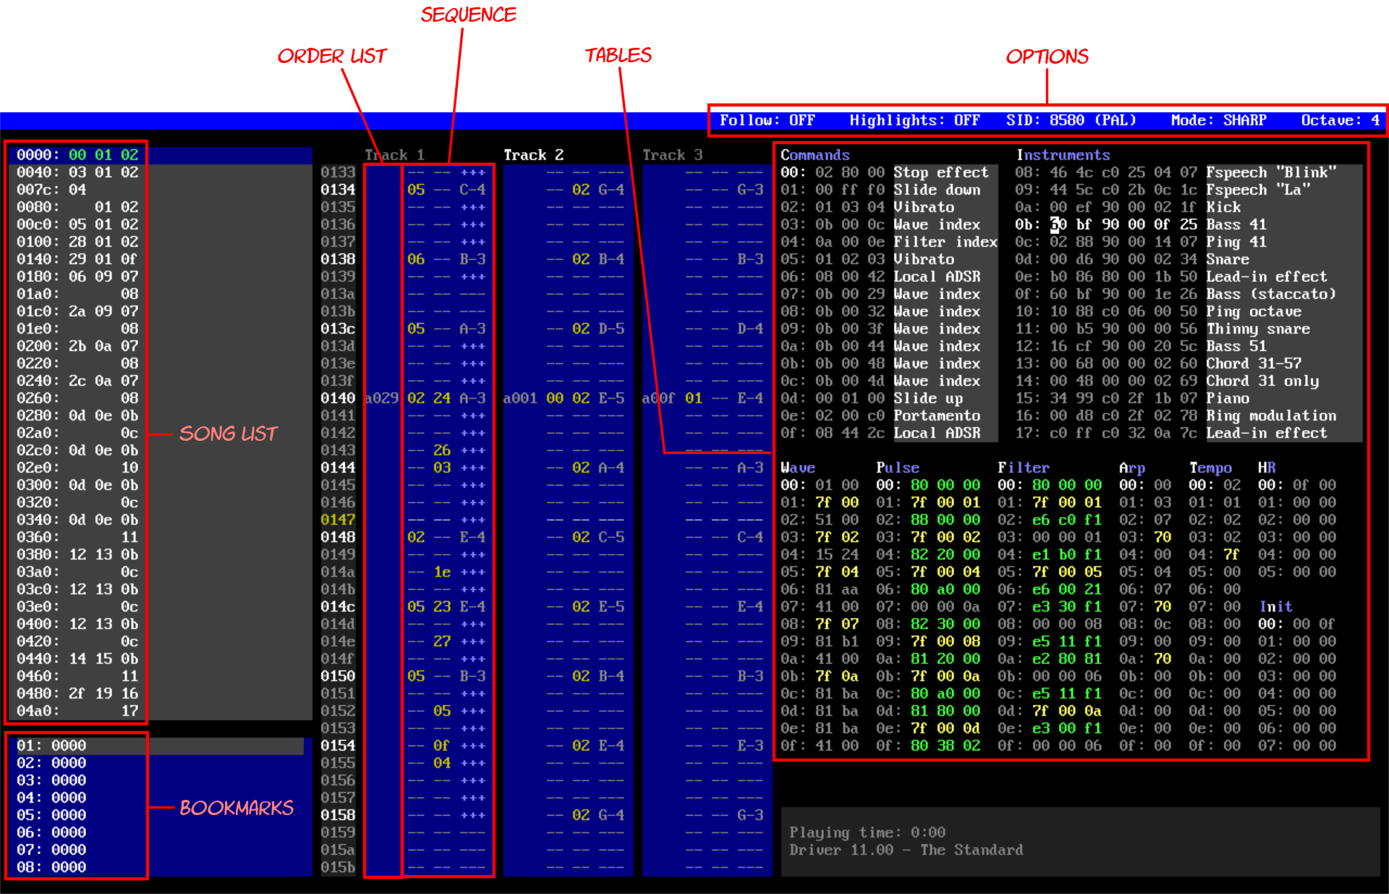

In the left side, the song list provides an overview of the entire song. It only show the sequence numbers and you cannot edit here. However, you can use it to go to and play from specific locations.

Just below it, the bookmarks makes it possible to add a marker that you can later go back to or even play from. You can have up to eight different bookmarks in a song.

Each of the three channels have an order list with transposition and sequence number, and the latter is then displayed as the sequence next to it. The sequence edits instruments, commands and notes.

The tables in the right side of the editor are tied to the driver version currently loaded. They may change their layout, sizes and meaning when another driver version is loaded. When starting SID Factory II, the default driver 11 is on the luxurious side with plenty of effects and commands available. If you hit the **F12** key now, the window expands with a hotkey overlay that also explains these tables.

## Options

There are a few option flags in the right side of the status bar in the top of the editor. Some of these have hotkeys, but most of them can be left-clicked too.



You can choose between the 6581 or 8580 SID chip, sharp or flat notes (e.g. D#4 or Eb4 shown in the sequence) and you can toggle **Highlights** on or off. The latter turns notes and values green in the sequence whenever the instrument or command matches what is selected in their tables.

**TIP:** You can also use **F9** to toggle 6581/8580, and **Shift+F9** to toggle PAL/NTSC.

## Tracks

The core of the editor is the three blue tracks for the SID voices. Click any one and you can use the **Enter** key to toggle between the order list entry and its contents. The entry has the format XXYY, where XX is transpose and YY the sequence number. XX is usually A0 as the default. Type e.g. 94 for one octave lower, or AC for one octave higher.

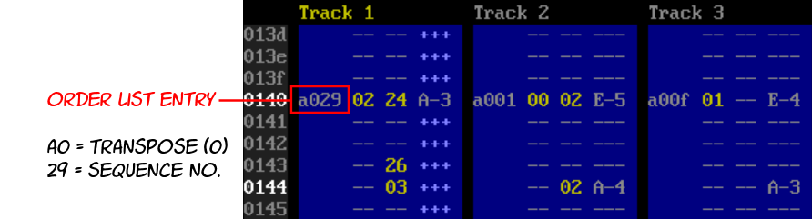

SID Factory II uses the same contiguous sequence stacking system as JCH’s original native C64 editor did. CheeseCutter also uses this. It means that all the sequences in each voice can be in various lengths independently from the neighbor tracks. The sequences are simply stacked on top of each other, like a game of perfect Tetris.

Only, the bottom sequences won’t magically disappear, of course.

The first column to the left is the instrument number, and the second is the command. You can also toggle tie note on or off with **Shift+Enter**. A ** in the instrument column indicates that the note is tied, which means that the effects of the note will not restart. This can be useful when using portamento.

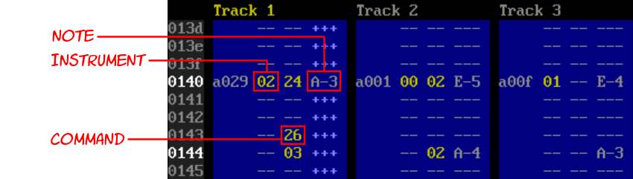

Notes are entered in the right-most column by hitting one of the many standard letter and number keys on the keyboard. They match the keys on a piano like this:

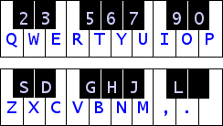

You can replace with --- (gate off) with **Space** or with +++ (gate on) with **Shift+Space**. SID Factory II thus adheres to the same gate on/off system that JCH’s C64 editor did. This is different from how GoatTracker and CheeseCutter handles it. The SID chip uses an [ADSR envelope](https://en.wikipedia.org/wiki/Envelope_(music)) to control the amplitude of each voice. As long as there are +++ below the note, the amplitude is attacked, decayed and sustained. Changing to --- later releases it.

Using this gate system can sometimes be more work than the simpler gate off indicator used by most other modern C64 editors, but it does have its advantages. You have more control over continuous gating on and off during the lifetime of a note, and it’s visually logical.

**TIP:** You can “fill” upwards with **Ctrl+Shift+Up**, downwards with **Ctrl+Shift+Down**.

SID Factory II is normally silent as you type in notes. However, if you hold down **Shift** while typing the notes, you can hear the currently chosen instrument playing. This also temporarily stops all editing, making it suitable for quickly testing a melody or an instrument. If you want to be able to hear the instrument as you type in the notes, click the **Caps Lock** key first.

Use **F3** to decrease the octave or **F4** to increase the octave of the note you are typing. It is also possible to transpose all of the notes in the entire sequence directly. To transpose it one semitone, use **Shift+F3** and **Shift+F4**; for one octave use **Ctrl+F3** and **Ctrl+F4** (**Shift+Cmd+F3** and **Shift+Cmd+F4** in macOS).

Deleting and inserting in a sequence moves the notes up or down, but it does not change the length of the sequence. If you want to do that too, you need to hold down **Ctrl** as well.

**TIP:** Hit **F5** to prepare a new sequence with many lines, or **Shift+F5** to insert lines.

Hit **Enter** again to return to the sequence number. You can also insert and delete here too, and you can hit **Ctrl+F** to insert the next unused sequence where old data is ignored. (If you want the next truly empty unused sequence, hit **Ctrl+Shift+F** instead.)

To mute and unmute channels, use **Ctrl+1**, **Ctrl+2** or **Ctrl+3**.

## Song list

While inserting and deleting sequence positions or inside the sequences themselves, you may have noticed that things changed in the gray box in the left side of the editor. This is the song list overview. It shows the same sequence numbers as in the tracks, only without the transpositions and contents. This condenses it down for a nice overview of the entire song.



The sequences in the song list cannot be edited – they only serve as information and quick navigation. You can click anywhere to browse a line up and down, home and end, or use page up/down. Clicking a line (or using **Enter**) will go to that spot in the song. Double-clicking (or using **Ctrl+Enter**) will go to that spot and play from there.

**NOTE:** You will also be able to edit descriptions in a future version of SID Factory II.

## Bookmarks

The small blue box in the bottom left corner is the list of bookmarks.



You can define up to eight different bookmarks in a song. Each bookmark is selected with **Alt+1** to **Alt+8**. To set a bookmark, hit **Ctrl+M** anywhere in the song – even in the middle of sequences. The row number is added as the bookmark number. You can now return to that spot with **Ctrl+G**.

But more importantly, you can now also *play* from that spot with **F2**.

## Tables

Each driver available to SID Factory II has a text file in a sub folder called *documentation*, explaining all the tables. You can also just hit **F12** to open an overlay with this information.

Actually navigating the tables is as simple as using the cursor keys, tab across the tracks and tables, or clicking a table to enter that position in it. You can also page up/down or use the mouse wheel to scroll it. **Numpad +** and **Numpad -** changes the current instrument (**Cmd+Up** and **Cmd+Down** in macOS), and **Ctrl+Numpad +** and **Ctrl+Numpad -** the command (**Shift+Cmd+Up** and **Shift+Cmd+Down** in macOS).

**TIP:** First time you hit **End** (**Fn+Right** in macOS) it goes to the end of the used data.

You can edit the descriptions for individual commands and instruments. Simple hit **Enter** and edit it, then hit **Enter** again to accept, or **Esc** to undo your typing.

Some table bytes may have one or more bits for controlling minor details. For example, the standard driver 11 has a byte with flags in an instrument row. Normally you would have to add the bit values together in your head, like e.g. 80 and 40 is C0, but you don’t have to do that in SID Factory II. It has a bit selector built in. Just hit **Shift+Enter** on that value and you can set the bits with the **Space** key as you cursor up and down. Then hit **Enter** to accept, or **Esc** to cancel.

You can use **Ctrl+Enter** to go to a table index pointer. This is used not only in instruments but also in commands. For example, the standard driver 11 has index pointers for pulse, filter and wave tables. Hit **Ctrl+Enter** on any of these to enter that spot in one of those tables. If a command also uses an index pointer to a table, **Ctrl+Enter** works there too.

SID Factory II is normally silent in the tables. However, if you hold down **Shift** while typing notes, you can hear the currently chosen instrument playing. This also temporarily stops all table input, making it suitable for quickly testing a melody or an instrument. You can repeatedly play the latest shifted note in the tables by pressing **Space**. If you use **Ctrl+Space** you will also apply the current command effect.

### Commands

This the table that is referred to from the middle numeric column in the sequences. Because of this it is not possible to insert and delete in it.

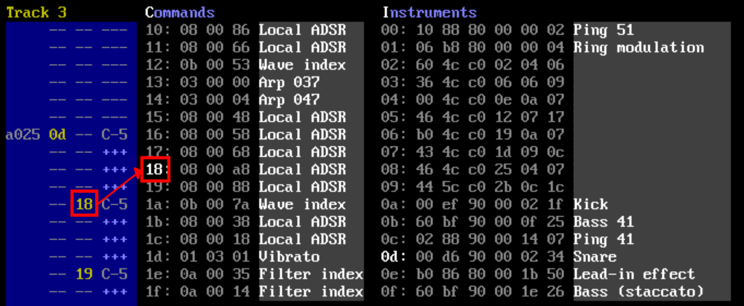

If you hit **F12** to open an expanded overlay, you can see a list of the commands offered by the currently loaded driver. Look for the magenta color.

### Instruments

The instruments are referred to from the left numeric column in the sequences – and just like with the commands, it is thus not possible to insert and delete in it.

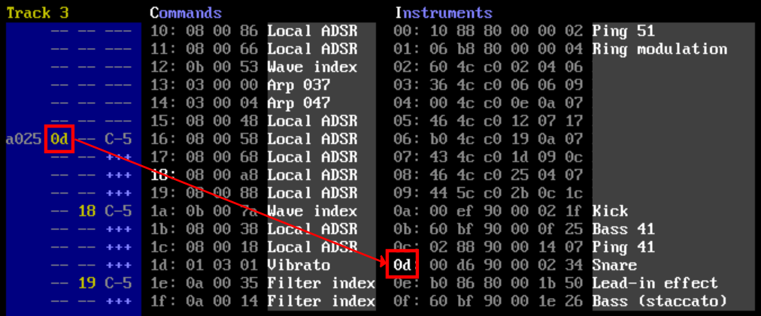

The amount of bytes and their purpose depends on the currently loaded driver, but typically at least the ADSR can be edited here. If there are support tables for e.g. waveforms, pulse or filter, there may also be index pointer bytes to rows in them. As mentioned before, you can jump to a row in one of these tables by placing the cursor on the index pointer value and then hit **Ctrl+Enter**.

### Wave

If the driver offers a wave table, it usually sets the waveform in the left column and the semitones add value in the right. For example, 11 0c means use the triangle waveform and play it one octave higher than what the note in the sequence states. However, if you add 80 to the right value, it will be a static note chosen directly from the table of frequency values. This is great for e.g. drums.

A left value of 7f expects the right value to be an absolute pointer to a different row. For example, 7f 02 means that it should wrap back to the third row in the table.

The above rules are common but might change when a different driver is loaded.

### Pulse

If the driver offers a pulse table, it is used to define the range and speeds of which the pulse travels to produce the swooping effects of waveform 41 as well as a few combined waveforms. Hit **F12** to open an expanded overlay that explains the commands in this table. Look for the pink color.

In some drivers, a more simple pulsating effect is defined in one or two bytes in the instrument.

### Filter

If the driver offers a filter table, it is also used to define the range and speeds. Unlike pulse, the filter in the SID chip is a global effect that can then be applied to one or more channels using a bit mask. This bit mask consists of three bits, for values 1, 2 and 4.

By combining these you can choose any combination of channels.

For example 1+2 = 3 adds the filter effect to the first two channels, 4 only to the third channel, while 1+2+4 = 7 to all three channels. Typically this bitmask is one of several settings in this table along with the filter cutoff start value and the resonance, but it depends on how the driver is written. Hit **F12** to open an expanded overlay that explains the commands in the table. Look for the orange color.

Note that some of the drivers available doesn’t even have any filter capabilities at all.

### Arp

Some drivers have an arpeggio table that is separate from the wave table. This is primarily used to make arpeggio chords, typically referred to from the command table. The values are added as semitones to the note in the sequence. A value in the command may even set the speed of the arpeggio. Hit **F12** to open an expanded overlay that explains the table. Look for the green color.

In the default driver that loads when SID Factory II starts (driver 11) the arpeggio only affect the values in the *wave table* where semitone add values are set to 00. Other add values ignore the arpeggio.

### Init

If the init table is present in the current driver, it points to a tempo table row and sets the main volume with 00 0f (the latter is the loudest volume possible in the SID chip). If you hit **F12** to open the overlay you can find its details in the box outlined in white.

**NOTE:** Multiple sub tunes are not yet supported and thus only the first row is used.

### HR

Most drivers utilize something called *hard restart*. In fact, most modern players on the C64 have some version of this technique. So what is this?

The ADSR for each channel defines the *Attack*, *Decay*, *Sustain* and *Release* of a note. How it increases in volume and then decays to a steady level as long as the note is gated on, which corresponds to holding down a piano key. As soon as you gate off – release the piano key – the release fades out the note. The ASDR is typically defined in the instrument table and can also be changed with commands.

While ADSR is definitely one of the best features of the SID chip, it is not perfect. If you were to, say, play a sequence full of smaller note durations, each kept gated on until the next note, then played it over and over without enabling hard restart in the instrument, you would probably hear the ADSR kind of stumble here and there. Of course this depends on what values you put into the ADSR registers and some values may also alleviate it, but it’s easy to keep running into this problem. The renowned C64 composer Martin Galway called this “the school band effect” which is as apt a description as any.

Hard restart was invented to defeat this ADSR bug.

The hard restart prevention works by gating off and resetting the ADSR values a few frames before the next note triggers. How to design hard restart in a player varies a lot depending on the creator, but in SID Factory II, most drivers that use it triggers the effect exactly two frames before. Say you trigger a note and keep it gated on with +++ rows for a few rows, adding up to a total of 15 frames. The note is first triggered with the ADSR defined in the instrument. After 13 of its 15 frames have passed, the hard restart takes over. It gates off and applies a different set of ADSR. Depending on this new set of ADSR, it may cut off the remainder of the note, making it sound a tiny bit staccato. However, this also stabilizes the ADSR and makes sure the next note always triggers perfectly. No more stumbling.

Defining this new ADSR is where the HR table comes in. In the default driver that loads when SID Factory II starts (driver 11) you can enable hard restart with a flag in the instrument and also point to an ADSR value in the HR table. This is typically 0F 00 which brings the note down fast. There is usually no reason to change this, but as you become more proficient with composing, you may want to experiment. You can also leave it as is for most instruments and create a second ADSR set that you point to from another instrument. If you hit **F12** to open the overlay, you can find the details in the cyan box with flags.

### Tempo

If the current driver supports a tempo table, this is where the pace of the song is defined. In the default driver that loads when SID Factory II starts (driver 11) the accompanying init table points to it.

A value in the tempo table defines the number of frames one row (or the smallest possible note) in a sequence lasts. Frames is the fastest possible update of the driver and is typically 50 times a second on PAL and 60 times a second on NTSC.

Smaller values means a faster tune. Depending on whether the driver uses hard restart and how this is set up, there may be a minimum value that works well with the driver. Usually this is 02, but if you are using a driver that doesn’t have hard restart (or uses a tight model of it) it may be smaller. The table won’t prevent you from trying small values, however, and sometimes they *may* work in a chain.

You may have a chain of tempo values until the wrap byte 7f restarts it. Every time the driver exhausts a tempo value, it will count down on the next one. This makes it possible to make funky shuffle rhythms or e.g. 2½ speeds. Sometimes it can also be handy to match the speed of a real song you’re covering.

## Changing drivers

Starting from scratch with a different driver is as simple as hitting **F10**, browsing to the folder with drivers (you can go back to a parent folder with **Backspace**) and loading it.

Loading a different driver will change the layout of tables in the right side of the window. Different drivers have different capabilities. Some have much fewer tables but make up for it by being tiny.

**TIP:** To study the rastertime, drag-and-drop an SF2 file into VICE and type SYS4093.

In each build archive, there is a sub folder called *documentation* where the details of each driver are listed and what the values in each table mean. You can also just hit **F12** to open an overlay.

Currently, the following drivers are available for SID Factory II:

* **Driver 11** – this is the standard driver loaded as the default. It is the luxury driver with the most features and table data. Fret slide was added in **11.01**. Pulse index, tempo change and main volume commands were added in **11.02**. Filter enable flag in instrument was added in **11.03**.
* **Driver 12** – this is an extremely simple driver that can only do the most basic effects.
* **Driver 13** – this is a driver that emulates the sound of Rob Hubbard’s driver. If you load the demo song for it, you may recognize some of the instruments.
* **Driver 14** – this is an experimental version of the standard driver that allows for a short duration of gate off, but also has a greater chance of instability.
* **Driver 15** – this tiny driver (mark I) is a slightly expanded version of driver 12 with a few more effects, but it also uses more of the zero page area.
* **Driver 16** – this tiny driver (mark II) is like driver 15 but with no commands at all.

It is also possible to change the driver in an existing source tune. To do this, first load the driver with **F10**, then hit **Ctrl+F10** to import your source tune on top of it. This will probably only be really useful for sub versions of the same major version driver. You could import a driver 11 tune into driver 12, but you would then have to overhaul the tables.

## Changing the settings

You can change various settings in an INI file. If you load the *config.ini* file (located in the same directory where the executable file resides) you will find comments describing how to make persistent changes to be placed in a secondary *user.ini* file. The documentation that comes with the distribution contains a template called *user.default.ini*. You can use this as a starting point by renaming it to *user.ini.* On macOS and linux, your *user.ini* file should be placed in the folder *~/.config/sidfactory2/*

INI files for the color schemes are location in the *color_schemes* sub directory and can be selected by specifying a numeric value for an entry in the *config.ini* file. Again, refer to that file for more information about selecting a persistent color scheme.

**NOTE:** A proper dialog box for the settings will be added in a future version of SF2.

You are welcome to try defining a new color scheme too. The rules are quite simple – copy and rename one of the INI files in the *color_schemes* sub directory, edit it, and change the hexadecimal RGB values there. You can create all new variable names and use them instead of values by prefixing them with a colon. Remember to also add new ColorScheme.Name and .Filename lines in *config.ini* too.

*If you manage to create a nice color scheme, consider sending it to us for future inclusion!*

***N.B.*** *custom color schemes are not supported on macOS yet.*

## Converting

SID Factory II also have the ability to convert from song formats made in other popular editors. Just hit **F10** as usual and load MOD (4-voice music from Amiga), SNG (GoatTracker 2) or CT (CheeseCutter) to convert it to the latest sub version of driver 11.

Since the cat is out of the bag, we might as well also tell you that you can load source tunes from JCH’s old NewPlayer 20.G4. It will be converted into a special driver that works almost exactly like it.

**TIP:** You can download a ZIP file with a ton of NP20 source tunes at our web site.

A console will tell you about the conversion process. It’s not guaranteed that the conversion process will succeed. Some of the editors mentioned above have room for more instruments than SID Factory II does, and it’s also possible that the conversion into additional commands might overflow. If this happens you will have to simplify the tune in the original editor.

## Packing

When you are finally done with your song, hit **F6** to open the list of utilities.

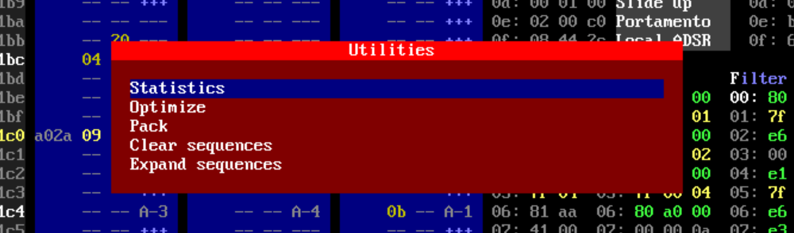

You can pack your song immediately using the dedicated menu item, but perhaps you should consider optimizing it first. This will remove unused instruments, commands and sequences while moving things closer together, taking up less memory.

**NOTE:** Currently, SID Factory II actually does **not** optimize the song when packing!

Although you can optimize if you are running out of both commands and instruments fast, we actually recommend waiting until packing the song, if you can. The reason for this is that the tidying of tables may change a lot of the instrument and command numbers you are used to for that song. The song should of course not break, but it can be a little confusing to learn that the bass drum on 15 is now 11 and the wave command on 1A is now 14.

When selecting the packer option, you are first asked where you would like to place the tune in memory. Both the range and the size will then be reported.

*And now comes the important part.*

If you type a filename without an extension, it will actually save to a PRG file as the default. But if you want to save it as a SID file, you have to specify the .sid extension too. Now SID Factory II asks for the title, author and copyright strings, and then saves a SID file.

# Controls

SID Factory II generally respects the logical use of keys such as **Tab** and **Shift+Tab** for next and previous input focus, **Home** and **End** (**Fn+Left** and **Fn+Right** in macOS) for start or end of input focus, etc.

You can also undo and redo virtually anything with **Ctrl+Z** and **Ctrl+Y** (or **Ctrl+X**) keys.

You can toggle an expanded version of the editor with a surrounding overlay using **F12**. This shows all of the most important keys along with detailed information about the table values for the current driver.

## Files

* **F10** loads an SF2 file or a different driver.
* **F10** to convert from another format (MOD, SNG from GoatTracker 2, or CT from CheeseCutter).
* **F10**, then load a specific driver, then hit **Ctrl+F10** and load an SF2 file to add that driver to it.
* **F11** saves your song as a specific SF2 file.
* **Ctrl+S** quick saves your song to the latest loaded or saved SF2 file.
* **F6** then select **Pack** to save as a PRG file.
* **F6** then select **Pack** and add extension .sid to save as a SID file.

While in any file dialog:

* **Tab** to toggle between browser or filename.
* Hit **A** to **Z** to jump to the files starting with this letter. Repeating also works.
* **Delete** to remove a file in a folder.
* **Backspace** for browsing to a parent folder.
* **Enter** to select a file.

## Playing

SID Factory II does not have a separate function key for stopping, they all work as toggle keys. This cut down on function keys for other purposes. However, **Esc** will also stop a tune.

* **F1** plays from the start of the entire song.
* **F2** plays from the currently selected bookmark (see below about these).
* **Shift+F2** plays from the top of the sequence you are currently editing.
* **Ctrl+F2** (**Cmd+F2** in macOS) plays from the current cursor position.
* **Ctrl+P** toggles follow-play on and off.
* Hold the key below **Esc** (**Minus** in macOS) for fast forward. Include **Shift** to go even faster.

## Tracks

These are the general keys that work when you are editing an order list or a sequence.

* **Enter** toggles between editing the order list or the sequence itself.
* **Tab** and **Shift+Tab** for next or previous track (order list or sequence).
* **Home** or **End** (**Fn+Left** or **Fn+Right** in macOS) for the absolute start or end of the entire song.
* **Ctrl+1**, **Ctrl+2** or **Ctrl+3** turns voice tracks on or off.
* **Ctrl+C** and **Ctrl+V** will copy and paste the entire sequence.
* **Ctrl+L** sets the song loop position (the order list values then turn green).
* **Shift+F3** and **Shift+F4** to decrease and increase the sequence itself by one semitone.
* **Ctrl+F3** and **Ctrl+F4** (**Shift+Cmd+F3** and **Shift+Cmd+F4** in macOS) to decrease and increase the sequence itself by one octave.
* **Alt+Up** and **Alt+Down** to decrease and increase the white intervals.
* **Alt+Shift+Up** and **Alt+Shift+Down** to “roll” the white intervals up or down.

## Order list

This is where you *edit* the transpose value and the sequence number itself in a blue track voice.

As soon as you start typing hexadecimal digits, the XXYY word turns white and you have to press **Enter** to accept or **Esc** to cancel (cursor up or down is prohibited until this is done).

* **Insert** and **Delete** (**Shift+Backspace** and **Backspace** in macOS) to insert and delete order list entries. **Backspace** also works in Windows for deleting the previous entry.
* **Ctrl+F** to insert the next unused sequence (whether it *has* data in it is ignored).
* **Ctrl+Shift+F** to insert the next unused *empty* sequence.
* **Ctrl+D** to duplicate and replace the currently edited sequence.
* **Ctrl+Shift+D** to duplicate and append a sequence after the currently edited one.

## Sequences

Notes are entered in the right-most column by hitting one of the many standard letter and number keys on the keyboard. They match the keys on a piano like this:



If you hold down **Shift** while doing so, editing is temporarily paused and you can play with the current instrument. To both edit *and* play it, toggle the **Caps Lock** key on.

* **Ctrl+Left** and **Ctrl+Right** (**Cmd+Left** and **Cmd+Right** in macOS) moves between the three columns in the sequence.
* **Insert** and **Delete** (**Shift+Backspace** and **Backspace** in macOS) to insert and delete without altering the size of the sequence. **Backspace** also works in Windows for deleting the previous row without altering the size of the sequence.
* **Ctrl+Insert** and **Ctrl+Delete** (**Ctrl+Shift+Backspace** and **Ctrl+Backspace** in macOS) to insert and delete while also altering the size of the sequence. **Ctrl+Backspace** also works in Windows for deleting the previous row while also altering the size of the sequence.
* **Space** to erase an instrument or command value, or for a --- (gate off) event.
* **Shift+Space** for a +++ (gate on) event.
* **Shift+Enter** toggles a ** (tie note) on and off.
* **Ctrl+Space** erases an entire row (i.e. the instrument, command and note).
* **Ctrl+I** adds the value for the current instrument (hit it again to remove it).
* **Ctrl+O** adds the value for the current command (hit it again to remove it).
* **F3** and **F4** to decrease and increase the octave for notes being typed in.
* **F5** resizes a sequence to a specific number of rows (preserves data unless truncated).
* **Shift+F5** inserts a specific number of rows at the exact cursor position.
* **Ctrl+B** splits a sequence. The existing upper part is resized while the lower part is new.

## Tables

* **Alt+[Letter]** to jump to or from that table. Use the highlighted letter in the table name.
* **Tab** or **Shift+Tab** for next or previous table.
* **Home** (**Fn+Left** in macOS) for the absolute top of the table.
* **End** (**Fn+Right** in macOS) for the end of *actual data* in the table. Hit it again for jumping to the absolute bottom of the table.
* **Enter** in commands or instruments to edit a description. Hit **Enter** to accept or **Esc** to undo.
* **Shift+Enter** on a value to edit bits. Use up/down, **Space** to toggle bits, then **Enter** or **Esc**.
* **Ctrl+Enter** on a table index pointer value jumps to that spot in the relevant table.
* **Insert** and **Delete** (**Shift+Backspace** and **Backspace** in macOS) to insert and delete rows (except in commands and instruments because of being referred to from sequences).
* **Space** plays the last instrument you played while holding down **Shift** and hitting letter keys.
* **Ctrl+Space** works as **Space** but also applies the effect of the current command.
* **Numpad +** and **Numpad** (**Cmd+Up** and **Cmd+Down** in macOS) **–** changes the instrument.
* **Ctrl+Numpad +** and **Ctrl+Numpad** (**Shift+Cmd+Up** and **Shift+Cmd+Down** in macOS) **–** changes the command.
* **Ctrl+U** to toggle between lower and upper case hex values in all tables.

## Options

You can left-click most options in the status bar, except PAL/NTSC. Use left- and right-click on the octave field to increase and decrease it (or use **F3** and **F4** directly).

* **F9** toggles between the 6581 or 8580 SID chip models.
* **Shift+F9** toggles between PAL and NTSC.
* **Shift+F7** reloads the settings
* **Ctrl+F7** selects the next color scheme
* **F6** opens the utilities menu.

## Song list

This is the gray box located in the left side of the SID Factory II. This overview only serves as information and quick navigation; you cannot edit values there.

* **Enter** (or left-click) a row jumps to that spot in the song.
* **Ctrl+Enter** (or double-click) a row jumps to that spot in the song and plays from it.
* **Home** (**Fn+Left** in macOS) for jumping to the top without scrolling the list. Hit it again for jumping to the absolute top.
* **End** (**Fn+Right** in macOS) for jumping to the bottom without scrolling the list. Hit it again for jumping to the absolute bottom.

## Bookmarks

* **Alt+1** to **Alt+8** selects one of the eight bookmark slots.
* **Ctrl+M** stores the current track position in the current bookmark slot.
* **Ctrl+G** goes to the position indicated by the current bookmark slot.
* **F2** plays from the position indicated by the current bookmark slot.
* **Enter** (or left-click) a row jumps to that spot in the song.
* **Ctrl+Enter** (or double-click) a row jumps to that spot in the song and plays from it.
* **Home** or **End** (**Fn+Left** or **Fn+Right** in macOS) for the start or end of the list.

We hope you'll have a lot of fun composing. Enjoy! =)

*- The SF2 Team*