Homework #2 (Probability & Statistics)
[Input Your ID # & name]
Rationale of the Homework #2

(1) Let's apply the statistical hypothesis tests you learned for real medical data via R-programming.

(2) Learn how to import data by referring to Googling or our course textbooks, such as https://rafalab.github.io/dsbook/importing-data.html. The final exam is also a practical exam, so you must study how to import data.

[Instruction]

(1) Once you download the compressed file from Blackboard and release it, there will be data.txt

(2) By placing data.txt file in your Working Directory (setwd(XXX)) and using the fread() function of the data.table package as following figure, you can load the data on your computer.

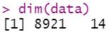

The following feature values ​​can be observed in the data, and these are values ​​that are actually used in clinical practice.

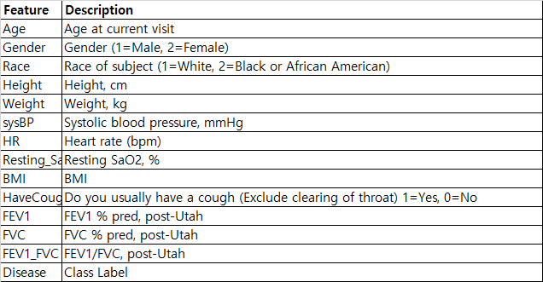

(3) Try to resolve the problems below in this state.

* You can consult with a friend, but copying the R code is absolutely prohibited (It will be shortcut for the F grade).

(4) Please fill in the blanks on the bottom report. Compress and submit this report (.docx), and the entire R-code (.R file) you wrote.

***The R-code should be executable when the TA runs.

***The submitted compressed file (.zip) must be named HW2_YourID_Yourname.zip.

[Q1] It is known by the NIH of the United States that the systolic blood pressure in normal people follows the following distribution: sysBP ~ N($128.65$, $σ$=16.5). Let's perform following hypothesis test under the 5% significance level to find evidence that COVID19 patients are different from the loaded data.
$$H_{0}:Collected Samples are not biased$$
$$H_{1}:CThe sample collected will be different from the population.$$
(1) Test statistics

(4) P-value

(5) Decision Making at 5% significance level
(*) Use all of the "Null hypothesis", "Reject", "Alternative hypothesis", "Select" and "Significance level" terminology to make a statistical conclusion.

[Q2] Under the same circumstances as [Step 1], please try to test statistically whether COVID19 patients show higher systolic blood pressure than known national statistics at 5% significance level.
*Tip: subset() or which() function can be employed to extract COVID19 subjects.
(1) Alternative Hypothesis

(2) Null Hypothesis

(3) Test statistics

(4) P-value

(5) Decision Making at 5% significance level
(*) Use all of the "Null hypothesis", "Reject", "Alternative hypothesis", "Select" and "Significance level" terminology to make a statistical conclusion.

[Q3] According to the National Institutes of Health (NIH) in the United States, heart rate in men is known to follow the distribution: HR_male ~ N(74$.62$, $σ^{2}$=11.1). Based on this, hypothesize and test alternative hypotheses with three different directions at 5% significance level, respectively. Also, please statistically interpret the final outcome clearly through the analysis.
[Answer]

[Q4] Perform the same analysis as in [Q3] at 10% significance level. After that, Please describe what is different from [Q3] and what you can learn from it.
[Answer]

[Q5] In a basic health checkup for Koreans surveyed by Korea's National Health Insurance, resting SaO2 was known to have an average of 96.0245 and a variance of 8.995. Based on this, please do hypothesis test to conclude whether the currently loaded "Data.txt" is an independent population in terms of resting SaO2. Feel free to set the significance level at an acceptable level, but make sure it leads to the correct conclusion statistically cleanly.
[Answer]

