# Question Number 1

# 

# 

# Question number 2

# 

# 

# Question number 4

# 

# 

# Question number 5

# 

# 

# Question number 8

# 

# 

# 

# Question number 3

# 

# 

# Question number 11

# 

# 

# Question number 6

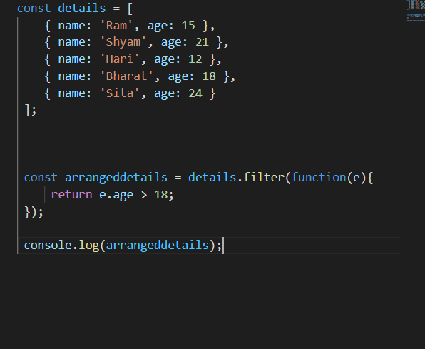

# 

# Question number 7

# 

# 

# 

# 

# Question number 9

# 

# 

# Question number 10

# 

# 