Foundations of Agile and Agile Frameworks

**EXERCISE WORKBOOK**

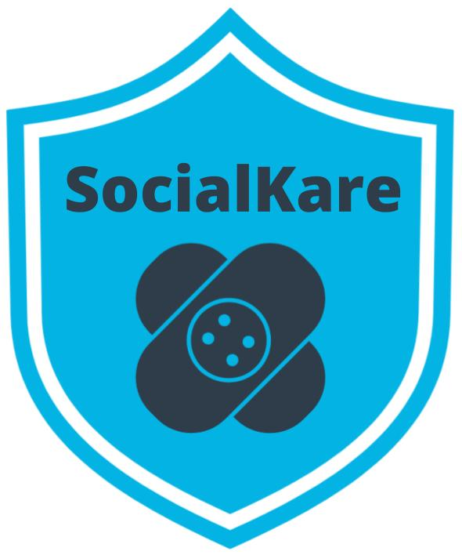



**Table of Contents**

1. SocialKare.gov Case Study

2. Why Agile Exercises

* Agile Mindset Anti-patterns
* Agile Manifesto
* Waterfall vs. Agile
* Setting an Agile Mindset

3. Agile Teams Exercises

* Three Core Roles
* High Performing Teams
* Non-Core Roles
* Agile Decision Making

 4. Agile Frameworks Exercises

* Set Up The Scrum Framework
* Kanban vs. XP
* Recommend a Framework

**Case Study: SocialKare.gov**

SocialKare.gov was launched to allow citizens of Nunamerica to enroll in Social Services provided by the government as a result of a devastating pandemic. Unfortunately, the launch of SocialKare.gov was seen as a disaster from all project management metrics, as well as by its key stakeholders’ low satisfaction ratings.

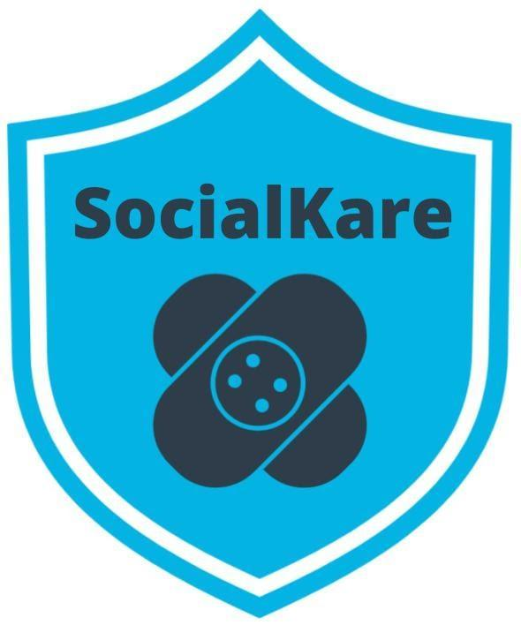

***We will be using this scenario for all of the exercises in this course***

**Independent Investigation**

An independent post-mortem investigation was launched into this project.

The investigation found a pattern of

* poor practices
* lack of clearly identified technical standards
* poor methods to identify software and coding errors.

This led to poor functionality on the website.

During the post-mortem, for virtually every error or gap, the project team claimed it had insufficient time to complete the website by the imposed deadline.

The project was a fixed fee contract with a clearly defined scope of work that was identified up front. As it eventually turned out, this was a complex website with a lot of unrealistic expectations. The multiple government agencies and stakeholders involved handed over a detailed set of inconsistent and difficult to decipher requirements up front. The expectations set for the project team was that they must deliver this content per the defined requirements and contract terms.

An anonymous survey of the team also indicated low morale, stress and employee fatigue.

**8 Key Findings from Independent Investigation**

1. The website launched across all States on the same day. With zero prior experience for citizens who had never used such a website for their important Social Services needs, there was tremendous confusion during the first few days. The system got overwhelmed with users and a multitude of performance issues were reported immediately.
2. Despite following strict government processes, the project developed the website without effective planning or oversight. The government agencies incurred significant cost increases, schedule mistakes and delayed system functionality because of changing requirements at the tail end of the project for functionality that had to go through a stringent change control review. This resulted in significant delays. More agencies were supposed to have input on the development of the website, but the project team did not have a structured approach to obtaining their input.
3. Major coding errors and insufficient capacity for scaling. An investigation identified excessive serious coding flaws in the structure of the website. The project team did not take enough steps to correct the issue until much later in the project life cycle. Some were resolved after going to production. The website was launched with insufficient visitor capacity, leading to further end user frustration. This was captured in the lessons learned session conducted after going to production. There were no Retrospectives and interim lessons learned sessions while the project was underway.
4. Majority of the eligibility requirements were never approved by SocialKare project sponsors and supporting systems integration testing was patchy. The project team claimed they were trying to develop the system in an expedited fashion to meet the deadline so steps ‘had to be missed’. Two months before the scheduled launch, integration tests on the website had not been completed. End-to-end testing, left as the last phase, was never completed before the website launched.
5. Despite thorough documentation and paper trails, oversight was inadequate. Theoretically, a number of governing committees were supposed to oversee the project through quarterly meetings with status updates. The project team spent a significant amount of time keeping up with the required project documents. However, no one raised issues of SocialKare.gov's functionality at the quarterly meetings since neither business representatives nor end user representatives had any hands-on demonstration of functionality that was being built.
6. The project team did not actively engage those business users who best understood the needs of the end users. The project team did not have a formal structure in place to ensure that everyone involved had a shared understanding of all the requirements.
7. While the project team was incentivized to deliver the requirements as specified, due to the time crunch, there was little in the way of ensuring these requirements made business sense throughout the project life cycle. The project team was overwhelmed with an excessive amount of requirements, all flagged as mandatory. What was given as detailed requirements upfront is what the project team worked diligently to deliver. The details were fuzzy in many instances, but the team did not have reliable business representatives readily available to clarify in a timely manner. So, the project team proceeded based on assumptions. It was later realized that several of these requirements were of little value to end users. Further, several key requirements were never uncovered until going to production.
8. Work was assigned by the Project Manager and her boss to the team members at the beginning of the project. Monthly status meetings were conducted by the Project Manager to check on progress based on the defined milestones upfront. Each team member worked on their own list of tasks in silos. The Project Manager monitored everyone’s technical progress individually and stepped in to troubleshoot technical problems. The developers started to depend on the Project Manager’s technical assistance.

**SocialKare.gov Employees**

*This information will be helpful for the Three Core Roles Exercise*

* **John Details**:   
  John is a detail oriented individual who likes to plan everything out in tremendous detail. He has several years of experience as a Technical Project Manager. Prior to stepping into the role of Project Manager, John was a Developer. He is known to have good communication skills.
* **Sarah Tenure**:   
  Sarah has been with the Agency responsible for launching SocialKare.gov for over 2 decades. Sarah has a lot of business knowledge and carries a certain amount of credibility due to this tenure. Sarah is strong headed and likes to make decisions based on how she sees things because she believes she has better insight than others who may have been with the organization for as long as she has.
* **Tim Devs**:   
  Tim has excellent technical skills. He prefers working as an individual contributor where he can spend time diving into the technical challenges on his own. He is well respected for his technical expertise. Tim maintains a strong focus on technical delivery and prefers the business users to stay out of his way while he is working through the development work. Tim leads a team of 5 developers with specialized vertical skills who are also on this project team
* **Jane Dollars**:   
  Jane has sponsored this project. She is a senior executive and likes to stay involved with the day to day activities of projects that she sponsors.

**Why Agile Exercises**

**Agile Mindset Anti-Patterns**

**Instructions:** Read the SocialKare.gov  case study and identify at least three anti-patterns that prevented the Agile mindset from being present. Explain why each anti-pattern is problematic.

|  |  |
| --- | --- |
| **Anti-Pattern** | **Evidence and Results** |
| Collaboration (lack of collaboration) | * More agencies were supposed to have input on the development of the website, but the project team did not have a structured approach to obtaining their input. * However, no one raised issues of SocialKare.gov's functionality at the quarterly meetings * The project team did not actively engage those business users who best understood the needs of the end users. The project team did not have a formal structure in place to ensure that everyone involved had a shared understanding of all the requirements. * The details were fuzzy in many instances, but the team did not have reliable business representatives readily available to clarify in a timely manner. So, the project team proceeded based on assumptions. It was later realized that several of these requirements were of little value to end users. * Monthly status meetings were conducted by the Project Manager to check on progress based on the defined milestones upfront. * Each team member worked on their own list of tasks in silos. * The Project Manager monitored everyone’s technical progress individually and stepped in to troubleshoot technical problems. |
| Focus on Delivering Value (lack of focus on delivering value) | * Major coding errors and insufficient capacity for scaling. An investigation identified excessive serious coding flaws in the structure of the website. The project team did not take enough steps to correct the issue until much later in the project life cycle. Some were resolved after going to production. The website was launched with insufficient visitor capacity, leading to further end user frustration. * supporting systems integration testing was patchy. * The project team claimed they were trying to develop the system in an expedited fashion to meet the deadline so steps ‘had to be missed’. * Two months before the scheduled launch, integration tests on the website had not been completed. * End-to-end testing, left as the last phase, was never completed before the website launched. * oversight was inadequate. * However, no one raised issues of SocialKare.gov's functionality at the quarterly meetings since neither business representatives nor end user representatives had any hands-on demonstration of functionality that was being built. |
| Adaptability to Change (there was a lack of adaptability to change) | * The government agencies incurred significant cost increases, schedule mistakes and delayed system functionality because of changing requirements at the tail end of the project for functionality that had to go through a stringent change control review. This resulted in significant delays. * There were no Retrospectives and interim lessons learned sessions while the project was underway. |
| Continuous Improvement (there was no focus on continuous improvement) | * The system got overwhelmed with users and a multitude of performance issues were reported immediately. * Major coding errors and insufficient capacity for scaling. * The project team did not take enough steps to correct the issue until much later in the project life cycle. Some were resolved after going to production. * The website was launched with insufficient visitor capacity, leading to further end user frustration. * There were no Retrospectives and interim lessons learned sessions while the project was underway. * The project team did not actively engage those business users who best understood the needs of the end users. * While the project team was incentivized to deliver the requirements as specified, due to the time crunch, there was little in the way of ensuring these requirements made business sense throughout the project life cycle. * The details were fuzzy in many instances, but the team did not have reliable business representatives readily available to clarify in a timely manner. So, the project team proceeded based on assumptions. * It was later realized that several of these requirements were of little value to end users. Further, several key requirements were never uncovered until going to production. |

**Agile Manifesto**

**Instructions:** Review the SocialKare.gov case study and review the Agile Manifesto Paired Core Values and Agile Principles.  Of the four Paired Core Values, which stand out as being absent at SocialKare.gov? Which Agile Principles are missing? Identify at least two of each and explain why.

|  |  |
| --- | --- |
| **Missing Paired Core Value** | **Evidence and Results** |
| Individuals and interactions over processes and tools | * More agencies were supposed to have input on the development of the website, but the project team did not have a structured approach to obtaining their input. * However, no one raised issues of SocialKare.gov's functionality at the quarterly meetings * The project team did not actively engage those business users who best understood the needs of the end users. The project team did not have a formal structure in place to ensure that everyone involved had a shared understanding of all the requirements. * The details were fuzzy in many instances, but the team did not have reliable business representatives readily available to clarify in a timely manner. So, the project team proceeded based on assumptions. It was later realized that several of these requirements were of little value to end users. * Monthly status meetings were conducted by the Project Manager to check on progress based on the defined milestones upfront. * Each team member worked on their own list of tasks in silos. * The Project Manager monitored everyone’s technical progress individually and stepped in to troubleshoot technical problems. |
| Working software over comprehensive documentation | * Major coding errors and insufficient capacity for scaling. An investigation identified excessive serious coding flaws in the structure of the website. The project team did not take enough steps to correct the issue until much later in the project life cycle. Some were resolved after going to production. The website was launched with insufficient visitor capacity, leading to further end user frustration. * supporting systems integration testing was patchy. * The project team claimed they were trying to develop the system in an expedited fashion to meet the deadline so steps ‘had to be missed’. * Two months before the scheduled launch, integration tests on the website had not been completed. * End-to-end testing, left as the last phase, was never completed before the website launched. * oversight was inadequate. * However, no one raised issues of SocialKare.gov's functionality at the quarterly meetings since neither business representatives nor end user representatives had any hands-on demonstration of functionality that was being built. * Despite thorough documentation and paper trails, oversight was inadequate. * The project team spent a significant amount of time keeping up with the required project documents. |
| Responding to changes over following a plan | * The government agencies incurred significant cost increases, schedule mistakes and delayed system functionality because of changing requirements at the tail end of the project for functionality that had to go through a stringent change control review. This resulted in significant delays. * There were no Retrospectives and interim lessons learned sessions while the project was underway. * The project team was overwhelmed with an excessive amount of requirements, all flagged as mandatory. * due to the time crunch, there was little in the way of ensuring these requirements made business sense throughout the project life cycle. * The project team claimed they were trying to develop the system in an expedited fashion to meet the deadline so steps ‘had to be missed’. |

|  |  |
| --- | --- |
| **Missing Agile Principle** | **Evidence and Results** |
| Welcome changing requirements, even late in development. Agile processes harness change for the customer's competitive advantage. | * The government agencies incurred significant cost increases, schedule mistakes and delayed system functionality because of changing requirements at the tail end of the project for functionality that had to go through a stringent change control review. This resulted in significant delays. * There were no Retrospectives and interim lessons learned sessions while the project was underway. * The project team was overwhelmed with an excessive amount of requirements, all flagged as mandatory. * due to the time crunch, there was little in the way of ensuring these requirements made business sense throughout the project life cycle. * The project team claimed they were trying to develop the system in an expedited fashion to meet the deadline so steps ‘had to be missed’. |
| Business people and developers must work together daily throughout the project. | * More agencies were supposed to have input on the development of the website, but the project team did not have a structured approach to obtaining their input. * However, no one raised issues of SocialKare.gov's functionality at the quarterly meetings * The project team did not actively engage those business users who best understood the needs of the end users. The project team did not have a formal structure in place to ensure that everyone involved had a shared understanding of all the requirements. * The details were fuzzy in many instances, but the team did not have reliable business representatives readily available to clarify in a timely manner. So, the project team proceeded based on assumptions. It was later realized that several of these requirements were of little value to end users. |
| Working software is the primary measure of progress. | * Major coding errors and insufficient capacity for scaling. An investigation identified excessive serious coding flaws in the structure of the website. The project team did not take enough steps to correct the issue until much later in the project life cycle. Some were resolved after going to production. The website was launched with insufficient visitor capacity, leading to further end user frustration. * supporting systems integration testing was patchy. * The project team claimed they were trying to develop the system in an expedited fashion to meet the deadline so steps ‘had to be missed’. * Two months before the scheduled launch, integration tests on the website had not been completed. * End-to-end testing, left as the last phase, was never completed before the website launched. |

**Agile vs. Waterfall**

**Instructions:** Review the SocialKare.gov case study. Where do you see weaknesses in the Waterfall approach to the SocialKare.gov project being applicable? Identify at least two weaknesses and explain why you see them as weaknesses when compared to the Agile approach for SocialKare.gov.

|  |  |
| --- | --- |
| **Weakness** | **Evidence and Results** |
| Change is a challenge - Waterfall has a stringent change process to the project must go through. | * The government agencies incurred significant cost increases, schedule mistakes and delayed system functionality because of changing requirements at the tail end of the project for functionality that had to go through a stringent change control review. This resulted in significant delays. * The project team claimed they were trying to develop the system in an expedited fashion to meet the deadline so steps ‘had to be missed’.   As indicated in the investigation there was a stringent change control review in place which caused delays in the project timeline and hindered the team’s ability to meet deadline and complete the entire scope of the project, more so due to this change process, the team was not able to add or remove requirements efficiently to allow for a proper delivered project. |
| Distinct phases – the project is broken down into project activities through structured phases. | * Despite following strict government processes, the project developed the website without effective planning or oversight. The government agencies incurred significant cost increases, schedule mistakes and delayed system functionality because of changing requirements at the tail end of the project for functionality that had to go through a stringent change control review. This resulted in significant delays. * Major coding errors and insufficient capacity for scaling. An investigation identified excessive serious coding flaws in the structure of the website. The project team did not take enough steps to correct the issue until much later in the project life cycle. Some were resolved after going to production. The website was launched with insufficient visitor capacity, leading to further end user frustration. * Two months before the scheduled launch, integration tests on the website had not been completed. End-to-end testing, left as the last phase, was never completed before the website launched. * It was later realized that several of these requirements were of little value to end users. Further, several key requirements were never uncovered until going to production.   The project was structured into phases which didn’t allow for the proper testing to be done during the building process to ensure coding standards were being met and a quality product was being delivered. Demos were never conducted and User Testing was never conducted. Due to the phase that testing was being conducting in and the stringent change process which changes had to go through, the team was not able to fully test the system, and fix errors and make adjustments necessary to meet the customer requirements. |
| Limited Synchronization | * Despite following strict government processes, the project developed the website without effective planning or oversight. * More agencies were supposed to have input on the development of the website, but the project team did not have a structured approach to obtaining their input. * There were no Retrospectives and interim lessons learned sessions while the project was underway. * Despite thorough documentation and paper trails, oversight was inadequate. Theoretically, a number of governing committees were supposed to oversee the project through quarterly meetings with status updates. * However, no one raised issues of SocialKare.gov's functionality at the quarterly meetings since neither business representatives nor end user representatives had any hands-on demonstration of functionality that was being built. * The project team did not actively engage those business users who best understood the needs of the end users. The project team did not have a formal structure in place to ensure that everyone involved had a shared understanding of all the requirements. * The details were fuzzy in many instances, but the team did not have reliable business representatives readily available to clarify in a timely manner. So, the project team proceeded based on assumptions. It was later realized that several of these requirements were of little value to end users. Further, several key requirements were never uncovered until going to production. * Monthly status meetings were conducted by the Project Manager to check on progress based on the defined milestones upfront. Each team member worked on their own list of tasks in silos. The Project Manager monitored everyone’s technical progress individually and stepped in to troubleshoot technical problems.   The project manager and stakeholders all had limited collaboration. The team communicated with the project manager and no direct stakeholder input was received by the team. Further, the team operated as individuals only communicating with the project manager and there didn’t appear to have any team collaboration. There were no demos or presentations done during the life cycle of the project and communication with stakeholders which knew what end users need was limited to none. The team had issues understanding requirements and there were no efforts made to communicate these issues with those who could clarify what was needed. |

**Setting An Agile Mindset**

**Instructions:** Review the SocialKare.gov case study. Outline three recommendations to set an Agile Mindset at SocialKare.gov. Consider the Agile Manifesto in your recommendation and avoid the negative pitfalls of Waterfall. Explain why your recommendation will help.

|  |  |
| --- | --- |
| **Recommendation** | **How It Will Help The Team** |
| Collaboration | Collaboration would have allowed the team to operate together and remove the one-on-one management style the project manager used which slowed down the progress of the team. Collaboration would have improved the team’s efficiency. Further, there was a need for collaboration between the team and stakeholders on issues of the requirements which were outlined and the needs of the end users. This communication between the team and stakeholders which had this knowledge would have produced a product that had features that met user requirements and the team would have had a clearer understanding of what needed to be done with the requirements they didn’t understand. |
| Adaptability to Change | There were many issues with change within the project due to the waterfall style of management used, which had stringent change process requirements for requested changes. This caused delays in project and the team fell out of scope. Should there have been a less stringent change process, the team would have had time to make their request and complete the work as a lot of time was spent waiting for these requests to be approved. |
| Focus on Delivering Value | The team was pressed to deliver the product and because of changes in scope and time, they were not focused on delivering a working product that met the requirements outlined or the customers needs. A change in focused to delivering a product of value would have produced a product of value that would have met the customers needs. The team would have conducted proper testing at regular intervals, collaboration with stakeholders to understand requirements and improve on features because they were focused on delivering a product that would be valuable to its end users. |
| Continuous Improvement | The team approached the product delivery with a mindset to deliver the product within a certain timeframe and there was not anything in place to allow the continuous improvement of the product during the various phases of the project. This caused many issues such as coding errors, end to end testing was never completed as well as system integration, the end product had many performance issues and the system could not handle the volume of uses. A mindset of continuous improvement would have caused the team to continuously improve on the product by following general standards of testing to ensure a working product as well as collaboration between the team and stakeholders to find out what end users needed and there would have been demos and user testing to collect feedback on what features should be improved on. |

**Agile Team Exercises**

**Three Core Roles**

**Instructions:** Review the SocialKare.gov case and focus on the employees. Identify the three Agile Core roles and their responsibilities and assign a SocialKare.gov employee to each role. Explain your assignments.

|  |  |  |  |
| --- | --- | --- | --- |
| **Role** | **Responsibilities** | **Employee** | **Justification** |
| Product Owner | Voice of Customer (VOC)  Prioritize Backlog  Share Business Decision and Provide Information | **Sarah Tenure** | Business Acumen  Credibility  Relationship with Business Users |
| Facilitator | Double up as Agile Coach  Facilitating the Agile Team’s work  Protecting from problems | **John Details** | Good communication skills  Experience as a Project Manager helpful |
| The Agile Team | Responsible for Creation and Delivery of solutions | **Tim Devs** | Tim has been indicated as a highly skilled team member who has T-Shaped skills which allow him to operate in a leadership capacity as well |
|  |  |  |  |

**High Performing Agile Teams**

**Instructions:** Review the SocialKare.gov case and focus on the employees. Choose three team members and identify areas where they are not following Agile best practices. Share suggestions for improvement as coaching opportunities and explain why the coaching is needed.

|  |  |  |
| --- | --- | --- |
| **Role/Team Member** | **Coaching Opportunity** | **Justification** |
| Product Owner – Sarah Tenure | Listen to the Agile Team for input  Make final priority decisions  Do not interfere in the Agile Teams technical decisions | Needs to be more collaborative  Let Facilitator run the Ceremonies |
| Facilitator – John Details | Focus on facilitation and not technical solutioning; let the SocialKare.gov team be self-organized and self-directed | Former technical background might inhibit ability to allow the team to be more autonomous  Should not stifle the Agile Team’s innovative and creative side |
| Agile Team – Tim Dev | Allow cross-functional skills development  Collaborate with business | Avoid micromanagement of developers  Give room to innovate |

**Non-Core Roles**

**Instructions:** Review the SocialKare.gov case. Identify at least three non-core roles for the Agile Team. Explain why that role is important to the team’s success.

|  |  |
| --- | --- |
| **Non-Core Role** | **Justification** |
| Government Agencies | These stakeholders have an interest in the product being developed but are not involved in the day to day development of the solution results. |
| Domain Subject Matter Expert | This individual can be very beneficial for the Product Owner, as well as Business Analyst. This person can be called upon as needed to provide Domain knowledge and advice |
| Enterprise Architect | An Enterprise Architect will be a valuable resource for the technical team members to seek guidance and to ensure whatever they develop is in alignment with SocialKare.gov’s enterprise-wide architecture model |
| Jane Dollars - Sponsor | Senior sponsorship is critical to the success of any Agile product delivery. |

**Agile Decision Making**

**Instructions:** Review the SocialKare.gov case study. identify three types of decisions that should be centralized and three that should be decentralized at SocialKare.gov. Explain your recommendations.

|  |  |
| --- | --- |
| **Centralized Decisions** | **Justification** |
|  |  |
|  |  |
|  |  |
| **Decentralized Decisions** | **Justification** |
|  |  |
|  |  |
|  |  |

**Agile Framework Exercises**

**The Benefits of Using Agile Frameworks**

**Instructions:** Review the SocialKare.gov case study. List at least 3 specific benefits of using an Agile Framework and explain how those benefits will help SocialKare.gov achieve its goals.

|  |  |
| --- | --- |
| **Benefit from Using an Agile Framework** | **How The Benefit will Help SocialKare.gov** |
|  |  |
|  |  |
|  |  |
|  |  |

**Set Up the Scrum Framework**

**Instructions:** Review the SocialKare.gov case study. Set up Scrum for the SocialKare.gov team by recommending the core roles to fil and the ceremonies to be conducted. Include the schedule, duration and agenda for each recommended ceremony.

|  |  |
| --- | --- |
| **Role** | **Responsibilities** |
|  |  |
|  |  |
|  |  |

|  |  |  |  |
| --- | --- | --- | --- |
| **Scrum Ceremony** | **Purpose** | **Agenda** | **Schedule and Frequency** |
|  |  |  |  |
|  |  |  |  |
|  |  |  |  |

|  |  |  |  |
| --- | --- | --- | --- |
| **Scrum Ceremony** | **Purpose** | **Agenda** | **Schedule and Frequency** |
|  |  |  |  |
|  |  |  |  |
|  |  |  |  |

**Kanban vs. XP**

**Instructions:** Review the Kanban and XP Frameworks. Identify key differences between the two frameworks in terms of roles, ceremonies and practices.  
  
**Core Roles in Kanban**

|  |  |
| --- | --- |
| **Role** | **Responsibilities** |
|  |  |
|  |  |
|  |  |

**Core Roles in XP**

|  |  |
| --- | --- |
| **Role** | **Responsibilities** |
|  |  |
|  |  |
|  |  |
|  |  |

**Kanban Ceremonies**

|  |  |  |  |
| --- | --- | --- | --- |
| **Ceremony** | **Purpose** | **Agenda** | **Schedule and Frequency** |
|  |  |  |  |
|  |  |  |  |
|  |  |  |  |
|  |  |  |  |

**XP Ceremonies**

|  |  |  |  |
| --- | --- | --- | --- |
| **Ceremony** | **Purpose** | **Agenda** | **Schedule and Frequency** |
|  |  |  |  |
|  |  |  |  |
|  |  |  |  |
|  |  |  |  |
|  |  |  |  |
|  |  |  |  |

|  |
| --- |
| **Key Differences Between Kanban and XP** |
|  |

**Recommend a Framework**

**Instructions:** Review the SocialKare.gov case study and the Scrum, Kanban and XP frameworks. Recommend a framework or combinations of frameworks for SocialKare.gov. Justify your recommendation by listing the specific characteristics of the framework that will bring value to SocialKare.gov.

|  |
| --- |
| **Recommended Framework** |
|  |

|  |  |
| --- | --- |
| **Characteristic** | **Justification** |
|  |  |
|  |  |
|  |  |