Building a Rock-Solid UI Test Framework for FileSharingApp
A Story of Design, Patterns & Power

Introduction: Why This Framework Matters
Testing a web application manually can be slow and error-prone. Our UI Test Framework for FileSharingApp ensures speed, clarity, and maintainability. It leverages modern tools and design principles to deliver robust automated testing.

Architecture Overview
The framework is organized into layers for clarity and scalability:
• Test Layer: Human-readable tests (SmokeUITest, Gherkin feature files)
• Glue Layer: Hooks, runners, listeners—connecting the dots
• Core Layer: The engine (TestBase, DriverFactory, SeleniumActions)
Project Structure:
src/test/java/com.filesharingapp.tests
├─ base → TestBase.java
├─ hooks → CucumberHooks, ExtentStepLogger
├─ listeners → ExtentReportManager, ExtentTestListener
├─ pages → IndexPage.java
├─ runners → CucumberTestRunner, FactoryRunner
├─ steps → FileSharingStepDefs.java
├─ tests → SmokeUITest.java
└─ utils → ConfigReader, DriverFactory, ScreenshotUtil, SeleniumActions
resources/features → file_sharing.feature, config.properties

Scenario Execution Flow
1. TestNG reads testng.xml and runs CucumberTestRunner.
2. Cucumber finds .feature files and maps steps to Java methods.
3. Hooks set up browser and page objects.
4. Steps call IndexPage, which uses SeleniumActions.
5. ExtentReports logs everything with screenshots.
6. ThreadLocal ensures parallel tests don’t clash.

Deep Dive into OOP Concepts

Inheritance
Definition: Allows classes to reuse behavior from parent classes.
Application in Framework: SmokeUITest extends TestBase to reuse setup and teardown logic.
Example:
public class SmokeUITest extends TestBase {
@Test
public void verifyStatusIsNotEmpty() {
String status = indexPage().statusText();
Assert.assertFalse(status.isEmpty());
}
}

Composition
Definition: Classes use other classes to achieve functionality.
Application in Framework: FileSharingStepDefs uses IndexPage via TestBase.
Example:
public class FileSharingStepDefs {
@Given("I open the FileSharing app")
public void openApp() {
TestBase.indexPage().clickStart();
}
}

Encapsulation
Definition: Hides internal details and exposes simple interfaces.
Application in Framework: IndexPage hides locators and Selenium calls.
Example:
public class IndexPage {
private By startButton = By.id("start");
public void clickStart() {
SeleniumActions.click(startButton);
}
}

Factory Pattern
Definition: Creates objects without exposing creation logic.
Application in Framework: DriverFactory decides which browser to create.
Example:
public class DriverFactory {
public static WebDriver create(String browser) {
if (browser.equalsIgnoreCase("chrome")) {
WebDriverManager.chromedriver().setup();
return new ChromeDriver();
} else {
WebDriverManager.edgedriver().setup();
return new EdgeDriver();
}
}
}

Page Object Model
Definition: Separates UI locators from test logic.
Application in Framework: Keeps tests clean and readable.
Example:
Feature: File Sharing
Scenario: Share a file successfully
Given I open the FileSharing app
When I choose a file and click start
Then I should see status as "Success"

Observer Pattern
Definition: Objects subscribe to events and react.
Application in Framework: Listeners update reports when events occur.
Example:
public class ExtentTestListener implements ITestListener {
public void onTestSuccess(ITestResult result) {
ExtentReportManager.getReporter().log(Status.PASS, "Test Passed");
}
}

ThreadLocal
Definition: Provides thread confinement for variables.
Application in Framework: Each thread gets its own WebDriver.
Example:
private static ThreadLocal<WebDriver> TL_DRIVER = new ThreadLocal<>();
public static WebDriver getDriver() {
return TL_DRIVER.get();
}

Infographic
Below is the visual summary of the architecture and OOP concepts:
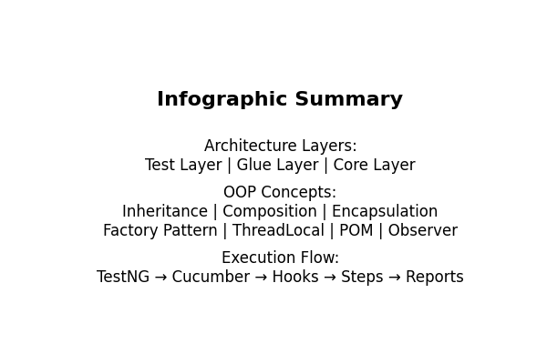

Additional Examples
Gherkin Feature Example:
Feature: File Sharing
Scenario: Upload a file
Given I open the FileSharing app
When I upload "sample.txt"
Then I should see status as "Uploaded"
Corresponding Step Definition:
@When("I upload {string}")
public void uploadFile(String fileName) {
TestBase.indexPage().chooseFile(fileName);
}

Benefits and Best Practices
• Scalable and maintainable architecture
• Clear separation of concerns
• Easy onboarding for new testers
• Robust parallel execution
• Leverages proven design patterns and OOP principles

