UNIVERSITY OF JAMMU

BHADERWAH CAMPUS



BACHELORS IN COMPUTER APPLICATIONS

(BCA-2ND SEMESTER 2025-29)

PRACTICAL FILE

INTRODUCTION TO DATA SCIENCE
SUBMITTED BY: SUBMITTED TO:

GAZALA TABASSUM MS. JAHANVI KOTWAL
(Course coordinator)
Dept. of CS and IT

ACKNOWLEDGEMENT
I would like to express my gratitude to all those people who helped me to complete this practical file. I want to thank Department of computer science and IT for providing me all the tools and resources for the completion of my practical file.
I have further more to thank our respected teacher MS. JAHANVI KOTWAL who encouraged me to move ahead and complete my work in time.
THANK YOU

GAZALA TABASSUM
BCA 2nd semester
377007010

CERTIFICATE

This is to certify that GAZALA TABASSUM student of BCA 2nd semester bearing university Roll no. 377007010 has completed that required number of practical of INTRODUCTION TO DATA SCIENCE under the guidance of class teacher MS. JAHANVI KOTWAL from the Department of Computer science and IT, Bhaderwah campus, University of Jammu.

Signature. Signature.

(I/C course coordinate) (Practical I/C )

INDEX

1-WAP TO ADD TWO NUMBERS.

# Taking input from user
num1 = int(input("Enter first number: "))
num2 = int(input("Enter second number: "))

# Adding the numbers
sum = num1 + num2

# Displaying the result
print("The sum is:", sum)

OUTPUT=

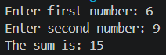

2-WAP TO FIND SQUARE AND CUBE OF A NUMBER.
# Taking input from user
num = int(input("Enter a number: "))
# Calculating square and cube
square = num * num
cube = num * num * num

# Displaying results
print("Square is:", square)
print("Cube is:", cube)

OUTPUT=
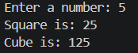

3-WAP TO SWAP TWO NUMBERS.

a = int(input("Enter first number: "))
b = int(input("Enter second number: "))

# Swapping
temp = a
a = b
b = temp

# Displaying result
print("After swapping:")
print("a =", a)
print("b =", b)

OUTPUT=

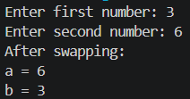

4-WAP TO CHECK ODD OR EVEN .

# Taking input from user
num = int(input("Enter a number: "))
# Checking condition
if num % 2 == 0:
print("The number is Even")
else:
print("The number is Odd")

OUTPUTS=

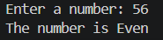

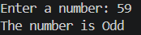

5- WAP TO CHECK PRIME NUMBER.

# Taking input from user
num = int(input("Enter a number: "))
# Checking prime condition
if num > 1:
for i in range(2, num):
if num % i == 0:
print("The number is not Prime")
break
else:
print("The number is Prime")
else:
print("The number is not Prime")

OUTPUTS=

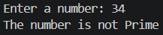

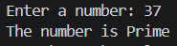

6-WAP TO FIND FACTORIAL OF A NUMBER.
# Taking input from user
num = int(input("Enter a number: "))
fact = 1
# Checking if number is negative
if num < 0:
print("Factorial does not exist for negative numbers")
elif num == 0:
print("Factorial of 0 is 1")
else:
for i in range(1, num + 1):
fact = fact * i
print("Factorial is:", fact)

OUTPUT=

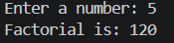

7-WAP TO GENERATE FIBONACCI SERIES.

# Taking input from user
n = int(input("Enter number of terms: "))
# First two terms
a = 0
b = 1
print("Fibonacci Series:")
for i in range(n):
print(a, end=" ")
c = a + b
a = b
b = c

OUTPUT=

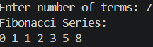

8- WAP TO FIND SUM OF N NATURAL NUMBERS.

# Taking input from user
n = int(input("Enter a number: "))
sum = 0
# Using loop
for i in range(1, n + 1):
sum = sum + i

print("Sum is:", sum)

OUTPUT=

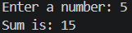

9-WAP TO FIND LARGEST OF THREE NUMBERS.

# Taking input from user
a = int(input("Enter first number: "))
b = int(input("Enter second number: "))
c = int(input("Enter third number: "))

# Checking largest number
if a >= b and a >= c:
print("Largest number is:", a)
elif b >= a and b >= c:
print("Largest number is:", b)
else:
print("Largest number is:", c)

OUTPUT=

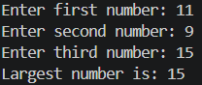

10-WAP TO CHECK ARMSTRONG NUMBER.

# Taking input from user
num = int(input("Enter a number: "))

# Storing original number
temp = num
sum = 0

# Finding number of digits
n = len(str(num))

# Calculating sum of digits raised to power n
while temp > 0:
digit = temp % 10
sum = sum + digit ** n
temp = temp // 10

# Checking result
if sum == num:
print("The number is an Armstrong number")
else:
print("The number is not an Armstrong number")

OUTPUT=

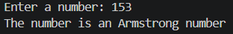

11-WAP TO PRINT MULTIPLICATION TABLE
# Taking input from user
num = int(input("Enter a number: "))

# Printing table
for i in range(1, 11):
print(num, "x", i, "=", num * i)

OUTPUT=

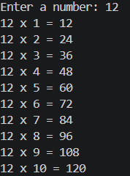

12- WAP TO COUNT DIGITS IN A NUMBER.

# Taking input from user
num = int(input("Enter a number: "))

count = 0

# Counting digits
while num != 0:
num = num // 10
count += 1

print("Number of digits:", count)

OUTPUT=

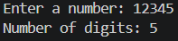

13-WAP TO REVERSE A NUMBER.

# Taking input from user
num = int(input("Enter a number: "))
rev = 0
# Reversing the number
while num != 0:
digit = num % 10
rev = rev * 10 + digit
num = num // 10

print("Reversed number is:", rev)

OUTPUT=

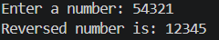

14- WAP TO CHECK PALINDROME NUMBER.

# Taking input from user
num = int(input("Enter a number: "))

# Store original number
temp = num
rev = 0

# Reverse the number
while num != 0:
digit = num % 10
rev = rev * 10 + digit
num = num // 10

# Check palindrome
if temp == rev:
print("The number is a Palindrome")
else:
print("The number is not a Palindrome")

OUTPUT=

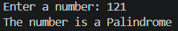

15- WAP TO CHECK PALINDROME STRING.

# Taking input from user
text = input("Enter a string: ")

# Checking palindrome
if text == text[::-1]:
print("The string is a Palindrome")
else:
print("The string is not a Palindrome")

OUTPUT=

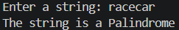

16- WAP TO REVERSE A STRING.

# Taking input from user
text = input("Enter a string: ")

# Reversing string
rev = text[::-1]

print("Reversed string is:", rev)

OUTPUTS=

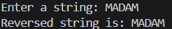

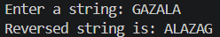

17-WAP TO COUNT VOWELS AND CONSONANTS.
# Program to count vowels and consonants

# Taking input from user
text = input("Enter a string: ")

vowels = 0
consonants = 0

# Checking each character
for ch in text:
if ch.isalpha(): # check only alphabets
if ch.lower() in 'aeiou':
vowels += 1
else:
consonants += 1

print("Vowels:", vowels)
print("Consonants:", consonants)

OUTPUT=

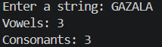

18-WAP TO COUNT FREQUENCY OF CHARACTERS IN A STRING.

# Taking input from user
text = input("Enter a string: ")
freq = {}

# Counting frequency
for ch in text:
if ch in freq:
freq[ch] += 1
else:
freq[ch] = 1

# Display result
print("Character Frequencies:")
for key, value in freq.items():
print(key, ":", value)

OUTPUT=

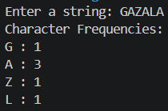

19-WAP TO REMOVE SPACES FROM A STRING.

text = input("Enter a string: ")

result = ""
for ch in text:
if ch != " ":
result += ch

print("String without spaces:", result)

OUTPUT=

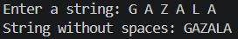

20-WAP TO CHECK IF TWO STRINGS ARE ANAGRAMS.

# Taking input from user
str1 = input("Enter first string: ")
str2 = input("Enter second string: ")

# Removing spaces and converting to lowercase
str1 = str1.replace(" ", "").lower()
str2 = str2.replace(" ", "").lower()

# Checking anagram
if sorted(str1) == sorted(str2):
print("The strings are Anagrams")
else:
print("The strings are not Anagrams")

OUTPUT=
