**Assignment 1**

**Write algorithms and flowchart for the following programs.**

1. **Check if the given number is EVEN or ODD.**

Ans: Algorithm:

Step1: assign n= number to be check

Step2: Divide n by 2.

Step3: If remainder of the division in step2 is 0, then n is even else odd.

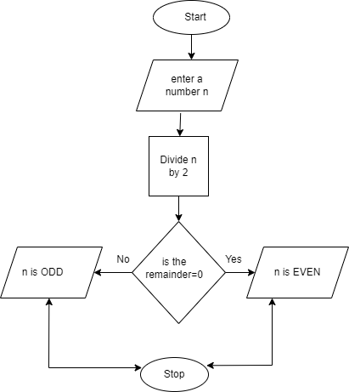

1. **Program to find the factorial of a given number.**

Ans: Algorithm:

Step1: assign n= number

Step2: assign m=1

Step3: assign i=1

Step4: assign m=m*i

Step5: repeat step4 for i=2, 3, 4 ...n.

Step6: print out m value.

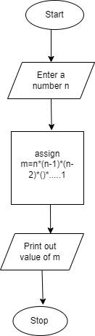

**5. Check whether a given number is positive or negative.**

Ans: Algorithm:

Step1: assign n= number

Step2 compare n with 0.

Step3: if n>0, number is positive

Step4: if n<0, number is negative

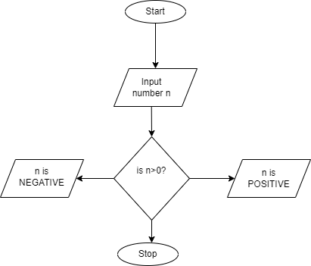

6. **Program to find whether a given number is leap year or not.**

Ans: Algorithm:

Step1: enter a year

Step2: divide the year by 4

Step3: if remainder is 0, the year is a leap year else not.

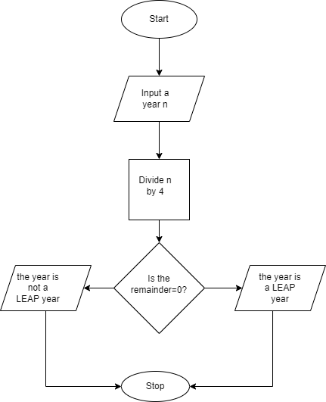

9. **Program to print all the factors of a number.**

Ans: Algorithm:

Step1: input a number n

Step2: divide n by 2, 3, 4....n

Step3: if remainder is not equal to zero, skip that divisor.

Step4: print all the divisor whose remainder is zero.

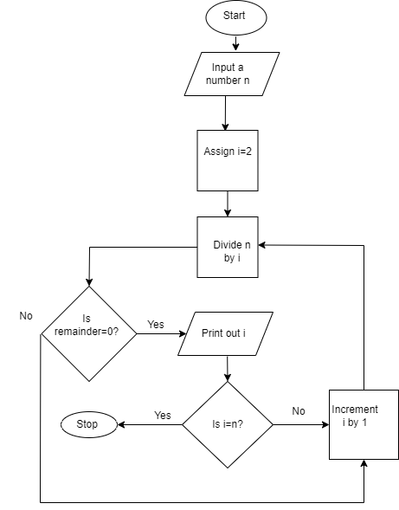

**11. Program to find the smallest of 3 number(a,b,c).**

Ans: Algorithm:

Step1. Input three numbers a,b,c

Step2: if a>b, compare b with c else compare a with c

Step3: if c<b, c is smallest else b is smallest

Step4: if c<a, c is smallest else a is smallest

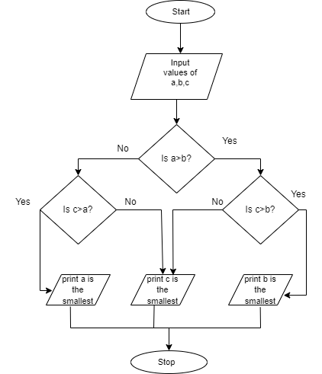

18. **Program to print all the prime factors of a given number.**

Ans: Algorithm:

Step1: Input n= a number

Step2: Divide n by i=2, 3, 4...n iteratively.

Step3: assign i= those value for which the remainder is 0 iteratively.

Step4: divide i by i-j where j =1, 2, 3,...i for each iterations

Step5: print out those values of i for whose remainders are not zero in step4.

Step6: values of i from step5 are the prime factors of the number.

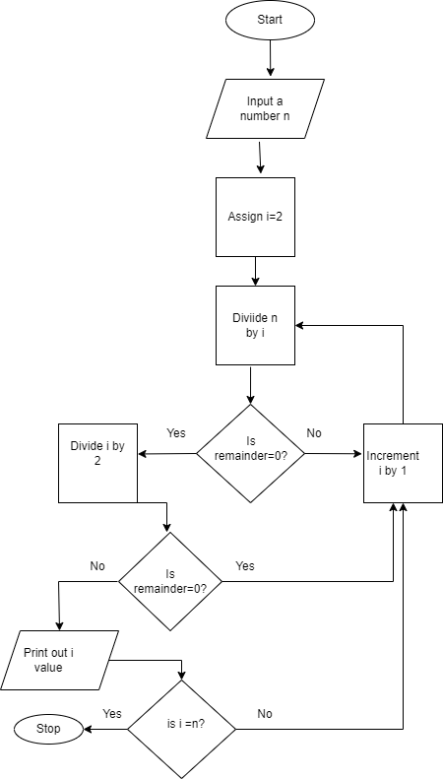

**19. program to print EVEN series 2, 4, 6, ,8, 10, 12, 14…..**

Ans: Algorithm:

Step1: assign i=2

Step2: increment i by 2

Step3: Repeat Step2 and print out all the cumulative values of i.

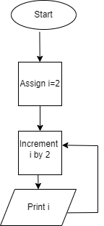

**20. Program to print ODD series 1, 3, 5,7, 9, 11,. . . . . .**

Ans: Algorithm:

Step1: assign i=1

Step2: increment i by 2

Step3: Repeat Step2 and print out all the cumulative values of i.

