“Hostel Connect – Hostel & Mess Management System”
A Project Report Submitted in the partial fulfillment of the requirements for the award of the degree of
BACHELOR OF TECHNOLOGY
In
DEPARTMENT OF COMPUTER SCIENCE ENGINEERING
&
DEPARTMENT OF COMPUTER SCIENCE AND INFORMATION TECHNOLOGY
By
C. DHANUSH CHANDRA 2520030014
R. VARSHITH REDDY 2520030250
PRANAV CHOWDARY 2520030555
Under the Esteemed Guidance of
Dr. D. Ramya Krishna
Instructor & Guide
Department of Computer Science and Engineering


Academic Year 2026–2027

K L (Deemed to be) University
DEPARTMENT OF COMPUTER SCIENCE ENGINEERING
Declaration
The Project Report entitled “Hostel Connect – Hostel & Mess Management System” is a record of bonafide work carried out by PRANAV CHOWDARY – 2520030555, R. VARSHITH REDDY – 2520030250, and DHANUSH CHANDRA – 2520030014, submitted in partial fulfillment of the academic requirements for the DBSE & DBD course under the Department of Computer Science Engineering, K L (Deemed to be) University. The project presents the analysis, design, implementation and testing of a database-driven hostel and mess management platform.
The work demonstrates the application of relational database concepts, MySQL programming, SQL queries, database design, backend integration and web application development. The project has been developed for academic evaluation and represents the work performed by the project team. The results and documentation presented in this report have not been copied from another department, university or institute.
We accept responsibility for the accuracy of the project implementation and documentation submitted for academic review.
PRANAV CHOWDARY – 2520030555
R. VARSHITH REDDY – 2520030250
DHANUSH CHANDRA – 2520030014
Student Signatures
Name | Signature
Pranav Chowdary | ____________________________
R. Varshith Reddy | ____________________________
Dhanush Chandra | ____________________________

K L (Deemed to be) University
DEPARTMENT OF COMPUTER SCIENCE ENGINEERING
CERTIFICATE
This is to certify that the project report entitled “Hostel Connect – Hostel & Mess Management System” is a bonafide work done and submitted by PRANAV CHOWDARY (2520030555), R. VARSHITH REDDY (2520030250), and DHANUSH CHANDRA (2520030014), in partial fulfillment of the academic requirements for the DBSE & DBD course in the Department of Computer Science Engineering, K L (Deemed to be) University, during the academic year 2026–2027.
The project demonstrates the practical application of relational database design, MySQL programming, SQL queries, primary and foreign keys, normalization, backend integration, role-based access and web application development. The work has been carried out under the guidance and supervision of the faculty mentioned below and is submitted for academic review and evaluation.
Role | Name | Signature
Instructor & Guide | Dr. D. Ramya Krishna | ________________________
Course Coordinator | Dr. R. Sateesh Kumara | ________________________
HOD / Department | Department of CSE | ________________________

Date: ____________________ Place: ____________________

ACKNOWLEDGEMENT
The successful completion of the Hostel Connect – Hostel & Mess Management System project would not have been possible without the guidance, support and encouragement of many people. We express our sincere gratitude to everyone who assisted us directly or indirectly throughout the planning, development, testing and documentation of this project.
We would like to express our deepest appreciation to our Instructor & Guide, Dr. D. Ramya Krishna, for providing valuable technical guidance, constructive suggestions and continuous encouragement. Her guidance helped us understand how database design principles could be applied to a practical hostel and mess management problem and helped us improve the quality of our implementation.
We sincerely thank our Course Coordinator, Dr. R. Sateesh Kumara, for providing the academic direction required for the DBSE & DBD project and for helping us understand the documentation, review and evaluation requirements. His coordination helped us organize the project work and maintain focus on the learning outcomes of the course.
We are grateful to the Department of Computer Science Engineering and K L (Deemed to be) University for providing the laboratory facilities, software resources and learning environment needed to design, implement and test the application. We also thank the teaching and non-teaching staff members for their assistance whenever required.
Finally, we thank our teammates, classmates, friends and family members for their cooperation, feedback and encouragement during database design, coding, debugging, testing and preparation of this report.
PRANAV CHOWDARY – 2520030555
R. VARSHITH REDDY – 2520030250
DHANUSH CHANDRA – 2520030014

ABSTRACT
Hostel Connect – Hostel & Mess Management System is a database-driven web application designed to centralize hostel accommodation, room allocation, mess operations, fee management, maintenance grievances and communication in one platform. The system addresses common limitations of manual hostel administration such as duplicated records, slow searches, inconsistent occupancy information, difficulty tracking payments and delayed complaint resolution. The public portal presents rooms and PGs, system features, mess and dining information and fee structure information, while authenticated users can access role-specific services.
The proposed platform combines a React/Vite frontend, a Node.js/Express backend and a MySQL relational database. The frontend handles page rendering and navigation, the backend exposes API endpoints and applies authentication and authorization, and MySQL stores persistent records. The database includes users, hostels, rooms, students, allocations, mess records, menus, meal attendance, fees, complaints, announcements and notifications. Primary keys identify records and foreign keys maintain relationships between dependent entities.
The project demonstrates DBSE & DBD concepts including entity identification, ER modelling, primary and foreign keys, normalization, DDL, DML, DQL, joins, aggregate functions, constraints and transactions. The system is structured so that future features such as online payments, biometric or QR meal attendance, mobile applications, advanced analytics, external notifications and cloud deployment can be added without replacing the core relational model.
Keywords: Hostel Management, Mess Management, MySQL, DBSE, DBD, React, Vite, Node.js, Express, SQL, Room Allocation, Fees, Complaints.

INDEX
S. No. | Chapter / Section | Page No.
1 | Acknowledgement | 4
2 | Abstract | 5
3 | 1. Introduction | 9–13
4 | 2. System Requirements | 14–15
5 | 3. Technology Stack | 16–17
6 | 4. System Architecture | 18–22
7 | 5. Database Design | 23–26
8 | 6. Implementation | 27–33
9 | 7. Features & SQL | 34–37
10 | 8. Testing | 38–39
11 | 9. Deployment & Execution | 40–42
12 | 10. Challenges, Limitations & Security | 43–44
13 | 11. Future Enhancements | 45–47
14 | 12. Conclusion | 48–49
15 | 13. References | 50
16 | 14. Appendices & User Guide | 51–55

The page numbers above follow the final formatted sequence of this report. Small shifts may occur if institutional printing settings or margins are changed.

DBSE & DBD CONCEPT MAPPING
Concept | How Hostel Connect Demonstrates It
Entity Identification | Users, Hostels, Rooms, Students, Allocations, Fees, Mess, Complaints and Announcements
Keys | Primary keys identify records; foreign keys connect related entities
Normalization | Master and transaction data are separated to reduce redundancy
SQL | DDL, DML, DQL, joins, grouping, aggregate functions and transactions
Integrity | NOT NULL, UNIQUE, foreign-key and application-level validation
Application Integration | React/Vite → Express API → MySQL relational database

INDEX – CONTINUED
Chapter | Detailed Topics
1 | 1.1 Background; 1.2 Problem Statement; 1.3 Scope; 1.4 Objectives; 1.5 Importance; 1.6 Users; 1.7 Existing System; 1.8 Proposed System; 1.9 Functional Requirements
2 | 2.1 Hardware; 2.2 Software; 2.3 Development Tools; 2.4 Non-Functional Requirements
3 | 3.1 Technology Overview; 3.2 React/Vite; 3.3 Node/Express; 3.4 MySQL
4 | 4.1 Architecture; 4.2 Block Diagram; 4.3 DFD; 4.4 Request Flow; 4.5 Deployment
5 | 5.1 Entities; 5.2 ER Diagram; 5.3 Schema; 5.4 Keys; 5.5 1NF; 5.6 2NF/3NF; 5.7 Data Dictionary
6 | 6.1 Folder Structure; 6.2 Authentication; 6.3 Authorization; 6.4 Rooms; 6.5 Allocation; 6.6 Students; 6.7 Mess; 6.8 Menu; 6.9 Meal Attendance; 6.10 Fees; 6.11 Payments; 6.12 Complaints; 6.13 Announcements; 6.14 Metrics
7 | 7.1 Home; 7.2 Rooms & PGs; 7.3 Features; 7.4 CRUD; 7.5 DDL; 7.6 DML; 7.7 DQL; 7.8 Joins; 7.9 Views/Procedures/Triggers
8 | 8.1 Testing Strategy; 8.2 Test Cases; 8.3 API Testing; 8.4 Database Testing
9 | 9.1 MySQL Setup; 9.2 Backend Setup; 9.3 Frontend Setup; 9.4 Environment; 9.5 Troubleshooting
10 | 10.1 Challenges; 10.2 Solutions; 10.3 Limitations; 10.4 Security
11 | 11.1 Payments; 11.2 Biometric/QR Meals; 11.3 Mobile App; 11.4 Analytics; 11.5 Notifications; 11.6 Cloud
12 | 12.1 Summary; 12.2 Achievements; 12.3 DBSE & DBD Learning Outcomes
13–14 | References; SQL Appendix; User Guide; Project Review / Signature Page

Project evidence and diagrams are included in the later chapters and appendices. The database design sections are intentionally detailed because the project is submitted under DBSE & DBD.

PROJECT REVIEW / SIGNATURE PAGE
Project: Hostel Connect – Hostel & Mess Management System
Course: DBSE & DBD
Department: Computer Science Engineering
Team: Pranav Chowdary, R. Varshith Reddy, Dhanush Chandra
Roll No. | Name | Signature
2520030555 | Pranav Chowdary | ____________________________
2520030250 | R. Varshith Reddy | ____________________________
2520030014 | Dhanush Chandra | ____________________________

Instructor & Guide: Dr. D. Ramya Krishna
Course Coordinator: Dr. R. Sateesh Kumara
Review Date: ____________________
This page is reserved for formal project review remarks and signatures. The final submitted report should be accompanied by the required institutional review documentation.

REVIEW REMARKS
Review Item | Remarks / Signature
Problem Statement Review | ______________________________________________
Database / ER Design Review | ______________________________________________
MySQL Implementation Review | ______________________________________________
Frontend / Backend Review | ______________________________________________
Final Demonstration Review | ______________________________________________
Evaluation coverage: Problem statement • Requirements • ER model • MySQL schema • SQL queries • Full-stack integration • Testing • Documentation

CHAPTER – 1 INTRODUCTION
1.1 Background of the Project
Hostel administration combines accommodation, resident records, dining services, fee collection, maintenance and communication. In a campus environment, these activities change every day: students join or leave, rooms become vacant, meals are planned, fees become due and maintenance requests are raised. A database-driven system is therefore useful because the same resident information can be connected across multiple operations without maintaining separate registers.
Hostel Connect addresses this requirement by providing a single portal for accommodation and mess management. The public interface presents rooms and PG options, system features, mess and dining information, fee structure information and navigation to role-specific services. The implementation shown by the project uses React/Vite for the frontend, Node.js and Express for the application layer, and MySQL for persistent relational storage.
From the DBSE and DBD perspective, the project is a practical case study in identifying entities, defining relationships, choosing primary and foreign keys, reducing redundancy through normalization and writing SQL for operational reports. The system also demonstrates how a database becomes the central source of truth for a full-stack application.
1.2 Problem Statement
Manual or fragmented hostel administration can produce duplicated records, slow searches and inconsistent information. A student may have one record for personal details, another for room allocation and another for fee status. If these records are not synchronized, staff may spend time checking multiple sources before answering a simple question such as which bed is vacant or whether a resident has pending dues.
Room occupancy is especially important because the number of residents cannot exceed physical capacity. Mess management introduces another recurring requirement because menus and meal sessions are associated with dates and meal types. Complaints also require a history of status changes so that maintenance work can be assigned and tracked.
Hostel Connect solves the core problem by connecting these activities through a relational database and backend API. Instead of treating each operation as an isolated form, the application links users, students, hostels, rooms, allocations, fees, mess records, complaints and announcements. This makes information easier to retrieve, validate and report.
A useful way to express the problem technically is as a consistency problem. The same real-world event, such as a room transfer or payment, affects more than one record. If the records are updated independently, the system can enter an inconsistent state. The proposed application reduces this risk by making the backend responsible for related changes and by using foreign keys and transactions at the database layer.
In practical use, the value of the system comes from the relationships between these operations. A student should not have to register separately for room information, fee information and complaint services. Once the identity is established, the database can provide the related records through foreign keys. This reduces repeated data entry and gives administrators a consistent view of the resident. The same design also supports reporting because a single query can combine student, hostel and room information when required.

CHAPTER – 1 INTRODUCTION
1.3 Scope of the Project
The scope of Hostel Connect covers the main information and workflows needed by a hostel and mess management environment. Accommodation functions include hostel listings, room types, capacity, occupancy, availability and allocation. Student functions include resident records and their association with a hostel. Management functions include fees, mess information, complaints, announcements and metrics.
The database scope is broader than the public website because it also supports backend operations. Tables can store authentication information, hostel master data, room details, allocation history, fee records, menu information, meal attendance, complaints, announcements and notifications. Relationships between these tables make it possible to produce combined reports without copying the same information into many places.
The current project is an academic prototype and local full-stack implementation. Production integrations such as online payment gateways, biometric meal attendance, SMS services and cloud-scale monitoring are treated as future extensions. The current scope is sufficient to demonstrate the database concepts required for DBSE and DBD.
1.4 Objectives
The first objective is to design a centralized relational database for hostel and mess information. The schema should represent users, hostels, rooms, students and operational transactions in a consistent manner. Each important entity receives a primary key, while dependent records reference parent entities through foreign keys.
The second objective is to provide useful application workflows. These include room and bed allocation, mess and menu management, fee tracking, complaint registration, announcements and role-specific dashboards. The interface should expose information in a form that is easy for students and staff to understand while the backend enforces the business rules.
The third objective is academic: to demonstrate practical use of SQL and database design. The project supports DDL commands for creating tables, DML commands for inserting and updating records, DQL commands for retrieving information, joins for combining related tables, aggregate functions for reports, and transactions for multi-step operations.
• Centralized relational database
• Reliable allocation and capacity checks
• Mess, fee and complaint workflows
• Role-specific access and SQL reporting
Each objective can be mapped to a measurable implementation result. The database objective is demonstrated through schema.sql and sample_data.sql. The allocation objective is demonstrated through room, student and allocation relationships. The service objective is demonstrated through fee, mess and complaint modules. The reporting objective is demonstrated through SQL joins, grouping and aggregate queries.
The scope can be viewed as a set of connected modules rather than isolated screens. Accommodation provides the master data for hostels and rooms; student records identify residents; allocations connect residents to rooms; fees and mess records capture recurring services; complaints and announcements support communication and resident care. The same database can therefore serve both public information pages and authenticated management dashboards.

CHAPTER – 1 INTRODUCTION
1.5 Importance of the Application
A hostel system is information-intensive because many operational records are related to the same student. A database-backed application reduces the need to maintain independent copies of information. For example, the student identity can remain in one table while room allocation, fees and complaints reference that identity.
The application also improves visibility. A room record can expose capacity, current occupancy, status, room type and price. A fee record can represent the amount, due date and payment status. A complaint can represent the category, priority, assigned staff member and current status. These details become searchable and reportable.
The importance is also educational. Hostel Connect provides a realistic environment for applying database principles rather than learning SQL only through isolated examples. The project connects conceptual topics such as entity relationships and normalization to visible features such as room availability, fee summaries and complaint dashboards.
1.6 Target Users and Stakeholders
Students are the primary resident users. They need to view accommodation information, understand room availability, see mess and dining information, check fees and raise maintenance issues. Their access should be limited to information and actions appropriate to their own records.
Wardens and hostel staff are operational users. They need to view residents, rooms, allocations, complaints, announcements and mess-related information. Their permissions are broader than those of students because they are responsible for day-to-day hostel operations.
Administrators have the widest management scope. They may maintain user accounts, hostel master data, room records, fee structures, announcements and metrics. The role-based design ensures that one user type does not automatically receive every permission in the system.
Different roles also imply different data views. A student normally needs personal and resident-level information, while a warden needs hostel-wide operational data and an administrator may need system-wide information. Designing the database and API around these access levels reduces unnecessary exposure of information and keeps the user interface focused.
The application becomes more valuable as the number of residents increases because the cost of manual searching grows with data volume. A database query can retrieve hundreds of related records consistently, while an administrator working with separate spreadsheets may have to reconcile several files. Centralized storage therefore improves both speed and consistency.

CHAPTER – 1 INTRODUCTION
1.7 Existing System
In a conventional hostel environment, records may be maintained using registers, spreadsheets, printed forms and separate files. Such methods can work for a small number of residents but become difficult to manage as the number of rooms and transactions increases. Searching for historical information can also take considerable time.
A fragmented system creates another issue: the same student information may be copied into several places. When a room changes or a payment is made, each copy must be updated. If one copy is missed, reports become inconsistent. Manual calculation of occupancy and outstanding fees also increases the chance of errors.
These limitations motivate a centralized database. Hostel Connect stores related information once and uses relationships to retrieve it where needed. The backend can apply validation before data is inserted or updated, while SQL queries can calculate operational summaries.
1.8 Proposed System
The proposed Hostel Connect platform uses a three-layer architecture. The presentation layer is implemented with React and Vite. It provides public pages and role-specific dashboards. React Router manages navigation while reusable components keep common interface elements consistent.
The application layer uses Node.js and Express. Routes receive HTTP requests and pass them to controllers. Middleware can authenticate requests and enforce role permissions. Controllers execute parameterized SQL queries through the database connection and return structured responses to the frontend.
The database layer is MySQL. It stores persistent records and enforces relational constraints. This separation of concerns makes the system easier to maintain because interface changes do not require redesigning the database, and database queries can be modified without rewriting the complete user interface.
The proposed architecture also creates a clear validation boundary. React can validate forms for usability, but the Express backend performs the authoritative checks before writing data. MySQL then enforces structural constraints. This three-level approach means that a user cannot bypass an important rule simply by sending a request directly to the API.
The main weakness of the existing approach is not simply the use of paper or spreadsheets; it is the lack of controlled relationships. A spreadsheet may show a room as available even after a separate register has allocated it. A fee sheet may not immediately reflect a student's current room. A complaint may be recorded in a message without a formal status. These gaps make reconciliation difficult.
CHAPTER – 1 INTRODUCTION
1.9 Functional Requirements
The system must support user registration and login, role-based access, hostel and room information, student records and room allocation. It must also support mess and menu information, fee tracking, complaint ticketing, announcements and administrative metrics.
Functional requirements describe what the system should do. For example, a student should be able to view available rooms, while an authorized administrator should be able to create or modify hostel and room information. A warden should be able to process operational requests related to residents and complaints.
Each functional requirement is mapped to database entities and backend operations. This traceability is important because a feature is complete only when its user interface, API and database operation work together. Validation is applied at both the application and database levels where appropriate.
• Authentication and registration
• Hostel and room management
• Student and allocation management
• Mess, fees, complaints and announcements
During review, each requirement can be demonstrated through a user scenario. The reviewer can log in, explore a room, check the related data, perform an allowed action and then verify the corresponding database change. This provides stronger evidence than showing only the user interface.
Functional requirements should be traceable to a database operation. Registration creates a user record, login reads a user record, room listing reads room and hostel records, allocation creates a transaction and updates occupancy, fee management reads and updates fee records, and complaint management creates and updates ticket records. This mapping helps the team identify missing backend endpoints.

CHAPTER – 2 SYSTEM REQUIREMENTS
2.1 Hardware Requirements
The project can be developed on a standard laptop or desktop computer. A multi-core processor, at least 8 GB RAM and sufficient storage are suitable for running Visual Studio Code, a browser, Node.js and MySQL simultaneously. A stable local network is useful when testing API calls between frontend and backend.
For demonstration, the system can run entirely on one development machine. The browser acts as the client, the Express server runs locally, and MySQL stores the database. This arrangement is convenient for academic evaluation because all components can be inspected and tested without requiring cloud infrastructure.
For larger deployments, server resources should be sized according to concurrent users, database workload, storage requirements and backup policies. The project architecture allows these components to be separated later without changing the fundamental relational model.
2.2 Software Requirements
The implementation uses a modern browser for the frontend, Node.js and npm for the backend and package management, Visual Studio Code as the development environment, and MySQL Server for relational storage. MySQL Workbench or the MySQL command-line client can be used to execute schema and sample-data scripts.
The frontend is a React application created around Vite. React Router supports page navigation and Context-based authentication can keep login state available across components. The backend uses Express to organize routes and controllers and a MySQL driver or helper to execute SQL queries.
The software environment should be configured consistently for all team members. Package versions should be recorded in package.json and database scripts should be kept inside the database folder. Environment variables should be used for database credentials rather than hard-coding passwords in source files.
The software components have clear responsibilities. The browser executes the React application, Node.js provides the server runtime, Express handles HTTP routing, MySQL provides relational storage, and VS Code supports development. SQL scripts provide reproducible database setup rather than requiring manual table creation.
Hardware requirements should be considered together with workload. A development laptop is sufficient because the prototype uses a relatively small local database and a browser-based client. If the system were deployed for a large campus, the server would require adequate CPU, memory and storage for concurrent requests, database indexes, backups and logs.

CHAPTER – 2 SYSTEM REQUIREMENTS
2.3 Development Tools
Visual Studio Code is used as the primary IDE because the project contains JavaScript/JSX, SQL and configuration files. Its Explorer view makes the separation between client, server and database folders visible, while the integrated terminal can run npm commands and the development server.
The project uses Git for source control and GitHub can be used for collaboration and version history. API tools such as Postman can be used to test backend endpoints independently from the React interface. MySQL Workbench or command-line tools provide direct access to the database for validation.
A disciplined development workflow is useful for a team project. Each module can be implemented and tested separately before integration. Database changes should be recorded in schema scripts, and sample data should be reproducible so that every team member can recreate the same local environment.
2.4 Non-Functional Requirements
The application should be reliable, responsive, maintainable and secure. Reliability means that valid data should persist correctly and invalid relationships should be rejected. Responsiveness means that pages should remain usable on common desktop and mobile screen sizes.
Maintainability is supported by separating React components, Express controllers, middleware, routes and database utilities. Security requires password hashing, authentication, role checks, input validation and parameterized SQL. Database constraints provide an additional protection layer against inconsistent records.
Performance is important when the number of students and transactions increases. Indexes can be added to frequently searched columns such as email, hostel_id, student_id and room_id. Queries should retrieve only the fields required by a page or report rather than repeatedly selecting unnecessary data.
• Reliability
• Security
• Maintainability
• Performance
Functional requirements should be traceable to a database operation. Registration creates a user record, login reads a user record, room listing reads room and hostel records, allocation creates a transaction and updates occupancy, fee management reads and updates fee records, and complaint management creates and updates ticket records. This mapping helps the team identify missing backend endpoints.
Tool selection also affects project maintainability. VS Code provides a single environment for JavaScript, JSX, SQL and configuration. Postman separates API testing from UI testing, which makes backend debugging easier. MySQL Workbench or the command line provides direct inspection of stored records and query results.

CHAPTER – 3 TECHNOLOGY STACK
3.1 Technology Stack Overview
Hostel Connect combines technologies that match the requirements of a database-driven web application. React and Vite form the presentation layer, Node.js and Express provide server-side application logic, and MySQL provides relational persistence. JavaScript connects the frontend and backend through HTTP APIs.
The stack is modular. React components are responsible for displaying information and collecting user actions. Express routes define API endpoints, controllers implement business operations, middleware applies authentication and authorization, and the database utility manages connections and SQL execution.
This combination is appropriate for an academic DBSE and DBD project because the database remains clearly visible rather than being hidden behind an unrelated framework. Students can inspect schema.sql, sample_data.sql, SQL joins and backend controllers and directly relate them to the concepts studied in class.
3.2 React and Vite
React provides a component-based way to build the Hostel Connect interface. Pages such as the landing page, room exploration page, features page and dining page can be organized as reusable components. Common navigation and authentication state can be shared across the application.
Vite provides a fast development server and build process. During development, npm run dev starts the local frontend and exposes it on the configured port. The screenshots supplied with the project show the application running on localhost and the VS Code terminal reporting a Vite development server.
React Router is used for navigation between public pages and dashboards. This approach avoids placing every screen in one component and makes the application structure easier to understand. Forms can call service functions that communicate with the Express API.
Component reuse is particularly useful for the Hostel Connect interface because several pages share navigation, buttons, cards and authentication behavior. Instead of copying the same markup into every page, React components can receive data as properties and render consistent structures.
The stack also illustrates how a database system becomes part of a complete software product. SQL is not executed directly by the browser. Instead, the browser calls an API, the backend decides what query is needed, and MySQL executes the query. The response then travels back through the API and becomes UI data.

CHAPTER – 3 TECHNOLOGY STACK
3.3 Node.js and Express
Node.js provides the runtime for the backend. Express adds routing and middleware support, allowing the server to be divided into logical modules. The project server folder contains controllers for authentication, allocation, announcements, complaints, dashboard information, fees, hostels, mess, notifications, rooms and students.
A typical request starts at a route, passes through middleware when authentication is required, and reaches a controller. The controller validates input, executes a SQL query and returns a JSON response. This flow keeps database operations away from the React components.
The controller-based organization also makes debugging easier. If announcement retrieval has an issue, the announcement controller can be inspected without searching through unrelated room or fee code. The same principle applies to other modules.
3.4 MySQL Database
MySQL is the central data store of Hostel Connect. The database folder contains schema.sql for table definitions and sample_data.sql for demonstration records. This separation is useful because the schema can be recreated independently of the data.
The relational model uses primary keys to identify rows and foreign keys to represent relationships. For example, a room references its hostel, while an allocation references both a student and a room. These relationships allow SQL joins to produce combined reports without duplicating the parent information.
MySQL also provides constraints, transactions, indexes and aggregate functions. These features are important for DBSE and DBD because they demonstrate that database design is not limited to creating tables; it also includes protecting data quality and supporting efficient queries.
• Relational storage
• Primary and foreign keys
• Constraints
• SQL and transactions
The database is not only a storage location; it also enforces rules. NOT NULL constraints ensure required values are present, UNIQUE constraints prevent duplicates, CHECK constraints can restrict values where supported, and foreign keys preserve relationships. Indexes improve retrieval for common searches and joins.
The controller structure shown in the project is a practical implementation of separation of concerns. Authentication logic is kept away from room logic, complaint operations are separated from fees, and announcement retrieval is handled in its own controller. Routes define the public API surface while middleware handles cross-cutting concerns.

CHAPTER – 4 SYSTEM ARCHITECTURE
4.1 High-Level Architecture
The high-level architecture contains three main layers: presentation, application and data. The React/Vite frontend is responsible for user interaction and page rendering. The Node.js/Express backend receives requests and performs business operations. MySQL provides persistent storage.
The frontend does not directly manipulate database tables. Instead, it communicates with REST-style API endpoints. This creates a controlled boundary between the user interface and database. The backend can validate input, check permissions and decide which SQL operations are allowed.
The architecture supports independent testing. The database can be tested with SQL, the API can be tested with Postman, and the frontend can be tested through browser workflows. Integration testing then verifies that the three layers work together.
The architecture is also useful for testing. Each layer can be tested independently before end-to-end integration. This reduces the search space when an error occurs and allows database queries to be validated directly in MySQL.
The architecture reduces coupling between layers. A change in the room card design does not require changing the room table, while a change in the SQL query can be made inside the controller without redesigning the page. The API contract acts as the communication boundary.
CHAPTER – 4 SYSTEM ARCHITECTURE
4.2 System Block Diagram
The system block diagram shows users communicating with the React/Vite frontend. The frontend sends requests to the Node.js/Express backend, which applies authentication and business rules before accessing MySQL. Responses travel back through the same layers and are rendered in the browser.
The major application modules are authentication, room allocation, mess and dining, fees, complaints and announcements. These modules share the same database rather than maintaining isolated storage. This makes it possible to connect an allocation with a student and room, or connect a complaint with the user who created it.
The architecture can later be extended with notification services, payment gateways or mobile clients. The core database and backend APIs can remain the central integration point.
This model prevents the frontend from becoming responsible for database credentials or SQL logic. It also allows a future mobile client to reuse the same application layer and database instead of duplicating business rules.
The arrows in the block diagram represent controlled data flow rather than direct database access. User actions are translated into HTTP requests, the backend checks permissions and business rules, and only then are SQL statements executed. Results are converted into JSON and rendered by React.
CHAPTER – 4 SYSTEM ARCHITECTURE
4.3 Data Flow Diagram
The Level-0 DFD represents the movement of information between external users, application processes and the database. Students provide login, room, fee and complaint requests. Administrators and wardens provide management operations and receive reports.
The authentication process verifies identity before protected actions are allowed. The room and allocation process reads room capacity and current occupancy before creating an allocation. Mess, fee and complaint processes read or write their respective transactional records.
The DFD helps separate user actions from internal processing. It also provides a useful review artifact because each major process can be traced to one or more database entities and API endpoints.
4.4 Request and Response Flow
A typical request begins when a user clicks a button or submits a form in the React interface. The frontend service sends an HTTP request to an Express endpoint. The server checks authentication information and validates required parameters.
The controller then prepares a SQL statement and sends it to MySQL. If the operation succeeds, the controller converts the database result into a JSON response. The frontend receives the response and updates the relevant component or displays a success or error message.
For operations involving multiple changes, such as allocation updates, a transaction can be used. The server begins a transaction, performs all required operations, commits if every step succeeds, or rolls back if a step fails. This prevents partial updates.
A well-defined request flow improves debugging. Browser developer tools can show the outgoing request, Express logs can show the route and controller, and MySQL tools can show the resulting data change. By tracing the same request through all three layers, the team can locate failures quickly.
The DFD is useful during requirements review because each process can be traced to a set of inputs, outputs and data stores. Authentication consumes credentials and returns an authenticated session. Allocation consumes student and room identifiers and produces an allocation result. Fees and complaints consume transaction details and return current status.
CHAPTER – 4 SYSTEM ARCHITECTURE
4.5 Deployment Architecture
For local development, the browser, Express server and MySQL server can run on the same computer. The frontend development server runs through Vite, the backend runs through Node.js and the database service runs separately. Environment variables provide configuration such as database host, username and password.
For production, the frontend can be built into static files and hosted on a web server or static hosting platform. The Node.js backend can run on an application server, while MySQL can be hosted on a managed database service. HTTPS, backups, monitoring and secret management become important in that environment.
The deployment architecture should preserve the logical separation used during development. Changing the physical location of the database should not require rewriting every React component if the API contract remains stable.
Environment-specific configuration should remain outside the source code. Database credentials, API URLs and secret keys should be injected through environment variables or a secret manager. This is important for both security and portability.
Deployment changes the physical location of the components but not the logical design. In a local demonstration all services may run on one computer. In production they can be separated across hosting services, with HTTPS protecting communication and a managed MySQL instance providing backups and monitoring.

CHAPTER – 5 DATABASE DESIGN
5.1 Entity Identification
Entity identification is the first major database-design activity. Hostel Connect contains entities that represent relatively stable objects or recurring transactions. Important entities include User, Hostel, Room, Student, Allocation, Fee, Mess, Menu, Meal Attendance, Complaint, Announcement and Notification.
Each entity is represented by a table and has a primary key. Attributes describe the entity, while foreign keys connect it to related entities. For example, Room contains hostel_id because a room belongs to a hostel, and Allocation contains student_id and room_id because an allocation connects a student to a room.
Separating entities prevents large duplicated tables. If hostel information were copied into every room row, changing a hostel contact number would require many updates. Instead, the hostel is stored once and rooms reference it.
5.2 ER Diagram
The ER diagram models the major relationships in Hostel Connect. A Hostel contains many Rooms, while a Student can have allocation records that connect the student to a Room. Users provide authentication information and can be associated with student, warden or administrator roles.
Fees are connected to students and can represent recurring or one-time financial records. Mess and menu records represent dining information, while meal attendance connects a student with a meal session. Complaints connect residents with maintenance workflows, and announcements connect creators with hostel-wide communication.
The ER model is converted into relational tables by representing one-to-many relationships with foreign keys. The diagram therefore acts as a bridge between the conceptual requirements and the SQL schema.
The ER diagram is a conceptual representation, so it focuses on entities and relationships rather than SQL syntax. The relational implementation then converts one-to-many relationships into foreign-key columns. This two-step process helps the team reason about the domain before writing CREATE TABLE statements.
An entity should be selected when the system needs to store a distinct real-world object or transaction and refer to it independently. A room is an entity because it has its own identity and properties. An allocation is an entity because it represents a distinct event connecting a student to a room for a period of time.

CHAPTER – 5 DATABASE DESIGN
5.3 Relational Schema
A representative relational schema begins with Users(user_id, name, email, password, role, phone). Hostels contain hostel_id, name, location, category or gender, total_rooms, description, warden_id and contact information. Rooms contain room_id, hostel_id, room_number, floor_number, room_type, capacity, current_occupancy, status and price.
Students reference users and hostels. Allocations reference students and rooms and contain dates and status. Fee records reference students and can store amount, due date, payment date and status. Mess-related tables represent menus and meal attendance.
Complaints, announcements and notifications are separate transaction or communication tables. This schema allows reports to combine tables through joins while keeping each type of information in an appropriate location.
5.4 Primary and Foreign Keys
A primary key uniquely identifies a row. User ID identifies a user, hostel ID identifies a hostel, room ID identifies a room and student ID identifies a student. Auto-increment integer keys are suitable for the project because they provide stable internal identifiers.
Foreign keys maintain relationships. Rooms.hostel_id references Hostels.id, Students.hostel_id references Hostels.id, and Allocations.room_id references Rooms.id. These constraints prevent child rows from referencing parent rows that do not exist.
Keys are also important for query performance. Indexes on primary and frequently joined foreign-key columns allow MySQL to locate related records more efficiently. Unique constraints can be added to values such as email or room numbers within a hostel where the business rule requires uniqueness.
• Primary keys uniquely identify records
• Foreign keys preserve relationships
• Indexes improve lookup performance
• Unique constraints prevent duplicates
Primary keys should be stable and should not be reused for another entity. Foreign keys should point to the correct parent key and should be indexed when they are frequently used in joins. Cascading behavior should be selected carefully because automatic deletion can remove more history than intended.
The schema separates master data from transactional data. Hostels and rooms are relatively stable master records, while allocations, payments and complaints represent events that occur over time. This separation supports both current-state queries and historical reporting.

CHAPTER – 5 DATABASE DESIGN
5.5 Normalization – 1NF
First Normal Form requires atomic values and avoids repeating groups. In Hostel Connect, each room record stores one room number, one capacity and one status. A student record stores individual attributes separately rather than putting several values into a single text field.
A non-normalized design might store all roommates in one column such as 'A, B, C'. This makes searching, updating and counting difficult. The normalized approach stores each student as a separate row and represents room membership through allocation records.
Applying 1NF makes SQL operations more predictable. Queries can filter one attribute at a time, joins can use keys, and updates do not require parsing combined strings. This is a basic but important step in building a reliable relational model.
5.6 Normalization – 2NF and 3NF
Second Normal Form removes partial dependency on part of a composite key. Although many Hostel Connect tables use a single primary key, the principle still matters when transaction tables contain multiple identifying attributes. Non-key attributes should depend on the complete key of the record.
Third Normal Form removes unnecessary transitive dependencies. For example, room details should remain in the Room table rather than being copied into Allocation. Similarly, hostel contact information should remain in Hostel rather than being repeated in every Room row.
Normalization reduces update anomalies. If the hostel contact number changes, only one hostel record needs to be updated. If a room price changes, the room record can be updated without rewriting historical allocation records. Transactional history can therefore remain meaningful.
• 1NF removes repeating groups
• 2NF removes partial dependencies
• 3NF reduces transitive dependencies
• Normalization reduces update anomalies
Normalization is not performed only to satisfy a textbook definition. It improves real operations by reducing repeated values and avoiding update anomalies. When information is stored once, an update has a single authoritative location and reports can retrieve it through joins.
Normalization is not performed only to satisfy a textbook definition. It improves real operations by reducing repeated values and avoiding update anomalies. When information is stored once, an update has a single authoritative location and reports can retrieve it through joins.
CHAPTER – 5 DATABASE DESIGN
5.7 Data Dictionary
A data dictionary describes the meaning of fields in the database. For Users, name stores the display name, email stores the login identifier, password stores the protected credential representation, and role determines authorization category.
For Rooms, room_number identifies the physical room within a hostel, capacity represents the maximum supported occupancy, current_occupancy represents the current count, status represents availability state, and price represents the configured accommodation charge.
For operational tables, dates and status fields are especially important. Allocation status can distinguish active and completed records, fee status can distinguish pending and paid records, and complaint status can distinguish open, assigned, in-progress and resolved states. A clear dictionary reduces ambiguity during development and testing.
For review purposes, the dictionary can also identify which screen uses a field. For example, room capacity is displayed on the room card and used by the allocation controller. This traceability helps ensure that changes to the schema are reflected across the complete application.
The data dictionary should ideally record field name, data type, key status, nullability, allowed values and meaning. It becomes a shared reference between database developers, backend developers and frontend developers.

CHAPTER – 6 IMPLEMENTATION
6.1 Project Folder Structure
The project is divided into client, server and database areas. The client contains React source code, pages, components, context, hooks, services and utilities. The server contains configuration, controllers, middleware, models or database helpers, routes and uploaded files. The database folder contains schema.sql and sample_data.sql.
This organization mirrors the three-layer architecture. Frontend code focuses on presentation, backend code focuses on application logic, and database scripts focus on persistence. A developer can therefore locate a feature by following its layer rather than searching the entire project.
The folder structure also supports team collaboration. Different members can work on frontend pages, backend controllers and database scripts with less overlap. Shared conventions for file names and route names make the project easier to review.
6.2 Authentication Module
Authentication verifies the identity of a user before protected resources are accessed. The project sample data includes roles such as Admin, Warden and Student. The login process should verify the supplied credentials against the stored user record and issue a session or token used for subsequent requests.
Passwords should not be stored as plain text. The project sample data uses bcrypt-style password hashes, showing the intended pattern of protected credential storage. The backend authentication controller can compare the entered password with the stored hash before granting access.
Authentication is different from authorization. Authentication answers 'who is the user?' while authorization answers 'what may this user do?'. Hostel Connect uses role information so that administrative actions are restricted to authorized users.
A secure login flow normally consists of input validation, user lookup, password verification and token or session creation. Protected requests then carry the authentication state back to the server. The server must verify it before returning restricted data.
A clear folder structure reduces cognitive load during development. When a new feature is added, the developer knows where to place the page, API route, controller and SQL changes. This is particularly important for a project containing many modules.

CHAPTER – 6 IMPLEMENTATION
6.3 Role-Based Authorization
Role-based authorization assigns permissions according to user role. An administrator may manage master records and system configuration, a warden may manage hostel operations, and a student may access resident services and submit requests.
Middleware is a suitable place to enforce these rules because it can run before a controller. A protected route can first verify the token, then verify that the role is allowed for that operation. If the check fails, the server returns an appropriate authorization response.
Role separation reduces accidental changes and supports the principle of least privilege. It also simplifies the user interface because dashboards can display only the operations relevant to the current role.
6.4 Hostel and Room Module
The hostel module stores information such as hostel name, location, category, room count, description, warden and contact information. The room module stores room number, floor, type, capacity, occupancy, status and price.
The public Explore Rooms & PGs page displays room cards with information such as sharing type, capacity, amenities, availability and monthly price. This presentation is backed by room records and can be filtered or searched as the system grows.
The database remains the authoritative source. When a room becomes occupied, the allocation process should update occupancy and status consistently. This prevents the public availability display from becoming disconnected from actual resident records.
Room data should remain consistent with hostel data. A room should not reference a hostel that does not exist, and a room number should follow the uniqueness rule defined for that hostel. Availability should be derived from capacity and active allocations rather than being treated as an independent fact whenever possible.
Authorization should be checked at the API boundary even if the frontend already hides restricted buttons. A malicious or accidental client can still send an HTTP request directly, so the server must make the final permission decision.
CHAPTER – 6 IMPLEMENTATION
6.5 Room and Bed Allocation
Room allocation is a central transaction because it connects a student to a physical accommodation resource. Before an allocation is created, the backend should verify that the room exists, the student is eligible and available capacity remains.
A typical transaction checks current occupancy against capacity, creates the allocation record and updates the room occupancy. If any step fails, the transaction should roll back. This is safer than updating the room first and hoping the allocation insert succeeds.
Room transfers can be represented by closing the old allocation and creating a new active allocation. Keeping the history makes it possible to understand where a student stayed previously and provides an audit trail for administrative review.
• Validate room existence
• Check capacity
• Create allocation
• Update occupancy atomically
6.6 Student Management
The student module links a resident to the authenticated user and hostel. A student record can include academic or contact information required by the institution, together with the hostel relationship needed for accommodation services.
Student information is reused by several modules. Allocations need student_id, fees need student_id, meal attendance needs student_id, and complaints can identify the student who raised the issue. This is why student identity should be stored once and referenced through foreign keys.
The module should support validation for required fields and avoid creating duplicate records. Unique constraints on appropriate identifiers and emails can prevent accidental duplication. Updates should preserve the stable student ID so that historical transactions remain connected.
Student records should be linked to authentication without duplicating credentials. The User table handles identity and login information, while the Student table stores resident-specific information. This separation supports different roles and reduces redundant data.
Allocation is one of the best examples of transaction processing in the project. It may require checking student eligibility, checking room capacity, inserting an allocation and updating occupancy. Treating these steps as one transaction prevents partial completion.

CHAPTER – 6 IMPLEMENTATION
6.7 Mess and Dining
The project interface describes a 4-meal daily dining workflow covering breakfast, lunch, evening snacks and dinner. Mess management therefore needs a structure that represents meal type, date, menu information and attendance.
Menus can be stored by mess, date and meal type. Dietary tags such as Pure Veg, Non-Veg or Jain can be represented as attributes or related categories depending on the final schema. Meal attendance can reference the student and the meal session.
From a database perspective, storing meal sessions separately from menu text allows the system to answer questions such as how many students attended breakfast on a particular date or which meals were served by a mess during a week.
6.8 Menu Management
Menu management provides a structured way to publish daily or weekly food information. Instead of storing a complete weekly menu in one large text field, individual menu records can represent a date, meal type and item or menu description.
This structure supports filtering by date and meal type. It also allows future nutritional information such as calories or allergen tags to be added without changing the entire application model.
Wardens or mess administrators can use the backend to create, update or publish menus. Students can then read the same database information through the dining page. This creates a single source of truth for the displayed menu.
Menu records should be date-aware so that students can see the correct information for the correct day. A meal type field avoids storing breakfast and dinner in unrelated columns and allows the same query pattern to retrieve any meal.
The four-meal structure makes time a key part of the database model. Breakfast, lunch, evening snacks and dinner are not simply labels; they are sessions associated with a date. This allows attendance and menu records to be queried for a particular day.
CHAPTER – 6 IMPLEMENTATION
6.9 Meal Attendance
Meal attendance records associate a student with a mess, date and meal type. A unique rule can prevent the same student from being counted twice for the same meal session.
Attendance data can be used for operational reporting. COUNT can calculate the number of students who attended breakfast, while GROUP BY can compare meal usage across dates. This information can help administrators understand demand and plan food quantities.
The current project describes biometric or manual meal check-in as part of the feature concept. A future implementation could integrate RFID, QR or biometric devices while keeping the database table as the final storage layer.
6.10 Fee Management
Fee management stores financial obligations associated with students or accommodation. The feature description includes room rent, mess fee, caution deposit, maintenance and other charges. Keeping these as itemized records makes invoices and reports easier to understand.
A fee record can contain student_id, fee type, amount, due date, payment date and status. Payment records can be separated when the system needs to store multiple payment attempts or receipts.
SQL aggregation can calculate outstanding balances. For example, SUM(amount) can calculate total charges while a WHERE condition can filter unpaid records. These queries can feed dashboard metrics and student fee summaries.
• Itemized charges
• Due dates
• Payment status
• Outstanding-balance reports
Fee data should distinguish between the definition of a charge and the transaction that records payment. This makes it possible to represent recurring fees and multiple payment events without overwriting the original charge.
A unique constraint or validation rule can prevent duplicate attendance for the same student, date and meal session. This is a database-quality rule rather than only a UI rule because the API may receive repeated requests.
CHAPTER – 6 IMPLEMENTATION
6.11 Payments and Receipts
The current project interface describes automated billing and digital official receipts. A payment workflow begins when a fee is generated, continues when a payment is recorded, and ends when the payment status becomes successful or verified.
A database payment record should preserve the student, fee reference, amount, date, payment method or reference and status. Historical records should not be overwritten simply because a later payment occurs; instead, new transaction records should be created when appropriate.
The present academic prototype can display payment history without requiring a live gateway. A future production version could integrate a payment provider and store only safe transaction references rather than sensitive card information.
6.12 Complaints and Maintenance
The Maintenance Grievance & Ticketing Pipeline provides a structured workflow for plumbing, electrical, Wi-Fi, carpentry and housekeeping issues. A complaint record can include category, description, priority, status, created time and assigned staff member.
Priority levels such as Emergency, High, Medium and Low help staff decide which tickets require immediate attention. Status values can show whether a complaint is open, assigned, in progress or resolved.
The complaint history provides traceability. Instead of relying on verbal communication, students and wardens can view the current state of a request. SQL queries can calculate pending complaints, average resolution time and category-wise counts.
Complaint records are naturally stateful. A ticket can move from open to assigned, in-progress and resolved. Keeping the current status in the main record provides fast display, while an optional history table can preserve every transition for auditing.
A receipt should identify the fee or invoice being settled and the payment transaction that confirms the settlement. The system should avoid treating a client-side success message as proof of payment; a trusted backend confirmation is required.
CHAPTER – 6 IMPLEMENTATION
6.13 Announcements and Notifications
Announcements provide a controlled communication channel for hostel-wide or system-wide information. The backend controller shown in the project joins announcement records with the user who created them and optionally with a hostel.
This relationship allows the system to display the creator name, creator role and hostel name along with the announcement. A hostel-specific announcement can be shown only to relevant residents, while a general announcement can be made available more broadly.
Notifications can complement announcements by recording whether a user has received or viewed a message. This creates a history that is more reliable than sending information through disconnected chat groups.
6.14 Dashboard and Metrics
The Metrics section can present occupancy rate, available beds, pending fees, complaint counts, meal attendance and hostel-wise resident totals. These values are not necessarily stored as separate numbers; many can be calculated from transactional tables.
For example, occupancy can be derived from active allocations or room occupancy fields. Pending fees can be calculated by summing unpaid amounts. Complaint counts can be grouped by status or priority. SQL aggregate functions such as COUNT, SUM and AVG are therefore central to the dashboard.
A dashboard should present calculated values with clear labels and consistent refresh behavior. Keeping the calculations close to the database ensures that reports are based on current stored records.
• Occupancy rate
• Available beds
• Pending fees
• Complaint and meal metrics
Dashboard values should ideally be derived from the same tables used by operational modules. This prevents the common problem of a dashboard number becoming stale because it was manually stored in a separate table.
The announcement controller demonstrates a useful join because a notice can be displayed together with creator and hostel information. This avoids storing creator names as duplicated text inside every announcement.

CHAPTER – 7 FEATURES & SQL
7.1 Public Home Page
The Hostel Connect home page presents the project as a campus and residential living portal. Its navigation includes Rooms & PGs, Features, Mess & Dining, Fee Structure, Hostel vs PG, Metrics and Contact. The design uses a dark interface with bright accent colors and card-based content.
The hero section explains that the platform covers student accommodation, room occupancy, dining logistics, fee billing and maintenance. Quick-access cards allow users to enter Admin, Warden or Student demo portals during development.
From a software-engineering perspective, the home page acts as an entry point rather than the place where database operations occur. Navigation links route users to pages that retrieve or display information through the application layer.
7.2 Explore Rooms and PGs
The Explore Rooms & PGs page presents accommodation cards containing room or PG name, sharing type, occupancy state, capacity, monthly price and amenities. Examples visible in the supplied project include single deluxe PG and double-sharing AC options.
The page demonstrates how database attributes become user-facing information. Room capacity and occupancy determine the availability label, while room type and price determine the descriptive information shown on the card. Amenities can be stored in a normalized child table or represented through a controlled attribute structure depending on the final schema.
The 'Check Availability & Inquire' action can be connected to a room-detail or inquiry workflow. In a production system, the backend should recheck availability at the time of allocation instead of trusting the older value displayed on the public page.
Each room card can be understood as a database projection: several fields from the room and hostel tables are transformed into a compact visual record. Availability, capacity, price and amenities are therefore not independent text; they are values produced by the data model.
The landing page is also an information architecture component. It gives users a clear route to accommodation, features, dining and fees before authentication is required. This supports discovery while protected dashboards handle management operations.

CHAPTER – 7 FEATURES & SQL
7.3 Features Page
The Features page presents four major capabilities: Smart Room & Bed Allocation Engine, 4-Meal Daily Dining & Mess Logistics, Automated Billing & Digital Official Receipts, and Maintenance Grievance & Ticketing Pipeline.
Each feature corresponds to a group of database operations. Allocation depends on rooms, students and allocation records. Dining depends on messes, menus and meal attendance. Billing depends on fees and payments. Maintenance depends on complaints, priorities, assignments and status history.
The page therefore communicates the project architecture in user-friendly language while the backend implements the corresponding data operations. This is an example of separating presentation from business logic.
7.4 Database CRUD Operations
CRUD represents Create, Read, Update and Delete operations. Hostel Connect requires CRUD across many modules. An administrator can create a hostel or room, read current records, update a description or price, and delete records when business rules allow it.
In a relational system, deletion must be handled carefully because child records may depend on a parent. Foreign-key constraints can prevent unsafe deletion. For example, a hostel with active rooms and allocations should not simply be deleted if historical records must be preserved.
The backend controllers provide a suitable place to implement CRUD rules. SQL statements should use parameters rather than concatenating user input. This reduces injection risk and makes the code easier to maintain.
CRUD operations should follow business rules rather than exposing unrestricted database commands. For example, a room with active allocations should normally be archived or marked inactive rather than deleted, because deleting it could break historical relationships.
The features page translates technical modules into user-facing benefits. This is useful in a project review because it connects the abstract database tables with practical outcomes. Reviewers can move from a feature statement to the corresponding controller and database tables.
CHAPTER – 7 FEATURES & SQL
7.5 SQL DDL Commands
Data Definition Language creates and changes database structures. CREATE DATABASE creates the database, CREATE TABLE defines a table, ALTER TABLE changes a structure, and DROP TABLE removes a table when appropriate.
A simplified example is: CREATE TABLE rooms (id INT PRIMARY KEY AUTO_INCREMENT, hostel_id INT NOT NULL, room_number VARCHAR(20), capacity INT, current_occupancy INT DEFAULT 0, status VARCHAR(30), price DECIMAL(10,2), FOREIGN KEY (hostel_id) REFERENCES hostels(id));
DDL should be maintained in schema.sql so that the complete database can be recreated. The order of table creation matters because foreign-key dependencies require parent tables to exist before child tables.
7.6 SQL DML Commands
Data Manipulation Language includes INSERT, UPDATE and DELETE. Sample data is inserted into the users, hostels, rooms and other tables through sample_data.sql. Updates change existing records such as fee status or room occupancy.
An example is UPDATE fees SET status='Paid', payment_date=CURDATE() WHERE id=?; The parameter placeholder is supplied by the backend rather than directly concatenating input.
DML operations should be validated before execution. For example, a room allocation update should not increase occupancy beyond capacity. Business rules should be checked in the backend and supported by database constraints where possible.
DML changes data rather than structure. INSERT adds records, UPDATE changes existing records and DELETE removes records. Each operation should be protected by validation because a wrong WHERE condition can modify many rows.
DDL is the foundation of reproducible database setup. The schema file should create the database objects in dependency order and define the constraints required by the application. If a new table references another table, the referenced table must be created first.
CHAPTER – 7 FEATURES & SQL
7.7 SQL DQL and SELECT Queries
Data Query Language is commonly represented by SELECT. Hostel Connect uses SELECT queries to display room lists, student records, fees, complaints and announcements.
A representative query is: SELECT h.name, r.room_number, r.current_occupancy, r.capacity FROM hostels h JOIN rooms r ON h.id=r.hostel_id; This combines hostel and room information without duplicating hostel names in the room table.
WHERE filters records, ORDER BY controls display order, LIMIT can restrict result size, and aliases improve readability. Queries should select only required columns when performance matters.
7.8 Joins and Aggregate Functions
Joins are essential because Hostel Connect stores related information in separate tables. INNER JOIN returns matching records, LEFT JOIN preserves rows from the left table even when no matching child exists, and multiple joins can combine several related entities.
Aggregate functions include COUNT, SUM, AVG, MIN and MAX. COUNT can calculate residents or complaints, SUM can calculate fees, and AVG can be used for measures such as average resolution time when the relevant timestamps are available.
GROUP BY organizes aggregate results. For example, hostel-wise resident totals can be produced by grouping students or allocations by hostel_id. HAVING can then filter groups after aggregation.
• INNER JOIN for matching rows
• LEFT JOIN for optional child records
• GROUP BY for reports
• COUNT/SUM/AVG for aggregates
7.9 Views, Procedures and Triggers
A view can expose a reusable query such as a student-room report. Instead of rewriting a complex join in several places, a view can provide a stable logical interface for reporting.
Stored procedures can encapsulate repeated database operations such as retrieving a student's fee summary or producing a hostel occupancy report. They can reduce repeated SQL in some architectures, although business logic may remain in the application layer depending on project conventions.
Triggers can automatically react to data changes. A carefully designed trigger could update derived room occupancy after an allocation change. Triggers must be used with caution because hidden automatic behavior can make debugging harder. The academic project can discuss these concepts as advanced DBSE extensions.
Views can make complex reporting queries easier to reuse. A student allocation view might join students, hostels and rooms and expose a simplified result for dashboards. Procedures can similarly encapsulate repeated database operations.
Join design should follow the actual relationships in the ER model. Joining rooms to hostels uses hostel_id, joining allocations to students uses student_id, and joining allocations to rooms uses room_id. Incorrect join conditions can create duplicate or misleading rows.
SELECT queries form the read layer of the application. A good query returns exactly the information needed by the page and applies filters at the database level. This reduces the amount of data transferred to the server and frontend.

CHAPTER – 8 TESTING
8.1 Testing Strategy
Testing verifies that the frontend, backend and database behave as expected. The project can be tested at three levels: database tests, API tests and user-interface tests.
Database tests verify keys, constraints, sample data, joins and transaction behavior. API tests verify HTTP status codes, request validation, authentication and JSON responses. UI tests verify navigation, forms, room cards, dashboards and error messages.
A good test strategy begins with normal cases and then checks invalid input. For example, a valid room allocation should succeed, while an allocation that exceeds capacity should be rejected. Invalid login credentials should not grant access.
8.2 Test Cases
Representative test cases include valid login, invalid login, room listing, room availability, allocation within capacity, allocation beyond capacity, fee status update, complaint creation, complaint resolution and announcement retrieval.
For each test case, the report should record an identifier, input, expected result, actual result and status. This makes testing repeatable and provides evidence during project review.
Database persistence should also be checked. After restarting the backend, previously stored records should remain available because the source of truth is MySQL rather than browser memory. This confirms that the application is genuinely database-backed.
• Valid and invalid login
• Capacity validation
• Fee status
• Complaint workflow
A test case should identify the precondition, input, expected output and actual output. For example, an over-capacity allocation test should start with a room whose occupancy equals capacity, attempt a new allocation and verify that the API rejects the request and that occupancy remains unchanged.
Testing should be traceable to requirements. Every major feature should have at least one normal case and one invalid or boundary case. Database tests should verify stored results, while UI tests should verify that the user sees the correct response.
CHAPTER – 8 TESTING
8.3 API Testing
Postman or a similar API client can test backend endpoints independently of the React interface. This is useful because a backend issue can be isolated before debugging the complete application.
Authentication endpoints can be tested with valid and invalid credentials. Room endpoints can be tested with filters or IDs. Complaint endpoints can be tested for creation, status updates and retrieval. Announcement endpoints can verify creator and hostel information returned by joins.
API testing should check both successful and failure responses. Status codes such as 200, 201, 400, 401, 403 and 404 communicate the result of a request clearly. Response bodies should also contain predictable JSON structures.
8.4 Database Testing
Database testing verifies that the relational model protects data quality. Primary keys should reject duplicate identifiers, unique fields should reject unwanted duplicates, and foreign keys should reject references to missing parent records.
Transaction testing is especially important for allocation. If the allocation insert succeeds but the occupancy update fails, the entire transaction should roll back. The final database state should therefore represent either the complete operation or none of it.
Query testing also checks correctness. Joins should return the intended relationships, aggregate reports should use the correct grouping column, and filters should return only the requested records.
• Primary/foreign-key checks
• Transaction rollback
• Join correctness
• Aggregate query correctness
Database tests should verify both positive and negative conditions. Valid foreign keys should be accepted, while invalid references should fail. Unique fields should reject duplicates, while valid updates should preserve relationships.
API tests are especially useful for separating frontend problems from backend problems. If an endpoint returns the correct JSON in Postman but the React page is blank, the issue is likely in frontend data handling rather than the database query.

CHAPTER – 9 DEPLOYMENT & EXECUTION
9.1 MySQL Setup
To run the project locally, MySQL Server must be installed and running. The database can be created with CREATE DATABASE hostel_connect; followed by USE hostel_connect;. The schema.sql file can then be executed to create tables.
After the schema is created, sample_data.sql can be executed to insert demonstration users, hostels, rooms and other records. The database credentials used by the backend must match the local MySQL configuration.
A repeatable setup process is important for team development. If a fresh database can be created from the two SQL scripts, another team member can reproduce the project without manually entering dozens of records.
9.2 Backend Setup
The backend setup begins by opening a terminal in the server directory and installing dependencies with npm install. Environment variables should be configured for the MySQL host, port, database name, user and password.
The backend can then be started with the appropriate npm script or node command defined by package.json. Once running, the API should be tested directly before starting the frontend. This confirms that the database connection and server configuration are correct.
If the backend reports a database connection error, check that MySQL is running, credentials are correct, the database exists and the configured port is reachable. Logging the connection error without exposing passwords is useful during troubleshooting.
After dependencies are installed, the backend should be started from the correct directory so that package.json and environment files are found. The server terminal should remain visible during testing because it provides useful request and error logs.
The database setup can be documented as a repeatable sequence: start the MySQL service, create or select the hostel_connect database, execute schema.sql, execute sample_data.sql, verify tables with SHOW TABLES and inspect sample rows with SELECT statements.
CHAPTER – 9 DEPLOYMENT & EXECUTION
9.3 Frontend Setup
The frontend is a Vite-based React application. In the client directory, npm install installs dependencies and npm run dev starts the development server. The browser can then open the localhost URL shown by Vite.
The project screenshots show the frontend running at localhost:5173. Navigation should be checked after startup, including the home page, Explore Rooms & PGs, Features and Mess & Dining pages.
If the frontend cannot reach the backend, the API base URL should be checked. Browser developer tools can show failed network requests, while the backend terminal can show incoming requests and database errors.
9.4 Environment Configuration
Environment variables separate configuration from source code. Database passwords, API URLs, token secrets and other deployment-specific values should not be hard-coded into public frontend files.
A development environment may contain values for a local MySQL instance, while production uses managed database credentials. The same source code can therefore be deployed to different environments without changing SQL or component logic.
Secrets should never be committed to GitHub. A .gitignore file should exclude .env files and generated uploads when appropriate. Team members can use an example environment file that contains variable names without real secrets.
Environment configuration is part of secure deployment because credentials should not be embedded in source code. The server can read database settings from environment variables while the frontend can use a configurable API base URL.
The Vite server reports the local URL after startup. The developer can then open the address in a browser and verify that the landing page loads. Browser console and Network tabs can be used to identify JavaScript errors or failed API requests.
CHAPTER – 9 DEPLOYMENT & EXECUTION
9.5 Troubleshooting
Common startup issues include missing npm dependencies, incorrect working directories, unavailable MySQL services, invalid credentials and port conflicts. The first troubleshooting step should always be to read the terminal error carefully rather than repeatedly restarting the application.
For a frontend issue, confirm that package.json exists in the current directory and run npm install. For a backend issue, verify the server folder and environment configuration. For MySQL errors, confirm the service is running and the database name matches the configuration.
A structured troubleshooting approach saves time. Check the layer where the error first appears, reproduce the problem with the smallest possible test, fix the underlying cause, and then retest the complete workflow.
• Check current directory
• Check dependencies
• Check MySQL service
• Check environment configuration
The team should keep a short troubleshooting checklist in the README. This reduces repeated setup mistakes and helps reviewers start the application without needing undocumented knowledge from the developers.
Troubleshooting is most effective when the error message is treated as evidence. A missing package error usually indicates dependency or working-directory problems, while a connection error points toward service availability or credentials. A 404 may indicate a route mismatch rather than a database problem.

CHAPTER – 10 CHALLENGES, LIMITATIONS & SECURITY
10.1 Development Challenges
One challenge is maintaining consistency between the database schema and backend queries. A column renamed in MySQL must also be updated in controllers and frontend data handling. Another challenge is maintaining room occupancy correctly when allocations change.
Authentication introduces another layer because protected pages must agree with backend authorization. A frontend can hide a button, but the backend must still reject unauthorized requests. This prevents users from bypassing interface restrictions by calling APIs directly.
Team collaboration can also create conflicts when several members modify related files. Git branches, clear module ownership and regular integration reduce this risk.
10.2 Solutions Applied
The project addresses complexity through modular design. Controllers divide backend operations by domain, while React pages and components divide frontend functionality. Database scripts keep schema and sample data reproducible.
Transactions can protect multi-step operations such as allocation. Foreign keys protect relationships, and parameterized queries protect SQL statements from direct user-input concatenation. Role middleware separates permissions.
The project also uses a consistent workflow of database setup, backend startup and frontend startup. This order makes it easier to identify whether an error belongs to MySQL, Express or React.
The applied solution is modularization combined with database constraints. Controllers isolate operations, middleware protects routes, and SQL constraints protect relationships. This reduces the amount of logic that any one file must understand.
Database-driven projects are challenging because one feature crosses multiple files and layers. A room feature may require a React page, API route, controller query, schema column and sample data. Keeping these pieces synchronized requires disciplined development.
CHAPTER – 10 CHALLENGES, LIMITATIONS & SECURITY
10.3 Current Limitations
The current implementation is an academic prototype and local deployment. Some production features described in the interface may still require integration, such as live online payment processing, biometric meal attendance, external SMS notifications and cloud monitoring.
The project also uses demonstration data. Production deployment would require stronger account lifecycle management, password reset procedures, audit logging, backup policies and operational monitoring.
These limitations do not prevent the project from demonstrating DBSE and DBD concepts. Instead, they define the boundary between the academic prototype and a production-ready hostel information system.
10.4 Security Considerations
Security begins with protecting user credentials. Passwords should be hashed using a suitable password hashing algorithm and should never be stored in plain text. Authentication tokens or sessions must be protected and expired appropriately.
SQL injection should be prevented through parameterized queries. Authorization should be enforced on the backend for every protected operation. File uploads, if enabled, should validate file type and size and should not allow executable content.
Production deployment should use HTTPS, secure environment variables, database backups, least-privilege database accounts and logging. Sensitive information should not be printed in error messages or committed to source control.
• Password hashing
• Parameterized SQL
• Backend authorization
• HTTPS and secrets
Security should be applied at multiple layers. The database account used by the backend should have only the permissions required by the application, while the API should validate every request. Logs should avoid passwords, tokens and sensitive personal information.
Limitations should be interpreted as the current boundary of the academic prototype rather than as failures of the design. The relational model is intentionally extensible, so production services can be added later through APIs and additional tables.

CHAPTER – 11 FUTURE ENHANCEMENTS
11.1 Online Payment Enhancement
A future version can integrate a secure payment gateway for room rent, mess charges and other fees. The application would create a payment request, redirect the user to the provider and receive a verified result through a callback or webhook.
The database can store a payment transaction ID, fee reference, amount, timestamp and final status. Sensitive card information should remain with the payment provider rather than being stored in the Hostel Connect database.
The existing fee model provides a natural integration point. A successful payment can update the corresponding fee status and generate a receipt, while failed payments can remain recorded as unsuccessful attempts without marking the fee as paid.
11.2 Biometric or QR Meal Attendance
The dining module can be extended with QR, RFID or biometric attendance. A student identity would be captured at the dining entrance and mapped to the correct meal session.
The database can remain unchanged at a conceptual level: each check-in still belongs to a student and a meal session. The new hardware or scanning application would simply become another client of the backend API.
Such integration would also support meal utilization reports. Administrators could compare breakfast, lunch, snack and dinner counts by date, hostel or student group and use the information for planning.
A unique constraint or validation rule can prevent duplicate attendance for the same student, date and meal session. This is a database-quality rule rather than only a UI rule because the API may receive repeated requests.
A payment integration would introduce a trusted external boundary. The application should create an order or payment request, receive a verified callback, and only then update the fee status. Idempotency is important so that repeated callbacks do not create duplicate payments.
CHAPTER – 11 FUTURE ENHANCEMENTS
11.3 Mobile Application
A mobile application could provide students with room information, fee summaries, mess menus, complaints and announcements. Wardens could receive a separate operational interface for room and complaint management.
The same backend API can serve a mobile client, which means the database does not need to be duplicated. Authentication tokens and role permissions can remain centralized.
React Native or Flutter could be considered for the mobile client. The important design principle is that business rules remain in the backend so that web and mobile applications follow the same validation rules.
11.4 Analytics and Reporting
Analytics can extend the Metrics page into a more detailed management dashboard. Occupancy trends can show how beds are used over time, while fee analytics can show paid and pending amounts.
Complaint analytics can group issues by category, priority and resolution duration. Mess analytics can compare meal attendance by day and meal type. These reports can be produced through SQL aggregation and displayed with charts.
Analytics should distinguish between current operational metrics and historical measures. Historical data should not be overwritten merely to keep a dashboard current; instead, reports should calculate the required values from stored transactions.
Analytics should be built from clearly defined metrics. For example, occupancy rate can be defined as occupied beds divided by total capacity, while complaint resolution time can be defined as the difference between creation and resolution timestamps.
A mobile application would reuse the same core entities and API endpoints. Authentication, role checks and validation would remain server-side, while the mobile interface would provide a new presentation layer.
CHAPTER – 11 FUTURE ENHANCEMENTS
11.5 Notifications
The system can be extended with email, SMS or push notifications. Fee reminders can be generated before due dates, complaint updates can notify residents, and announcements can be delivered to relevant hostel groups.
Notification records should be stored so that the application can track whether a message was created, sent and viewed. A retry mechanism may be required for external services.
Notifications should be event-driven rather than manually duplicated across every module. For example, when a complaint changes to resolved, the complaint service can create a notification record that is later delivered by the notification service.
11.6 Cloud Deployment
A cloud deployment can separate frontend hosting, backend application hosting and managed MySQL. The frontend can be delivered through a static hosting service, while the backend runs on a server or container platform.
Managed databases can provide backups, monitoring and controlled network access. Environment variables or a secret manager can hold credentials. Logging and metrics can be collected centrally so administrators can identify failures.
The cloud architecture should still preserve the same logical layers used in the academic project. The main change is physical hosting and operational management rather than the fundamental database design.
Cloud deployment introduces operational requirements such as monitoring, backups, scaling and secret management. These concerns do not replace the database design; they protect and operate it at a larger scale.
Notification delivery should be separated from notification creation. A business event creates a notification record, while a delivery component sends it through email, SMS or push. This design makes external service failures easier to retry without changing the original transaction.

CHAPTER – 12 CONCLUSION
12.1 Project Summary
Hostel Connect demonstrates how a relational database can support a complete hostel and mess management workflow. The project combines a React/Vite frontend, Node.js/Express backend and MySQL database.
The application covers accommodation, room allocation, student records, mess and dining, fees, complaints, announcements and metrics. These modules share relational data and therefore provide a useful case study for DBSE and DBD.
The project also demonstrates the importance of separating presentation, application logic and persistence. This architecture allows the same database to serve different pages and roles while keeping business rules in the backend.
12.2 Achievements
The project team completed a working prototype with a branded Hostel Connect interface, public pages, accommodation cards, feature descriptions, dining information and fee navigation. The backend is organized into controllers and middleware, while the database contains schema and sample-data scripts.
From a database perspective, the project demonstrates entity identification, keys, relationships, normalization, SQL CRUD operations, joins and aggregate reporting. From a software-development perspective, it demonstrates full-stack integration and modular organization.
The project therefore meets its academic purpose of connecting theoretical database concepts to a practical campus management problem.
The project achieved a coherent end-to-end structure: a modern frontend, modular backend controllers, SQL schema and sample data. The screenshots and source structure demonstrate that the team implemented more than a static UI.
The most important result is the integration of database concepts with a visible working application. The database is not an isolated assignment; it drives room information, allocation, fees, mess services and complaints through the API.
CHAPTER – 12 CONCLUSION
12.3 DBSE and DBD Learning Outcomes
The project provides practical experience in designing entities and relationships, converting an ER model into relational tables, choosing primary and foreign keys and reducing redundancy through normalization.
Students also gain experience with SQL commands, joins, grouping, aggregate functions, constraints and transactions. Connecting MySQL to an Express backend demonstrates how database operations become part of a real application rather than isolated command-line exercises.
The project also develops software-engineering skills including modular design, debugging, API testing, version control and documentation. These outcomes are directly relevant to future database-backed applications.
It also developed practical skills in API integration, authentication, debugging, testing and documentation. These skills are complementary because a well-designed database is most useful when it can be accessed safely and correctly by an application.
The project strengthened the ability to move from a real-world problem to a conceptual model, from the conceptual model to relational tables, and from tables to SQL-backed application features. This sequence is central to database engineering.

CHAPTER – 13 References and Project Resources
13 References and Project Resources
The report is based on the project source structure, database scripts, supplied interface screenshots and the DBSE & DBD requirements. Technical references include the official MySQL documentation for SQL syntax and database administration, React documentation for component-based interfaces, Vite documentation for the development workflow, Node.js documentation for the runtime, and Express documentation for server routing.
Additional learning resources include SQL textbooks and classroom material covering relational algebra, normalization, keys, constraints, transactions and query optimization. These sources support the conceptual explanations in the report while the project-specific implementation is based on the supplied Hostel Connect files.
The reference section should be updated with the exact URLs, books and course materials used by the team before final institutional submission. This keeps the report academically transparent and allows reviewers to reproduce the technical setup.
Project-specific claims should be supported by the supplied source code, schema scripts and screenshots. Keeping this distinction clear improves the credibility of the report and avoids attributing implementation details to unrelated sources.
The final submission should list exact editions, URLs and access dates for external references used by the team. Official documentation is preferred for framework syntax and database behavior, while textbooks and course notes can support theoretical explanations.

CHAPTER – 14 APPENDICES
14.1 SQL Appendix
The appendix can contain representative SQL used in the project. CREATE TABLE statements define the schema, INSERT statements populate sample records, SELECT statements retrieve information, UPDATE statements change statuses, and DELETE statements remove records where allowed.
Example room report query: SELECT h.name AS hostel_name, r.room_number, r.capacity, r.current_occupancy, r.status FROM hostels h JOIN rooms r ON h.id=r.hostel_id ORDER BY h.name, r.room_number; This demonstrates a relational join and ordered output.
Example occupancy query: SELECT h.name, SUM(r.capacity) AS total_capacity, SUM(r.current_occupancy) AS occupied_beds FROM hostels h JOIN rooms r ON h.id=r.hostel_id GROUP BY h.id, h.name; This demonstrates GROUP BY and aggregate functions.
14.2 User Guide
A student begins by opening the Hostel Connect portal and using the login or registration flow. After authentication, the student can access relevant resident features such as accommodation information, fees, mess details and complaint submission.
A warden signs in to access operational functions. The warden can review rooms and residents, process allocation-related activities, manage announcements and follow complaint status. An administrator has broader control over users, hostels, rooms, fees and reporting.
For demonstration, the project can use the sample credentials stored in sample_data.sql. Credentials should be changed or removed before any real deployment. The user guide should also include screenshots of the final working interface and the exact startup commands used by the team.
A useful demonstration follows a fixed sequence: start MySQL, load the schema and sample data, start the backend, start the Vite client, open the portal and test a representative workflow. This avoids confusion caused by starting components in the wrong order.
The appendix examples are intentionally compact. During the final demonstration, the team can open schema.sql and sample_data.sql and explain how the displayed query relates to the actual table definitions. Reviewers can then verify keys, joins and sample records directly.
CHAPTER – 14 APPENDICES
14.3 Project Review and Signature Page
The final project review page records the project title, course, team members and signatures. The project title is Hostel Connect – Hostel & Mess Management System and the course is DBSE & DBD.
The team consists of Pranav Chowdary (2520030555), R. Varshith Reddy (2520030250) and Dhanush Chandra (2520030014). The Instructor & Guide is Dr. D. Ramya Krishna and the Course Coordinator is Dr. R. Sateesh Kumara.
The signature section should provide adequate space for each team member and faculty sign-off without creating unrelated empty boxes. The page is intended for academic review and should remain visually consistent with the rest of the original institutional document.
The final document should be checked carefully before printing so that the names, roll numbers, guide name, coordinator name and project title match the approved allocation records.
The review page is intentionally concise because it is an institutional sign-off page rather than a technical chapter. It records the project identity, team members, course and faculty details and provides space for signatures.

CHAPTER – 14 APPENDICES
SYSTEM BLOCK DIAGRAM
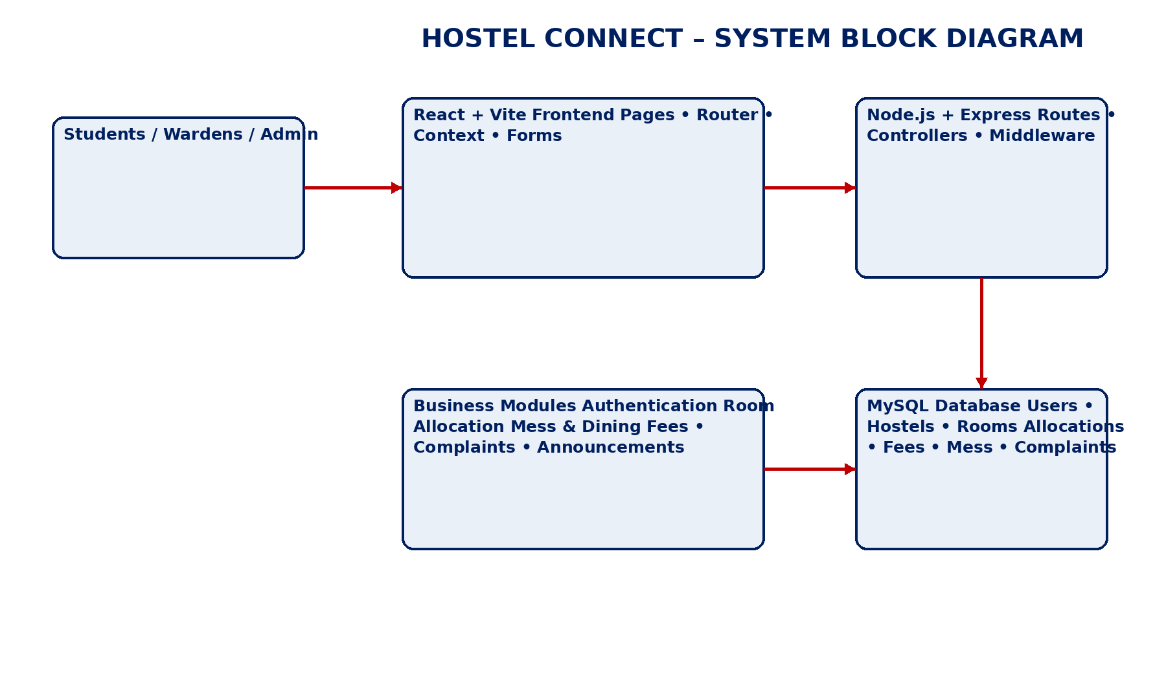
The block diagram summarizes the complete Hostel Connect flow. Students, wardens and administrators interact with the React/Vite frontend. The frontend sends requests to the Node.js/Express application layer, where authentication, authorization and business rules are applied. The backend then reads or updates the MySQL database. The separation ensures that the user interface does not directly access database tables and that the same business rules can be reused by different clients.

CHAPTER – 14 APPENDICES
ENTITY–RELATIONSHIP DIAGRAM
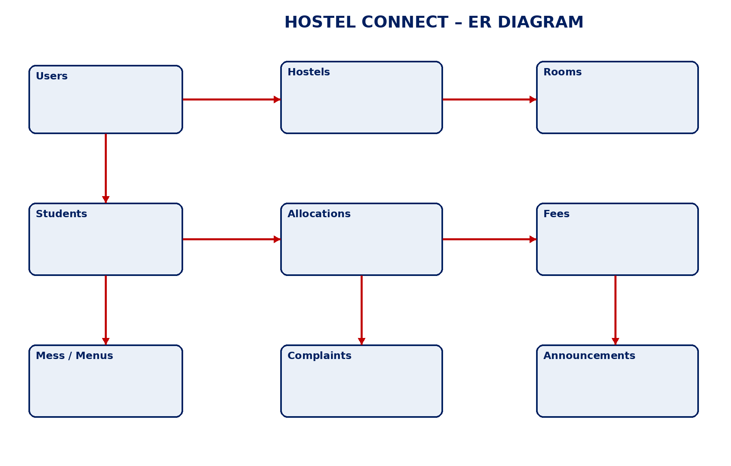
The ER diagram represents the principal entities used by Hostel Connect and their relationships. Users provide identity and role information, hostels contain rooms, students are linked to hostels, and allocations connect students to rooms. Fees, mess records, complaints and announcements represent operational transactions or communication. The relational schema implements these relationships with primary and foreign keys.

CHAPTER – 14 APPENDICES
LEVEL-0 DATA FLOW DIAGRAM
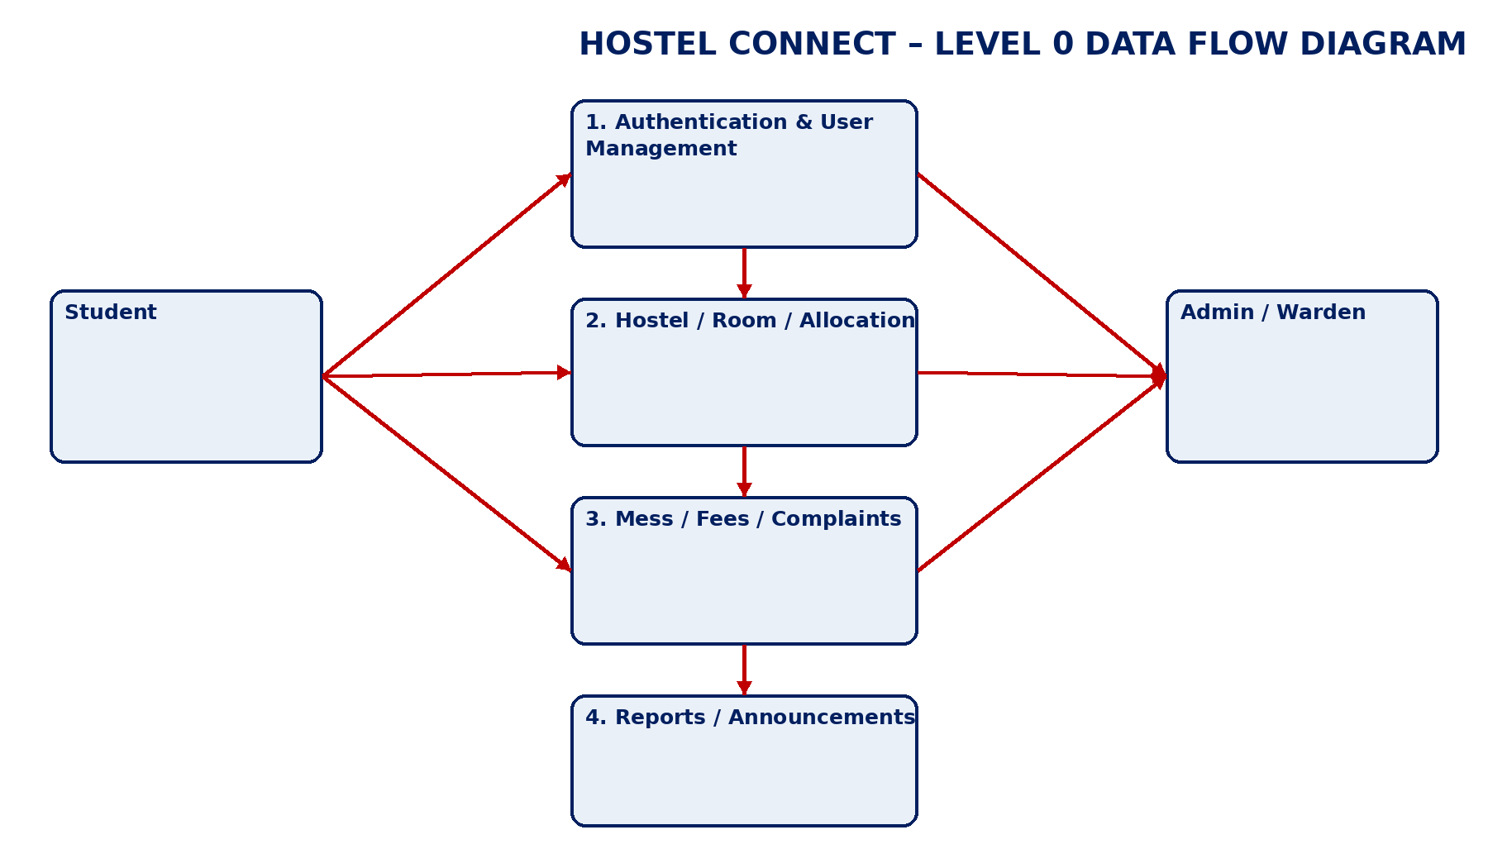
The Level-0 DFD describes how information moves through the application. Students and management users submit requests to authentication, room/allocation, mess/fees/complaints and reporting processes. Each process reads or writes the appropriate relational data. The DFD helps reviewers understand the boundary between external actors, application processing and stored information.

CHAPTER – 14 APPENDICES
DEPLOYMENT / EXECUTION ARCHITECTURE
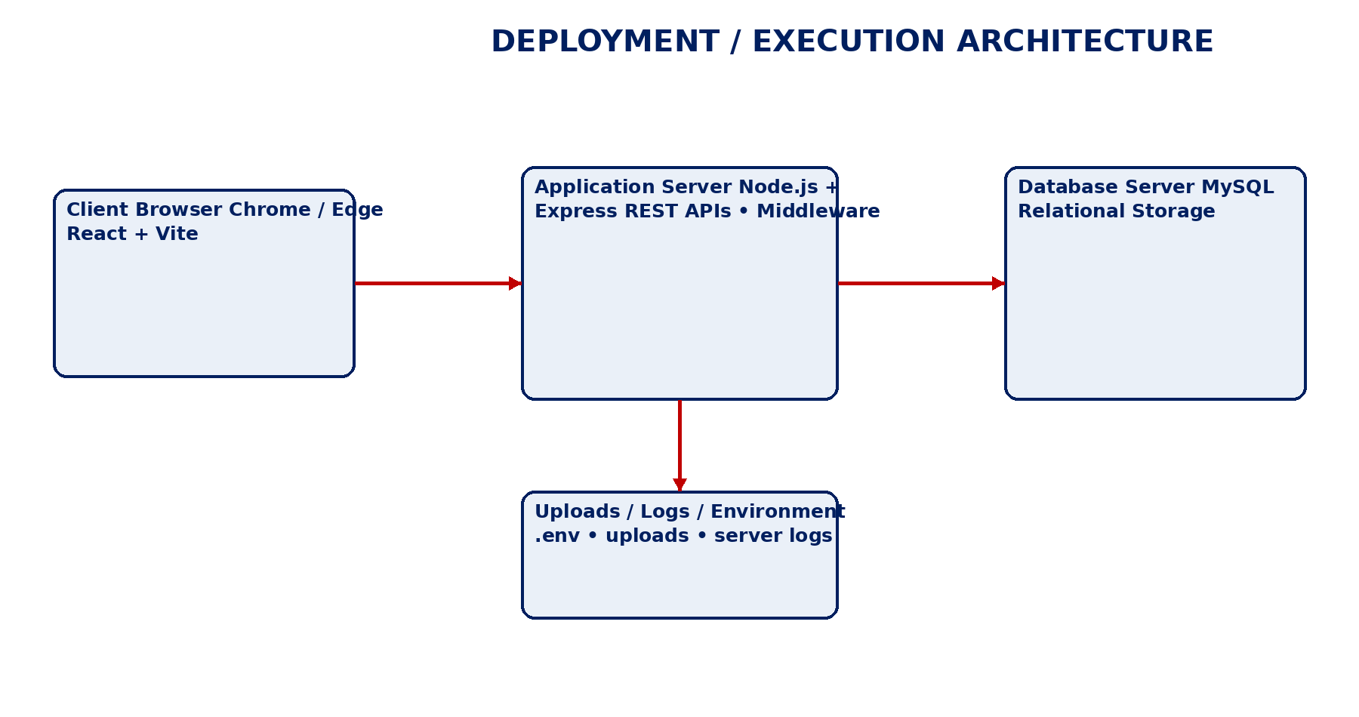
The deployment architecture shows a typical local or production arrangement. A browser runs the React/Vite client, which communicates with the Node.js/Express application server. The backend connects to MySQL for persistent storage. Environment variables hold configuration, while uploads and logs are maintained separately. The same logical structure can be moved from a local development machine to cloud infrastructure.
CHAPTER – 14 APPENDICES
SQL QUICK REFERENCE AND FINAL REVIEW
The following examples summarize the principal SQL operations demonstrated by the Hostel Connect project. They are intended as a compact revision page for the DBSE & DBD review and should be matched with the exact final schema.sql used by the team.
Operation | Representative SQL | Purpose
Create | CREATE TABLE rooms (...); | Defines relational structure
Insert | INSERT INTO rooms (...) VALUES (...); | Adds a room record
Read | SELECT * FROM rooms WHERE status="Available"; | Retrieves matching rooms
Update | UPDATE fees SET status="Paid" WHERE id=?; | Changes a fee status
Join | SELECT ... FROM hostels h JOIN rooms r ON ...; | Combines related tables
Aggregate | SELECT hostel_id, COUNT(*) FROM rooms GROUP BY hostel_id; | Produces grouped reports
Transaction | START TRANSACTION; ... COMMIT; | Keeps multi-step changes consistent

Final Review Checklist: verify that all three team members' names and roll numbers are correct; verify the Instructor & Guide and Course Coordinator names; execute schema.sql and sample_data.sql on a clean MySQL database; start the backend and frontend; verify room, mess, fee and complaint workflows; and attach the final screenshots required by the department.
Project Team: Pranav Chowdary – 2520030555 | R. Varshith Reddy – 2520030250 | Dhanush Chandra – 2520030014
Instructor & Guide: Dr. D. Ramya Krishna | Course Coordinator: Dr. R. Sateesh Kumara

DETAILED MYSQL ER DIAGRAM
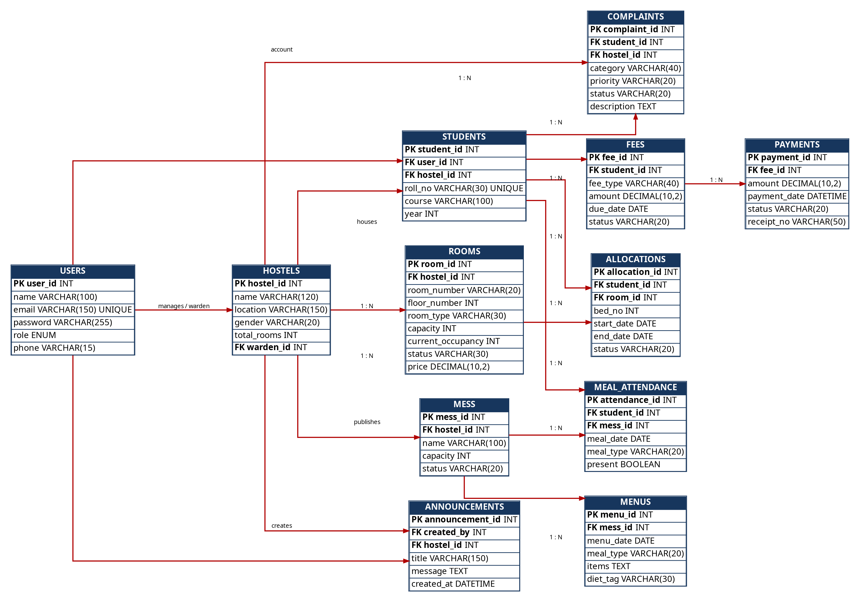
The ER model represents the database entities required for Hostel Connect. Users provide authentication and role information. Hostels contain rooms and are associated with students and mess services. Students are connected to allocations, fees, meal attendance and complaints. Payments depend on fee records, while announcements are linked to their creator and the target hostel.
The diagram identifies primary keys and foreign keys so that the relationships can be implemented directly in MySQL. The model supports referential integrity and SQL joins used by the hostel, mess, fee and complaint modules.

SYSTEM ARCHITECTURE – HOSTEL CONNECT
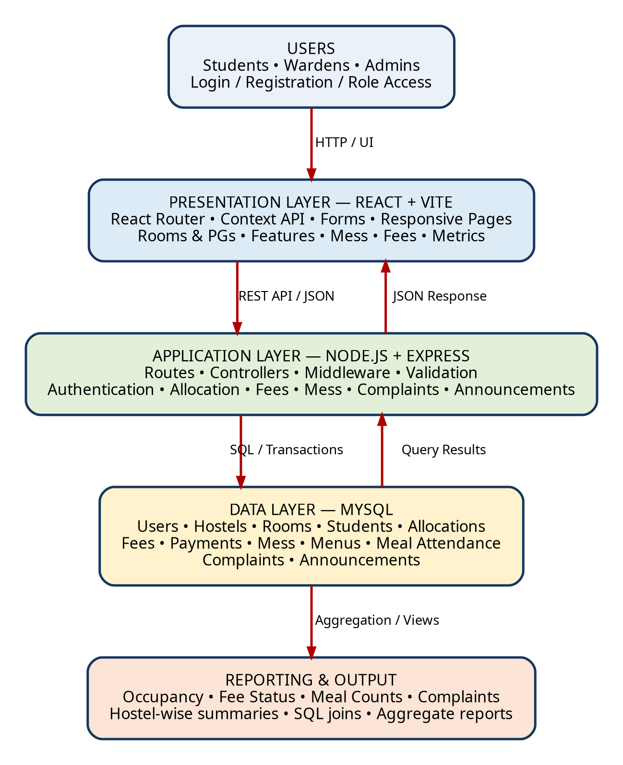
The architecture uses three major layers: presentation, application and database. React/Vite provides the interface and navigation. Node.js/Express receives API requests, applies validation and business rules, and calls MySQL. MySQL stores the persistent relational records used by every operational module.
The separation of layers makes the application easier to maintain because UI changes do not require redesigning the database. It also provides a clear DBSE & DBD explanation of how SQL operations move from the application to the relational database.

SYSTEM BLOCK DIAGRAM
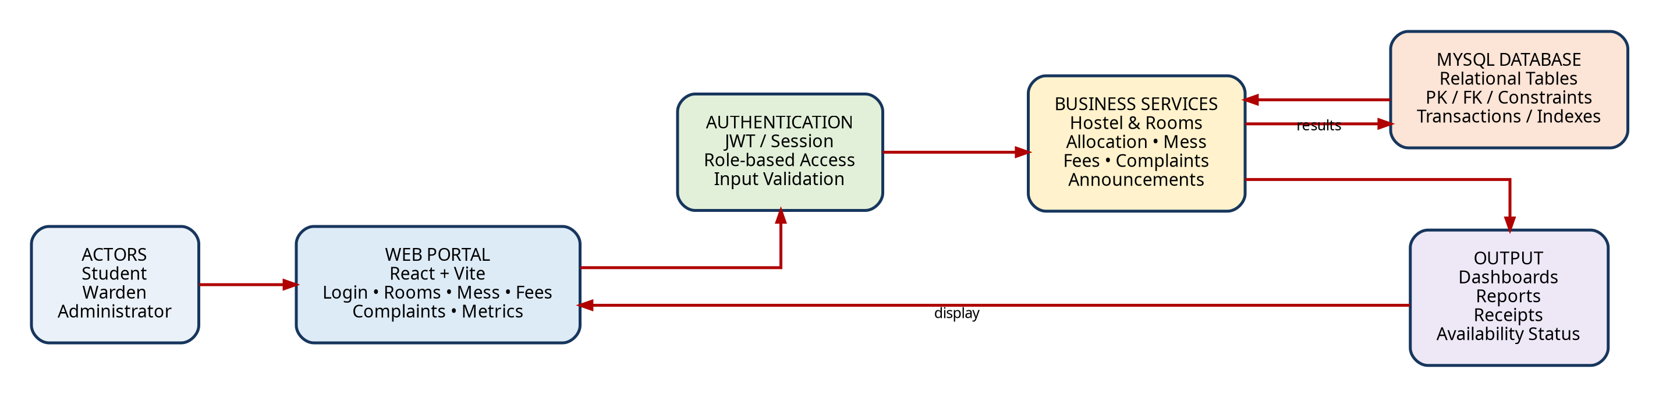
The block diagram shows the end-to-end flow from students, wardens and administrators to the Hostel Connect portal. Authentication controls access, business services implement hostel operations and MySQL stores the resulting records.
For example, when a student checks room availability, the request moves from React to the room service, the service queries MySQL and the result is returned to the browser as available room information.

DATA FLOW DIAGRAM – LEVEL 0
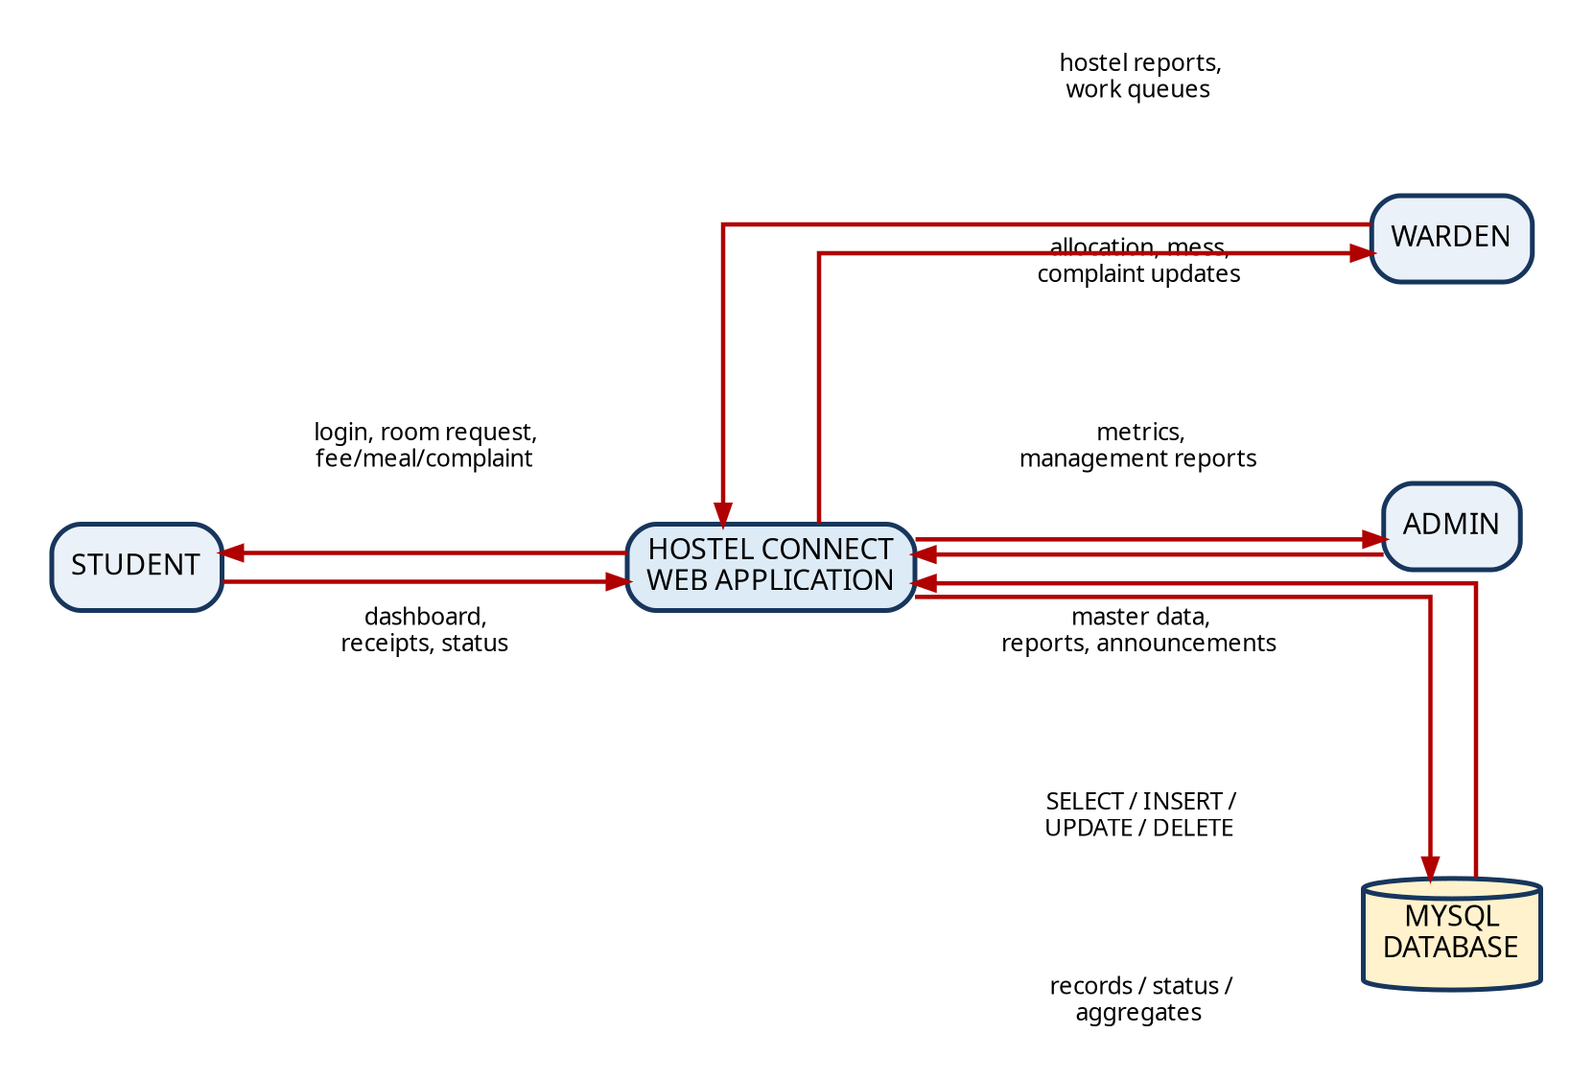
The Level-0 DFD identifies Student, Warden and Administrator as the principal external entities. Each role interacts with the central Hostel Connect application for its permitted activities.
The application reads and writes the MySQL database using SQL operations. The resulting records are returned as dashboards, availability information, fee status, complaint status, announcements and administrative reports.

MYSQL DATABASE IMPLEMENTATION
The database folder contains schema.sql and sample_data.sql. The schema creates the hostel_connect database structures, while the sample data script provides demonstration records. This separation is useful because the same schema can be reused with different datasets. The database is the central source of truth for accommodation, resident, mess, fee and maintenance information.
• Create the database and select it with CREATE DATABASE and USE commands.
• Create parent tables before child tables so foreign-key references can be established.
• Insert users, hostels and rooms before creating allocations and other dependent records.
• Use parameterized SQL from the backend for application-generated queries.
• Verify the structure using SHOW TABLES and DESCRIBE commands.
• Use transactions when one user action changes more than one related table.
SQL | Purpose
CREATE DATABASE hostel_connect | Create project database
USE hostel_connect | Select active database
SHOW TABLES | Verify tables
DESCRIBE rooms | Inspect columns
SELECT ... JOIN ... | Generate reports

ROOM, BED AND STUDENT MANAGEMENT
Room management is one of the core database operations of Hostel Connect. A room belongs to a hostel and stores capacity, current occupancy, type, status and price. Student records are connected to authenticated users and the selected hostel. Allocation records preserve the relationship between a student, a room and a bed over a period of time.
• A room cannot be allocated when current occupancy equals capacity.
• The allocation table preserves assignment history instead of overwriting old records.
• A transfer can close the previous allocation and create a new allocation.
• SQL joins can display student name, roll number, hostel and room in one report.
• The database can enforce unique room numbers within each hostel.
• Occupancy reports can be generated using COUNT and GROUP BY.
Module | Main Database Records | Output
Students | users + students | Student profile
Rooms | hostels + rooms | Room availability
Allocation | students + allocations + rooms | Current/historical assignment
Occupancy | rooms + allocations | Hostel occupancy report

MESS, FEES AND COMPLAINT WORKFLOWS
The mess, fee and complaint modules demonstrate how different operational activities can be connected through relational tables. A mess belongs to a hostel, menus are stored by date and meal type, and attendance records associate students with meals. Fees store financial obligations while payments store transactions. Complaints record maintenance issues and their progress.
• Mess records support breakfast, lunch, evening snacks and dinner.
• Fee records can separate room rent, mess fee, caution deposit and maintenance.
• Payment records provide receipt numbers and payment status.
• Complaints use category, priority and status fields.
• SQL aggregation supports fee collection and complaint counts.
• Role-based access prevents students from changing administrative records.
Module | Important Fields | Example Query
Mess | mess_id, hostel_id, name | Daily mess listing
Menu | menu_date, meal_type, items | Weekly menu
Fees | student_id, amount, due_date, status | Pending fees
Payments | fee_id, amount, receipt_no | Payment history
Complaints | category, priority, status | Open issues

SQL QUERIES, JOINS AND REPORTING
SQL is used throughout Hostel Connect to retrieve, insert, update and summarize data. SELECT statements provide room lists and student records, while JOIN operations combine normalized tables. Aggregate functions create metrics such as total residents, occupancy, pending fees and complaint counts.
• Use INNER JOIN for records that must have a matching relationship.
• Use LEFT JOIN when the report should also show records without child rows.
• Use COUNT for residents or complaints.
• Use SUM for fee collections and outstanding amounts.
• Use GROUP BY for hostel-wise or date-wise reporting.
• Use ORDER BY for consistent display order.
• Use WHERE and HAVING for filtering rows and aggregated groups.
Report | Tables | SQL Technique
Hostel occupancy | hostels, rooms, allocations | JOIN + COUNT + GROUP BY
Fee summary | students, fees, payments | JOIN + SUM
Complaint queue | complaints, students | JOIN + WHERE + ORDER BY
Meal headcount | meal_attendance, mess | COUNT + GROUP BY
Room availability | hostels, rooms | WHERE + ORDER BY

DATABASE SECURITY, INTEGRITY AND TESTING
Database reliability depends on both design and application controls. Primary keys uniquely identify rows, foreign keys protect relationships and unique constraints prevent duplicate business identifiers. The backend should use password hashing, role-based authorization and parameterized SQL. Testing should cover valid workflows as well as invalid and boundary cases.
• Test valid and invalid login credentials.
• Test allocation at exactly the room capacity.
• Test rejection of an allocation beyond room capacity.
• Test payment status changes and receipt generation.
• Test complaint creation, assignment and resolution.
• Test unauthorized access to administrator or warden routes.
• Test database persistence after restarting the backend.
Test Case | Expected Result
Valid login | User receives permitted dashboard
Invalid login | Request rejected
Full room allocation | System prevents over-allocation
New complaint | Ticket saved in MySQL
Fee payment | Payment stored and status updated
Unauthorized route | Access denied

PROJECT LEARNING OUTCOMES AND FUTURE SCOPE
Hostel Connect provides a practical DBSE & DBD case study because the application begins with real-world requirements and converts them into entities, relationships and relational tables. The project demonstrates normalization, keys, constraints, SQL queries, joins, aggregation and backend integration with MySQL.
• Understanding ER modelling and relational schema design.
• Applying 1NF, 2NF and 3NF to reduce redundancy.
• Writing DDL, DML and DQL statements in MySQL.
• Using joins and aggregate functions for operational reports.
• Connecting a Node.js/Express backend with MySQL.
• Designing role-based application workflows.
• Testing database integrity and application behavior.
• Future scope includes online payment integration, biometric/QR meal attendance, mobile apps, cloud deployment and analytics.
Area | Current Project | Possible Extension
Payments | Fee/payment records | Online gateway
Meals | Manual/recorded attendance | QR/biometric
Reports | SQL dashboards | Advanced analytics
Notifications | Application announcements | Push/email notifications
Deployment | Local prototype | Cloud-hosted platform

MYSQL TABLE REFERENCE – HOSTEL CONNECT
Table | Primary Key | Foreign Keys | Purpose
users | user_id | — | Authentication and roles
hostels | hostel_id | warden_id | Hostel master
rooms | room_id | hostel_id | Room and capacity
students | student_id | user_id, hostel_id | Resident details
allocations | allocation_id | student_id, room_id | Room/bed assignment
fees | fee_id | student_id | Fee obligations
payments | payment_id | fee_id | Payment records
mess | mess_id | hostel_id | Mess master
menus | menu_id | mess_id | Daily/weekly menus
meal_attendance | attendance_id | student_id, mess_id | Meal attendance
complaints | complaint_id | student_id, hostel_id | Maintenance
announcements | announcement_id | created_by, hostel_id | Notices

This table provides a quick review of the relational design. During the project presentation, each table can be explained through its primary key, foreign-key relationships and role in the Hostel Connect application.

PROJECT INTERFACE, IMPLEMENTATION & REVIEW EVIDENCE
This section presents the actual Hostel Connect interface and implementation evidence produced during the project. The screenshots are arranged according to the project workflow: public landing interface, room and PG exploration, feature modules, frontend implementation, MySQL sample data, backend controller implementation, and the project review photograph. These pages provide visual evidence that the documented DBSE & DBD design has been connected to a working full-stack prototype.

HOSTEL CONNECT – LANDING PAGE
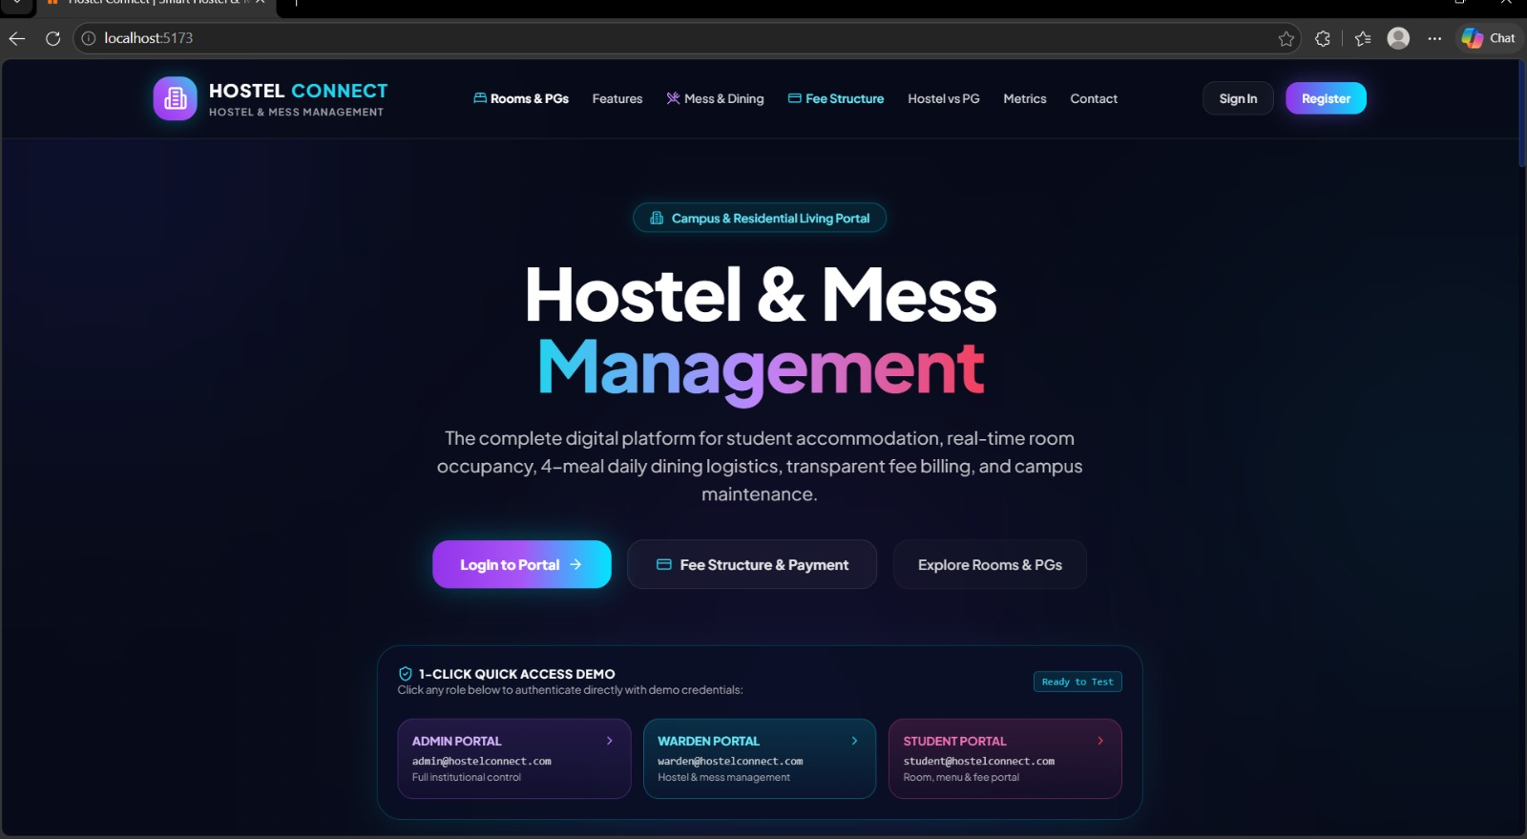
Figure: Hostel Connect – Landing Page
The landing page introduces Hostel Connect as a digital hostel and mess management platform. It provides navigation to Rooms & PGs, Features, Mess & Dining, Fee Structure, Hostel vs PG, Metrics and Contact. The quick-access area also demonstrates role-based entry points for administrator, warden and student users.

HOSTEL CONNECT – ROOMS & PGs INTERFACE
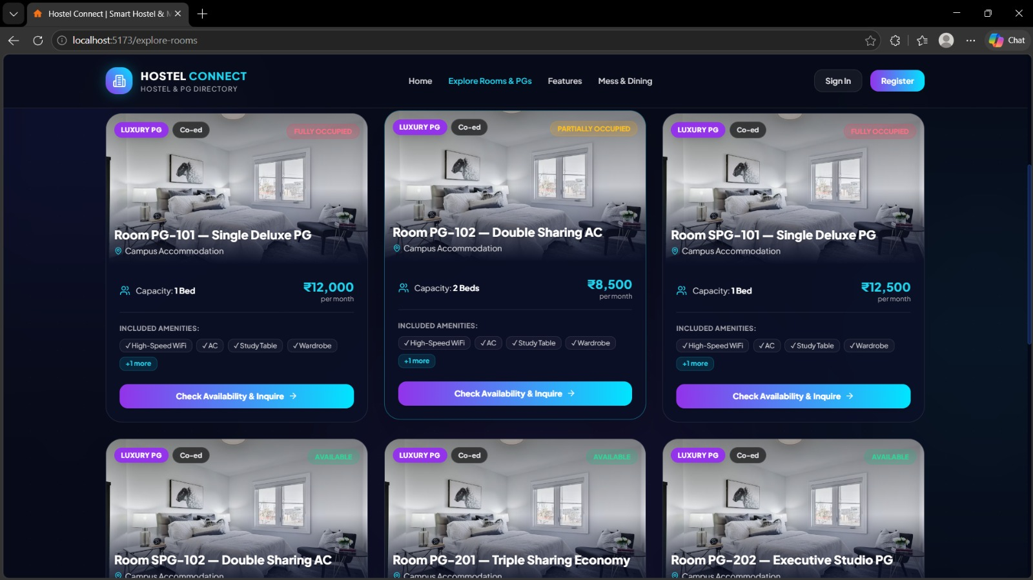
Figure: Hostel Connect – Rooms & Pgs Interface
The Rooms & PGs page displays accommodation cards with room identifiers, room type, occupancy state, capacity, monthly price and included amenities. The interface is designed to make availability information easy to understand before a student submits an enquiry or allocation request.

HOSTEL CONNECT – SYSTEM FEATURES
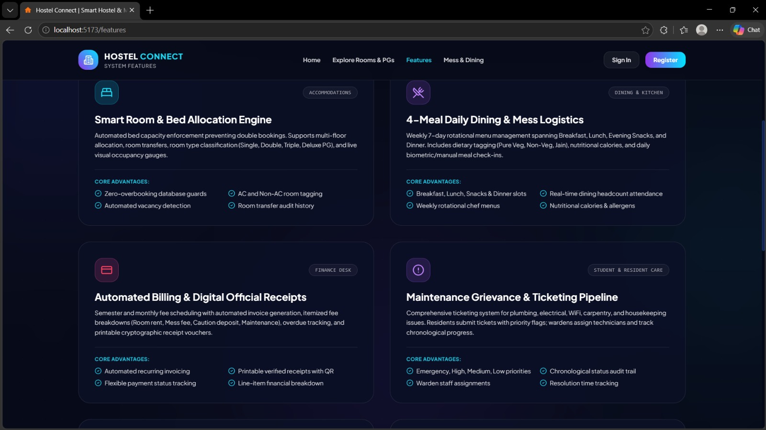
Figure: Hostel Connect – System Features
The Features page presents the major functional modules of the system, including smart room and bed allocation, four-meal daily dining, automated billing and maintenance grievance tracking. These interface modules map directly to the database entities and transaction workflows described in the ER model.

FRONTEND IMPLEMENTATION – REACT APP STRUCTURE
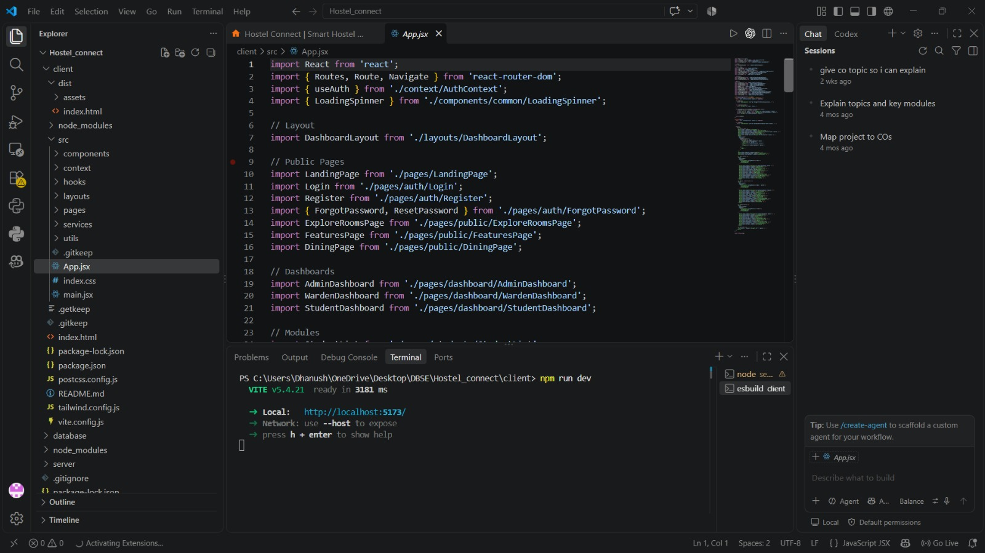
Figure: Frontend Implementation – React App Structure
This screenshot shows the React/Vite frontend implementation in Visual Studio Code. The project uses page components, layouts, authentication context, routing and dashboard modules. The App.jsx file connects public pages and role-specific dashboards, demonstrating the frontend structure used to build the Hostel Connect portal.

MYSQL DATABASE – SAMPLE DATA IMPLEMENTATION
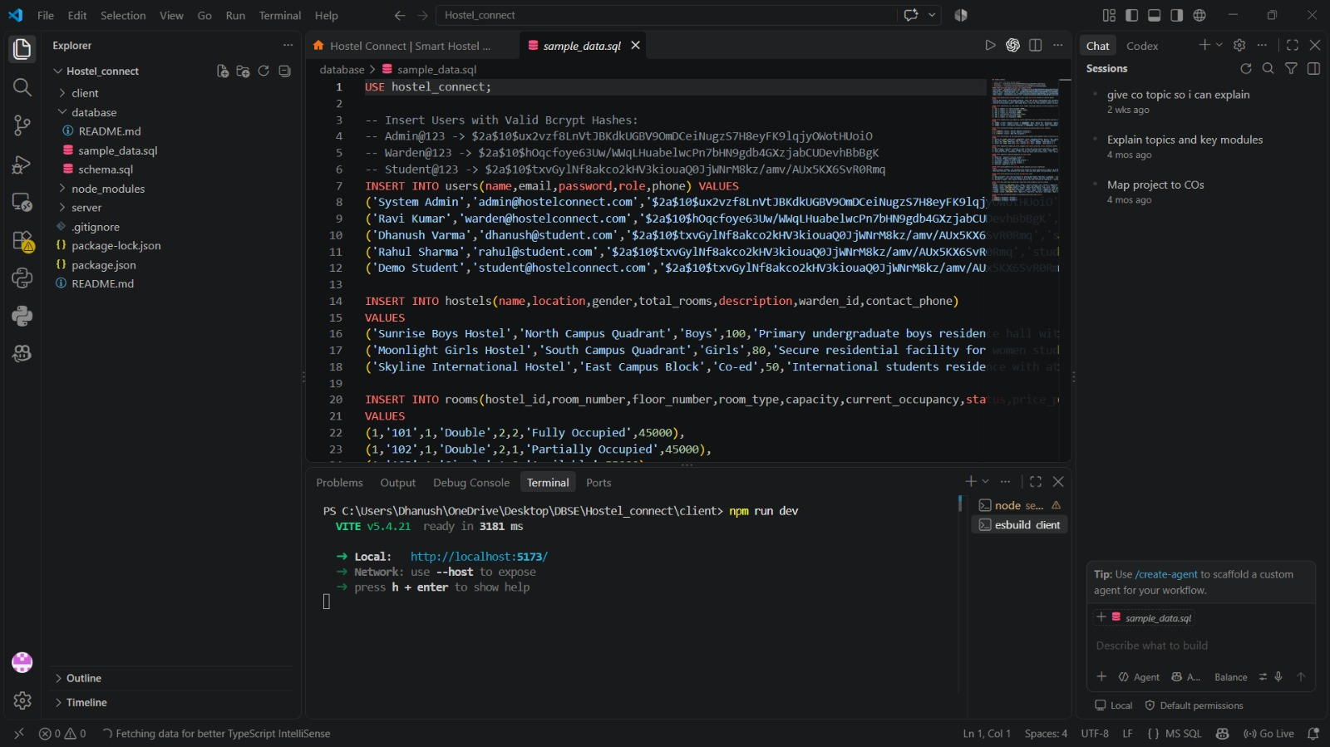
Figure: Mysql Database – Sample Data Implementation
This screenshot shows the MySQL sample_data.sql implementation. The script inserts users, hostels and room records into hostel_connect and provides realistic demonstration data for the application. It also demonstrates the relationship between master records and the dependent room information used by the interface.

BACKEND IMPLEMENTATION – ANNOUNCEMENT CONTROLLER
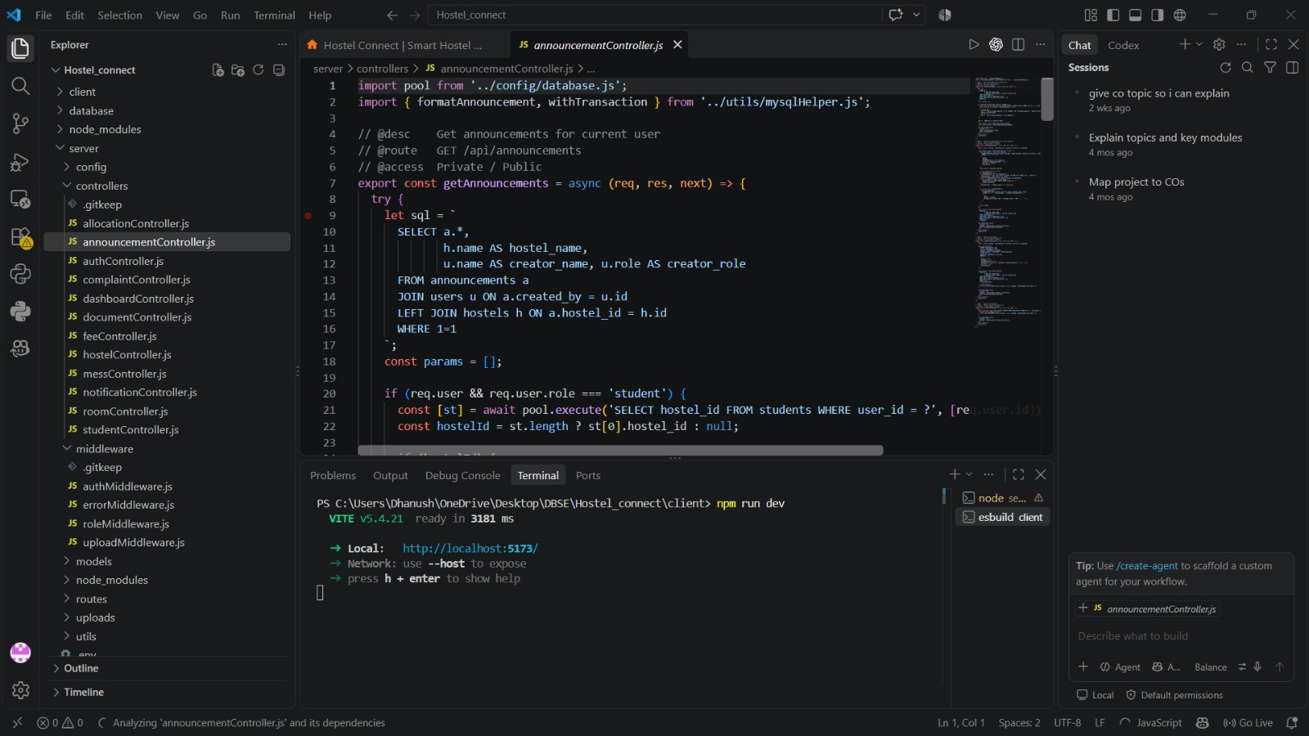
Figure: Backend Implementation – Announcement Controller
This screenshot shows the Node.js/Express backend controller for announcements. The controller uses SQL joins to combine announcement, user and hostel information and applies role-specific logic for students. This is evidence of the application layer communicating with the relational MySQL database.

PROJECT REVIEW – TEAM IMPLEMENTATION EVIDENCE
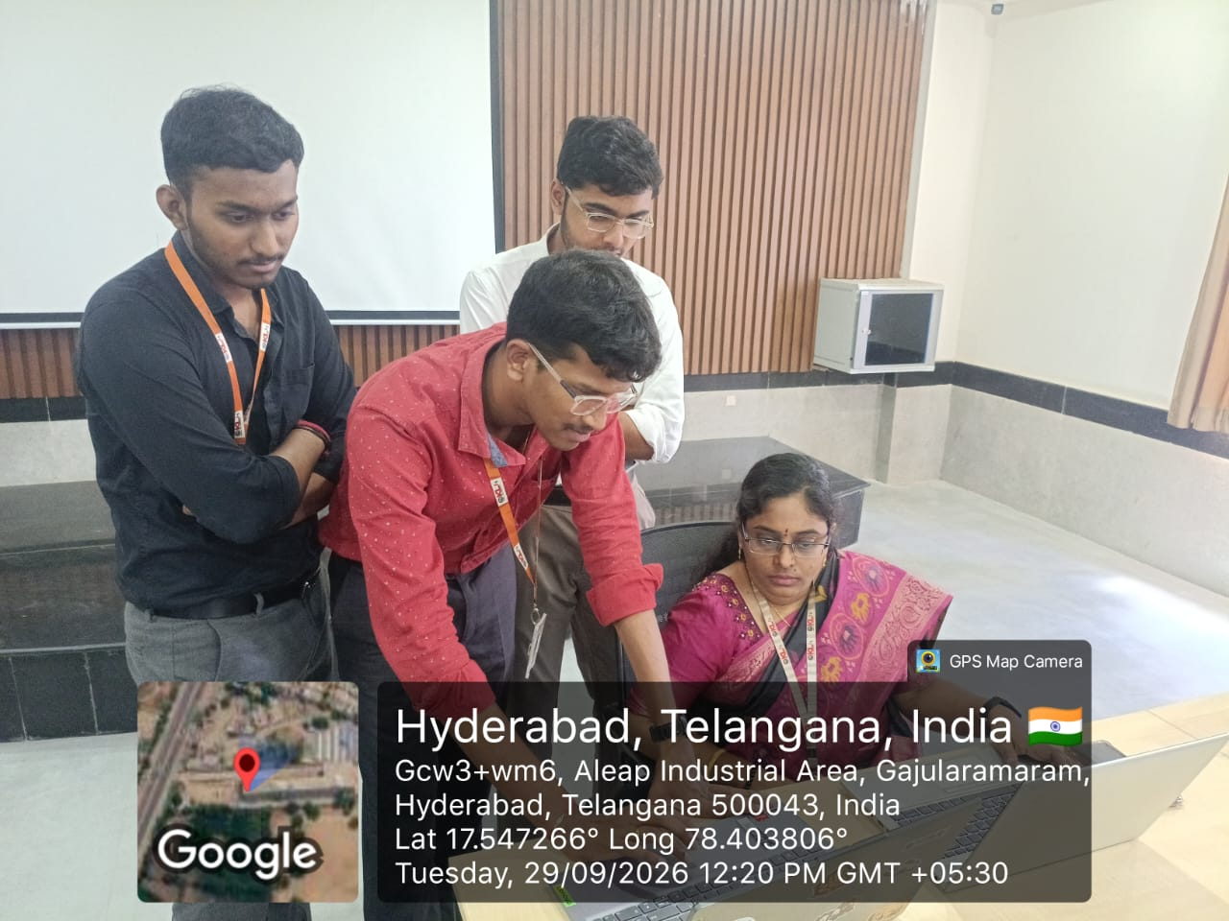
Figure: Project Review – Team Implementation Evidence
The photograph records the project review and implementation activity. It shows the team working with the project interface during the review session. This page is included as project evidence and complements the technical screenshots of the React frontend, MySQL database and Node.js backend.

PROJECT REVIEW – FINAL IMPLEMENTATION SUMMARY
Hostel Connect integrates the documented DBSE & DBD concepts with a working web application. The React/Vite frontend provides the user interface, Node.js and Express implement the application and API layer, and MySQL stores the structured relational data. The project demonstrates the complete path from requirement analysis and ER modelling to database implementation, SQL operations, API controllers and final user-facing screens.
During the review, the team can demonstrate the system in the following order: open the landing page, explore rooms and PGs, explain the feature modules, show the React project structure, open the MySQL schema and sample data, demonstrate the backend controller, and finally explain the project review evidence. This sequence connects the visible interface with the database concepts required for DBSE & DBD.
Team Member | Roll Number | Review Responsibility
Pranav Chowdary | 2520030555 | Project interface, database and module demonstration
R. Varshith Reddy | 2520030250 | Backend, SQL and system workflow demonstration
Dhanush Chandra | 2520030014 | Frontend integration, documentation and review presentation
Instructor & Guide: Dr. D. Ramya Krishna
Course Coordinator: Dr. R. Sateesh Kumara

