“Complaint Tracker – Smart Complaint Management Using Advanced Data Structures and Algorithms”

Project Report submitted for the partial fulfilment of grade for the course
Data Structures and Algorithms -3 (25CS2103E)
in

DEPARTMENT OF COMPUTER SCIENCE ENGINEERING

by

C Dhanush Chandra :2520030014

B Surya Prakash Reddy :2520030145

CH Meghanadh Sai Reddy :2520030274

Team Number: 11
Section: 8
Under the Guidance of
Dr. V.Sireesha
Professor
Department of Computer Science and Engineering




2026-27

DEPARTMENT OF COMPUTER SCIENCE ENGINEERING

Declaration

The Project Report entitled “Complaint Tracker – Smart Complaint Management Using Advanced Data Structures and Algorithms” is a record of Bonafide work of C Dhanush Chandra – 2520030014, B Surya Prakash Reddy – 2520030145, CH Meghanadh Sai Reddy – 2520030274 submitted in partial fulfillment for the award of B. Tech in Computer Science and Engineering. The results embodied in this report have not been copied from any other departments/University/Institute.

C Dhanush Chandra :2520030014

B Surya Prakash Reddy :2520030145

CH Meghanadh Sai Reddy :2520030274

DEPARTMENT OF COMPUTER SCIENCE ENGINEERING

CERTIFICATE

This is certify that the mini project based report entitled “Complaint Tracker – Smart Complaint Management Using Advanced Data Structures and Algorithms” is a bonafide work done and submitted by C Dhanush Chandra – 2520030014, B Surya Prakash Reddy – 2520030145, CH Meghanadh Sai Reddy – 2520030274 in partial fulfillment of the requirements for the award of the degree of BACHELOR OF TECHNOLOGY in Department of Computer Science Engineering, during the academic year 2026-27.

Signature of the Guide Signature of the HOD
(Dr. V.Sireesha)

Signature of the External Examiner
ACKNOWLEDGEMENT

Description in Times New Roman font 12 size with two to three paragraphs thanking guide Dr. V.Sireesha, Associate Professor, Dept. of CSE and Dr. P. Venkateshwara Rao, Associate Professor, HOD CSE

C Dhanush Chandra :2520030014
B Surya Prakash Reddy :2520030145
CH Meghanadh Sai Reddy :2520030274

Abstract

Organizations receive a large number of customer complaints every day, making it challenging to manage, track, prioritize, assign, and resolve issues efficiently through manual processes. Delayed responses, misplaced records, duplicate complaints, and lack of proper tracking can negatively affect customer satisfaction and service quality. The Complaint Tracker provides a centralized solution for complaint management.

The Complaint Tracker is designed as a JavaFX desktop application in which complaints can be registered, categorized, prioritized, assigned, searched, updated, and resolved. Each complaint receives a unique tracking ID and its history can be maintained for efficient retrieval and monitoring. The project applies advanced algorithms including hashing, KMP and Rabin-Karp string matching, Dynamic Programming with Edit Distance, Priority Queue processing, and Network Flow/Bipartite Matching for department assignment.

The system also provides an Advanced Algorithm Lab to visualize algorithm steps and complexity, along with complaint history, priority queues, SLA-oriented monitoring, analytics, and reports. By combining practical complaint-management requirements with appropriate data structures and algorithms, the application reduces manual effort, improves response time, and provides transparent complaint processing.

Table of Contents

 |  |  | Page No.
 | Acknowledgement
 | Abstract
 | Table of Contents
 | List of Figures
1 | Introduction | 1.1 Overview  1.2 Problem statement  1.3 Scope of the project  1.4 Objectives | 5-15
2 | System Requirements | 2.1 Functional Requirements  2.2 Non-Functional Requirements | 16-21
3 | System Design | 3.1 High-level Architecture Diagram  3.2 Description of each layer | 33-36
4 | Implementation | 4.1 Module-wise implementation  4.2 Front-end logic (UI rendering, state management)  4.3 API integration  4.4 ……. | 38-47
5 | Results |  | 56-64
6 | Challenges & Limitations | 6.1 Issues faced during development  6.2 Solutions applied  6.3 Limitations of the System | 74-82
7 | Conclusion & Future Work | 7.1 Conclusion  7.2 Future Work  7.3 Skills learned during development | 89-97
 | References | - Books, tutorials, APIs, documentation sites used | 98-99

List of Figures

1.1 Complaint Tracker High-Level Architecture
1.2 Complaint Processing Workflow
1.3 Complaint Priority and Escalation Flow
1.4 Advanced Algorithm Mapping
1.5 Department Assignment Using Bipartite Matching
1.6 Complaint Status Lifecycle
1.7 Matrix Factorization based Recommendation System 40

- INTRODUCTION

1.1 Overview
The Complaint Tracker is a JavaFX-based desktop application for centralized complaint registration, tracking, prioritization, department assignment, and resolution. The system uses advanced data structures and algorithms to improve complaint retrieval and processing. Fig. 1.1 presents the high-level architecture of the Complaint Tracker.

System Overview and Architecture Components
The Complaint Tracker is designed as a modular JavaFX desktop system in which the user interface, complaint-processing services, data structures, and algorithm modules work together to provide fast and transparent complaint management.

• Presentation Layer: Provides login, dashboard, complaint registration, search, status updates, reports, and analytics through JavaFX screens.
• Complaint Management Layer: Handles complaint creation, unique tracking-ID generation, category selection, priority calculation, status changes, and complaint history.
• Data Management Layer: Uses structured collections such as HashMap, ArrayList, Queue, and Priority Queue for efficient storage, retrieval, ordering, and processing.
• Advanced Algorithm Layer: Applies KMP/Rabin-Karp for text searching, Edit Distance for duplicate or similar complaint detection, and graph-based assignment for department allocation.
• Reporting and Analytics Layer: Summarizes complaint categories, priority levels, department workload, resolution status, SLA performance, and recurring complaint trends.
This layered design separates user interaction from the core DSA logic, making the system easier to test, maintain, and extend. It also demonstrates how advanced algorithms can be applied to a practical complaint-management problem.
1.2 Problem Statement

2. Challenges, Limitations, Future Scope and DSA-3 Mapping
The project combines a practical complaint workflow with advanced algorithmic concepts, so the main challenges are both software-engineering and algorithmic. The final design should state limitations clearly rather than presenting the prototype as a complete enterprise platform.
One challenge is keeping algorithm code independent from JavaFX controllers. If UI code directly manipulates queues, hash buckets, or dynamic-programming tables, testing becomes difficult. Another challenge is selecting realistic thresholds for duplicate detection and priority scoring. These values should be configurable and documented rather than hidden inside event handlers.
The desktop scope is suitable for a course project but has limitations. A local application is not a replacement for a distributed production platform. Multi-user synchronization, cloud deployment, large-scale notification services, advanced identity management, and real-time collaboration would require additional infrastructure.
Future work can include multilingual complaint entry, smarter semantic similarity, predictive analytics, mobile access, cloud synchronization, richer notifications, automatic assignment with more constraints, and an expanded Algorithm Lab for Aho-Corasick, suffix arrays, Min-Cost Max-Flow, randomized algorithms, and parallel processing. The DSA mapping is direct: string algorithms → KMP/Rabin-Karp; advanced DP → Edit Distance; network flow → assignment; priority queue → urgent processing; hashing → tracking lookup; scheduling → SLA and escalation.
• String Algorithms → KMP, Rabin-Karp, keyword search
• Advanced DP → Edit Distance and similarity
• Network Flow → department/capacity assignment
• Priority Queue → urgent complaint processing
• Hashing → fast complaint lookup
• Scheduling → SLA and escalation
• Randomized/parallel extensions → future Algorithm Lab work

3. Complexity and Performance Analysis
Complexity analysis explains why the selected data structures and algorithms are appropriate. The report distinguishes theoretical complexity from measured runtime so that technical claims remain accurate.
Hash-based complaint lookup has average O(1) time for insertion and search under a suitable load factor. KMP provides O(n+m) pattern matching. Rabin-Karp has efficient expected behavior with rolling hashes but can degrade in the worst case because of collisions.
Edit Distance requires O(nm) time for strings of lengths n and m in the standard implementation. Comparing every new complaint with every historical complaint can become expensive as the dataset grows. Pre-filtering by category, length, or keywords can reduce the number of full comparisons.
Priority queue insertion and removal are O(log n), while peeking is O(1). Network-flow complexity depends on the actual algorithm used. Edmonds-Karp has O(VE²). Performance can be improved through indexing, filtering, caching, bounded comparisons, and background tasks while preserving algorithmic correctness.
• CustomHashMap — average O(1) lookup
• KMP — O(n+m)
• Rabin-Karp — expected efficient, collision-sensitive
• Edit Distance — O(nm)
• CustomPriorityQueue — O(log n) insertion/removal
• Network Flow — depends on chosen flow algorithm

4. Detailed Test Cases and Expected Results
The following test design provides a structured checklist for demonstration. Expected results describe intended system behavior and should not be presented as measured execution results unless the team records the actual run.
Each test case can use an identifier, input condition, action, expected result, and status field. This makes it easier to demonstrate the project systematically and record pass or fail outcomes during final testing.
Boundary cases are important for DSA implementations. Empty strings test Edit Distance initialization. A pattern longer than the complaint tests string matching boundaries. Duplicate priorities test heap ordering. A graph with no compatible department tests the assignment failure path. A short SLA tests escalation logic.
The same dataset can be reused in the Algorithm Lab and main application. Reusing test data reduces inconsistency and helps the team explain how theoretical algorithms correspond to real complaint records.
• TC-01 Valid complaint → unique ID and storage
• TC-02 Missing description → validation message
• TC-03 ID search → correct complaint
• TC-04 Keyword search → matching records
• TC-05 Similar complaint → duplicate warning
• TC-06 Urgent complaint → correct queue position
• TC-07 Compatible department → assignment
• TC-08 No compatible department → clear failure path
• TC-09 Status update → state plus history
• TC-10 SLA deadline → escalation state

5. Testing Strategy and Test Categories
Testing should verify both the DSA implementations and the end-to-end complaint workflow. A test plan can be divided into unit, integration, functional, usability, persistence, and error tests.
Unit tests validate algorithms with known cases. KMP should cover beginning, middle, end, and no-match cases. Edit Distance should cover identical strings, empty strings, substitutions, insertions, and deletions. The priority queue should cover ordered, reverse-ordered, and duplicate-priority elements.
Integration tests verify cooperation between modules. A registration test should create a complaint, store it, place it in the queue, and make it searchable. A duplicate test should create similar complaints and confirm that a similarity warning appears. A status test should confirm that history is appended while the current state changes.
UI tests should verify validation, navigation, table refresh, dialog messages, filtering, and role restrictions. Persistence tests should reopen the application and confirm that stored complaints remain available. The report should state actual execution results only when the team has performed the tests.
• Unit testing
• Integration testing
• Functional testing
• Persistence testing
• UI/usability testing
• Error and boundary testing

6. Advanced Algorithm Lab Design
The Algorithm Lab is one of the strongest ways to demonstrate the DSA-3 syllabus inside the application. It should execute the same algorithm classes used by the complaint-management workflow instead of displaying pre-recorded animations.
For hashing, the lab can show the key, hash value, bucket index, collision chain, and lookup result. For KMP, it can show the pattern and LPS array. For Rabin-Karp, it can show the pattern hash, rolling window hash, and verified matches. For Edit Distance, it can display the dynamic-programming matrix and final distance.
For the priority queue, the lab can display the heap after insertion and removal. For network flow, it can show the graph, residual capacities, augmenting paths, and final flow value for a small example. Every algorithm screen should include explanation, input, output, complexity, and application mapping.
The lab should validate small inputs and provide reset controls. The goal is clarity: the user should understand what the algorithm did and why it is useful for Complaint Tracker. This makes the application suitable for project review and viva demonstration.
• Hashing → bucket and collision view
• KMP → LPS and match positions
• Rabin-Karp → rolling hashes
• Edit Distance → DP matrix
• Priority Queue → heap state
• Network Flow → augmenting paths and final flow

7. Analytics and Reporting Design
Reporting converts individual complaint records into information that can support operational decisions. The project can provide summary cards as well as detailed tabular reports.
A dashboard can show total complaints, open complaints, resolved complaints, critical complaints, SLA-at-risk cases, and average resolution time. Category charts can reveal issue volume. Department views can show assignment load and unresolved backlog. Time-based charts can show complaint volume across selected periods.
Reports should be filterable by date range, category, department, status, and priority. The same filter logic can be reused by analytics services so that every chart is based on consistent data. Recurring issue detection can count repeated keywords, categories, and similar descriptions without claiming machine-learning prediction.
An exportable report can include generation date, filter criteria, totals, and complaint rows. This demonstrates how the application converts DSA-backed records into a useful management artifact.
• Volume by category
• Open vs resolved
• Priority distribution
• Department workload
• SLA compliance
• Average resolution time
• Recurring issue indicators

8. Security, Roles and Audit Trail
Although this is a local academic project, complaint records can contain personal and service-related information. The design therefore includes basic access control and audit concepts.
The application can distinguish customer-oriented actions from administrator actions. A customer can create a complaint and view status, while an administrator can assign departments, change priority, update status, review duplicates, and generate reports. Role checks should be enforced in controller logic rather than only by hiding buttons.
An audit trail records complaint creation, assignment, priority changes, status transitions, and resolution. Each entry can include timestamp, actor, previous value, new value, and optional comment. This supports accountability and helps diagnose disputes about when a complaint was processed.
Passwords, if included in the local login module, should never be stored as plain text. Production deployment would require proper password hashing, secure storage, stronger identity management, and access controls. The academic prototype should clearly distinguish demonstration behavior from production security requirements.
• Role-based access
• Audit history
• Controlled display of personal information
• Safe credential handling
• Clear separation between prototype and production security

9. Persistence, Validation and Error Handling
A desktop application still needs reliable data handling. Persistence ensures that closing the program does not erase complaints, while validation and error handling protect the application from invalid states.
A repository layer should expose operations such as saveComplaint, findComplaintById, searchComplaints, updateComplaint, appendHistory, and loadAllComplaints. Controllers should call repository methods through services rather than directly manipulating storage details.
Validation should happen at the boundary. Empty titles, missing descriptions, invalid contact values, unsupported categories, and malformed identifiers should produce clear messages. Exception handling should distinguish user input errors from storage or infrastructure failures.
If SQLite is used, transactions can group related operations such as complaint creation and initial history insertion. If file-based persistence is used, complete records should be written safely and missing or corrupted files should be handled gracefully. The selected approach should be documented in the implementation section.
• Validate before storage
• Keep persistence behind a repository/service layer
• Record meaningful exceptions
• Preserve complaint history
• Avoid silent data loss

10. Module-Wise Implementation
The project can be divided into focused modules so each feature has a clear responsibility and each advanced DSA concept is visible in an application workflow.
The Authentication module controls access. Complaint Registration validates input, generates the tracking ID, stores the record, and starts processing. Complaint Management provides status updates, assignment, history, and resolution actions. Search combines ID lookup, keyword matching, and similarity checks.
The Priority Management module maintains active processing order. Department Assignment applies compatibility rules and, where enabled, graph-based matching. SLA Management calculates deadlines and escalation states. Analytics transforms stored records into counts, percentages, trend summaries, workload views, and resolution statistics.
The Algorithm Lab is an educational module. It accepts small inputs and runs the actual algorithm classes used by the system. Output can include arrays, matrices, heap states, hash buckets, flow values, and complexity information. This supports both project demonstration and DSA learning.
• Login and role management
• Complaint registration and tracking
• Search and duplicate detection
• Priority queue
• Department assignment
• SLA and escalation
• Analytics and reports
• Algorithm Lab
• Settings and configuration

11. JavaFX Application Architecture
The application is a JavaFX desktop system. JavaFX provides windows, scenes, controls, tables, charts, dialogs, and event handling, while the DSA engine remains a separate Java layer. No React, Vite, Node.js, Express, or browser-based architecture is required for this desktop design.
The recommended structure follows a lightweight MVC-style separation. Model classes represent Complaint, User, Department, HistoryEntry, and supporting records. Controllers respond to button clicks and table events. Service classes coordinate workflows. Algorithm classes contain DSA implementations. Repository classes handle persistence.
FXML can define screens such as Login, Dashboard, Complaint Form, Complaint List, Search, Priority Queue, Department Assignment, Algorithm Lab, Analytics, Reports, and Settings. JavaFX CSS can provide consistent fonts, spacing, badges, buttons, cards, tables, and sidebar styling.
Long-running operations such as large similarity comparisons or report generation should not block the JavaFX Application Thread. Background tasks can perform computation and then update the UI safely. The algorithm engine should also be testable without launching JavaFX.
• Java 17+
• JavaFX controls, scenes and charts
• FXML for screen layout
• JavaFX CSS for presentation
• Services and algorithms independent of UI

12. Scheduling, SLA Monitoring and Escalation
Complaint processing is also a scheduling problem. The application must track elapsed time, identify approaching deadlines, and ensure that high-impact complaints are not hidden behind many low-priority cases.
Each complaint can have an SLA target based on category and priority. At creation time, the target deadline is calculated from the timestamp. A monitoring service compares the current time with the deadline and assigns a state such as Safe, At Risk, or Breached.
Escalation rules can raise priority when the remaining time becomes small. A JavaFX-compatible scheduled service can refresh SLA indicators at controlled intervals, while business rules remain outside the UI thread so that the interface remains responsive.
Reports can show average resolution time, number of SLA breaches, unresolved complaints by age, and department workload. These measures help identify bottlenecks and demonstrate that the project performs active processing rather than only storing records.
• Safe → At Risk → Breached
• Escalation updates priority
• Queue is refreshed after priority changes
• Analytics summarize SLA compliance and backlog age.

13. Network Flow and Bipartite Department Assignment
Department assignment can be represented as a bipartite matching problem when complaints are connected to departments according to category, capability, or service constraints. This provides a direct application of the Network Flow module from DSA-3.
The left side of the graph contains complaint nodes and the right side contains department nodes. An edge exists when a department can handle a complaint. A source connects to complaint nodes and departments connect to a sink. Maximum flow can then determine how many compatible assignments are possible.
An implementation can demonstrate Ford-Fulkerson or Edmonds-Karp. Edmonds-Karp uses BFS to find augmenting paths and has O(VE²) complexity. If department capacity is limited, the edge from each department to the sink can represent its available service slots.
The resulting assignment should remain reviewable by an administrator. Graph algorithms recommend feasible assignments, but real organizations can have constraints such as staff absence, escalation policies, or special customer requirements that are outside the simplified academic model.
• Complaint nodes → compatible department edges → capacity constraints → maximum flow → feasible assignment.

SYSTEM ARCHITECTURE – COMPLAINT TRACKER
The Complaint Tracker follows a layered JavaFX desktop architecture that separates the user interface, business workflow, advanced data-structure and algorithm engine, persistence, and reporting. This separation keeps the DSA implementations independent from JavaFX controllers and makes the system easier to test, maintain, and demonstrate for the Data Structures and Algorithms-3 course.
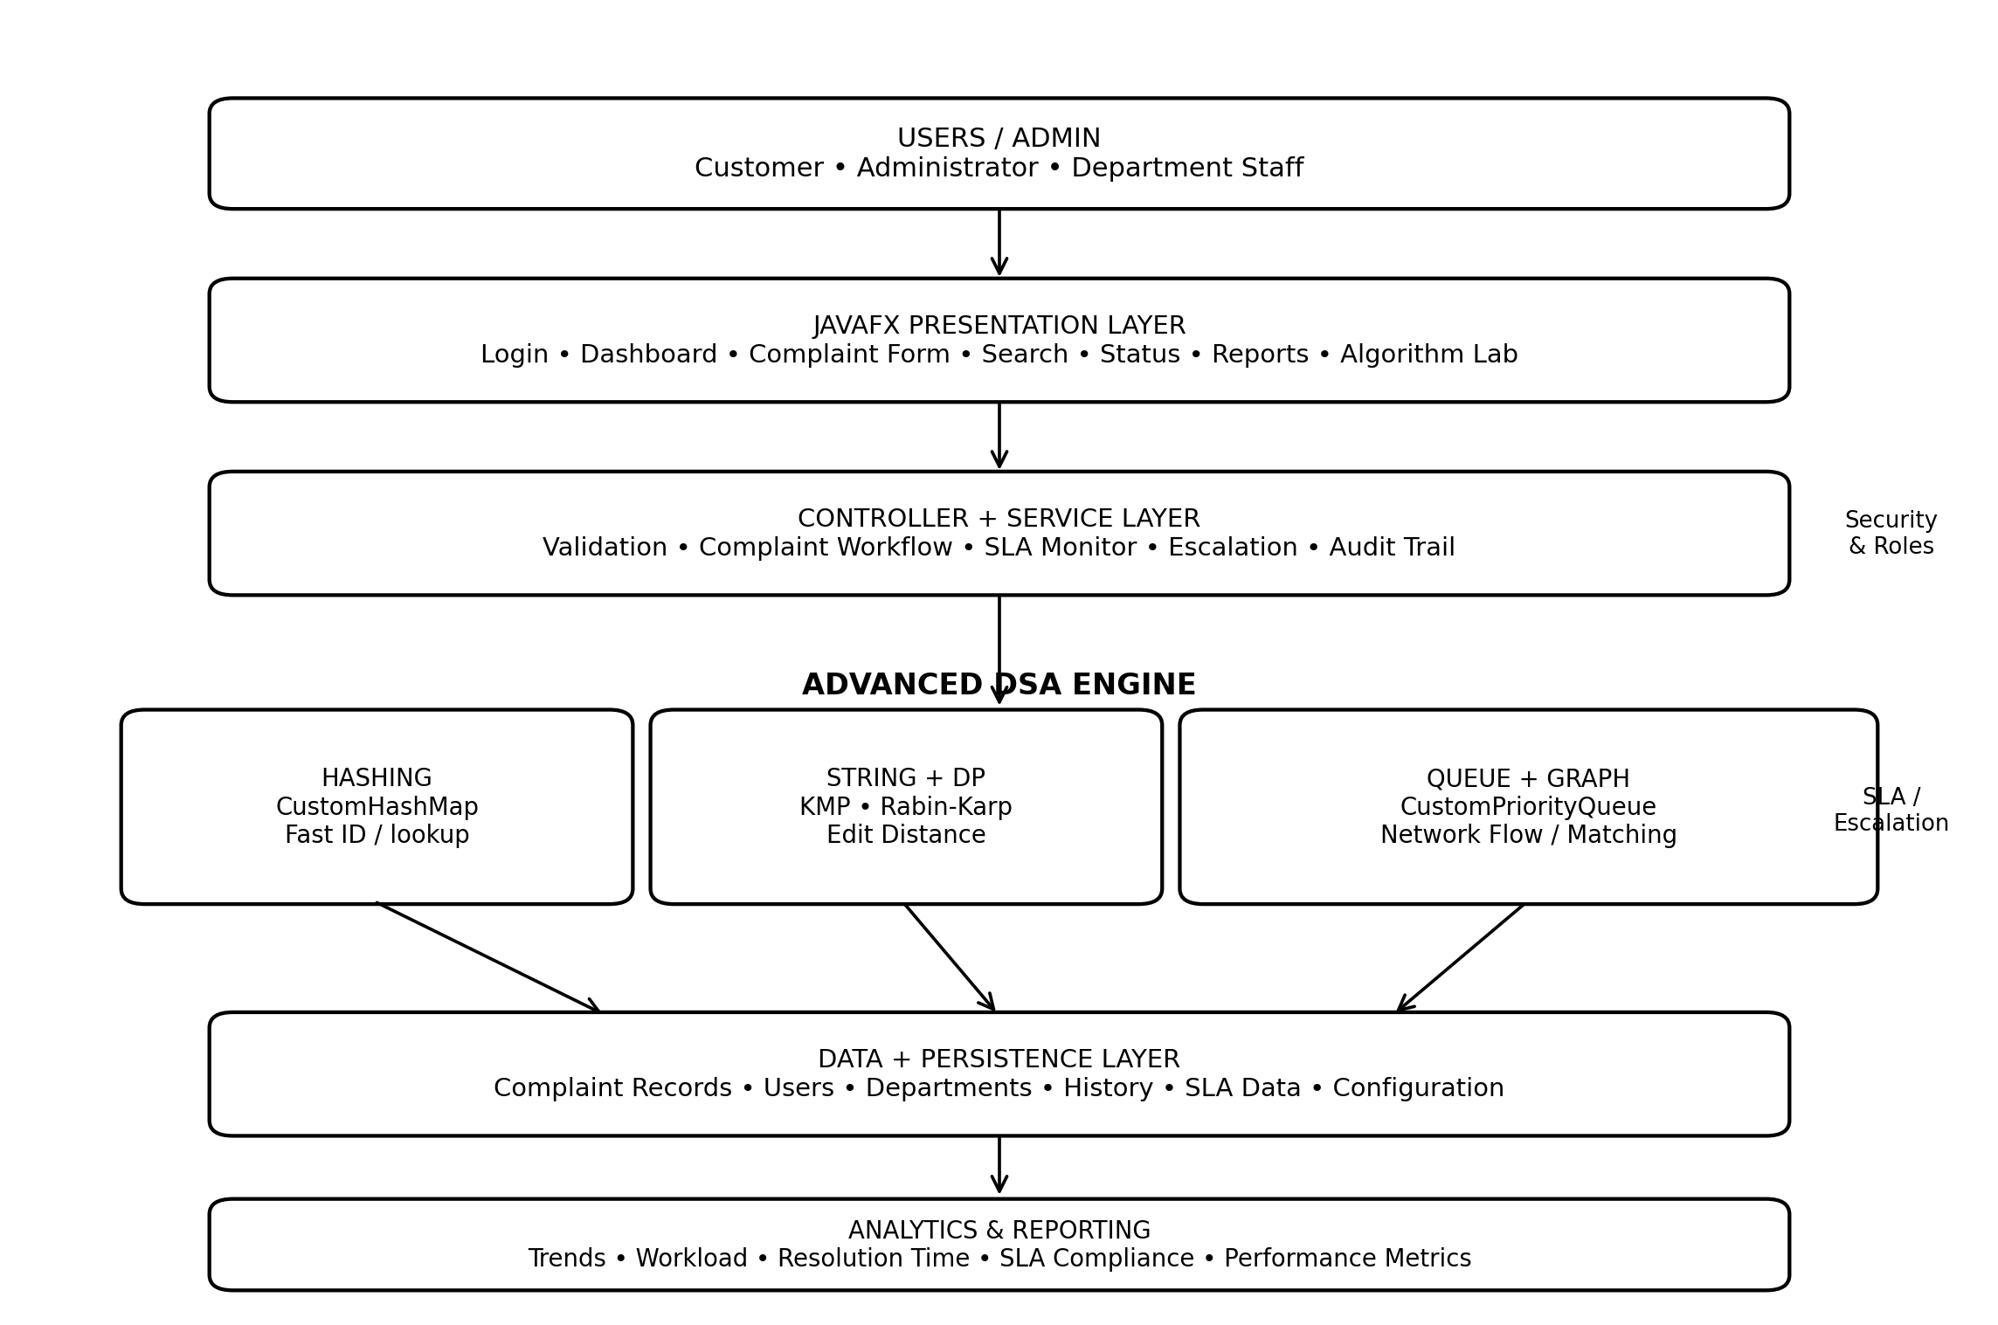
Figure: High-level system architecture of the Complaint Tracker
1. Presentation Layer: Provides login, dashboard, complaint registration, search, status updates, tables, charts, reports, and the Algorithm Lab using JavaFX, FXML, and JavaFX CSS.
2. Controller and Service Layer: Coordinates validation, complaint creation, tracking-ID generation, category handling, SLA monitoring, escalation, department assignment, and audit-history updates.
3. Advanced DSA Engine: Contains CustomHashMap for fast lookup, KMP and Rabin-Karp for text searching, Edit Distance for duplicate detection, CustomPriorityQueue for urgent processing, and Network Flow/Bipartite Matching for department assignment.
4. Data and Persistence Layer: Stores users, complaints, departments, complaint history, SLA information, configuration, and algorithm-related records using local persistence such as SQLite or structured files.
5. Analytics and Reporting: Converts stored complaint data into category statistics, priority distribution, department workload, average resolution time, SLA compliance, unresolved backlog, and trend reports.
End-to-end data flow: User/Admin → JavaFX UI → Controllers/Services → DSA Engine → Persistence → Analytics/Reports. Results and status changes are returned to the dashboard, while the audit trail records important actions for transparency.

14. Priority Queue and Urgent Complaint Processing
A complaint system should not process every complaint strictly in arrival order. Critical service failures, high-impact incidents, and repeated SLA breaches may need immediate attention. A priority queue models this requirement directly.
The priority queue stores complaints according to an ordering rule rather than insertion time alone. A heap can be used, with the comparator considering severity, SLA urgency, and waiting time. This produces a consistent processing order and keeps priority logic inside a dedicated data structure.
A CustomPriorityQueue is useful for the DSA course because heap insertion, removal, peek, parent-child indexing, and heapify can be demonstrated directly. Insertion and removal take O(log n), while reading the highest-priority item takes O(1). Bottom-up heap construction can be performed in O(n).
Priority should be recalculated when severity changes or a complaint approaches its SLA deadline. The dashboard can display the next few complaints with priority, department, age, and SLA state, making the queue a visible operational feature rather than a hidden implementation detail.
• Critical incidents first
• SLA urgency as a secondary factor
• Older complaints may receive an aging boost
• Heap insertion/removal: O(log n)
• Highest-priority access: O(1)

15. Edit Distance for Duplicate and Similar Complaint Detection
Duplicate complaints are common when customers submit the same issue more than once or describe an existing problem with different wording. Levenshtein Edit Distance provides a practical dynamic-programming method for estimating textual similarity.
The distance between two strings is the minimum number of insertions, deletions, and substitutions required to transform one string into the other. A two-dimensional dynamic-programming table is built from smaller prefixes, and each cell chooses the minimum cost among the permitted edit operations.
The application can normalize descriptions by converting text to lowercase, trimming repeated spaces, and optionally removing punctuation. A threshold can then flag likely duplicates. Similarity should remain advisory because two complaints with similar wording can still represent separate incidents.
The standard implementation requires O(nm) time and O(nm) space. If only the final distance is needed, space can be reduced to O(min(n,m)) using two rows. The full matrix is valuable in the Algorithm Lab because it makes the recurrence visible to the user.
• Normalize text → compute distance → compare with threshold → show candidate duplicates → administrator confirms action.

16. Rabin-Karp and Multi-Keyword Searching
Rabin-Karp complements KMP by using rolling hashes to compare a pattern with successive text windows. It is useful for demonstrating hash-based string matching and for scanning many complaint descriptions for selected keywords.
The algorithm calculates a hash for the pattern and the first text window. When the window moves, the rolling hash updates without rebuilding the complete hash. If the hash values match, character comparison verifies the result so that a collision is not treated as a real match.
Complaint Tracker can use Rabin-Karp for keyword scanning across complaint descriptions, particularly for recurring phrases such as login, refund, network, billing, or delivery. The result can support classification or analytics but should not automatically replace human review.
Expected behavior is efficient with a suitable hash, while the worst case can degrade because of collisions. The Algorithm Lab should display the rolling hash and verification step so the user understands both the benefit and limitation of hashing.
• Rolling hash updates the current window efficiently.
• Hash equality is followed by character verification.
• Useful for repeated keyword scanning.
• Worst-case behavior can degrade because of collisions.

17. KMP String Matching for Complaint Search
Knuth-Morris-Pratt string matching is appropriate when the application needs to locate a keyword or phrase inside complaint descriptions without repeatedly comparing characters that have already been matched.
KMP preprocesses the pattern and constructs the longest-prefix-suffix array. The LPS value records how much of the pattern can be reused after a mismatch. During searching, the text index does not move backward unnecessarily, which gives predictable linear-time matching.
A Complaint Search screen can normalize the input, select the description field, and run KMP against each relevant complaint. The result can be a match position, a Boolean flag, or a list of complaints containing the keyword. Search results can then be displayed in a JavaFX TableView with category, priority, status, and matching text.
The preprocessing phase takes O(m), where m is the pattern length, and the search phase takes O(n), where n is the text length. Therefore the overall complexity is O(n+m), with O(m) auxiliary space for the LPS array. Keeping the KMP class independent from JavaFX makes unit testing simple.
• Input: complaint description + search pattern
• Preprocess: build LPS table
• Search: compare text and pattern
• Output: match position or match flag
• Complexity: O(n+m) time and O(m) auxiliary space

18. HashMap and Fast Complaint Retrieval
Hashing is a central data-structure concept because every complaint has a unique tracking ID. A hash table provides fast average-case retrieval and directly connects a DSA concept with the tracking feature of the application.
The logical structure is a mapping from complaint ID to Complaint object. During insertion, the key is transformed into a hash value and mapped to a bucket. Search repeats the same hash calculation and examines the corresponding bucket. With good distribution, only a small number of entries must be inspected.
For a course-focused implementation, a CustomHashMap can be implemented instead of relying entirely on java.util.HashMap. This exposes bucket management, collision handling, resizing, and lookup behavior. Separate chaining is a practical collision strategy because multiple keys can share a bucket while keeping the implementation understandable.
The structure supports tracking-ID search, administrator lookup, status updates, and history retrieval. Average insertion, search, and deletion are O(1), while the worst case can degrade to O(n) if many keys collide. The Algorithm Lab can display the hash value, bucket index, collision chain, and final lookup path.
• Average search: O(1)
• Average insertion: O(1)
• Average deletion: O(1)
• Worst-case lookup: O(n)
• Space: O(n)

19. Complaint Data Model and Data Lifecycle
A consistent data model is necessary because the algorithms operate on structured complaint attributes. The data model should preserve both the current state and enough historical information to explain how the complaint reached that state.
The core Complaint entity can contain complaint ID, customer identifier, title, description, category, priority, status, department, creation time, last-update time, SLA deadline, resolution time, and feedback. A history collection stores status transitions, timestamps, actor information, and optional notes. This history provides transparency because the current status alone does not show what happened earlier.
The complaint lifecycle begins when the object is created. Validation ensures required fields are present. Classification adds category and priority. Assignment adds a department and processing position. Status updates modify the current state while appending an event to history. Closure records the resolution summary and completion time. Analytics can then use the same structured records.
For local persistence, the project can use structured file storage or SQLite depending on the implementation stage. The local desktop scope is sufficient for the course project because it removes the need for a separate server while still demonstrating persistence. Categories, statuses, priorities, and timestamps should use controlled representations so sorting and filtering remain reliable.
• Complaint ID — unique tracking key
• Category — groups similar issues
• Priority — determines processing order
• Status — represents lifecycle state
• Department — responsible service unit
• Created/updated time — supports SLA measurement
• Description — input for search and similarity
• Resolution — final action taken

20. Detailed Functional Workflow
The functional workflow converts an incoming complaint into a controlled processing sequence. The design separates validation, storage, analysis, assignment, and resolution so that each stage can be tested independently and the interface remains easy to understand.
At registration time, the system collects complainant details, complaint title, detailed description, category, and other required fields. Validation prevents empty mandatory values and rejects malformed data. A unique tracking identifier is generated only after the complaint passes validation and is stored in the central complaint structure.
After registration, the category and priority engine examines the complaint. Priority can depend on severity, customer impact, category, and elapsed time. Duplicate detection compares the new description with relevant historical records. Exact and keyword matching can be followed by Edit Distance so that spelling and wording differences do not hide similar complaints.
Once classification is complete, the assignment module selects an appropriate department. A simple implementation can use category-to-department rules, while an advanced implementation can represent complaints and departments as a bipartite graph. The selected complaint enters the priority queue and moves through states such as New, Assigned, In Progress, Waiting for Customer, Resolved, and Closed.
• START → Register → Validate → Generate ID → Store → Categorize → Prioritize → Duplicate Check → Assign → Queue → Process → Resolve → Close → Report
• Every important status transition is recorded in complaint history.
• SLA monitoring identifies cases that are approaching or exceeding their deadlines.

21. System Context, Stakeholders and Use Cases
The Complaint Tracker is designed as a desktop-oriented complaint management solution for organizations that receive, categorize, assign, monitor, and close service complaints. The project is intentionally centered on Data Structures and Algorithms-3 concepts rather than treating complaint handling as only a form-entry problem.
The primary stakeholder is the customer or complainant who needs a simple way to submit a problem, obtain a unique tracking identifier, review status, and receive a clear resolution history. The administrator or service coordinator needs a consolidated view of open complaints, priorities, departments, deadlines, and unresolved cases. Department staff receive assigned work and update progress.
The application supports a complete complaint lifecycle: registration, validation, categorization, priority calculation, duplicate checking, department assignment, queueing, status updates, resolution, feedback, and reporting. A complaint is treated as a structured object rather than a free-form note, allowing text to be connected with category, priority, status, department, timestamps, and SLA information.
The project demonstrates how algorithmic decisions improve an ordinary administrative workflow. Hash-based lookup reduces sequential scanning, string algorithms accelerate keyword searches, dynamic programming identifies similar complaints, priority queues order urgent work, and graph-based matching provides a principled approach to department allocation.
• Customer registration and tracking
• Administrator review and search
• Duplicate detection
• Urgent complaint processing
• Department assignment
• Resolution history and reports

SYSTEM IMPLEMENTATION SCREENSHOTS
The following screenshots document the implemented Complaint Tracker desktop application. They demonstrate the main dashboard, department workload balancing, advanced search and pattern matching, and algorithmic execution metrics. These screens provide visual evidence of the system modules described in the implementation and results chapters.

1. Figure: Complaint Tracker Dashboard and Real-Time Analytics
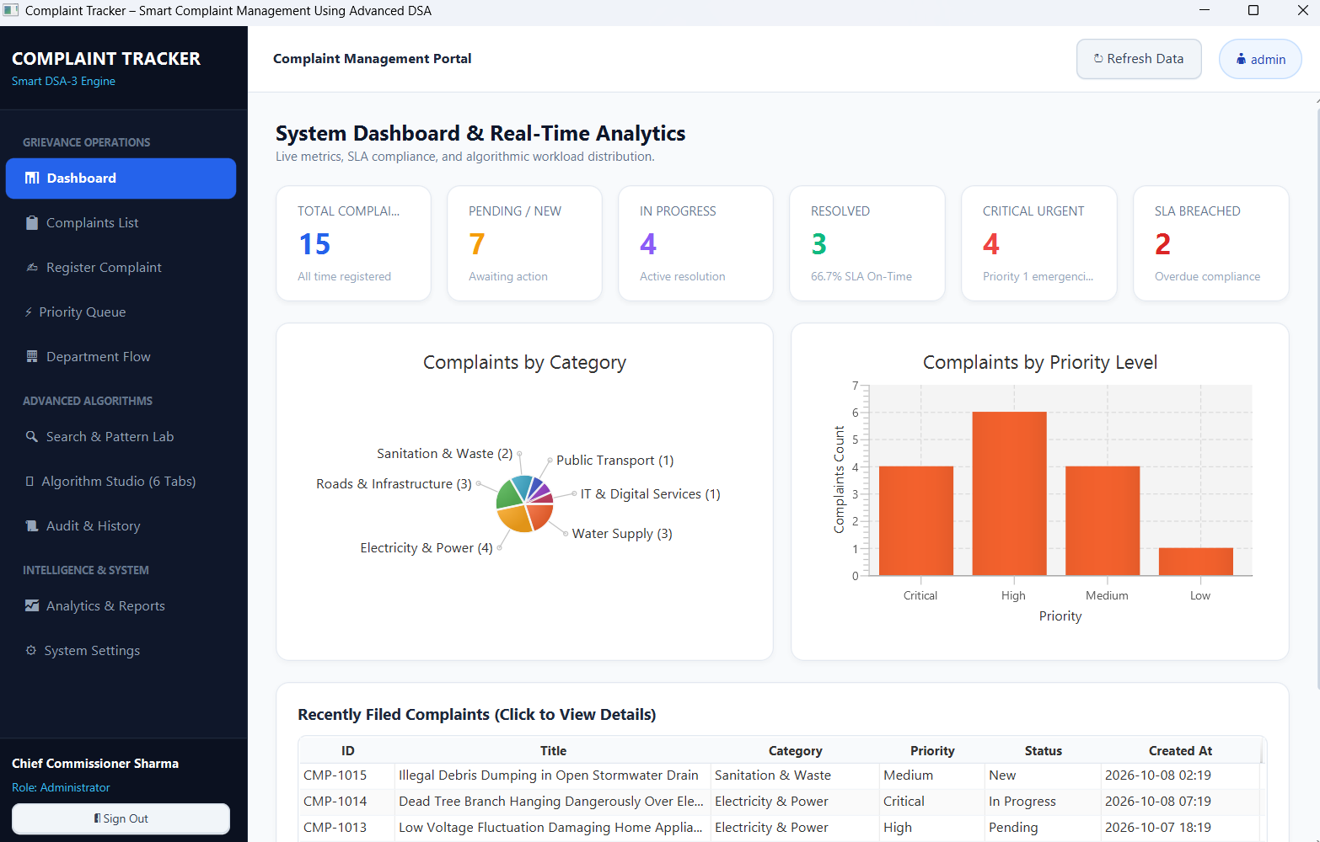
Figure: Complaint Tracker Dashboard and Real-Time Analytics
The dashboard provides an operational overview of the complaint system. It displays total complaints, pending and new complaints, in-progress complaints, resolved complaints, critical urgent complaints, and SLA-breached cases. Category and priority charts support quick analysis, while the recent complaints table provides direct access to complaint records.
• Live summary cards for complaint status and SLA condition.
• Category and priority visualizations for operational analysis.
• Recent complaint table for quick record access.

2. Figure: Department Capacity and Workload Balancing
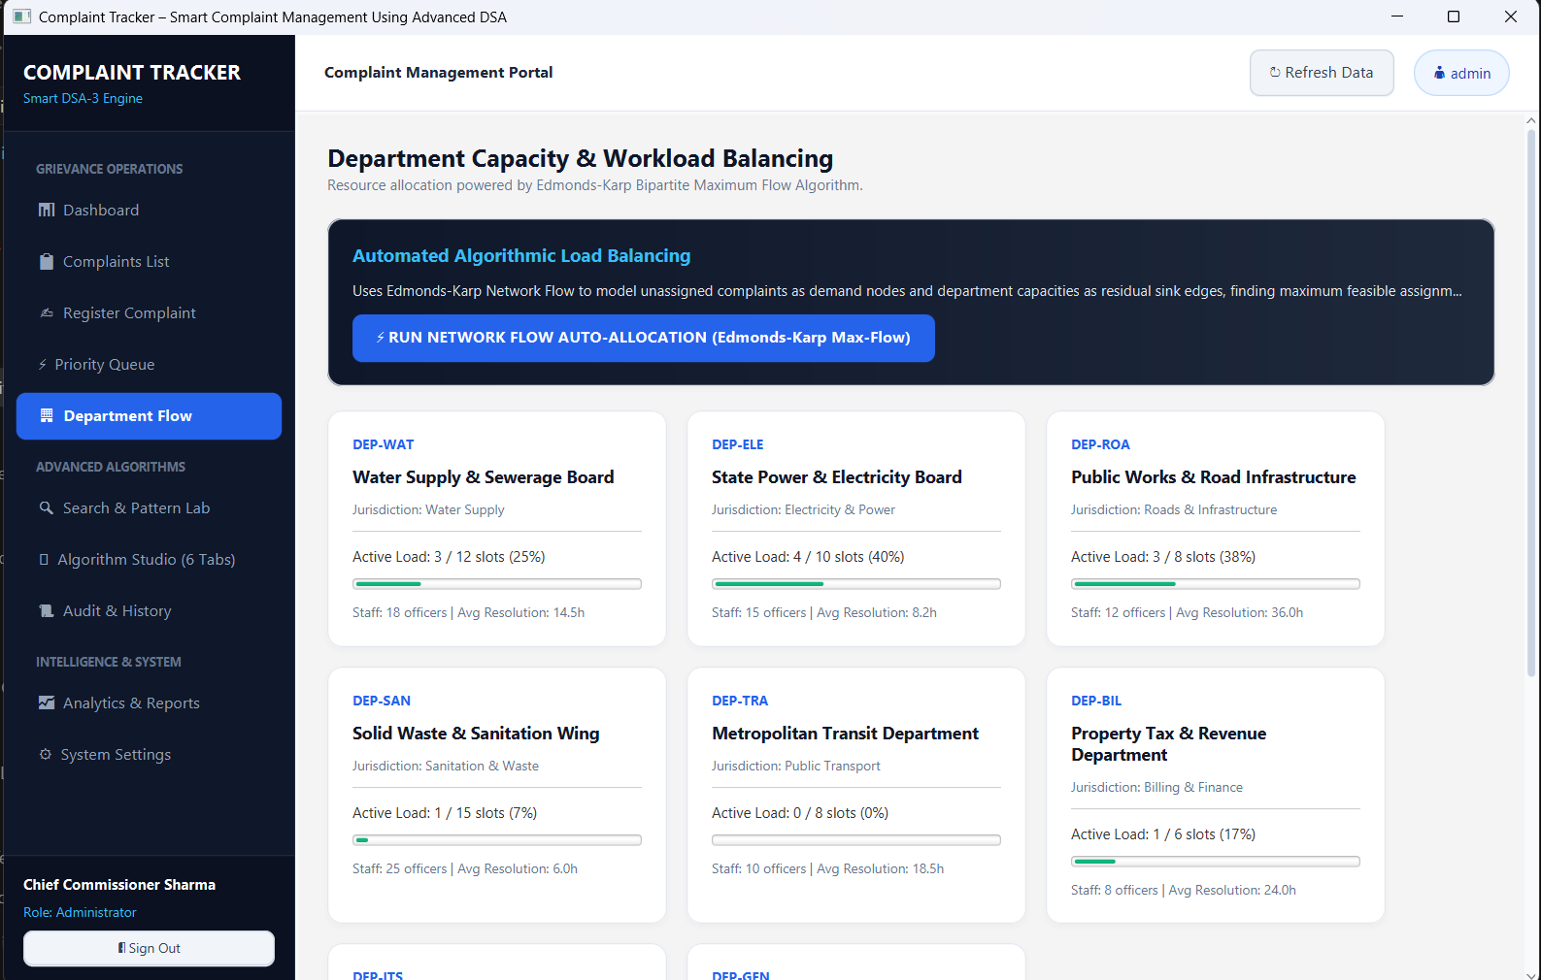
Figure: Department Capacity and Workload Balancing
The Department Flow screen shows department-wise capacity, active workload, staff availability, and average resolution time. The Edmonds-Karp network-flow based allocation option supports automated distribution of unassigned complaints while considering available department capacity.
• Department capacity and active-load indicators.
• Staff and average-resolution information.
• Network-flow based automated allocation control.

3. Figure: Search and Pattern Matching Laboratory
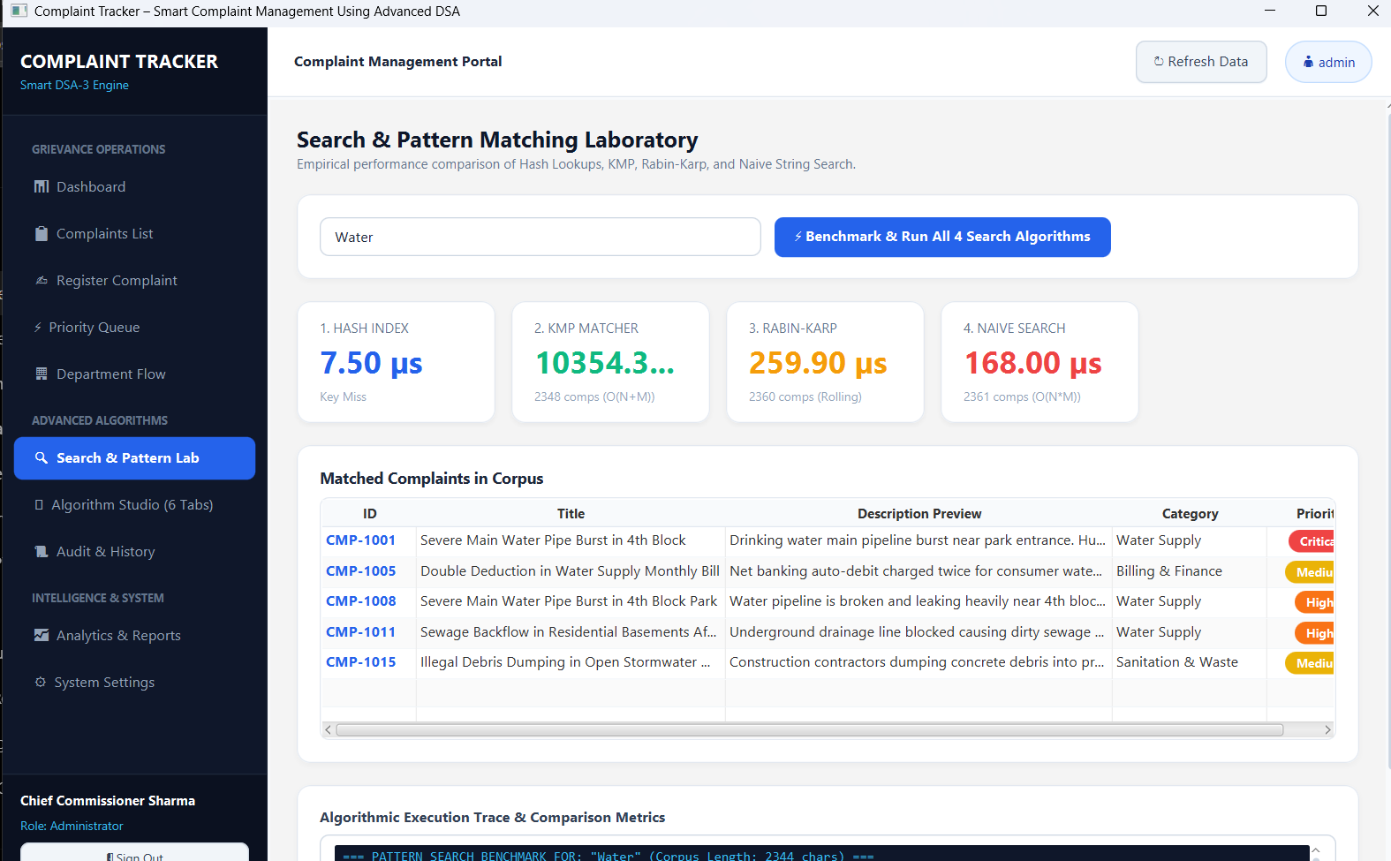
Figure: Search and Pattern Matching Laboratory
The Search and Pattern Matching Laboratory demonstrates the algorithmic search layer. It compares Hash Index lookup, KMP matching, Rabin-Karp matching, and Naive String Search and displays matched complaints from the complaint corpus.
• Pattern input field and multi-algorithm benchmark control.
• Hash lookup, KMP, Rabin-Karp, and Naive Search comparison.
• Matched complaint records displayed with category and priority.

4. Figure: Algorithmic Execution Trace and Comparison Metrics
Figure: Algorithmic Execution Trace and Comparison Metrics
The execution area provides algorithmic trace information and comparison metrics for the selected search operation. This screen is useful for demonstrating the practical application of advanced string algorithms and their empirical performance within the Complaint Tracker.
• Algorithm execution trace for the selected search.
• Empirical comparison metrics supporting DSA analysis.
• Evidence that the algorithm layer is integrated into the application workflow.

5. SOURCE CODE AND UNIT TESTING – STRING MATCHING MODULE
The following implementation screenshot shows the StringMatchingTest.java file in Visual Studio Code. The test class verifies standard string matching behaviour, multiple match positions, patterns longer than the text, and empty-string edge cases. The project structure also contains dedicated test modules for Aho-Corasick, suffix structures, Bitmask DP, Edit Distance, Interval DP, Sequence Alignment, and Tree DP.
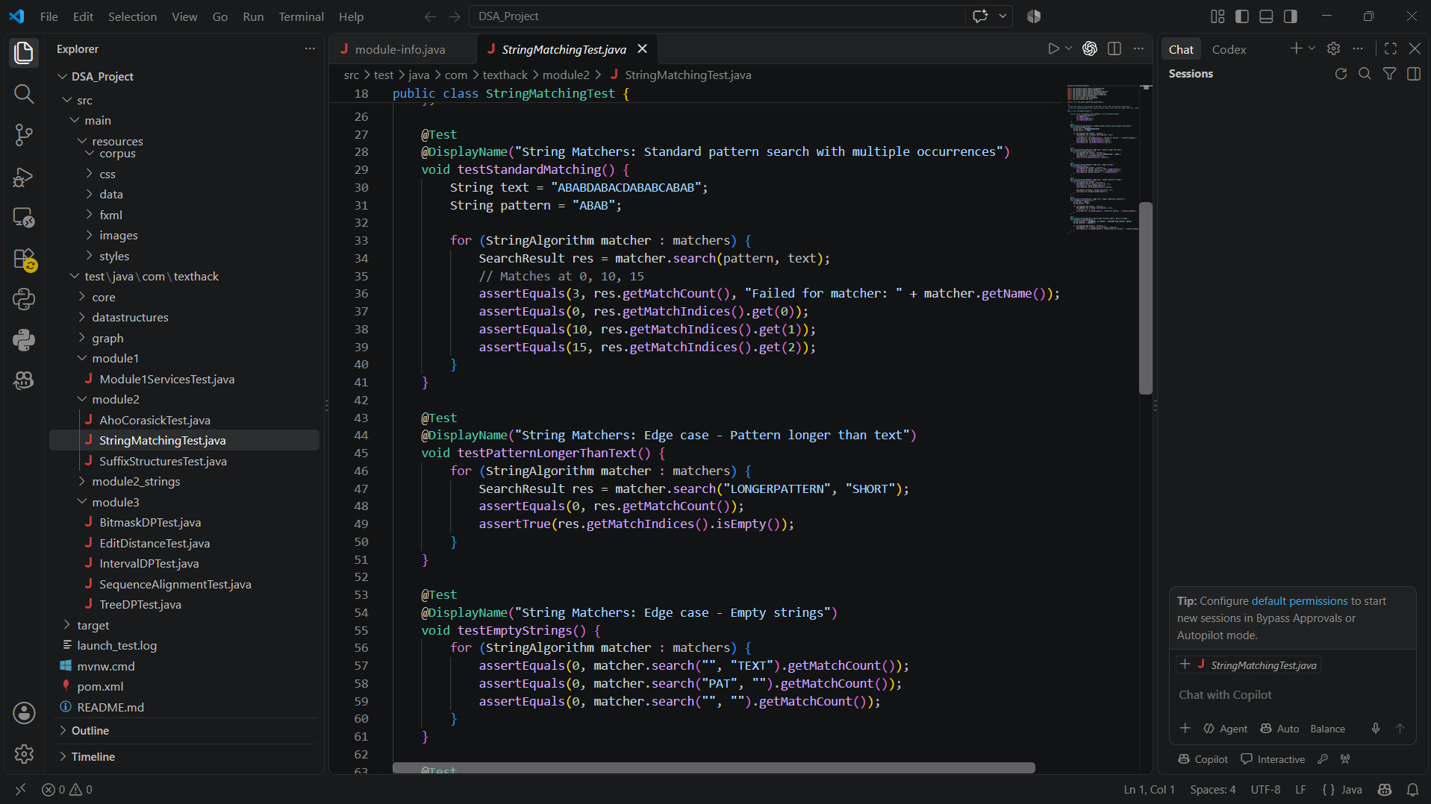
Figure: Visual Studio Code – String Matching unit tests and DSA-3 project structure
• Standard pattern matching test verifies expected match count and match indices.
• Edge-case tests verify behaviour when the pattern is longer than the text.
• Empty-string cases are explicitly tested to improve algorithm reliability.
• The project structure separates core algorithms, data structures, graph modules, and advanced DSA test modules.
REFERENCES

[1] T. H. Cormen, C. E. Leiserson, R. L. Rivest, and C. Stein, Introduction to Algorithms, 4th ed., MIT Press, 2022.
[2] J. Kleinberg and É. Tardos, Algorithm Design, Pearson Education.
[3] S. S. Skiena, The Algorithm Design Manual, Springer.
[4] M. T. Goodrich, R. Tamassia, and M. H. Goldwasser, Data Structures and Algorithms in Java, Wiley.
[5] Oracle, Java SE Documentation and API Reference.
[6] OpenJFX, JavaFX Documentation and API Reference.
[7] Course material for Data Structures and Algorithms-3 (25CS2103E), including String Algorithms, Advanced Dynamic Programming, Network Flow, NP-Completeness and Approximation, and Randomized and Parallel Algorithms.
[8] Project implementation notes and test cases prepared by the project team for Complaint Tracker – Smart Complaint Management Using Advanced Data Structures and Algorithms.
