A CASE-STUDY BASED REPORT
ON
Stock Return Prediction Using Ridge and Lasso Regression with Feature Scaling
submitted in partial fulfilment of the requirements for the Course
MACHINE LEARNING
BACHELOR OF TECHNOLOGY
in
A.Y.: 2026-27
by
Dhanush Roll No. 2520030014
Akshith Roll No. 2520030041
Under the Esteemed guidance of
Mr. Shaik Asif
Asst. Professor, Dept. of CSE




INDEX
Abstract
Introduction
Background
Motivation for the Project
Overview of the Work Carried Out
Scope and Responsible-Use Statement
Problem Statement
Case-Study Scenario
Central Case-Study Question
Formal Problem Definition
Objectives that Guide the Study
Assumptions and Limitations
Dataset and Exploratory Data Analysis
About the Dataset
Purpose of EDA
Preparation Steps Actually Performed
EDA Exploration - Implementation
Summary of EDA Findings
Algorithm Selection and Implementation

Conclusion

Signature of the Team members

ABSTRACT
This case study presents a machine-learning approach for predicting the daily stock return of Reliance Industries using historical market data. The study uses Open, High, Low, Close, Adjusted Close and Trading Volume as input features. Exploratory Data Analysis (EDA) is performed to understand the data distribution, trends, relationships, missing values, duplicates and possible outliers. The analysis shows extremely strong correlations among the OHLC price variables, indicating multicollinearity. Therefore, Ridge and Lasso Regression are selected as regularized linear models. Before modelling, StandardScaler is applied because the variables have very different numerical scales. The target variable is the daily return calculated from the percentage change in closing price. The models are trained and evaluated using MSE, RMSE, MAE and R². The actual implementation shows that Ridge provides lower prediction error and a higher R² than the selected Lasso configuration on the held-out test set. The study is intended for educational analysis and should not be treated as financial advice or a guaranteed trading system.

1. INTRODUCTION

1.1 Background
Stock prices change continuously because of market conditions, company performance, investor expectations, economic factors and other external events. Historical stock-market data provides a structured way to study these movements. Machine learning can be used to learn relationships between historical variables and a selected target such as daily return.
In this project, Reliance Industries historical data is analyzed. Instead of directly predicting the absolute stock price, the project predicts daily return. Return is useful because it expresses the relative day-to-day movement of the stock.

1.2 Motivation for the Project
The main motivation is to demonstrate how regularized regression algorithms can be applied to a real historical financial dataset. Open, High, Low and Close are strongly related to each other, which creates multicollinearity. This makes the dataset suitable for demonstrating why Ridge and Lasso regularization are useful. Feature scaling is also important because price and volume values are on very different numerical scales.

1.3 Overview of the Work Carried Out

1. Load the Reliance Industries historical stock CSV dataset.
2. Inspect dataset dimensions, columns, data types, missing values and duplicate records.
3. Convert the date column to datetime format and identify the historical date range.
4. Calculate daily Return from the Close price.
5. Perform EDA using statistical summaries, trend graphs, distributions, boxplots and correlation analysis.
6. Use the IQR method to identify possible return outliers.
7. Select Open, High, Low, Close, Adjusted Close and Volume as model features.
8. Split the data into training and testing sets.
9. Standardize the input features using StandardScaler.
10. Train Ridge Regression and Lasso Regression models.
11. Predict daily return on the test set.
12. Evaluate both models using MSE, RMSE, MAE and R².
13. Compare the algorithms and interpret their coefficients.

1.4 Scope and Responsible-Use Statement
The scope of this project is limited to historical-data analysis and supervised regression for educational purposes. The model does not include news, macroeconomic variables, market sentiment, company announcements, technical indicators beyond the supplied variables, transaction costs, slippage or real-time market information. Predictions should therefore not be interpreted as guaranteed future prices or investment recommendations.

2. PROBLEM STATEMENT
To develop a machine-learning model that predicts the daily return of Reliance Industries using historical stock-market features and compares Ridge and Lasso Regression after feature scaling.

2.1 Case-Study Scenario
Consider an investor or financial analyst who wants to study the historical behavior of Reliance Industries and estimate its daily return from available market variables. The historical dataset contains Open, High, Low, Close, Adjusted Close and Trading Volume. Since the price variables are strongly correlated and the feature scales are different, a direct ordinary linear regression model may produce unstable or difficult-to-interpret coefficients. The analyst therefore applies feature scaling and compares two regularized regression techniques: Ridge and Lasso.

2.2 Central Case-Study Question
Can scaled historical stock-market features be used to predict Reliance Industries daily return, and which of Ridge or Lasso Regression provides the better predictive performance under the selected experimental setup?

2.3 Formal Problem Definition
Given a dataset D = {(Xᵢ, yᵢ)}, where Xᵢ contains Open, High, Low, Close, Adjusted Close and Volume, the target yᵢ is the daily return. The task is to learn a regression function f(X) that minimizes prediction error on unseen test data. Ridge and Lasso add regularization penalties to the ordinary least-squares objective.

2.4 Objectives that Guide the Study

• Understand the structure and quality of the historical stock dataset.
• Perform practical EDA and visualize important stock characteristics.
• Calculate daily return as the prediction target.
• Identify multicollinearity among numerical features.
• Apply StandardScaler before regularized regression.
• Implement Ridge Regression for coefficient shrinkage and multicollinearity control.
• Implement Lasso Regression for regularization and feature selection.
• Evaluate both models using MSE, RMSE, MAE and R².
• Compare the results and draw an educational conclusion from the experiment.

2.5 Assumptions and Limitations
• Historical relationships are assumed to contain useful information for the prediction task.
• The selected six features are assumed to be sufficient for this classroom experiment.
• The train-test split uses test_size = 0.20 and random_state = 42.
• StandardScaler is fitted only on the training data and then applied to the test data.
• The chosen Ridge alpha is 1.0 and the chosen Lasso alpha is 0.001.
• The model does not establish causality between market variables and future returns.
• Financial markets are affected by information not present in this dataset.
• The experiment is educational and is not an investment recommendation.

3. DATASET AND EXPLORATORY DATA ANALYSIS

3.1 About the Dataset
The project uses the supplied Reliance Industries historical stock dataset RELIANCE.NS_1973-05-08_2025-03-01.csv. The file contains 7,324 records and 7 original columns. Although the filename includes an earlier date, the records used in the dataset span from 1996-01-01 to 2025-02-28.
Property | Value
Records | 7,324
Original columns | 7
Date range | 1996-01-01 to 2025-02-28
Features used for modelling | Open, High, Low, Close, Adjusted Close, Volume
Target | Daily Return
Rows after removing first Return NaN | 7,323
Missing values in original dataset | 0
Duplicate rows | 0

3.2 Dataset Variables
Column | Meaning | Role
date | Trading date | Time/reference
open | Opening stock price | Feature
high | Highest price during the trading day | Feature
low | Lowest price during the trading day | Feature
close | Closing stock price | Feature used to calculate target
adj_close | Adjusted closing price | Feature
volume | Number of shares traded | Feature
Return | Percentage change in Close from previous record | Target

3.3 Purpose of EDA
EDA is performed before modelling to understand the dataset and detect issues that could affect the model. In this project, EDA checks data size, data types, missing values, duplicates, date range, descriptive statistics, price trends, volume behavior, return distribution, outliers and correlations between variables.

3.4 Preparation Steps Actually Performed
1. Read the CSV file using pandas.
2. Printed the number of rows and columns and inspected column names.
3. Displayed the first and last records.
4. Checked data types using df.info().
5. Checked missing values using df.isnull().sum().
6. Checked duplicate rows using df.duplicated().sum().
7. Converted date to pandas datetime format.
8. Calculated descriptive statistics using df.describe().
9. Calculated daily return using close.pct_change().
10. Removed the first row with NaN Return.
11. Calculated cumulative return for exploratory visualization.
12. Computed the correlation matrix.
13. Used the IQR rule to identify possible return outliers.

3.5 EDA Exploration - Implementation
The following are the main code fragments used in the practical EDA implementation:
import pandas as pd
import numpy as np
import matplotlib.pyplot as plt
df = pd.read_csv("RELIANCE.NS_1973-05-08_2025-03-01.csv")
print(df.shape)
print(df.columns.tolist())
print(df.info())
print(df.isnull().sum())
print(df.duplicated().sum())
df["date"] = pd.to_datetime(df["date"], errors="coerce")
df["Return"] = df["close"].pct_change()
df = df.dropna(subset=["Return"])
df["Cumulative_Return"] = (1 + df["Return"]).cumprod() - 1
features = ["open", "high", "low", "close", "adj_close", "volume"]
X = df[features]
y = df["Return"]
X_train, X_test, y_train, y_test = train_test_split(
X, y, test_size=0.20, random_state=42
)
scaler = StandardScaler()
X_train_scaled = scaler.fit_transform(X_train)
X_test_scaled = scaler.transform(X_test)
ridge_model = Ridge(alpha=1.0)
ridge_model.fit(X_train_scaled, y_train)
ridge_prediction = ridge_model.predict(X_test_scaled)
lasso_model = Lasso(alpha=0.001)
lasso_model.fit(X_train_scaled, y_train)
lasso_prediction = lasso_model.predict(X_test_scaled)
mse = mean_squared_error(actual, predicted)
rmse = np.sqrt(mse)
mae = mean_absolute_error(actual, predicted)
r2 = r2_score(actual, predicted)

3.6 EDA Exploration - Graphs and Interpretation
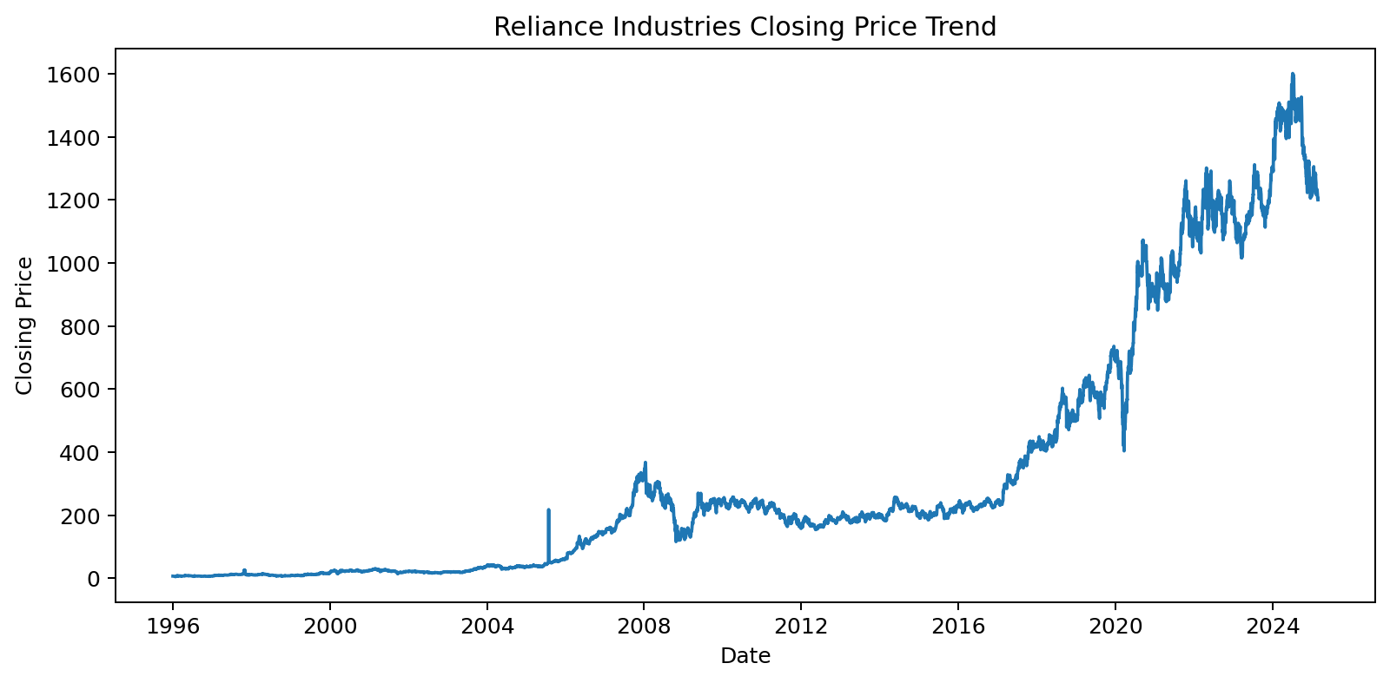
Figure 1. Closing Price Trend
The closing-price graph shows the long-term movement of Reliance stock. It helps identify broad trends, changes in price level and periods of strong movement.
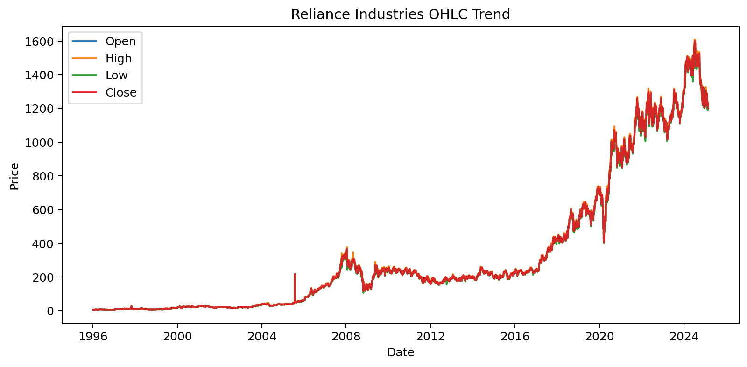
Figure 2. OHLC Trend
The OHLC graph compares Open, High, Low and Close prices. It helps understand daily price movement and the relationship between the four price measures.
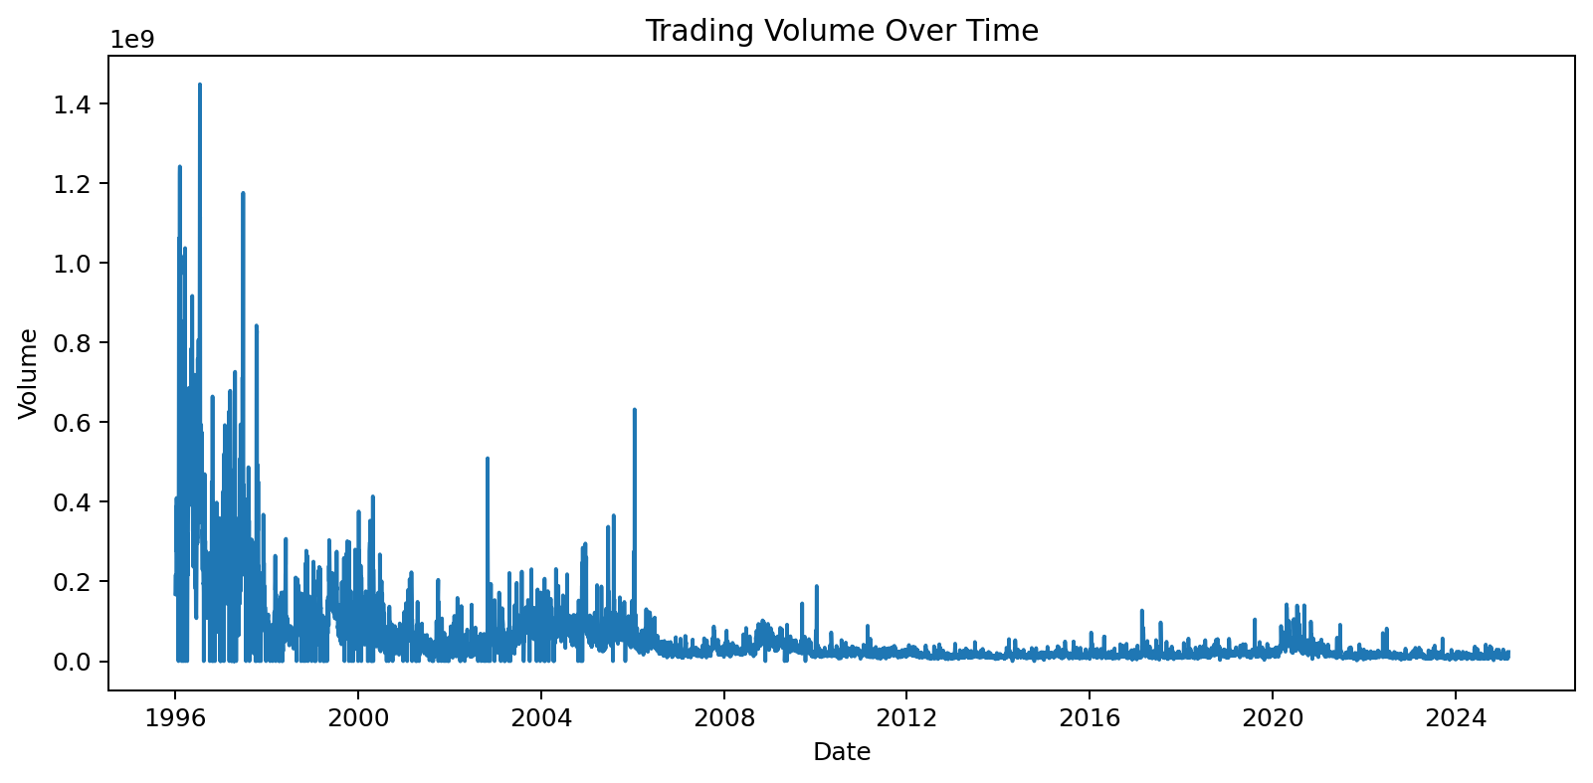
Figure 3. Trading Volume
Trading volume represents the number of shares traded. Spikes in volume indicate periods of unusually high trading activity.
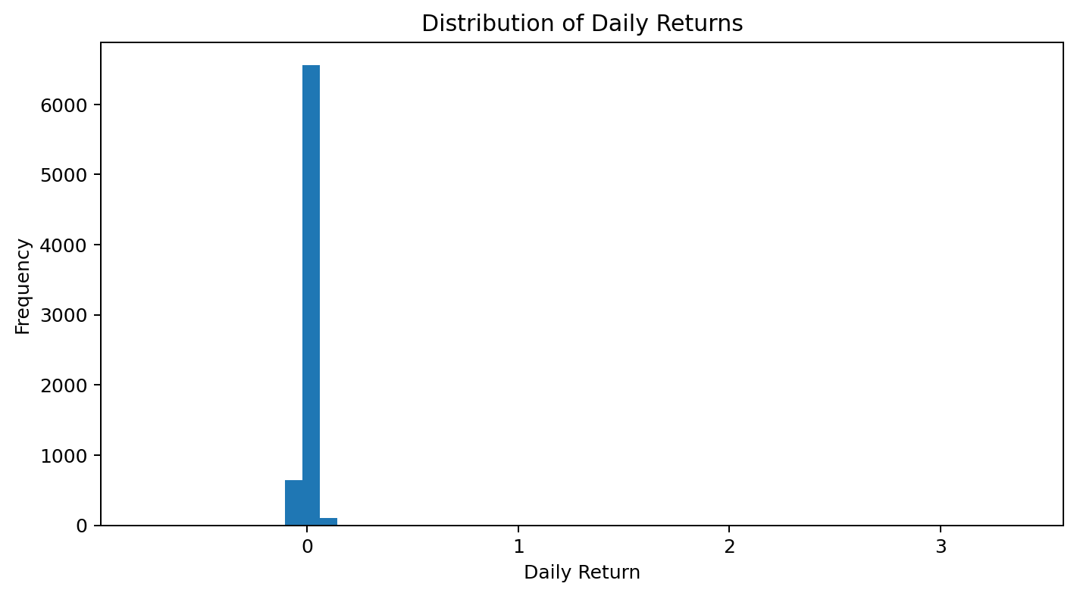
Figure 4. Daily Return Distribution
The histogram shows how frequently different daily return values occur. Most observations are concentrated around small returns, while the tails show relatively extreme movements.
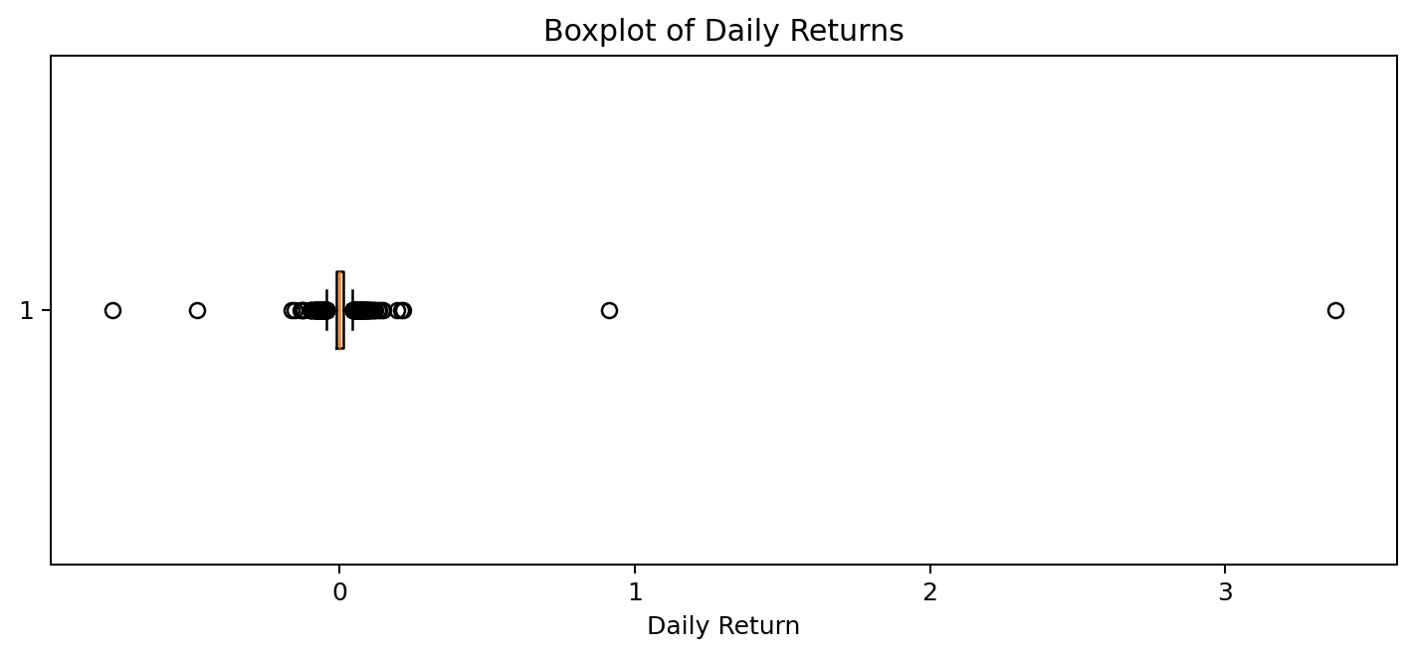
Figure 5. Daily Return Boxplot
The boxplot summarizes the median, quartiles and spread of daily returns and makes possible outlier observations visible.
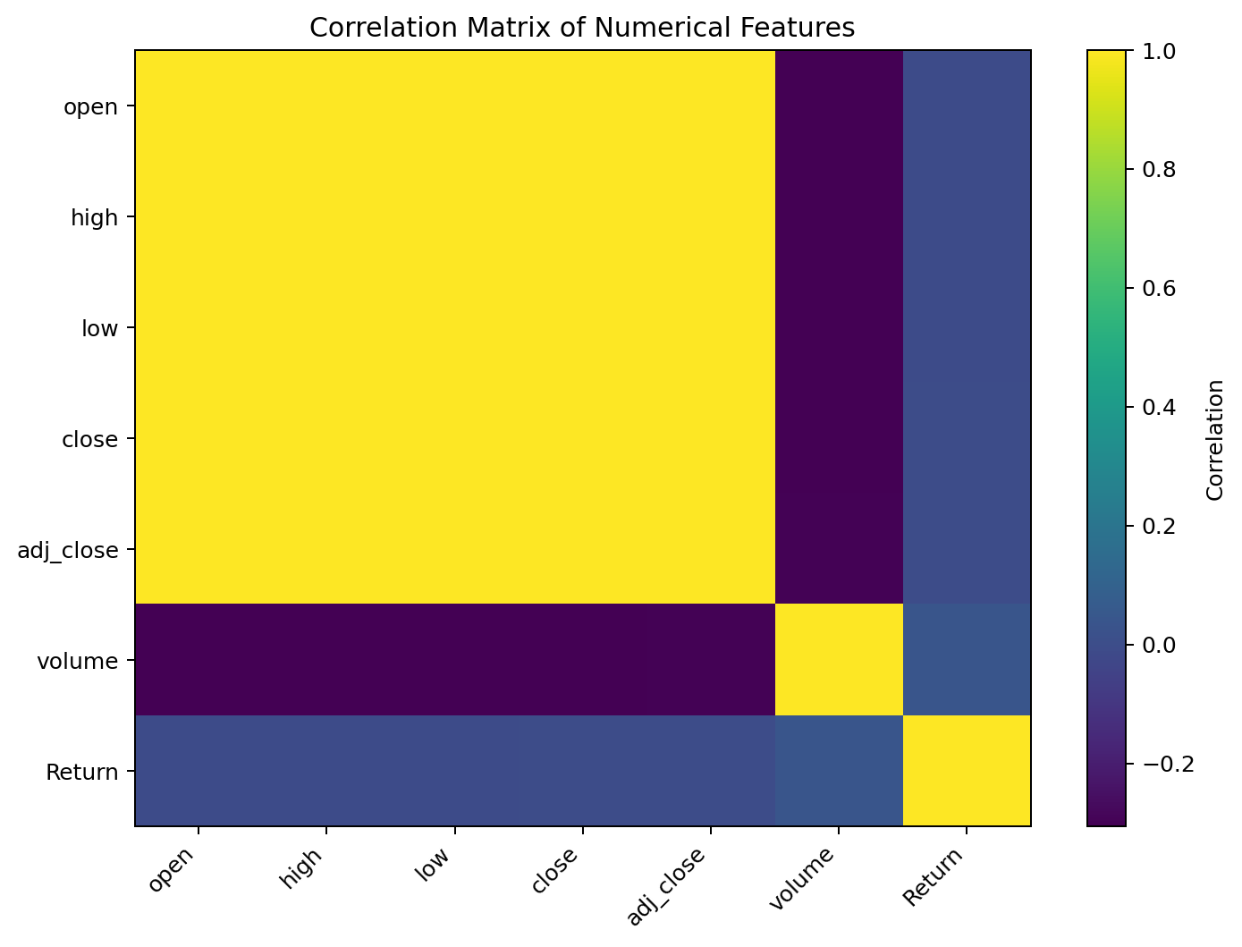
Figure 6. Correlation Matrix
The correlation analysis is especially important. Open, High, Low and Close have correlations close to 1.0 with each other. Adjusted Close is also strongly correlated with the price variables, indicating multicollinearity and motivating regularization.
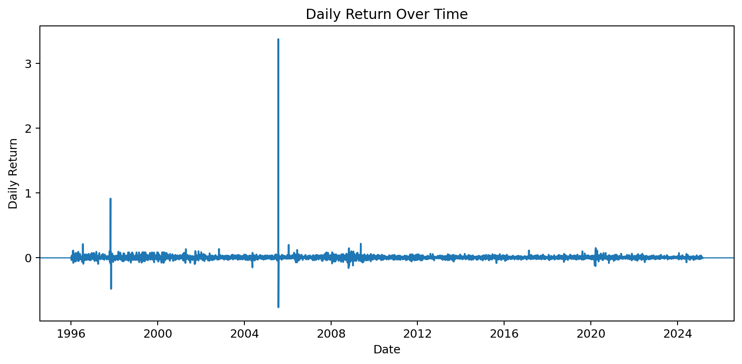
Figure 7. Daily Return Over Time
The daily-return trend shows positive and negative movements around zero and highlights periods with larger return fluctuations.
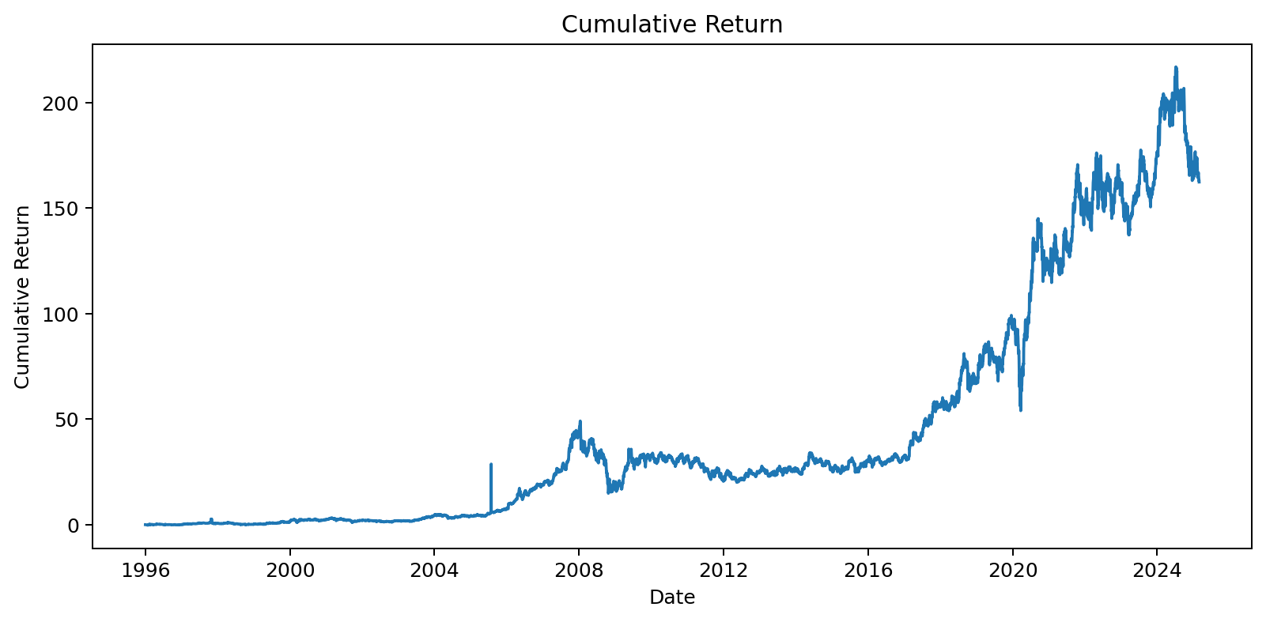
Figure 8. Cumulative Return
The cumulative-return graph shows the compounded effect of the sequence of daily returns over the historical period. It is an exploratory measure and is not itself the prediction target.

3.7 Summary of EDA Findings
EDA Item | Finding | Importance
Dataset size | 7,324 original rows and 7 columns | Sufficient historical observations for the classroom model
Missing values | 0 in the original columns | No missing-value treatment required for original data
Duplicates | 0 duplicate rows | No repeated complete records
Date range | 1996-01-01 to 2025-02-28 | Long historical period
Price correlation | OHLC correlations approximately 0.9998–0.9999 | Strong multicollinearity
Volume correlation | Around -0.30 with price variables | Different relationship from price variables
Return correlation | Near zero with most price features; 0.0356 with volume | Weak simple linear relationship with individual inputs
IQR outliers | 356 possible Return outliers | Extreme daily movements exist

4. ALGORITHM SELECTION AND IMPLEMENTATION

4.1 Why Regression?
Regression is appropriate because the target variable, daily Return, is a continuous numerical value. The task is therefore formulated as supervised regression rather than classification.

4.2 Why Ridge Regression?
Ridge Regression applies L2 regularization. It is selected because the EDA revealed strong multicollinearity among Open, High, Low and Close. Ridge reduces the magnitude of coefficients and makes the solution more stable while generally retaining all input variables.
Ridge objective: Loss = RSS + α × Σ(βj²)

4.3 Why Lasso Regression?
Lasso Regression applies L1 regularization. It is selected because it can shrink some coefficients exactly to zero, providing automatic feature selection in addition to regularization.
Lasso objective: Loss = RSS + α × Σ|βj|

4.4 Why Feature Scaling?
The dataset contains variables on very different scales. Stock prices are measured in hundreds of units while trading volume can reach hundreds of millions or more. StandardScaler converts the features to a comparable scale before regularization, preventing a large numerical scale from dominating the penalty.

4.5 Model Configuration
Item | Configuration
Target | Return
Features | Open, High, Low, Close, Adjusted Close, Volume
Train/Test split | 80% / 20%
random_state | 42
Scaling | StandardScaler
Ridge | Ridge(alpha=1.0)
Lasso | Lasso(alpha=0.001)
Evaluation | MSE, RMSE, MAE, R²

4.6 Algorithm Workflow
1. Load historical Reliance stock data.
2. Calculate daily Return from Close.
3. Select six numerical input features.
4. Split data into training and testing sets.
5. Fit StandardScaler only on the training data.
6. Transform training and test features.
7. Train Ridge Regression.
8. Train Lasso Regression.
9. Generate predictions on the test data.
10. Calculate MSE, RMSE, MAE and R².
11. Compare the two models.

4.7 Evaluation Metrics
Metric | Meaning | Better Value
MSE | Average squared prediction error | Lower
RMSE | Square root of MSE; error in target scale | Lower
MAE | Average absolute prediction error | Lower
R² | Proportion of target variance explained by the model | Higher
Formulas:
MSE = (1/n) Σ(yi − ŷi)²
RMSE = √MSE
MAE = (1/n) Σ|yi − ŷi|
R² = 1 − [Σ(yi − ŷi)² / Σ(yi − ȳ)²]

4.8 Actual Experimental Results
These values were obtained by running the project implementation on the supplied Reliance dataset with an 80/20 random train-test split, random_state=42, StandardScaler, Ridge alpha=1.0 and Lasso alpha=0.001.
Model | MSE | RMSE | MAE | R²
Ridge | 0.0003946743 | 0.0198664122 | 0.0131139701 | 0.2017682515
Lasso | 0.0004924941 | 0.0221922090 | 0.0153331578 | 0.0039269793
Under this exact configuration, Ridge has lower MSE, RMSE and MAE and a higher R² than Lasso. Therefore Ridge performs better on this particular held-out test set. This does not mean Ridge will always outperform Lasso; changing the split, regularization strength, features or validation method can change the result.

4.9 Model Coefficients
Feature | Ridge coefficient | Lasso coefficient
open | -0.31239426 | -0.00000000
high | 0.00591685 | -0.00000000
low | 0.00818825 | -0.00000000
close | 0.30607128 | -0.00000000
adj_close | -0.00757909 | -0.00000000
volume | 0.00171825 | 0.00063740
In this run, Lasso shrinks the coefficients of Open, High, Low, Close and Adjusted Close to zero, while retaining a small Volume coefficient. This demonstrates Lasso's feature-selection behavior. Ridge retains non-zero coefficients for all six features while shrinking their magnitudes.

4.10 Interpretation of the Model Comparison
• Ridge is better in the current experiment because its test-set errors are smaller and its R² is higher.
• The strong OHLC multicollinearity makes Ridge particularly relevant.
• Lasso provides a useful alternative because it can simplify the model through coefficient selection.
• The model is a regression demonstration rather than a complete financial forecasting system.

5. CONCLUSION
This case study demonstrates a complete machine-learning workflow for Reliance Industries stock-return prediction. The historical dataset was inspected, daily return was calculated as the target, and EDA was used to understand trends, distributions, outliers and correlations. The most important EDA finding was the extremely high correlation among the OHLC price variables, which indicates multicollinearity and motivates the use of Ridge and Lasso Regression.
Feature scaling using StandardScaler was applied before regularization. Ridge achieved MSE = 0.0003946743, RMSE = 0.0198664122, MAE = 0.0131139701, and R² = 0.2017682515. Lasso achieved MSE = 0.0004924941, RMSE = 0.0221922090, MAE = 0.0153331578, and R² = 0.0039269793.
The comparison indicates that Ridge is the better-performing model for this particular experiment, while Lasso demonstrates useful feature-selection behavior. Future work could use time-ordered validation, hyperparameter tuning, lagged returns, technical indicators, market indices, company fundamentals and external market information while carefully avoiding data leakage and overfitting.

6. TEAM CONTRIBUTION / PRESENTATION POINTS
Team Member | Suggested Responsibility
Dhanush – 2520030014 | EDA, dataset preparation, feature scaling, Ridge/Lasso explanation and results
Akshith – 2520030041 | Case-study scenario, problem definition, visualizations, evaluation metrics and documentation
Guide | Mr. Shaik Asif, Asst. Professor, Dept. of CSE

7. SIGNATURE OF THE TEAM MEMBERS
Dhanush — Roll No. 2520030014 Signature: __________________________
Akshith — Roll No. 2520030041 Signature: __________________________
Guide: Mr. Shaik Asif Signature: __________________________

