**README:**

**1. Project’s Title: ChatApp.**

**2. Project Description:**

ChatApp is a real time chat application using SignalR. ASP.NET. This real-time chat application has been developed by using SignalR, Bootstrap, and jQuery Modal Popup. There is a Login system for existing users and registration for new users. First, the user has to create an account and then they can login by using their login credentials, so the login authentications are required. After login, a user can participate in chat or discussion. The users can change their display picture after logging in the application. Login user can send send private messages using chat box.User can Clear the old chat history if he wants, for clearing chat history we added the clear chat icon on the top of the group chat box header, in private chat we can clear the chat by closing the chat box, but in group chat we cannot close the chat box, so here we have given the option of clearing chat.

Technologies employed: Asp.net

* **Backend:** .NET 4.8 Web API
* **Frontend:** WebForms
* **Real-time Communication:** SignalR
* **Database:** SQL

The challenges faced: Issue while using Azure free service for deployment.

**Future features envisioned:**

**TODO**

* Focus on a simple deployment pipeline setup, not complex infrastructure.
* Pipeline setup from Dev to QA stage is the minimum setup scope.

**3. Table of Contents**

**Core Requirements (Must-Haves):**

* **Basic Chat Functionality:**
  + Users can register/login (simple authentication)
  + Users can send text messages to other users in real time.
  + Messages are displayed in a chat window and visibly update as new messages arrive.
  + Creation of Private Chat
  + Title Bar Notification Alert system
  + Message Count
  + Clear Chat History.
* **Real-time Updates:**
  + Implement SignalR for real-time message exchange and user presence (if applicable).

**Additional Features:**

* **Chat Box:** Users can create/join chat rooms.
* **Message History:** Messages are persisted.
* **Emoji Support:** Users can send emojis within messages.
* **Read Receipts:** Title Bar Notification Alert implemented when a new message arrives with message count.
* **Added Feature of Sending Picture / File Attachment: Users can** send images, words, documents, Text files, PDF Files and Excel files

4. Project Code Explanation:

* Created an ASP.NET C# WebForm application.
* Added the following packages through NuGet Package Manager.
* Bootstrap
* jQuery
* Font-awesome
* AjaxControlToolkit
* Microsoft.AspNet.SignalR
* Created Startup. cs
* Created ChatHub.cs
* Created Login WebForm
* Created Register WebFrom
* Created Chat WebForm
* Created a Database in SQL Server
* Code
* Created Private chat

**Screenshots:**

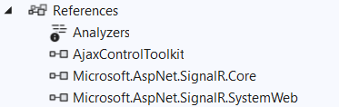

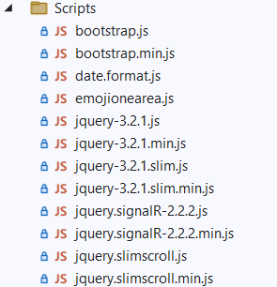

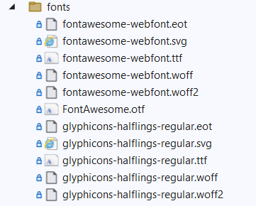

**Login Page:**

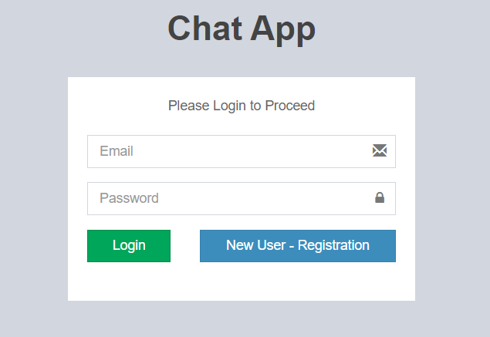

**Registration Page:**

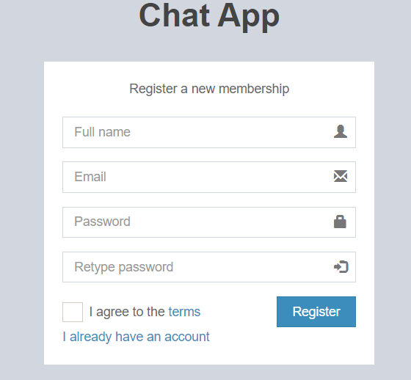

**Chat Page:**

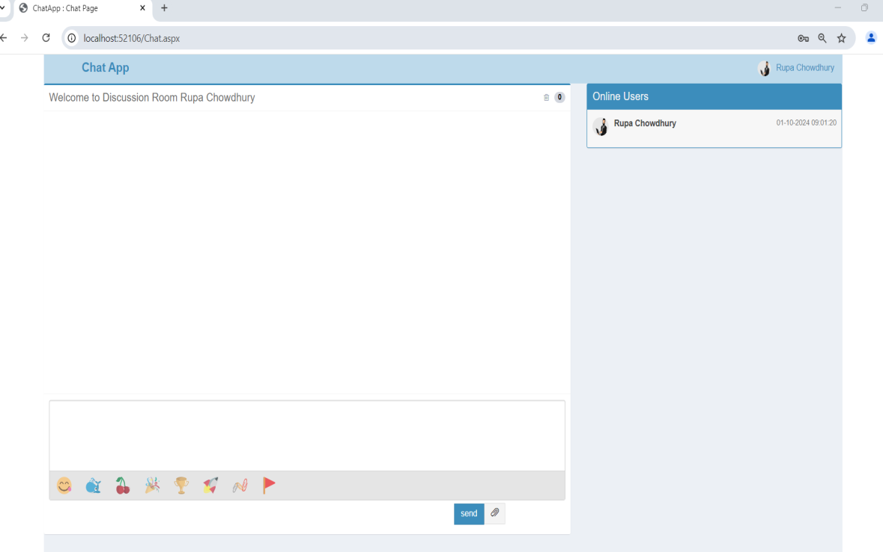

**Change Picture:**

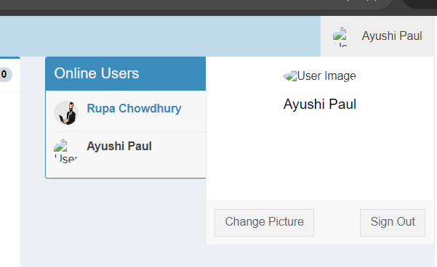



**Chat Room:**

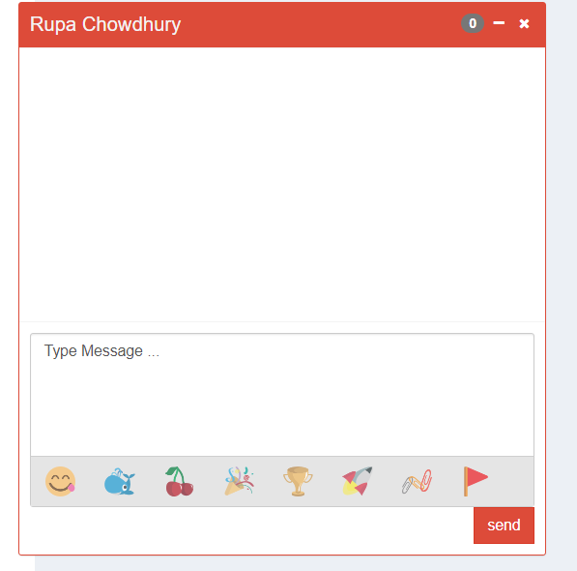 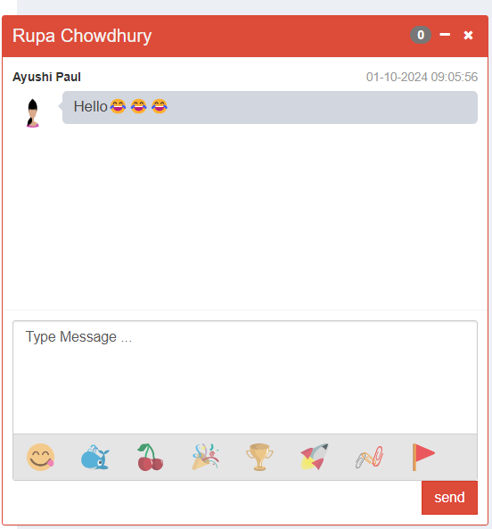

**Conclusion:**

ChatApp is a real time chat application using SignalR. ASP.NET SignalR is a library for ASP.NET developers that simplifies the process of adding real-time web functionality to applications, i.e., the ability to have server code push the content to connected clients instantly as it becomes available, rather than having the server wait for a client to request new data.