

Online examination system

A Software Development Project



sylhet engineering college

dept. of computer science and engineering

Project Report

Project Name : Online Examination System

Course Title : Software Development

Course Code : 612

Submitted by :

Abdullah Al Naseeh Chowdhury

Reg: 2018331501

Syme Al-Azad Shuvo

Reg: 2017331554

Objectives :

The purpose of the online examination system is to test the subject knowledge of the students. Such a system eliminates logistical hassles and drawbacks in the traditional mode of the pen-and-paper examination. Students don't have to assemble in the classroom to give the exam. They can do it within a given time frame from their own device. You don't have to rent a classroom.

Introduction :

The computer network and information technology area is developing rapidly in recent days. It is making vital changes to human beings in the fields of study, work and the way of life. Due to availability of internet technology, online examinations are becoming important method of accessing and evaluating the success potential in students. The proposed system is developed to overcome the debugs of existing manual testing system. The primary goal of the proposed system is to effectively assess the student performance thoroughly with the help of completely automated system that not only helps to save a lot of time but also gives quick outcomes. The purpose of the online examination system is to companies or institutions to conduct various examinations for any number of candidates at a time, in a paperless manner. It helps to save the time consumption and amount of efforts required to conduct the variety of examinations and their evaluation process. It also provides a facility to add tests for particular subject, to add a new subject in efficient and flexible way which allows performing paperless work. The online examination system is also useful to maintain the safety factor which is necessary situation without disturbing educational life. This online examination system also makes the user easy to collect the information about aptitude test which is important for placement and higher studies.

Project Requirements :

Interface Requirements :

•The system shall provide an option to add/delete quizzes with questions.

•The system shall provide an option to see and attend the quizzes.

•The system should give option for login for students.

•The system shall provide option to see scores and ranking.

Software Requirements :

Programming language : PHP, MYSQL

Operating system : ANY OS

Application required : Standalone desktop application

Xampp Coding language: PHP, HTML, CSS, Javascript

Methodology:

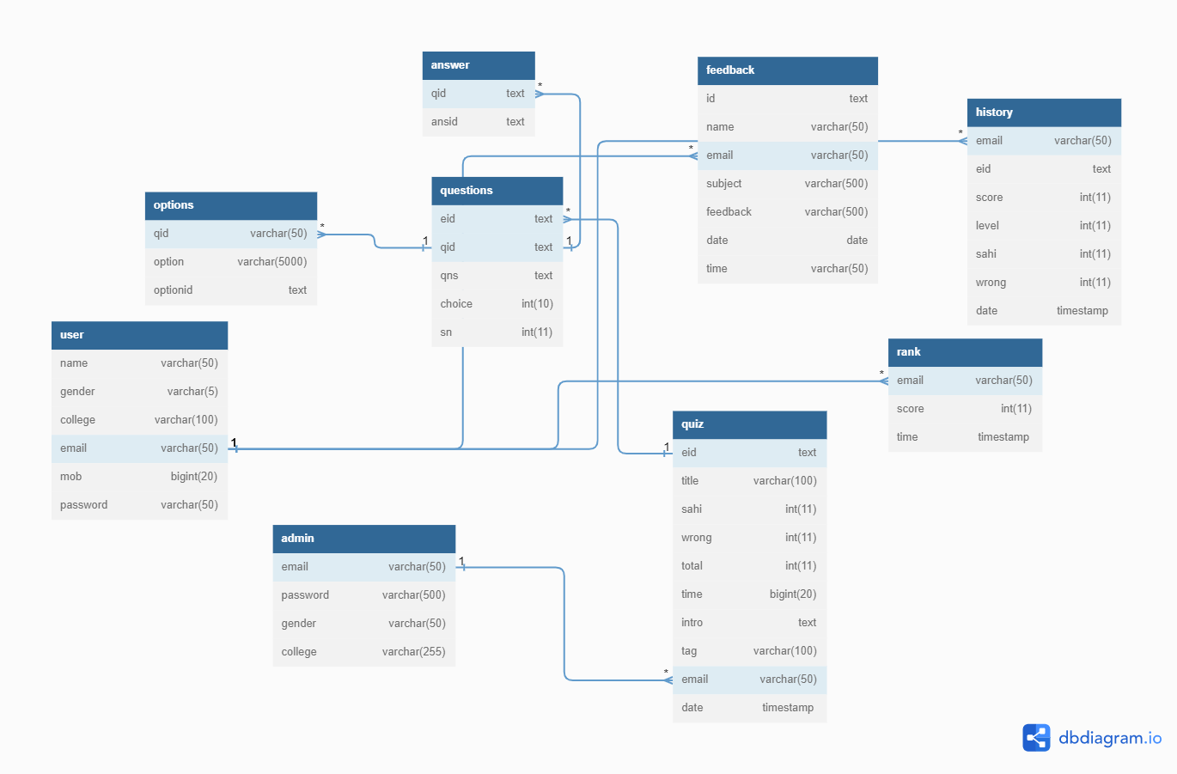

ER Diagram

Conclusion :

The online examination system provides better functionality for an examination to be more efficient and reduce manual paperwork in order to automate all possible tasks. For implementing this system, PHP, HTML, CSS, JavaScript and MySql are used.

The system comprises of following features:

• Management of quiz.

• Automated grading.

• Adding/deleting quizzes and questions.

• Ranking student according their score.

• Simultaneous feedback review.