AI RISK MANAGEMENT
GOVERNANCE AND SECURITY
Practical Manager and Junior Analyst Manual

What this manual does: Explains how to approve, map, test, secure, monitor, and prove responsible AI use. It covers traditional ML, generative AI, RAG, agents, tools, NIST AI RMF, ISO standards, OWASP risks, CSA AICM, manager decisions, analyst work, and safe labs.

Alberto (Al) Leiva
First Edition • July 2026

Preface
Artificial intelligence can assist people, create content, rank choices, detect patterns, and take actions. It can also be wrong, biased, manipulated, overly powerful, difficult to explain, or used beyond its approved purpose. Good governance helps an organization obtain value while protecting people, information, operations, and trust.
This manual uses plain language and focuses on practical work. It is not legal advice, a certification guide, or a promise that a system is safe. Laws, standards, model behavior, threats, and provider features change quickly. Confirm current authoritative sources and involve qualified legal, privacy, security, data science, human-rights, safety, procurement, audit, and business professionals for real decisions.
Current-information note: Verified July 14, 2026. NIST AI RMF 1.0 remains the published framework but NIST states it is being revised. NIST AI 600-1 remains the Generative AI Profile. CSA AICM v1.1 was released in June 2026. EU AI Act obligations apply progressively, and proposed timing changes are not final law unless adopted; verify status with official sources and counsel.

How to use this manual
- Managers: start with Chapters 1–10, 22–28, then use the decision records in Chapter 30.
- Junior analysts: study in order, run only authorized labs, and build the portfolio in Chapter 29.
- Developers and data teams: focus on Chapters 10–23 and the testing tools in Chapter 26.
- GRC, privacy, legal, and audit teams: focus on Chapters 2–9 and 20–25.
- Record the exact system, model, version, data, use, users, geography, impact, evidence, limitations, and decision for every assessment.

Table of Contents
This file contains a true native Word table of contents plus a permanent page-numbered chapter guide.
Preface 2
How to use this manual 2
Table of Contents 3
Chapter Guide 7
1. AI Foundations and Trustworthy Use 8
1.1 Trustworthy characteristics 8
2. Governance, Standards, and Legal Landscape 9
2.1 Legal and obligation register 9
3. NIST AI RMF Core 10
4. GOVERN: Culture, Accountability, and Policy 11
4.1 Governance structure 11
5. MAP: Context, People, and Impact 12
5.1 Context record 12
6. MEASURE: Testing and Risk Analysis 13
6.1 Measurement plan 13
7. MANAGE: Treatment, Deployment, and Improvement 14
7.1 Deployment gate 14
8. NIST Generative AI Profile 15
9. ISO/IEC 42001 and ISO/IEC 23894 16
9.1 Certification and copyright cautions 16
10. AI Inventory, Use Cases, and Life Cycle 17
10.1 Life-cycle controls 17
11. Data Governance and Data Security 18
11.1 Data control chain 18
12. Model Governance and Model Risk 19
12.1 Validation questions 19
13. Foundation Models and Third Parties 20
13.1 Concentration and value-chain risk 20
14. AI Security Threat Modeling 21
14.1 Threat-model method 21
15. OWASP Top 10 for LLM Applications 2025 22
15.1 How an analyst uses the list 22
16. Agentic AI Security 23
17. Retrieval-Augmented Generation Security 24
17.1 RAG controls 24
18. Prompt, Interface, and Output Security 25
18.1 Output handling examples 25
19. Identity, Tools, APIs, and MCP 26
19.1 MCP security 26
20. Privacy, Intellectual Property, and Records 27
20.1 Privacy and records assessment 27
20.2 Intellectual property 27
21. Fairness, Transparency, Explainability, and Human Oversight 28
21.1 Avoid common mistakes 28
22. Evaluation, Red Teaming, and Acceptance 29
22.1 Red-team rules of engagement 29
23. Monitoring, Incidents, Change, and Retirement 30
23.1 AI incident response 30
24. Assurance, Evidence, Testing, and Metrics 31
24.1 Control test method 31
25. CSA AI Controls Matrix v1.1 32
25.1 Practical use 32
26. Open-Source AI Assurance and Security Tools 33
26.1 Garak 33
26.2 Promptfoo 33
26.3 Giskard 34
26.4 PyRIT 34
26.5 Inspect AI 34
26.6 Adversarial Robustness Toolbox 34
26.7 LLM Guard 34
26.8 Presidio 35
26.9 Guardrails AI 35
26.10 OpenAI Evals 35
26.11 Langfuse 35
26.12 MLflow 35
26.13 Evidently 36
26.14 Deepchecks 36
26.15 ModelScan 36
26.16 Gitleaks 36
26.17 Trivy 37
26.18 MITRE ATLAS 37
27. Manager’s AI Governance Playbook 38
27.1 Operating rhythm 38
27.2 Questions leaders must answer 38
28. Junior AI Risk and Security Analyst Career Guide 39
28.1 Entry-level roles 39
28.2 Daily work 39
28.3 Resume evidence 40
29. Fictional Laboratory, Thirty-Day Plan, and Interviews 41
29.1 Portfolio lab 41
29.2 Thirty-day plan 41
29.3 What is the NIST AI RMF? 42
29.4 Model risk versus system risk? 42
29.5 What is prompt injection? 42
29.6 How do you evaluate an LLM? 42
29.7 What is RAG? 42
29.8 Why is human oversight difficult? 42
29.9 What is an AI inventory? 42
29.10 How do tools prove compliance? 42
29.11 How do you report a finding? 42
29.12 What makes a good junior analyst? 42
30. Templates, Glossary, Index, and References 43
30.1 AI use-case inventory 43
30.2 AI impact and risk assessment 43
30.3 AI evaluation workpaper 43
30.4 AI incident and change record 43
30.5 Glossary 44
30.6 Subject index 44
30.7 Official references 45

Chapter Guide
Chapter | Title | Starts on page
1 | AI Foundations and Trustworthy Use | 5
2 | Governance, Standards, and Legal Landscape | 6
3 | NIST AI RMF Core | 7
4 | GOVERN: Culture, Accountability, and Policy | 8
5 | MAP: Context, People, and Impact | 10
6 | MEASURE: Testing and Risk Analysis | 12
7 | MANAGE: Treatment, Deployment, and Improvement | 13
8 | NIST Generative AI Profile | 14
9 | ISO/IEC 42001 and ISO/IEC 23894 | 15
10 | AI Inventory, Use Cases, and Life Cycle | 16
11 | Data Governance and Data Security | 17
12 | Model Governance and Model Risk | 18
13 | Foundation Models and Third Parties | 19
14 | AI Security Threat Modeling | 20
15 | OWASP Top 10 for LLM Applications 2025 | 21
16 | Agentic AI Security | 22
17 | Retrieval-Augmented Generation Security | 23
18 | Prompt, Interface, and Output Security | 24
19 | Identity, Tools, APIs, and MCP | 25
20 | Privacy, Intellectual Property, and Records | 26
21 | Fairness, Transparency, Explainability, and Human Oversight | 27
22 | Evaluation, Red Teaming, and Acceptance | 28
23 | Monitoring, Incidents, Change, and Retirement | 29
24 | Assurance, Evidence, Testing, and Metrics | 31
25 | CSA AI Controls Matrix v1.1 | 32
26 | Open-Source AI Assurance and Security Tools | 33
27 | Manager’s AI Governance Playbook | 39
28 | Junior AI Risk and Security Analyst Career Guide | 40
29 | Fictional Laboratory, Thirty-Day Plan, and Interviews | 42
30 | Templates, Glossary, Index, and References | 45

1. AI Foundations and Trustworthy Use
Trustworthy AI depends on the complete system, its people, purpose, data, model, interfaces, controls, and real-world effects.
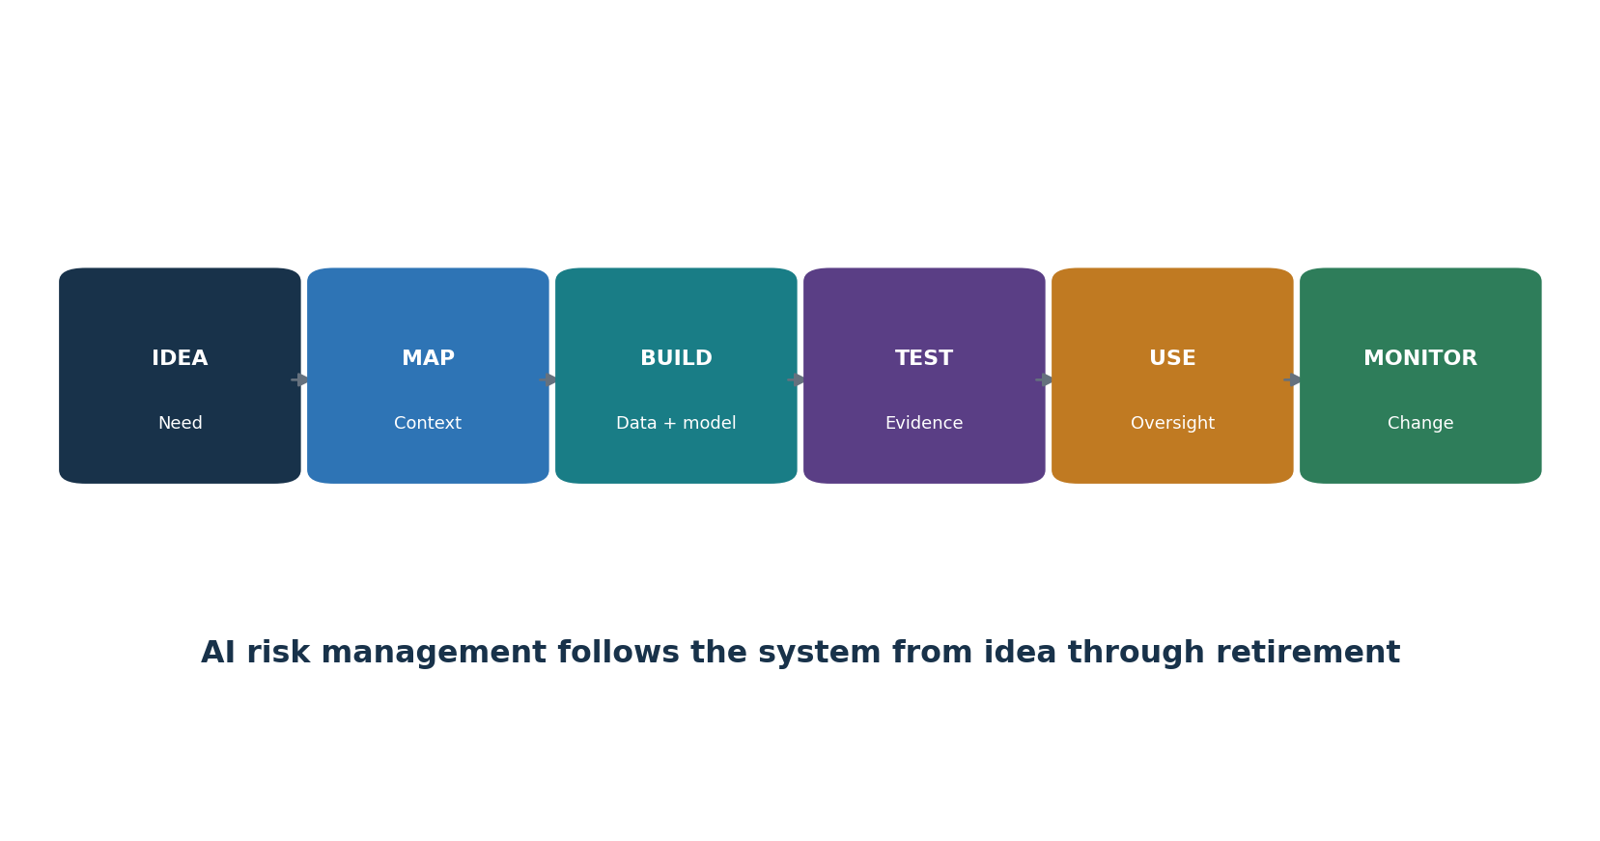
Figure 1. AI system life cycle
Concept | Plain meaning | Analyst question
AI system | People, data, models, software, infrastructure, rules, and processes used for an outcome | What is the complete boundary?
Machine learning | Software learns patterns from data rather than only fixed rules | What data and metric support the behavior?
Generative AI | A model produces text, images, audio, video, code, or other content | What can be invented, leaked, or abused?
Agentic AI | A system plans and uses tools to pursue goals with some autonomy | What authority can it exercise?
Trustworthiness | Evidence that characteristics such as validity, safety, security, privacy, fairness, transparency, and accountability are addressed | What claim, threshold, test, and owner support it?

1.1 Trustworthy characteristics
- Valid and reliable: works for the defined purpose and conditions.
- Safe: unacceptable physical, financial, legal, emotional, or operational harm is prevented or reduced.
- Secure and resilient: resists attack, misuse, failure, and disruption and can recover.
- Accountable and transparent: decisions, owners, limits, and evidence can be examined.
- Explainable and interpretable: people receive useful reasons appropriate to the decision.
- Privacy-enhanced and fair: data and outcomes are handled lawfully and harmful bias is evaluated.

2. Governance, Standards, and Legal Landscape
Governance connects voluntary frameworks, management systems, technical practices, contracts, and applicable law.
Source | Use | Important limit
NIST AI RMF 1.0 | Voluntary risk framework organized as Govern, Map, Measure, Manage | Published 2023; NIST says revision is underway
NIST AI 600-1 | Generative AI risk profile and actions | A profile, not a certification
ISO/IEC 42001:2023 | AI management system requirements | Copyrighted standard; certification scope matters
ISO/IEC 23894:2023 | AI risk management guidance | Tailor to organization and context
EU AI Act | Risk-based legal duties for covered roles and uses | Application is phased; facts and current law control
OWASP / MITRE ATLAS | Security risks, techniques, defenses, and testing ideas | Not a full compliance program
CSA AICM v1.1 | AI control objectives and assurance mapping | Use current artifact and applicable scope

2.1 Legal and obligation register
- Identify jurisdictions, sectors, customers, contracts, employment rules, consumer duties, privacy law, intellectual property, records, accessibility, discrimination, product safety, and cybersecurity requirements.
- Classify organizational role: provider/developer, deployer/operator, importer, distributor, user, data controller/processor, or another role defined by law or contract.
- Record the exact use, affected people, prohibited or high-impact features, notice, consent or other authority, human review, rights, reporting, retention, and supplier duties.
- Treat regulatory summaries as screening aids. Obtain qualified advice for applicability and deadlines.

3. NIST AI RMF Core
The NIST AI RMF Core uses four connected functions to manage AI risks to people, organizations, and society.
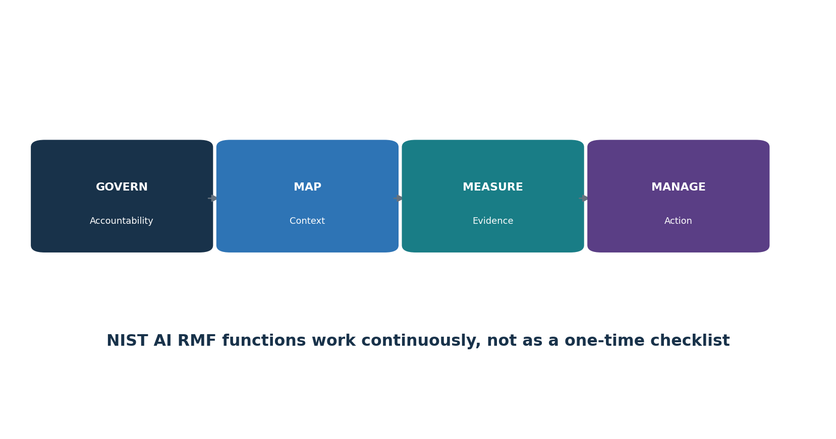
Figure 2. NIST AI RMF Core
Function | Purpose | Typical evidence
GOVERN | Policies, roles, culture, accountability, risk tolerance, suppliers, and continuous improvement | Charter, policy, RACI, training, inventory, exceptions, minutes
MAP | Purpose, context, people, impacts, dependencies, and risks | System map, use case, stakeholders, impact assessment, threat model
MEASURE | Methods, tests, metrics, uncertainty, limitations, and independent review | Test plan, datasets, results, confidence, red-team report, validation
MANAGE | Prioritize, treat, accept, deploy, monitor, respond, and retire | Risk register, approvals, conditions, monitoring, incident/change/retirement records

Do not use the RMF as a checkbox: A category or subcategory becomes useful only after it is tied to an owned system, risk, action, evidence, result, decision, and review date.

4. GOVERN: Culture, Accountability, and Policy
GOVERN establishes who may decide, what rules apply, and how concerns reach accountable leaders.
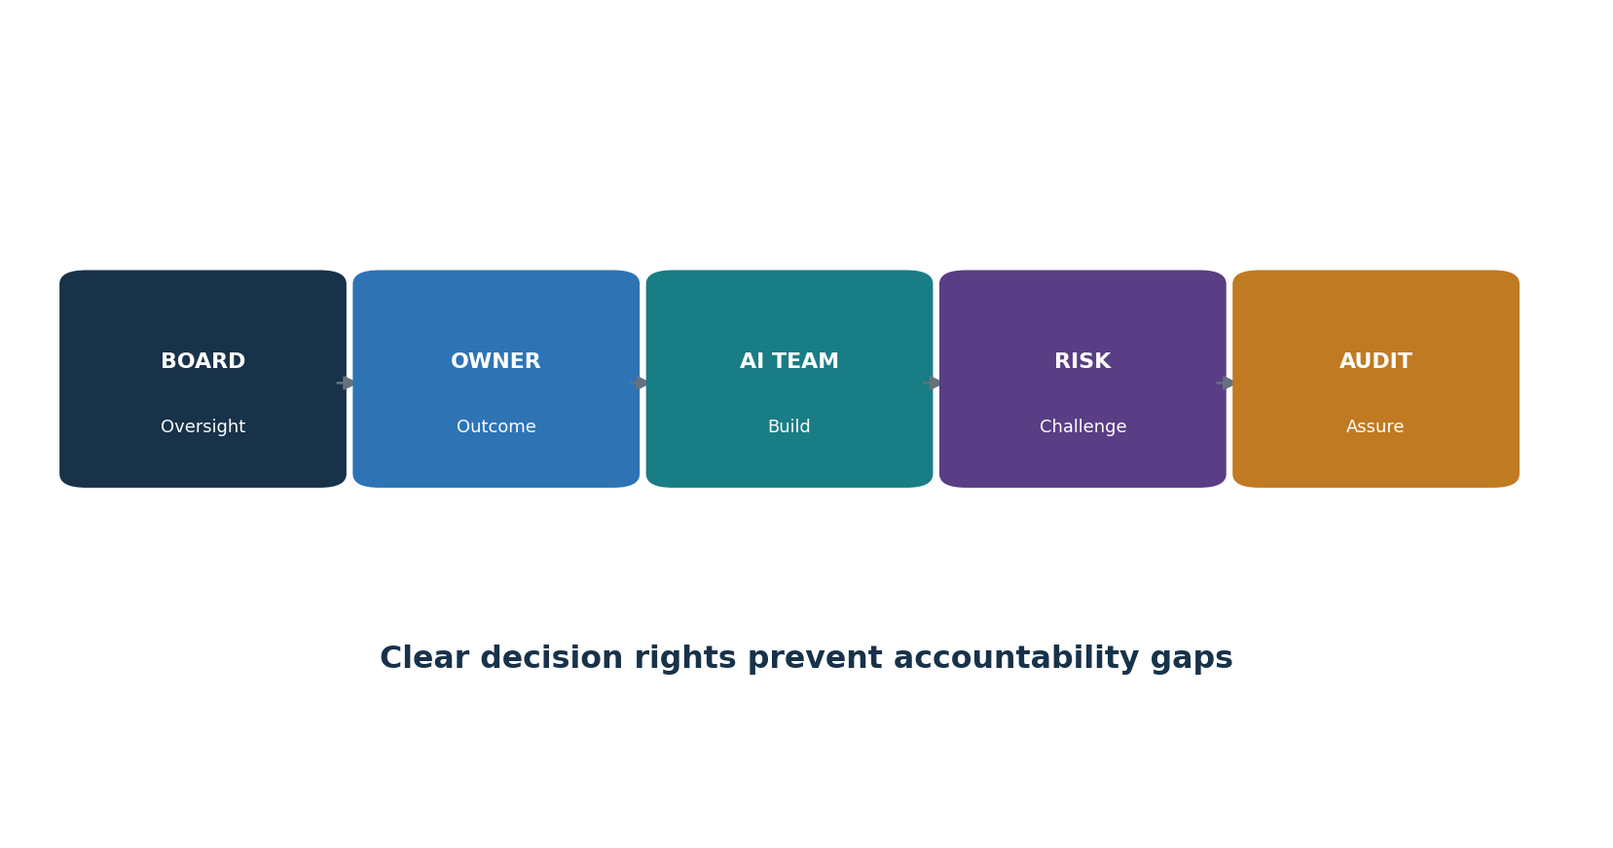
Figure 3. AI governance roles

4.1 Governance structure
- Board or governing body: oversee material risk and management performance.
- Executive sponsor: set direction, resources, risk appetite, and escalation.
- Business owner: own purpose, benefit, affected process, human oversight, and outcome.
- AI/model owner: own model selection, configuration, evaluation, versions, and limitations.
- Data owner: authorize sources, quality, access, use, retention, and deletion.
- Security, privacy, legal, compliance, safety, HR, procurement, accessibility, and domain experts: review their risks.
- Independent risk or validation: challenge evidence and decisions at a level matched to impact.
- Internal audit: independently assess governance and control operation without becoming the owner.
- Policy area | - Minimum decision
Acceptable use | Approved, restricted, and prohibited uses and data
Risk tiering | Impact factors, thresholds, required reviews, and authority
Development/acquisition | Secure life cycle, supplier evidence, testing, approval, and change
Human oversight | Reviewer competence, authority, workload, information, override, and escalation
Exceptions | Risk, compensating controls, approver, expiry, monitoring, and closure
Concerns | Speak-up, non-retaliation, investigation, protection, and reporting

5. MAP: Context, People, and Impact
MAP turns a model description into an understandable picture of purpose, people, context, and impact.
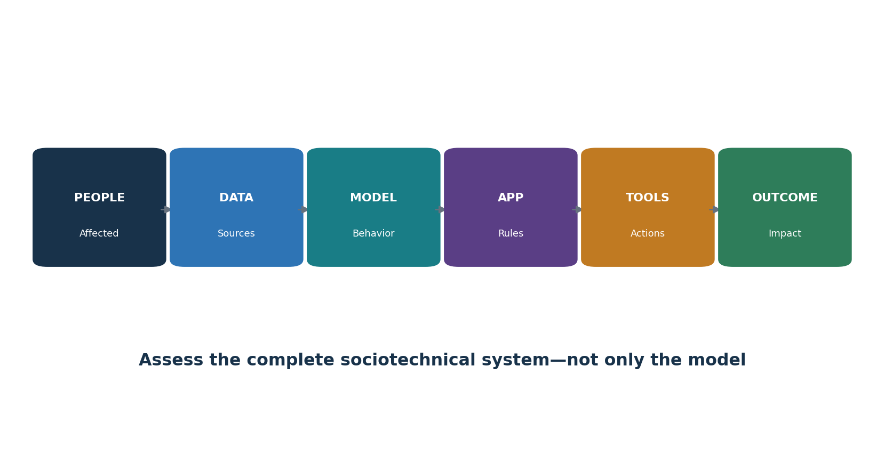
Figure 4. Complete AI system map

5.1 Context record
- Business need, intended benefit, success measure, owner, users, and prohibited uses.
- Affected people and communities, including people who may never interact directly with the system.
- Decision or content produced, degree of automation, consequences, alternatives, contestability, and human authority.
- Data sources, lineage, rights, representativeness, sensitive attributes, proxies, and quality.
- Model, provider, version, configuration, prompts, retrieval, fine-tuning, tools, integrations, infrastructure, and dependencies.
- Deployment conditions, geography, language, accessibility, culture, time sensitivity, scale, and reasonably foreseeable misuse.
- Failure modes, threat actors, harms, benefits, uncertainty, existing controls, and monitoring.
Impact factor | Lower concern example | Higher concern example
Decision | Drafting internal text | Eligibility, employment, credit, care, safety, or legal decision
People | Trained staff with review | Public or vulnerable people with limited choice
Autonomy | Suggestion only | Acts through accounts, money, systems, or physical devices
Scale | Small reversible pilot | Large, persistent, difficult-to-reverse effect
Data | Synthetic or public | Sensitive, biometric, confidential, or children’s data
Transparency | Clearly disclosed and contestable | Hidden use or weak appeal
Failure | Minor inconvenience | Material financial, health, rights, security, or safety harm

6. MEASURE: Testing and Risk Analysis
MEASURE creates credible evidence about performance, harm, misuse, security, privacy, and uncertainty.

6.1 Measurement plan
- Translate each important risk into a testable claim and acceptance threshold before seeing the result.
- Use representative, protected, versioned evaluation data with documented provenance, exclusions, and known gaps.
- Test normal, edge, subgroup, multilingual, accessibility, adversarial, high-impact, and safe-failure cases.
- Separate development, validation, and final acceptance data where practical to reduce overfitting.
- Measure both benefits and harms; averages can hide severe failures for a subgroup or rare event.
- Record model/system version, prompt, tools, data, environment, scorer, human rubric, sample, randomness, cost, result, confidence, and limitations.
- Use independent review when impact, uncertainty, conflict of interest, or external reliance is high.
Measure | Question | Example evidence
Task quality | Does it do the intended task? | Accuracy, groundedness, error severity, human rating
Safety | Does it avoid unacceptable harm? | Scenario tests, refusals, escalation, hazard analysis
Security | Can an attacker manipulate or extract value? | Threat model, injection tests, tool-abuse tests, red-team report
Fairness | Do errors or treatment differ meaningfully? | Subgroup results, intersectional review, causal/context analysis
Privacy | Can data be exposed, inferred, retained, or misused? | DPIA, leakage tests, access/retention/deletion evidence
Resilience | Does it fail safely under change or outage? | Load, drift, dependency, rollback, recovery tests

7. MANAGE: Treatment, Deployment, and Improvement
MANAGE converts measured risk into an owned decision, a treatment, deployment conditions, monitoring, and improvement.
Treatment | When useful | Required record
Avoid | Use is prohibited or risk cannot be justified | Decision, affected scope, alternatives, enforcement
Reduce | Controls can lower likelihood or impact | Control, owner, due date, residual risk, test
Transfer/share | Contract or insurance allocates part of consequence | Exact allocation, exclusions, dependency, remaining risk
Accept | Residual risk is within authority and appetite | Rationale, evidence, approver, conditions, expiry, monitoring
Pilot | Uncertainty can be reduced safely | Limited people/data/authority/time, stop rule, measurement, exit

7.1 Deployment gate
- Required reviews are complete and unresolved findings are within authorized tolerance.
- Acceptance thresholds are met on the production-like complete system, not only the base model.
- Users understand purpose, limits, prohibited uses, verification duties, and escalation.
- Human reviewers have time, skill, information, authority, and a usable override.
- Security, privacy, supplier, logging, incident, continuity, rollback, record, and deletion controls are ready.
- Monitoring has owners, thresholds, alerts, response playbooks, change triggers, and retirement criteria.

8. NIST Generative AI Profile
NIST AI 600-1 adapts the AI RMF to risks that are especially important for generative AI.
Risk theme | Practical meaning | Example treatment
Confabulation | Plausible output may be false | Grounding, citations, verification, uncertainty, limited decision use
Dangerous or hateful content | Output may facilitate harm or abuse | Use limits, classifiers, policy, review, monitoring, reporting
Data privacy | Sensitive information may enter or leave the system | Minimization, redaction, access, retention, deletion, leakage tests
Information integrity | Synthetic content may mislead or distort ecosystems | Disclosure, provenance, verification, rate limits, response
Information security | Attackers may inject, steal, evade, or exploit | Threat modeling, isolation, least privilege, secure output handling
Intellectual property | Training, input, or output may create rights issues | Provenance, terms, licenses, review, records, dispute process
Environmental impacts | Training and use consume resources | Measure energy/compute where material; set efficiency and use controls
Human-AI configuration | Automation bias or emotional reliance may cause harm | Interface design, literacy, human review, escalation, wellbeing safeguards
Value chain | Risk travels through data, model, platform, integrator, and user | Supplier mapping, contracts, evidence, change notice, shared incidents

Profile use: Select the relevant risks and actions for the actual use case. Do not claim every generative AI risk is solved because a general-purpose provider offers safeguards.

9. ISO/IEC 42001 and ISO/IEC 23894
ISO/IEC 42001 provides an AI management system; ISO/IEC 23894 provides AI risk management guidance.
Management-system element | Practical output
Context | Interested parties, obligations, AI scope, processes, dependencies
Leadership | Policy, accountability, roles, resources, risk direction
Planning | Risks, opportunities, objectives, actions, change planning
Support | Competence, awareness, communication, documented information
Operation | AI risk process, impact assessment, life-cycle controls, suppliers
Performance evaluation | Monitoring, measurement, internal audit, management review
Improvement | Nonconformity, corrective action, continual improvement

9.1 Certification and copyright cautions
- Use an authorized copy of ISO standards; this manual does not reproduce their requirement or control text.
- Define the AI management system scope precisely: organization, products, services, locations, technologies, and exclusions.
- A certificate supports only the named organization, scope, standard, dates, and certification status.
- Certification does not prove every AI output is accurate, fair, secure, lawful, or safe.
- Map existing security, privacy, quality, risk, supplier, and audit processes to avoid parallel paperwork.

10. AI Inventory, Use Cases, and Life Cycle
An accurate inventory and controlled life cycle are the foundation of governance.
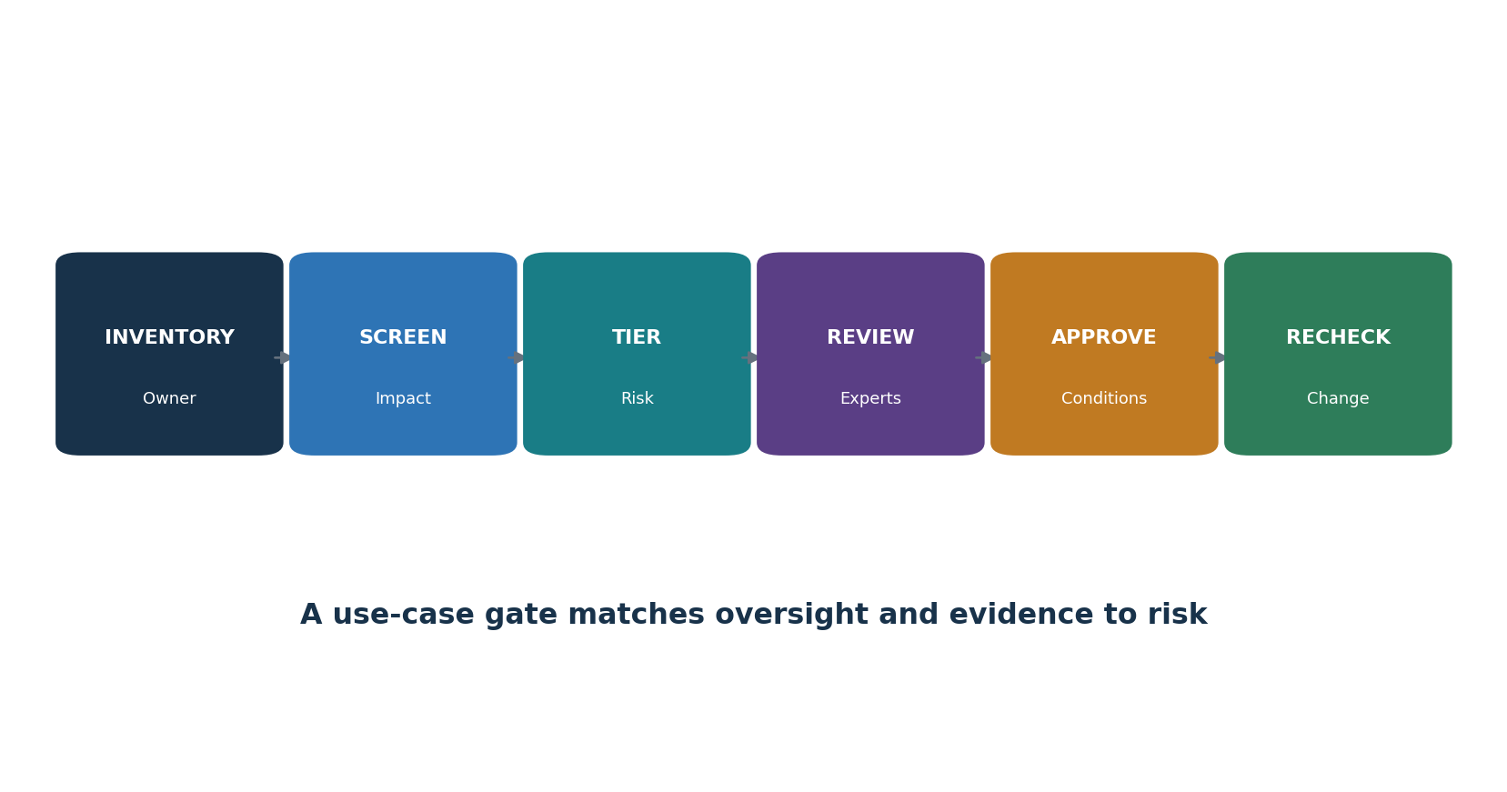
Figure 5. AI use-case gate
Inventory field | What to record
Identity | System/use-case name, ID, owner, sponsor, team, status
Purpose | Intended use, users, affected people, decisions, benefit, prohibited use
Technology | Model/provider/version, prompts, RAG, agents, tools, APIs, hosting
Data | Sources, owners, sensitivity, rights, location, retention, training use
Impact | Risk tier, harms, laws, contracts, assessments, human oversight
Evidence | Evaluation, security, privacy, supplier, accessibility, approval
Operations | Monitoring, incidents, changes, dependencies, recovery, retirement

10.1 Life-cycle controls
- Intake and screen before acquisition, experimentation with real data, or public use.
- Design system and data maps, impact and threat assessments, requirements, acceptance thresholds, and rollback.
- Build with version control, protected environments, approved components, lineage, testing, and review.
- Validate the complete system independently enough for its impact and uncertainty.
- Approve with recorded conditions; deploy through change control; train users and reviewers.
- Monitor quality, security, safety, privacy, fairness, cost, use, suppliers, and incidents.
- Reassess material changes; retire access, integrations, data, artifacts, accounts, and records safely.

11. Data Governance and Data Security
Data controls determine what an AI system can learn, expose, reproduce, or unfairly emphasize.

11.1 Data control chain
- Purpose and authority: why each source is needed and what rights, notices, permissions, or licenses allow use.
- Provenance and lineage: source, collection method, date, version, transformations, labels, filters, and downstream uses.
- Quality and representativeness: completeness, accuracy, timeliness, duplicates, imbalance, label error, historical bias, and relevant populations.
- Security: classification, least privilege, separation, encryption, secrets, secure transfer, monitoring, backup, and deletion.
- Privacy: minimization, pseudonymization/de-identification, re-identification risk, data-subject rights, retention, transfer, and privacy-enhancing techniques.
- Poisoning defense: trusted sources, contributor controls, validation, anomaly review, signed/versioned datasets, quarantine, and rollback.
- Evaluation protection: prevent test-set leakage and preserve a controlled final acceptance set.
Evidence | Minimum detail
Dataset card | Purpose, source, people/populations, collection, fields, labels, exclusions, limits, license
Lineage record | Source-to-feature transformations, code/version, owner, approvals, dates
Quality report | Rules, population, exceptions, subgroup analysis, corrections, limitations
Access report | Users/services, roles, grants, reviews, removals, privileged activity
Deletion test | Request, systems/copies/indexes/backups, method, result, residual limits

12. Model Governance and Model Risk
Model governance controls selection, documentation, validation, change, deployment, and retirement.
Artifact | Purpose
Model/system card | Intended use, prohibited use, architecture, data, performance, limitations, ethics/safety/security
Version record | Model, weights, provider release, configuration, prompt, adapters, tools, code, environment
Validation report | Independence, methods, data, thresholds, results, failures, limitations, decision
Risk tier | Impact factors, required reviews, decision authority, monitoring
Change record | Reason, affected components, regression scope, approval, rollout, rollback
Retirement record | Replacement, users, integrations, access, artifacts, data, retention, deletion, residual duties

12.1 Validation questions
- Is the use within the model’s demonstrated and approved conditions?
- Are data and evaluation populations relevant to production?
- Are thresholds tied to business harm instead of only technical averages?
- Does the complete application add prompts, retrieval, tools, post-processing, or human behavior that changes risk?
- Are uncertainty and limitations visible to decision makers and users?
- Can a prior version be restored and can dependent decisions be traced to the active version?

13. Foundation Models and Third Parties
A foundation-model provider supplies one layer; the deploying organization still owns its use, integrations, data, and effects.
Supplier evidence | Review question
System/model documentation | Exact model/version, intended/forbidden use, capabilities, limits, evaluation
Security assurance | Scope, period, testing, vulnerabilities, incident process, tenant isolation
Data terms | Prompt/upload/output/log/feedback use, training, retention, deletion, location, subprocessors
Change management | Notice, version pinning, deprecation, regression evidence, rollback
Availability/resilience | Dependencies, limits, support, recovery, continuity, export
Legal/IP | Roles, licenses, indemnity, restrictions, transparency, regulatory support
Audit/evidence | Reports, logs, customer configuration, access, incident and deletion evidence
Exit | Data/model/configuration export, migration, account closure, verified deletion

13.1 Concentration and value-chain risk
- Map model, cloud, data, labeling, embeddings, vector database, orchestration, tools, content moderation, monitoring, and human-service suppliers.
- Identify common dependencies that could fail or change together.
- Test contractual responsibility against the technical architecture.
- Maintain alternatives or a controlled shutdown where the business impact justifies it.
- Reassess provider changes, new training terms, model retirement, acquisitions, incidents, sanctions, and subprocessor changes.

14. AI Security Threat Modeling
Threat modeling identifies assets, trust boundaries, attackers, abuse paths, controls, detections, and safe recovery.

14.1 Threat-model method
- Draw users, admins, services, model endpoints, data stores, indexes, prompts, tools, networks, logs, providers, and human reviewers.
- Mark assets: sensitive data, model weights, system prompts, credentials, decisions, money, accounts, reputation, and safety.
- Mark trust boundaries and every place untrusted content can become instructions or actions.
- Describe threat actors, access, goals, preconditions, attack path, business impact, evidence, and recovery.
- Map relevant MITRE ATLAS and OWASP techniques, but add domain-specific misuse and ordinary application threats.
- Choose preventive, detective, responsive, and recovery controls; test combinations and bypasses.
- Update after model, data, prompt, tool, provider, permission, interface, or use change.
Threat surface | Examples
Input | Direct prompt injection, malicious files, hidden text, image/audio instructions
Context | Poisoned RAG documents, cross-tenant retrieval, stale or unauthorized sources
Model | Extraction, inversion, evasion, poisoning, unsafe capability, denial of service
Output | XSS, SQL/command injection, insecure code, harmful advice, false claims
Tools/agents | Privilege abuse, confused deputy, transaction fraud, loops, lateral movement
Operations | Weak logs, shadow use, leaked keys, unsafe updates, poor incident rollback

15. OWASP Top 10 for LLM Applications 2025
The OWASP 2025 list is a practical starting point for generative-AI application security.
ID / risk | What can happen | Core protections
LLM01 — Prompt Injection | Untrusted instructions change model behavior or reach connected tools. | Separate trust zones; constrain tools; filter context; validate actions; test direct and indirect injection.
LLM02 — Sensitive Information Disclosure | Prompts, outputs, logs, training data, or connectors reveal protected information. | Minimize data; classify; redact; control access; set retention; test leakage; monitor.
LLM03 — Supply Chain | Models, data, packages, adapters, services, or artifacts are compromised or untrusted. | Approve sources; verify provenance, signatures, hashes, licenses, vulnerabilities, and change notices.
LLM04 — Data and Model Poisoning | Manipulated data or model components create hidden or unsafe behavior. | Protect lineage; validate sources; isolate contributions; run anomaly and behavioral tests.
LLM05 — Improper Output Handling | Downstream systems trust model output as safe code, content, or commands. | Treat output as untrusted; validate, encode, parameterize, sandbox, and authorize.
LLM06 — Excessive Agency | An AI system has more tools, permissions, autonomy, or time than needed. | Least privilege; narrow tools; limits; approvals; transaction boundaries; kill switch; audit.
LLM07 — System Prompt Leakage | Hidden instructions or secrets are exposed or relied on as a security boundary. | Keep secrets outside prompts; enforce controls externally; test leakage; limit sensitive context.
LLM08 — Vector and Embedding Weaknesses | Indexes or embeddings allow unauthorized retrieval, poisoning, mixing, or inference. | Tenant isolation; source ACLs; metadata filtering; ingestion review; retrieval tests; deletion.
LLM09 — Misinformation | Confident but incorrect output can lead to harmful decisions or actions. | Ground claims; cite sources; define uncertainty; human review; factual evaluation; safe failure.
LLM10 — Unbounded Consumption | Inputs, loops, output, or tool calls exhaust money, compute, or service capacity. | Rate, token, time, recursion, spend, and concurrency limits; alerts; quotas; circuit breakers.

15.1 How an analyst uses the list
- Confirm the application version and architecture; the base model alone is not the assessment target.
- Map each applicable risk to components, threat scenarios, controls, evidence, test cases, owner, and residual risk.
- Test controls together: filters can be bypassed, and model behavior is probabilistic.
- Validate safe failure, user messaging, detection, response, rollback, and retest.
- Do not label an application ‘OWASP compliant’; OWASP Top 10 is awareness and testing guidance, not a certification standard.

16. Agentic AI Security
Agentic systems add planning, memory, tool selection, delegation, persistence, and real-world authority.
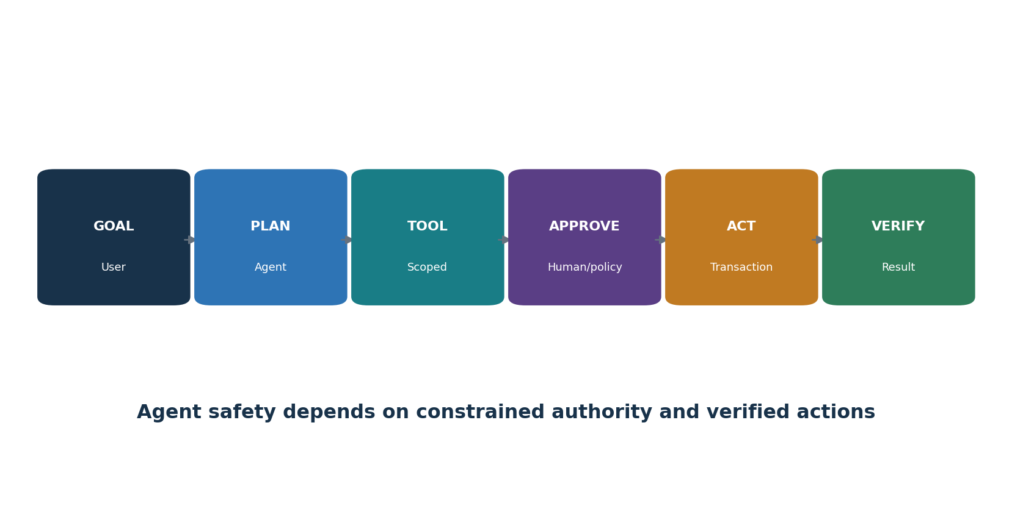
Figure 6. Constrained agent action loop
Agentic risk theme | Example | Control
Goal manipulation | Untrusted content changes the objective | Trusted goal channel, instruction hierarchy, context separation, confirmation
Tool misuse | Agent calls email, code, payment, admin, or database tool unsafely | Allowlist, schemas, narrow identity, policy enforcement, sandbox
Excessive autonomy | Agent acts without meaningful review | Risk-based approvals, transaction preview, two-person control, stop switch
Memory poisoning | Bad content persists and influences future work | Source trust, scoped memory, validation, expiry, review, deletion
Agent-to-agent trust | One agent treats another’s output as authority | Mutual identity, provenance, contracts, validation, least privilege
Runaway behavior | Loops consume time, money, calls, or cause repeated effects | Step/time/cost limits, idempotency, rate controls, circuit breaker
Accountability gap | No person owns a chain of automated decisions | Owner, trace, action receipt, escalation, rollback, incident review

Current source: OWASP released its peer-reviewed Top 10 for Agentic Applications for 2026 on December 9, 2025. Use the official document for its exact risk names and details; apply it with ordinary application, identity, API, data, and transaction security.

17. Retrieval-Augmented Generation Security
RAG can improve grounding, but it adds ingestion, index, retrieval, authorization, citation, and deletion risks.
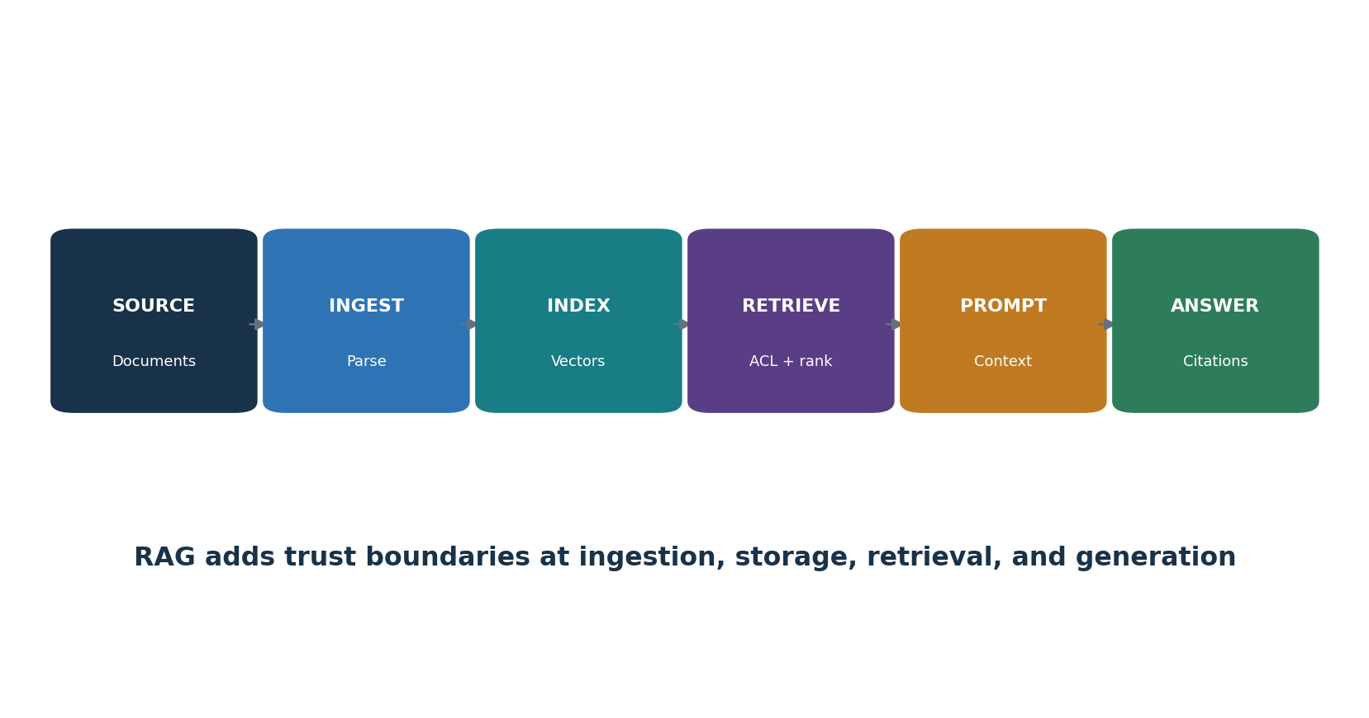
Figure 7. RAG trust boundaries

17.1 RAG controls
- Approve sources, owners, rights, freshness, sensitivity, allowed users, and ingestion method.
- Scan files and content; detect hidden instructions; quarantine and review untrusted contributions.
- Preserve source identity, tenant, classification, ACL, version, date, and deletion status in metadata.
- Enforce authorization before retrieval and again before display; do not rely only on similarity.
- Separate tenants and security domains in storage, keys, indexes, caching, logs, and evaluation.
- Test poisoning, indirect injection, unauthorized retrieval, cross-tenant leakage, stale content, citation accuracy, and deletion.
- Require answers to show useful citations and uncertainty; verify high-impact claims against authoritative sources.
- Propagate source deletion/correction to chunks, vectors, caches, derived stores, and monitoring datasets.

18. Prompt, Interface, and Output Security
Prompts and outputs are application data, not trustworthy control boundaries.
Layer | Control examples
User interface | Purpose, notice, prohibited use, verification duty, safe examples, feedback, appeal
Input | Size/type limits, malware scanning, encoding normalization, classification, redaction, abuse detection
Instructions | Versioned templates, separation of data/instructions, minimal secrets, approval, tests
Model call | Approved model/version, parameters, time/token/rate limits, protected credentials
Output | Schema, allowlist, encoding, parameterization, citation, safety review, confidence/uncertainty
Downstream use | Treat as untrusted; human or policy approval; sandbox; transaction validation; rollback
Logs | Trace IDs and decisions with minimization, access, retention, integrity, and privacy

18.1 Output handling examples
- Never place model output directly into a shell, SQL query, browser DOM, template, access policy, or production code path without purpose-specific validation.
- Use structured schemas but still validate types, lengths, values, authorization, and business rules outside the model.
- Separate content generation from permission to act. A fluent response is not proof of authority or truth.
- Design refusal and error states that do not reveal secrets and that direct users to safe alternatives.

19. Identity, Tools, APIs, and MCP
Identity and tool controls determine the difference between an AI suggestion and an AI-caused event.
Control | Implementation question
Human identity | Is the user authenticated strongly and authorized for the requested data and action?
Workload identity | Does each agent/service have a unique, short-lived, narrowly scoped identity?
Delegation | Can the system prove who delegated what authority, for which resource, purpose, and time?
Tool allowlist | Are tools, methods, parameters, destinations, and data classes explicitly allowed?
Transaction control | Are amount, volume, recipient, environment, and irreversible-action limits enforced outside the model?
Approval | Does the reviewer see the exact proposed action, material context, risk, and change?
Audit | Can each goal, context, model decision, tool call, approval, result, and rollback be reconstructed?

19.1 MCP security
- Model Context Protocol (MCP) connects AI applications to tools and data through standardized interfaces; it does not make a server or tool trusted.
- Inventory servers, owners, code/source, transport, authentication, permissions, tools, schemas, data, network destinations, logs, and update path.
- Use approved registries, verified packages, pinned versions, restricted execution, egress controls, secret isolation, and least-privilege credentials.
- Treat tool descriptions, resources, prompts, and returned content as potentially untrusted and able to influence the model.
- Require authorization at the actual data/action service, not only in the conversational layer.
- Test malicious server behavior, tool-name confusion, parameter injection, cross-server data flow, excessive permissions, and unsafe updates.

20. Privacy, Intellectual Property, and Records
AI data flows raise questions about privacy, confidentiality, intellectual property, recordkeeping, and disclosure.

20.1 Privacy and records assessment
- Identify people, data categories, sensitivity, source, purpose, authority/legal basis, notices, choices, rights, and vulnerable groups.
- Map prompts, uploads, outputs, embeddings, fine-tunes, logs, feedback, human review, training use, providers, subprocessors, locations, and transfers.
- Minimize collection and context; use redaction, pseudonymization, private retrieval, local processing, or synthetic data where appropriate.
- Set retention and deletion by data type and system copy; test rights and deletion through providers, indexes, logs, backups, and derived data.
- Evaluate memorization, inference, re-identification, attribute prediction, membership inference, and cross-user leakage.
- Preserve records needed for decisions, notices, consent/authority, versions, approvals, incidents, disputes, and accountability without retaining everything forever.

20.2 Intellectual property
- Confirm rights and licenses for training, tuning, evaluation, retrieval, prompts, media, code, and outputs.
- Review provider terms for ownership, training use, confidentiality, indemnity, restrictions, and opt-out settings.
- Use provenance and content credentials where appropriate; retain source citations and human contribution records.
- Screen high-risk outputs for copyright-protected material, trademarks, confidential information, open-source license duties, and publicity/personality rights.
- Escalate legal questions; technical similarity tools do not decide infringement.

21. Fairness, Transparency, Explainability, and Human Oversight
Responsible use requires examining unequal effects, meaningful explanations, and real human authority.
Topic | Practical test
Fairness | Define the relevant harm and groups; compare rates and severity; examine causes, proxies, history, and alternatives
Transparency | Tell the right people AI is used, its purpose, role, limits, data, and how to get help
Explainability | Provide reasons useful to the affected person, operator, reviewer, auditor, or developer
Human oversight | Test reviewer time, competence, information, independence, authority, override, and escalation
Contestability | Provide a usable way to question, correct, appeal, and obtain human review
Accessibility | Test languages, disabilities, literacy, devices, and assistive technology in the real workflow

21.1 Avoid common mistakes
- A fairness metric is not a moral or legal conclusion; different harms may require different measures.
- Removing a protected attribute does not remove proxies or historical patterns.
- An explanation that is technically detailed but unusable to the affected person is not meaningful.
- A human click is not oversight if the reviewer cannot detect error, is overloaded, or cannot disagree.
- Document tradeoffs, affected voices, rejected alternatives, residual uncertainty, and decision authority.

22. Evaluation, Red Teaming, and Acceptance
Evaluation proves defined claims only when the system, data, methods, thresholds, and limitations are traceable.
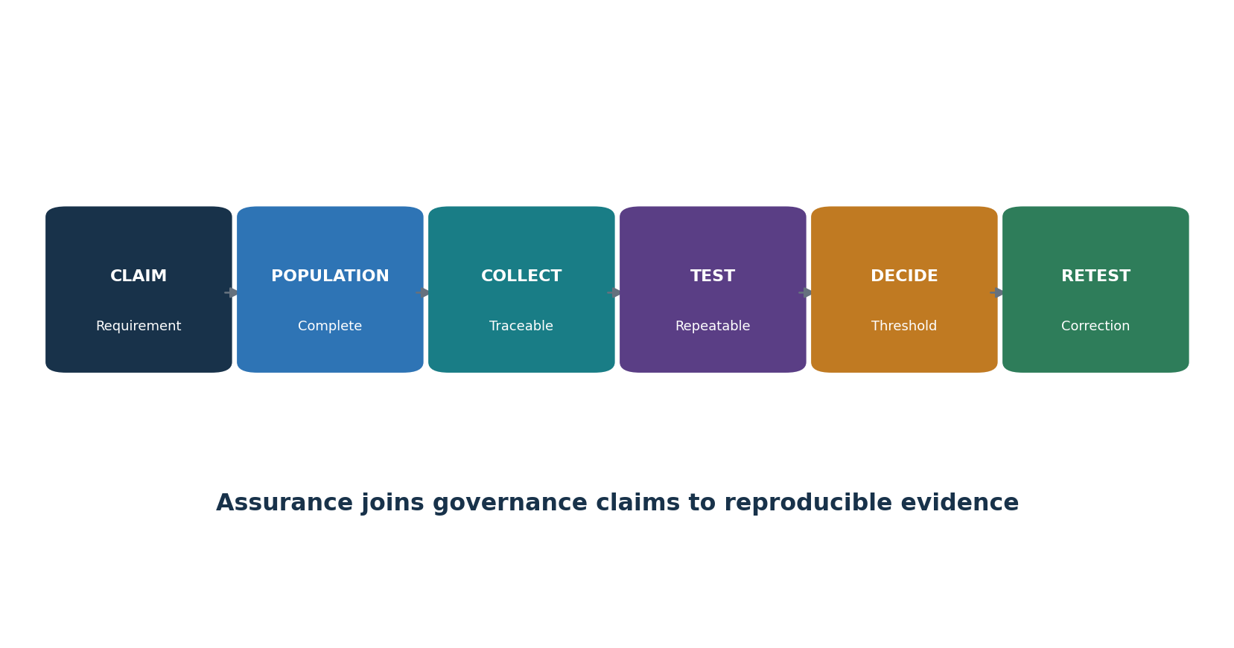
Figure 8. Evaluation and evidence chain
Test type | Examples
Functional | Task completion, accuracy, relevance, groundedness, citation, format
Safety | Harmful content, unsafe advice, escalation, refusal, vulnerable users
Security | Injection, extraction, poisoning, tool abuse, output injection, denial of service
Privacy | PII leakage, memorization, inference, unauthorized retrieval, deletion
Fairness/accessibility | Subgroup errors, language/dialect, disability, proxy effects, usability
Robustness | Noise, paraphrase, adversarial input, long context, dependency failure, drift
Operational | Latency, capacity, rate/cost limits, monitoring, failover, rollback, incident response

22.1 Red-team rules of engagement
- Written authorization, named target, environment, time, people, prohibited actions, data, budget, rate, and stop conditions.
- Synthetic or approved test data; no uncontrolled harmful content, real-person targeting, public scanning, or third-party testing.
- Secure storage for prompts, outputs, vulnerabilities, credentials, and personal information.
- Immediate path for severe findings, accidental exposure, system instability, or safety concern.
- Reproduction, severity rationale, owner, correction, regression test, and closure evidence.

23. Monitoring, Incidents, Change, and Retirement
AI risk changes when data, models, prompts, tools, users, providers, or the outside world change.
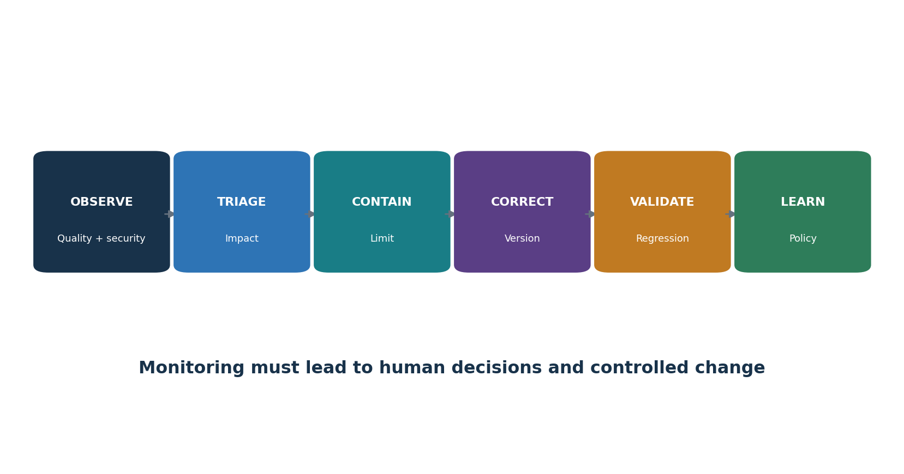
Figure 9. Monitoring and incident loop
Signal | Example response trigger
Quality | Severe-error rate or groundedness falls below approved threshold
Safety | Confirmed harmful output, refusal bypass, or high-impact near miss
Security | Injection success, unauthorized tool call, leakage, abuse, or credential event
Fairness | Material subgroup shift, complaint pattern, or newly affected population
Privacy | Unexpected retention, disclosure, inference, rights failure, or provider-use change
Operations | Cost/latency spike, dependency outage, runaway loop, capacity failure
Change | New model, prompt, data, tool, permission, provider, geography, use, or law

23.1 AI incident response
- Detect and preserve prompts, context, retrieval, model/version, configuration, tools, identities, approvals, outputs, downstream actions, and logs.
- Protect affected people first; stop or limit the system, tools, data, users, transactions, or outputs under approved authority.
- Scope the complete chain and identify repeated decisions or content that require correction, notification, reversal, or human review.
- Coordinate security, safety, privacy, legal, communications, provider, business, and domain response.
- Correct through trusted versions; run regression tests; deploy gradually; watch recurrence.
- Record lessons, accountability, redress, control changes, risk reapproval, and disclosures required by law or contract.

24. Assurance, Evidence, Testing, and Metrics
Assurance connects a requirement to complete scope, reliable evidence, a repeatable test, a conclusion, and retesting.

24.1 Control test method
- State exact criterion, source/version, system/use/version, period, owner, risk, and expected behavior.
- Identify complete populations: use cases, models, users, decisions, prompts, tools, incidents, changes, suppliers, or evaluation cases.
- Reconcile inventory to independent sources such as API billing, code, model registry, identity, procurement, network, or logs.
- Collect source, query, date, permissions, configuration, hash/version, sample, and chain of custody; minimize sensitive evidence.
- Test design and operation; reproduce automated results; validate exceptions and control bypasses.
- Write condition, evidence, population, risk, cause, action, owner, date, interim protection, and retest.
Metric | Definition example
Inventory ownership | Active AI systems with approved owner ÷ active AI systems
Assessment coverage | In-scope systems with current impact/threat/privacy review ÷ in-scope systems
Evaluation pass | Required cases meeting approved thresholds ÷ required cases, with severity and subgroup views
Human override | Eligible decisions reviewed/overridden/escalated with outcomes and reviewer load
Security exposure | Open AI security findings by severity, reachability, age, owner, exception
Incident performance | Detection, containment, correction, redress, recurrence, and overdue actions
Supplier assurance | Critical AI suppliers with current scoped review and closed material gaps ÷ critical suppliers

Dashboard caution: A green percentage can hide missing systems, poor tests, rare severe failures, excluded groups, stale evidence, or accepted risk. Always show population, source, period, threshold, exceptions, uncertainty, and action.

25. CSA AI Controls Matrix v1.1
CSA AICM v1.1 provides a current control matrix for AI governance, security, privacy, operations, and assurance.

25.1 Practical use
- Download the current official AICM v1.1 artifact and record its release, version, license, and any implementation guidance used.
- Define the organization, AI service, life-cycle stage, provider/customer role, technology, data, geography, and control boundary.
- Tailor applicability rather than marking every objective yes; state rationale for not applicable items.
- Map each relevant objective to policy, architecture, process, owner, evidence, test, result, finding, action, and retest.
- Use CSA mappings and STAR for AI materials as aids; verify the exact scope and assurance level of any external claim.
- Do not invent certification or claim compliance based only on a completed questionnaire.
Control theme | Examples of expected evidence
Governance and accountability | AI policy, roles, inventory, risk tiering, training, exceptions, oversight
Data and privacy | Lineage, rights, classification, minimization, quality, access, retention, deletion
Model/system life cycle | Requirements, cards, validation, secure development, versions, approvals, change
Security | Threat model, identity, supplier, testing, logging, incidents, resilience
Responsible AI | Impact assessment, fairness, transparency, human oversight, complaints/redress
Assurance | Control mapping, populations, evidence, independent review, findings, metrics, improvement

26. Open-Source AI Assurance and Security Tools
Open-source tools can improve repeatability, but they do not decide compliance, safety, fairness, or business acceptance.
Tool | Purpose
Garak | LLM vulnerability scanning and probe framework
Promptfoo | Prompt, model, RAG, and red-team evaluation
Giskard | Testing and vulnerability scanning for ML and LLM systems
PyRIT | Risk identification and red-team orchestration for generative AI
Inspect AI | Reproducible AI model evaluations
Adversarial Robustness Toolbox | Adversarial ML attacks and defenses for authorized research
LLM Guard | Input and output scanners for LLM applications
Presidio | Detection and de-identification of personally identifiable information
Guardrails AI | Structured validation and guardrails for model outputs
OpenAI Evals | Open-source framework for model and system evaluation
Langfuse | Open-source LLM tracing, prompt management, and evaluation
MLflow | Experiment tracking, model registry, lineage, and deployment records
Evidently | Data quality, drift, and model monitoring
Deepchecks | Data and model validation for ML and LLM applications
ModelScan | Static scanning of serialized model files
Gitleaks | Secret discovery in source code and history
Trivy | Vulnerability, secret, dependency, image, and configuration scanning
MITRE ATLAS | Knowledge base of adversary tactics and techniques against AI systems

Authorization and safety: Use tools only against systems, models, accounts, repositories, data, and providers you own or are expressly authorized to test. Start with isolated labs and synthetic data. Set request, cost, time, content, and stop limits. Protect credentials, prompts, outputs, and findings.

26.1 Garak
Purpose: LLM vulnerability scanning and probe framework. Official project: Garak
Safe quick start: Install in an isolated environment; select a lab model and a small approved probe set; protect prompts and outputs; validate results manually.
Retain: written authority, target and version, environment, data, identity/permissions, tool/version/configuration, test cases, thresholds, date, logs, results, analyst validation, limitations, finding, correction, and retest.

26.2 Promptfoo
Purpose: Prompt, model, RAG, and red-team evaluation. Official project: Promptfoo
Safe quick start: Create a small YAML test suite with expected behavior; use synthetic data; run locally; review failures; add the suite to version control and CI.
Retain: written authority, target and version, environment, data, identity/permissions, tool/version/configuration, test cases, thresholds, date, logs, results, analyst validation, limitations, finding, correction, and retest.

26.3 Giskard
Purpose: Testing and vulnerability scanning for ML and LLM systems. Official project: Giskard
Safe quick start: Connect only an approved test model and dataset; run focused scans; review assumptions and false positives; preserve the report and remediation retest.
Retain: written authority, target and version, environment, data, identity/permissions, tool/version/configuration, test cases, thresholds, date, logs, results, analyst validation, limitations, finding, correction, and retest.

26.4 PyRIT
Purpose: Risk identification and red-team orchestration for generative AI. Official project: PyRIT
Safe quick start: Use a lab target and documented rules of engagement; start with harmless objectives; cap requests and cost; review transcripts; never test third parties without permission.
Retain: written authority, target and version, environment, data, identity/permissions, tool/version/configuration, test cases, thresholds, date, logs, results, analyst validation, limitations, finding, correction, and retest.

26.5 Inspect AI
Purpose: Reproducible AI model evaluations. Official project: Inspect AI
Safe quick start: Define a task, dataset, solver, and scorer; pin versions; run against an approved model; retain logs, configuration, results, and limitations.
Retain: written authority, target and version, environment, data, identity/permissions, tool/version/configuration, test cases, thresholds, date, logs, results, analyst validation, limitations, finding, correction, and retest.

26.6 Adversarial Robustness Toolbox
Purpose: Adversarial ML attacks and defenses for authorized research. Official project: Adversarial Robustness Toolbox
Safe quick start: Use a local toy model and synthetic data; select a single threat; compare baseline and defended results; document applicability and limitations.
Retain: written authority, target and version, environment, data, identity/permissions, tool/version/configuration, test cases, thresholds, date, logs, results, analyst validation, limitations, finding, correction, and retest.

26.7 LLM Guard
Purpose: Input and output scanners for LLM applications. Official project: LLM Guard
Safe quick start: Test scanners on synthetic prompts before production; tune thresholds; measure missed and blocked cases; use as one layer, not the only control.
Retain: written authority, target and version, environment, data, identity/permissions, tool/version/configuration, test cases, thresholds, date, logs, results, analyst validation, limitations, finding, correction, and retest.

26.8 Presidio
Purpose: Detection and de-identification of personally identifiable information. Official project: Presidio
Safe quick start: Run on synthetic samples; configure recognizers for the data and language; review false positives and misses; protect analyzer output.
Retain: written authority, target and version, environment, data, identity/permissions, tool/version/configuration, test cases, thresholds, date, logs, results, analyst validation, limitations, finding, correction, and retest.

26.9 Guardrails AI
Purpose: Structured validation and guardrails for model outputs. Official project: Guardrails AI
Safe quick start: Define an output schema and validators; test valid, invalid, and adversarial cases; fail safely; log validation decisions without exposing sensitive content.
Retain: written authority, target and version, environment, data, identity/permissions, tool/version/configuration, test cases, thresholds, date, logs, results, analyst validation, limitations, finding, correction, and retest.

26.10 OpenAI Evals
Purpose: Open-source framework for model and system evaluation. Official project: OpenAI Evals
Safe quick start: Create a small private evaluation set; define measurable criteria; run a baseline and candidate; inspect failures; protect test data and credentials.
Retain: written authority, target and version, environment, data, identity/permissions, tool/version/configuration, test cases, thresholds, date, logs, results, analyst validation, limitations, finding, correction, and retest.

26.11 Langfuse
Purpose: Open-source LLM tracing, prompt management, and evaluation. Official project: Langfuse
Safe quick start: Self-host or configure an approved environment; redact sensitive fields; trace a lab workflow; set access and retention; build a small quality dashboard.
Retain: written authority, target and version, environment, data, identity/permissions, tool/version/configuration, test cases, thresholds, date, logs, results, analyst validation, limitations, finding, correction, and retest.

26.12 MLflow
Purpose: Experiment tracking, model registry, lineage, and deployment records. Official project: MLflow
Safe quick start: Use a local project; log parameters, dataset reference, metrics, artifacts, owner, and approval; register only a tested model; restrict registry changes.
Retain: written authority, target and version, environment, data, identity/permissions, tool/version/configuration, test cases, thresholds, date, logs, results, analyst validation, limitations, finding, correction, and retest.

26.13 Evidently
Purpose: Data quality, drift, and model monitoring. Official project: Evidently
Safe quick start: Create reference and current synthetic datasets; run a report; define action thresholds; investigate drift before retraining or rollback.
Retain: written authority, target and version, environment, data, identity/permissions, tool/version/configuration, test cases, thresholds, date, logs, results, analyst validation, limitations, finding, correction, and retest.

26.14 Deepchecks
Purpose: Data and model validation for ML and LLM applications. Official project: Deepchecks
Safe quick start: Run a selected test suite on approved data; review failing checks and relevance; record exceptions; rerun after correction.
Retain: written authority, target and version, environment, data, identity/permissions, tool/version/configuration, test cases, thresholds, date, logs, results, analyst validation, limitations, finding, correction, and retest.

26.15 ModelScan
Purpose: Static scanning of serialized model files. Official project: ModelScan
Safe quick start: Scan downloaded model artifacts in quarantine; verify source and hash; investigate warnings; never load an untrusted artifact merely to test it.
Retain: written authority, target and version, environment, data, identity/permissions, tool/version/configuration, test cases, thresholds, date, logs, results, analyst validation, limitations, finding, correction, and retest.

26.16 Gitleaks
Purpose: Secret discovery in source code and history. Official project: Gitleaks
Safe quick start: Scan an authorized repository; validate findings; revoke exposed test credentials; remove safely; add prevention; rescan.
Retain: written authority, target and version, environment, data, identity/permissions, tool/version/configuration, test cases, thresholds, date, logs, results, analyst validation, limitations, finding, correction, and retest.

26.17 Trivy
Purpose: Vulnerability, secret, dependency, image, and configuration scanning. Official project: Trivy
Safe quick start: Scan an authorized AI service repository or image; validate reachability and context; correct or approve a time-bound exception; rescan.
Retain: written authority, target and version, environment, data, identity/permissions, tool/version/configuration, test cases, thresholds, date, logs, results, analyst validation, limitations, finding, correction, and retest.

26.18 MITRE ATLAS
Purpose: Knowledge base of adversary tactics and techniques against AI systems. Official project: MITRE ATLAS
Safe quick start: Map a lab architecture to relevant techniques; select mitigations and detections; create a tabletop scenario; do not treat the catalog as a complete checklist.
Retain: written authority, target and version, environment, data, identity/permissions, tool/version/configuration, test cases, thresholds, date, logs, results, analyst validation, limitations, finding, correction, and retest.

27. Manager’s AI Governance Playbook
Managers create value by setting decision rights, limiting authority, demanding evidence, and stopping unsafe work.
Manager question | Strong answer | Red flag
Why use AI? | Defined need, benefit, alternative, owner, success and stop measures | Technology looking for a problem
Who can be harmed? | Affected people, severity, likelihood, voice, redress | Only the paying user considered
What can it do? | Documented data, decisions, tools, permissions, limits | Unknown agents, integrations, or shadow use
What proves readiness? | Production-like tests, thresholds, failures, independent challenge | Demo or vendor claim only
Where is the human? | Competent, informed, authorized, measured oversight | Rubber-stamp approval
What changes risk? | Inventory, monitoring, trigger list, regression, rollback | Automatic model updates without review
Who accepts residual risk? | Named authority within appetite, conditions and expiry | Developer accepts business/legal risk alone

27.1 Operating rhythm
- Weekly: severe incidents, active abuse, unauthorized tools/data, critical findings, provider changes, and risk-gate exceptions.
- Monthly: inventory reconciliation, monitoring thresholds, complaints, drift, evaluation failures, tool permissions, spend, and overdue actions.
- Quarterly: portfolio risk, affected groups, supplier concentration, human oversight, red-team themes, legal changes, and retirement candidates.
- At every material change: remap the system, reassess impact/threat/privacy, rerun relevant evaluations, approve, deploy gradually, and retain evidence.

27.2 Questions leaders must answer
- Which AI systems could materially affect people, money, safety, rights, regulated decisions, critical operations, or confidential data?
- What uses are prohibited even if technically possible?
- Can the organization disable tools, stop decisions, notify people, correct records, and recover from a model/provider failure?
- Are incentives rewarding speed or engagement at the expense of safety and truth?
- Can employees raise concerns without retaliation, and are unresolved concerns visible to decision makers?

28. Junior AI Risk and Security Analyst Career Guide
Junior analysts add value by creating accurate inventories, clear system maps, reproducible tests, useful findings, and honest limits.
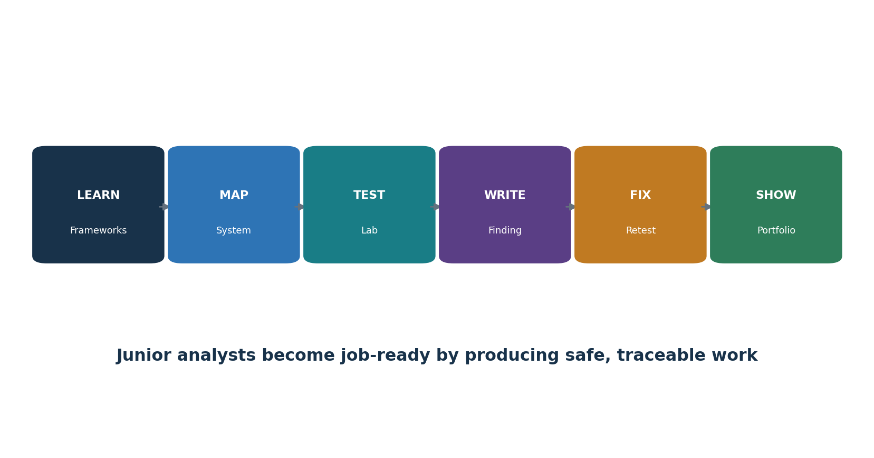
Figure 10. Junior AI risk and security pathway

28.1 Entry-level roles
- Junior AI Governance or Responsible AI Analyst
- AI Risk / Model Risk Analyst
- AI Security or GenAI Security Analyst
- GRC / Compliance Analyst with AI focus
- Data Governance or Privacy Analyst
- Third-Party AI Risk Analyst
- AI Evaluation / Trust and Safety Analyst
- Security Assurance Analyst

28.2 Daily work
Discover AI use cases and reconcile inventory across procurement, code, APIs, identity, network, expenses, and interviews.
Document system/data flows, affected people, use limits, suppliers, permissions, and human oversight.
Map NIST, ISO, OWASP, CSA, legal, contractual, and internal requirements to controls and evidence.
Run authorized evaluations and security tests; validate results and protect evidence.
Review provider documentation, terms, model cards, assurance reports, incidents, changes, and customer responsibilities.
Write findings in plain language; assign actions; retest; build metrics with known populations and limitations.
Support AI incident timelines, affected-decision review, corrective action, and lessons learned.

28.3 Resume evidence
- One-page system and data-flow map with trust boundaries.
- AI inventory and risk-tiering method for a fictional company.
- Impact, threat, privacy, and supplier assessments.
- Evaluation plan with acceptance thresholds and reproducible results.
- Three findings with condition, evidence, risk, cause, action, owner, and retest.
- Manager memo explaining go, conditional go, pilot, or no-go decision.
- Sanitized screenshots/configuration only; clearly label work as fictional and educational.

29. Fictional Laboratory, Thirty-Day Plan, and Interviews
A fictional AI application can demonstrate governance, testing, security, and communication without risking real people or systems.
Lab rule: Use local or approved test models, synthetic data, isolated accounts, fixed budgets, and written authorization. Never test a public service, employer, interview company, or third-party model beyond its published program and permission.

29.1 Portfolio lab
- Create a fictional 80-person company building an internal HR policy assistant with RAG. It may explain policy but cannot make employment decisions.
- Write purpose, prohibited uses, affected people, risk tier, RACI, inventory, model/provider choice, and approval gate.
- Create synthetic policy documents, including one malicious indirect-injection file; document provenance, ACLs, ingestion, retention, and deletion.
- Draw data/model/RAG/tool/human trust boundaries and create a MITRE ATLAS/OWASP-based threat model.
- Build evaluation cases for groundedness, citation, privacy, fairness/accessibility, prompt injection, unsafe advice, and unbounded use.
- Use Promptfoo, Garak, Giskard, or Inspect AI in an isolated test; cap activity; validate results manually.
- Correct retrieval ACLs, instruction separation, output validation, least privilege, logging, limits, and escalation; rerun.
- Write an assurance workpaper, three findings, a residual-risk decision, monitoring dashboard, incident tabletop, and retirement checklist.
- Publish only sanitized synthetic evidence and explain what the lab does not prove.

29.2 Thirty-day plan
Days | Focus | Deliverable
1–3 | AI basics and trustworthy characteristics | Concept map and glossary
4–6 | NIST AI RMF and governance | RACI, policy outline, inventory
7–9 | Use-case mapping and impact | System map and impact assessment
10–12 | Data/model governance | Dataset and model cards
13–15 | Threats, OWASP, ATLAS | Threat model and security requirements
16–18 | RAG, agents, identity, MCP | Trust boundaries and tool policy
19–21 | Evaluation and red teaming | Test plan, thresholds, results
22–24 | Privacy, fairness, transparency | Three review workpapers
25–27 | Monitoring, incident, assurance | Dashboard, tabletop, control tests
28–30 | Portfolio and interviews | Manager memo and five STAR stories

29.3 What is the NIST AI RMF?
A voluntary framework for managing AI risks through Govern, Map, Measure, and Manage. It focuses on risks to people, organizations, and society.

29.4 Model risk versus system risk?
Model risk concerns model behavior; system risk includes people, data, interfaces, tools, infrastructure, suppliers, processes, and real-world decisions.

29.5 What is prompt injection?
Untrusted content is interpreted as instructions that change behavior or reach data and tools. Treat content as data, constrain authority, validate actions, and test bypasses.

29.6 How do you evaluate an LLM?
Define the use and harms, create representative cases and thresholds, test the complete versioned system, review failures and uncertainty, approve conditions, and monitor change.

29.7 What is RAG?
Retrieval-augmented generation retrieves external content and gives it to a model. It adds source, access, poisoning, injection, citation, freshness, and deletion risks.

29.8 Why is human oversight difficult?
A reviewer may lack time, information, skill, independence, or authority and may trust automation too much. Oversight must be designed and tested.

29.9 What is an AI inventory?
An owned record of use, purpose, people, technology, models, data, suppliers, impact, approvals, controls, monitoring, and retirement.

29.10 How do tools prove compliance?
They do not. Tools produce evidence that an analyst must scope, validate, interpret against requirements, and connect to decisions and remediation.

29.11 How do you report a finding?
State condition, evidence/population, requirement, business and people impact, cause, recommendation, owner, due date, interim protection, and retest.

29.12 What makes a good junior analyst?
Curiosity, careful scope, respect for people and data, reproducible tests, clear writing, honest uncertainty, safe tool use, and follow-through.

30. Templates, Glossary, Index, and References
Reusable forms and authoritative sources help turn concepts into consistent work.

30.1 AI use-case inventory
Field | Entry
System/use ID, status, owner, sponsor | ________________________________________
Purpose, benefit, users, affected people | ________________________________________
Decisions/content, autonomy, prohibited uses | ________________________________________
Model/provider/version/configuration | ________________________________________
Data, rights, sensitivity, location, retention | ________________________________________
RAG, agents, tools, APIs, MCP | ________________________________________
Impact tier, laws/contracts, assessments | ________________________________________
Human oversight, appeal, redress | ________________________________________
Evaluation, approval, conditions | ________________________________________
Monitoring, incidents, changes, retirement | ________________________________________

30.2 AI impact and risk assessment
Field | Entry
Context, people, alternatives, dependency | ________________________________________
Benefits and success measures | ________________________________________
Harms: rights, safety, financial, social, operational | ________________________________________
Likelihood, severity, scale, reversibility, uncertainty | ________________________________________
Affected groups and accessibility | ________________________________________
Data/model/supplier limitations | ________________________________________
Controls and evaluation thresholds | ________________________________________
Human oversight and contestability | ________________________________________
Residual risk and decision authority | ________________________________________
Review triggers and expiry | ________________________________________

30.3 AI evaluation workpaper
Field | Entry
Claim, risk, requirement, threshold | ________________________________________
System/model/prompt/tool versions | ________________________________________
Environment and permissions | ________________________________________
Dataset provenance and population | ________________________________________
Cases, scorers, human rubric, sample | ________________________________________
Randomness/repetitions and confidence | ________________________________________
Results, failures, subgroup analysis | ________________________________________
Limitations and known exclusions | ________________________________________
Decision, conditions, findings | ________________________________________
Correction and regression retest | ________________________________________

30.4 AI incident and change record
Field | Entry
Case/change ID, owner, severity | ________________________________________
Affected system/version/people/decisions | ________________________________________
Prompt, context, retrieval, tools, identities | ________________________________________
Timeline, evidence preservation, provider | ________________________________________
Containment and affected-person protection | ________________________________________
Correction, reversal, redress, notice | ________________________________________
Root/contributing causes | ________________________________________
Trusted version, validation, rollback | ________________________________________
Risk reapproval and monitoring | ________________________________________
Lessons, actions, retest, closure | ________________________________________

30.5 Glossary
Term | Meaning
Agent | AI-enabled software that plans and uses tools toward a goal.
AI RMF | NIST Artificial Intelligence Risk Management Framework.
AICM | CSA AI Controls Matrix.
Confabulation | Plausible but false or unsupported generated content.
Embedding | Numeric representation used to compare meaning or similarity.
Evaluation | Structured measurement of defined system claims and risks.
Foundation model | Broad model that can be adapted to many downstream tasks.
Groundedness | Degree to which output is supported by provided or authoritative sources.
Human oversight | Meaningful human ability to understand, supervise, intervene, override, or stop.
Impact assessment | Review of intended and foreseeable effects on people and organizations.
Inference | Using a trained model to produce a prediction or output.
MCP | Model Context Protocol, a standard for connecting AI applications to tools and data.
Model card | Structured documentation of intended use, performance, limits, and other facts.
Model drift | Change in performance or behavior as data or context changes.
Prompt injection | Untrusted instructions alter model or application behavior.
RAG | Retrieval-augmented generation.
Red teaming | Authorized adversarial evaluation of risks and failure modes.
Sociotechnical system | Technology and the people, rules, institutions, and context around it.
System card | Documentation of the complete AI system, evaluation, risks, and limits.
Vector database | Store and search service for embeddings and associated metadata.

30.6 Subject index
Subject | Chapter
Agents/autonomy | 16, 19
AICM | 25
Assurance/evidence | 22–25
Data/privacy | 11, 20
EU AI Act | 2
Fairness/oversight | 21
GenAI Profile | 8
Inventory/life cycle | 10
ISO 42001 / 23894 | 9
Manager | 27
MCP / tools | 19
Models/suppliers | 12–13
Monitoring/incidents | 23
NIST AI RMF | 3–7
Open-source tools | 26
OWASP / threat model | 14–16
RAG | 17
Testing / red team | 6, 22
Junior analyst | 28–29

30.7 Official references
- NIST AI Risk Management Framework
- NIST AI RMF 1.0 PDF
- NIST AI RMF Playbook and AIRC
- NIST AI 600-1 Generative AI Profile
- NIST Adversarial Machine Learning Taxonomy
- ISO/IEC 42001:2023
- ISO/IEC 23894:2023
- EU AI Act policy page
- EU AI Act official implementation timeline
- OWASP Top 10 for LLM Applications 2025
- OWASP Top 10 for Agentic Applications 2026
- OWASP GenAI Security Project
- MITRE ATLAS
- CSA AI Controls Matrix resources
- CSA STAR for AI
- OECD AI Principles
- UNESCO Recommendation on the Ethics of AI
- CISA AI resources
- UK AI Security Institute Inspect
Final reminder: AI law, standards, threats, model behavior, providers, terms, tools, and official guidance change rapidly. Verify the current source, system version, facts, and jurisdiction before implementation, assessment, deployment, or risk acceptance.

