PRACTICAL CYBERSECURITY, PRIVACY & COMPLIANCE SERIES
HIPAA
A Practical Compliance and Security Manual for Managers and Junior Analysts
How health-information privacy, security, breach response, evidence, and oversight work in practice
Alberto (Al) Leiva
First Edition • July 2026
Inside: Privacy Rule • Security Rule • Breach Notification • Part 2 • Manager playbook • Open-source tools • Junior analyst labs • Interview preparation

Publication and Use Notice
Author: Alberto (Al) Leiva
Edition: First Edition, July 2026
Purpose: Free, practical education for managers, students, career changers, junior analysts, privacy professionals, and cybersecurity practitioners.

Educational and legal notice
This manual provides general educational information. It is not legal advice and does not replace advice from qualified counsel, privacy officers, security officers, or health-information professionals. HIPAA duties depend on facts, role, contracts, current federal regulations and guidance, state law, and other health-information rules.

Ethical and authorized use
Use technical tools and exercises only with written authorization and only with fictional, synthetic, or properly de-identified data. Never place real patient information in a public repository, training lab, demonstration, portfolio, or unapproved service. Technical skill does not create permission.

Preface
A welcoming introduction to practical HIPAA work.
HIPAA is often reduced to one sentence: do not share patient information. That is incomplete. Real HIPAA work includes understanding who is regulated, what information is protected, which uses and disclosures are allowed, how individual rights work, how electronic PHI is secured, how incidents are assessed, and how evidence proves that controls actually operate.
Managers must assign responsibility, fund reasonable safeguards, remove obstacles, review risk honestly, and make timely decisions. Junior analysts support data and system mapping, access reviews, risk analysis, policy evidence, rights requests, business associate files, incident facts, training records, and corrective actions.
This manual follows a methodology-first approach. A scanning tool can identify a weakness, but it cannot decide whether the whole risk analysis is accurate and thorough. A contract repository can store a BAA, but it cannot prove that the vendor follows it. A dashboard can show green status, but management remains responsible for what that status means.
Central lesson: HIPAA compliance is a continuing management program connecting health-information privacy, cybersecurity, workforce behavior, vendors, patient rights, incident response, and evidence.

— Alberto (Al) Leiva

How to Use This Manual
- Managers should begin with Chapters 1 through 13 and use the playbook and templates as working references.
- Junior analysts should study the regulatory guide, evidence, tools, fictional laboratory, portfolio projects, and interview chapter.
- Technical readers should connect each technical finding to ePHI, a risk, a safeguard, an owner, review evidence, and correction.
- Privacy and legal teams should verify current HHS guidance, eCFR text, state laws, and other specialized health-information rules.
Edition note: The visible chapter guide contains verified page numbers for this edition. The native Word field can be refreshed after editing by selecting Update Table, then Update entire table.

Table of Contents
Publication and Use Notice 2
Educational and legal notice 2
Ethical and authorized use 2
Preface 3
How to Use This Manual 4
Table of Contents 4
1. HIPAA Foundations 9
1.1 The HIPAA Rules 9
1.2 HIPAA is not a general health-data law 9
1.3 Current-law checkpoint 9
2. Scope, Roles, PHI, and ePHI 10
2.1 Covered entities 10
2.2 Business associates 10
2.3 PHI and ePHI 10
2.4 De-identification 11
3. Privacy Rule: Uses and Disclosures 12
3.1 Required versus permitted 12
3.2 Treatment, payment, and health care operations 12
3.3 Authorization 12
3.4 Minimum necessary 12
3.5 Special permitted disclosures 12
4. Individual Rights and Privacy Operations 13
4.1 Rights overview 13
4.2 Access is not the same as authorization 13
4.3 Defensible request file 13
5. Security Rule Foundations 14
5.1 General requirements 14
5.2 Required and addressable 14
5.3 Risk analysis and risk management 14
6. Administrative Safeguards 16
6.1 Information-system activity review 16
6.2 Contingency evidence 16
7. Physical and Technical Safeguards 17
7.1 Technical control principles 17
8. Breach Notification Rule 18
8.1 Breach presumption and four-factor assessment 18
8.2 Exceptions 18
9. Business Associates and Vendor Oversight 19
9.1 Business associate agreement contents 19
9.2 Due diligence 19
10. Part 2 and Special Health Information 20
10.1 42 CFR Part 2 20
10.2 Specialized and state rules 20
10.3 Reproductive-health rule status 20
11. Enforcement, State Law, and Current Developments 21
11.1 OCR enforcement 21
11.2 Penalty tiers 21
11.3 State-law preemption 21
11.4 Security Rule NPRM 21
11.5 Online tracking technologies 21
12. Complete Regulatory Requirements Guide 22
12.1 Security Rule 22
12.2 Privacy Rule 22
12.3 Breach Notification Rule 23
12.4 Enforcement and preemption 23
12.5 Compliance verification method 24
12.6 Practical verification tests 25
12.7 Evidence reliability 25
13. Manager’s HIPAA Playbook 26
13.1 Questions for every owner 26
13.2 Monthly dashboard 26
13.3 Common management mistakes 26
14. From Beginner to Junior HIPAA Analyst 27
14.1 Job titles 27
14.2 Typical junior work 27
14.3 Portfolio proof 28
15. Open-Source Tools for HIPAA Work 29
15.1 Tool-to-requirement verification matrix 29
15.2 How to validate a tool before relying on it 30
15.3 Tool evidence package 31
15.4 CISO Assistant 31
Quick start 31
Evidence to retain 31
15.5 Wazuh 32
Quick start 32
Evidence to retain 32
15.6 OpenSCAP 32
Quick start 32
Evidence to retain 32
15.7 Greenbone Community Edition 32
Quick start 32
Evidence to retain 32
15.8 osquery 32
Quick start 33
Evidence to retain 33
15.9 Trivy 33
Quick start 33
Evidence to retain 33
15.10 OWASP ZAP 33
Quick start 33
Evidence to retain 33
15.11 Keycloak 33
Quick start 34
Evidence to retain 34
15.12 DefectDojo 34
Quick start 34
Evidence to retain 34
15.13 Velociraptor 34
Quick start 34
Evidence to retain 34
15.14 Open Policy Agent 34
Quick start 34
Evidence to retain 35
15.15 Free government resource 35
15.16 Tool governance checklist 35
16. Fictional Healthcare Laboratory and Portfolio 36
Project 1 — Scope and roles 36
Project 2 — Risk analysis 36
Project 3 — Security safeguards 36
Project 4 — Privacy rights 36
Project 5 — Breach 36
Project 6 — Vendor 36
Project 7 — Tools 36
16.1 Portfolio ethics 36
17. Thirty-Day Learning Plan 37
17.1 Daily habit 37
18. Interview Preparation 38
Who must comply with HIPAA? 38
What is PHI? 38
PHI versus ePHI? 38
What is minimum necessary? 38
What is a HIPAA risk analysis? 38
Does addressable mean optional? 38
What is the breach standard? 38
How do business associates support compliance? 38
How do you prove a safeguard works? 38
18.1 Manager’s 60-second answer 39
19. Templates and Checklists 40
19.1 ePHI inventory fields 40
19.2 Risk register fields 40
19.3 Breach fact sheet 40
19.4 BAA checklist 40
19.5 Manager pre-audit checklist 41
20. Glossary 42
21. Subject Index 44
22. Official References and Further Study 45

1. HIPAA Foundations
What HIPAA covers, what it does not cover, and how its main rules work together.
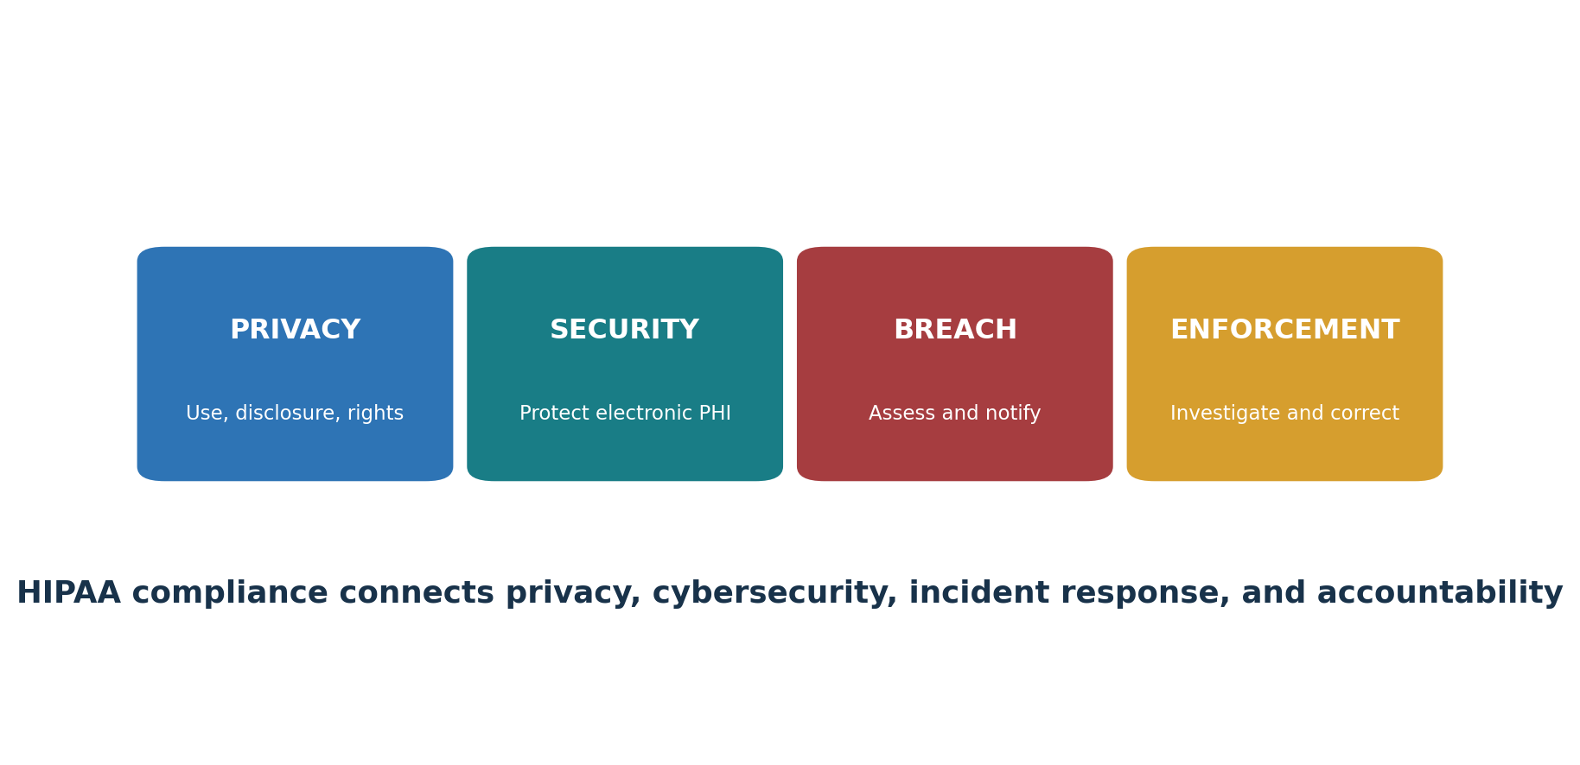
Figure 1. The main HIPAA compliance areas

1.1 The HIPAA Rules
Area | Purpose | Primary focus
Privacy Rule | Limits uses and disclosures and gives individuals rights | PHI in electronic, paper, and oral form
Security Rule | Protects electronic PHI | Administrative, physical, and technical safeguards
Breach Notification Rule | Requires assessment and notification after certain breaches | Unsecured PHI and documented risk decisions
Enforcement Rule | Explains investigations and penalties | Complaints, compliance reviews, evidence, correction
Transactions and Code Sets | Standardizes covered electronic health transactions | Administrative simplification standards

1.2 HIPAA is not a general health-data law
HIPAA applies to covered entities, business associates, and certain related arrangements. A fitness app, employer, school, life insurer, or direct-to-consumer service may hold sensitive health data without being a HIPAA covered entity. Other federal and state laws may still apply.

1.3 Current-law checkpoint
Important: The December 2024 HIPAA Security Rule update is a proposed rule, not the current final Security Rule. This manual explains the current rule and clearly labels the proposal as a future-development item.

2. Scope, Roles, PHI, and ePHI
How to identify regulated entities, protected information, boundaries, and responsibilities.
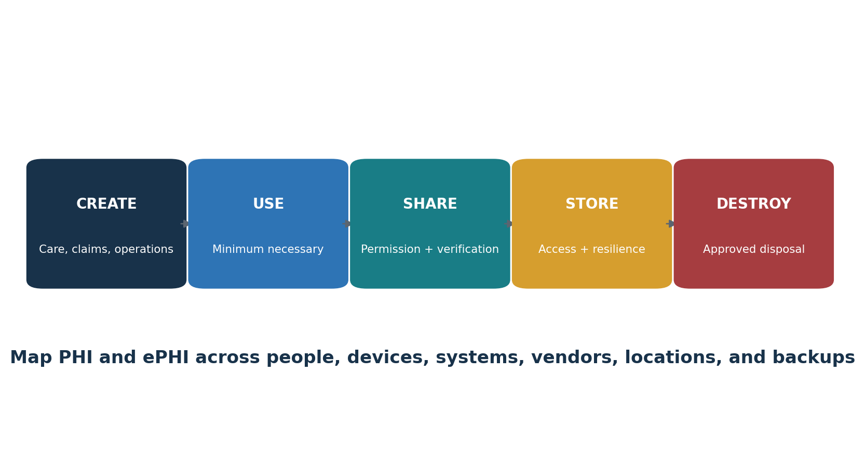
Figure 2. PHI lifecycle

2.1 Covered entities
- Health plans
- Health care clearinghouses
- Health care providers that transmit health information electronically in connection with a covered transaction

2.2 Business associates
A business associate performs certain functions or services for a covered entity involving PHI. A subcontractor that creates, receives, maintains, or transmits PHI on behalf of a business associate can also be a business associate. Status comes from the facts and rules, not merely from whether a contract is signed.

2.3 PHI and ePHI
Protected health information is individually identifiable health information held or transmitted by a covered entity or business associate, subject to exclusions such as certain education and employment records. ePHI is PHI maintained or transmitted electronically. The Security Rule protects ePHI; the Privacy Rule protects PHI in any form.

2.4 De-identification
Method | Plain meaning | Evidence
Expert determination | A qualified expert determines and documents that identification risk is very small | Expert qualifications, method, assumptions, report
Safe Harbor | Remove the listed identifiers and have no actual knowledge that remaining information identifies a person | Identifier checklist, quality review, approval

Manager checkpoint: Require a written scope and role analysis for each legal entity, service, product, employer function, research activity, vendor, and data flow.

3. Privacy Rule: Uses and Disclosures
Permitted uses, authorizations, minimum necessary, verification, notices, and special situations.

3.1 Required versus permitted
The Privacy Rule requires disclosure to the individual in certain rights situations and to HHS for enforcement. It permits many other uses and disclosures when conditions are met. A permitted disclosure is not always mandatory; other laws and professional duties may affect the decision.

3.2 Treatment, payment, and health care operations
Covered entities may use and disclose PHI for treatment, payment, and health care operations under the rule. Teams must still confirm the purpose, recipient, role, applicable minimum-necessary rule, notices, and other conditions.

3.3 Authorization
- Describe the information in a specific and meaningful way.
- Name or describe who may disclose and receive it.
- State the purpose, expiration, and required statements.
- Use plain language and obtain signature and date.
- Track revocation and reliance already taken.
- Apply special rules for psychotherapy notes, marketing, and sale of PHI.

3.4 Minimum necessary
When the minimum-necessary standard applies, limit uses, disclosures, and requests to the PHI reasonably needed for the purpose. Define workforce roles, routine protocols, nonroutine review, and reasonable reliance. The standard has exceptions, including disclosures to or requests by a health care provider for treatment.

3.5 Special permitted disclosures
Situation | Required analysis
Required by law | Identify the exact legal requirement and limit the disclosure
Public health | Verify recipient authority and permitted purpose
Abuse, neglect, or domestic violence | Apply conditions, safety considerations, and notice rules
Health oversight | Confirm oversight authority and scope
Judicial or administrative proceeding | Review order, subpoena, notice, protective-order, and objection conditions
Law enforcement | Identify the precise permission and verify the requester
Research | Confirm authorization, waiver, preparatory review, or decedent conditions
Serious threat | Apply good-faith and applicable-law conditions
Workers’ compensation | Limit disclosure to what the law authorizes

4. Individual Rights and Privacy Operations
How to receive, verify, complete, and document patient and member requests.

4.1 Rights overview
Right | Typical deadline | Operational work
Notice of privacy practices | At required service, enrollment, posting, and revision points | Current notice, distribution, acknowledgment, website
Access | Generally 30 days; one 30-day extension with timely written notice | Verify, search designated record set, review exclusions, format, fees, delivery
Amendment | Generally 60 days; one 30-day extension with notice | Review, accept or deny, link records, notify parties
Accounting of disclosures | Generally 60 days; one 30-day extension with notice | Search disclosure logs, apply exceptions, deliver accounting
Restriction request | Review and respond; certain paid-in-full health-plan restrictions must be accepted | Decision, system flag, downstream control
Confidential communications | Accommodate reasonable requests under the applicable rule | Alternate address, channel, safety handling
Complaint | No retaliation; process under policy | Log, investigate, respond, mitigate, retain evidence

4.2 Access is not the same as authorization
An individual’s right of access under 45 CFR 164.524 has its own scope, timing, denial, format, and fee rules. Do not automatically apply an authorization process or create barriers that the access rule does not allow.

4.3 Defensible request file
- Request and receipt date
- Identity and personal-representative decision
- Designated record set and systems searched
- Exclusions, reviewable denial, and legal analysis
- Format, delivery method, and fee calculation
- Extension notice when used
- Response, delivery proof, and completion date

5. Security Rule Foundations
General requirements, flexibility, required and addressable specifications, and evidence.
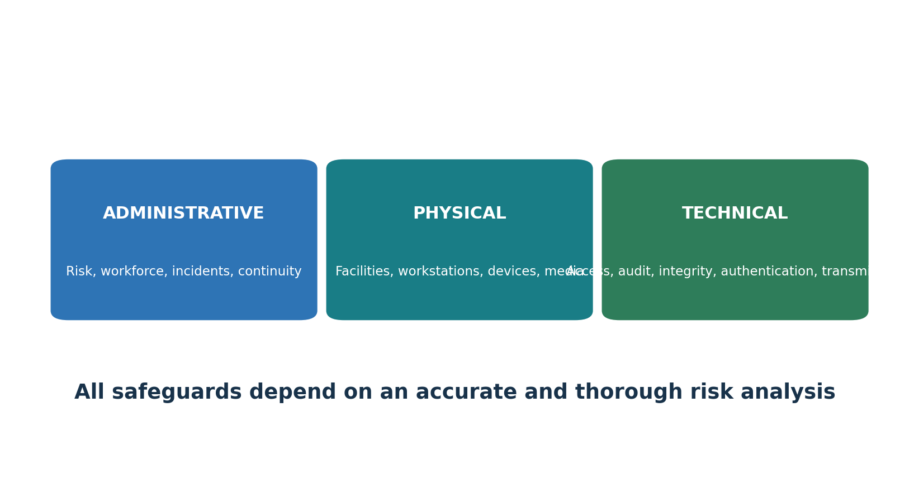
Figure 3. HIPAA Security Rule safeguards

5.1 General requirements
- Ensure confidentiality, integrity, and availability of ePHI.
- Protect against reasonably anticipated threats and hazards.
- Protect against reasonably anticipated impermissible uses or disclosures.
- Ensure workforce compliance.

5.2 Required and addressable
Addressable does not mean optional: For an addressable specification, assess whether it is reasonable and appropriate. Implement it when it is. If it is not, document why and implement an equivalent reasonable and appropriate alternative when one exists.

5.3 Risk analysis and risk management
- Define all ePHI and regulated-entity boundaries.
- Map systems, applications, devices, people, locations, vendors, networks, interfaces, backups, and media.
- Identify threats, vulnerabilities, existing measures, likelihood, and impact.
- Determine risk consistently.
- Assign treatments, owners, resources, dates, and acceptance authority.
- Retest and update after changes, incidents, new threats, and control failures.
The current Security Rule does not set one fixed risk-analysis frequency. HHS guidance states the process should be ongoing and updated as needed.

6. Administrative Safeguards
The management processes that turn policy into repeatable protection.
Citation | Standard | Manager action | Evidence
164.308(a)(1) | Security management process | Perform risk analysis, risk management, sanctions, and information-system activity review. | Risk analysis, treatment plan, sanctions, log-review evidence
164.308(a)(2) | Assigned security responsibility | Designate the official responsible for Security Rule policies and procedures. | Role description, appointment, reporting line
164.308(a)(3) | Workforce security | Authorize, supervise, clear, and promptly remove workforce access. | Access approvals, screening, termination evidence
164.308(a)(4) | Information access management | Control access based on role and need, including establishment and modification. | Access matrix, approvals, periodic reviews
164.308(a)(5) | Security awareness and training | Train the workforce and address reminders, malware, log-in monitoring, and password management. | Training, simulations, reminders, follow-up
164.308(a)(6) | Security incident procedures | Identify, respond to, mitigate, document, and report incidents. | Incident plan, tickets, evidence, lessons
164.308(a)(7) | Contingency plan | Operate backups, disaster recovery, emergency mode, testing, and criticality analysis. | Backup reports, restore tests, exercises, recovery plans
164.308(a)(8) | Evaluation | Perform periodic technical and nontechnical evaluation after relevant changes. | Evaluation scope, findings, correction plan
164.308(b) | Business associate arrangements | Use contracts or other arrangements that require appropriate safeguards. | BAA, due diligence, monitoring

6.1 Information-system activity review
Define which audit logs, access reports, security events, exception reports, and alerts are reviewed; how often; by whom; how evidence is retained; and how suspicious activity becomes an incident or corrective action.

6.2 Contingency evidence
- Backup job and failure reports
- Offline or otherwise protected backup design
- Documented restore tests
- Emergency-mode procedures
- Disaster-recovery exercises
- Critical application and data analysis
- Lessons, owners, and due dates

7. Physical and Technical Safeguards
Facilities, workstations, media, identity, access, audit, integrity, and transmission controls.
Citation | Standard | Manager action | Evidence
164.310(a) | Facility access controls | Limit physical access while allowing authorized access and continuity. | Facility plan, visitor logs, maintenance records
164.310(b) | Workstation use | Define proper functions and physical surroundings for workstations using ePHI. | Workstation policy, training, observations
164.310(c) | Workstation security | Restrict physical access to workstations that access ePHI. | Secure locations, screens, device controls
164.310(d) | Device and media controls | Control receipt, movement, reuse, backup, disposal, and accountability. | Inventory, chain of custody, wiping and destruction proof
164.312(a) | Access control | Use unique IDs, emergency access, and suitable logoff and encryption controls. | IAM settings, emergency test, encryption record
164.312(b) | Audit controls | Record and examine activity in systems containing or using ePHI. | Logs, review schedule, investigation records
164.312(c) | Integrity | Protect ePHI from improper alteration or destruction. | Integrity checks, change controls, validation
164.312(d) | Person or entity authentication | Verify that a person or entity seeking access is the one claimed. | Authentication settings, MFA, identity records
164.312(e) | Transmission security | Protect ePHI against unauthorized access while transmitted. | Encryption, secure protocols, architecture tests
164.314 | Organizational requirements | Address business associate contracts and group health plan requirements. | Contracts, plan documents, reviews
164.316 | Policies, procedures, and documentation | Implement reasonable policies and retain required documentation for six years. | Approved policies, versions, six-year retention evidence

7.1 Technical control principles
- Give every user a unique identity.
- Use least privilege and timely removal.
- Protect privileged and emergency access.
- Record meaningful activity and review it.
- Use strong authentication suitable for risk.
- Protect ePHI at rest and in transit based on the documented analysis.
- Test integrity, recovery, and control effectiveness.
- Manage exceptions with owner, reason, compensating controls, expiry, and approval.

8. Breach Notification Rule
How to assess unsecured PHI incidents and meet notification duties.
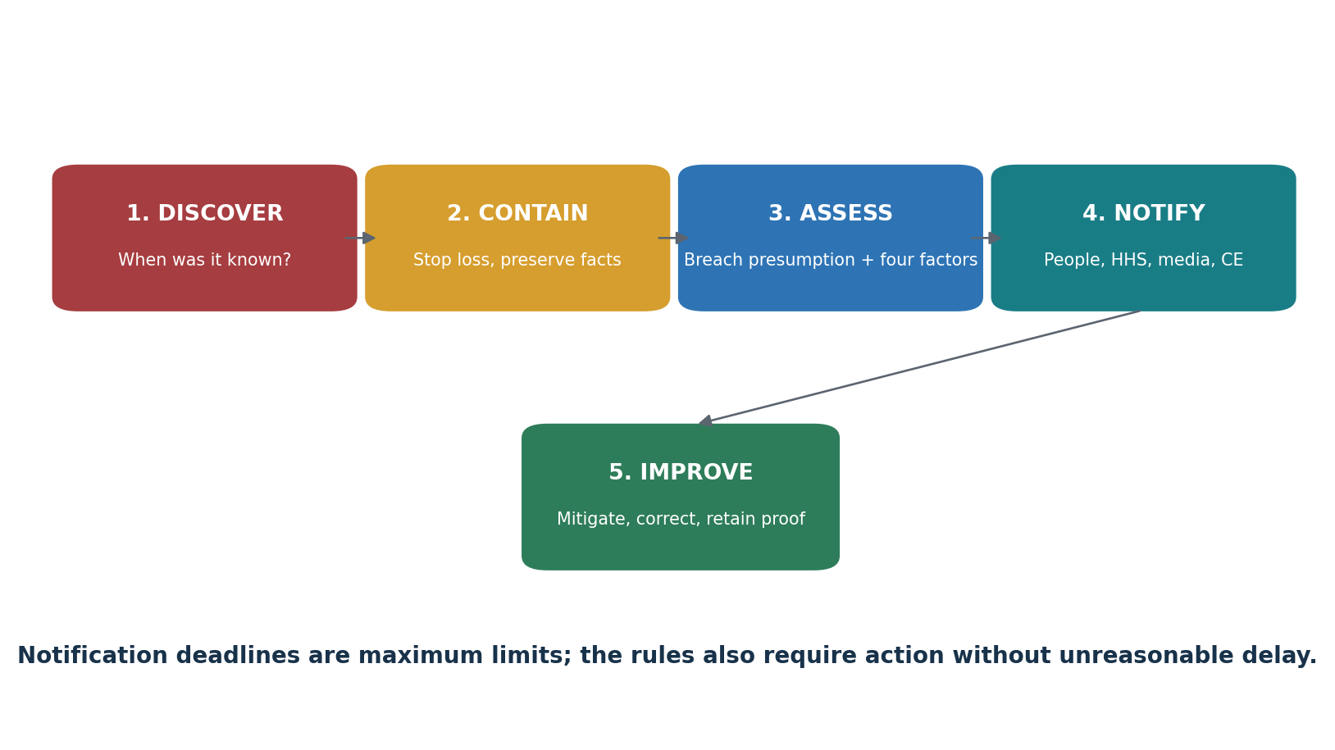
Figure 4. HIPAA breach workflow

8.1 Breach presumption and four-factor assessment
An impermissible use or disclosure of PHI is presumed to be a breach unless the covered entity or business associate demonstrates a low probability that the PHI was compromised. Assess at least the nature and extent of PHI and likelihood of re-identification, the unauthorized person, whether PHI was actually acquired or viewed, and the extent of mitigation.
Notification | Timing overview | Evidence
Individuals | Without unreasonable delay and no later than 60 days after discovery | Content, delivery, substitute notice, proof
HHS — 500 or more | Under the rule’s contemporaneous reporting timing | HHS submission and affected count
HHS — fewer than 500 | Annual reporting, no later than 60 days after the end of the calendar year | Small-breach log and submission
Media | More than 500 residents of a state or jurisdiction | Jurisdiction count, media notice
Business associate to covered entity | Without unreasonable delay and no later than 60 days | Discovery date, identities if known, facts and notice

8.2 Exceptions
The breach definition contains narrow exceptions involving certain unintentional or inadvertent workforce access and good-faith beliefs that an unauthorized recipient could not reasonably retain the information. Document facts and legal review before relying on an exception.

9. Business Associates and Vendor Oversight
Contracts, subcontractors, due diligence, monitoring, incidents, and termination.

9.1 Business associate agreement contents
- Permitted and required uses and disclosures
- No use or disclosure beyond the contract or law
- Appropriate safeguards and Security Rule compliance for ePHI
- Breach, incident, and unsecured-PHI reporting
- Support for access, amendment, and accounting duties
- PHI availability for HHS compliance review
- Return or destruction at termination when feasible
- Subcontractor agreements with the same applicable restrictions
- Termination rights for material violation

9.2 Due diligence
Area | Questions | Evidence
Scope | What PHI/ePHI, purpose, services, locations, and interfaces? | Data flow, inventory, architecture
Security | Risk analysis, encryption, identity, logging, vulnerability, backups, incident response? | Policies, tests, reports, remediation
Privacy | Minimum necessary, workforce access, rights support, disclosure controls? | Procedures, roles, samples
Subcontractors | Who, where, for what purpose, under what agreement? | Subprocessor list and terms
Incidents | When and how will the BA report and cooperate? | BAA, exercise, contacts
Exit | How will access end and PHI be returned or destroyed? | Exit plan, deletion proof, residual-risk record

Management point: A signed BAA is necessary in many relationships, but it does not replace due diligence, risk management, access control, monitoring, or incident coordination.

10. Part 2 and Special Health Information
Substance use disorder records, mental health, genetics, and other overlapping rules.

10.1 42 CFR Part 2
The 2024 Part 2 Final Rule became effective April 16, 2024, and compliance was required by February 16, 2026. It aligns important consent, enforcement, breach-notification, and notice provisions more closely with HIPAA while retaining special protections for records of federally assisted substance use disorder programs.
- Determine whether the organization is a Part 2 program, lawful holder, or recipient.
- Use the current Part 2 consent, redisclosure, complaint, breach, and notice requirements.
- Do not assume that HIPAA permission alone always resolves Part 2 duties.
- Update notices of privacy practices and Part 2 patient notices as required for February 16, 2026 compliance.

10.2 Specialized and state rules
State law may be more stringent than HIPAA and may impose special rules for mental health, HIV, reproductive health, genetics, minors, telehealth, biometric data, or breach notice. Other federal rules can apply to substance use disorder records, education records, clinical research, information blocking, consumer health apps, and sensitive-data transfers.

10.3 Reproductive-health rule status
Current status: A federal district court order dated June 18, 2025 vacated most of the 2024 HIPAA reproductive-health privacy rule. HHS states that only certain Notice of Privacy Practices modifications remained. Verify the current HHS page and legal advice before using any 2024 attestation or reproductive-health workflow.

11. Enforcement, State Law, and Current Developments
Complaints, investigations, penalties, preemption, court decisions, and proposed changes.

11.1 OCR enforcement
- Receive and investigate complaints.
- Conduct compliance reviews and audits.
- Request records and cooperation.
- Seek voluntary compliance and corrective action.
- Enter resolution agreements and corrective-action plans.
- Impose civil money penalties where authorized.
- Refer possible criminal violations to the Department of Justice.

11.2 Penalty tiers
Civil penalty analysis considers knowledge, reasonable cause, willful neglect, correction, nature and extent, harm, history, financial condition, and other factors. Dollar amounts are adjusted periodically. Verify current HHS and Federal Register amounts instead of relying on an old chart.

11.3 State-law preemption
HIPAA generally preempts contrary state law, but the rules contain exceptions, including for certain more stringent privacy protections and public-health or reporting laws. Maintain a state-law matrix and obtain legal review for each service location and individual population.

11.4 Security Rule NPRM
HHS proposed major Security Rule changes in a notice published January 6, 2025, including more specific asset inventory, network mapping, risk analysis, testing, encryption, multifactor authentication, segmentation, recovery, and business-associate verification duties. As of this manual’s July 2026 publication, official HHS materials continue to identify it as a proposed rule. Monitor it, plan readiness, but do not describe proposed text as current final law.

11.5 Online tracking technologies
HHS notes that a court vacated part of its tracking-technology guidance concerning an IP address combined with a visit to an unauthenticated public webpage about health conditions or providers. Inventory tracking technologies, verify actual data and context, review contracts and disclosures, and use current legal guidance rather than broad assumptions.

12. Complete Regulatory Requirements Guide
A practical cross-reference to current Privacy, Security, and Breach Notification requirements.

12.1 Security Rule
Citation | Requirement | Manager action | Typical evidence
164.306 | General rules | Protect ePHI confidentiality, integrity, and availability; address anticipated threats and impermissible uses. | Security program, risk decisions, flexibility analysis
164.308(a)(1) | Security management process | Perform risk analysis, risk management, sanctions, and information-system activity review. | Risk analysis, treatment plan, sanctions, log-review evidence
164.308(a)(2) | Assigned security responsibility | Designate the official responsible for Security Rule policies and procedures. | Role description, appointment, reporting line
164.308(a)(3) | Workforce security | Authorize, supervise, clear, and promptly remove workforce access. | Access approvals, screening, termination evidence
164.308(a)(4) | Information access management | Control access based on role and need, including establishment and modification. | Access matrix, approvals, periodic reviews
164.308(a)(5) | Security awareness and training | Train the workforce and address reminders, malware, log-in monitoring, and password management. | Training, simulations, reminders, follow-up
164.308(a)(6) | Security incident procedures | Identify, respond to, mitigate, document, and report incidents. | Incident plan, tickets, evidence, lessons
164.308(a)(7) | Contingency plan | Operate backups, disaster recovery, emergency mode, testing, and criticality analysis. | Backup reports, restore tests, exercises, recovery plans
164.308(a)(8) | Evaluation | Perform periodic technical and nontechnical evaluation after relevant changes. | Evaluation scope, findings, correction plan
164.308(b) | Business associate arrangements | Use contracts or other arrangements that require appropriate safeguards. | BAA, due diligence, monitoring
164.310(a) | Facility access controls | Limit physical access while allowing authorized access and continuity. | Facility plan, visitor logs, maintenance records
164.310(b) | Workstation use | Define proper functions and physical surroundings for workstations using ePHI. | Workstation policy, training, observations
164.310(c) | Workstation security | Restrict physical access to workstations that access ePHI. | Secure locations, screens, device controls
164.310(d) | Device and media controls | Control receipt, movement, reuse, backup, disposal, and accountability. | Inventory, chain of custody, wiping and destruction proof
164.312(a) | Access control | Use unique IDs, emergency access, and suitable logoff and encryption controls. | IAM settings, emergency test, encryption record
164.312(b) | Audit controls | Record and examine activity in systems containing or using ePHI. | Logs, review schedule, investigation records
164.312(c) | Integrity | Protect ePHI from improper alteration or destruction. | Integrity checks, change controls, validation
164.312(d) | Person or entity authentication | Verify that a person or entity seeking access is the one claimed. | Authentication settings, MFA, identity records
164.312(e) | Transmission security | Protect ePHI against unauthorized access while transmitted. | Encryption, secure protocols, architecture tests
164.314 | Organizational requirements | Address business associate contracts and group health plan requirements. | Contracts, plan documents, reviews
164.316 | Policies, procedures, and documentation | Implement reasonable policies and retain required documentation for six years. | Approved policies, versions, six-year retention evidence

12.2 Privacy Rule
Citation | Requirement | Plain meaning | Typical evidence
164.502 | General use and disclosure rules | Use or disclose PHI only as required or permitted; apply business associate and deceased-person rules. | Use/disclosure matrix, approvals, disclosure records
164.504 | Organizational requirements | Address hybrid entities, affiliated groups, business associates, and plan-sponsor boundaries. | Designations, BAA, plan documents, firewalls
164.506 | Treatment, payment, and operations | Allows defined TPO uses and disclosures and related consent practices. | TPO purpose map, notice, role access
164.508 | Authorizations | Require a valid written authorization for uses and disclosures not otherwise permitted, including special authorization rules. | Authorization form, revocation, disclosure proof
164.510 | Opportunity to agree or object | Covers facility directories and involvement in care or payment after giving a suitable opportunity where required. | Preference record, identity and relationship check
164.512 | Uses and disclosures without authorization or opportunity | Permits specific activities such as required-by-law, public health, oversight, judicial, law-enforcement, research, and serious-threat situations when conditions are met. | Legal basis, request, verification, approval, disclosure log
164.514 | Other use and disclosure requirements | Covers de-identification, re-identification codes, minimum necessary, limited data sets, data use agreements, fundraising, and verification. | Method, expert determination, DUA, verification, minimum-necessary review
164.520 | Notice of privacy practices | Requires a clear notice describing uses, disclosures, duties, rights, complaints, and contacts. | Current NPP, distribution, acknowledgment, website
164.522 | Requests for privacy protection | Covers restrictions and confidential communications, including required acceptance of certain paid-in-full restrictions to health plans. | Request, decision, system flag, communication method
164.524 | Access | Provides access to PHI in a designated record set, generally within 30 days, subject to exclusions, denial rules, format, and permitted fees. | Request log, search, denial review, delivery, fee calculation
164.526 | Amendment | Lets individuals request amendment; requires decisions, notices, statements of disagreement, and record linking. | Request, decision, amendment or denial, notifications
164.528 | Accounting of disclosures | Requires an accounting of certain disclosures during the applicable six-year period, with exceptions. | Disclosure log, request, accounting, response date
164.530 | Administrative requirements | Requires privacy personnel, training, safeguards, complaints, sanctions, mitigation, nonretaliation, policies, and documentation. | Role appointment, training, complaints, sanctions, policies
164.532–535 | Transition and compliance provisions | Addresses transition rules and compliance dates. | Legal register, transition decision, dated approval

12.3 Breach Notification Rule
Citation | Requirement | Plain meaning | Typical evidence
164.400 | Applicability | Applies the breach-notification subpart to covered entities and business associates. | Scope and role analysis
164.402 | Definitions and breach risk assessment | A breach of unsecured PHI is presumed unless the entity shows a low probability of compromise using the required factors. | Four-factor assessment, facts, mitigation, approval
164.404 | Notice to individuals | Notify affected individuals without unreasonable delay and no later than 60 days after discovery; meet content and delivery rules. | Notification, address search, delivery and substitute notice
164.406 | Notice to media | For breaches affecting more than 500 residents of a state or jurisdiction, notify prominent media within the required period. | Count by jurisdiction, media notice, delivery proof
164.408 | Notice to the Secretary | Report breaches to HHS under the timing rules for 500 or more and fewer than 500 individuals. | HHS submission, annual small-breach log
164.410 | Notice by a business associate | A BA must notify the covered entity without unreasonable delay and no later than 60 days, with available identification and facts. | BA notice, discovery date, affected-person information
164.412 | Law-enforcement delay | Delay notice when a qualified law-enforcement statement meets the rule. | Written or oral request record and delay calculation
164.414 | Administrative requirements and burden of proof | Apply workforce training, policies, nonretaliation, documentation, and proof that notices were made or not required. | Policies, training, risk assessment, notification evidence

12.4 Enforcement and preemption
Citation area | Focus | Manager action | Evidence
45 CFR Part 160 Subpart B | Preemption of state law | Maintain legal matrix and escalation path | State-law review, counsel decision
Part 160 Subpart C | Compliance and investigations | Cooperate, preserve facts, avoid retaliation | Complaint and response file
Part 160 Subparts D–E | Civil money penalties and procedures | Correct promptly and manage response | Findings, corrective action, hearing file

12.5 Compliance verification method
A verification test should connect a requirement to actual operations and reliable evidence. It should not begin with a screenshot or a tool report. Begin with the risk, regulated entity, ePHI boundary, requirement, and control that management says is operating.
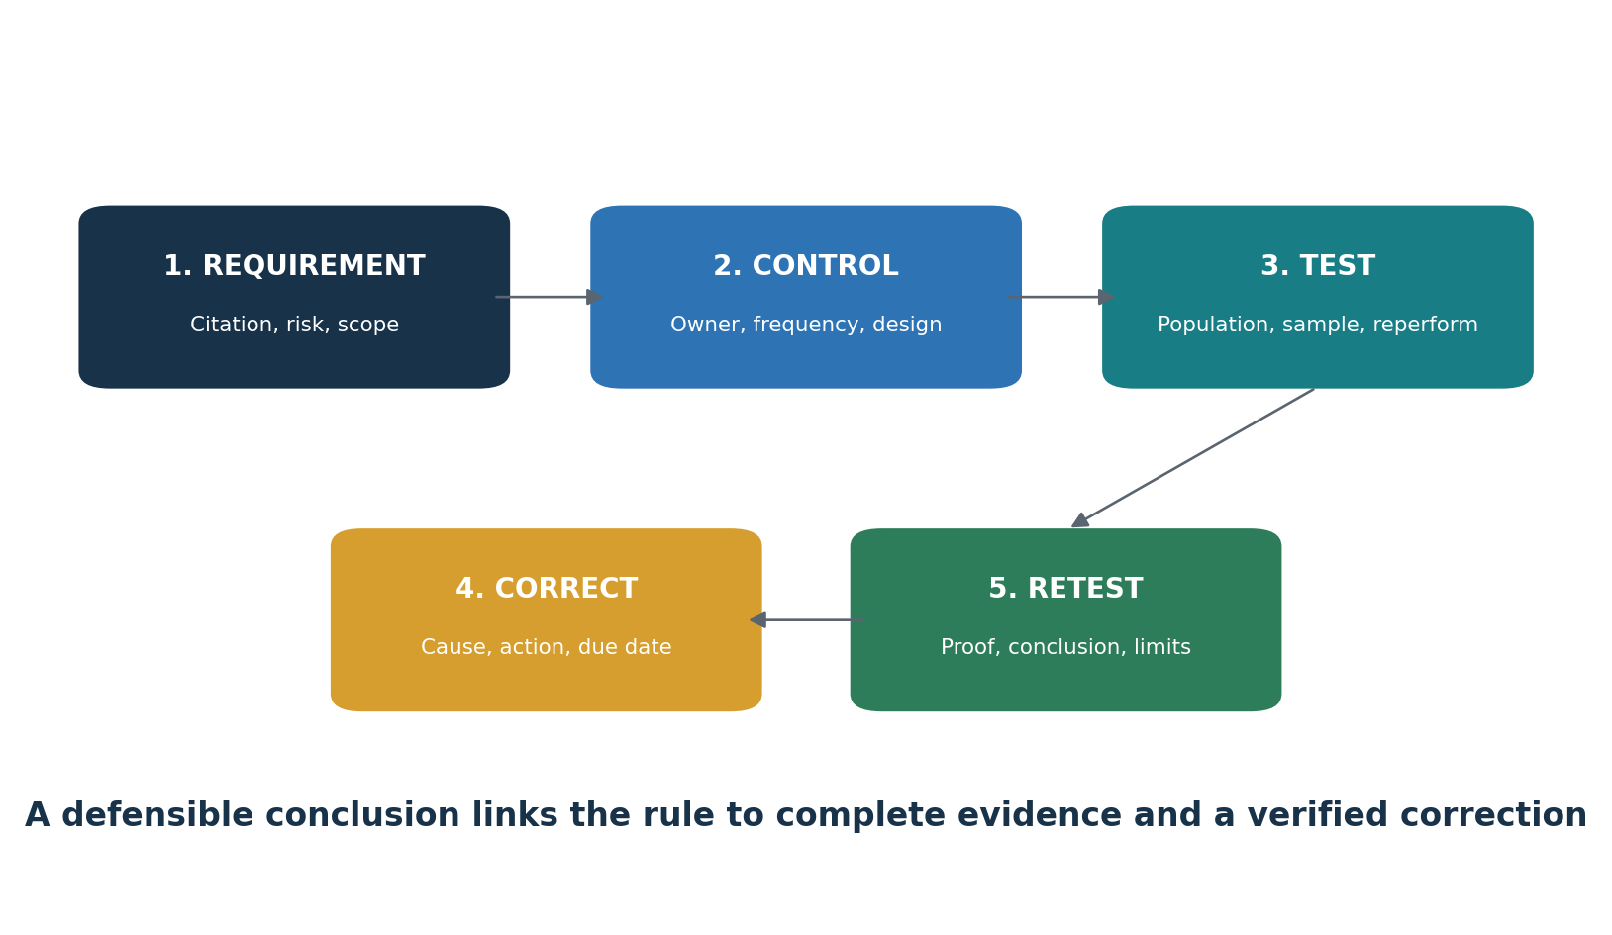
Figure 6. Compliance verification cycle
- Define the requirement, risk, control, owner, frequency, systems, period, and expected evidence.
- Obtain the complete population for the period and test whether it is complete and accurate.
- Select a risk-based sample that covers relevant times, systems, locations, owners, and unusual items.
- Inspect evidence and, where practical, reperform or independently confirm the control result.
- Record exceptions with the exact requirement, facts, cause, affected ePHI, duration, likelihood, and impact.
- Assign corrective action, owner, due date, interim protection, and escalation.
- Retest the correction and confirm it works across the affected population, not only for one example.
- Write a conclusion that states scope, period, work performed, result, exceptions, and limitations.

12.6 Practical verification tests
Control area | Population and sample | Test procedure | Evidence and conclusion
Terminated access | All workforce terminations in the period; sample higher-risk and ordinary departures | Compare HR termination time with account, badge, remote-access, email, EHR, and privileged-access disablement; inspect exceptions | Complete HR list, IAM and system logs, tickets, approvals, disablement time, exception and retest
Periodic access review | All required reviews by system and period; sample systems with ePHI and privileged roles | Confirm complete user population, qualified reviewer, role need, decisions, removals, completion date, and follow-up | User export, reviewer evidence, removal tickets, late-item follow-up, conclusion
Information-system activity review | All scheduled daily, weekly, or monthly reviews; sample across the period | Inspect source logs, alert coverage, reviewer identity, investigation, escalation, and retained proof | SIEM report, review record, ticket, decision, unresolved gap
Vulnerability management | All in-scope assets and findings; select critical, high, aged, and accepted findings | Confirm scan coverage and credentials, validate findings, compare deadlines, inspect correction, and rescan | Asset inventory, scan settings, report, ticket, exception, rescan, residual risk
Backups and recovery | All backup jobs and required restore tests; sample success, failure, and recovery events | Inspect job status, failure alerts, response, protected copies, restore evidence, recovery objective, and lessons | Backup logs, alert ticket, restore output, exercise record, corrective action
Security incidents and breaches | Complete incident population reconciled to alerts, help desk, privacy, and breach logs | Test classification, containment, four-factor assessment, notification timing, mitigation, and closure | Incident file, risk assessment, notices, approval, corrective action, retest
Business associates | Complete vendor and BA population; sample high-risk, new, changed, and terminated vendors | Verify status, BAA terms, due diligence, subcontractors, security evidence, incidents, changes, and exit | Vendor inventory, BAA, assessment, findings, monitoring, destruction or return proof
Individual rights | All access, amendment, restriction, confidential-communication, accounting, and complaint requests | Test identity, scope, search, deadlines, extension, denial review, fee, delivery, and retained result | Request log, search evidence, response, delivery proof, exception and conclusion
Training and sanctions | Complete workforce and contractor population; sample roles, new hires, late learners, and incidents | Compare assignments with workforce population, test completion timing, content, follow-up, and sanctions when applicable | Roster, completion report, reminders, sanction record, management review

12.7 Evidence reliability
Evidence quality | Meaning | Analyst response
Weak | Verbal statement, undated screenshot, partial export, or owner-created summary without source proof | Request source data, date, scope, system identity, reviewer, and complete population
Useful | Dated system report tied to the correct scope and period | Confirm configuration, completeness, access, and interpretation
Strong | System-generated result plus independent review, decisions, tickets, correction, and retest | Trace the full chain and record any limitation

Verification rule: A tool finding is an input, not a conclusion. Compliance verification requires scope, complete data, human review, legal and policy context, corrective action, and evidence that the control works over time.

13. Manager’s HIPAA Playbook
Questions, dashboards, meetings, and decisions managers should control.

13.1 Questions for every owner
- What PHI or ePHI is involved?
- Which covered entity or business associate role applies?
- What use, disclosure, or access is permitted and necessary?
- Where does the information flow and remain?
- Who has access and who reviews it?
- What threats and vulnerabilities affect it?
- What safeguard applies and where is the evidence?
- What vendors and subcontractors are involved?
- How will rights, incidents, and deletion work?
- Who accepts residual risk and by what authority?

13.2 Monthly dashboard
Area | Manager question | Status
Risk analysis | Are all ePHI, systems, locations, and changes covered? | Green / Yellow / Red
Risk treatment | Are high risks assigned, funded, and on schedule? | Green / Yellow / Red
Access | Were onboarding, changes, reviews, and termination completed? | Green / Yellow / Red
Activity review | Are logs and alerts reviewed with evidence? | Green / Yellow / Red
Vulnerabilities | Are findings validated, prioritized, fixed, and retested? | Green / Yellow / Red
Backups | Did backups and restore tests succeed? | Green / Yellow / Red
Incidents | Were facts, breach decisions, and notices timely? | Green / Yellow / Red
Vendors | Are BAAs, due diligence, incidents, and exits controlled? | Green / Yellow / Red
Rights | Are requests complete, accurate, secure, and timely? | Green / Yellow / Red

13.3 Common management mistakes
- Treating HIPAA as a yearly training event.
- Limiting risk analysis to the electronic health record.
- Calling addressable specifications optional.
- Signing a BAA without monitoring the vendor.
- Ignoring medical devices, cloud platforms, backups, interfaces, and remote support.
- Running scans without validating, correcting, and retesting findings.
- Delaying incident escalation until every fact is known.
- Using proposed Security Rule text as if it were final.
- Ignoring more stringent state requirements.

14. From Beginner to Junior HIPAA Analyst
A safe, honest path to entry-level privacy, security, and compliance work.
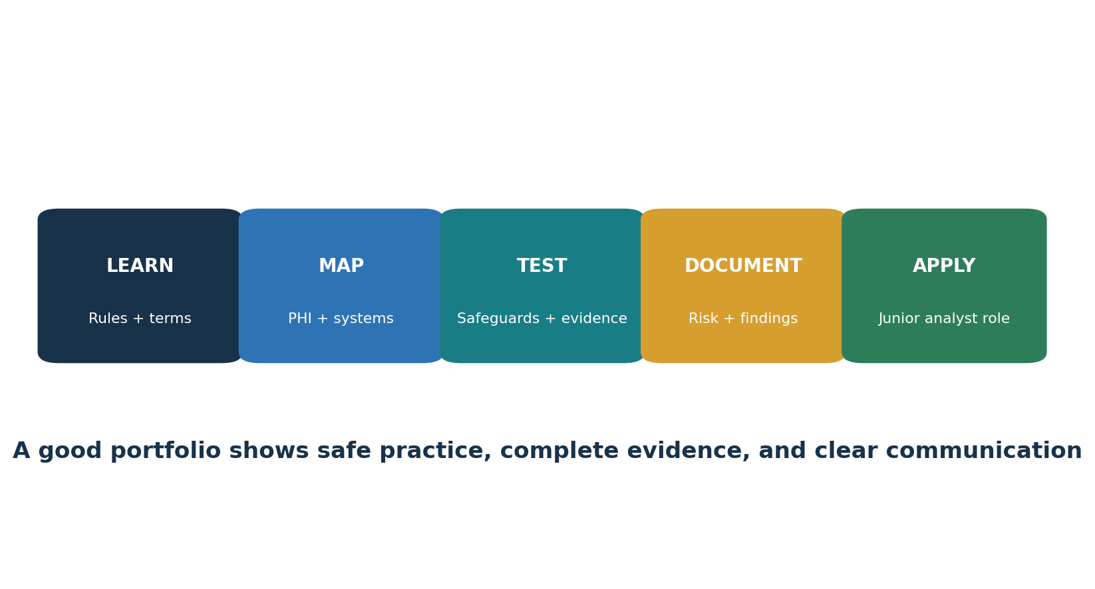
Figure 5. Junior HIPAA analyst pathway

14.1 Job titles
- Junior HIPAA Compliance Analyst
- Healthcare GRC Analyst
- Privacy Operations Analyst
- Information Security Compliance Analyst
- Third-Party Risk Analyst — Healthcare
- Health Information Privacy Analyst
- Security Risk Analyst
- HIPAA Program Coordinator

14.2 Typical junior work
- Update PHI, ePHI, system, device, and vendor inventories.
- Gather risk-analysis and safeguard evidence.
- Review access, termination, training, log, backup, and vulnerability samples.
- Track BAAs, due diligence, corrective actions, and expiry dates.
- Coordinate individual rights and disclosure records.
- Prepare incident timelines and breach-assessment facts.
- Write clear findings without making unsupported legal conclusions.
- Follow up on remediation and retain retest proof.

14.3 Portfolio proof
Skill | Fictional portfolio item
Scoping | Covered-entity and business-associate role memo
Data mapping | ePHI lifecycle, system inventory, and data-flow diagram
Risk | Risk analysis and treatment register
Security | Safeguard matrix with evidence samples
Privacy | Access-request and disclosure-accounting files
Incident response | Breach four-factor assessment and notification decision
Vendor risk | BAA checklist, due diligence, and corrective-action plan
Management communication | One-page dashboard and executive risk summary

Career honesty: A laboratory portfolio is training work, not professional experience. Label it as fictional, protect all information, and explain what required expert or legal review.

15. Open-Source Tools for HIPAA Work
Official links, safe quick starts, evidence, and limitations.
Methodology first: A tool can support a safeguard or evidence process. It cannot certify HIPAA compliance, replace risk analysis, or decide whether a disclosure or breach is lawful.

Tool | Purpose | Possible HIPAA support
CISO Assistant | GRC, risks, controls, evidence | Risk analysis, safeguard operation, evidence, or remediation
Wazuh | SIEM, endpoint monitoring, file integrity | Risk analysis, safeguard operation, evidence, or remediation
OpenSCAP | Linux configuration assessment | Risk analysis, safeguard operation, evidence, or remediation
Greenbone Community Edition | Vulnerability scanning | Risk analysis, safeguard operation, evidence, or remediation
osquery | Endpoint inventory and queries | Risk analysis, safeguard operation, evidence, or remediation
Trivy | Code, image, secret, and configuration scanning | Risk analysis, safeguard operation, evidence, or remediation
OWASP ZAP | Authorized web-application testing | Risk analysis, safeguard operation, evidence, or remediation
Keycloak | Identity, roles, authentication, MFA | Risk analysis, safeguard operation, evidence, or remediation
DefectDojo | Finding intake and remediation tracking | Risk analysis, safeguard operation, evidence, or remediation
Velociraptor | Endpoint visibility and incident response | Risk analysis, safeguard operation, evidence, or remediation
Open Policy Agent | Policy as code | Risk analysis, safeguard operation, evidence, or remediation

15.1 Tool-to-requirement verification matrix
Tool or resource | HIPAA support | Verification task | Output to retain | Important limitation
CISO Assistant | 164.308(a)(1), 164.316, vendor and evidence governance | Map ePHI risks to safeguards, owners, evidence, findings, and treatment | Risk register, control matrix, approvals, audit trail | Records what users enter; does not prove source evidence is complete or accurate
HHS/ONC SRA Tool | 164.308(a)(1)(ii)(A) risk analysis | Use structured questions to identify possible scope and control gaps | Completed assessment, supporting evidence, treatment actions | A starting aid; it does not guarantee an accurate and thorough enterprise risk analysis
osquery | 164.308(a)(1), 164.310(d), 164.312(a) and (d) | Query endpoint users, software, encryption, services, and device state | Query, host list, timestamps, full results, reviewer decision | Coverage depends on installed and reporting endpoints and operating-system tables
Keycloak | 164.308(a)(3)–(4), 164.312(a) and (d) | Test unique identity, roles, least privilege, MFA, emergency access, and removal | Configuration export, user and role population, test results, approvals | Only verifies systems using that identity platform; downstream authorization may differ
Wazuh | 164.308(a)(1)(ii)(D), 164.308(a)(6), 164.312(b) | Test log collection, alert generation, file integrity, review, investigation, and escalation | Agent inventory, rules, alert, review ticket, response and closure | An alert without documented human review and response does not prove the safeguard operates
OpenSCAP | 164.308(a)(8), 164.312(a), 164.312(c) | Compare approved Linux hosts with a selected security baseline and retest correction | Profile, content version, host scope, HTML/ARF report, exception, rescan | Baseline compliance is not the same as HIPAA compliance and may affect applications
Greenbone | 164.308(a)(1), 164.308(a)(8) | Measure authenticated vulnerability coverage, validate findings, track deadlines, and rescan | Target list, feed and scanner version, settings, report, tickets, rescan | Cannot find every weakness; scope, credentials, false positives, and fragile systems matter
Trivy | 164.308(a)(1), 164.312(c), software and cloud risk | Scan pinned code, images, dependencies, secrets, and infrastructure configuration | Target digest, database and tool version, settings, result, ticket, retest | Results can contain secrets and may miss runtime, business-logic, and deployment risks
OWASP ZAP | 164.308(a)(8), 164.312(c) and (e) | Passively review and, when authorized, actively test a laboratory or approved web application | Written scope, version, settings, findings, validation, correction, retest | Active scans can change data or interrupt care systems; automation is not a full penetration test
DefectDojo | 164.308(a)(1), 164.308(a)(6), corrective-action evidence | Import findings, deduplicate, assign, track risk decisions, retest, and close | Finding history, owner, due date, evidence, risk acceptance, verified closure | Workflow status does not prove a fix; closure must be supported by independent retest
Velociraptor | 164.308(a)(6), 164.312(b) | Collect approved endpoint artifacts during an isolated investigation and document chain of custody | Collection request, client scope, results, analyst notes, preservation record | Powerful collection can expose PHI or disrupt endpoints; use strict authorization and minimization
Open Policy Agent | 164.308(a)(1), 164.312(a) and (c) | Test policy-as-code rules for required ownership, classification, encryption, or deployment conditions | Policy version, tests, allowed and denied inputs, pipeline decision, approval | Rules only cover encoded conditions; bad logic or missing integration creates false confidence

15.2 How to validate a tool before relying on it
- Approve the purpose, owner, systems, ePHI boundaries, data collected, hosting, support access, and retention.
- Verify the official software source, version, dependencies, release integrity, update process, and secure configuration.
- Create a known test condition and confirm the tool detects or blocks it as expected.
- Create a known allowed condition and confirm the tool does not create an unnecessary failure.
- Compare the tool’s asset or agent population with an independent inventory and investigate missing coverage.
- Restrict administrative access, log changes, protect credentials, and test backup or recovery of the tool itself.
- Define human review, escalation, exception, correction, and retest procedures.
- Revalidate after major upgrades, configuration changes, new integrations, or material control failures.

15.3 Tool evidence package
- Written authorization and approved scope
- Architecture and data-flow note
- Tool, rule, feed, database, and content versions
- Configuration and service-account permissions
- Complete asset, agent, target, or repository population
- Raw and summarized results
- Reviewer identity, date, decision, and escalation
- Finding tickets, corrective action, risk acceptance, and due dates
- Retest and closure proof
- Known limitations and untested areas
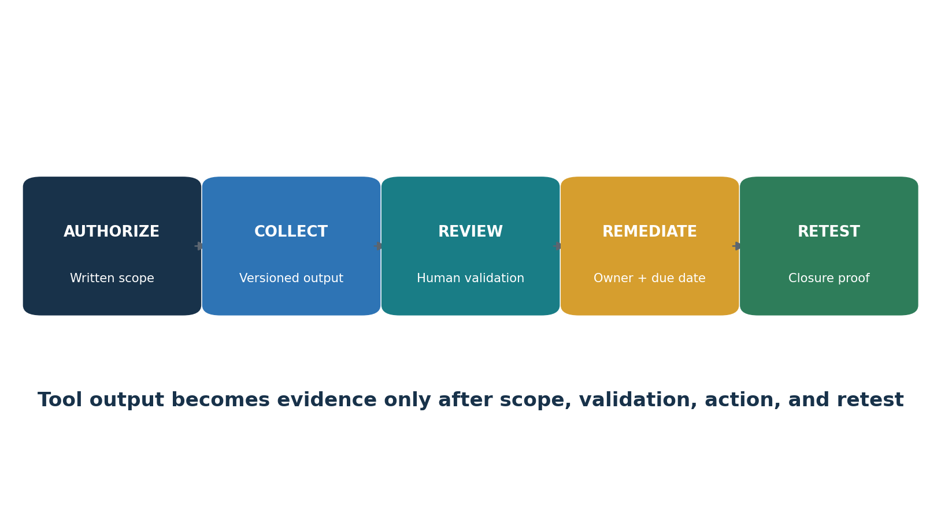
Figure 7. From tool output to compliance evidence

15.4 CISO Assistant
GRC, risks, controls, evidence.
Official documentation and setup: Open the official CISO Assistant guide

Quick start
Create a fictional healthcare organization, add one ePHI risk, map a Security Rule safeguard, assign an owner, and attach sanitized evidence.

Evidence to retain
Record approval, purpose, owner, scope, systems, data classification, tool and content version, configuration, complete result, reviewer, decision, corrective action, and retest. Protect reports containing ePHI, credentials, architecture, identities, or vulnerabilities.

15.5 Wazuh
SIEM, endpoint monitoring, file integrity.
Official documentation and setup: Open the official Wazuh guide

Quick start
Connect one lab endpoint, create a harmless event, review the alert, and save the event, reviewer decision, and follow-up.

Evidence to retain
Record approval, purpose, owner, scope, systems, data classification, tool and content version, configuration, complete result, reviewer, decision, corrective action, and retest. Protect reports containing ePHI, credentials, architecture, identities, or vulnerabilities.

15.6 OpenSCAP
Linux configuration assessment.
Official documentation and setup: Open the official OpenSCAP guide

Quick start
Assess a laboratory Linux host against a suitable profile, export the report, fix one approved setting, and compare results.

Evidence to retain
Record approval, purpose, owner, scope, systems, data classification, tool and content version, configuration, complete result, reviewer, decision, corrective action, and retest. Protect reports containing ePHI, credentials, architecture, identities, or vulnerabilities.

15.7 Greenbone Community Edition
Vulnerability scanning.
Official documentation and setup: Open the official Greenbone Community Edition guide

Quick start
Scan only an approved lab target, validate one finding, correct it, rescan, and record scope, version, result, and reviewer.

Evidence to retain
Record approval, purpose, owner, scope, systems, data classification, tool and content version, configuration, complete result, reviewer, decision, corrective action, and retest. Protect reports containing ePHI, credentials, architecture, identities, or vulnerabilities.

15.8 osquery
Endpoint inventory and queries.
Official documentation and setup: Open the official osquery guide

Quick start
Query users, software, encryption, or processes on a lab endpoint and record the query, host, date, result, and review.

Evidence to retain
Record approval, purpose, owner, scope, systems, data classification, tool and content version, configuration, complete result, reviewer, decision, corrective action, and retest. Protect reports containing ePHI, credentials, architecture, identities, or vulnerabilities.

15.9 Trivy
Code, image, secret, and configuration scanning.
Official documentation and setup: Open the official Trivy guide

Quick start
Scan a pinned laboratory image or test repository, protect the report, validate one finding, fix it, and scan again.

Evidence to retain
Record approval, purpose, owner, scope, systems, data classification, tool and content version, configuration, complete result, reviewer, decision, corrective action, and retest. Protect reports containing ePHI, credentials, architecture, identities, or vulnerabilities.

15.10 OWASP ZAP
Authorized web-application testing.
Official documentation and setup: Open the official OWASP ZAP guide

Quick start
Proxy a local training application, start with passive analysis, validate one result, and export the scope and report.

Evidence to retain
Record approval, purpose, owner, scope, systems, data classification, tool and content version, configuration, complete result, reviewer, decision, corrective action, and retest. Protect reports containing ePHI, credentials, architecture, identities, or vulnerabilities.

15.11 Keycloak
Identity, roles, authentication, MFA.
Official documentation and setup: Open the official Keycloak guide

Quick start
Create a lab realm, roles, users, and MFA; test least privilege and export configuration and review evidence.

Evidence to retain
Record approval, purpose, owner, scope, systems, data classification, tool and content version, configuration, complete result, reviewer, decision, corrective action, and retest. Protect reports containing ePHI, credentials, architecture, identities, or vulnerabilities.

15.12 DefectDojo
Finding intake and remediation tracking.
Official documentation and setup: Open the official DefectDojo guide

Quick start
Import a lab scan, validate and assign one finding, record correction, retest it, and close it with evidence.

Evidence to retain
Record approval, purpose, owner, scope, systems, data classification, tool and content version, configuration, complete result, reviewer, decision, corrective action, and retest. Protect reports containing ePHI, credentials, architecture, identities, or vulnerabilities.

15.13 Velociraptor
Endpoint visibility and incident response.
Official documentation and setup: Open the official Velociraptor guide

Quick start
Use an isolated lab client, collect one harmless approved artifact, review the result, and record purpose, scope, and access.

Evidence to retain
Record approval, purpose, owner, scope, systems, data classification, tool and content version, configuration, complete result, reviewer, decision, corrective action, and retest. Protect reports containing ePHI, credentials, architecture, identities, or vulnerabilities.

15.14 Open Policy Agent
Policy as code.
Official documentation and setup: Open the official Open Policy Agent guide

Quick start
Write a lab rule that denies an ePHI resource without an owner or classification label; test allowed and denied inputs.

Evidence to retain
Record approval, purpose, owner, scope, systems, data classification, tool and content version, configuration, complete result, reviewer, decision, corrective action, and retest. Protect reports containing ePHI, credentials, architecture, identities, or vulnerabilities.

15.15 Free government resource
HHS/ONC Security Risk Assessment Tool: Open the official SRA Tool page
This free government resource can help small and medium practices begin a structured risk assessment. It does not guarantee compliance and does not replace a complete, organization-specific risk analysis.

15.16 Tool governance checklist
- Use only fictional or properly de-identified data in training.
- Obtain written authorization before scanning, monitoring, collection, or testing.
- Approve owner, scope, hosting, access, data handling, retention, and support location.
- Verify software sources, releases, dependencies, signatures, and update procedures.
- Use least privilege and protect service credentials and reports.
- Define who validates results, fixes findings, approves exceptions, and retests.
- Do not upload PHI or ePHI to any external service without approved legal, privacy, security, contract, and data-flow review.

16. Fictional Healthcare Laboratory and Portfolio
A complete practice environment using only synthetic information.
Harbor Light Health is a fictional outpatient clinic and health plan administrator. It uses an EHR, billing system, cloud email, patient portal, medical devices, remote support, and several business associates. Every person, record, address, claim, diagnosis, and identifier in the laboratory is invented.

Project 1 — Scope and roles
Document covered-entity functions, business associates, hybrid boundaries, PHI, ePHI, systems, and data flows.

Project 2 — Risk analysis
Create a system inventory, threat and vulnerability register, risk method, findings, and treatment plan.

Project 3 — Security safeguards
Build a Security Rule matrix with owners, implementation choices, evidence, exceptions, and retests.

Project 4 — Privacy rights
Complete fictional access, amendment, confidential-communication, and accounting requests.

Project 5 — Breach
Assess a misdirected billing export using the four factors and prepare notification decisions.

Project 6 — Vendor
Review a fictional cloud BA, contract terms, subprocessors, security evidence, incident duties, and exit plan.

Project 7 — Tools
Use three Chapter 15 tools in an isolated lab and document scope, limitations, findings, correction, and retest.

16.1 Portfolio ethics
- Never publish real patient, member, employee, provider, or claim information.
- Label each file as fictional training work.
- Do not copy a company’s confidential risk analysis, BAA, incident, or architecture.
- Remove usernames, paths, hostnames, tokens, keys, IP addresses, and hidden metadata before publication.
- Explain assumptions and where legal, privacy, clinical, or security review is required.

17. Thirty-Day Learning Plan
A realistic month of official reading, practice, portfolio work, and interview preparation.
Week | Focus | Required output
Week 1 | Scope, roles, PHI/ePHI, Privacy Rule | Scope memo, data map, use/disclosure examples
Week 2 | Security Rule and risk analysis | Asset inventory, risk register, safeguard matrix
Week 3 | Rights, breach, vendors, Part 2 | Rights file, breach assessment, vendor review
Week 4 | Tools, portfolio, interview | Sanitized portfolio and practiced answers

17.1 Daily habit
- Read one current HHS, eCFR, or NIST section.
- Explain one requirement in your own words.
- Create one fictional evidence item.
- Review it for completeness, sensitivity, and dates.
- Add one correction or lesson to the portfolio.

18. Interview Preparation
Questions and short answers for analysts and managers.

Who must comply with HIPAA?
Covered entities, business associates, and certain related arrangements. Covered entities include health plans, clearinghouses, and qualifying providers that conduct covered electronic transactions.

What is PHI?
Individually identifiable health information held or transmitted by a covered entity or business associate, subject to regulatory exclusions.

PHI versus ePHI?
PHI may be electronic, paper, or oral. ePHI is PHI maintained or transmitted electronically and is the focus of the Security Rule.

What is minimum necessary?
When it applies, limit PHI use, disclosure, and requests to what is reasonably needed for the purpose.

What is a HIPAA risk analysis?
An accurate and thorough assessment of potential risks and vulnerabilities to the confidentiality, integrity, and availability of all ePHI held by the regulated entity.

Does addressable mean optional?
No. Assess the specification and implement it if reasonable and appropriate. Otherwise document the decision and use an equivalent alternative when reasonable and appropriate.

What is the breach standard?
An impermissible use or disclosure is presumed a breach unless a documented four-factor assessment shows a low probability that PHI was compromised or an exception applies.

How do business associates support compliance?
They follow BAAs and applicable HIPAA duties, protect ePHI, manage subcontractors, report incidents and breaches, support rights, and return or destroy PHI as required.

How do you prove a safeguard works?
Use complete, dated evidence connecting scope, risk, requirement, implementation, owner, review, exception, corrective action, and retest.

18.1 Manager’s 60-second answer
Interview response: I treat HIPAA as an operating program, not a policy binder. I define regulated roles and ePHI scope, perform ongoing risk analysis, implement administrative, physical, and technical safeguards, manage access and vendors, make privacy rights work, assess incidents promptly, and require reliable evidence. Management owns resources and risk decisions while privacy, legal, security, clinical, and compliance teams provide specialized review.

19. Templates and Checklists
Practical structures for an approved organizational system.

19.1 ePHI inventory fields
- System, application, device, interface, repository, media, or service
- Business and technical owner
- Covered entity or business associate role
- ePHI types, volume, people, purpose, and criticality
- Users, privileged access, and authentication
- Location, hosting, remote support, and data flow
- Encryption, logging, backup, recovery, retention, and disposal
- Vendor, BAA, subcontractors, and incident contact
- Last review, change trigger, and next review

19.2 Risk register fields
- Asset and ePHI scope
- Threat, vulnerability, and existing safeguard
- Likelihood and impact
- Risk rating and method
- Treatment, owner, resources, and date
- Residual risk and acceptance authority
- Exception expiry
- Validation and retest evidence

19.3 Breach fact sheet
Field | Required information
Discovery | Who discovered it, when, and when the entity became aware
Incident | What happened, systems, accounts, location, containment
PHI | Nature, sensitivity, identifiers, people, amount, likelihood of re-identification
Recipient | Who received or accessed it and their obligations
Acquisition | Whether PHI was actually acquired or viewed
Mitigation | Retrieval, deletion, assurances, account actions, monitoring
Decision | Exception or low-probability analysis, notices, approvers
Action | Correction, sanctions, training, testing, lessons

19.4 BAA checklist
- Roles and services correct
- Permitted and required use/disclosure defined
- Safeguards and Security Rule duties
- Incident and breach reporting timing and content
- Subcontractor flow-down
- Rights and accounting support
- HHS access
- Return/destruction and infeasibility handling
- Termination rights
- Contacts, locations, changes, and review cadence

19.5 Manager pre-audit checklist
- Scope and organizational roles approved
- Complete ePHI inventory and data-flow map
- Current accurate and thorough risk analysis
- Risk treatment with evidence and retests
- Safeguard implementation decisions documented
- Access, activity review, training, backup, and incident samples complete
- BAA population and monitoring complete
- Privacy rights and disclosure evidence complete
- Breach log and HHS reports reconciled
- Policies current and required documentation retained six years

20. Glossary
Plain-English definitions of important HIPAA and healthcare privacy terms.
Addressable implementation specification. A Security Rule specification that must be assessed and implemented when reasonable and appropriate, or replaced by a documented equivalent alternative when appropriate.
Authorization. A written permission meeting the Privacy Rule’s required elements and statements.
Breach. An impermissible acquisition, access, use, or disclosure that compromises PHI security or privacy, subject to the rule’s presumption, risk assessment, and exceptions.
Business associate. A person or organization performing certain functions or services involving PHI for a covered entity.
Covered entity. A health plan, health care clearinghouse, or qualifying health care provider under HIPAA.
Designated record set. Records maintained by or for a covered entity that determine or document specified health, claims, payment, or case-management information and support access rights.
ePHI. Protected health information maintained or transmitted electronically.
Health care operations. Defined operational activities such as quality, competency, underwriting limits, auditing, planning, and management functions.
HITECH Act. A federal law that expanded health-information technology, breach, business associate, and HIPAA enforcement provisions.
Minimum necessary. A requirement, when applicable, to limit PHI use, disclosure, and requests to what is reasonably needed.
Part 2. The federal confidentiality rules for records of federally assisted substance use disorder programs under 42 CFR Part 2.
PHI. Individually identifiable health information protected by HIPAA when held or transmitted by a covered entity or business associate, subject to exclusions.
Privacy Rule. The HIPAA standards for PHI use, disclosure, individual rights, and privacy administration.
Required implementation specification. A Security Rule implementation specification that must be implemented.
Risk analysis. An accurate and thorough assessment of risks and vulnerabilities to all ePHI.
Risk management. Security measures that reduce identified risks and vulnerabilities to a reasonable and appropriate level.
Security Rule. The HIPAA standards protecting ePHI through administrative, physical, and technical safeguards.
Treatment, payment, and health care operations. Core categories for permitted PHI use and disclosure under the rule.
Unsecured PHI. PHI not rendered unusable, unreadable, or indecipherable through technology or methodology specified by HHS.

21. Subject Index
An alphabetical guide to major topics. References point to sections so the index remains useful after editing.
Topic | Sections | Topic | Sections
Access right | 4, 12.2, 19 | Notice of privacy practices | 4, 10, 12.2
Addressable | 5.2, 20 | Open-source tools | 15
Administrative safeguards | 6, 12.1 | Part 2 | 10
Authorization | 3.3, 12.2 | PHI | 2.3, 20
Breach | 8, 12.3, 19.3 | Physical safeguards | 7, 12.1
Business associate | 2.2, 9, 19.4 | Privacy Rule | 3–4, 12.2
De-identification | 2.4, 3.5 | Reproductive health | 10.3
ePHI | 2.3, 5–7 | Risk analysis | 5.3, 6, 12.1
Enforcement | 11, 12.4 | Security incident | 6, 8
HIPAA Security Rule NPRM | 1.3, 11.4 | State law | 10.2, 11.3
Individual rights | 4 | Technical safeguards | 7, 12.1
Junior analyst | 14, 16–18 | Vendor oversight | 9, 13
Minimum necessary | 3.4, 12.2 | Workforce training | 6, 12.1

22. Official References and Further Study
Current government law, guidance, tools, and official project documentation used for verification.
- eCFR — 45 CFR Part 160
- eCFR — 45 CFR Part 164
- HHS — HIPAA for Professionals
- HHS — Privacy Rule
- HHS — Security Rule
- HHS — Breach Notification Rule
- HHS — Risk Analysis Guidance
- HHS — HIPAA Audit Protocol
- HHS — Business Associate Agreement Provisions
- HHS — 42 CFR Part 2
- HHS — Reproductive Health Rule Status
- HHS — Security Rule NPRM
- NIST SP 800-66 Rev. 2
- HealthIT.gov — Security Risk Assessment Tool
- CISO Assistant documentation
- Wazuh documentation
- OpenSCAP documentation
- Greenbone Community Edition documentation
- osquery documentation
- Trivy documentation
- OWASP ZAP documentation
- Keycloak documentation
- DefectDojo documentation
- Velociraptor documentation
- Open Policy Agent documentation
Final reminder: Regulations, court decisions, guidance, penalty amounts, technology, and facts change. Verify the current eCFR, HHS and NIST sources, state law, Part 2 status, and qualified legal advice before acting on a real matter.

