THIRD-PARTY RISK MANAGEMENT
AND CYBER SUPPLY CHAIN SECURITY
Practical Manager and Junior Analyst Manual

What this manual does: Explains how to identify, assess, contract with, monitor, respond to, and safely exit suppliers. It combines governance, practical testing, current NIST guidance, open-source tools, reusable templates, and career preparation.

Alberto (Al) Leiva
First Edition • July 2026

Preface
Organizations depend on cloud platforms, software, payment processors, consultants, data providers, managed services, artificial intelligence, and many other outsiders. The organization may outsource the work, but it does not outsource the business impact. A supplier failure can expose data, interrupt operations, weaken products, or create legal and customer obligations.
This manual teaches a repeatable life-cycle method. It is not a legal opinion, a guarantee, or a universal certification program. Requirements vary by contract, law, regulator, sector, customer, system, and country. Use qualified legal, privacy, procurement, security, and audit professionals when decisions require them.
Current-information note: The manual reflects official material checked on July 14, 2026, including NIST SP 1326 (final July 8, 2026), NIST SP 800-18 Rev. 2 (final June 30, 2026), NIST SP 800-161 Rev. 1 Update 1, NIST SP 1305, and NIST CSF 2.0.

How to use this manual
- Managers: begin with Chapters 2–4, 8–13, 19, and 25.
- Junior analysts: study in order, then complete Chapters 26–29 and the fictional lab.
- Procurement and legal teams: focus on intake, due diligence, contracts, onboarding, monitoring, incidents, and exit.
- Technical teams: focus on cloud, software supply chain, AI, open-source tools, evidence testing, and incident coordination.
- Use the templates as starting points; tailor criteria and approvals to your organization.

Table of Contents
This is a native Word table of contents. In Microsoft Word, click inside it, choose Update Table, and select Update entire table. Word will rebuild the entries and page numbers after editing.
Preface 2
How to use this manual 2
Table of Contents 3
Chapter Guide 6
1. TPRM and Cyber Supply Chain Foundations 7
1.1 What good TPRM produces 7
1.2 Important limits 7
2. The Third-Party Life Cycle 8
3. Governance, Strategy, and Risk Appetite 9
3.1 Program documents 9
4. Inventory, Classification, and Tiering 10
4.1 Inventory fields 10
4.2 Tiering factors 10
5. Intake and Inherent Risk 11
6. Due Diligence and Research 12
6.1 NIST SP 1326 assessment components 12
6.2 Research sources 12
7. Evidence Review and Trust 14
8. Risk Scoring and Treatment 15
8.1 A defensible method 15
9. Contract Requirements 16
10. Secure Onboarding 17
10.1 Acceptance evidence 17
11. Continuous Monitoring 18
11.1 Frequency 18
12. Findings, Remediation, and Exceptions 19
12.1 Exception discipline 19
13. Supplier Incidents and Notification 20
13.1 Prepare before an incident 20
14. Fourth Parties, Concentration, and Systemic Risk 21
14.1 What to map 21
14.2 Treat concentration 21
15. Cloud and SaaS Vendors 23
16. Software and Open-Source Supply Chains 24
16.1 Supplier and product checks 24
16.2 SBOM limits 24
17. Artificial Intelligence Vendors 25
18. Privacy and Data Protection 26
19. Resilience, Continuity, and Exit 27
19.1 Exit test 27
20. NIST CSF 2.0 Supplier Outcomes 28
21. NIST C-SCRM Guidance in Practice 29
21.1 Three-level thinking 29
22. Compliance and Framework Mappings 30
23. Evidence Testing and Metrics 31
23.1 Test method 31
24. Open-Source Tools 33
24.1 CISO Assistant 33
24.2 Dependency-Track 33
24.3 CycloneDX 34
24.4 Syft 34
24.5 Grype 34
24.6 Trivy 34
24.7 OpenSSF Scorecard 34
24.8 GUAC 35
24.9 OSV-Scanner 35
24.10 DefectDojo 35
24.11 Wazuh 35
24.12 Keycloak 35
24.13 OWASP ZAP 36
24.14 Greenbone Community Edition 36
24.15 Nmap 36
24.16 Open Policy Agent 36
25. Manager’s TPRM Playbook 37
25.1 Manager operating rhythm 37
26. Junior Analyst Career Guide 38
26.1 Common job titles 38
26.2 Typical junior work 38
27. Fictional Laboratory and Portfolio 40
28. Thirty-Day Learning Plan 41
29. Interview Preparation 42
29.1 What is TPRM? 42
29.2 TPRM versus C-SCRM? 42
29.3 Inherent versus residual risk? 42
29.4 How do you tier a supplier? 42
29.5 How do you review a SOC 2 report? 42
29.6 Questionnaire limitation? 42
29.7 What is an SBOM? 42
29.8 How do you close a finding? 42
29.9 What if a critical supplier refuses evidence? 42
29.10 What makes a good junior analyst? 43
29.11 Questions to ask the employer 43
30. Templates, Glossary, Index, and References 44
30.1 Supplier inventory record 44
30.2 Due-diligence workpaper 44
30.3 Assurance review 44
30.4 Finding and exception record 44
30.5 Contract and exit checklist 45
30.6 Glossary 45
30.7 Subject index 45
30.8 Official references 46

Chapter Guide

1. TPRM and Cyber Supply Chain Foundations
Third-party risk management (TPRM) controls risks posed by external organizations, products, people, and services.
A third party may host systems, process data, supply software, provide staff, run critical operations, or support customers. Cyber supply-chain risk management (C-SCRM) is broader: it considers how technology is designed, developed, manufactured, integrated, delivered, operated, maintained, and retired across many tiers.

1.1 What good TPRM produces
A complete, owned supplier inventory.
Risk-based assessment before commitment.
Security, privacy, resilience, audit, and incident terms in agreements.
Controlled access and data handling during service.
Monitoring that detects material changes and overdue risks.
Practiced incident coordination and an executable exit plan.

1.2 Important limits
Item | What it does not prove
Questionnaire | A supplier assertion is not independent proof.
SOC 2 report | It covers stated systems, criteria, period, testing, and limitations—not every risk.
ISO certificate | It applies only to the certified scope and current certificate details.
Security rating | External signals can be useful but may be incomplete, stale, or misattributed.
Contract | A promise does not show that a control operates.
Tool result | Automation supports testing; it does not make the business decision.

Core principle: Outsource the activity, not accountability. The business owner remains responsible for understanding and managing the impact.

2. The Third-Party Life Cycle
A life-cycle process prevents assessment from becoming a one-time questionnaire.
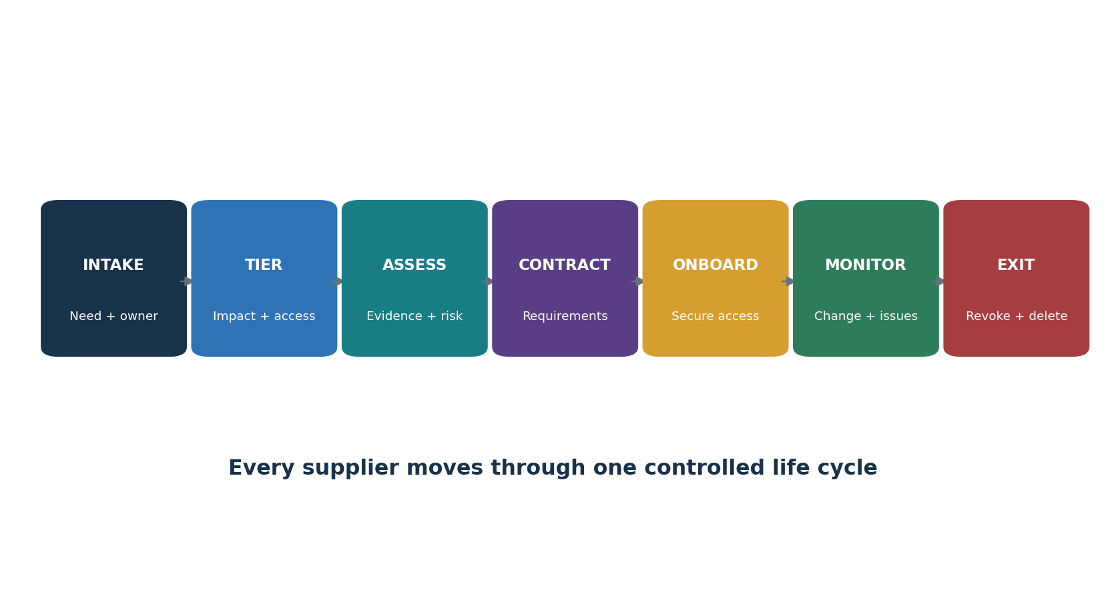
Figure 1. Third-party risk life cycle
Stage | Key decision | Minimum evidence
Intake | Is there a valid need and accountable owner? | Request, service description, owner, alternatives
Tier | How much harm could failure cause? | Data, access, dependency, availability, geography
Assess | Is residual risk acceptable? | Research, evidence, tests, findings, treatment
Contract | Are obligations enforceable? | Signed security/privacy/resilience terms
Onboard | Is access limited and approved? | Configuration, account, data-flow, acceptance records
Monitor | Has risk or performance changed? | Events, attestations, issues, metrics, reassessments
Exit | Are access, data, assets, and dependencies removed? | Revocation, deletion/return, transition, confirmation

3. Governance, Strategy, and Risk Appetite
Governance sets decision rights, risk boundaries, funding, and escalation.

3.1 Program documents
- TPRM/C-SCRM policy and standards.
- Risk appetite and mandatory rejection or escalation rules.
- Supplier classification and assessment method.
- Contract clause library and deviation approval.
- Monitoring, incident, exception, and exit procedures.
- Metrics, reporting, record retention, quality review, and program improvement.
Role | Accountability
Board/executive | Oversight, risk direction, resources, material-risk challenge
Business owner | Need, criticality, performance, residual-risk ownership, exit readiness
Procurement | Sourcing workflow, commercial terms, renewal, supplier record
Legal / privacy | Contract, legal basis, regulatory, data-transfer, notification advice
Security / TPRM | Method, due diligence, technical analysis, monitoring, findings
IT/engineering | Architecture, configuration, access, integration, testing, recovery
Internal audit | Independent evaluation of program design and operation
Supplier | Accurate information, contracted controls, notice, correction, cooperation

Manager decision: Define who may accept which level of residual risk. A risk owner must have authority, context, and accountability—not merely a convenient signature.

4. Inventory, Classification, and Tiering
Know every supplier and scale work to likely harm.
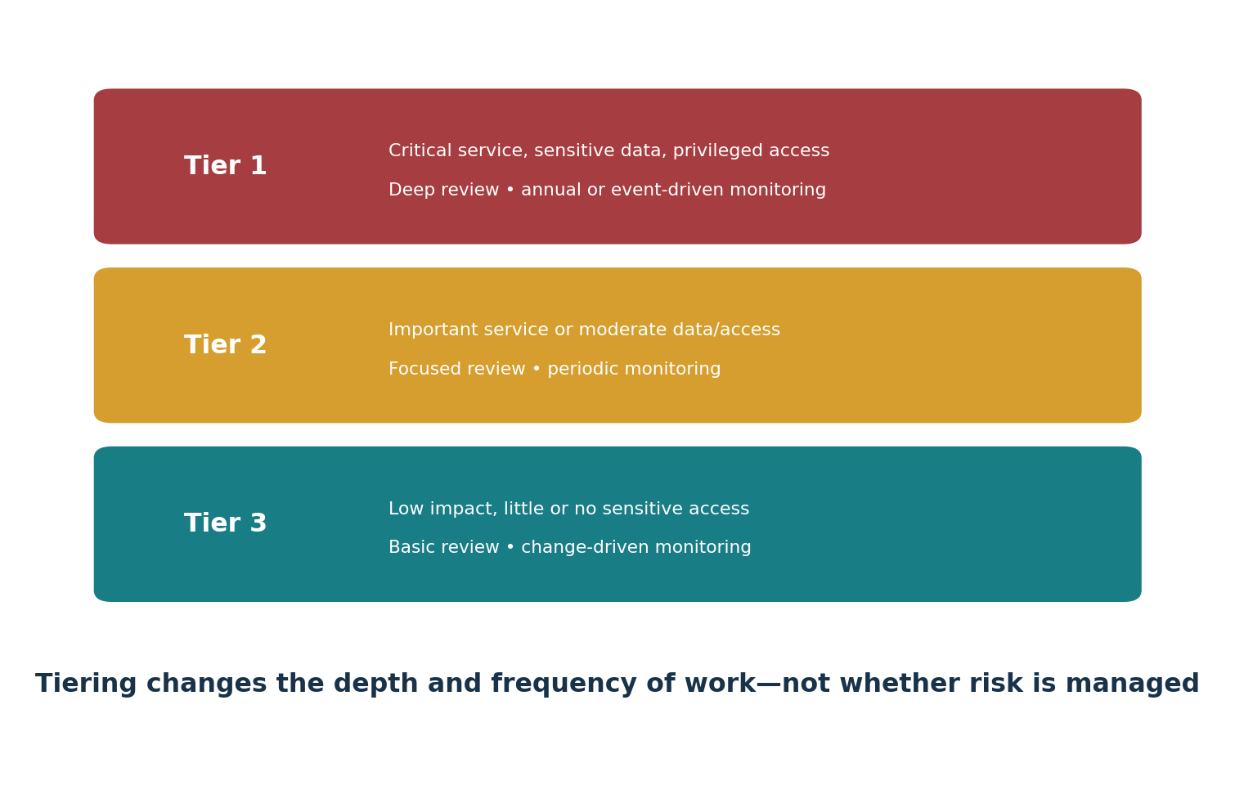
Figure 2. Example supplier tiers

4.1 Inventory fields
- Legal name, aliases, product/service, business owner, technical owner, and contract owner.
- Purpose, systems, integrations, accounts, privileges, data categories, data locations, and transfer paths.
- Critical processes, recovery needs, replacement difficulty, fourth parties, concentration, and geographic exposure.
- Tier, inherent risk, residual risk, assessment status, findings, exceptions, contract dates, renewal, and exit status.

4.2 Tiering factors
Factor | Example high-risk condition
Data | Sensitive personal, health, payment, secrets, or regulated information
Access | Privileged, production, remote, persistent, or broad API access
Availability | Failure stops a critical product, operation, or customer service
Change | Supplier can update code, firmware, models, rules, or infrastructure
Dependency | Few substitutes, difficult migration, proprietary format, long recovery
Reach | Supplier serves many critical systems, regions, customers, or subsidiaries
Downstream | Material subprocessor, cloud, identity, model, or software dependency

5. Intake and Inherent Risk
Intake captures the complete proposed use before commercial pressure makes review difficult.
- Describe the business purpose and why an external supplier is needed.
- Name accountable business, technical, privacy, security, procurement, and contract contacts.
- Map data collected, created, accessed, stored, transmitted, trained on, returned, and deleted.
- Describe connections, privileges, users, locations, fourth parties, and support access.
- Determine criticality, recovery expectations, alternatives, and exit difficulty.
- Identify laws, contracts, customer requirements, data residency, and sector obligations.
- Calculate inherent risk before considering supplier controls.
- Assign the required review path and stop unauthorized purchase or connection.
Inherent versus residual risk: Inherent risk is exposure before considering controls. Residual risk is what remains after verified controls, contract terms, design choices, and other treatment.

6. Due Diligence and Research
Due diligence gathers pertinent information so the organization can make an informed acquisition or continued-use decision.
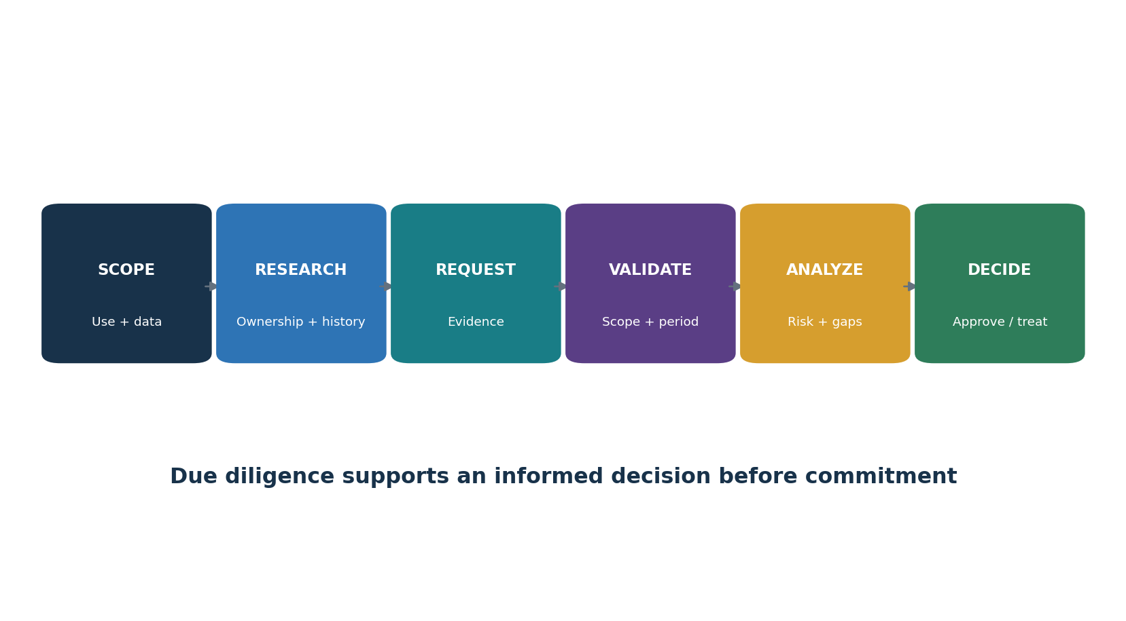
Figure 3. Due-diligence workflow

6.1 NIST SP 1326 assessment components
Component | Questions to investigate
Foreign ownership, control, or influence | Who owns or influences the supplier? What jurisdictions or legal pressures matter?
Provenance | Where did the product, code, components, hardware, and data originate? Can claims be traced?
Resilience | Can the supplier withstand, respond to, and recover from disruption?
Foundational cyber practices | Are basic governance, access, vulnerability, logging, development, response, and recovery practices present?
Supply-chain tiers | Which upstream and downstream organizations materially affect the product or service?

6.2 Research sources
- Supplier-provided organizational, technical, assurance, privacy, resilience, and product evidence.
- Official company, regulator, certification, court, sanctions, breach, vulnerability, and product-security sources were lawful and relevant.
- Independent audit or assessment reports and customer-managed technical tests.
- Architecture and data-flow interviews with people who operate the service—not only sales staff.
Fairness and accuracy: Verify identity, date, relevance, jurisdiction, and source quality. Give the supplier a reasonable opportunity to correct material factual errors. Follow law and policy for screening and personal information.

7. Evidence Review and Trust
Evidence is useful only when it matches the service, period, control, and risk being evaluated.
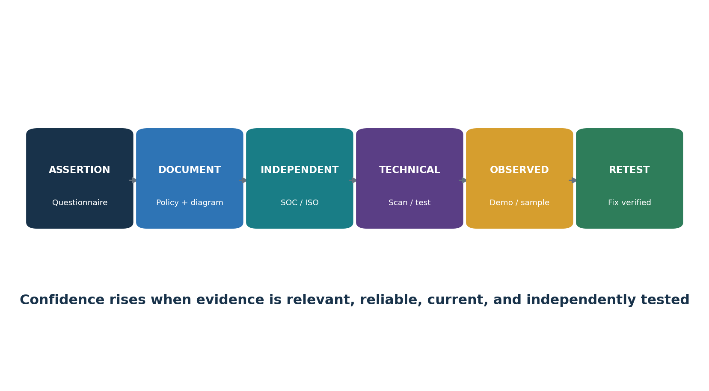
Figure 4. Evidence confidence ladder
Artifact | Review points | Common trap
SOC 2 Type 2 | Entity/system scope, criteria, period, opinion, tests, exceptions, CUECs, subservice organizations, subsequent events | Accepting the cover page or a report for another product
ISO/IEC 27001 certificate | Certified organization and locations, scope, ISO version, certificate body, accreditation, dates, status | Assuming certification covers every service and control
Penetration-test report | Tester independence/skill, scope, date, method, exclusions, severity, remediation, retest | Accepting an executive summary with unknown scope
Policy / standard | Approval, owner, version, scope, required action, exceptions | Treating written policy as operating proof
Questionnaire | Qualified respondent, precise answer, supporting evidence, unresolved gaps | Scoring every yes answer as verified
Architecture / data flow | Systems, trust boundaries, integrations, locations, encryption, administrators, fourth parties | Using an old sales diagram
BC/DR test | Scenario, scope, recovery objectives, observed results, failures, correction, retest | Accepting a plan without a test
Vulnerability evidence | Asset coverage, credentials, date, severity, remediation, exceptions, rescan | Counting scan output as risk treatment

8. Risk Scoring and Treatment
Risk scoring supports consistent decisions, but numbers must not hide uncertainty or severe single issues.

8.1 A defensible method
- Define likelihood and impact scales in plain language.
- Score by scenario: threat or failure, affected asset/process, weakness, and consequence.
- Separate inherent risk from control effectiveness and residual risk.
- Record evidence quality, uncertainty, assumptions, and missing information.
- Allow mandatory escalation for prohibited data use, privileged access, critical dependence, legal restrictions, or unresolved severe findings.
- Require approval at the correct authority level and record review/expiry.
Treatment | Example | Required record
Avoid | Choose another product or keep the activity internal | Decision and rationale
Reduce | Limit data, remove admin access, add MFA, fix vulnerabilities | Control, owner, date, test
Transfer/share | Insurance, indemnity, service credits, contractual allocation | Exact term and remaining risk
Accept | Authorized owner accepts defined residual risk for a period | Scope, reason, approver, expiry, monitoring
Contingency | Backup supplier, manual process, data export, tested recovery | Trigger, resources, test result

Scoring warning: Do not average away a catastrophic issue. Report severe scenarios, evidence gaps, and concentration separately from the overall score.

9. Contract Requirements
Contracts convert selected requirements into enforceable responsibilities.
Clause area | Questions for the agreement
Security program | Which framework, controls, policies, testing, training, and assurance evidence are required?
Data use | What data may be used, where, for what purpose, for how long, and for model training?
Access | How are least privilege, MFA, logging, support access, and termination handled?
Vulnerability | What scanning, disclosure, patch, severity, remediation, and notice rules apply?
Incident | What event triggers notice, how quickly, through which channel, with what updates and cooperation?
Subprocessors | Is approval or notice required? Do equivalent duties flow down? Is a current list available?
Audit / evidence | What reports, certifications, records, testing rights, and remediation proof may be requested?
Resilience | What availability, recovery, backup, testing, crisis communication, and continuity duties apply?
Change | Which ownership, hosting, location, feature, AI model, or control changes require notice or approval?
Exit | How are access, data, keys, assets, logs, transition support, retention, and deletion handled?
Liability | How do limitations, indemnity, insurance, remedies, and regulatory cooperation align with risk?

Legal review: Clause language and enforceability depend on law, jurisdiction, bargaining position, facts, and the entire agreement. Use qualified legal counsel.

10. Secure Onboarding
Onboarding turns promises into safe technical and operational settings.
- Confirm approval, signed terms, residual-risk decision, owners, and open preconditions.
- Verify architecture, data flow, environments, locations, subprocessors, and support model.
- Create named accounts; use SSO/MFA where appropriate; apply least privilege, approval, expiry, and logging.
- Secure API keys, secrets, certificates, agents, integrations, network paths, and administrative channels.
- Configure retention, deletion, sharing, training use, backups, export, alerts, and customer options.
- Test security, privacy, availability, support, incident contacts, and recovery/export requirements.
- Record the accepted configuration baseline and add the supplier to monitoring, incident, renewal, and exit schedules.

10.1 Acceptance evidence
- Approved onboarding checklist and unresolved exceptions.
- Access list, roles, MFA/SSO, privileged path, expiry, and test results.
- Production data-flow and architecture record.
- Configuration export or screenshots with date, reviewer, and sensitive values protected.
- Monitoring, incident contact, backup/export, and exit readiness test.

11. Continuous Monitoring
Monitoring detects meaningful changes and verifies that treatment continues to work.
Signal | Possible action
New critical vulnerability or exploitation | Confirm affected product/version, exposure, mitigation, patch, and retest
Incident, outage, or control failure | Invoke notification and coordination process; reassess risk
SOC/ISO/pen-test change | Review scope, exceptions, opinion/status, correction, and applicability
New subprocessor, owner, location, or model provider | Assess change, contract rights, data path, and concentration
Financial or operational distress | Review continuity, escrow/export, alternatives, and exit trigger
Repeated SLA or finding failure | Escalate corrective action and residual-risk decision
Renewal or material feature change | Reassess before commitment; update contract and architecture
No evidence or stale contact | Escalate according to tier and contract; do not silently mark complete

11.1 Frequency
- Use tier- and trigger-based events, not a single universal annual schedule.
- Critical suppliers may need continuous signals, regular service review, annual assurance, exercises, and event-driven reassessment.
- Lower-tier suppliers still need ownership, control over contracts/renewals, incident routing, and change-driven review.

12. Findings, Remediation, and Exceptions
A finding is a documented gap between criteria and observed condition.
Finding element | Content
Criteria | Exact requirement, contract term, policy, or approved standard
Condition | What evidence showed, including affected population and date
Risk | Credible scenario and business impact
Cause | Why the gap occurred; avoid unsupported guesses
Action | Specific correction or compensating control
Owner / due date | Accountable person and risk-based deadline
Interim protection | Short-term measure while full correction is pending
Retest | Method, evidence, result, reviewer, and closure date

12.1 Exception discipline
Define scope, reason, affected assets/data/processes, risk, and alternatives.
Require authorized acceptance and an expiry date.
Add conditions, compensating controls, monitoring, and triggers for earlier review.
Track renewal separately from remediation; an exception is not permanent compliance.
Close only when evidence proves correction or the affected relationship ends.

13. Supplier Incidents and Notification
Supplier incidents require shared facts, roles, clocks, channels, and recovery decisions.
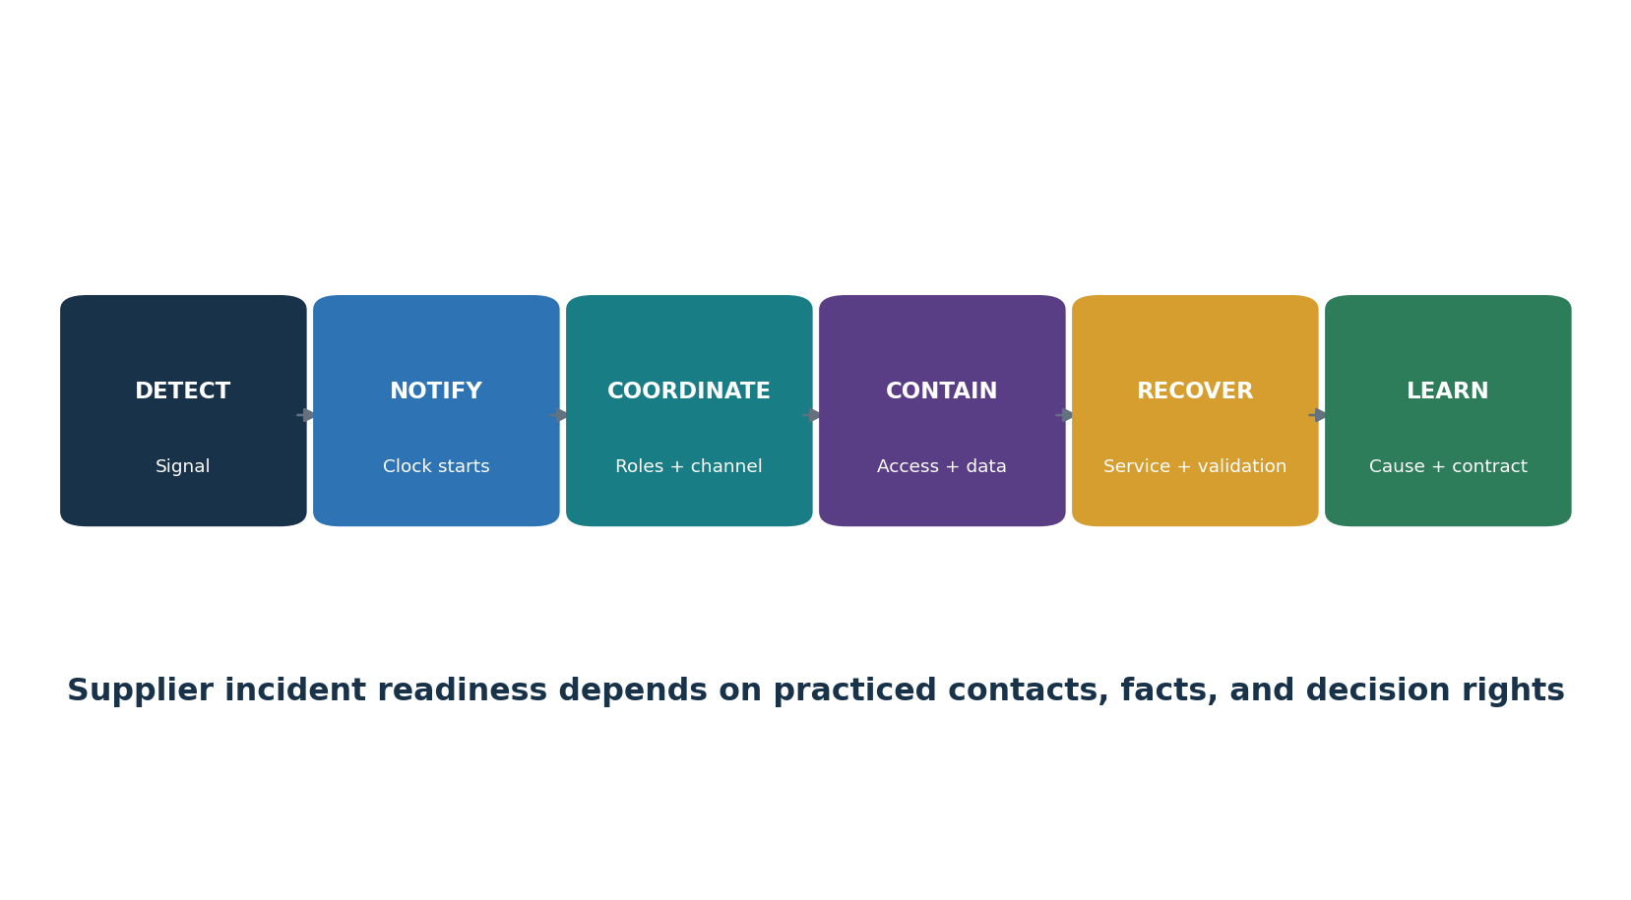
Figure 5. Supplier incident coordination

13.1 Prepare before an incident
- Define reportable events and notification time, method, recipients, required facts, update frequency, and escalation.
- Map supplier access, data, integrations, assets, fourth parties, and business dependencies.
- Preapprove safe communication channels and alternate contacts.
- Clarify evidence preservation, forensic access, regulator/customer support, public statements, containment, recovery, and cost responsibilities.
- Exercise realistic supplier outage, breach, software compromise, identity compromise, and data-deletion scenarios.
First questions | Why they matter
What happened and when? | Establish timeline and notification obligations
Which product, tenant, region, version, accounts, data, and subprocessors? | Determine scope
Is the event contained? What remains active? | Guide protection decisions
What evidence supports the current conclusion? | Separate fact from assumption
What customer actions are required? | Coordinate keys, access, patches, configurations, and communication
When is the next update? | Maintain a reliable operating rhythm

14. Fourth Parties, Concentration, and Systemic Risk
Fourth-party and concentration risk can turn many separate supplier records into one shared failure.
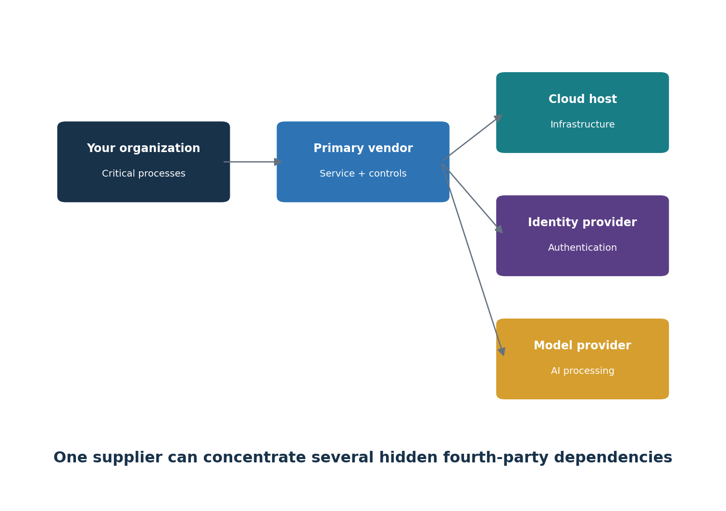
Figure 6. Hidden fourth-party concentration

14.1 What to map
- Cloud regions, identity services, DNS/CDN, payment rails, telecommunications, certificate authorities, code repositories, package registries, model providers, data providers, and managed operations.
- Common owners, geographies, facilities, technologies, software components, and support channels.
- Supplier dependencies that cannot be replaced within required recovery time.
- Contractual visibility, flow-down controls, incident notice, evidence rights, and exit support for material fourth parties.

14.2 Treat concentration
- Use diverse architecture only when it reduces correlated failure and can be operated safely.
- Build tested manual workarounds, data exports, alternate identity/recovery paths, and replacement plans.
- Set exposure limits and executive escalation for unavoidable concentration.
- Exercise simultaneous disruption across multiple suppliers.

15. Cloud and SaaS Vendors
Cloud and SaaS risk depends on the shared-responsibility model and the organization’s configuration.
Area | Verify
Tenant security | SSO, MFA, roles, admin accounts, sessions, support access, logging
Data | Categories, tenancy, encryption, keys, regions, replicas, backups, retention, deletion
Integration | APIs, tokens, webhooks, agents, networks, secrets, scopes, rate limits
Assurance | Exact cloud service and locations within report/certificate scope
Operations | Vulnerability, change, monitoring, incident, capacity, availability, recovery
Customer duties | Configuration, identities, endpoints, data classification, logs, backups, response
Exit | Export format, completeness, timing, cost, dependencies, secure deletion, continuity

Shared responsibility: A secure provider does not automatically create a secure tenant. Test the customer’s configuration, access, integrations, data choices, and monitoring.

16. Software and Open-Source Supply Chains
Software risk includes supplier practices and every component, build step, update channel, and dependency.
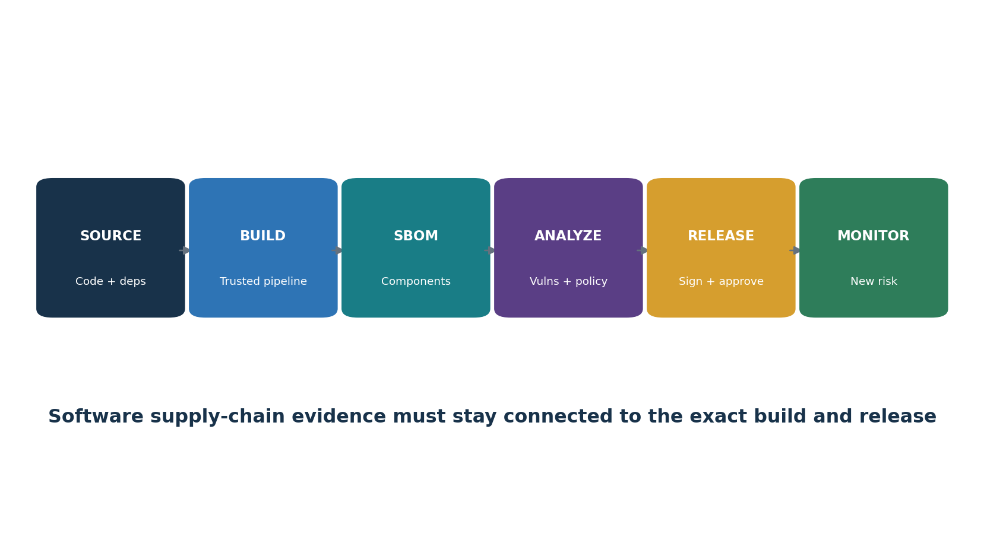
Figure 7. Software supply-chain evidence flow

16.1 Supplier and product checks
- Secure development governance, threat modeling, code review, testing, build isolation, secrets, access, provenance, signing, release approval, and change control.
- Vulnerability disclosure channel, coordinated disclosure, severity method, patch targets, supported versions, end-of-life notice, and customer advisories.
- SBOM format, version, completeness, direct/transitive components, licenses, hashes, and relationship to the shipped artifact.
- Update authenticity, rollback, telemetry, remote administration, default settings, and safe failure.
- Open-source maintenance, contributor trust, ownership transfer, release process, dependency pinning, and abandoned-component plan.

16.2 SBOM limits
- An SBOM is an inventory, not proof that software is safe.
- A vulnerability match requires applicability and exposure analysis.
- An SBOM may omit runtime, service, firmware, build, or dynamically loaded dependencies.
- Protect SBOMs when they reveal sensitive architecture; keep them current for every material release.

17. Artificial Intelligence Vendors
AI suppliers add changing models, training and prompt data, uncertain outputs, and hidden provider chains.
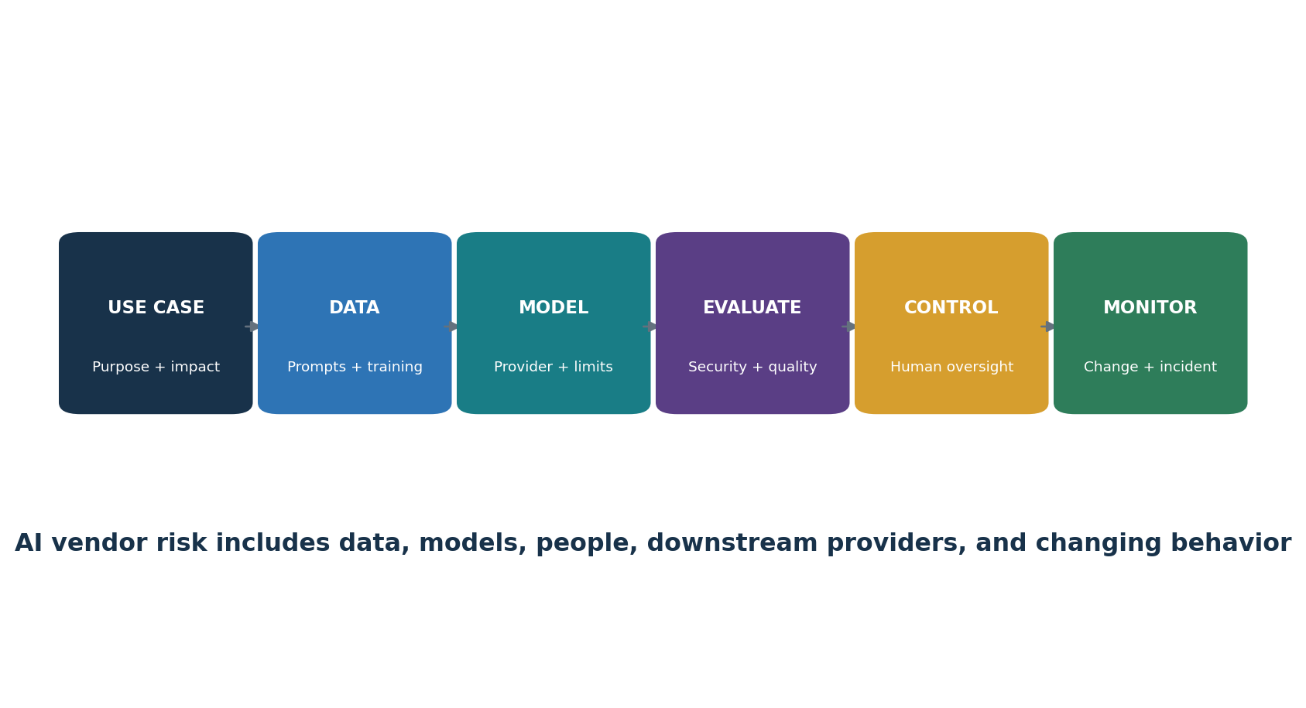
Figure 8. AI vendor risk workflow
Area | Questions
Use case / impact | What decision or task is supported? Who can be harmed? Is human review meaningful?
Data | Are prompts, uploads, outputs, feedback, and logs retained, shared, or used for training?
Model chain | Which model, hosting, plugins, agents, data sources, and subprocessors are involved?
Security | How are tenant isolation, access, secrets, tool permissions, prompt injection, abuse, and monitoring handled?
Privacy / IP | What legal basis, ownership, licensing, deletion, location, transfer, and rights apply?
Quality | How are accuracy, bias, robustness, explainability, drift, and unsafe output evaluated for this use?
Change | What model, policy, feature, provider, or training changes trigger notice and reevaluation?
Incident | How are harmful output, leakage, model compromise, abuse, outage, and evidence handled?
Exit | Can prompts, files, indexes, fine-tunes, logs, and derived data be exported or deleted?

18. Privacy and Data Protection
Privacy review follows the data through the entire supplier chain.
- Identify people, data categories, sensitivity, source, purpose, legal basis, and prohibited uses.
- Minimize fields, records, users, locations, retention, and access before transfer.
- Map controller/processor or equivalent roles and every material subprocessor.
- Evaluate notices, consent or other lawful basis, individual rights, government requests, and cross-border transfer requirements.
- Require security, confidentiality, breach cooperation, audit/evidence, return/deletion, and flow-down terms.
- Test access, export, correction, deletion, retention, backup behavior, and tenant configuration.
- Reassess when purpose, data, model training, location, subprocessor, ownership, or feature changes.
Data minimization: The safest sensitive data is often the data a supplier never receives. Reduce collection and access before relying on complicated controls.

19. Resilience, Continuity, and Exit
Resilience means delivering critical outcomes despite supplier disruption and leaving safely when necessary.
Capability | Evidence to test
Business impact | Critical service, maximum tolerable disruption, RTO/RPO, dependencies
Backup/recovery | Scope, isolation, restore test, observed time, data loss, failures, retest
Continuity | People, facilities, technology, communications, manual workarounds, exercises
Capacity/availability | Architecture, regions, limits, monitoring, incidents, SLA performance
Exit plan | Triggers, decision rights, alternative, data export, access removal, migration sequence
Deletion | Production, backup, logs, devices, derived data, AI artifacts, subprocessors, evidence
Post-termination | Retention, legal hold, confidentiality, vulnerability/incident notice, support

19.1 Exit test
- Export a representative data set and confirm completeness, format, metadata, permissions, and usable restoration.
- Inventory every supplier account, key, certificate, agent, route, device, license, integration, and data copy.
- Estimate migration time and business interruption from observed tests—not sales claims.
- Document who confirms return/deletion and how exceptions such as legal hold or backup retention are controlled.

20. NIST CSF 2.0 Supplier Outcomes
NIST CSF 2.0 places supply-chain governance in the GV.SC Category.
Outcome | Plain meaning | Example evidence
GV.SC-01 | A C-SCRM program, strategy, objectives, policies, and processes are established and agreed to by organizational stakeholders. | Approved program and stakeholder record
GV.SC-02 | Cybersecurity roles and responsibilities for suppliers, customers, and partners are established, communicated, and coordinated. | RACI, contacts, agreements, exercises
GV.SC-03 | C-SCRM is integrated into enterprise risk management, cybersecurity risk assessment, and improvement processes. | ERM linkage, risk register, lessons and improvements
GV.SC-04 | Suppliers are known and prioritized by criticality. | Complete supplier inventory and criticality method
GV.SC-05 | Supply-chain cybersecurity requirements are established, prioritized, and included in contracts and agreements. | Requirements library, signed terms, deviations
GV.SC-06 | Planning and due diligence are performed before entering formal supplier relationships. | Intake, research, evidence, analysis, approval
GV.SC-07 | Supplier risks are understood, recorded, prioritized, assessed, treated, and monitored throughout the relationship. | Risk records, monitoring, findings, treatment
GV.SC-08 | Relevant suppliers are included in incident planning, response, and recovery. | Plans, contacts, tabletops, incident records
GV.SC-09 | Supply-chain security practices are integrated and monitored throughout the technology product and service life cycle. | Lifecycle requirements, product/service evidence
GV.SC-10 | Cybersecurity supply chain plans include activities that occur after a partnership or service agreement ends. | Exit plan, access/data removal, post-termination duties

Using GV.SC: Define a Current Profile from observed outcomes and a Target Profile from business needs. Prioritize gaps, owners, resources, and dates; do not treat a mapping as automatic implementation.

21. NIST C-SCRM Guidance in Practice
Current NIST publications provide complementary guidance on program, assessment, and planning.
Publication | Current role
NIST SP 800-161 Rev. 1 Update 1 | Integrates C-SCRM into organization-wide risk management at enterprise, mission/business, and system levels; includes strategy, policy, plans, assessments, and controls.
NIST SP 1305 | Uses NIST CSF 2.0 GV.SC to establish and operate C-SCRM and communicate supplier requirements.
NIST SP 1326 (final July 8, 2026) | Quick-start considerations for ICT supplier due diligence assessments: FOCI, provenance, resilience, foundational cyber practices, and supply chain tiers.
NIST SP 800-18 Rev. 2 (final June 30, 2026) | Defines essential elements for system security, privacy, and C-SCRM plans, including purpose, control status, responsibilities, and expected behavior.

21.1 Three-level thinking
Level | Focus | Example
Enterprise | Strategy, risk appetite, common policy, resources, oversight | Supplier concentration limits and program metrics
Mission / business process | Critical services and dependencies | Payment operations or patient scheduling
System | Specific product, service, architecture, controls, and plan | Customer platform using a cloud and identity provider

Plan versus proof: A C-SCRM plan explains intended and implemented arrangements. Assessors still need reliable evidence that the relevant controls operate.

22. Compliance and Framework Mappings
Mappings coordinate work, but each obligation must be interpreted and tested on its own terms.
Framework / obligation | Supplier-risk connection | Caution
SOC 2 | Vendor management, risks, commitments, system boundaries, subservice organizations, CUECs | Review exact report scope, period, criteria, opinion, tests, exceptions
ISO/IEC 27001:2022 | Interested parties, supplier relationships, ICT supply chain, cloud use, monitoring and change | Certification scope and control applicability vary
PCI DSS v4.0.1 | Third-party service providers, responsibilities, agreements, monitoring, incident support | Validate the entity’s own scope and responsibilities
HIPAA | Business associates, agreements, safeguards, incidents, subcontractors | Legal status and duties depend on facts and law
GDPR | Processors, contracts, subprocessors, security, transfers, assistance, deletion/audit | Roles, jurisdiction, lawful basis, and transfer mechanism require legal analysis
CIS Controls v8.1 | Control 15 service-provider inventory, policy, classification, contracts, assessment, monitoring, decommissioning | Safeguards are a prioritized baseline, not universal legal compliance
NIST CSF 2.0 | GV.SC plus organization-wide Govern, Identify, Protect, Detect, Respond, Recover outcomes | Profiles are tailored; CSF is not a certification

23. Evidence Testing and Metrics
Testing asks whether controls are properly designed, implemented, and operating for the complete scope.
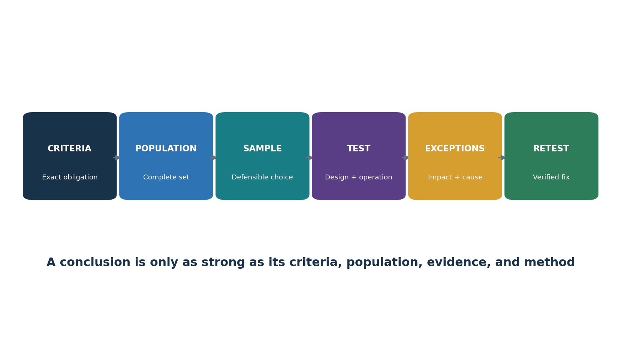
Figure 9. Evidence-testing chain

23.1 Test method
Define exact criteria, objective, period, systems, suppliers, data, locations, and exclusions.
Identify the complete population and validate its completeness and accuracy using independent sources where possible.
Choose full-population testing or a defensible sample; record selection and limitations.
Inspect, observe, inquire, and reperformance as appropriate. Inquiry alone is usually weak.
Record evidence source, date, owner, version, reviewer, and protected location.
Describe exceptions precisely and evaluate frequency, severity, pattern, impact, cause, and compensating controls.
Track correction and perform an independent retest before closure.
Metric | Example calculation | What it can reveal
Inventory ownership | Suppliers with valid owner ÷ active suppliers | Orphaned relationships
Assessment coverage | In-scope suppliers with current completed assessment ÷ in-scope suppliers | Program backlog
Contract coverage | High-tier suppliers with required clauses ÷ high-tier suppliers | Unenforceable expectations
Critical finding age | Days from finding date to closure or today | Remediation delay
Incident notice performance | Events notified within contracted time ÷ reportable events | Coordination reliability
Exit readiness | Critical suppliers with tested export/exit plan ÷ critical suppliers | Lock-in and recovery exposure
Concentration | Critical services dependent on same provider/region/technology | Correlated failure

Metric quality: Always show numerator, denominator, as-of date, inclusion rules, data owner, limitations, trend, and action. A green percentage can hide one severe exception.

24. Open-Source Tools
Open-source tools can support inventory, evidence, software assurance, technical testing, monitoring, and remediation.
Tool | Purpose
CISO Assistant | Risk, controls, assessments, evidence, and findings
Dependency-Track | SBOM analysis and component-risk monitoring
CycloneDX | Software bill of materials standard and tools
Syft | SBOM generation for images and filesystems
Grype | Vulnerability scanning for images and SBOMs
Trivy | Repository, image, dependency, secret, and IaC checks
OpenSSF Scorecard | Signals about open-source project security practices
GUAC | Graphing software supply-chain metadata
OSV-Scanner | Known-vulnerability checks for dependencies
DefectDojo | Finding intake, deduplication, remediation, and retest
Wazuh | Endpoint monitoring, file integrity, log analysis, and alerts
Keycloak | Identity, roles, MFA, sessions, and events
OWASP ZAP | Authorized web application testing
Greenbone Community Edition | Authorized vulnerability assessment
Nmap | Authorized service and asset discovery
Open Policy Agent | Policy-as-code decisions

Authorization and limits: Use tools only on systems, repositories, networks, data, and accounts you own or have written permission to test. Protect results. A tool supports evidence; it does not certify a supplier or replace legal, business, and human judgment.

24.1 CISO Assistant
Purpose: Risk, controls, assessments, evidence, and findings. Official project: CISO Assistant
Safe quick start: Create a scoped project, define risk criteria, assign owners, attach reviewed evidence, record findings, and restrict access.
Evidence to retain: approval and scope, tool/version, configuration or command, date, target population, raw result, analyst validation, limitation, finding, action, and retest. Limit access because results may expose sensitive architecture or weaknesses.

24.2 Dependency-Track
Purpose: SBOM analysis and component-risk monitoring. Official project: Dependency-Track
Safe quick start: Import a CycloneDX SBOM from a lab project, confirm components, review vulnerability and policy alerts, assign action, and import a fresh SBOM after correction.
Evidence to retain: approval and scope, tool/version, configuration or command, date, target population, raw result, analyst validation, limitation, finding, action, and retest. Limit access because results may expose sensitive architecture or weaknesses.

24.3 CycloneDX
Purpose: Software bill of materials standard and tools. Official project: CycloneDX
Safe quick start: Use an official generator for the project language, create an SBOM, validate it, protect sensitive metadata, and provide it to approved analysis tools.
Evidence to retain: approval and scope, tool/version, configuration or command, date, target population, raw result, analyst validation, limitation, finding, action, and retest. Limit access because results may expose sensitive architecture or weaknesses.

24.4 Syft
Purpose: SBOM generation for images and filesystems. Official project: Syft
Safe quick start: Run against an authorized lab image, export CycloneDX JSON, review package coverage, record the version and command, and store the result safely.
Evidence to retain: approval and scope, tool/version, configuration or command, date, target population, raw result, analyst validation, limitation, finding, action, and retest. Limit access because results may expose sensitive architecture or weaknesses.

24.5 Grype
Purpose: Vulnerability scanning for images and SBOMs. Official project: Grype
Safe quick start: Scan the lab image or its SBOM, validate important results, identify fixed versions, remediate, and rescan.
Evidence to retain: approval and scope, tool/version, configuration or command, date, target population, raw result, analyst validation, limitation, finding, action, and retest. Limit access because results may expose sensitive architecture or weaknesses.

24.6 Trivy
Purpose: Repository, image, dependency, secret, and IaC checks. Official project: Trivy
Safe quick start: Scan only approved repositories or images, review scope and false positives, correct findings, document exceptions, and rescan in CI.
Evidence to retain: approval and scope, tool/version, configuration or command, date, target population, raw result, analyst validation, limitation, finding, action, and retest. Limit access because results may expose sensitive architecture or weaknesses.

24.7 OpenSSF Scorecard
Purpose: Signals about open-source project security practices. Official project: OpenSSF Scorecard
Safe quick start: Review a public project or an authorized repository, understand each check, verify important signals manually, and do not treat the score as proof of safety.
Evidence to retain: approval and scope, tool/version, configuration or command, date, target population, raw result, analyst validation, limitation, finding, action, and retest. Limit access because results may expose sensitive architecture or weaknesses.

24.8 GUAC
Purpose: Graphing software supply-chain metadata. Official project: GUAC
Safe quick start: Load the approved SBOM and vulnerability metadata in a lab, query component relationships, verify provenance, and protect the graph, as it may reveal the architecture.
Evidence to retain: approval and scope, tool/version, configuration or command, date, target population, raw result, analyst validation, limitation, finding, action, and retest. Limit access because results may expose sensitive architecture or weaknesses.

24.9 OSV-Scanner
Purpose: Known-vulnerability checks for dependencies. Official project: OSV-Scanner
Safe quick start: Scan an authorized lockfile, repository, image, or SBOM; validate applicability; upgrade or mitigate; and preserve before-and-after results.
Evidence to retain: approval and scope, tool/version, configuration or command, date, target population, raw result, analyst validation, limitation, finding, action, and retest. Limit access because results may expose sensitive architecture or weaknesses.

24.10 DefectDojo
Purpose: Finding intake, deduplication, remediation, and retest. Official project: DefectDojo
Safe quick start: Create a test engagement, import safe results, validate deduplication, assign owners and due dates, attach proof, and close only after retest.
Evidence to retain: approval and scope, tool/version, configuration or command, date, target population, raw result, analyst validation, limitation, finding, action, and retest. Limit access because results may expose sensitive architecture or weaknesses.

24.11 Wazuh
Purpose: Endpoint monitoring, file integrity, log analysis, and alerts. Official project: Wazuh
Safe quick start: Enroll a lab endpoint, produce a harmless test event, confirm collection and alerting, investigate, and retain coverage and response evidence.
Evidence to retain: approval and scope, tool/version, configuration or command, date, target population, raw result, analyst validation, limitation, finding, action, and retest. Limit access because results may expose sensitive architecture or weaknesses.

24.12 Keycloak
Purpose: Identity, roles, MFA, sessions, and events. Official project: Keycloak
Safe quick start: Create a lab realm, configure roles and MFA, test joiner-mover-leaver cases and vendor access expiry, then review events.
Evidence to retain: approval and scope, tool/version, configuration or command, date, target population, raw result, analyst validation, limitation, finding, action, and retest. Limit access because results may expose sensitive architecture or weaknesses.

24.13 OWASP ZAP
Purpose: Authorized web application testing. Official project: OWASP ZAP
Safe quick start: Use a training application, proxy traffic, crawl passively, use active scanning only with written approval, validate findings, fix, and retest.
Evidence to retain: approval and scope, tool/version, configuration or command, date, target population, raw result, analyst validation, limitation, finding, action, and retest. Limit access because results may expose sensitive architecture or weaknesses.

24.14 Greenbone Community Edition
Purpose: Authorized vulnerability assessment. Official project: Greenbone Community Edition
Safe quick start: Update feeds, define approved lab targets, use safe credentials, review coverage, validate findings, correct, and rescan.
Evidence to retain: approval and scope, tool/version, configuration or command, date, target population, raw result, analyst validation, limitation, finding, action, and retest. Limit access because results may expose sensitive architecture or weaknesses.

24.15 Nmap
Purpose: Authorized service and asset discovery. Official project: Nmap
Safe quick start: Scan only written-authorized ranges with limited options, compare results with inventory, investigate unknown services, and preserve scope and command evidence.
Evidence to retain: approval and scope, tool/version, configuration or command, date, target population, raw result, analyst validation, limitation, finding, action, and retest. Limit access because results may expose sensitive architecture or weaknesses.

24.16 Open Policy Agent
Purpose: Policy-as-code decisions. Official project: Open Policy Agent
Safe quick start: Write a small lab policy for an approved supplier attribute, test allow and deny cases, peer-review changes, log decisions, and keep human exception approval.
Evidence to retain: approval and scope, tool/version, configuration or command, date, target population, raw result, analyst validation, limitation, finding, action, and retest. Limit access because results may expose sensitive architecture or weaknesses.

25. Manager’s TPRM Playbook
Managers make the program real by setting priorities, resolving conflict, funding treatment, and challenging evidence.
Dashboard area | Manager question | Escalate when
Inventory | Do we know every active supplier, owner, service, data path, and dependency? | Unknown critical service or orphaned owner
Assessment | Are high-risk decisions completed before commitment? | Purchase, access, or data transfer bypassed review
Evidence | Does assurance cover the exact service and period? | Material gap, exception, weak scope, or stale report
Contracts | Are material requirements signed and deviations approved? | Critical clause absent or unenforceable
Findings | Who owns severe and overdue issues? | Severe risk lacks interim protection or decision
Incidents | Can we contact and coordinate with critical suppliers now? | Contacts, clocks, or roles untested
Concentration | Where could one event disrupt several critical services? | Unavoidable concentration lacks contingency
Exit | Can we retrieve data and replace the service in time? | No tested export, alternative, or deletion path

25.1 Manager operating rhythm
Monthly: review critical changes, severe findings, incidents, bypasses, overdue work, and concentration.
Quarterly: challenge high-tier coverage, treatment progress, contract gaps, monitoring quality, and exit readiness.
At least annually: review strategy, appetite, tiering, methods, resources, major dependencies, exercises, metrics, and program improvement.
At renewal or material change: reassess before new commitment, not after signature.
Questions that matter: What can fail? Who is affected? What evidence supports the conclusion? What remains uncertain? Who must act by when? How will we know the fix worked?

26. Junior Analyst Career Guide
Junior analysts create value by producing accurate inventories, evidence reviews, findings, and follow-through.
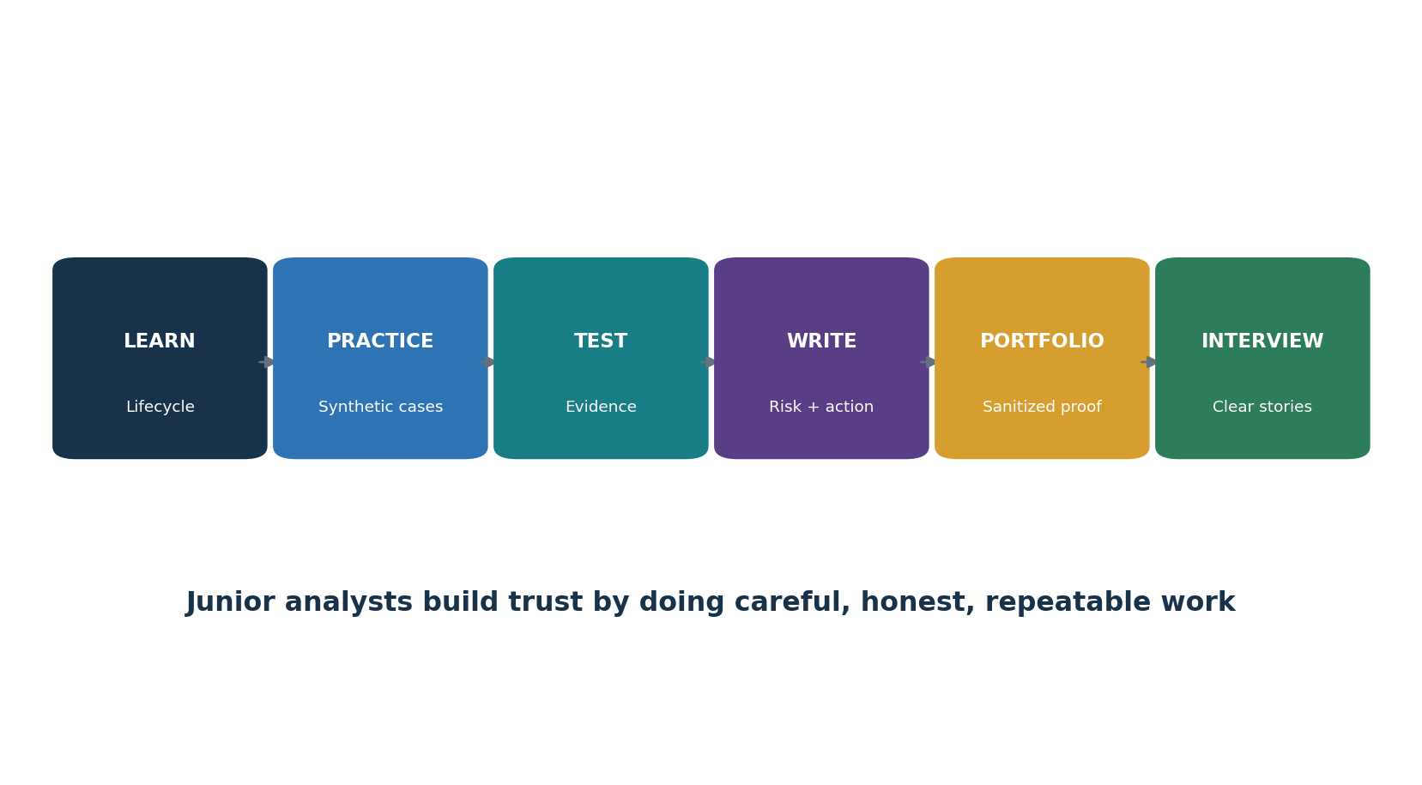
Figure 10. Junior TPRM analyst pathway

26.1 Common job titles
Third-Party Risk Analyst
Vendor Risk Analyst
Cyber Supply Chain Analyst
GRC Analyst
Security Assurance Analyst
IT Risk or Compliance Analyst
Supplier Security Analyst
Software Supply Chain Analyst

26.2 Typical junior work
Review intake forms and reconcile supplier inventories.
Classify suppliers using approved criteria and escalate unclear high-risk facts.
Request, track, and organize evidence without altering source records.
Read SOC 2 reports, certificates, policies, diagrams, test summaries, and resilience evidence.
Write criteria-condition-risk-action findings and track correction through retest.
Maintain contract requirement, subprocessor, incident contact, reassessment, renewal, and exit records.
Use authorized tools in labs or approved environments and explain limitations.
Prepare clear manager summaries without claiming certainty beyond the evidence.
Skill | Portfolio proof
Lifecycle | Supplier record from intake through exit
Evidence | Annotated SOC 2/ISO/pen-test review checklist using synthetic facts
Risk | Three scenario-based assessments with uncertainty
Technical literacy | SBOM and vulnerability analysis from a training project
Writing | Finding, manager summary, contract gap, and retest memo
Data | Dashboard with defined populations and calculations
Ethics | Written authorization, synthetic data, redaction, and honest limitations

27. Fictional Laboratory and Portfolio
Build a safe portfolio with a fictional company, synthetic suppliers, and isolated technical labs.
Lab rule: Never scan or test public targets, employers, suppliers, or accounts without written authorization. Use synthetic data and intentionally vulnerable training systems. Do not publish secrets or sensitive results.

- Create a fictional 75-person company with customer data, cloud services, remote staff, a payment function, and an AI pilot.
- Create ten fictional suppliers and a complete inventory with owners, data, access, dependencies, contract dates, and tiers.
- Write intake and inherent-risk records for a cloud CRM, managed IT provider, payroll service, software library, and AI assistant.
- Create synthetic SOC 2, ISO certificate, pen-test summary, policy, data flow, and recovery-test facts; document scope and gaps.
- Write three due-diligence assessments using the five NIST SP 1326 components.
- Build a risk register, treatment plans, exception, contract checklist, onboarding checklist, and monitoring calendar.
- Generate an SBOM for an authorized training project with Syft or CycloneDX; analyze it with Grype, Trivy, OSV-Scanner, or Dependency-Track.
- Create a fourth-party concentration map and a cloud shared-responsibility matrix.
- Run a supplier breach tabletop and a supplier outage/exit exercise.
- Publish sanitized workpapers, a dashboard, and a one-page manager report clearly labeled fictional and educational.
Artifact | What it demonstrates
Supplier inventory and tiering | Population management and prioritization
Due-diligence memo | Research, evidence quality, and reasoned decision
Assurance review | Scope, period, exceptions, CUECs, and limitations
Risk register / finding | Scenario, criteria, action, owner, and retest
Contract checklist | Translation of risk into enforceable requirements
SBOM lab | Software component and vulnerability literacy
Incident tabletop | Roles, facts, communication, and improvement
Exit test | Resilience, portability, revocation, and deletion
Manager dashboard | Clear metrics, severe issues, uncertainty, and action

28. Thirty-Day Learning Plan
A focused month can build useful entry-level capability.
Days | Focus | Deliverable
1–3 | TPRM/C-SCRM terms, lifecycle, roles | Concept map and lifecycle record
4–6 | Inventory, criticality, tiering, inherent risk | Ten-supplier inventory and tier memo
7–10 | Due diligence and NIST SP 1326 | Three research-based assessments
11–13 | SOC 2, ISO, pen test, policy, diagrams | Evidence review workpapers
14–16 | Risk, findings, treatment, exceptions | Risk register and two findings
17–19 | Contracts, onboarding, monitoring | Clause and onboarding checklists
20–22 | Incidents, resilience, exit | Tabletop and exit test
23–25 | Cloud, software supply chain, AI | Three focused assessments
26–27 | Open-source tool lab | SBOM, scan, correction, rescan
28–30 | Metrics, portfolio, interview | Dashboard, manager memo, five STAR stories

29. Interview Preparation
Interview answers should be short, accurate, and tied to examples.

29.1 What is TPRM?
A life-cycle process for identifying, assessing, contracting for, monitoring, responding to, and exiting risks from outside organizations, products, people, and services.

29.2 TPRM versus C-SCRM?
TPRM manages outside relationships broadly. C-SCRM focuses on cybersecurity risk across the full technology supply chain and product or service life cycle.

29.3 Inherent versus residual risk?
Inherent risk exists before controls. Residual risk remains after verified controls and treatment.

29.4 How do you tier a supplier?
Use documented impact factors such as data, privilege, availability, change authority, substitutability, reach, geography, and downstream dependencies.

29.5 How do you review a SOC 2 report?
Check the exact entity and system, criteria, period, opinion, tests, exceptions, CUECs, subservice organizations, and subsequent events; then map it to the actual use.

29.6 Questionnaire limitation?
It is a supplier assertion. I validate important answers with relevant, current, reliable evidence and record gaps.

29.7 What is an SBOM?
A structured inventory of software components and relationships. It improves visibility but does not prove security or vulnerability applicability.

29.8 How do you close a finding?
Retest the corrected control using defined criteria and reliable evidence; do not close only because the supplier says it is fixed.

29.9 What if a critical supplier refuses evidence?
Record the gap, use available independent evidence, consider design and contract options, assess uncertainty and risk, and escalate to the authorized decision maker.

29.10 What makes a good junior analyst?
Careful scope, complete records, evidence skepticism, clear writing, respectful follow-up, secure handling, and honest conclusions.

29.11 Questions to ask the employer
Which suppliers and risks are most important to the program?
How are inventories reconciled with procurement, finance, identity, network, and application records?
What evidence and contract standards are used by tier?
How are severe findings, exceptions, incidents, and renewals escalated?
Which tools are approved, and how is analyst work reviewed?
What would success look like in the first 90 days?

30. Templates, Glossary, Index, and References
Reusable structures, key terms, a subject index, and official starting points.

30.1 Supplier inventory record
Field | Entry
Legal name / service | ________________________________________
Business and technical owners | ________________________________________
Purpose and critical processes | ________________________________________
Data / locations / transfers | ________________________________________
Access / integrations / privileges | ________________________________________
Fourth parties / concentration | ________________________________________
Tier / inherent / residual risk | ________________________________________
Contract / renewal / notice dates | ________________________________________
Assessment / findings / exceptions | ________________________________________
Monitoring / incident / exit status | ________________________________________

30.2 Due-diligence workpaper
Field | Entry
Decision and scope | ________________________________________
Sources / dates / reliability | ________________________________________
FOCI | ________________________________________
Provenance | ________________________________________
Resilience | ________________________________________
Foundational cyber practices | ________________________________________
Supply-chain tiers | ________________________________________
Evidence gaps / uncertainty | ________________________________________
Risk scenarios / treatment | ________________________________________
Conclusion / approver / expiry | ________________________________________

30.3 Assurance review
Field | Entry
Artifact / issuer / date | ________________________________________
Entity / system / location scope | ________________________________________
Criteria / standard / period | ________________________________________
Opinion or status | ________________________________________
Tests / exceptions / findings | ________________________________________
CUECs / customer duties | ________________________________________
Subservice organizations | ________________________________________
Subsequent events / changes | ________________________________________
Applicability to our use | ________________________________________
Gaps / action / retest | ________________________________________

30.4 Finding and exception record
Field | Entry
Criteria | ________________________________________
Condition / population / evidence | ________________________________________
Risk scenario / impact | ________________________________________
Cause / uncertainty | ________________________________________
Action / interim protection | ________________________________________
Owner / due date | ________________________________________
Exception approver / expiry | ________________________________________
Monitoring / trigger | ________________________________________
Retest method / evidence | ________________________________________
Closure result / date | ________________________________________

30.5 Contract and exit checklist
Security, privacy, confidentiality, access, logging, vulnerability, development, data use, AI training, location, subprocessor, assurance, audit, incident, resilience, change, insurance/liability, termination, transition, return, deletion, and post-termination duties reviewed.
Every material deviation has a documented risk decision and owner.
Exit inventory covers data, accounts, keys, certificates, agents, routes, devices, integrations, subprocessors, backups, logs, AI artifacts, legal holds, and deletion proof.

30.6 Glossary
Term | Meaning
Attestation | A statement or report that provides assurance about specified subject matter.
C-SCRM | Cybersecurity supply chain risk management.
Concentration risk | Exposure created when several critical services depend on the same provider, place, technology, or resource.
CUEC | Complementary user entity control: a control the customer is expected to perform for report objectives to be achieved.
Due diligence | Investigative research of pertinent supplier or product information for an informed decision.
First party | The organization managing its own risk.
FOCI | Foreign ownership, control, or influence.
Fourth party | A supplier or dependency used by the organization’s third party.
Inherent risk | Risk before considering controls or treatment.
Provenance | Traceable origin and history of a product, component, code, data, or process.
Residual risk | Risk remaining after treatment.
Risk appetite | Amount and type of risk an organization is willing to pursue or retain.
SBOM | Software bill of materials: a structured component inventory.
Subprocessor | A party engaged by a processor to process personal data.
Third party | An outside organization, product, service, or person that supports the organization.
TPRM | Third-party risk management across the relationship life cycle.

30.7 Subject index
Subject | Chapter
AI vendors | 17
Cloud / SaaS | 15
Concentration | 14, 25
Contracts | 9, 30
Due diligence | 6, 21, 30
Evidence | 7, 23
Exit | 19, 30
Fourth parties | 14
Incidents | 13
Inventory / tiering | 4
Junior analyst | 26–29
Metrics | 23, 25
NIST CSF GV.SC | 20
NIST SP 1326 | 6, 21
Open-source tools | 24
Privacy | 18
Risk scoring | 8
SBOM / software | 16, 24
SOC 2 / ISO evidence | 7
Supplier monitoring | 11

30.8 Official references
NIST SP 1326 — Due Diligence Assessment Quick-Start Guide
NIST SP 800-18 Rev. 2 — System Security, Privacy, and C-SCRM Plans
NIST SP 800-161 Rev. 1 Update 1 — C-SCRM Practices
NIST SP 1305 — CSF 2.0 C-SCRM Quick-Start Guide
NIST Cybersecurity Framework 2.0
NIST C-SCRM Publications
CISA ICT Supply Chain Resource Library
CISA ICT SCRM Task Force
CISA Vendor SCRM Questionnaire Template
CISA ICT SCRM Resources for Small and Medium Businesses
OWASP Software Component Verification Standard
OpenSSF Best Practices
Final reminder: Frameworks, guidance, laws, contracts, suppliers, threats, tools, products, and official interpretations change. Confirm the current official source and applicable obligations before a real decision or assessment.

