Manual 11 - GDPR Privacy and Data Protection Controlled Implementation
CONTROLLED PUBLICATION QA CANDIDATE
Controlled source revision: 30410f7ba0ed3aa51b4d2ffd581fa51b05f90a28 | Language: en | GDPR legal/privacy human-decision boundaries retained.
Legal and assurance boundary: This manual operationalizes GDPR privacy and data-protection practices but does not provide organization-specific legal advice, determine applicability or roles, establish lawful-basis sufficiency, decide DPIA adequacy or breach notification, validate international transfers, or guarantee GDPR compliance. Material legal/privacy decisions require competent human judgment.

Implementation paths

Manual 11 — GDPR Implementation Paths
These paths scale implementation depth without changing the underlying legal obligations. Applicability and legal interpretation remain organization-specific and require competent human judgment.

Path A — Essential
Designed for smaller or less complex organizations that process personal data in a comparatively bounded environment.
Minimum operating package:
- processing inventory and accountable owners;
- applicability and role analysis;
- documented lawful-basis decisions;
- privacy notices and rights-request workflow;
- processor register and core contractual controls;
- retention/deletion rules;
- security-of-processing baseline;
- breach assessment/escalation workflow;
- DPIA screening and escalation criteria;
- international-transfer inventory and review;
- evidence register and periodic management review.

Path B — Structured
Designed for organizations with multiple systems, business units, suppliers, jurisdictions, data types, or higher processing complexity.
Add:
- formal privacy governance committee or equivalent;
- structured records of processing activities (ROPA);
- data-flow maps and system-to-purpose mappings;
- lawful-basis and legitimate-interest decision records;
- special-category and children-data controls where applicable;
- privacy-by-design gates in product/project lifecycle;
- DPIA methodology, review board, and remediation tracking;
- rights-request metrics and quality review;
- processor/subprocessor due diligence and monitoring;
- transfer mechanism and transfer-risk governance;
- breach tabletop exercises and decision logs;
- privacy control testing and internal audit readiness;
- training by role and risk.

Path C — Enhanced
Designed for large, complex, highly regulated, multinational, data-intensive, AI-enabled, or high-risk environments.
Add:
- enterprise privacy architecture and control framework;
- integrated privacy/security/data/AI governance;
- automated ROPA/data-discovery support with human validation;
- advanced data lineage and provenance;
- formal model for privacy risk and residual-risk acceptance;
- high-risk processing portfolio governance;
- independent DPIA challenge for material processing;
- algorithmic/automated-decision governance;
- AI/web-scraping/anonymisation/pseudonymisation specialist review;
- continuous processor and transfer monitoring;
- regulatory-response playbooks;
- evidence automation with provenance controls;
- privacy metrics tied to outcomes, not activity counts alone;
- independent assurance and executive reporting;
- crosswalks to ISO/IEC 27701, NIST Privacy Framework, ISO/IEC 27001, sector regulations, and organizational policies where useful.

Seven-gate operating lifecycle
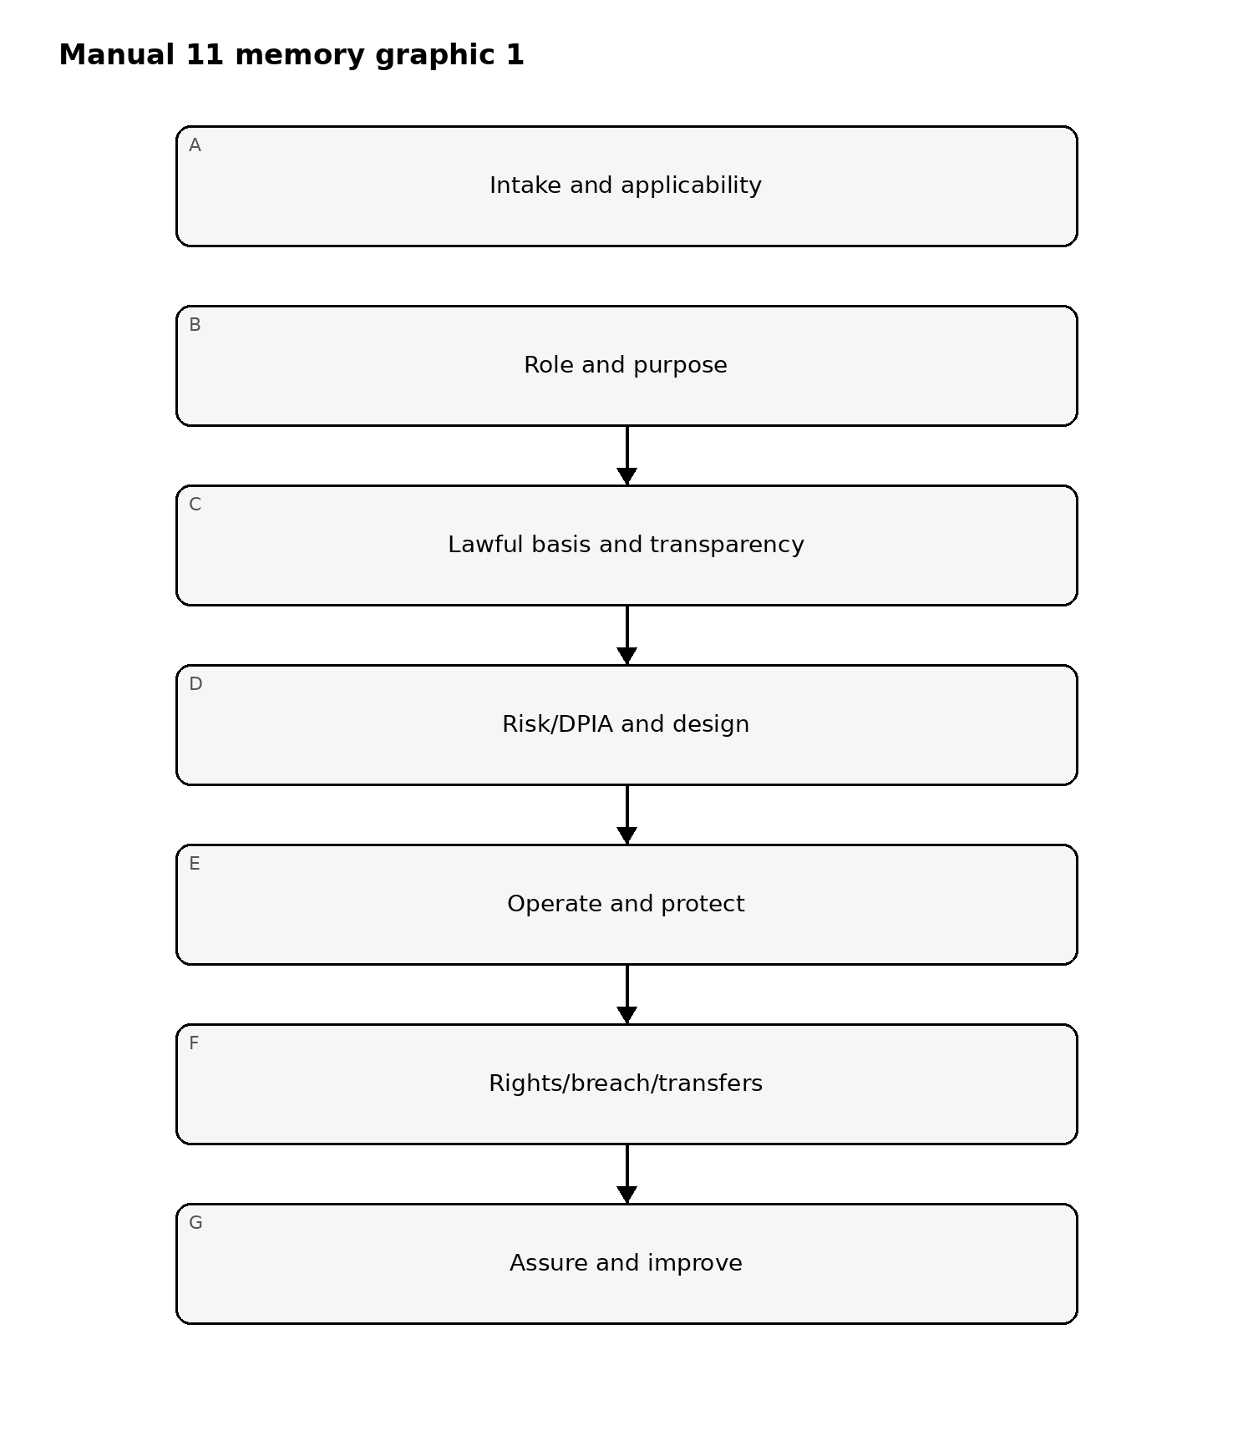
Figure 1. GDPR implementation memory graphic
Accessible explanation: GDPR implementation moves from applicability and role analysis through purpose/lawful-basis/transparency, privacy risk and design, operational controls, rights/breach/transfer handling, and finally assurance and improvement. A material defect at an earlier gate should be corrected before relying on later-stage evidence.

Accountability and evidence loop
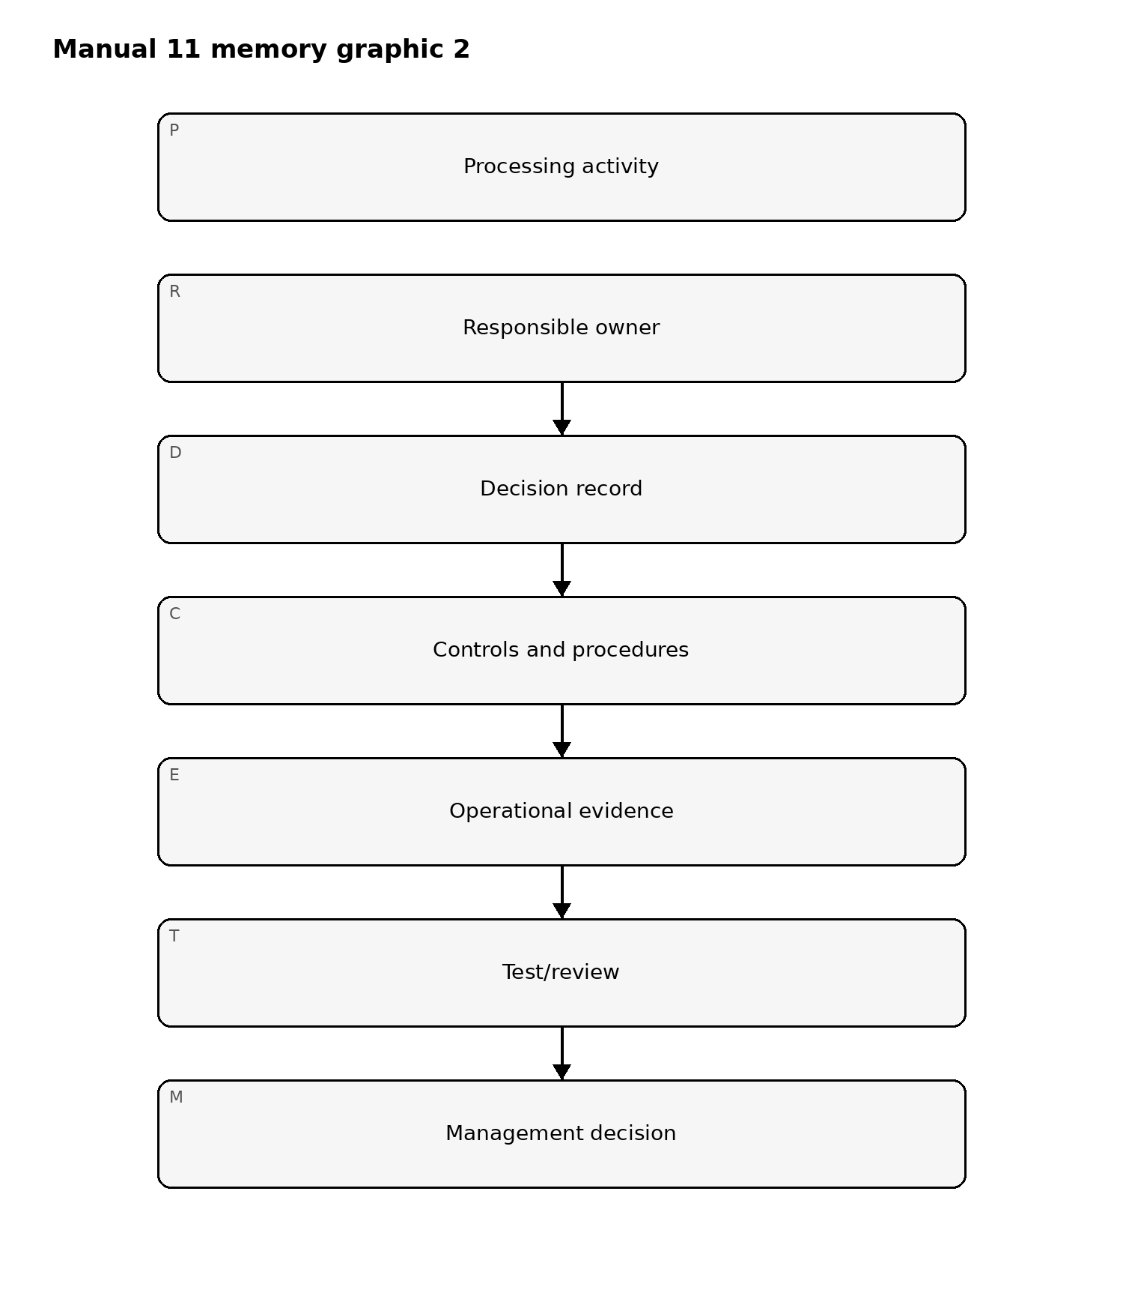
Figure 2. GDPR implementation memory graphic
Accessible explanation: Each processing activity needs accountable ownership, documented decisions, implemented controls, operational evidence, review/testing, and management action. The loop repeats as processing, law, technology, risk, or guidance changes.

Rights-request routing
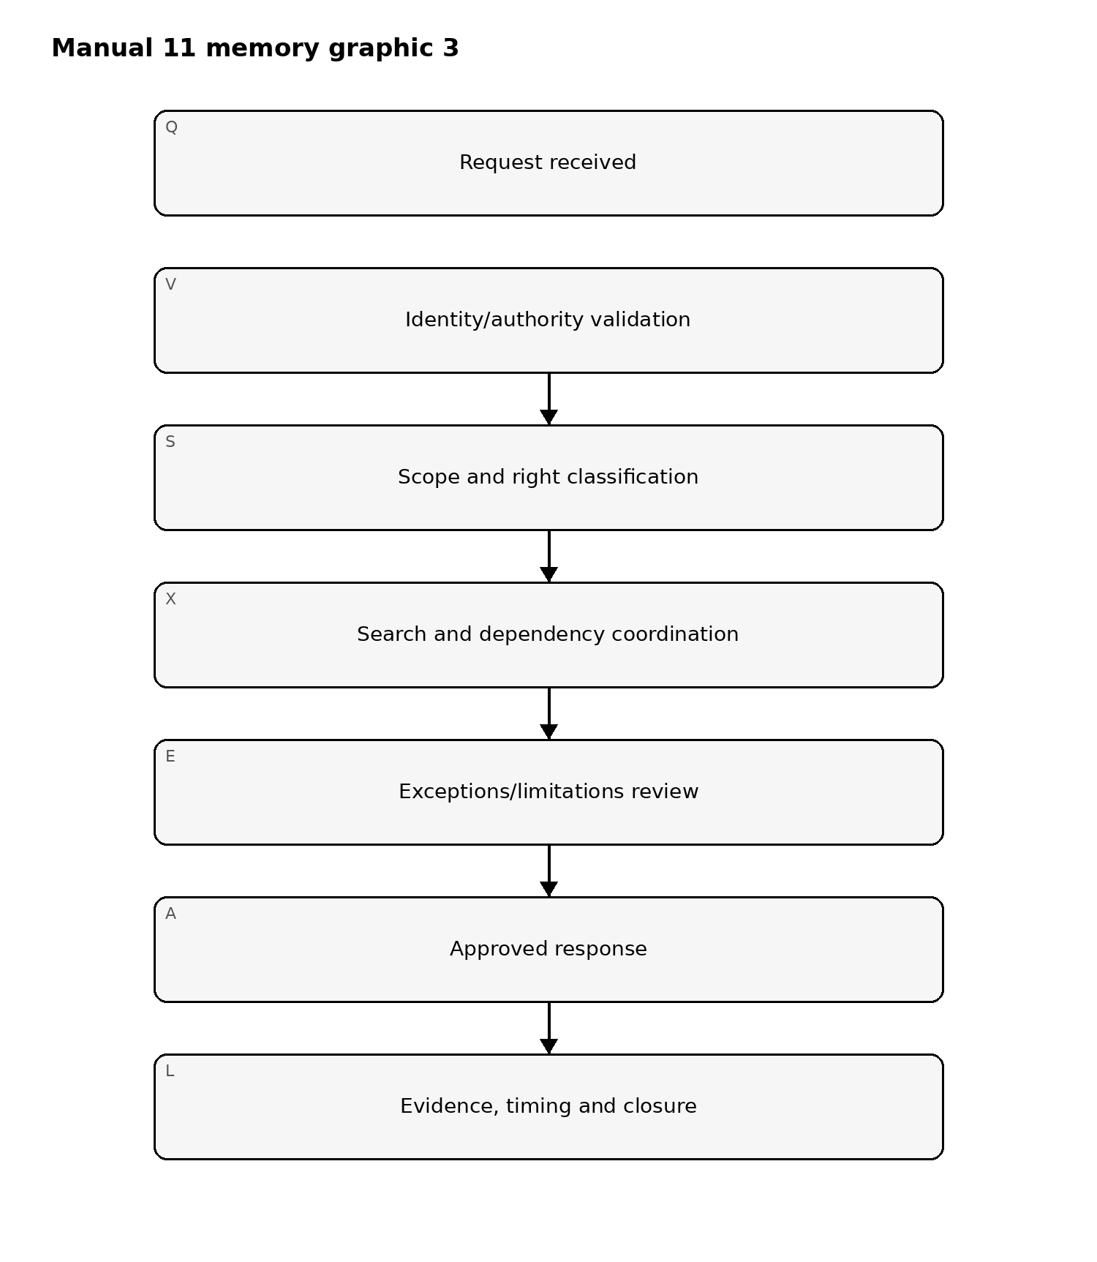
Figure 3. GDPR implementation memory graphic
Accessible explanation: A rights request should be validated, classified, scoped across systems and processors, reviewed for applicable limitations or exceptions, approved by accountable personnel, and closed with evidence of timing, search, decision, and response.

Fail-closed release boundary
Automated checks can verify that required fields, workflow stages, source-state labels, files, and evidence relationships exist. They cannot determine legal sufficiency or automatically make organization-specific GDPR decisions. Human legal/privacy review and Final Human Release Approval remain mandatory.

Controlled 32-chapter manual

Chapter 01 — GDPR purpose, scope, and accountability
Start by identifying why personal data is processed, whose data is involved, which entities participate, where processing occurs, and which legal and operational relationships matter. GDPR implementation should connect legal obligations to accountable owners, systems, data flows, contracts, controls, evidence, and review.
Applicability conclusions should be documented with scope, assumptions, jurisdictional facts, responsible reviewers, and unresolved questions.

Chapter 02 — Material and territorial scope
Assess whether activities involve personal data and whether GDPR territorial rules apply, including establishment-based processing and relevant offering/monitoring scenarios involving individuals in the Union.
Do not rely on headquarters location alone. Record entities, establishments, markets, data subjects, processing locations, services, monitoring behavior, and representative requirements where applicable.

Chapter 03 — Personal data and identifiability
Identify direct and indirect identifiers, online identifiers, device and location data, account data, behavioral information, inferred attributes, pseudonymous records, and combinations of data that may relate to an identifiable natural person.
Anonymisation conclusions require evidence that re-identification risk has been reduced to an appropriate level in context; pseudonymised data generally remains personal data.

Chapter 04 — Controller, processor, and joint-controller roles
Determine roles from actual purposes and means of processing rather than contract labels alone. Document who decides why processing occurs, essential means, instructions, independent uses, shared decisions, and processor/subprocessor chains.
Role analysis should be revisited when services, data uses, AI functionality, contracts, or decision rights change.

Chapter 05 — Data-protection principles
Operationalize lawfulness, fairness, transparency, purpose limitation, data minimisation, accuracy, storage limitation, integrity/confidentiality, and accountability as design and operating requirements.
Each material processing activity should show how principles affect collection, use, access, sharing, retention, deletion, notices, security, and evidence.

Chapter 06 — Accountability and evidence
Accountability requires more than policy statements. Maintain evidence of decisions, ownership, notices, records of processing, contracts, DPIAs, rights handling, security controls, training, incident decisions, transfer mechanisms, reviews, and corrective actions.
Evidence should be attributable, current, scoped to the actual processing, and retained according to a controlled evidence model.

Chapter 07 — Governance and privacy operating model
Define decision rights across privacy, legal, security, data governance, engineering, product, procurement, HR, marketing, operations, audit, and business leadership. Establish escalation paths for high-risk processing, rights conflicts, incidents, transfers, supplier issues, and unresolved legal interpretation.
The operating model should distinguish advisory, approval, implementation, challenge, and oversight responsibilities.

Chapter 08 — Applicability and governance fail-closed gate
Do not proceed as if GDPR obligations are fully mapped when scope is unresolved, roles are unclear, material processing is not inventoried, accountable owners are missing, or significant legal questions have no assigned reviewer.
Automation may assist discovery and classification, but it cannot make final organization-specific applicability or role determinations without competent human review.

Chapter 09 — Lawful bases
Map each material processing purpose to a documented lawful basis and the facts supporting that choice. Record purpose, data categories, data subjects, decision owner, supporting evidence, alternatives considered, dependencies, and review triggers.
Do not treat lawful-basis selection as a dropdown choice. Contract necessity, legal obligation, vital interests, public task, legitimate interests, and consent each have distinct conditions and limitations.

Chapter 10 — Consent and withdrawal
Where consent is used, design collection, evidence, granularity, transparency, voluntariness, withdrawal, and downstream system behavior so that consent can be demonstrated and revoked in practice.
Consent should not be relied upon where imbalance, bundling, ambiguity, or inability to withdraw would undermine validity.

Chapter 11 — Legitimate interests and balancing
Where legitimate interests are considered, document the interest pursued, necessity, impact on individuals, reasonable expectations, safeguards, alternatives, objections, and residual risk. Reassess when purpose, technology, data, affected populations, or safeguards change.
Automated balancing templates may support consistency but do not replace legal/privacy judgment.

Chapter 12 — Special-category and criminal-offence data
Identify processing involving special-category data or criminal-conviction/offence data and document the applicable additional legal condition, purpose, safeguards, access restrictions, retention, sharing rules, and specialist review.
High-sensitivity processing should be visible in the ROPA, DPIA screening, supplier review, security design, and incident response processes.

Chapter 13 — Transparency and privacy notices
Provide clear, accessible, accurate information about identity, purposes, lawful bases, recipients, retention, rights, transfers, automated decision-making, and other required information according to context.
Notices should match actual processing. Material product, data-use, supplier, AI, or transfer changes should trigger notice-impact analysis.

Chapter 14 — Data-subject rights operations
Implement controlled intake, identity/authority validation, right classification, search, processor coordination, exception review, response approval, timing, delivery, logging, and closure for applicable rights.
Maintain evidence of what systems and parties were searched, decisions made, limitations applied, deadlines, communications, and completion.

Chapter 15 — Automated decision-making and profiling
Identify profiling and automated decision processes, determine whether legal restrictions or enhanced transparency apply, and document human involvement, decision significance, logic explanations where required, contestability, safeguards, bias/quality risks, and review.
AI-enabled decision support must not be labeled “human reviewed” merely because a person can theoretically intervene.

Chapter 16 — Privacy by design/default and rights fail-closed gate
Embed privacy requirements into requirements, architecture, defaults, data collection, retention, access, testing, deployment, change management, and decommissioning. Defaults should support minimisation and purpose alignment rather than maximize collection or exposure.
Do not pass the gate when lawful basis is unsupported, notices materially diverge from actual processing, rights cannot be executed end-to-end, or high-impact automated decisions lack accountable review and safeguards.

Chapter 17 — Records of processing and data inventory
Maintain records that connect processing purpose, data categories, data subjects, systems, recipients, processors, transfers, retention, security measures, owners, lawful basis, and related DPIAs or notices where applicable.
The ROPA should operate as a living governance record rather than an annual spreadsheet disconnected from architecture and business change.

Chapter 18 — DPIA screening and initiation
Screen new and changed processing for factors that may indicate high risk, including scale, sensitivity, systematic monitoring, profiling, automated decisions, vulnerable individuals, novel technology, data combination, tracking, and barriers to exercising rights.
Record screening rationale, reviewer, date, evidence, and escalation. A “no DPIA required” conclusion should be explainable and revisited after material change.

Chapter 19 — DPIA analysis and treatment
Where a DPIA is required, describe processing, necessity and proportionality, risks to individuals, sources of harm, likelihood/plausibility, safeguards, residual risk, owners, and approval. Integrate security, privacy, legal, product, engineering, and business evidence.
DPIA templates can support consistency but do not automatically establish adequacy.

Chapter 20 — Security of processing
Implement security measures appropriate to risk, considering confidentiality, integrity, availability, resilience, recovery, access control, encryption or pseudonymisation where appropriate, vulnerability management, monitoring, backup, testing, supplier security, and human factors.
Security claims should be supported by implementation and operating evidence, not policy statements alone.

Chapter 21 — Personal-data breach detection and triage
Define how suspected personal-data breaches are identified, escalated, contained, investigated, and distinguished from other security or privacy events. Preserve timelines, affected data, populations, systems, causes, controls, recipients, and evidence.
The incident record should support risk-to-individuals assessment and later supervisory or data-subject notification decisions.

Chapter 22 — Breach notification decision process
Establish a controlled workflow for assessing notification obligations, timing, content, supervisory-authority engagement, individual notification, documentation of non-notification decisions, and coordination with processors or other controllers.
Automation may calculate deadlines or assemble facts, but it must not make an unreviewed legal determination that notification is or is not required.

Chapter 23 — Processor and subprocessor governance
Select processors using sufficient guarantees appropriate to risk and maintain required contractual and operating controls. Track instructions, confidentiality, security, subprocessors, rights assistance, DPIA/breach support, return/deletion, audit information, locations, transfers, and material service changes.
Contracts should align with actual processing and be supported by evidence of implementation.

Chapter 24 — International transfers and fail-closed gate
Inventory transfers and remote-access scenarios involving personal data leaving the relevant protected area. Document the transfer mechanism, recipient, country, processor chain, safeguards, supplementary measures where needed, data flows, and review triggers.
Do not pass the gate when DPIA decisions are unsupported, breach workflows cannot meet required decision timing, processors are materially ungoverned, or international transfers lack a documented lawful mechanism and competent review.

Chapter 25 — Retention, deletion, minimisation, and data quality
Define retention and deletion rules by purpose, legal need, business requirement, data category, system, processor, and evidence requirement. Implement defensible deletion, archival, legal-hold exceptions, and verification where appropriate.
Data minimisation and accuracy should be monitored throughout the lifecycle, including derived, duplicated, cached, analytics, backup, and AI-related data where relevant.

Chapter 26 — DPO governance and independence
Where a Data Protection Officer is required or voluntarily appointed, define reporting lines, access to senior management, independence, resources, expertise, involvement in high-risk matters, conflict controls, and evidence of advice and escalation.
Do not treat appointment of a DPO as transfer of accountability away from controllers or processors.

Chapter 27 — Training, awareness, and role competence
Provide privacy training proportional to role, data access, decision authority, and risk. Product, engineering, marketing, HR, procurement, security, incident response, customer support, legal/privacy, and executive roles require different practical competencies.
Track completion, role-specific content, recurring errors, lessons from incidents and rights cases, and whether training changes behavior where measurable.

Chapter 28 — Supervisory-authority and enforcement readiness
Maintain an organized evidence package for significant processing decisions, notices, ROPA, DPIAs, processor contracts, transfer decisions, rights cases, incidents, security controls, DPO advice, training, governance, and remediation.
Regulatory engagement should be coordinated by accountable legal/privacy leadership and supported by accurate, preserved, reviewable evidence.

Chapter 29 — AI, web scraping, and automated processing
Assess AI and data-intensive processing for purpose, lawful basis, transparency, data sourcing, minimisation, data-subject rights, profiling/automated-decision concerns, model inputs/outputs, retention, security, provenance, vendor relationships, and high-risk indicators.
Current EDPB work on generative-AI web scraping and other emerging topics should be monitored with clear draft-versus-final status controls.

Chapter 30 — Anonymisation, pseudonymisation, research, and novel technology
Evaluate anonymisation claims in context and distinguish them from pseudonymisation. For research, blockchain, synthetic data, privacy-enhancing technologies, and novel architectures, document purpose, identifiability, reversibility, data linkage, governance, rights implications, security, and specialist review.
Emerging-technology labels do not change the need to analyze actual processing and risk.

Chapter 31 — Privacy assurance, metrics, and corrective action
Assess whether privacy governance and controls are designed appropriately, implemented, operating, evidenced, and improved. Use metrics tied to meaningful outcomes such as rights performance, stale ROPA records, unresolved DPIA actions, processor evidence, retention execution, incident quality, and recurring control failures.
Formal legal opinions, certifications, or independent assurance conclusions require competent professionals and sufficient appropriate evidence.

Chapter 32 — Manual release and continuous-improvement boundary
Manual 11 closes only when authoritative-source verification, the controlled 32-chapter English master, technical/privacy/legal editorial review, es-419 and pt-BR localization with human semantic review, graphics/accessibility review, DOCX/PDF publication QA, repository/workflow security review, manifest/checksums/provenance, exact-head changed-scope reconciliation, and Final Human Release Approval are complete for the same exact candidate.
Completion establishes a reviewed training and implementation baseline. It does not provide organization-specific legal advice, guarantee GDPR compliance, predict enforcement outcomes, or replace competent privacy/legal professionals or supervisory authorities.

