PRACTICAL CYBERSECURITY, PRIVACY & COMPLIANCE SERIES
GDPR
A Practical Manual for Managers and Junior Analysts
How privacy work is scoped, operated, evidenced, and improved—explained in clear professional language
Alberto (Al) Leiva
First Edition • July 2026
Inside: Plain-English GDPR articles • Manager playbook • Open-source tools • Evidence examples • Junior analyst labs • Interview preparation

Publication and Use Notice
Author: Alberto (Al) Leiva
Edition: First Edition, July 2026
Purpose: Free, practical education for managers, students, career changers, junior analysts, privacy professionals, and cybersecurity practitioners.

Educational and legal notice
This manual provides general educational information. It is not legal advice and does not replace advice from qualified counsel or an organization’s data protection officer. GDPR duties depend on facts, Member State law, regulator guidance, contracts, and court decisions. Always verify the current official sources before acting on a real matter.

Ethical and authorized use
Use tools and exercises only with written authorization and only with fictional, synthetic, or properly sanitized data. Personal data can harm people when it is exposed or misused. Technical skill does not create permission.

Preface
A welcoming introduction to practical privacy work.
GDPR can look like a wall of legal language. In daily work, it becomes a set of practical questions: What personal data do we use? Why do we need it? Who can see it? How long do we keep it? How do we protect it? How can a person exercise a right? How do we prove that our answers are true?
Managers need clear ownership, honest risk decisions, suitable resources, and reliable evidence. Junior analysts need to map processing, review notices and contracts, coordinate rights requests, support DPIAs, organize breach facts, and communicate without hiding uncertainty.
This manual follows a methodology-first approach. Tools can help discover data, control access, find weaknesses, and organize records. They cannot choose a lawful basis, decide whether a person’s rights were respected, or replace legal and professional judgment.
Central lesson: GDPR compliance is not a one-time document project. It is a continuing program for lawful, fair, transparent, secure, and accountable use of personal data.

— Alberto (Al) Leiva

How to Use This Manual
Managers should begin with Chapters 1 through 8 and use the playbook and templates as working references.
Junior analysts should study the rights, evidence, article guide, tools, fictional laboratory, portfolio projects, and interview chapter.
Technical readers should connect every tool to a defined purpose, risk, control, owner, and review process.
Legal and privacy teams should verify Member State rules and the current EDPB or supervisory authority guidance.
Edition note: The final table of contents includes verified page numbers for this edition. If the manual is edited, confirm the new layout and update the page references.

Table of Contents
Publication and Use Notice 2
Educational and legal notice 2
Ethical and authorized use 2
Preface 3
How to Use This Manual 4
Table of Contents 4
1. GDPR Foundations 9
1.1 What GDPR protects 9
1.2 Compliance is more than security 9
1.3 What GDPR does not mean 9
2. Scope, Roles, and Definitions 10
2.1 Scope questions 10
2.2 Core roles 10
2.3 Personal, special-category, and criminal data 10
3. Principles and Lawful Bases 11
3.1 Article 5 principles 11
3.2 Lawful bases under Article 6 11
3.3 Consent and sensitive data 12
4. Data Subject Rights 13
4.1 The request clock 13
4.2 A defensible request file 14
5. Controller and Processor Governance 15
5.1 Records of processing activities 15
5.2 Processor due diligence and Article 28 contracts 15
5.3 Accountability records 15
6. Security and Personal Data Breaches 16
6.1 Article 32 security 16
6.2 Breach decisions 16
7. DPIAs, Privacy by Design, and the DPO 17
7.1 DPIA workflow 17
7.2 Privacy by design and default 17
7.3 DPO independence 17
8. International Data Transfers 18
8.1 Transfer workflow 18
8.2 Common transfer evidence 18
9. Complete Article-by-Article Guide 19
9.1 Chapter I — General provisions 19
9.2 Chapter II — Principles 19
9.3 Chapter III — Rights of the data subject 19
9.4 Chapter IV — Controller and processor 20
9.5 Chapter V — Transfers to third countries or international organizations 21
9.6 Chapter VI — Independent supervisory authorities 22
9.7 Chapter VII — Cooperation and consistency 22
9.8 Chapter VIII — Remedies, liability and penalties 23
9.9 Chapter IX — Specific processing situations 23
9.10 Chapter X — Delegated and implementing acts 24
9.11 Chapter XI — Final provisions 24
10. Manager’s GDPR Playbook 25
10.1 Questions for every processing owner 25
10.2 Monthly dashboard 25
10.3 Common management mistakes 25
11. From Beginner to Junior Privacy Analyst 26
11.1 Job titles 26
11.2 Typical junior work 26
11.3 Skills employers can observe 27
12. Open-Source Tools for GDPR Work 28
12.1 CISO Assistant 28
Quick start 28
Evidence to retain 28
12.2 OpenMetadata 28
Quick start 29
Evidence to retain 29
12.3 Microsoft Presidio 29
Quick start 29
Evidence to retain 29
12.4 ARX 29
Quick start 29
Evidence to retain 29
12.5 Keycloak 29
Quick start 30
Evidence to retain 30
12.6 Wazuh 30
Quick start 30
Evidence to retain 30
12.7 OWASP ZAP 30
Quick start 30
Evidence to retain 30
12.8 Trivy 30
Quick start 30
Evidence to retain 31
12.9 Open Policy Agent 31
Quick start 31
Evidence to retain 31
12.10 Klaro! 31
Quick start 31
Evidence to retain 31
12.11 Greenbone Community Edition 31
Quick start 31
Evidence to retain 32
12.12 Tool governance checklist 32
13. Fictional SaaS Laboratory and Portfolio 33
Project 1 — Scope and roles 33
Project 2 — ROPA 33
Project 3 — Rights 33
Project 4 — DPIA 33
Project 5 — Breach 33
Project 6 — Vendor and transfer 33
Project 7 — Tools 33
13.1 Portfolio ethics 33
14. Thirty-Day Learning Plan 34
14.1 Daily habit 34
15. Interview Preparation 35
What is personal data? 35
Controller versus processor? 35
Is consent always needed? 35
What is a ROPA? 35
How do you handle a rights request? 35
When is a DPIA needed? 35
What is a personal data breach? 35
What happens at 72 hours? 35
How do you prove compliance? 35
15.1 Manager’s 60-second answer 36
16. Templates and Checklists 37
16.1 ROPA fields 37
16.2 Rights-request register 37
16.3 DPIA screen 37
16.4 Breach fact sheet 38
16.5 Manager pre-launch checklist 38
17. GDPR, AI, and Analytics 39
17.1 Practical review questions 39
18. Glossary 40
19. Subject Index 42
20. Official References and Further Study 43

1. GDPR Foundations
What the law protects, what compliance means, and what managers own.
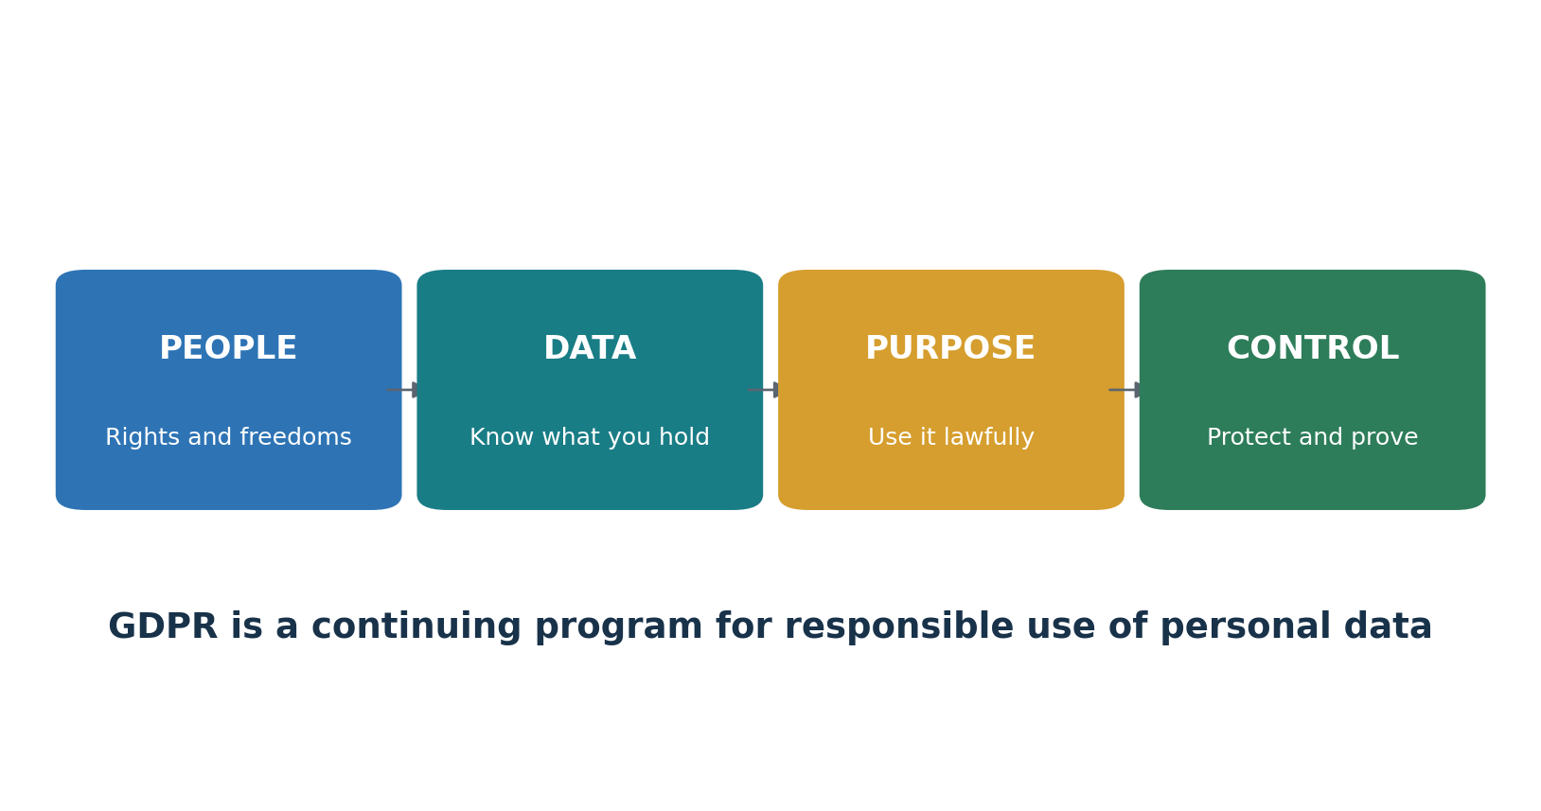
Figure 1. GDPR as a practical management program

1.1 What GDPR protects
GDPR protects natural persons when their personal data is processed. Personal data is information relating to an identified or identifiable person. It can include names, identifiers, location data, online identifiers, employment records, financial details, images, device data, and many other facts.

1.2 Compliance is more than security
Security matters, but GDPR also requires lawful and fair processing, clear information, respect for rights, purpose limits, data minimization, retention control, and accountability.

1.3 What GDPR does not mean
- Consent is not the only lawful basis.
- Encryption alone does not create compliance.
- A privacy notice does not fix unlawful processing.
- A processor contract does not remove the controller’s responsibility.
- A tool cannot guarantee that personal data has been fully discovered or deleted.
- A fine is not the only risk; people may suffer material or non-material harm.

2. Scope, Roles, and Definitions
How to decide whether GDPR applies and who is responsible.

2.1 Scope questions
- Identify the organization’s EU establishments.
- Identify offers of goods or services to people in the EU.
- Identify monitoring of behavior in the EU.
- Document excluded activities and the reason for exclusion.
- Check Member State laws and other sector rules.

2.2 Core roles
Role | Plain meaning | Key responsibility
Data subject | The person the data relates to | Exercise rights and receive clear information
Controller | Decides why and essential means of processing | Lawfulness, rights, design, vendors, evidence
Joint controllers | Two or more parties jointly decide purpose and means | Transparent allocation of duties
Processor | Processes personal data for a controller | Follow instructions, protect data, assist controller
Subprocessor | Processor engaged by another processor | Meet approved contractual and security duties
DPO | Independent adviser and monitor where appointed | Advise, monitor, support DPIAs, cooperate with authority
Supervisory authority | Independent privacy regulator | Guidance, investigation, corrective action, enforcement

2.3 Personal, special-category, and criminal data
Personal data is broader than information that directly names someone. Special-category data includes information about racial or ethnic origin, political opinions, religion or beliefs, trade-union membership, genetics, biometrics used for unique identification, health, sex life, or sexual orientation. Criminal conviction and offense data have separate controls under Article 10.
Manager checkpoint: Require a written scope and role analysis before approving a new product, vendor, tracking technology, AI use case, or international data flow.

3. Principles and Lawful Bases
The rules that shape every processing purpose.
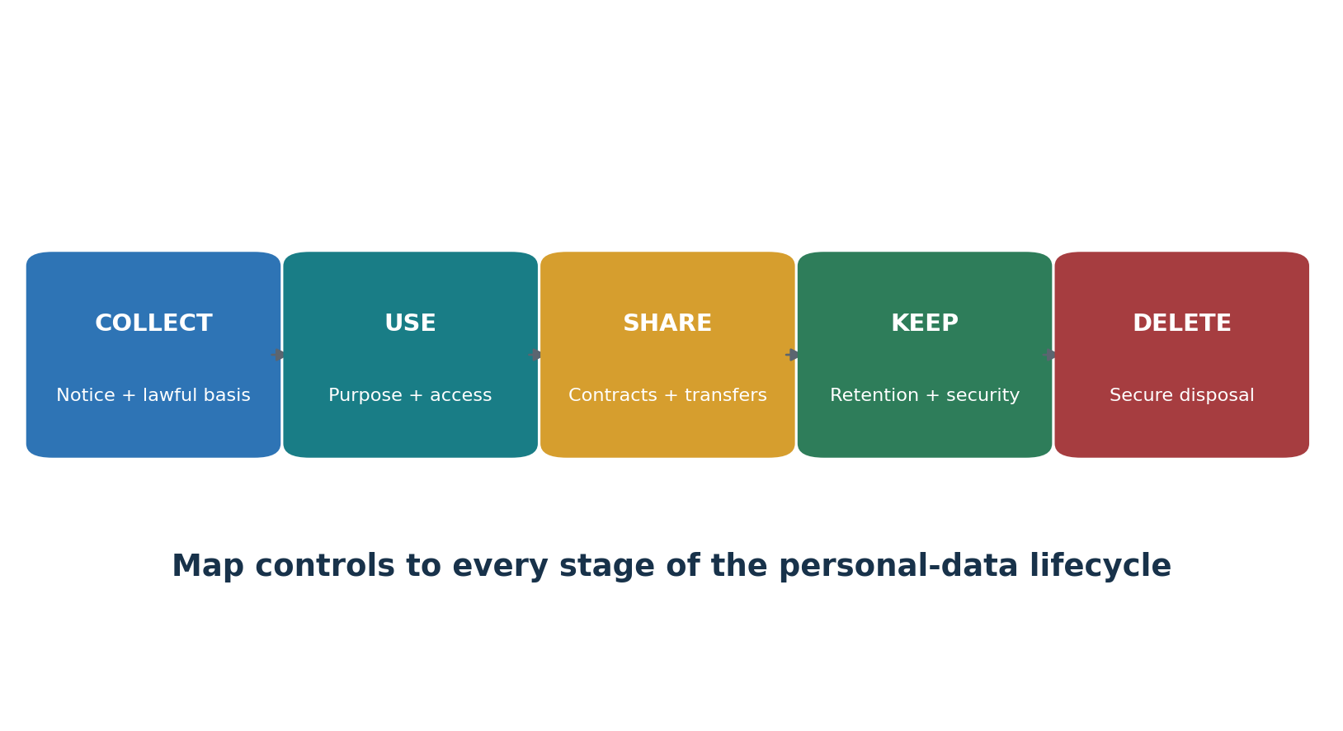
Figure 2. Personal-data lifecycle

3.1 Article 5 principles
Principle | Manager question | Useful evidence
Lawfulness, fairness, transparency | Would the use be legal, honest, and understandable to the person? | Lawful-basis record, notice, fairness review
Purpose limitation | Is the purpose specific, stated, and compatible with later use? | Purpose statement, compatibility review
Data minimization | Do we collect only what is needed? | Field review, form design decision
Accuracy | How do we correct or refresh important data? | Validation rules, correction log
Storage limitation | When will we delete or anonymize it? | Retention schedule, deletion proof
Integrity and confidentiality | Are security measures suitable for the risk? | Risk assessment, control evidence, tests
Accountability | Can we prove the above? | ROPA, approvals, reviews, training, audit trail

3.2 Lawful bases under Article 6
Basis | Use when | Common caution
Consent | The person has a real choice and can withdraw | Do not bundle or pressure consent
Contract | Processing is objectively necessary for a contract with the person or requested pre-contract steps | Convenience is not necessity
Legal obligation | EU or Member State law requires processing | Record the legal source
Vital interests | Needed to protect life or another vital interest | Usually narrow and exceptional
Public task | Required for a public-interest task or official authority grounded in law | Identify the legal basis
Legitimate interests | A real interest is necessary and not overridden by the person’s rights | Complete and retain a balancing test

3.3 Consent and sensitive data
Consent must be specific, informed, unambiguous, freely given, and demonstrable. Special-category data usually needs both an Article 6 lawful basis and an Article 9 condition. Withdrawal must be as easy as giving consent.

4. Data Subject Rights
How to receive, assess, complete, and document requests.
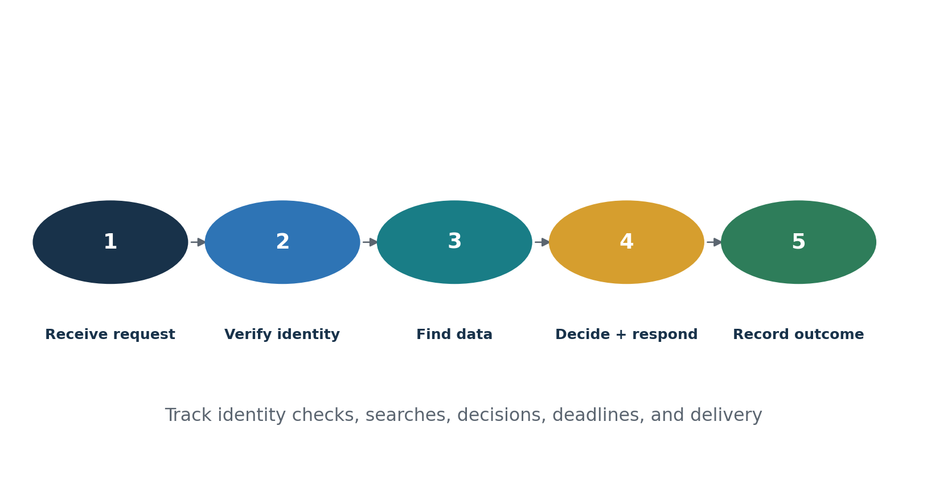
Figure 3. Data-subject-rights workflow
Right | Practical work | Watch for
Information | Give clear, timely notices | Layered notices, children, indirect collection
Access | Search, review, redact where lawful, and deliver securely | Other people’s rights, identity, complete systems
Rectification | Correct inaccurate or incomplete data | Downstream recipients and system copies
Erasure | Delete where the right applies | Legal holds, claims, public-interest and other exceptions
Restriction | Limit use while an issue is resolved | Flags must work across systems
Portability | Provide qualifying data in a reusable format | Only certain automated processing and supplied/observed data
Objection | Assess public-task or legitimate-interest use; stop direct marketing | Compelling grounds and research exceptions
Automated decisions | Provide safeguards for qualifying solely automated decisions | Meaningful human involvement and explanation

4.1 The request clock
The normal response period is one month after receipt. It may be extended by two further months when necessary due to complexity and the number of requests, but the person must be told within the first month. Identity checks must be proportionate. Fees or refusal are limited to cases that are manifestly unfounded or excessive, especially because of repetition.

4.2 A defensible request file
- Request and receipt date
- Identity-check decision
- Systems, vendors, and owners searched
- Search terms and date ranges
- Legal issues, exemptions, and redactions
- Approval and secure delivery
- Response date and retained outcome

5. Controller and Processor Governance
The operating records, contracts, roles, and reviews that make accountability real.

5.1 Records of processing activities
A ROPA is more than a spreadsheet of applications. It connects purposes, categories of people and data, recipients, transfers, retention, security, owners, and legal reasoning. Keep controller and processor records separate where needed.

5.2 Processor due diligence and Article 28 contracts
Assess expertise, reliability, security, location, subprocessors, and incident history.
Document subject matter, duration, nature, purpose, data types, people, and controller rights.
Require instructions, confidentiality, security, subprocessor controls, rights assistance, breach help, deletion or return, and audit information.
Monitor material changes and retain decisions.

5.3 Accountability records
Record | Owner | Review trigger
ROPA | Privacy program + business owner | New or changed processing
Privacy notices | Legal/privacy + product | Purpose, source, recipient, or law change
Vendor register | Procurement/privacy/security | New vendor, subprocessor, location, incident
Retention schedule | Records/legal/privacy | Legal, system, or business change
Rights log | Privacy operations | Request, complaint, overdue item
DPIA register | Privacy/DPO | High-risk feature or material change

6. Security and Personal Data Breaches
Risk-based safeguards, incident facts, notification decisions, and proof.
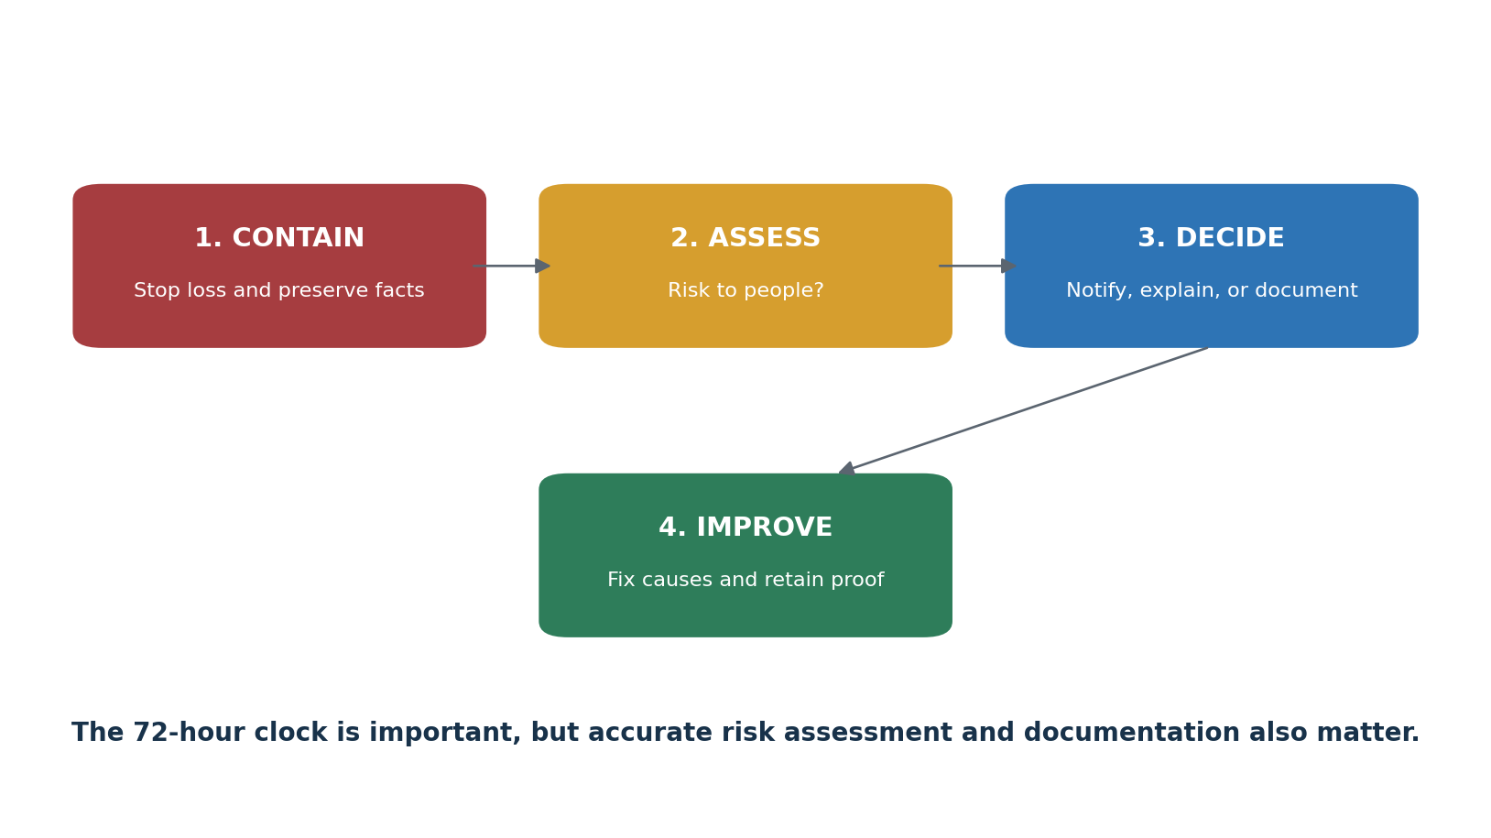
Figure 4. Personal-data-breach workflow

6.1 Article 32 security
Controllers and processors must use technical and organizational measures appropriate to risk. Consider confidentiality, integrity, availability, resilience, restoration, regular testing, the state of the art, costs, and the nature, scope, context, and purposes of processing.

6.2 Breach decisions
Question | Possible result | Evidence
Was there destruction, loss, alteration, unauthorized disclosure, or unauthorized access to personal data? | If yes, it may be a personal data breach | Incident facts, affected systems and data
Is risk to people unlikely? | Authority notification may not be required, but document the decision | Risk analysis and approval
Is there risk to people? | Notify the authority without undue delay and, where feasible, within 72 hours | Notification and delay explanation
Is high risk likely? | Communicate clearly to affected people unless an exception applies | Communication decision and delivery proof

Important: A processor must notify the controller without undue delay after becoming aware of a personal data breach. The controller remains responsible for the Article 33 decision.

7. DPIAs, Privacy by Design, and the DPO
How to find high-risk processing early and build safeguards into decisions.

7.1 DPIA workflow
- Describe the processing, purpose, systems, data, people, recipients, locations, and lifecycle.
- Assess necessity and proportionality.
- Identify risks to rights and freedoms, not only risks to the company.
- Select safeguards and owners.
- Evaluate residual risk.
- Seek the DPO’s advice where applicable.
- Consult the authority before processing if unmitigated high risk remains.
- Review when risk or processing changes.

7.2 Privacy by design and default
Minimize fields and access by default.
Separate identifiers where practical.
Make retention and deletion work technically.
Prevent optional sharing until a valid choice is made.
Test notices, rights, exports, deletion, and logs before launch.
Record design decisions and rejected options.

7.3 DPO independence
The DPO must be involved in a timely way, receive resources and access, report to the highest management level, and avoid conflicts of interest. Management owns decisions. The DPO advises and monitors, but should not be held responsible for business purposes or the means of processing.

8. International Data Transfers
How to identify transfers and use lawful transfer tools.

8.1 Transfer workflow
- Map exporters, importers, remote access, support locations, subprocessors, and onward transfers.
- Confirm the roles and countries.
- Check for an adequacy decision.
- If needed, select appropriate safeguards such as SCCs or approved BCRs.
- Assess whether the safeguard works in practice and identify supplementary measures.
- Use Article 49 derogations only when their narrow conditions apply.
- Monitor legal, vendor, and technical changes.

8.2 Common transfer evidence
Item | What it should show
Transfer map | Data, purpose, systems, countries, recipients, remote access, onward transfers
Transfer mechanism | Adequacy, SCC module, BCR, approved code/certification, or narrow derogation
Assessment | Relevant law and practice, requests, safeguards, risks, and conclusion
Supplementary measures | Encryption, key control, minimization, pseudonymization, policy and challenge procedures
Monitoring | Changes in law, importer, subprocessor, location, service, and access

9. Complete Article-by-Article Guide
A concise working guide to all 99 GDPR articles. Use the official legal text for real legal analysis.
How to read this chapter: The table explains each article in plain language. The manager action and evidence columns are practical starting points, not a complete legal opinion.

9.1 Chapter I — General provisions
Art. | Article topic | Plain meaning | Manager action | Typical evidence
1 | Subject-matter and objectives | Sets the Regulation’s purpose: protect people and allow lawful movement of personal data. | Confirm applicability, scope, and definitions; document the decision. | Scope memo, service map, data map
2 | Material scope | Explains which automated and structured manual processing is covered and which activities are excluded. | Confirm applicability, scope, and definitions; document the decision. | Scope memo, service map, data map
3 | Territorial scope | Can apply to EU establishments and to some organizations outside the EU that offer goods or services to, or monitor, people in the EU. | Confirm applicability, scope, and definitions; document the decision. | Scope memo, service map, data map
4 | Definitions | Defines personal data, processing, controller, processor, consent, breach, profiling, and other key terms. | Confirm applicability, scope, and definitions; document the decision. | Scope memo, service map, data map

9.2 Chapter II — Principles
Art. | Article topic | Plain meaning | Manager action | Typical evidence
5 | Principles relating to processing | Requires lawfulness, fairness, transparency, purpose limitation, minimization, accuracy, storage limits, security, and accountability. | Map each purpose, data type, lawful basis, safeguard, and proof. | ROPA, lawful-basis record, consent or exception proof
6 | Lawfulness of processing | Requires at least one valid lawful basis for each processing purpose. | Map each purpose, data type, lawful basis, safeguard, and proof. | ROPA, lawful-basis record, consent or exception proof
7 | Conditions for consent | Consent must be demonstrable, clear, separate where appropriate, and as easy to withdraw as to give. | Map each purpose, data type, lawful basis, safeguard, and proof. | ROPA, lawful-basis record, consent or exception proof
8 | Children’s consent for information-society services | Sets rules for a child’s consent in certain online services and permits Member States to set the age from 13 to 16. | Map each purpose, data type, lawful basis, safeguard, and proof. | ROPA, lawful-basis record, consent or exception proof
9 | Special categories of personal data | Generally, prohibits sensitive-data processing unless a listed exception applies. | Map each purpose, data type, lawful basis, safeguard, and proof. | ROPA, lawful-basis record, consent or exception proof
10 | Criminal-conviction and offense data | Limits this processing to official authority or processing authorized by law with safeguards. | Map each purpose, data type, lawful basis, safeguard, and proof. | ROPA, lawful-basis record, consent or exception proof
11 | Processing not requiring identification | Does not require keeping extra identifying data only to comply when identification is not needed. | Map each purpose, data type, lawful basis, safeguard, and proof. | ROPA, lawful-basis record, consent or exception proof

9.3 Chapter III — Rights of the data subject
Art. | Article topic | Plain meaning | Manager action | Typical evidence
12 | Transparent information, communication and modalities | Requires clear notices and practical methods for people to exercise rights. | Build a tracked rights process with identity checks, deadlines, decisions, and secure delivery. | Notice, request log, identity check, search and response
13 | Information collected from the data subject | Lists notice information to give when personal data comes directly from the person. | Build a tracked rights process with identity checks, deadlines, decisions, and secure delivery. | Notice, request log, identity check, search and response
14 | Information not obtained from the data subject | Lists notice information and timing when data comes from another source. | Build a tracked rights process with identity checks, deadlines, decisions, and secure delivery. | Notice, request log, identity check, search and response
15 | Right of access | Let’s a person confirm processing and obtain information and a copy of personal data, subject to limits. | Build a tracked rights process with identity checks, deadlines, decisions, and secure delivery. | Notice, request log, identity check, search and response
16 | Right to rectification | Let’s people correct inaccurate data and complete incomplete data. | Build a tracked rights process with identity checks, deadlines, decisions, and secure delivery. | Notice, request log, identity check, search and response
17 | Right to erasure | Requires deletion in listed situations, subject to legal exceptions. | Build a tracked rights process with identity checks, deadlines, decisions, and secure delivery. | Notice, request log, identity check, search and response
18 | Right to restriction of processing | Let’s people limit processing while certain issues are checked. | Build a tracked rights process with identity checks, deadlines, decisions, and secure delivery. | Notice, request log, identity check, search and response
19 | Notification regarding rectification, erasure or restriction | Requires telling recipients about changes unless impossible or disproportionate. | Build a tracked rights process with identity checks, deadlines, decisions, and secure delivery. | Notice, request log, identity check, search and response
20 | Right to data portability | Provides certain data in a structured, commonly used, machine-readable format when conditions apply. | Build a tracked rights process with identity checks, deadlines, decisions, and secure delivery. | Notice, request log, identity check, search and response
21 | Right to object | Let’s people object to some public-task, legitimate-interest, research, and direct-marketing processing. | Build a tracked rights process with identity checks, deadlines, decisions, and secure delivery. | Notice, request log, identity check, search and response
22 | Automated decision-making and profiling | Provides safeguards against certain solely automated decisions with legal or similarly significant effects. | Build a tracked rights process with identity checks, deadlines, decisions, and secure delivery. | Notice, request log, identity check, search and response
23 | Restrictions | Allows Union or Member State law to restrict listed rights only when legal safeguards and conditions are met. | Build a tracked rights process with identity checks, deadlines, decisions, and secure delivery. | Notice, request log, identity check, search and response

9.4 Chapter IV — Controller and processor
Art. | Article topic | Plain meaning | Manager action | Typical evidence
24 | Responsibility of the controller | Requires risk-based measures and proof that processing complies. | Assign roles, contracts, instructions, records, and accountability. | Policies, RACI, contracts, instructions, ROPA
25 | Data protection by design and by default | Requires privacy safeguards in system design and privacy-protective default settings. | Assign roles, contracts, instructions, records, and accountability. | Policies, RACI, contracts, instructions, ROPA
26 | Joint controllers | Requires joint controllers to define responsibilities transparently and provide the arrangement’s essence to people. | Assign roles, contracts, instructions, records, and accountability. | Policies, RACI, contracts, instructions, ROPA
27 | Representatives outside the Union | Requires some non-EU controllers and processors to name an EU representative, with stated exceptions. | Assign roles, contracts, instructions, records, and accountability. | Policies, RACI, contracts, instructions, ROPA
28 | Processor | Requires suitable processors and detailed contracts or other legal acts governing processing. | Assign roles, contracts, instructions, records, and accountability. | Policies, RACI, contracts, instructions, ROPA
29 | Processing under authority | Limits staff and processors to instructions unless law requires otherwise. | Assign roles, contracts, instructions, records, and accountability. | Policies, RACI, contracts, instructions, ROPA
30 | Records of processing activities | Requires controller and processor records, with a limited small-organization exception that often does not apply. | Assign roles, contracts, instructions, records, and accountability. | Policies, RACI, contracts, instructions, ROPA
31 | Cooperation with the supervisory authority | Requires cooperation with the regulator when requested. | Assign roles, contracts, instructions, records, and accountability. | Policies, RACI, contracts, instructions, ROPA
32 | Security of processing | Requires security appropriate to risk, including resilience, restoration, testing, and measures such as encryption where suitable. | Operate risk-based security and a tested breach-response process. | Risk assessment, controls, logs, incident and breach record
33 | Notification of a breach to the supervisory authority | Requires controller notification without undue delay and, where feasible, within 72 hours unless the breach is unlikely to create risk. | Operate risk-based security and a tested breach-response process. | Risk assessment, controls, logs, incident and breach record
34 | Communication of a breach to the data subject | Requires notice to affected people when a breach is likely to create high risk, subject to exceptions. | Operate risk-based security and a tested breach-response process. | Risk assessment, controls, logs, incident and breach record
35 | Data protection impact assessment | Requires a DPIA before processing likely to create high risk. | Screen high-risk work, support the DPO, and consult when required. | DPIA screen, DPIA, DPO record, consultation file
36 | Prior consultation | Requires consulting the authority before processing when a DPIA shows unmitigated high risk. | Screen high-risk work, support the DPO, and consult when required. | DPIA screen, DPIA, DPO record, consultation file
37 | Designation of the data protection officer | Lists when a DPO must be appointed and permits voluntary appointment. | Screen high-risk work, support the DPO, and consult when required. | DPIA screen, DPIA, DPO record, consultation file
38 | Position of the data protection officer | Protects DPO independence, access, resources, and direct reporting. | Screen high-risk work, support the DPO, and consult when required. | DPIA screen, DPIA, DPO record, consultation file
39 | Tasks of the data protection officer | Lists advice, monitoring, DPIA, cooperation, and regulator-contact duties. | Screen high-risk work, support the DPO, and consult when required. | DPIA screen, DPIA, DPO record, consultation file
40 | Codes of conduct | Allows sector codes to help apply GDPR requirements. | Use codes or certification only with clear scope, oversight, and proof. | Code or certification scope, monitoring and findings
41 | Monitoring of approved codes | Sets requirements for bodies that monitor compliance with approved codes. | Use codes or certification only with clear scope, oversight, and proof. | Code or certification scope, monitoring and findings
42 | Certification | Allows voluntary certification mechanisms, seals, and marks without reducing controller or processor responsibility. | Use codes or certification only with clear scope, oversight, and proof. | Code or certification scope, monitoring and findings
43 | Certification bodies | Sets accreditation and operating requirements for certification bodies. | Use codes or certification only with clear scope, oversight, and proof. | Code or certification scope, monitoring and findings

9.5 Chapter V — Transfers to third countries or international organizations
Art. | Article topic | Plain meaning | Manager action | Typical evidence
44 | General principle for transfers | Requires Chapter V conditions for transfers while preserving all other GDPR duties. | Map transfers and validate the lawful transfer tool and safeguards. | Transfer map, adequacy/SCC/BCR file, assessment and safeguards
45 | Transfers based on an adequacy decision | Allows transfers where the Commission recognizes adequate protection. | Map transfers and validate the lawful transfer tool and safeguards. | Transfer map, adequacy/SCC/BCR file, assessment and safeguards
46 | Transfers subject to appropriate safeguards | Allows transfers using safeguards such as SCCs or BCRs with enforceable rights and remedies. | Map transfers and validate the lawful transfer tool and safeguards. | Transfer map, adequacy/SCC/BCR file, assessment and safeguards
47 | Binding corporate rules | Sets approval and content requirements for BCRs within corporate groups. | Map transfers and validate the lawful transfer tool and safeguards. | Transfer map, adequacy/SCC/BCR file, assessment and safeguards
48 | Transfers or disclosures not authorized by Union law | Foreign court or authority orders alone are not a transfer basis unless supported by an applicable international agreement. | Map transfers and validate the lawful transfer tool and safeguards. | Transfer map, adequacy/SCC/BCR file, assessment and safeguards
49 | Derogations for specific situations | Provides narrow transfer exceptions and conditions when adequacy or safeguards are unavailable. | Map transfers and validate the lawful transfer tool and safeguards. | Transfer map, adequacy/SCC/BCR file, assessment and safeguards
50 | International cooperation | Encourages cooperation with non-EU countries and organizations in privacy enforcement. | Map transfers and validate the lawful transfer tool and safeguards. | Transfer map, adequacy/SCC/BCR file, assessment and safeguards

9.6 Chapter VI — Independent supervisory authorities
Art. | Article topic | Plain meaning | Manager action | Typical evidence
51 | Supervisory authority | Requires each Member State to provide one or more independent public authorities. | Know the regulator, cooperation path, and records needed for cross-border matters. | Authority correspondence, case file, cooperation record
52 | Independence | Requires authorities and their members to act independently and without outside instruction. | Know the regulator, cooperation path, and records needed for cross-border matters. | Authority correspondence, case file, cooperation record
53 | General conditions for members | Sets appointment, qualification, and conduct conditions for authority members. | Know the regulator, cooperation path, and records needed for cross-border matters. | Authority correspondence, case file, cooperation record
54 | Rules on establishment | Requires Member State law to define establishment, powers, terms, and related rules. | Know the regulator, cooperation path, and records needed for cross-border matters. | Authority correspondence, case file, cooperation record
55 | Competence | Defines the general authority of each supervisory authority within its territory. | Know the regulator, cooperation path, and records needed for cross-border matters. | Authority correspondence, case file, cooperation record
56 | Lead supervisory authority | Sets the one-stop-shop lead-authority rules for cross-border processing. | Know the regulator, cooperation path, and records needed for cross-border matters. | Authority correspondence, case file, cooperation record
57 | Tasks | Lists regulator duties, including monitoring, awareness, complaints, investigations, and guidance. | Know the regulator, cooperation path, and records needed for cross-border matters. | Authority correspondence, case file, cooperation record
58 | Powers | Lists investigative, corrective, authorization, and advisory powers. | Know the regulator, cooperation path, and records needed for cross-border matters. | Authority correspondence, case file, cooperation record
59 | Activity reports | Requires annual public reports by supervisory authorities. | Know the regulator, cooperation path, and records needed for cross-border matters. | Authority correspondence, case file, cooperation record

9.7 Chapter VII — Cooperation and consistency
Art. | Article topic | Plain meaning | Manager action | Typical evidence
60 | Cooperation between lead and concerned authorities | Creates the cooperation process for cross-border cases. | Know the regulator, cooperation path, and records needed for cross-border matters. | Authority correspondence, case file, cooperation record
61 | Mutual assistance | Requires authorities to provide relevant information and assistance to one another. | Know the regulator, cooperation path, and records needed for cross-border matters. | Authority correspondence, case file, cooperation record
62 | Joint operations | Allows joint investigations and enforcement work. | Know the regulator, cooperation path, and records needed for cross-border matters. | Authority correspondence, case file, cooperation record
63 | Consistency mechanism | Creates a process for consistent GDPR application across the EU. | Know the regulator, cooperation path, and records needed for cross-border matters. | Authority correspondence, case file, cooperation record
64 | Opinion of the Board | Lists matters requiring or allowing an EDPB opinion. | Know the regulator, cooperation path, and records needed for cross-border matters. | Authority correspondence, case file, cooperation record
65 | Dispute resolution by the Board | Allows binding EDPB decisions in specified authority disputes. | Know the regulator, cooperation path, and records needed for cross-border matters. | Authority correspondence, case file, cooperation record
66 | Urgency procedure | Allows urgent provisional or final measures and urgent EDPB action. | Know the regulator, cooperation path, and records needed for cross-border matters. | Authority correspondence, case file, cooperation record
67 | Exchange of information | Allows the Commission to define formats and procedures for authority exchanges. | Know the regulator, cooperation path, and records needed for cross-border matters. | Authority correspondence, case file, cooperation record
68 | European Data Protection Board | Establishes the EDPB as an EU body with legal personality. | Know the regulator, cooperation path, and records needed for cross-border matters. | Authority correspondence, case file, cooperation record
69 | Independence of the Board | Requires independent performance of EDPB duties. | Know the regulator, cooperation path, and records needed for cross-border matters. | Authority correspondence, case file, cooperation record
70 | Tasks of the Board | Lists EDPB guidance, consistency, dispute, accreditation, and advisory tasks. | Know the regulator, cooperation path, and records needed for cross-border matters. | Authority correspondence, case file, cooperation record
71 | Reports | Requires an annual EDPB report on personal-data protection. | Know the regulator, cooperation path, and records needed for cross-border matters. | Authority correspondence, case file, cooperation record
72 | Procedure | Sets EDPB voting rules. | Know the regulator, cooperation path, and records needed for cross-border matters. | Authority correspondence, case file, cooperation record
73 | Chair | Requires election of a chair and two deputy chairs. | Know the regulator, cooperation path, and records needed for cross-border matters. | Authority correspondence, case file, cooperation record
74 | Tasks of the Chair | Lists meeting, notice, and performance duties of the chair. | Know the regulator, cooperation path, and records needed for cross-border matters. | Authority correspondence, case file, cooperation record
75 | Secretariat | Provides an EDPS-supplied secretariat under the chair’s direction. | Know the regulator, cooperation path, and records needed for cross-border matters. | Authority correspondence, case file, cooperation record
76 | Confidentiality | Sets confidentiality rules for Board discussions and document access. | Know the regulator, cooperation path, and records needed for cross-border matters. | Authority correspondence, case file, cooperation record

9.8 Chapter VIII — Remedies, liability and penalties
Art. | Article topic | Plain meaning | Manager action | Typical evidence
77 | Right to lodge a complaint | Lets a person complain to a supervisory authority, especially where they live, work, or believe a violation occurred. | Maintain complaint, litigation, liability, and enforcement-response procedures. | Complaint, legal hold, decision, remediation and payment record
78 | Judicial remedy against a supervisory authority | Provides court remedies against legally binding authority decisions and certain delays. | Maintain complaint, litigation, liability, and enforcement-response procedures. | Complaint, legal hold, decision, remediation and payment record
79 | Judicial remedy against a controller or processor | Provides court remedies when a person believes GDPR rights were violated. | Maintain complaint, litigation, liability, and enforcement-response procedures. | Complaint, legal hold, decision, remediation and payment record
80 | Representation of data subjects | Allows qualified nonprofit bodies to represent people, subject to national rules. | Maintain complaint, litigation, liability, and enforcement-response procedures. | Complaint, legal hold, decision, remediation and payment record
81 | Suspension of proceedings | Helps courts coordinate related GDPR cases in different Member States. | Maintain complaint, litigation, liability, and enforcement-response procedures. | Complaint, legal hold, decision, remediation and payment record
82 | Compensation and liability | Provides compensation for material or non-material damage and allocates controller and processor liability. | Maintain complaint, litigation, liability, and enforcement-response procedures. | Complaint, legal hold, decision, remediation and payment record
83 | General conditions for administrative fines | Requires fines to be effective, proportionate, and dissuasive and lists factors and maximum tiers. | Maintain complaint, litigation, liability, and enforcement-response procedures. | Complaint, legal hold, decision, remediation and payment record
84 | Penalties | Requires Member States to set other effective, proportionate, and dissuasive penalties for infringements not covered by Article 83. | Maintain complaint, litigation, liability, and enforcement-response procedures. | Complaint, legal hold, decision, remediation and payment record

9.9 Chapter IX — Specific processing situations
Art. | Article topic | Plain meaning | Manager action | Typical evidence
85 | Freedom of expression and information | Requires Member States to reconcile data protection with expression and information rights. | Check applicable Member State rules and document special safeguards. | National-law review, safeguards, approvals
86 | Public access to official documents | Allows national rules to reconcile public-document access with data protection. | Check applicable Member State rules and document special safeguards. | National-law review, safeguards, approvals
87 | National identification number | Allows Member States to set specific conditions and safeguards. | Check applicable Member State rules and document special safeguards. | National-law review, safeguards, approvals
88 | Employment context | Allows more specific national or collective-agreement rules with safeguards for employee data. | Check applicable Member State rules and document special safeguards. | National-law review, safeguards, approvals
89 | Archiving, research and statistics | Requires safeguards and allows certain rights exceptions under stated conditions. | Check applicable Member State rules and document special safeguards. | National-law review, safeguards, approvals
90 | Obligations of secrecy | Allows rules that balance regulator access with professional secrecy. | Check applicable Member State rules and document special safeguards. | National-law review, safeguards, approvals
91 | Churches and religious associations | Allows existing comprehensive data-protection rules to continue if aligned with GDPR and independently supervised. | Check applicable Member State rules and document special safeguards. | National-law review, safeguards, approvals

9.10 Chapter X — Delegated and implementing acts
Art. | Article topic | Plain meaning | Manager action | Typical evidence
92 | Exercise of the delegation | Sets how the Commission may exercise delegated powers under specified articles. | Track the legal rule and any Commission or Member State action affecting the organization. | Legal register, review notes, management decision
93 | Committee procedure | Sets the committee process supporting Commission implementing acts. | Track the legal rule and any Commission or Member State action affecting the organization. | Legal register, review notes, management decision

9.11 Chapter XI — Final provisions
Art. | Article topic | Plain meaning | Manager action | Typical evidence
94 | Repeal of Directive 95/46/EC | Repeals the former Data Protection Directive and preserves reference continuity. | Track the legal rule and any Commission or Member State action affecting the organization. | Legal register, review notes, management decision
95 | Relationship with the ePrivacy Directive | Avoids extra GDPR duties where specific electronic-communications duties already cover the same matter. | Track the legal rule and any Commission or Member State action affecting the organization. | Legal register, review notes, management decision
96 | Previously concluded agreements | Allows compliant pre-24 May 2016 international agreements to remain until changed or replaced. | Track the legal rule and any Commission or Member State action affecting the organization. | Legal register, review notes, management decision
97 | Commission reports | Requires periodic evaluation reports, especially on transfers and cooperation. | Track the legal rule and any Commission or Member State action affecting the organization. | Legal register, review notes, management decision
98 | Review of other Union legal acts | Requires review and possible amendment of other EU data-protection laws for consistency. | Track the legal rule and any Commission or Member State action affecting the organization. | Legal register, review notes, management decision
99 | Entry into force and application | States entry into force and application from 25 May 2018. | Track the legal rule and any Commission or Member State action affecting the organization. | Legal register, review notes, management decision

10. Manager’s GDPR Playbook
Questions, meetings, metrics, decisions, and warning signs for management.

10.1 Questions for every processing owner
- What is the exact purpose?
- What personal data is used and about whom?
- What is the lawful basis and, if needed, Article 9 condition?
- What notice is given?
- Who receives or accesses the data?
- Where is it stored or remotely accessed?
- How long is it kept and how is deletion proved?
- What rights apply and how will they work?
- What could harm people?
- Which owner reviews evidence and changes?

10.2 Monthly dashboard
Area | Manager question | Status
ROPA | Are new and changed activities recorded? | Green / Yellow / Red
Rights | Are requests complete and on time? | Green / Yellow / Red
DPIAs | Are high-risk changes screened before launch? | Green / Yellow / Red
Breaches | Are decisions timely and supported? | Green / Yellow / Red
Vendors | Are contracts, subprocessors, and locations current? | Green / Yellow / Red
Transfers | Are mechanisms and assessments current? | Green / Yellow / Red
Retention | Are deletion jobs operating and reviewed? | Green / Yellow / Red
Training | Are role-based training and follow-up complete? | Green / Yellow / Red

10.3 Common management mistakes
- Treating consent as the answer to every purpose.
- Keeping data because it may be useful someday.
- Buying a privacy tool before defining the operating process.
- Launching high-risk processing before the DPIA.
- Ignoring employee and business-contact data.
- Signing SCCs without mapping transfers or assessing practical safeguards.
- Making the DPO own business decisions.
- Hiding incidents or delaying escalation while facts are incomplete.

11. From Beginner to Junior Privacy Analyst
A safe and honest path from learning the law to demonstrating entry-level ability.
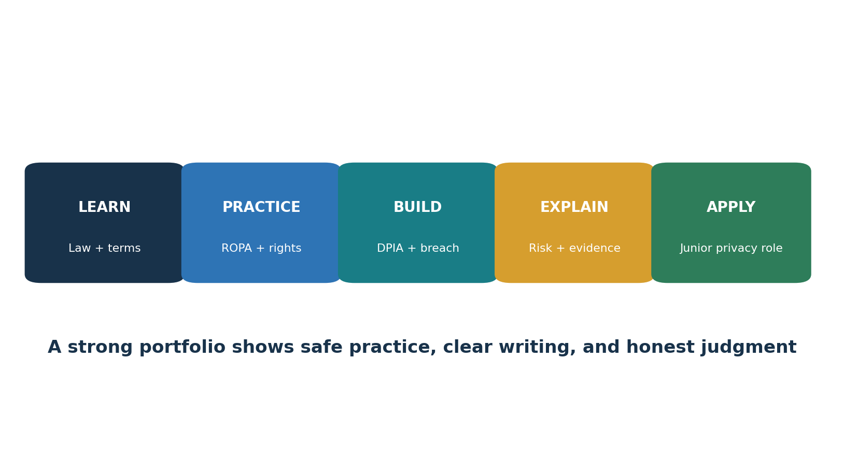
Figure 5. Junior privacy analyst pathway

11.1 Job titles
Junior Privacy Analyst
Data Protection Analyst
Privacy Operations Analyst
GRC Analyst — Privacy
Data Governance Analyst
Third-Party Privacy Analyst
Privacy and Security Analyst
Privacy Program Coordinator

11.2 Typical junior work
- Update ROPA records from owner interviews.
- Check notices against processing facts.
- Log, coordinate, and document rights requests.
- Gather processor, security, and transfer evidence.
- Perform DPIA screening and prepare drafts for review.
- Maintain breach facts and decision timelines.
- Track actions, owners, due dates, and retests.
- Prepare clear reports without making unsupported legal conclusions.

11.3 Skills employers can observe
Skill | Portfolio proof
Data mapping | Fictional ROPA and lifecycle diagram
Legal reasoning | Lawful-basis and legitimate-interest examples with assumptions
Rights operations | Request log, identity decision, search checklist, response draft
Risk | DPIA screen and completed fictional DPIA
Incidents | Breach fact sheet, risk assessment, notification decision
Communication | One-page manager summary and interview explanation

Career honesty: A laboratory portfolio is not professional work experience. Label it clearly as practice, use fictional data, and explain what you learned and what required expert review.

12. Open-Source Tools for GDPR Work
What each tool can support, how to start safely, and what evidence to retain.
Methodology first: A tool can support discovery, access, security, anonymization, or evidence. It cannot determine legal compliance by itself.

Tool | Purpose | Typical GDPR support
CISO Assistant | GRC and control records | Accountability, security, minimization, rights, or privacy-by-design evidence
OpenMetadata | Data catalog and lineage | Accountability, security, minimization, rights, or privacy-by-design evidence
Microsoft Presidio | PII detection and de-identification | Accountability, security, minimization, rights, or privacy-by-design evidence
ARX | Data anonymization and risk analysis | Accountability, security, minimization, rights, or privacy-by-design evidence
Keycloak | Identity and access management | Accountability, security, minimization, rights, or privacy-by-design evidence
Wazuh | Security monitoring | Accountability, security, minimization, rights, or privacy-by-design evidence
OWASP ZAP | Authorized web testing | Accountability, security, minimization, rights, or privacy-by-design evidence
Trivy | Code, image, secret, and configuration scanning | Accountability, security, minimization, rights, or privacy-by-design evidence
Open Policy Agent | Policy as code | Accountability, security, minimization, rights, or privacy-by-design evidence
Klaro! | Consent interface support | Accountability, security, minimization, rights, or privacy-by-design evidence
Greenbone Community Edition | Vulnerability scanning | Accountability, security, minimization, rights, or privacy-by-design evidence

12.1 CISO Assistant
GRC and control records.
Official documentation and setup: Open the official CISO Assistant guide

Quick start
Create a fictional organization, map one GDPR requirement to a control, assign an owner, and attach sanitized evidence.

Evidence to retain
Record the approved purpose, owner, scope, data used, tool and content version, configuration, complete result, reviewer, decision, corrective action, and retest. Protect reports that contain personal data, credentials, or vulnerabilities.

12.2 OpenMetadata
Data catalog and lineage.
Official documentation and setup: Open the official OpenMetadata guide

Quick start
Deploy a lab catalog, register a sample data asset, add an owner, classification, purpose note, and retention tag.

Evidence to retain
Record the approved purpose, owner, scope, data used, tool and content version, configuration, complete result, reviewer, decision, corrective action, and retest. Protect reports that contain personal data, credentials, or vulnerabilities.

12.3 Microsoft Presidio
PII detection and de-identification.
Official documentation and setup: Open the official Microsoft Presidio guide

Quick start
Run sample text containing invented identifiers, review detections, apply masking, and record false positives and misses.

Evidence to retain
Record the approved purpose, owner, scope, data used, tool and content version, configuration, complete result, reviewer, decision, corrective action, and retest. Protect reports that contain personal data, credentials, or vulnerabilities.

12.4 ARX
Data anonymization and risk analysis.
Official documentation and setup: Open the official ARX guide

Quick start
Load a synthetic dataset, mark identifiers and quasi-identifiers, apply a privacy model, and compare utility and risk.

Evidence to retain
Record the approved purpose, owner, scope, data used, tool and content version, configuration, complete result, reviewer, decision, corrective action, and retest. Protect reports that contain personal data, credentials, or vulnerabilities.

12.5 Keycloak
Identity and access management.
Official documentation and setup: Open the official Keycloak guide

Quick start
Create a lab realm, users, roles, and MFA; test least privilege and export the configuration and review evidence.

Evidence to retain
Record the approved purpose, owner, scope, data used, tool and content version, configuration, complete result, reviewer, decision, corrective action, and retest. Protect reports that contain personal data, credentials, or vulnerabilities.

12.6 Wazuh
Security monitoring.
Official documentation and setup: Open the official Wazuh guide

Quick start
Connect one lab endpoint, create a harmless event, review the alert, and save the event, analyst decision, and follow-up.

Evidence to retain
Record the approved purpose, owner, scope, data used, tool and content version, configuration, complete result, reviewer, decision, corrective action, and retest. Protect reports that contain personal data, credentials, or vulnerabilities.

12.7 OWASP ZAP
Authorized web testing.
Official documentation and setup: Open the official OWASP ZAP guide

Quick start
Proxy a local training application, begin with passive findings, validate one result, and export the approved scope and report.

Evidence to retain
Record the approved purpose, owner, scope, data used, tool and content version, configuration, complete result, reviewer, decision, corrective action, and retest. Protect reports that contain personal data, credentials, or vulnerabilities.

12.8 Trivy
Code, image, secret, and configuration scanning.
Official documentation and setup: Open the official Trivy guide

Quick start
Scan a pinned laboratory image or repository, protect reports, validate one finding, fix it, and scan again.

Evidence to retain
Record the approved purpose, owner, scope, data used, tool and content version, configuration, complete result, reviewer, decision, corrective action, and retest. Protect reports that contain personal data, credentials, or vulnerabilities.

12.9 Open Policy Agent
Policy as code.
Official documentation and setup: Open the official Open Policy Agent guide

Quick start
Write a lab rule that denies a data resource without an owner or retention tag; test allowed and denied inputs.

Evidence to retain
Record the approved purpose, owner, scope, data used, tool and content version, configuration, complete result, reviewer, decision, corrective action, and retest. Protect reports that contain personal data, credentials, or vulnerabilities.

12.10 Klaro!
Consent interface support.
Official documentation and setup: Open the official Klaro! guide

Quick start
Configure a lab page so optional services remain off until choice; test accept, reject, change, and withdrawal paths.

Evidence to retain
Record the approved purpose, owner, scope, data used, tool and content version, configuration, complete result, reviewer, decision, corrective action, and retest. Protect reports that contain personal data, credentials, or vulnerabilities.

12.11 Greenbone Community Edition
Vulnerability scanning.
Official documentation and setup: Open the official Greenbone Community Edition guide

Quick start
Scan only an approved lab target, validate a finding, correct it, rescan, and record scope, version, result, and reviewer.

Evidence to retain
Record the approved purpose, owner, scope, data used, tool and content version, configuration, complete result, reviewer, decision, corrective action, and retest. Protect reports that contain personal data, credentials, or vulnerabilities.

12.12 Tool governance checklist
- Use fictional or sanitized data in training.
- Approve purpose, owner, scope, access, hosting, and retention before production use.
- Review licenses, software sources, releases, checksums, and dependencies.
- Test detection accuracy and document false positives and false negatives.
- Restrict and log administrative access.
- Define human review, escalation, correction, and deletion processes.
- Do not upload personal data to an external service without an approved legal, security, and transfer review.

13. Fictional SaaS Laboratory and Portfolio
A complete practice company using only synthetic information.
Blue Lantern Analytics is a fictional EU-facing SaaS provider with 30 employees. It serves business customers, uses cloud hosting and support vendors, monitors application activity, sends product messages, and plans an AI support feature. It has no real customers or real personal data.

Project 1 — Scope and roles
Define establishments, targeting, services, roles, systems, people, and data.

Project 2 — ROPA
Create 12 processing activities with purpose, basis, data, recipients, transfers, retention, security, and owners.

Project 3 — Rights
Complete fictional access, correction, deletion, objection, and portability requests.

Project 4 — DPIA
Assess monitoring or the AI support feature and define safeguards.

Project 5 — Breach
Assess a lost support export, build the timeline, decide notifications, and write a manager brief.

Project 6 — Vendor and transfer
Review a fictional processor, Article 28 terms, location, SCC module, assessment, and safeguards.

Project 7 — Tools
Use three Chapter 12 tools in an isolated lab and document limitations and evidence.

13.1 Portfolio ethics
- Never publish real employee, customer, applicant, patient, or user data.
- Label every file as fictional training work.
- Do not copy a company’s confidential notice, DPIA, contract, or incident report.
- Explain assumptions, uncertainty, and where legal review would be required.

14. Thirty-Day Learning Plan
A realistic month of study, practice, portfolio work, and interview preparation.
Week | Focus | Required output
Week 1 | Scope, roles, definitions, principles, lawful bases | Scope memo, role map, lawful-basis examples
Week 2 | Rights, ROPA, retention, processors | ROPA, rights checklist, processor review
Week 3 | Security, breach, DPIA, design, transfers | Breach file, DPIA, transfer map
Week 4 | Tools, portfolio, interview, application | Sanitized portfolio and practiced answers

14.1 Daily habit
- Read one official source section.
- Explain one concept in your own words.
- Create one small fictional record.
- Review the record for clarity and evidence.
- Add one improvement to the portfolio.

15. Interview Preparation
Questions and short answers for junior analysts and managers.

What is personal data?
Information relating to an identified or identifiable natural person. Context matters; indirect identifiers can also make someone identifiable.

Controller versus processor?
A controller decides the purpose and essential means. A processor acts on behalf of the controller under instructions.

Is consent always needed?
No. Article 6 provides six lawful bases. Consent is appropriate only when its conditions and genuine choice are met.

What is a ROPA?
A record of processing activities that helps explain purposes, people, data, recipients, transfers, retention, security, and roles.

How do you handle a rights request?
Log it, verify identity proportionately, clarify scope if needed, search complete systems and vendors, review legal issues, respond securely, and retain the decision trail.

When is a DPIA needed?
Before processing likely to result in high risk to people’s rights and freedoms.

What is a personal data breach?
A security breach causing accidental or unlawful destruction, loss, alteration, unauthorized disclosure of, or access to personal data.

What happens at 72 hours?
A controller notifies the authority where required without undue delay and, where feasible, within 72 hours after awareness. Delay reasons must be explained.

How do you prove compliance?
With reliable, dated records that connect the requirement, processing, control, owner, review, decision, action, and outcome.

15.1 Manager’s 60-second answer
Interview response: I treat GDPR as an operating program. I define scope and roles, map processing and lawful bases, make rights and deletion work, assess high-risk changes, manage processors and transfers, operate risk-based security and breach response, and require evidence. The DPO and legal team provide independent advice, while management owns business decisions and resources.

16. Templates and Checklists
Practical structures to copy into an approved organizational system.

16.1 ROPA fields
- Activity and owner
- Controller/processor role
- Purpose
- People and data categories
- Lawful basis and Article 9/10 condition
- Recipients and processors
- Countries and transfer tool
- Retention and deletion
- Security measures
- Notice and rights process
- DPIA status
- Last review and next review

16.2 Rights-request register
- Request ID and receipt date
- Person and right
- Identity decision
- Scope clarification
- Systems, owners, and processors searched
- Legal review and redactions
- Extension or fee decision
- Response and secure delivery
- Completion date and outcome

16.3 DPIA screen
- Evaluation or scoring
- Automated decisions with significant effect
- Systematic monitoring
- Sensitive or highly personal data
- Large scale
- Matching datasets
- Vulnerable people
- New technology
- Prevents access to service or right
- Supervisory-authority list trigger

16.4 Breach fact sheet
Field | Required information
Awareness | When the controller became aware and why
Incident | What happened and current containment
Data and people | Categories, approximate numbers, sensitivity, context
Consequences | Likely effects on people
Risk | Likelihood, severity, high-risk analysis
Decision | Authority and person notification decisions
Action | Containment, recovery, protection, correction, lessons
Approval | Decision owner, legal/DPO input, dates

16.5 Manager pre-launch checklist
- Purpose and owner approved
- Scope and role analysis complete
- Lawful basis and sensitive-data condition recorded
- Notice accurate
- Fields and default settings minimized
- Rights and deletion tested
- Processor and transfer reviews complete
- Security risk assessed
- DPIA complete if needed
- Evidence and review date retained

17. GDPR, AI, and Analytics
Applying established GDPR duties to models, training data, monitoring, and automated decisions.
AI does not create an exception to GDPR. Start with the same questions: scope, roles, purpose, lawful basis, fairness, transparency, minimization, accuracy, rights, retention, security, transfers, and accountability. Then assess risks specific to the model and use case.

17.1 Practical review questions
- What personal data enters training, fine-tuning, retrieval, prompts, logs, evaluation, and output?
- Is the purpose compatible with the source and notice?
- Can people reasonably understand the processing and consequences?
- Could output reveal, infer, or falsely state sensitive facts?
- Is there solely automated decision-making with legal or similar significant effect?
- Can access, correction, objection, deletion, and restriction work in practice?
- What data leaves the organization or crosses borders?
- Does the DPIA cover model error, discrimination, security, misuse, and impacts on vulnerable people?
- What human review is meaningful, trained, authorized, and documented?
Do not assume: Removing direct names may not make data anonymous. Pseudonymous data remains personal data when it can be linked back using additional information.

18. Glossary
Plain-English definitions of important GDPR and privacy terms.
Accountability. The duty to comply and be able to prove compliance.
Anonymization. Processing that makes a person no longer identifiable by reasonably likely means. Truly anonymous data falls outside GDPR.
Binding corporate rules. Approved internal transfer rules for groups of companies.
Consent. A freely given, specific, informed, and unambiguous indication of wishes through a statement or clear affirmative action.
Controller. The party deciding why and essential means of processing.
Data protection impact assessment. A written assessment of planned high-risk processing, necessity, proportionality, risks, and safeguards.
Data protection officer. An independent adviser and monitor required in certain cases or appointed voluntarily.
Data subject. The natural person the personal data relates to.
EDPB. The European Data Protection Board.
International transfer. Making personal data available to a recipient in a third country or international organization under Chapter V.
Lawful basis. An Article 6 ground that permits processing for a defined purpose.
Legitimate interests assessment. A documented purpose, necessity, and balancing analysis for Article 6(1)(f).
Personal data. Information relating to an identified or identifiable natural person.
Personal data breach. A security breach causing accidental or unlawful destruction, loss, alteration, unauthorized disclosure, or access.
Processing. Almost any operation performed on personal data, including collection, use, storage, disclosure, or deletion.
Processor. A party processing personal data for a controller.
Profiling. Automated processing used to evaluate certain personal aspects.
Pseudonymization. Separating identifying information so data cannot be linked to a person without additional information kept separately.
ROPA. Record of processing activities under Article 30.
SCCs. European Commission standard contractual clauses used as an appropriate transfer safeguard when their conditions are met.
Special-category data. Sensitive categories listed in Article 9.
Supervisory authority. An independent public privacy regulator.
Transfer impact assessment. A practical assessment of whether a transfer safeguard can work in the destination context and what extra measures are needed.

19. Subject Index
An alphabetical guide to major topics. References point to sections so the index remains useful after editing.
Topic | Sections | Topic | Sections
Accountability | 1, 3, 5, 9, 10 | Open-source tools | 12
AI and analytics | 17 | Personal data | 1, 2, 18
Article 28 contract | 5.2, 9.4 | Privacy by design | 7.2, 9.4
Automated decisions | 4, 9.3, 17 | Processor | 2.2, 5.2, 9.4
Breach | 6, 9.4, 16.4 | Pseudonymization | 6, 7, 18
Consent | 3.2–3.3, 9.2 | Records of processing | 5.1, 9.4, 16.1
Controller | 2.2, 5, 9.4 | Retention | 3.1, 5, 16
Data minimization | 3.1, 7.2 | Security | 6, 9.4
Data subject rights | 4, 9.3 | Special-category data | 2.3, 3.3, 9.2
DPIA | 7.1, 9.4, 16.3 | Supervisory authority | 6, 9.6–9.7
DPO | 7.3, 9.4 | Table of contents | How to Use
International transfers | 8, 9.5 | Tools | 12
Junior analyst | 11, 13–15 | Transfer safeguards | 8, 9.5
Lawful bases | 3.2, 9.2 | Vendor management | 5.2, 8, 10

20. Official References and Further Study
Authoritative law, EU guidance, and official project documentation used for verification and further study.
EUR-Lex — Regulation (EU) 2016/679
EUR-Lex — GDPR summary updated March 2026
European Data Protection Board
EDPB SME Data Protection Guide
EDPB breach notification Guidelines 9/2022
European Commission — Data protection
European Commission — Standard Contractual Clauses
European Commission — Adequacy decisions
ENISA — Handbook on Security of Personal Data Processing
CISO Assistant documentation
OpenMetadata documentation
Microsoft Presidio documentation
ARX documentation
Keycloak documentation
Wazuh documentation
OWASP ZAP documentation
Trivy documentation
Open Policy Agent documentation
Klaro! documentation
Greenbone Community Edition documentation
Final reminder: Law, guidance, technology, and facts change. Verify the official legal text, current EDPB and supervisory-authority guidance, Member State law, and qualified legal advice before acting on a real matter.

