Manual 09 - NIST Cybersecurity Framework 2.0 Controlled Implementation
CONTROLLED PUBLICATION QA CANDIDATE
Controlled source revision: 321d4fd0e034995ef589a3308af53cab361a9859 | Language: en | CSF outcome and human decision boundaries retained.
Assurance boundary: This manual operationalizes NIST CSF 2.0 outcomes but does not create NIST certification, guarantee cybersecurity effectiveness, establish legal compliance, or prove that one control set is universally sufficient. Profiles, Tiers, exceptions, residual risk, and material decisions require accountable human judgment.

Implementation paths

Manual 09 — NIST CSF 2.0 Implementation Paths

Purpose
These paths translate NIST CSF 2.0 outcomes into proportional operating patterns without treating the Framework as a prescriptive control catalog or certification scheme. Each path requires an explicit organizational context, risk strategy, Target Profile, accountable owners, evidence, exception handling, and human decisions.

Essential path
Use where organizational complexity and cybersecurity exposure allow a focused implementation.
Minimum operating pattern:
- establish accountable cybersecurity governance and risk ownership;
- define critical mission/business services and dependencies;
- maintain a basic Current Profile and risk-informed Target Profile;
- identify important assets, data, services, suppliers, and technology dependencies;
- maintain a prioritized cybersecurity risk register;
- implement risk-based identity/access, data protection, platform protection, monitoring, incident response, and recovery practices;
- define material incident and risk escalation routes;
- retain evidence for significant decisions, tests, incidents, exceptions, and remediation;
- review progress and material changes on a defined cadence.
Completion requires evidence that the organization can explain its priority CSF outcomes, current gaps, accountable actions, accepted residual risk, and next review point.

Structured path
Use where multiple business units, regulated obligations, material suppliers, or more complex technology environments require repeatable governance.
Adds to Essential:
- formal enterprise Current and Target Profiles;
- defined use of CSF Implementation Tiers as context for cybersecurity risk-governance characteristics, not maturity certificates;
- integration with enterprise risk management and executive reporting;
- documented cybersecurity roles, competencies, workforce demand, and training plans;
- systematic supplier and cyber supply-chain risk governance;
- defined metrics tied to outcomes and decisions rather than activity counts alone;
- formal control/evidence mappings using authoritative informative references where useful;
- independent or second-line challenge for material risk decisions;
- tested incident and recovery playbooks linked to business priorities;
- periodic Profile reassessment and improvement planning.
Completion requires traceable evidence across all six Functions and an approved improvement plan for material gaps.

Enhanced path
Use where systemic importance, threat exposure, regulatory complexity, critical services, or organizational risk appetite warrants deeper integration and assurance.
Adds to Structured:
- quantitative or scenario-based risk analysis where decision-useful;
- continuous or high-frequency monitoring of material outcomes and control signals;
- machine-consumable crosswalks and informative-reference workflows with provenance and validation;
- advanced supplier concentration, fourth-party, resilience, and exit-risk analysis;
- threat-informed testing and adversarial exercises;
- automated evidence collection with integrity, lineage, access, and exception controls;
- executive and board-level risk reporting tied to enterprise objectives and risk appetite;
- cross-framework mapping that preserves source semantics and does not imply equivalence where none exists;
- formal assurance over selected high-risk outcomes;
- continuous improvement based on incidents, near misses, testing, audit findings, business change, and threat intelligence.
Completion requires evidence that automated or advanced practices remain governed by accountable human decisions and that exceptions or model/tool limitations are visible.

Six-Function operating loop
- GOVERN establishes context, objectives, risk strategy, policy, roles, oversight, and supply-chain expectations.
- IDENTIFY determines what matters, what can go wrong, and where improvement is needed.
- PROTECT implements safeguards proportionate to prioritized risk.
- DETECT provides timely awareness of relevant adverse events and conditions.
- RESPOND contains, analyzes, communicates, and mitigates cybersecurity incidents.
- RECOVER restores capabilities and incorporates lessons into future governance and improvement.
The loop is iterative. Material changes, incidents, failed tests, supplier changes, or changed risk assumptions return affected decisions to GOVERN and IDENTIFY.
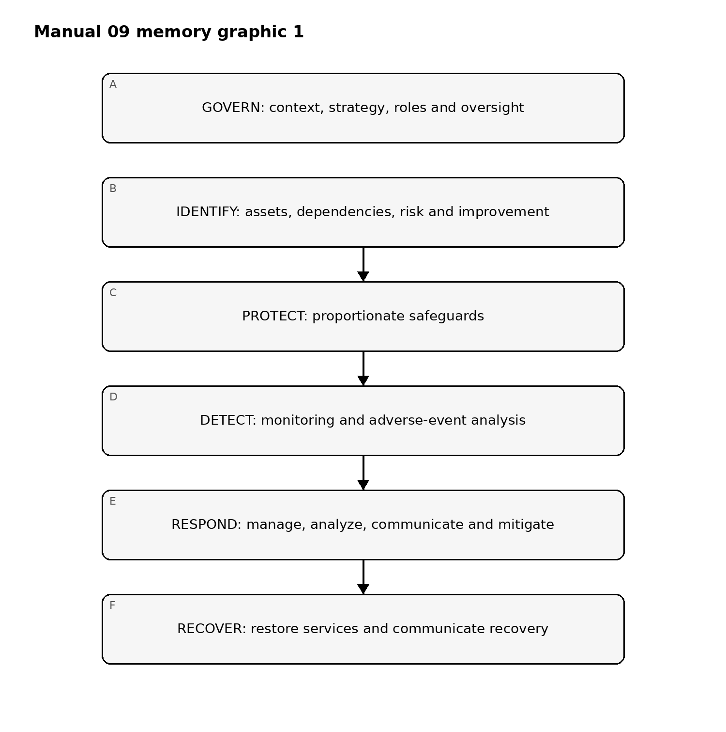
Figure 1. Implementation memory graphic
Accessible explanation: The six NIST CSF 2.0 Functions operate as a connected cycle rather than isolated checklists. Governance sets the context for identification and protection; detection informs response; recovery feeds lessons, changed assumptions, and improvement priorities back into governance.

Profile and improvement route
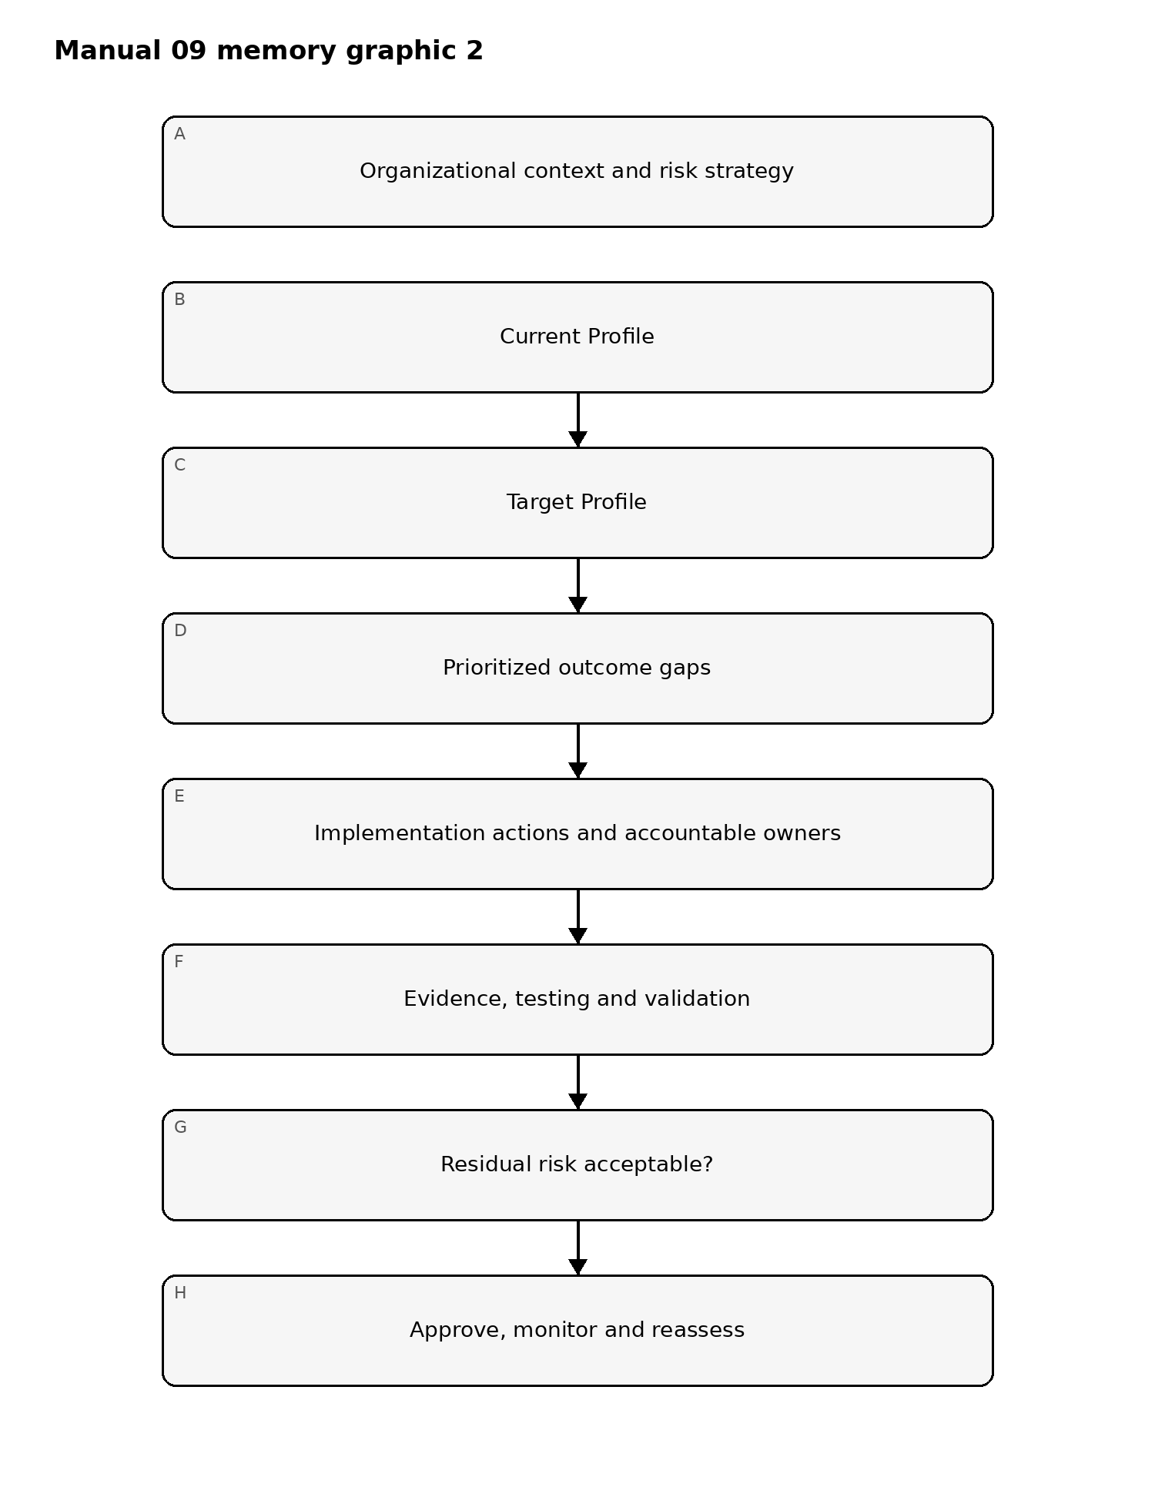
Figure 2. Implementation memory graphic
Accessible explanation: CSF implementation begins with organizational context, compares Current and Target Profiles, prioritizes outcome gaps, implements accountable actions, and validates evidence. Unacceptable residual risk returns to treatment; accepted risk remains monitored and is reassessed as conditions change.

Proportional implementation routing
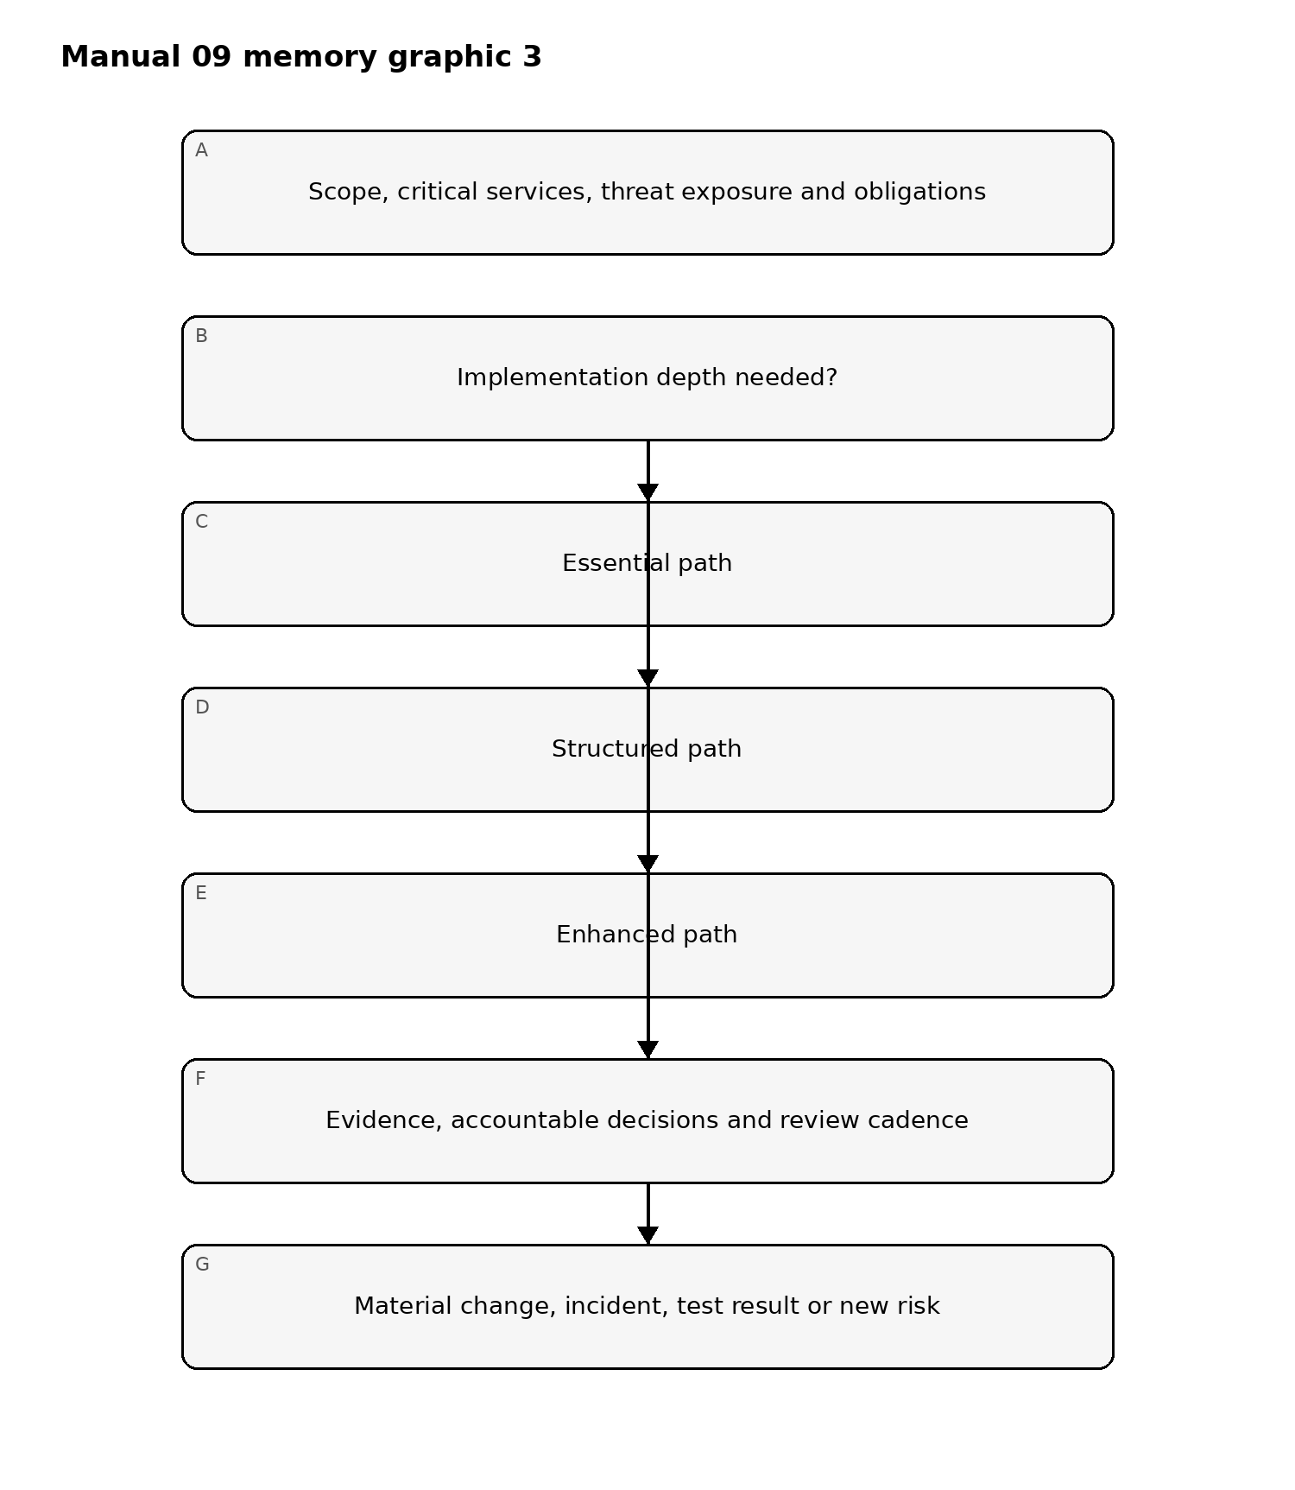
Figure 3. Implementation memory graphic
Accessible explanation: The Essential, Structured, and Enhanced paths scale implementation depth to organizational context and exposure. All paths retain evidence, accountable decisions, and reassessment; material changes or new risk can move the organization to a different depth rather than locking it permanently into one tier.

Evidence and decision loop
For each material CSF outcome, record:
- outcome/subcategory reference;
- organizational applicability and rationale;
- implementation method;
- accountable owner;
- evidence expected and evidence observed;
- test or validation method where applicable;
- gap/finding;
- risk consequence;
- treatment or exception;
- target date;
- residual risk;
- approver;
- next review date.
A policy statement, tool purchase, questionnaire response, or mapped control is not sufficient by itself to demonstrate an outcome.

Stop and rollback conditions
Implementation or release stops when material scope is unknown, high-risk gaps lack accountable treatment, evidence contradicts claimed outcomes, authoritative sources are stale or unresolved, automated mappings lack provenance/validation, required human review is incomplete, or a material change invalidates earlier approval.

Assurance statement
Manual 09 is implementation guidance. Use of the manual does not create NIST certification, guarantee cybersecurity effectiveness, establish legal or regulatory compliance, or prove that a particular control set is sufficient for every organization. Organizations remain responsible for context-specific risk decisions and competent human review.

Controlled 32-chapter manual

Chapter 01 — Organizational context and mission dependency
Define the mission, business objectives, critical services, stakeholders, legal and contractual context, technology environment, and external dependencies that shape cybersecurity risk. The record should make clear which outcomes matter most and why.
Implementation evidence should include scope, critical services, dependency maps, accountable owners, assumptions, and unresolved scope questions. Material business or technology change must trigger reassessment.

Chapter 02 — Cybersecurity risk governance
Establish decision rights for cybersecurity risk, including executive accountability, escalation paths, delegated authority, oversight bodies, and relationships with enterprise risk management.
Governance evidence should show who may accept risk, who challenges decisions, how material issues reach leadership, and how cybersecurity considerations enter strategy, investment, acquisitions, outsourcing, and change decisions.

Chapter 03 — Risk strategy and risk appetite
Translate enterprise objectives into cybersecurity risk assumptions, priorities, tolerances, response expectations, and escalation thresholds. Risk strategy should be usable in real decisions rather than limited to policy language.
Document risk appetite or equivalent decision criteria, treatment options, exception rules, review cadence, and how uncertainty is handled.

Chapter 04 — Roles, responsibilities, and authorities
Define cybersecurity responsibilities across leadership, technology, security, legal, privacy, procurement, HR, business operations, incident management, resilience, and suppliers where applicable.
Evidence should identify accountable owners, responsible operators, consulted specialists, approval authority, segregation of duties, deputies, and gaps in required capability.

Chapter 05 — Policy and control expectations
Policies and standards should translate risk strategy into actionable expectations while allowing context-specific implementation. Maintain ownership, approval, versioning, exceptions, review dates, and communication records.
A policy is not evidence that an outcome is achieved. Testing, operational records, technical evidence, and observed behavior are needed where relevant.

Chapter 06 — Oversight and performance review
Leadership should review cybersecurity risk, material findings, incidents, exceptions, supplier issues, recovery readiness, and improvement progress using decision-useful information.
Metrics should connect to outcomes and risk. Activity counts alone should not be used to imply effective risk reduction.

Chapter 07 — Cybersecurity supply-chain governance
Define how supplier, service-provider, software, cloud, data, AI, and other external dependencies enter cybersecurity governance. Apply proportional due diligence, contracting, monitoring, incident coordination, concentration analysis, and exit planning.
Supplier evidence should remain traceable to critical services and risk decisions rather than becoming a questionnaire-only compliance exercise.

Chapter 08 — GOVERN fail-closed gate
GOVERN is incomplete when material scope is unresolved, risk authority is unclear, leadership lacks visibility into significant risk, high-risk exceptions lack authorized acceptance, or supplier dependencies are not governed proportionately.
Automated QA may validate structure and required evidence fields, but final governance adequacy requires competent human judgment.

Chapter 09 — Asset and service inventory
Maintain sufficient visibility of systems, applications, data, identities, facilities, cloud services, operational technology, suppliers, and business services to support risk decisions. Inventories should identify owners, criticality, dependencies, lifecycle state, and unknowns.
Unmanaged or unidentified assets should be treated as risk requiring investigation rather than assumed to be outside scope.

Chapter 10 — Cybersecurity risk assessment
Identify threats, vulnerabilities, exposure, likelihood or plausibility, consequences, existing safeguards, uncertainty, and affected objectives using a repeatable method appropriate to the organization.
Assessment evidence should distinguish facts, assumptions, estimates, and limitations. Risk scores without traceable reasoning should not be treated as sufficient evidence.

Chapter 11 — Risk prioritization and improvement
Convert assessment results, incidents, tests, audits, business changes, and threat information into prioritized improvement actions. Record owners, target dates, dependencies, interim measures, residual risk, and escalation.
Improvement should be continuous and risk-driven, not limited to periodic compliance cycles.

Chapter 12 — Identity and access management
Manage identities, credentials, authentication, authorization, privileged access, service accounts, and access lifecycle according to risk and business need.
Evidence should support joiner/mover/leaver controls, privileged-access governance, periodic review, exception handling, and timely removal or restriction of unnecessary access.

Chapter 13 — Awareness and workforce resilience
Define cybersecurity knowledge and behavior expectations for the workforce and relevant third parties. Training should reflect role, access, threat exposure, and responsibilities.
Track assignment, completion, overdue items, role-specific requirements, lessons from incidents, and whether training changes behavior or reduces risk where measurable.

Chapter 14 — Data security
Protect data according to sensitivity, business value, legal or contractual needs, lifecycle state, and threat exposure. Address access, encryption or equivalent protection where appropriate, integrity, backup, retention, transfer, disposal, and leakage risk.
Data protection claims should be supported by inventories, configurations, monitoring, tests, or other relevant evidence.

Chapter 15 — Platform and configuration security
Establish risk-based secure configuration, vulnerability management, patching, malware defense, endpoint/server/cloud controls, software integrity, and lifecycle management.
Exceptions, unsupported technology, compensating controls, and remediation ownership should be visible rather than hidden by aggregate compliance percentages.

Chapter 16 — Infrastructure resilience and protective gate
Design networks, services, facilities, cloud dependencies, backups, capacity, segmentation, redundancy, and recovery-enabling safeguards according to criticality and risk.
PROTECT is incomplete when critical safeguards are unknown, material vulnerabilities lack accountable treatment, privileged access is uncontrolled, data protections cannot be evidenced, or resilience assumptions remain untested.

Chapter 17 — Continuous monitoring strategy
Define what conditions, events, assets, identities, services, suppliers, and control signals require monitoring. Establish telemetry sources, ownership, coverage, retention, protection, review cadence, and known blind spots.
Monitoring evidence should identify missing or unreliable sources rather than assuming that tool deployment equals effective visibility.

Chapter 18 — Adverse-event detection
Use technical and operational signals to identify potential cybersecurity events. Detection logic should be risk-informed, tested, tuned, versioned where appropriate, and connected to accountable triage processes.
Record detection coverage, false-positive and false-negative concerns, escalation thresholds, and material detection gaps.

Chapter 19 — Event analysis and correlation
Analyze events using relevant context such as asset criticality, identity, behavior, threat intelligence, vulnerabilities, business impact, and related activity. Preserve evidence sufficient to support decisions and later review.
Automated correlation or AI-supported analysis must not conceal uncertainty, unsupported inference, provenance gaps, or the need for human escalation.

Chapter 20 — Incident declaration and coordination
Define criteria and authority for declaring incidents, assigning severity, activating response structures, and coordinating security, technology, business, legal, privacy, communications, resilience, and supplier participants.
The record should capture who made material decisions, when, based on what evidence, and with what unresolved assumptions.

Chapter 21 — Incident containment and mitigation
Contain and mitigate incidents using predefined and situation-specific actions that consider operational, safety, legal, evidence, and recovery consequences.
Actions should be logged with owner, time, rationale, affected systems, validation, rollback needs, and residual risk.

Chapter 22 — Incident communications
Plan internal and external communications, escalation, stakeholder coordination, regulatory or contractual notification analysis, and supplier/customer interaction according to applicable requirements and incident facts.
Automation may support routing and drafting but should not make unreviewed legal notification determinations.

Chapter 23 — Response evidence and lessons
Preserve timelines, alerts, logs, forensic evidence, decisions, communications, containment actions, findings, unresolved questions, and follow-up actions. Conduct lessons-learned review proportionate to incident significance.
Lessons should feed governance, risk assessment, architecture, detection, training, supplier oversight, and recovery improvement.

Chapter 24 — DETECT and RESPOND fail-closed gate
DETECT and RESPOND are incomplete when material monitoring blind spots are unacknowledged, incident authority is unclear, critical alerts are not triaged, evidence preservation is inadequate, or significant response actions cannot be reconstructed.
Repository QA can validate expected records and structural controls; incident effectiveness and legal obligations require competent human assessment.

Chapter 25 — Recovery planning and prioritization
Define recovery priorities from mission and business impact, critical-service dependencies, risk, safety, data integrity, contractual needs, and stakeholder expectations. Establish recovery roles, communication routes, dependencies, restoration criteria, and fallback options.
Plans should identify assumptions and dependencies that can fail during a real incident.

Chapter 26 — Recovery execution and validation
Restore affected capabilities using controlled priorities and evidence-based decisions. Validate service functionality, security, data integrity, access, monitoring, and unresolved risk before declaring recovery complete.
Recovery records should distinguish temporary restoration, permanent remediation, accepted residual risk, and follow-up work.

Chapter 27 — Recovery communication and improvement
Coordinate recovery status and expectations with leadership, business owners, technical teams, suppliers, customers, and other stakeholders as appropriate. Capture lessons and feed them into governance, risk assessment, architecture, response, and resilience planning.
Recurring recovery weaknesses should become visible improvement items rather than repeatedly accepted operational surprises.

Chapter 28 — Organizational Profiles
Use Current and Target Profiles to describe selected CSF outcomes in organizational context, identify gaps, prioritize improvement, and communicate risk decisions. Profile scope, rationale, assumptions, owners, evidence, and review dates should be controlled.
Profiles are decision tools, not certificates or universal maturity scores.

Chapter 29 — Community Profiles and shared requirements
Where sector, community, ecosystem, or mission-specific Profiles are used, map them transparently to organizational context. Record where community expectations apply, where organization-specific tailoring is necessary, and how conflicts or gaps are resolved.
External Profile use should not erase local risk ownership or create unsupported equivalence claims.

Chapter 30 — Implementation Tiers and enterprise integration
Use CSF Tiers to characterize cybersecurity risk-governance and management practices in context. Tier discussions should support decisions about desired characteristics and investment without treating a Tier as a certification level or an automatic target for every organization.
Integrate cybersecurity risk with enterprise risk and workforce planning where useful, preserving accountable ownership and decision evidence.

Chapter 31 — Informative references, crosswalks, and assurance
Use informative references to connect CSF outcomes with other standards, controls, practices, or requirements. Maintain source identity, version, mapping rationale, directionality, limitations, provenance, and validation.
Machine-readable or AI-assisted mappings require continuous evaluation and human review. A mapping must not be treated as proof that two requirements are equivalent or that an outcome is achieved.
Assurance should distinguish design, implementation, operation, and evidence quality. Formal assurance opinions require competent independent judgment and sufficient appropriate evidence.

Chapter 32 — Release, maintenance, and continuous improvement
Manual 09 closes only when source verification, the complete controlled English master, technical/editorial/security review, localization and human semantic review, accessibility, publication QA, repository/workflow security review, provenance, changed-scope reconciliation, and Final Human Release Approval are complete for the same exact candidate.
After release, changes to NIST CSF resources, material business or threat changes, incidents, audit findings, failed tests, supplier changes, or evidence defects trigger impact analysis and, where material, a new controlled review cycle. Completion establishes a reviewed baseline; it does not guarantee future cybersecurity effectiveness.

