PRACTICAL CYBERSECURITY, PRIVACY & COMPLIANCE SERIES
ISO/IEC 27001:2022 & ISO/IEC 27002:2022
Practical ISMS, Risk, Audit, Controls, and Open-Source Tools
A working manual for managers, junior analysts, students, career changers, internal auditors, and security teams
Alberto (Al) Leiva
First Edition • July 2026
Inside: Clauses 4–10 • all 93 Annex A controls • risk • Statement of Applicability • audit • certification • evidence • tools • labs • career preparation

Publication and Use Notice
Author: Alberto (Al) Leiva
Edition: First Edition, July 2026
This independent educational manual is not an ISO publication, legal advice, certification decision, audit report, or substitute for licensed ISO/IEC standards. ISO publications are copyrighted. The control and clause descriptions here are original summaries; use the official standards for exact requirements and guidance.
ISO develops standards but does not certify organizations. Certification is optional and is performed by certification bodies. Verify accreditation, scope, locations, version, and certificate status before relying on a certification claim.

Ethical and authorized use
Use technical tools only on systems, applications, networks, cloud accounts, repositories, and data that you own or are specifically authorized in writing to assess. Use synthetic data and isolated systems in laboratories.

Preface
A practical introduction to information-security management and evidence-based assurance.
ISO/IEC 27001 is a requirements standard for establishing, implementing, maintaining, and continually improving an information security management system. It uses risk management to preserve confidentiality, integrity, and availability in a way that fits the organization. ISO/IEC 27002 provides detailed control guidance but is not itself a certification standard.
The current base editions are ISO/IEC 27001:2022 and ISO/IEC 27002:2022. ISO/IEC 27001:2022 Amendment 1:2024 adds explicit climate-change consideration to organizational context and notes that interested parties may have climate-related requirements. The amendment does not mean that every organization must create a climate program; it must make and support a reasoned determination of relevance within the ISMS context.
A successful ISMS is not a folder of policies. It is a functioning management system: leaders set direction, risk owners make informed treatment decisions, teams operate controls, internal audit tests the system, management reviews results, and corrective action prevents recurrence.

How to Use This Manual
Managers should begin with Chapters 1–5 and 18–23.
Junior analysts should study clauses, Annex A themes, evidence testing, tools, lab, and interview preparation.
Internal auditors should focus on objective criteria, independence, complete populations, sampling, findings, corrective action, and follow-up.
Organizations seeking certification should confirm the licensed standard, amendment, certification scope, and accreditation expectations with competent professionals.
True Word contents: This document contains a native Word table-of-contents field and a verified chapter guide. After editing, right-click the contents and choose Update Field, then Update entire table.

Table of Contents
Publication and Use Notice 2
Ethical and authorized use 2
Preface 3
How to Use This Manual 4
Table of Contents 4
1. ISO/IEC 27001 and 27002 Foundations 7
2. ISMS Scope and Interested Parties 8
3. Risk Assessment and Risk Treatment 9
4. Statement of Applicability 10
5. Documentation and Evidence 11
6. Clause 4 — Context of the organization 12
7. Clause 5 — Leadership 13
8. Clause 6 — Planning 14
9. Clause 7 — Support 15
10. Clause 8 — Operation 16
11. Clause 9 — Performance evaluation 17
12. Clause 10 — Improvement 18
13. Annex A 5 Organizational controls 19
14. Annex A 6 People controls 22
15. Annex A 7 Physical controls 23
16. Annex A 8 Technological controls 24
17. Implementing Controls with ISO/IEC 27002 26
18. Metrics and Control Testing 27
19. Internal Audit 28
20. Management Review and Corrective Action 29
21. Certification Readiness 30
22. Open-Source Tools 31
22.1 CISO Assistant 31
22.2 SimpleRisk Community 31
22.3 Wazuh 31
22.4 osquery 32
22.5 OpenSCAP 32
22.6 Greenbone Community Edition 32
22.7 Nmap 32
22.8 Trivy 32
22.9 OWASP ZAP 33
22.10 Keycloak 33
22.11 DefectDojo 33
22.12 AIDE 33
22.13 Lynis 33
22.14 Open Policy Agent 33
23. Manager’s ISMS Playbook 35
24. Junior Analyst Career Guide 36
24.1 Typical junior work 36
24.2 Skills employers value 37
25. Fictional Laboratory and Portfolio 38
26. Thirty-Day Learning Plan 39
27. Interview Preparation 40
27.1 What is an ISMS? 40
27.2 ISO 27001 versus 27002? 40
27.3 What is the SoA? 40
27.4 Are all Annex A controls mandatory? 40
27.5 How do you test a control? 40
27.6 What is a nonconformity? 40
27.7 What changed in 2024? 40
27.8 What can a junior analyst safely conclude? 40
27.9 Questions to ask the employer 40
28. Templates, Glossary, Index, and References 42
28.1 Minimal risk record 42
28.2 Control test workpaper 42
28.3 Glossary 42
28.4 Subject index 43
28.5 Official references 43

1. ISO/IEC 27001 and 27002 Foundations
Current editions, purpose, relationship, and important limitations.
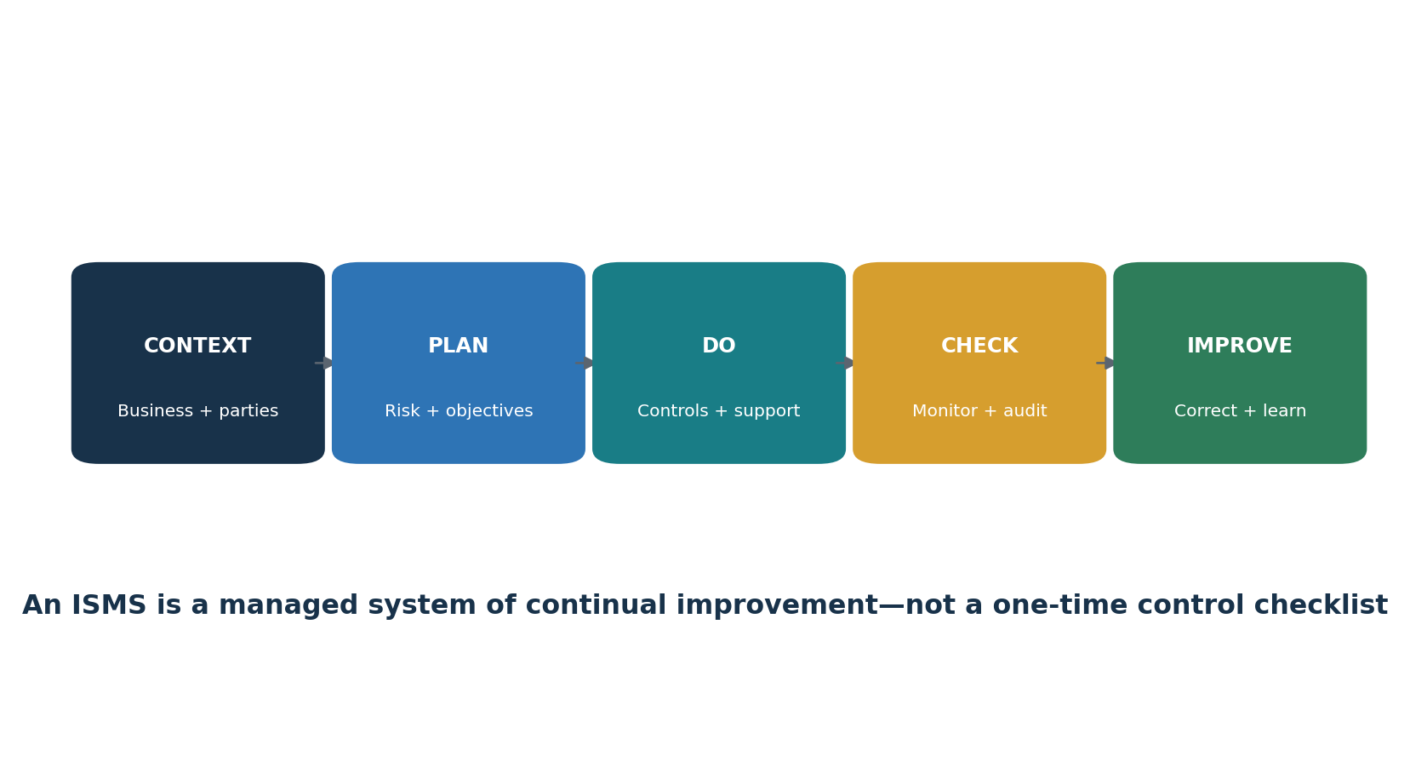
Figure 1. ISMS continual-improvement cycle
Document | Role | Certification
ISO/IEC 27001:2022 | Normative ISMS requirements, including Annex A reference controls | Organizations can be certified to it
ISO/IEC 27001:2022/Amd 1:2024 | Climate-action changes affecting context and interested-party consideration | Applied with the base standard
ISO/IEC 27002:2022 | Implementation guidance for information-security controls | Not a certification standard
ISO/IEC 27005:2022 | Guidance for information-security risk management | Supporting guidance, not the 27001 certification standard

- Clauses 4–10 contain requirements an organization must address for conformity.
- Annex A lists 93 reference controls in four themes: 37 organizational, 8 people, 14 physical, and 34 technological.
- Control selection follows risk treatment and applicable obligations; Annex A is not a universal checklist where every control must always be implemented.
- The Statement of Applicability records necessary controls, justification, implementation status, and justified exclusions from Annex A.

2. ISMS Scope and Interested Parties
How to define a defensible boundary for the management system.
- Identify business objectives, products, services, processes, information, legal entities, locations, people, suppliers, technologies, and dependencies.
- Understand relevant internal issues such as strategy, culture, skills, architecture, governance, and resources.
- Understand relevant external issues such as threats, laws, contracts, markets, suppliers, physical conditions, and technology change.
- Determine interested parties and relevant requirements, including customers, regulators, workers, owners, suppliers, communities, and certification stakeholders.
- Consider whether climate change is relevant to ISMS effectiveness and whether interested parties have climate-related requirements; document the reasoning.
- Define scope boundaries, interfaces, exclusions, dependencies, and justification in language that can be audited.
- Keep scope aligned with asset, process, network, cloud, supplier, and data-flow inventories.
Scope test | Manager question | Evidence
Boundary | Which legal entities, sites, services, processes, and technology are included? | Approved scope statement and maps
Interfaces | What connects the scope to other teams, systems, suppliers, and locations? | Data flows, architecture, contracts, responsibility matrix
Completeness | Could important information or risk be hidden outside the stated boundary? | Reconciled inventories and discovery
Change | What triggers a scope review? | Change records, acquisition and product gates
Climate relevance | Could climate effects or stakeholder expectations affect availability, suppliers, facilities, people, or obligations? | Context analysis, decision, actions when relevant

3. Risk Assessment and Risk Treatment
A repeatable method that connects business risk to control decisions.
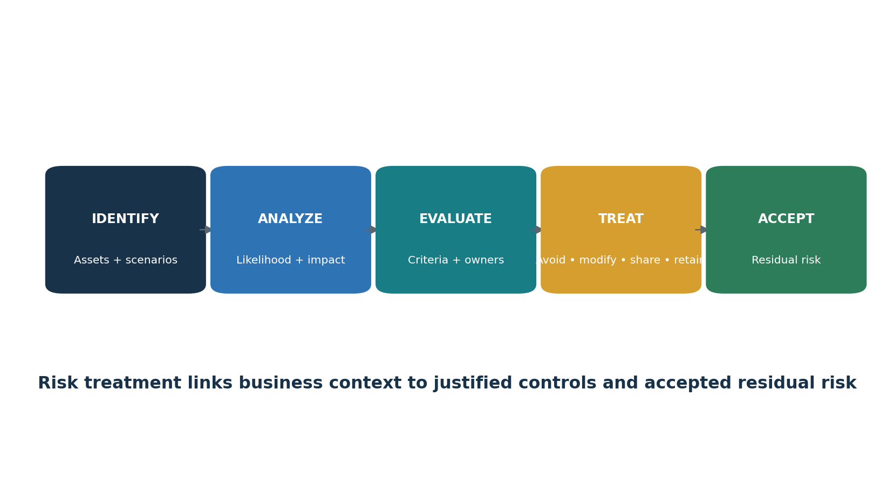
Figure 2. Information-security risk workflow
Define risk criteria before scoring: risk identification method, likelihood and consequence scales, calculation rules, acceptance thresholds, required treatment, escalation, review frequency, and risk-owner authority. Apply the method consistently enough to produce valid and comparable results.
Field | Example content
Asset or objective | Customer portal and contractually required availability
Threat event | Credential theft followed by unauthorized administrative access
Vulnerability or condition | Weak enrollment and no phishing-resistant MFA
Consequences | Data disclosure, outage, contractual breach, response cost
Existing controls | MFA, conditional access, logging, support verification
Inherent or current risk | Score using approved likelihood and consequence criteria
Treatment | Modify risk through stronger authentication and monitored recovery
Owner and date | Named accountable risk owner and target date
Residual risk | Reassess after treatment; obtain explicit owner approval

4. Statement of Applicability
The bridge between risk treatment, Annex A, other controls, and audit evidence.
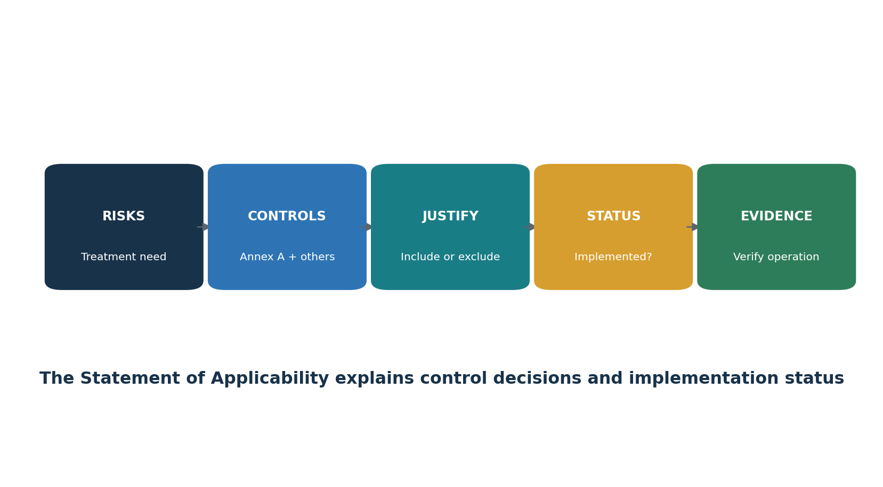
Figure 3. Statement of Applicability workflow
- List the controls necessary to treat identified information-security risks and meet legal, regulatory, contractual, and business requirements.
- Compare selected controls to Annex A so necessary reference controls are not overlooked.
- Record whether each Annex A control is applicable and justify inclusion or exclusion.
- Record implementation status clearly and keep it consistent with the risk-treatment plan and operating evidence.
- Include organization-specific controls when Annex A does not fully address a risk.
- Control the SoA as documented information and update it after material risk, scope, legal, supplier, technology, or control changes.
Control | Applicable? | Justification | Status | Owner / evidence
Example 8.15 logging | Yes | Needed for detection, investigation, and obligations | Implemented with open actions | Security Operations / source inventory and review records
Example 7.9 off-premises assets | Yes | Remote and traveling personnel use company devices | Implemented | IT Operations / inventory and encryption proof
Example organization control | Yes | Specific product-safety risk requires signed releases | Partially implemented | Engineering / pipeline records
Example exclusion | No | The described technology or scenario is absent from the controlled scope | Not applicable | Scope and architecture evidence

5. Documentation and Evidence
How to maintain useful documented information without creating bureaucracy.
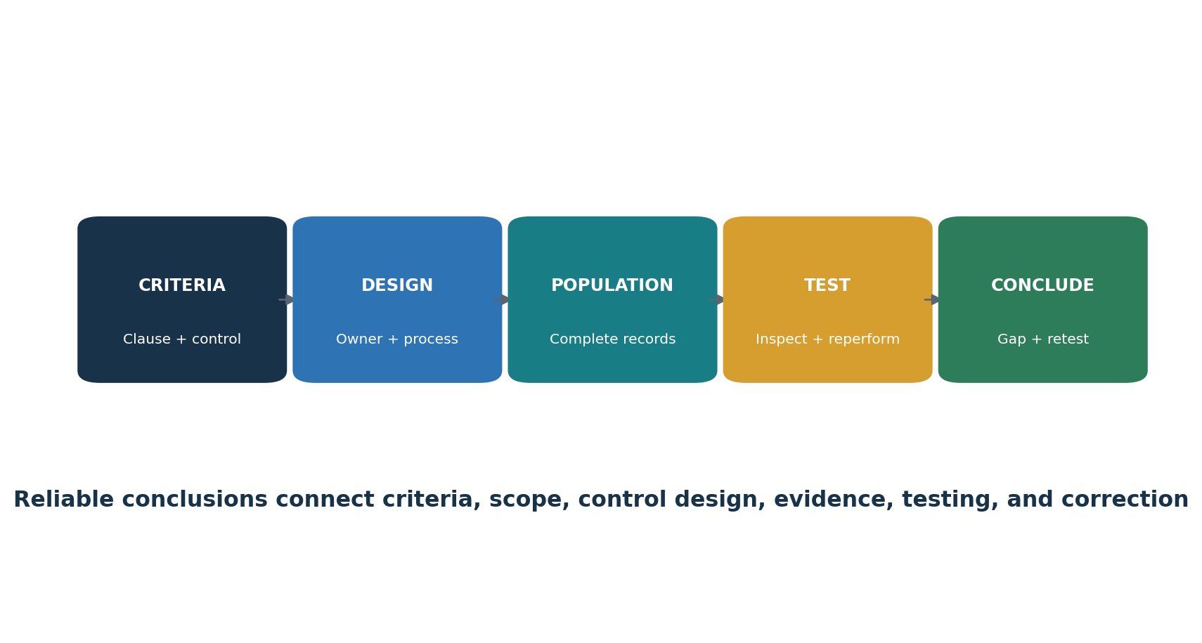
Figure 4. Requirement-to-evidence chain
Document or record | Purpose | Control checks
ISMS scope | Defines boundary and interfaces | Approved, current, consistent with reality
Policy | Sets direction and commitments | Approved, communicated, reviewed
Risk method and register | Shows repeatable assessment and decisions | Criteria applied consistently; owners approve residual risk
Risk-treatment plan | Tracks actions, owners, resources, and dates | Aligned to risks and SoA
Statement of Applicability | Explains control selection and status | All Annex A controls addressed; justifications supported
Objectives and metrics | Shows planned outcomes and evaluation | Measurable, owned, analyzed, acted upon
Competence and awareness records | Supports capability and understanding | Role-based, evaluated, current
Operational evidence | Shows controls actually operated | Complete, authentic, protected, retained
Audit and review records | Supports oversight and decisions | Objective, complete, followed through
Corrective-action records | Shows root cause and effective correction | Cause addressed, recurrence considered, effectiveness verified

6. Clause 4 — Context of the organization
Plain-language requirements, verification focus, and example evidence.
Clause purpose: Context of the organization

Clause | Plain meaning | Verification focus | Example evidence
4.1 | Understand internal and external issues that can affect the ISMS; explicitly consider whether climate change is relevant. | Confirm ownership, scope, method, approval, operating evidence, exceptions, correction, and retained records. | Policies, registers, plans, records, minutes, results, approvals, and follow-up evidence.
4.2 | Identify relevant interested parties, their requirements, and whether they include climate-related expectations. | Confirm ownership, scope, method, approval, operating evidence, exceptions, correction, and retained records. | Policies, registers, plans, records, minutes, results, approvals, and follow-up evidence.
4.3 | Define and maintain the ISMS scope, including boundaries, interfaces, dependencies, locations, technology, and exclusions. | Confirm ownership, scope, method, approval, operating evidence, exceptions, correction, and retained records. | Policies, registers, plans, records, minutes, results, approvals, and follow-up evidence.
4.4 | Establish, operate, maintain, and continually improve the ISMS and its required processes. | Confirm ownership, scope, method, approval, operating evidence, exceptions, correction, and retained records. | Policies, registers, plans, records, minutes, results, approvals, and follow-up evidence.

Use the licensed official ISO/IEC 27001 text for exact normative requirements. This manual paraphrases concepts for education and does not replace the standard.
2024 amendment: Explicitly determine whether climate change is relevant to the ISMS context and recognize that relevant interested parties may have climate-related requirements. Keep evidence of the reasoning and any resulting action.

7. Clause 5 — Leadership
Plain-language requirements, verification focus, and example evidence.
Clause purpose: Leadership

Clause | Plain meaning | Verification focus | Example evidence
5.1 | Top management demonstrates commitment, integrates the ISMS into business processes, supplies resources, and supports improvement. | Confirm ownership, scope, method, approval, operating evidence, exceptions, correction, and retained records. | Policies, registers, plans, records, minutes, results, approvals, and follow-up evidence.
5.2 | Establish, communicate, and maintain an information-security policy appropriate to the organization. | Confirm ownership, scope, method, approval, operating evidence, exceptions, correction, and retained records. | Policies, registers, plans, records, minutes, results, approvals, and follow-up evidence.
5.3 | Assign and communicate information-security responsibilities and reporting authority. | Confirm ownership, scope, method, approval, operating evidence, exceptions, correction, and retained records. | Policies, registers, plans, records, minutes, results, approvals, and follow-up evidence.

Use the licensed official ISO/IEC 27001 text for exact normative requirements. This manual paraphrases concepts for education and does not replace the standard.

8. Clause 6 — Planning
Plain-language requirements, verification focus, and example evidence.
Clause purpose: Planning

Clause | Plain meaning | Verification focus | Example evidence
6.1.1 | Determine ISMS-level risks and opportunities, plan actions, integrate them into ISMS processes, and evaluate effectiveness. | Confirm ownership, scope, method, approval, operating evidence, exceptions, correction, and retained records. | Policies, registers, plans, records, minutes, results, approvals, and follow-up evidence.
6.1.2 | Define and apply consistent information-security risk criteria and assessment methods; identify owners and analyze and evaluate risks. | Confirm ownership, scope, method, approval, operating evidence, exceptions, correction, and retained records. | Policies, registers, plans, records, minutes, results, approvals, and follow-up evidence.
6.1.3 | Choose risk-treatment options and controls, compare them with Annex A, produce the Statement of Applicability and treatment plan, and obtain risk-owner approval. | Confirm ownership, scope, method, approval, operating evidence, exceptions, correction, and retained records. | Policies, registers, plans, records, minutes, results, approvals, and follow-up evidence.
6.2 | Set measurable security objectives with owners, resources, dates, and evaluation methods. | Confirm ownership, scope, method, approval, operating evidence, exceptions, correction, and retained records. | Policies, registers, plans, records, minutes, results, approvals, and follow-up evidence.
6.3 | Plan ISMS changes so their purpose, consequences, resources, responsibilities, and system integrity are considered. | Confirm ownership, scope, method, approval, operating evidence, exceptions, correction, and retained records. | Policies, registers, plans, records, minutes, results, approvals, and follow-up evidence.

Use the licensed official ISO/IEC 27001 text for exact normative requirements. This manual paraphrases concepts for education and does not replace the standard.

9. Clause 7 — Support
Plain-language requirements, verification focus, and example evidence.
Clause purpose: Support

Clause | Plain meaning | Verification focus | Example evidence
7.1 | Provide people, funding, technology, and other resources needed by the ISMS. | Confirm ownership, scope, method, approval, operating evidence, exceptions, correction, and retained records. | Policies, registers, plans, records, minutes, results, approvals, and follow-up evidence.
7.2 | Define competence needs, close gaps, evaluate results, and keep evidence. | Confirm ownership, scope, method, approval, operating evidence, exceptions, correction, and retained records. | Policies, registers, plans, records, minutes, results, approvals, and follow-up evidence.
7.3 | Ensure people understand the policy, their contribution, and consequences of nonconformity. | Confirm ownership, scope, method, approval, operating evidence, exceptions, correction, and retained records. | Policies, registers, plans, records, minutes, results, approvals, and follow-up evidence.
7.4 | Plan what, when, with whom, and how the organization communicates internally and externally. | Confirm ownership, scope, method, approval, operating evidence, exceptions, correction, and retained records. | Policies, registers, plans, records, minutes, results, approvals, and follow-up evidence.
7.5 | Create, approve, identify, protect, distribute, retain, and control required documented information. | Confirm ownership, scope, method, approval, operating evidence, exceptions, correction, and retained records. | Policies, registers, plans, records, minutes, results, approvals, and follow-up evidence.

Use the licensed official ISO/IEC 27001 text for exact normative requirements. This manual paraphrases concepts for education and does not replace the standard.

10. Clause 8 — Operation
Plain-language requirements, verification focus, and example evidence.
Clause purpose: Operation

Clause | Plain meaning | Verification focus | Example evidence
8.1 | Plan and control ISMS processes, criteria, changes, outsourced work, and evidence of proper operation. | Confirm ownership, scope, method, approval, operating evidence, exceptions, correction, and retained records. | Policies, registers, plans, records, minutes, results, approvals, and follow-up evidence.
8.2 | Perform information-security risk assessments at planned intervals and when significant changes occur. | Confirm ownership, scope, method, approval, operating evidence, exceptions, correction, and retained records. | Policies, registers, plans, records, minutes, results, approvals, and follow-up evidence.
8.3 | Implement the risk-treatment plan and retain evidence of results. | Confirm ownership, scope, method, approval, operating evidence, exceptions, correction, and retained records. | Policies, registers, plans, records, minutes, results, approvals, and follow-up evidence.

Use the licensed official ISO/IEC 27001 text for exact normative requirements. This manual paraphrases concepts for education and does not replace the standard.

11. Clause 9 — Performance evaluation
Plain-language requirements, verification focus, and example evidence.
Clause purpose: Performance evaluation

Clause | Plain meaning | Verification focus | Example evidence
9.1 | Define what to monitor and measure, how and when to do it, who evaluates it, and how results are retained and analyzed. | Confirm ownership, scope, method, approval, operating evidence, exceptions, correction, and retained records. | Policies, registers, plans, records, minutes, results, approvals, and follow-up evidence.
9.2.1 | Conduct internal audits at planned intervals to evaluate conformity with organizational and ISO/IEC 27001 requirements and effective implementation. | Confirm ownership, scope, method, approval, operating evidence, exceptions, correction, and retained records. | Policies, registers, plans, records, minutes, results, approvals, and follow-up evidence.
9.2.2 | Maintain an audit program with frequency, methods, responsibilities, planning, reporting, scope, criteria, objective auditors, retained results, and timely corrective action. | Confirm ownership, scope, method, approval, operating evidence, exceptions, correction, and retained records. | Policies, registers, plans, records, minutes, results, approvals, and follow-up evidence.
9.3.1 | Top management reviews the ISMS at planned intervals for continuing suitability, adequacy, and effectiveness. | Confirm ownership, scope, method, approval, operating evidence, exceptions, correction, and retained records. | Policies, registers, plans, records, minutes, results, approvals, and follow-up evidence.
9.3.2 | Review required inputs such as previous actions, context changes, interested-party needs, performance, feedback, risk, treatment, and improvement opportunities. | Confirm ownership, scope, method, approval, operating evidence, exceptions, correction, and retained records. | Policies, registers, plans, records, minutes, results, approvals, and follow-up evidence.
9.3.3 | Record management-review decisions about improvement and needed ISMS changes. | Confirm ownership, scope, method, approval, operating evidence, exceptions, correction, and retained records. | Policies, registers, plans, records, minutes, results, approvals, and follow-up evidence.

Use the licensed official ISO/IEC 27001 text for exact normative requirements. This manual paraphrases concepts for education and does not replace the standard.
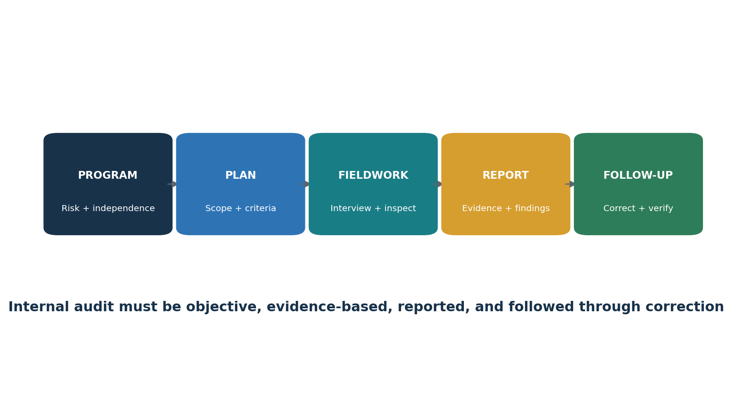
Figure 5. Internal-audit workflow

12. Clause 10 — Improvement
Plain-language requirements, verification focus, and example evidence.
Clause purpose: Improvement

Clause | Plain meaning | Verification focus | Example evidence
10.1 | Continually improve the suitability, adequacy, and effectiveness of the ISMS. | Confirm ownership, scope, method, approval, operating evidence, exceptions, correction, and retained records. | Policies, registers, plans, records, minutes, results, approvals, and follow-up evidence.
10.2 | React to nonconformities, correct them, analyze causes, prevent recurrence, verify effectiveness, and retain evidence. | Confirm ownership, scope, method, approval, operating evidence, exceptions, correction, and retained records. | Policies, registers, plans, records, minutes, results, approvals, and follow-up evidence.

Use the licensed official ISO/IEC 27001 text for exact normative requirements. This manual paraphrases concepts for education and does not replace the standard.
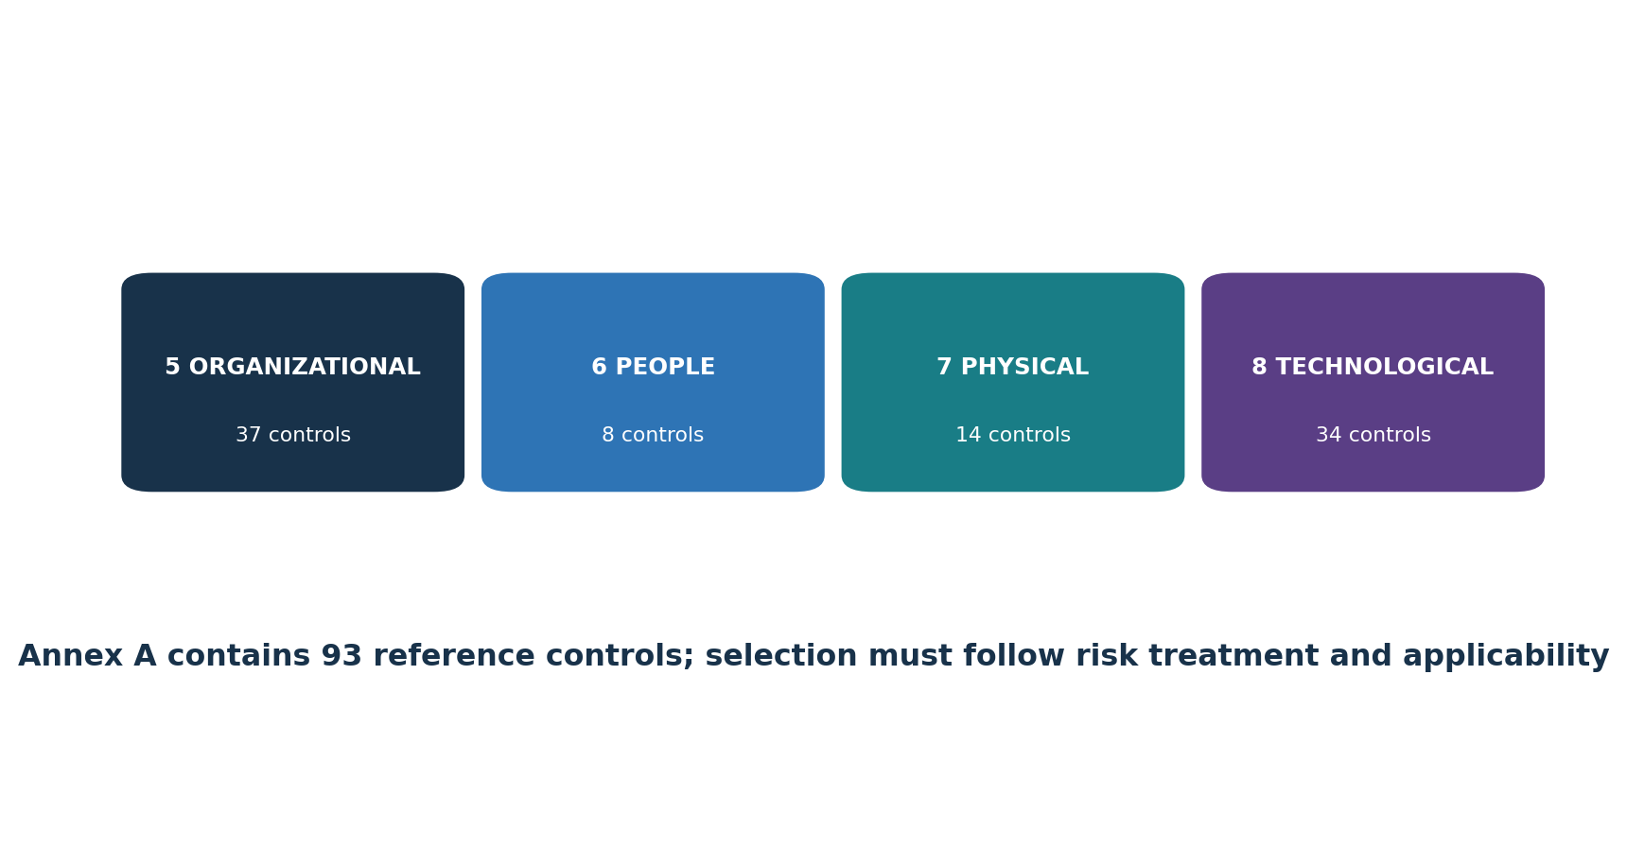
Figure 6. Annex A control themes

13. Annex A 5 Organizational controls
Original summaries of the reference controls, verification focus, and evidence examples.
Control | Practical meaning | Verification focus | Example evidence
5.1 | Maintain approved information-security policies. | Confirm risk or obligation, design, owner, implementation, operation, exceptions, and measurement. | Procedure, configuration, record, log, ticket, review, test, or observation.
5.2 | Define security roles and responsibilities. | Confirm risk or obligation, design, owner, implementation, operation, exceptions, and measurement. | Procedure, configuration, record, log, ticket, review, test, or observation.
5.3 | Separate conflicting duties. | Confirm risk or obligation, design, owner, implementation, operation, exceptions, and measurement. | Procedure, configuration, record, log, ticket, review, test, or observation.
5.4 | Require managers to enforce security responsibilities. | Confirm risk or obligation, design, owner, implementation, operation, exceptions, and measurement. | Procedure, configuration, record, log, ticket, review, test, or observation.
5.5 | Maintain appropriate contact with authorities. | Confirm risk or obligation, design, owner, implementation, operation, exceptions, and measurement. | Procedure, configuration, record, log, ticket, review, test, or observation.
5.6 | Participate in relevant security groups and professional forums. | Confirm risk or obligation, design, owner, implementation, operation, exceptions, and measurement. | Procedure, configuration, record, log, ticket, review, test, or observation.
5.7 | Collect and use threat intelligence. | Confirm risk or obligation, design, owner, implementation, operation, exceptions, and measurement. | Procedure, configuration, record, log, ticket, review, test, or observation.
5.8 | Build security into project management. | Confirm risk or obligation, design, owner, implementation, operation, exceptions, and measurement. | Procedure, configuration, record, log, ticket, review, test, or observation.
5.9 | Inventory information and associated assets. | Confirm risk or obligation, design, owner, implementation, operation, exceptions, and measurement. | Procedure, configuration, record, log, ticket, review, test, or observation.
5.10 | Define acceptable use and handling rules. | Confirm risk or obligation, design, owner, implementation, operation, exceptions, and measurement. | Procedure, configuration, record, log, ticket, review, test, or observation.
5.11 | Recover organizational assets when roles end or change. | Confirm risk or obligation, design, owner, implementation, operation, exceptions, and measurement. | Procedure, configuration, record, log, ticket, review, test, or observation.
5.12 | Classify information according to need and risk. | Confirm risk or obligation, design, owner, implementation, operation, exceptions, and measurement. | Procedure, configuration, record, log, ticket, review, test, or observation.
5.13 | Label information consistently with classification. | Confirm risk or obligation, design, owner, implementation, operation, exceptions, and measurement. | Procedure, configuration, record, log, ticket, review, test, or observation.
5.14 | Protect information transfers. | Confirm risk or obligation, design, owner, implementation, operation, exceptions, and measurement. | Procedure, configuration, record, log, ticket, review, test, or observation.
5.15 | Establish access-control rules. | Confirm risk or obligation, design, owner, implementation, operation, exceptions, and measurement. | Procedure, configuration, record, log, ticket, review, test, or observation.
5.16 | Manage identities throughout their life cycle. | Confirm risk or obligation, design, owner, implementation, operation, exceptions, and measurement. | Procedure, configuration, record, log, ticket, review, test, or observation.
5.17 | Protect authentication information. | Confirm risk or obligation, design, owner, implementation, operation, exceptions, and measurement. | Procedure, configuration, record, log, ticket, review, test, or observation.
5.18 | Approve, review, modify, and remove access rights. | Confirm risk or obligation, design, owner, implementation, operation, exceptions, and measurement. | Procedure, configuration, record, log, ticket, review, test, or observation.
5.19 | Manage security risk in supplier relationships. | Confirm risk or obligation, design, owner, implementation, operation, exceptions, and measurement. | Procedure, configuration, record, log, ticket, review, test, or observation.
5.20 | Include security requirements in supplier agreements. | Confirm risk or obligation, design, owner, implementation, operation, exceptions, and measurement. | Procedure, configuration, record, log, ticket, review, test, or observation.
5.21 | Manage ICT supply-chain security risk. | Confirm risk or obligation, design, owner, implementation, operation, exceptions, and measurement. | Procedure, configuration, record, log, ticket, review, test, or observation.
5.22 | Monitor, review, and control supplier-service changes. | Confirm risk or obligation, design, owner, implementation, operation, exceptions, and measurement. | Procedure, configuration, record, log, ticket, review, test, or observation.
5.23 | Govern acquisition, use, management, and exit from cloud services. | Confirm risk or obligation, design, owner, implementation, operation, exceptions, and measurement. | Procedure, configuration, record, log, ticket, review, test, or observation.
5.24 | Prepare and plan for security-incident management. | Confirm risk or obligation, design, owner, implementation, operation, exceptions, and measurement. | Procedure, configuration, record, log, ticket, review, test, or observation.
5.25 | Assess events and decide whether they are incidents. | Confirm risk or obligation, design, owner, implementation, operation, exceptions, and measurement. | Procedure, configuration, record, log, ticket, review, test, or observation.
5.26 | Respond to security incidents. | Confirm risk or obligation, design, owner, implementation, operation, exceptions, and measurement. | Procedure, configuration, record, log, ticket, review, test, or observation.
5.27 | Learn from incidents and improve controls. | Confirm risk or obligation, design, owner, implementation, operation, exceptions, and measurement. | Procedure, configuration, record, log, ticket, review, test, or observation.
5.28 | Identify, collect, acquire, and preserve evidence. | Confirm risk or obligation, design, owner, implementation, operation, exceptions, and measurement. | Procedure, configuration, record, log, ticket, review, test, or observation.
5.29 | Protect information during disruption. | Confirm risk or obligation, design, owner, implementation, operation, exceptions, and measurement. | Procedure, configuration, record, log, ticket, review, test, or observation.
5.30 | Prepare ICT to support business continuity. | Confirm risk or obligation, design, owner, implementation, operation, exceptions, and measurement. | Procedure, configuration, record, log, ticket, review, test, or observation.
5.31 | Identify and meet legal, regulatory, and contractual requirements. | Confirm risk or obligation, design, owner, implementation, operation, exceptions, and measurement. | Procedure, configuration, record, log, ticket, review, test, or observation.
5.32 | Protect intellectual-property rights. | Confirm risk or obligation, design, owner, implementation, operation, exceptions, and measurement. | Procedure, configuration, record, log, ticket, review, test, or observation.
5.33 | Protect records throughout their life cycle. | Confirm risk or obligation, design, owner, implementation, operation, exceptions, and measurement. | Procedure, configuration, record, log, ticket, review, test, or observation.
5.34 | Protect privacy and personally identifiable information. | Confirm risk or obligation, design, owner, implementation, operation, exceptions, and measurement. | Procedure, configuration, record, log, ticket, review, test, or observation.
5.35 | Arrange independent reviews of information security. | Confirm risk or obligation, design, owner, implementation, operation, exceptions, and measurement. | Procedure, configuration, record, log, ticket, review, test, or observation.
5.36 | Check compliance with security policies, rules, and standards. | Confirm risk or obligation, design, owner, implementation, operation, exceptions, and measurement. | Procedure, configuration, record, log, ticket, review, test, or observation.
5.37 | Maintain documented operating procedures. | Confirm risk or obligation, design, owner, implementation, operation, exceptions, and measurement. | Procedure, configuration, record, log, ticket, review, test, or observation.

Selection rule: Annex A is a reference set used to check that necessary controls were not overlooked. The organization may need other controls. Every inclusion or exclusion must be justified through risk treatment and recorded in the Statement of Applicability.

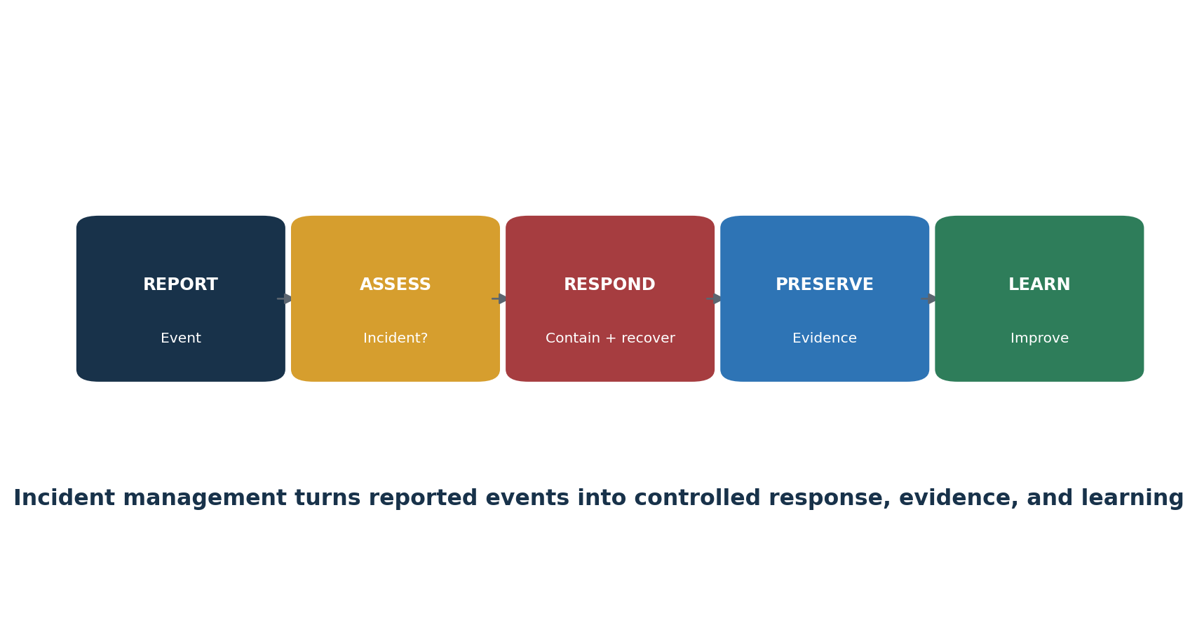
Figure 7. Security-incident management

14. Annex A 6 People controls
Original summaries of the reference controls, verification focus, and evidence examples.
Control | Practical meaning | Verification focus | Example evidence
6.1 | Screen candidates and personnel according to law, role, and risk. | Confirm risk or obligation, design, owner, implementation, operation, exceptions, and measurement. | Procedure, configuration, record, log, ticket, review, test, or observation.
6.2 | Include security responsibilities in employment terms. | Confirm risk or obligation, design, owner, implementation, operation, exceptions, and measurement. | Procedure, configuration, record, log, ticket, review, test, or observation.
6.3 | Provide continuing role-based awareness, education, and training. | Confirm risk or obligation, design, owner, implementation, operation, exceptions, and measurement. | Procedure, configuration, record, log, ticket, review, test, or observation.
6.4 | Operate a fair, communicated disciplinary process. | Confirm risk or obligation, design, owner, implementation, operation, exceptions, and measurement. | Procedure, configuration, record, log, ticket, review, test, or observation.
6.5 | Manage security duties after termination or role change. | Confirm risk or obligation, design, owner, implementation, operation, exceptions, and measurement. | Procedure, configuration, record, log, ticket, review, test, or observation.
6.6 | Use suitable confidentiality or non-disclosure agreements. | Confirm risk or obligation, design, owner, implementation, operation, exceptions, and measurement. | Procedure, configuration, record, log, ticket, review, test, or observation.
6.7 | Protect information during remote work. | Confirm risk or obligation, design, owner, implementation, operation, exceptions, and measurement. | Procedure, configuration, record, log, ticket, review, test, or observation.
6.8 | Make security-event reporting easy and timely. | Confirm risk or obligation, design, owner, implementation, operation, exceptions, and measurement. | Procedure, configuration, record, log, ticket, review, test, or observation.

Selection rule: Annex A is a reference set used to check that necessary controls were not overlooked. The organization may need other controls. Every inclusion or exclusion must be justified through risk treatment and recorded in the Statement of Applicability.

15. Annex A 7 Physical controls
Original summaries of the reference controls, verification focus, and evidence examples.
Control | Practical meaning | Verification focus | Example evidence
7.1 | Define and protect physical security perimeters. | Confirm risk or obligation, design, owner, implementation, operation, exceptions, and measurement. | Procedure, configuration, record, log, ticket, review, test, or observation.
7.2 | Control physical entry. | Confirm risk or obligation, design, owner, implementation, operation, exceptions, and measurement. | Procedure, configuration, record, log, ticket, review, test, or observation.
7.3 | Secure offices, rooms, and facilities. | Confirm risk or obligation, design, owner, implementation, operation, exceptions, and measurement. | Procedure, configuration, record, log, ticket, review, test, or observation.
7.4 | Monitor premises for unauthorized physical access. | Confirm risk or obligation, design, owner, implementation, operation, exceptions, and measurement. | Procedure, configuration, record, log, ticket, review, test, or observation.
7.5 | Protect against physical and environmental threats. | Confirm risk or obligation, design, owner, implementation, operation, exceptions, and measurement. | Procedure, configuration, record, log, ticket, review, test, or observation.
7.6 | Apply working rules for secure areas. | Confirm risk or obligation, design, owner, implementation, operation, exceptions, and measurement. | Procedure, configuration, record, log, ticket, review, test, or observation.
7.7 | Use clear-desk and clear-screen practices. | Confirm risk or obligation, design, owner, implementation, operation, exceptions, and measurement. | Procedure, configuration, record, log, ticket, review, test, or observation.
7.8 | Site and protect equipment appropriately. | Confirm risk or obligation, design, owner, implementation, operation, exceptions, and measurement. | Procedure, configuration, record, log, ticket, review, test, or observation.
7.9 | Protect assets used away from organizational premises. | Confirm risk or obligation, design, owner, implementation, operation, exceptions, and measurement. | Procedure, configuration, record, log, ticket, review, test, or observation.
7.10 | Manage storage media throughout its life cycle. | Confirm risk or obligation, design, owner, implementation, operation, exceptions, and measurement. | Procedure, configuration, record, log, ticket, review, test, or observation.
7.11 | Protect supporting utilities. | Confirm risk or obligation, design, owner, implementation, operation, exceptions, and measurement. | Procedure, configuration, record, log, ticket, review, test, or observation.
7.12 | Protect power and data cabling. | Confirm risk or obligation, design, owner, implementation, operation, exceptions, and measurement. | Procedure, configuration, record, log, ticket, review, test, or observation.
7.13 | Maintain equipment securely. | Confirm risk or obligation, design, owner, implementation, operation, exceptions, and measurement. | Procedure, configuration, record, log, ticket, review, test, or observation.
7.14 | Securely dispose of or reuse equipment. | Confirm risk or obligation, design, owner, implementation, operation, exceptions, and measurement. | Procedure, configuration, record, log, ticket, review, test, or observation.

Selection rule: Annex A is a reference set used to check that necessary controls were not overlooked. The organization may need other controls. Every inclusion or exclusion must be justified through risk treatment and recorded in the Statement of Applicability.

16. Annex A 8 Technological controls
Original summaries of the reference controls, verification focus, and evidence examples.
Control | Practical meaning | Verification focus | Example evidence
8.1 | Secure user endpoint devices. | Confirm risk or obligation, design, owner, implementation, operation, exceptions, and measurement. | Procedure, configuration, record, log, ticket, review, test, or observation.
8.2 | Control privileged access rights. | Confirm risk or obligation, design, owner, implementation, operation, exceptions, and measurement. | Procedure, configuration, record, log, ticket, review, test, or observation.
8.3 | Restrict access to information according to policy. | Confirm risk or obligation, design, owner, implementation, operation, exceptions, and measurement. | Procedure, configuration, record, log, ticket, review, test, or observation.
8.4 | Control access to source code and development tools. | Confirm risk or obligation, design, owner, implementation, operation, exceptions, and measurement. | Procedure, configuration, record, log, ticket, review, test, or observation.
8.5 | Use secure authentication. | Confirm risk or obligation, design, owner, implementation, operation, exceptions, and measurement. | Procedure, configuration, record, log, ticket, review, test, or observation.
8.6 | Manage capacity. | Confirm risk or obligation, design, owner, implementation, operation, exceptions, and measurement. | Procedure, configuration, record, log, ticket, review, test, or observation.
8.7 | Protect against malware. | Confirm risk or obligation, design, owner, implementation, operation, exceptions, and measurement. | Procedure, configuration, record, log, ticket, review, test, or observation.
8.8 | Manage technical vulnerabilities. | Confirm risk or obligation, design, owner, implementation, operation, exceptions, and measurement. | Procedure, configuration, record, log, ticket, review, test, or observation.
8.9 | Manage configurations. | Confirm risk or obligation, design, owner, implementation, operation, exceptions, and measurement. | Procedure, configuration, record, log, ticket, review, test, or observation.
8.10 | Delete information securely when no longer needed. | Confirm risk or obligation, design, owner, implementation, operation, exceptions, and measurement. | Procedure, configuration, record, log, ticket, review, test, or observation.
8.11 | Mask sensitive data when appropriate. | Confirm risk or obligation, design, owner, implementation, operation, exceptions, and measurement. | Procedure, configuration, record, log, ticket, review, test, or observation.
8.12 | Prevent data leakage. | Confirm risk or obligation, design, owner, implementation, operation, exceptions, and measurement. | Procedure, configuration, record, log, ticket, review, test, or observation.
8.13 | Maintain and test backups. | Confirm risk or obligation, design, owner, implementation, operation, exceptions, and measurement. | Procedure, configuration, record, log, ticket, review, test, or observation.
8.14 | Provide redundancy where availability requires it. | Confirm risk or obligation, design, owner, implementation, operation, exceptions, and measurement. | Procedure, configuration, record, log, ticket, review, test, or observation.
8.15 | Generate, protect, retain, and review logs. | Confirm risk or obligation, design, owner, implementation, operation, exceptions, and measurement. | Procedure, configuration, record, log, ticket, review, test, or observation.
8.16 | Monitor systems and networks for abnormal behavior. | Confirm risk or obligation, design, owner, implementation, operation, exceptions, and measurement. | Procedure, configuration, record, log, ticket, review, test, or observation.
8.17 | Synchronize clocks. | Confirm risk or obligation, design, owner, implementation, operation, exceptions, and measurement. | Procedure, configuration, record, log, ticket, review, test, or observation.
8.18 | Control powerful system utilities. | Confirm risk or obligation, design, owner, implementation, operation, exceptions, and measurement. | Procedure, configuration, record, log, ticket, review, test, or observation.
8.19 | Control software installation on operational systems. | Confirm risk or obligation, design, owner, implementation, operation, exceptions, and measurement. | Procedure, configuration, record, log, ticket, review, test, or observation.
8.20 | Secure networks. | Confirm risk or obligation, design, owner, implementation, operation, exceptions, and measurement. | Procedure, configuration, record, log, ticket, review, test, or observation.
8.21 | Secure network services. | Confirm risk or obligation, design, owner, implementation, operation, exceptions, and measurement. | Procedure, configuration, record, log, ticket, review, test, or observation.
8.22 | Segregate networks where needed. | Confirm risk or obligation, design, owner, implementation, operation, exceptions, and measurement. | Procedure, configuration, record, log, ticket, review, test, or observation.
8.23 | Control access to external websites. | Confirm risk or obligation, design, owner, implementation, operation, exceptions, and measurement. | Procedure, configuration, record, log, ticket, review, test, or observation.
8.24 | Use and manage cryptography appropriately. | Confirm risk or obligation, design, owner, implementation, operation, exceptions, and measurement. | Procedure, configuration, record, log, ticket, review, test, or observation.
8.25 | Operate a secure development life cycle. | Confirm risk or obligation, design, owner, implementation, operation, exceptions, and measurement. | Procedure, configuration, record, log, ticket, review, test, or observation.
8.26 | Define application-security requirements. | Confirm risk or obligation, design, owner, implementation, operation, exceptions, and measurement. | Procedure, configuration, record, log, ticket, review, test, or observation.
8.27 | Apply secure architecture and engineering principles. | Confirm risk or obligation, design, owner, implementation, operation, exceptions, and measurement. | Procedure, configuration, record, log, ticket, review, test, or observation.
8.28 | Use secure coding practices. | Confirm risk or obligation, design, owner, implementation, operation, exceptions, and measurement. | Procedure, configuration, record, log, ticket, review, test, or observation.
8.29 | Perform security testing in development and acceptance. | Confirm risk or obligation, design, owner, implementation, operation, exceptions, and measurement. | Procedure, configuration, record, log, ticket, review, test, or observation.
8.30 | Control outsourced development. | Confirm risk or obligation, design, owner, implementation, operation, exceptions, and measurement. | Procedure, configuration, record, log, ticket, review, test, or observation.
8.31 | Separate development, test, and production environments. | Confirm risk or obligation, design, owner, implementation, operation, exceptions, and measurement. | Procedure, configuration, record, log, ticket, review, test, or observation.
8.32 | Manage changes securely. | Confirm risk or obligation, design, owner, implementation, operation, exceptions, and measurement. | Procedure, configuration, record, log, ticket, review, test, or observation.
8.33 | Protect test information. | Confirm risk or obligation, design, owner, implementation, operation, exceptions, and measurement. | Procedure, configuration, record, log, ticket, review, test, or observation.
8.34 | Protect operational systems during audit testing. | Confirm risk or obligation, design, owner, implementation, operation, exceptions, and measurement. | Procedure, configuration, record, log, ticket, review, test, or observation.

Selection rule: Annex A is a reference set used to check that necessary controls were not overlooked. The organization may need other controls. Every inclusion or exclusion must be justified through risk treatment and recorded in the Statement of Applicability.

17. Implementing Controls with ISO/IEC 27002
How to turn risk decisions into controls that fit the organization.
- Start with the risk-treatment decision, obligation, and expected outcome—not with a tool.
- Use ISO/IEC 27002 guidance and relevant attributes to understand purpose, implementation considerations, and relationships.
- Tailor the control to people, process, technology, physical environment, legal constraints, and business operations.
- Define owner, scope, trigger, inputs, steps, outputs, records, frequency, dependencies, exceptions, and escalation.
- Evaluate whether the design would reasonably achieve the intended outcome.
- Implement through controlled change and train affected people.
- Measure operation and effectiveness, investigate exceptions, and improve.
- Update risks, treatment plan, SoA, procedures, and evidence when the control changes.
Important distinction: ISO/IEC 27002 provides guidance. The organization remains responsible for selecting and designing controls that treat its risks and meet applicable requirements.

18. Metrics and Control Testing
How to verify whether the ISMS and its controls work.
Area | Population and sample | Test | Evidence
Risk | All current risks; sample high, changed, accepted, and overdue items | Reperform scoring, trace treatment, confirm owner approval and review | Method, register, approvals, treatment and residual risk
Access | All workforce, privileged, service, and third-party identities | Test need, approval, MFA, review, change, inactivity, and termination | Populations, exports, tickets, settings and logs
Vulnerabilities | All assets and findings | Validate coverage, prioritization, exceptions, deadlines, correction, and rescan | Inventory, scans, tickets, approvals and retests
Suppliers | Complete supplier population; sample critical and changed services | Test due diligence, agreement, responsibility, monitoring, incident and exit | Inventory, assessment, contract, review and termination proof
Incidents | All reported events and incidents | Test classification, response, evidence, communications, recovery and learning | Cases, timeline, decisions, evidence log and lessons
Continuity | Critical processes and supporting ICT | Trace business needs to recovery design and exercises | BIA, plans, test records, gaps and retests
Objectives | All ISMS objectives and measures | Check definition, data quality, trend, target, analysis, decision, and action | Metric definitions, source data, dashboards, minutes and actions

- Define exact criteria, scope, period, population, control, owner, evidence, and expected outcome.
- Evaluate design before testing operation.
- Obtain the complete population and validate its completeness and accuracy independently.
- Select a risk-based sample covering relevant dates, owners, locations, failures, exceptions, and changes.
- Inspect records, observe work, interview personnel, examine configuration, and reperform where practical.
- Document exceptions as facts linked to criteria; do not exaggerate or hide limitations.
- Assign correction, root-cause analysis, owner, due date, interim protection, and escalation.
- Retest and state the final conclusion and remaining limitation.

19. Internal Audit
An independent evaluation of conformity and effective implementation.
Maintain an audit program that considers process importance, change, risk, and previous results.
Define objective, scope, criteria, timing, method, sampling, records, and reporting for each audit.
Select auditors who are competent and sufficiently objective; auditors should not audit their own work without safeguards.
Use the licensed standard, organizational requirements, risk decisions, SoA, policies, and applicable obligations as criteria.
Record evidence and findings clearly enough that another competent person can understand the basis.
Report results to relevant management and track corrections and corrective actions through effectiveness review.
Finding type | Meaning | Required response
Conformity | Evidence supports the criteria | Maintain and monitor
Opportunity for improvement | A useful improvement suggestion that is not a hidden nonconformity | Evaluate voluntarily and record decision
Nonconformity | One or more requirements are not fulfilled | Correct, analyze cause, act to prevent recurrence, and verify effectiveness
Audit limitation | Scope, evidence, time, independence, or access restricted the conclusion | Disclose clearly and resolve when possible

20. Management Review and Corrective Action
Leadership decisions that keep the ISMS suitable and effective.
Management-review input | Questions
Previous actions | Were prior decisions completed and effective?
Context and interested parties | What changed, including climate relevance and stakeholder needs?
Performance | What do metrics, objectives, incidents, audit results, and nonconformities show?
Interested-party feedback | What do customers, regulators, workers, suppliers, and owners report?
Risk and treatment | Are risk levels, acceptance, treatment, resources, and SoA still appropriate?
Improvement opportunities | What changes should leadership approve?

- Contain or correct the immediate problem.
- Determine the extent and whether similar failures exist elsewhere.
- Analyze root cause using evidence, not blame.
- Plan action proportionate to the effect and recurrence risk.
- Implement changes under ownership and due dates.
- Verify effectiveness using defined evidence after enough operating time.
- Update risk, controls, documents, training, objectives, and SoA when needed.

21. Certification Readiness
What certification does, how it generally proceeds, and what it does not guarantee.
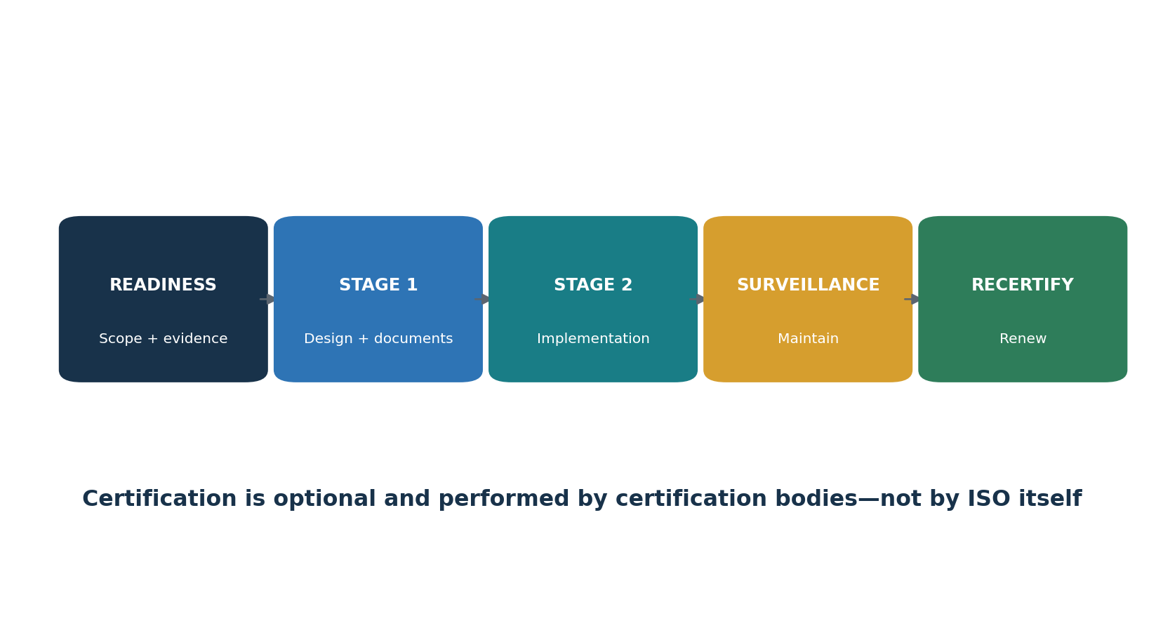
Figure 8. Certification pathway
Certification is optional; organizations may implement ISO/IEC 27001 without seeking a certificate.
ISO does not perform certification. An independent certification body conducts certification audits.
Accreditation provides additional confidence in a certification body’s competence; verify the relevant accreditation and certificate scope.
Stage 1 generally evaluates readiness, scope, documented system, and preparation for the implementation audit.
Stage 2 evaluates implementation and effectiveness across the defined scope.
Surveillance and recertification activities evaluate continuing conformity; details should be confirmed with the selected certification body and accreditation rules.
A certificate is scoped and time-bound. It does not prove that every product is secure, that no incident can occur, or that every system in the company is included.
Readiness area | Acceptance check
Scope | Clear, supportable, reflected in real operations and certificate intent
Risk | Method used consistently; complete register; owners accept residual risk
SoA | All Annex A controls addressed; selections, exclusions, and status supported
Controls | Implemented, operated long enough to produce reliable evidence, and measured
Internal audit | Program and full-scope audit completed with objective evidence and follow-up
Management review | Required inputs considered and decisions recorded
Corrective action | Nonconformities corrected; cause and effectiveness addressed
Amendment | Climate relevance and interested-party requirements considered and evidenced

22. Open-Source Tools
Official links, safe quick starts, evidence, and limitations.
Tool | Purpose | Possible support
CISO Assistant | intuitem.github.io | ISMS, risks, controls, evidence
SimpleRisk Community | www.simplerisk.com | Risk register and treatment
Wazuh | wazuh.com | SIEM, endpoint monitoring, FIM
osquery | www.osquery.io | Endpoint inventory and queries
OpenSCAP | www.open-scap.org | Linux configuration assessment
Greenbone Community Edition | greenbone.github.io | Vulnerability management
Nmap | nmap.org | Asset and service discovery
Trivy | trivy.dev | Code, image, dependency, secret, and configuration scanning
OWASP ZAP | www.zaproxy.org | Authorized web-application testing
Keycloak | www.keycloak.org | Identity, MFA, roles, and logs
DefectDojo | www.defectdojo.org | Finding intake and remediation
AIDE | aide.github.io | File-integrity monitoring
Lynis | cisofy.com | Linux security auditing
Open Policy Agent | www.openpolicyagent.org | Policy as code

Critical limitation: Tools support controls and evidence; they do not select risk treatment, determine conformity, replace competent auditors, or certify an organization. Validate coverage, data quality, configuration, permissions, updates, and human review.

22.1 CISO Assistant
Purpose: ISMS, risks, controls, evidence. Official project: CISO Assistant
Safe quick start: Deploy in an isolated test environment; create a framework project, scope, risk register, treatment actions, owners, and evidence records.
Evidence: approved scope, configuration, version, coverage, results, review, exception, remediation, and retest. Protect credentials, logs, reports, and backups.

22.2 SimpleRisk Community
Purpose: Risk register and treatment. Official project: SimpleRisk Community
Safe quick start: Install securely, define risk criteria, record risks and owners, choose treatments, track due dates, and export reviewed reports.
Evidence: approved scope, configuration, version, coverage, results, review, exception, remediation, and retest. Protect credentials, logs, reports, and backups.

22.3 Wazuh
Purpose: SIEM, endpoint monitoring, FIM. Official project: Wazuh
Safe quick start: Install a lab manager and agent, confirm enrollment, trigger an authorized test event, review the alert, and preserve configuration and alert evidence.
Evidence: approved scope, configuration, version, coverage, results, review, exception, remediation, and retest. Protect credentials, logs, reports, and backups.

22.4 osquery
Purpose: Endpoint inventory and queries. Official project: osquery
Safe quick start: Install on a lab host, run read-only queries for software, users, processes, or settings, schedule approved queries, and document coverage.
Evidence: approved scope, configuration, version, coverage, results, review, exception, remediation, and retest. Protect credentials, logs, reports, and backups.

22.5 OpenSCAP
Purpose: Linux configuration assessment. Official project: OpenSCAP
Safe quick start: Select an appropriate profile, scan a lab system, validate findings manually, record exceptions, remediate, and rescan.
Evidence: approved scope, configuration, version, coverage, results, review, exception, remediation, and retest. Protect credentials, logs, reports, and backups.

22.6 Greenbone Community Edition
Purpose: Vulnerability management. Official project: Greenbone Community Edition
Safe quick start: Authorize targets, update feeds, run authenticated lab scans, validate coverage and findings, assign remediation, and rescan.
Evidence: approved scope, configuration, version, coverage, results, review, exception, remediation, and retest. Protect credentials, logs, reports, and backups.

22.7 Nmap
Purpose: Asset and service discovery. Official project: Nmap
Safe quick start: Use only on authorized ranges; begin with a limited service scan, compare results to inventory, investigate unknowns, and retain command and scope.
Evidence: approved scope, configuration, version, coverage, results, review, exception, remediation, and retest. Protect credentials, logs, reports, and backups.

22.8 Trivy
Purpose: Code, image, dependency, secret, and configuration scanning. Official project: Trivy
Safe quick start: Scan a test repository or container image, validate findings, suppress only with approval and reason, fix, and rescan.
Evidence: approved scope, configuration, version, coverage, results, review, exception, remediation, and retest. Protect credentials, logs, reports, and backups.

22.9 OWASP ZAP
Purpose: Authorized web-application testing. Official project: OWASP ZAP
Safe quick start: Proxy a training application, crawl passively, use active scanning only with written approval, validate results, and record remediation.
Evidence: approved scope, configuration, version, coverage, results, review, exception, remediation, and retest. Protect credentials, logs, reports, and backups.

22.10 Keycloak
Purpose: Identity, MFA, roles, and logs. Official project: Keycloak
Safe quick start: Create a lab realm, users, groups, least-privilege roles, MFA, session settings, and events; test joiner, mover, and leaver cases.
Evidence: approved scope, configuration, version, coverage, results, review, exception, remediation, and retest. Protect credentials, logs, reports, and backups.

22.11 DefectDojo
Purpose: Finding intake and remediation. Official project: DefectDojo
Safe quick start: Import safe scanner results, carefully deduplicate, assign owners, set risk-based deadlines, attach proof, and close only after retesting.
Evidence: approved scope, configuration, version, coverage, results, review, exception, remediation, and retest. Protect credentials, logs, reports, and backups.

22.12 AIDE
Purpose: File-integrity monitoring. Official project: AIDE
Safe quick start: Create a baseline on a lab host, make an authorized file change, run a check, investigate the difference, and protect the baseline.
Evidence: approved scope, configuration, version, coverage, results, review, exception, remediation, and retest. Protect credentials, logs, reports, and backups.

22.13 Lynis
Purpose: Linux security auditing. Official project: Lynis
Safe quick start: Audit a lab host, review suggestions against scope and risk, document decisions, remediate selected items, and rerun.
Evidence: approved scope, configuration, version, coverage, results, review, exception, remediation, and retest. Protect credentials, logs, reports, and backups.

22.14 Open Policy Agent
Purpose: Policy as code. Official project: Open Policy Agent
Safe quick start: Write a small lab rule, test allowed and denied inputs, version the policy and tests, and preserve results as supporting evidence.
Evidence: approved scope, configuration, version, coverage, results, review, exception, remediation, and retest. Protect credentials, logs, reports, and backups.

23. Manager’s ISMS Playbook
Questions, dashboard, ownership, and decisions managers must control.
Is the ISMS scope still aligned with strategy, services, locations, suppliers, cloud use, people, and data flows?
What changed in context, interested parties, legal obligations, threats, technology, or climate relevance?
Are the risk criteria reliable, and are owners explicitly approving the treatment and residual risk?
Does the SoA match real control implementation and open actions?
Are objectives and metrics producing decisions rather than decorative dashboards?
Are incidents, audit findings, exceptions, overdue actions, and repeat failures escalated?
Do internal audit and management review have enough independence, competence, time, and evidence?
Are certification claims, scope, accreditation, and customer statements accurate?
Area | Manager question | Status
Context and scope | Are boundaries, dependencies, parties, and changes current? | Green / Yellow / Red
Risk | Are the criteria consistent and the owner's decisions timely? | Green / Yellow / Red
SoA and controls | Are selection, status, and evidence aligned? | Green / Yellow / Red
Performance | Do objectives, metrics, incidents, and trends drive action? | Green / Yellow / Red
Suppliers | Are risk, responsibility, monitoring, incidents, and exits controlled? | Green / Yellow / Red
Assurance | Are audits objective and findings corrected effectively? | Green / Yellow / Red
Improvement | Are root causes, recurrence, and lessons addressed? | Green / Yellow / Red
Certification | Are claims scoped, current, and supportable? | Green / Yellow / Red

24. Junior Analyst Career Guide
A practical route into ISMS, GRC, risk, audit, and compliance work.
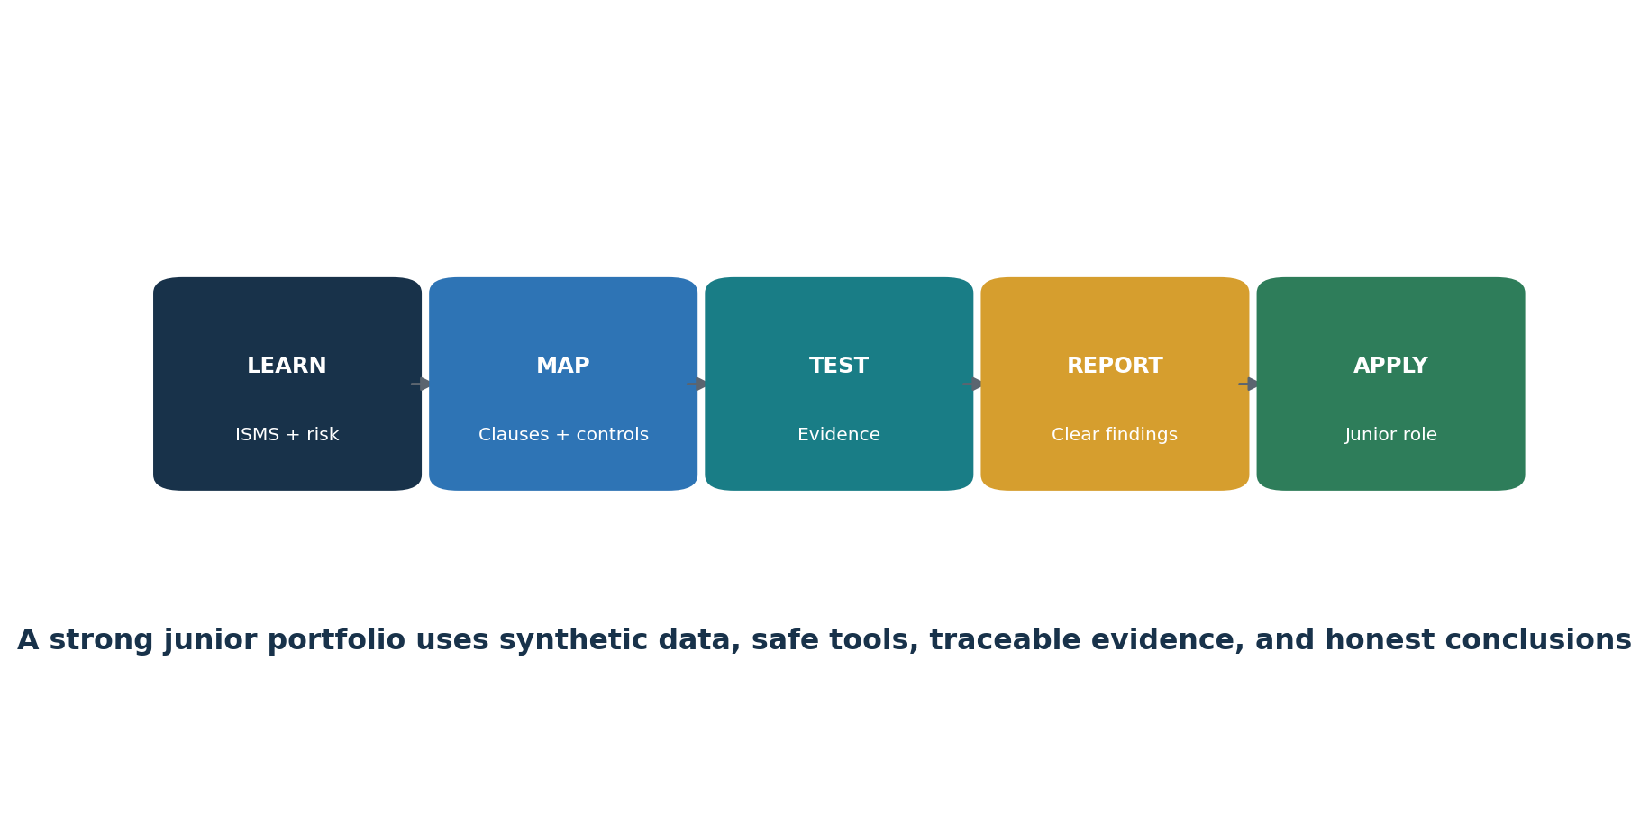
Figure 9. Junior ISO 27001 analyst pathway
Junior GRC Analyst
ISO 27001 Compliance Analyst
Security Controls Analyst
ISMS Coordinator
Risk Analyst
Internal Audit Associate
Third-Party Risk Analyst
Security Assurance Analyst

24.1 Typical junior work
- Maintain scope, asset, obligation, supplier, risk, control, SoA, evidence, finding, and action registers.
- Gather evidence without changing source records and validate completeness.
- Map risks and requirements to controls, owners, procedures, systems, and evidence.
- Test samples for access, change, vulnerability, incident, backup, supplier, awareness, physical, and continuity controls.
- Support internal audits, management reviews, metrics, corrective actions, and certification preparation.
- Write factual conclusions and disclose sampling, scope, and evidence limitations.
- Protect confidential information and stay within authorization.

24.2 Skills employers value
Skill | Proof
ISMS concepts | Explain clauses 4–10 and continual improvement
Risk | Build a consistent register and treatment plan
SoA | Justify selections, exclusions, status, and evidence
Evidence testing | Define populations, samples, procedures, exceptions, and retests
Technical literacy | Interpret identity, cloud, logging, vulnerability, backup, and configuration evidence
Communication | Write concise findings, actions, and management summaries
Ethics | Use synthetic data, authorized systems, and honest claims

25. Fictional Laboratory and Portfolio
A safe practice environment using synthetic data and authorized lab systems.
Lab rule: Use a fictional organization, synthetic data, isolated systems, and tools you are authorized to operate. Do not claim that a portfolio project is a real certification or client audit.

- Create a fictional company with two products, one cloud service, a remote workforce, and three suppliers.
- Write a one-page context analysis, interested-party register, climate-relevance determination, and scope statement.
- Create risk criteria and a ten-scenario risk register with owners and treatment decisions.
- Create a treatment plan and SoA that addresses all 93 Annex A controls with concise justifications and honest implementation status.
- Build sample policies, procedures, objectives, metrics, asset and supplier registers, training record, incident record, and continuity exercise.
- Use a few open-source tools in isolated labs and capture scope, configuration, results, validation, remediation, and retest evidence.
- Design and execute an internal-audit plan against selected clauses and controls.
- Write two nonconformities, root-cause records, corrective actions, and effectiveness tests.
- Create management-review minutes showing inputs, decisions, owners, resources, and deadlines.
- Publish only sanitized, synthetic artifacts with a clear limitations statement.
Portfolio artifact | What it demonstrates
Context, parties, scope | Clause 4 reasoning and boundaries
Risk method, register, treatment | Clause 6 and risk ownership
Statement of Applicability | Traceable control decisions
Control test workpaper | Evidence, sampling, exception, and conclusion
Internal-audit package | Program, plan, criteria, report, and follow-up
Management-review minutes | Leadership evaluation and decisions
Corrective-action record | Root cause and effectiveness
Tool evidence memo | Technical literacy and limitations

26. Thirty-Day Learning Plan
A focused schedule for building useful junior-level capability.
Days | Focus | Deliverable
1–5 | ISMS, CIA, clauses, ISO 27001/27002 relationship, scope | One-page concept map and scope statement
6–10 | Risk criteria, scenarios, assessment, treatment, acceptance | Ten-risk register and treatment plan
11–14 | Annex A themes and Statement of Applicability | Complete fictional SoA
15–18 | Policies, competence, communication, document control, operations | Evidence index and three sample procedures
19–22 | Metrics, monitoring, internal audit, management review | Metric sheet, audit plan, review agenda
23–25 | Nonconformity, root cause, corrective action, improvement | Two finding and corrective-action records
26–28 | Authorized open-source tool labs | Two evidence and retest memos
29–30 | Portfolio cleanup and interview practice | Sanitized portfolio and five STAR stories

27. Interview Preparation
Clear answers, practical scenarios, and questions for the employer.

27.1 What is an ISMS?
A management system for controlling information-security risk through leadership, planning, operation, evaluation, and continual improvement.

27.2 ISO 27001 versus 27002?
27001 contains certifiable ISMS requirements; 27002 provides detailed control guidance and is not itself a certification standard.

27.3 What is the SoA?
A controlled record of necessary controls, Annex A inclusion or exclusion justification, and implementation status, linked to treatment and evidence.

27.4 Are all Annex A controls mandatory?
The organization must use Annex A as a reference check and justify decisions. Necessary controls follow risk treatment and obligations; other controls may also be required.

27.5 How do you test a control?
Define criteria and scope, validate the population, sample by risk, inspect and reperform evidence, document exceptions, and retest correction.

27.6 What is a nonconformity?
Failure to fulfill a requirement. It requires correction, cause evaluation, appropriate action, and effectiveness review.

27.7 What changed in 2024?
The amendment requires explicit climate-change relevance consideration in context and notes that interested parties may have climate-related requirements.

27.8 What can a junior analyst safely conclude?
State facts supported by defined evidence and scope, disclose limitations, and avoid claiming auditor or certification authority.

27.9 Questions to ask the employer
- What is the certified or intended ISMS scope?
- Who owns risk acceptance and the SoA?
- How are evidence populations produced and validated?
- What systems manage risks, controls, suppliers, findings, and corrective action?
- How is internal-auditor independence maintained?
- Which technical teams will this role work with?
- How are junior conclusions reviewed and coached?

28. Templates, Glossary, Index, and References
Reusable work structures, important terms, and authoritative starting points.

28.1 Minimal risk record
Field | Entry
Risk ID and owner | ____________________________
Objective / asset | ____________________________
Threat event and condition | ____________________________
Consequence | ____________________________
Existing controls | ____________________________
Likelihood and impact | ____________________________
Current risk | ____________________________
Treatment and action owner | ____________________________
Residual risk and acceptance | ____________________________
Review date | ____________________________

28.2 Control test workpaper
Field | Entry
Criteria and control | ____________________________
Scope and period | ____________________________
Owner and systems | ____________________________
Population and completeness check | ____________________________
Sample and rationale | ____________________________
Procedure performed | ____________________________
Evidence inspected | ____________________________
Exceptions | ____________________________
Conclusion and limitation | ____________________________
Correction and retest | ____________________________

28.3 Glossary
Term | Meaning
Annex A | Reference set of 93 information-security controls in ISO/IEC 27001:2022.
CIA | Confidentiality, integrity, and availability.
Conformity | Fulfillment of a requirement.
Control | Measure that modifies or maintains risk.
Corrective action | Action addressing the cause of a nonconformity to prevent recurrence.
Documented information | Information the organization must control and maintain or retain.
Interested party | Person or organization that can affect, be affected by, or perceive itself affected by a decision or activity.
ISMS | Information security management system.
Nonconformity | Failure to fulfill a requirement.
Residual risk | Risk remaining after treatment.
Risk owner | Person or entity accountable and authorized to manage a risk.
SoA | Statement of Applicability.
Top management | Person or group directing and controlling the organization at the highest level within scope.

28.4 Subject index
Subject | Chapter
Annex A controls | 13–16
Audit | 19
Certification | 21
Climate amendment | 1, 2, 6, 21
Corrective action | 12, 20
Evidence | 5, 18
Interested parties | 2, 6
Junior analyst | 24–27
Management review | 11, 20
Metrics | 11, 18
Open-source tools | 22
Risk assessment and treatment | 3, 8, 10
Scope | 2, 6
Statement of Applicability | 4
Suppliers | 13, 18, 23

28.5 Official references
ISO/IEC 27001:2022 overview
ISO/IEC 27001:2022/Amd 1:2024
ISO/IEC 27002:2022 overview
ISO/IAF climate-change communiqué
ISO certification overview
ISO/IEC 27000 family
Final reminder: Purchase or lawfully access the official standards before implementation or assessment. Confirm current editions, amendments, accreditation, certification scope, legal requirements, contracts, technology, threats, and organizational change.

