PRACTICAL CYBERSECURITY, PRIVACY & COMPLIANCE SERIES
CIS Critical Security Controls v8.1
Practical Implementation, Measurement, Evidence, and Open-Source Tools
A working manual for managers, junior analysts, students, career changers, assessors, and security teams
Alberto (Al) Leiva
First Edition • July 2026
Inside: 18 Controls • 153 Safeguards • IG1, IG2, IG3 • measurement • evidence • tools • manager playbook • labs • career preparation

Publication and Use Notice
Author: Alberto (Al) Leiva
Edition: First Edition, July 2026
This independent educational manual is not a Center for Internet Security publication, certification, accreditation, audit report, legal opinion, or guarantee of security or compliance. CIS Controls and CIS Benchmarks are trademarks of the Center for Internet Security. Use official CIS resources for exact content and current guidance.
The CIS Controls are cybersecurity best practices. They do not replace applicable laws, regulations, contracts, sector requirements, risk assessment, or management responsibility. A mapping shows relationships; it does not automatically prove compliance with another framework.

Ethical and authorized use
Use technical tools only on assets, networks, applications, cloud accounts, repositories, and data that you own or are specifically authorized in writing to assess. Use synthetic information and isolated systems in laboratories.

Preface
A practical introduction to prioritized cyber defense and evidence-based measurement.
The CIS Controls turn common defensive needs into focused Safeguards. Their strength is practical prioritization: know what you own, control software and data, secure configurations and identities, manage vulnerabilities and logs, prepare for disruption and attacks, and test whether defenses work.
Version 8.1 is the current edition. It is an iterative update to v8 that realigned mappings to NIST CSF 2.0, expanded reserved-term definitions, revised asset classes and Safeguard mappings, corrected minor issues, clarified some Safeguards, and incorporated the Govern security function in mappings. The 18 Controls and 153 Safeguards remain the central structure.
A tool installation is not implementation. Effective implementation requires defined scope, complete populations, secure configuration, operating evidence, trained owners, exception handling, measurement, correction, and retesting. Managers decide priorities and resources; analysts make those decisions reliable through accurate inventories and evidence.

How to Use This Manual
- Managers should begin with Chapters 1–5 and 24–25.
- Junior analysts should study the 18 Control chapters, measurement method, tools, lab, and interview chapter.
- Technical teams should connect every Safeguard to assets, data, owners, procedures, configuration, monitoring, exception handling, and evidence.
- Assessors should use the official CIS Controls Assessment Specification for exact inputs, operations, measures, metrics, assumptions, and procedure reviews.
True Word contents: This document contains a native Word table-of-contents field. The chapter guide will contain verified page numbers for this edition. After editing, right-click the contents and choose Update Field, then Update entire table.

Table of Contents
Publication and Use Notice 2
Ethical and authorized use 2
Preface 3
How to Use This Manual 4
Table of Contents 4
1. CIS Controls v8.1 Foundations 7
2. Implementation Groups and Prioritization 8
3. Governance, Scope, and Ownership 9
4. Measurement with the CIS Assessment Specification 10
5. Implementation Roadmap 11
6. Control 1 — Inventory and Control of Enterprise Assets 12
7. Control 2 — Inventory and Control of Software Assets 13
8. Control 3 — Data Protection 14
9. Control 4 — Secure Configuration of Enterprise Assets and Software 16
10. Control 5 — Account Management 18
11. Control 6 — Access Control Management 19
12. Control 7 — Continuous Vulnerability Management 21
13. Control 8 — Audit Log Management 23
14. Control 9 — Email and Web Browser Protections 24
15. Control 10 — Malware Defenses 25
16. Control 11 — Data Recovery 26
17. Control 12 — Network Infrastructure Management 27
18. Control 13 — Network Monitoring and Defense 28
19. Control 14 — Security Awareness and Skills Training 30
20. Control 15 — Service Provider Management 31
21. Control 16 — Application Software Security 32
22. Control 17 — Incident Response Management 34
23. Control 18 — Penetration Testing 36
24. Open-Source Tools 37
24.1 CIS Controls Navigator 37
24.2 CIS Controls Assessment Specification 37
24.3 CIS-CAT Lite 37
24.4 CISO Assistant 38
24.5 Wazuh 38
24.6 osquery 38
24.7 OpenSCAP 38
24.8 Lynis 38
24.9 Nmap 39
24.10 Greenbone Community Edition 39
24.11 Trivy 39
24.12 OWASP ZAP 39
24.13 Suricata 39
24.14 Keycloak 39
24.15 DefectDojo 40
24.16 Velociraptor 40
25. Manager’s CIS Controls Playbook 41
26. Junior Analyst Career Guide 42
26.1 Typical junior work 42
27. Fictional Laboratory and Portfolio 44
28. Thirty-Day Learning Plan 45
29. Interview Preparation 46
29.1 What are the CIS Controls? 46
29.2 What is IG1? 46
29.3 Does IG1 fit every requirement? 46
29.4 How do you measure a Safeguard? 46
29.5 Why are inventories important? 46
29.6 Vulnerability scan versus penetration test? 46
29.7 Does a framework mapping prove compliance? 46
29.8 What can a junior analyst conclude? 46
29.9 Questions to ask the employer 46
30. Templates, Glossary, Index, and References 48
30.1 Safeguard measurement workpaper 48
30.2 Finding and retest record 48
30.3 Glossary 48
30.4 Subject index 49
30.5 Official references 49

1. CIS Controls v8.1 Foundations
The current version, structure, purpose, and limitations.
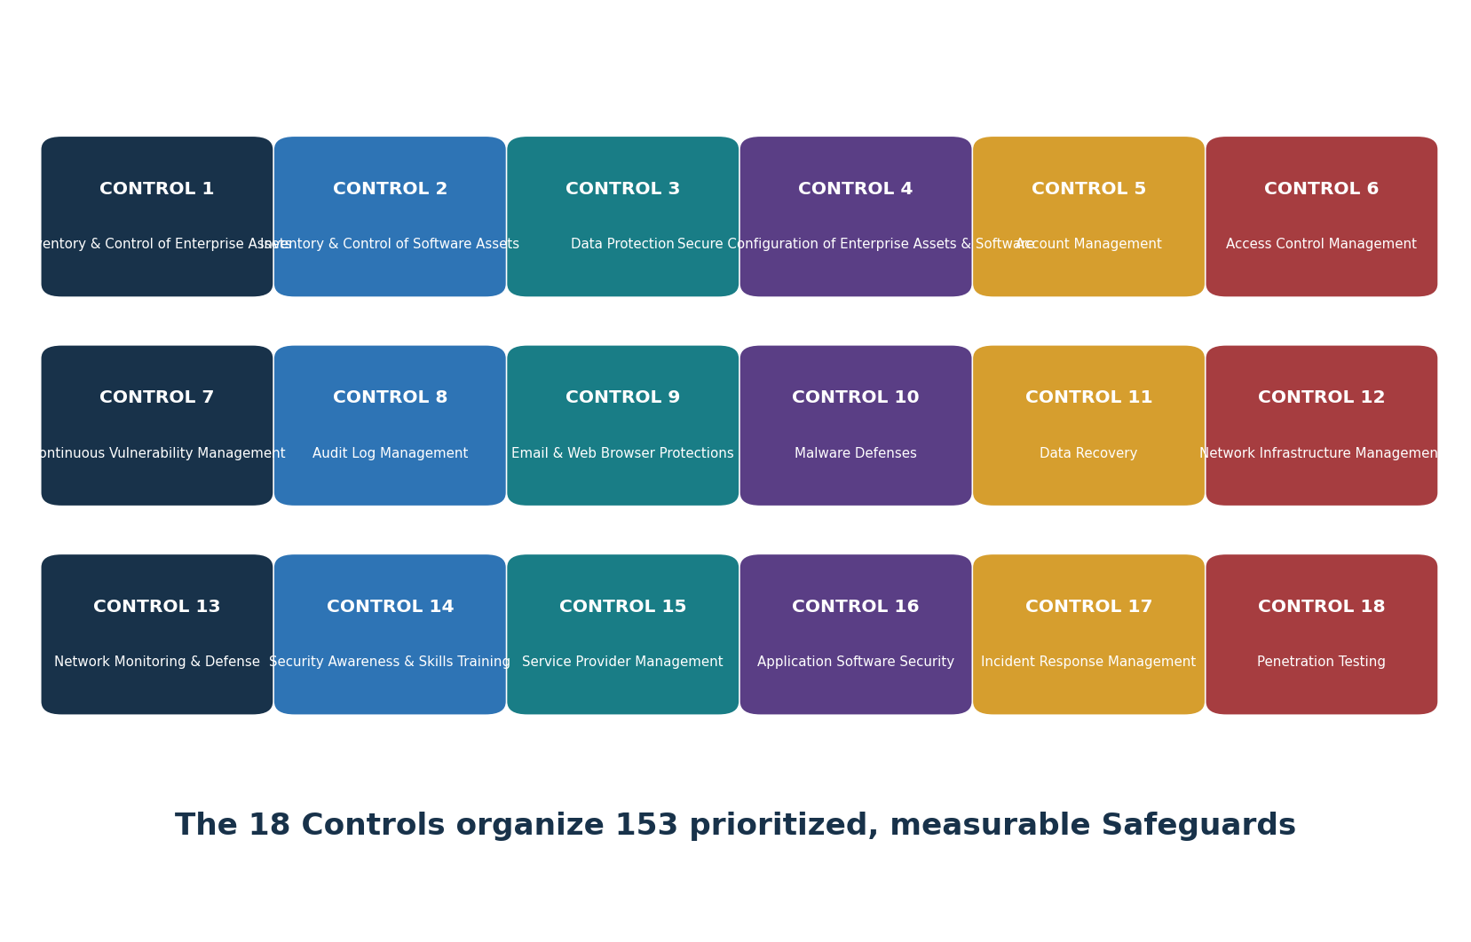
Figure 1. The 18 CIS Critical Security Controls
- CIS Controls v8.1 was published in June 2024 and remains the current edition as of July 2026.
- The Controls are prioritized best practices designed to defend systems and networks against prevalent attacks.
- The framework contains 18 Controls and 153 Safeguards.
- Safeguards map to asset classes, security functions, and Implementation Groups.
- Version 8.1 aligns its NIST CSF mapping to CSF 2.0 and includes Govern mappings.
- Official mappings exist for multiple frameworks, but implementation must be verified separately for each applicable requirement.
Layer | Purpose
Control | Broad defensive outcome, such as asset inventory or incident response
Safeguard | Focused action that can be assigned, implemented, and measured
Asset class | Type of subject affected, such as devices, software, data, network, users, or documentation
Security function | Govern, Identify, Protect, Detect, Respond, or Recover mapping
Implementation Group | Recommended prioritization based on risk profile and resources
Assessment measure | Inputs, operations, measures, metrics, and procedure review used to evaluate a Safeguard

2. Implementation Groups and Prioritization
How IG1, IG2, and IG3 help organizations choose a realistic starting point.
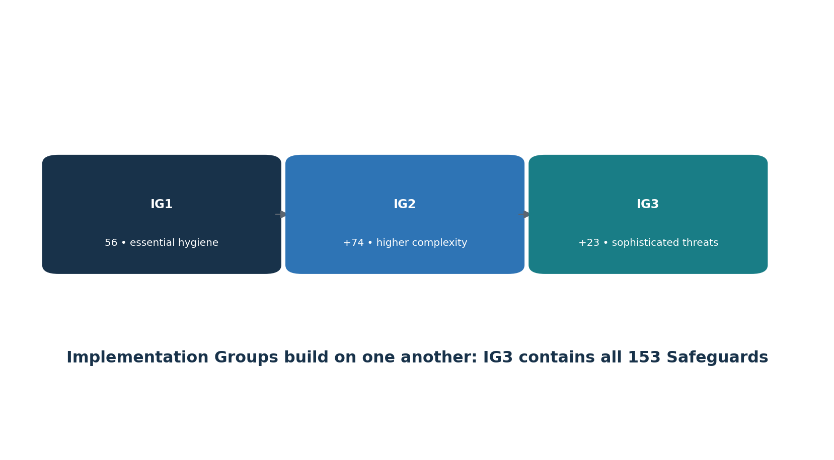
Figure 2. Implementation Group progression
Group | Safeguards | Typical situation | Objective
IG1 | 56 | Limited security resources and expertise; lower sensitivity; high need for basic continuity | Essential cyber hygiene against common attacks
IG2 | IG1 + 74 | Multiple departments, greater complexity, sensitive information, and more operational dependence | Manage increased risk and operational complexity
IG3 | IG1 + IG2 + 23 = 153 | Security specialists, sensitive or regulated data, critical services, and sophisticated threats | Reduce targeted and advanced attack impact

- Every enterprise should start with IG1 according to CIS guidance.
- Select an IG by considering data sensitivity, critical services, threat exposure, legal and contractual duties, business tolerance, technology, staffing, and expertise.
- An IG is a prioritization aid, not permission to ignore a material risk or mandatory requirement.
- Document tailored additions, sequencing, exceptions, risk acceptance, owners, and dates.
- Use the official CIS Controls Navigator to filter v8.1 Safeguards and review mappings.

3. Governance, Scope, and Ownership
The management foundation needed to make Safeguards operate consistently.
- Define business objectives, critical services, sensitive data, legal and contractual obligations, threat profile, risk tolerance, and chosen Implementation Group.
- Create complete inventories for enterprise assets, software, data, accounts, authentication systems, network infrastructure, logs, suppliers, applications, and recovery resources.
- Assign one accountable owner for each Safeguard and operational owners for each affected platform or process.
- Define scope, applicability, dependencies, service-provider responsibilities, allowed exceptions, approval authority, and review triggers.
- Plan funding, people, skills, technology, time, and change management.
- Define metrics and reporting before implementation so coverage and failure are visible.
- Operate a governance cycle: prioritize, implement, measure, correct, retest, and improve.
Role | Decision or responsibility
Executive sponsor | Direction, risk tolerance, funding, escalation, and accountability
Control owner | Safeguard design, scope, procedure, measurement, exceptions, and improvement
Asset or service owner | Accurate inventory, approved use, configuration, business impact, and remediation
Security operations | Monitoring, alerting, investigation, response, and evidence
IT / Engineering | Implementation, change control, patching, configuration, and recovery
GRC / Analyst | Mapping, evidence, measurement, findings, action tracking, and reporting
Internal audit / assessor | Objective criteria, testing, limitations, and conclusions
Service provider | Contracted controls, evidence, incidents, changes, and exit support

4. Measurement with the CIS Assessment Specification
A repeatable method for deciding whether Safeguards are implemented.
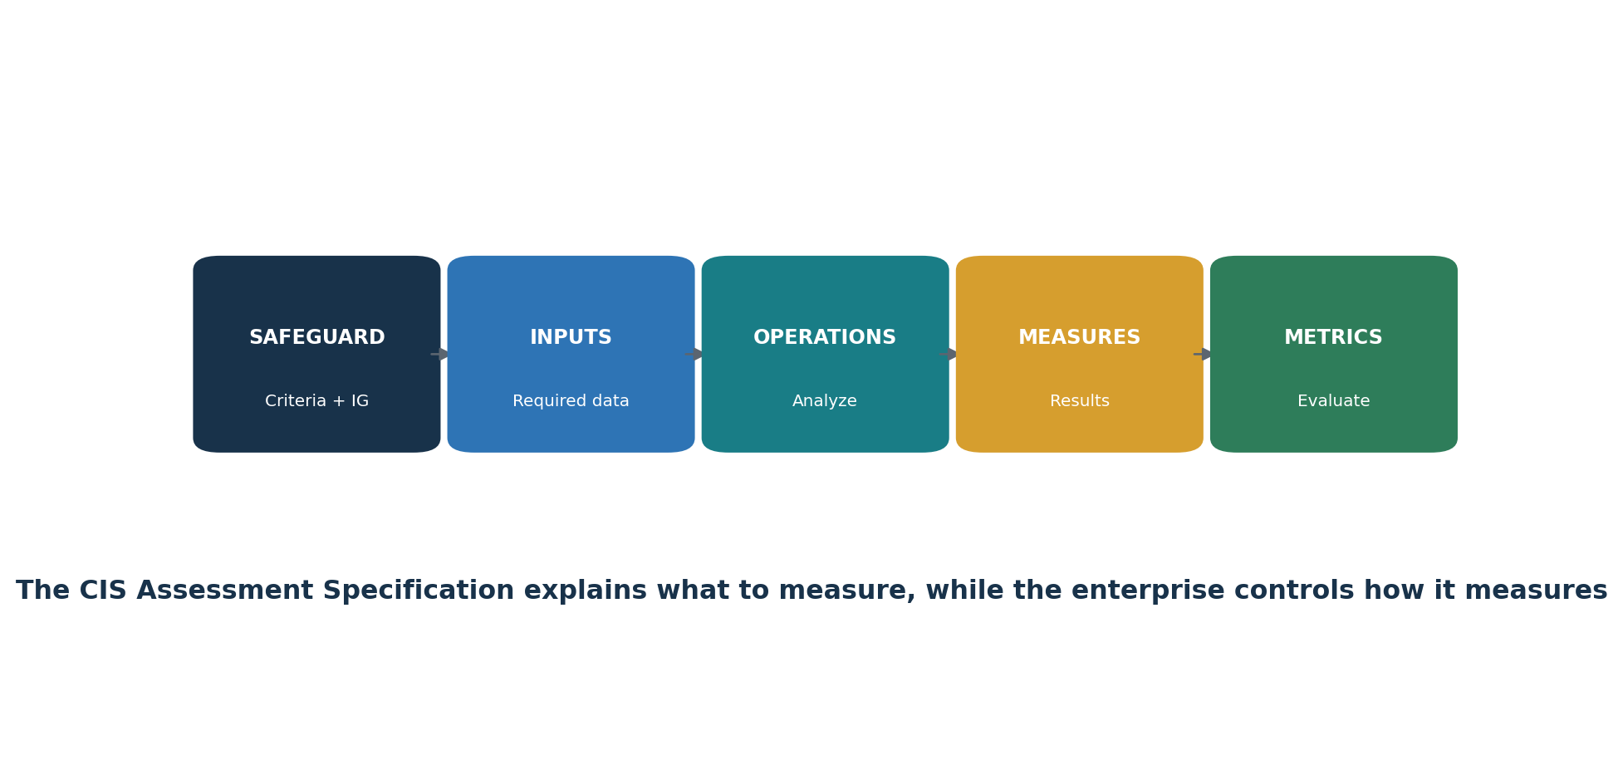
Figure 3. CIS Safeguard measurement structure
Element | Question
Safeguard metadata | What is the exact Safeguard, asset class, security function, and IG?
Dependencies | What other Safeguards or populations must exist first?
Assumptions | What accepted condition affects the measurement?
Inputs | What complete and reliable data is required?
Operations | What analysis must be performed on the inputs?
Measures | What counts, lists, dates, configurations, or outcomes result?
Metrics | How are measures calculated and interpreted?
Procedure review | Does a documented process exist and include required elements?

- Define the exact Safeguard and scoped population.
- Obtain required inputs and validate completeness, accuracy, timing, ownership, and source reliability.
- Follow the official measurement operations or document an equivalent reliable method.
- Retain measure calculations and the underlying exception population—not only a percentage.
- Evaluate whether the Safeguard is implemented and how well it is operating.
- Assign a correction for missing coverage, bad configuration, overdue review, exceptions, or unreliable data.
- Retest using the same criteria and refreshed population.
- Report scope, result, exception, limitation, owner, action, and date.

5. Implementation Roadmap
A practical sequence from inventories to tested resilience.
- Choose and document the initial Implementation Group and any required additions.
- Build and reconcile the core populations: assets, software, data, accounts, authentication systems, network, suppliers, applications, and logs.
- Implement IG1 safeguards with owners, procedures, coverage metrics, exceptions, and evidence.
- Secure identities, configurations, vulnerabilities, email, browsers, malware defenses, backups, and essential monitoring.
- Exercise incident response and recovery before a real emergency.
- Measure every applicable Safeguard using reliable inputs and repeatable operations.
- Correct incomplete coverage and repeat failures; verify fixes through retesting.
- Expand toward IG2 or IG3 based on risk, obligations, maturity, and threat exposure.
- Use official mappings to coordinate other frameworks without treating mappings as automatic compliance.
Implementation principle: A smaller group of Safeguards that is fully scoped, operated, measured, and improved is more defensible than a long list marked complete without reliable evidence.

6. Control 1 — Inventory and Control of Enterprise Assets
All 5 Safeguards, plain meaning, verification focus, and example evidence.
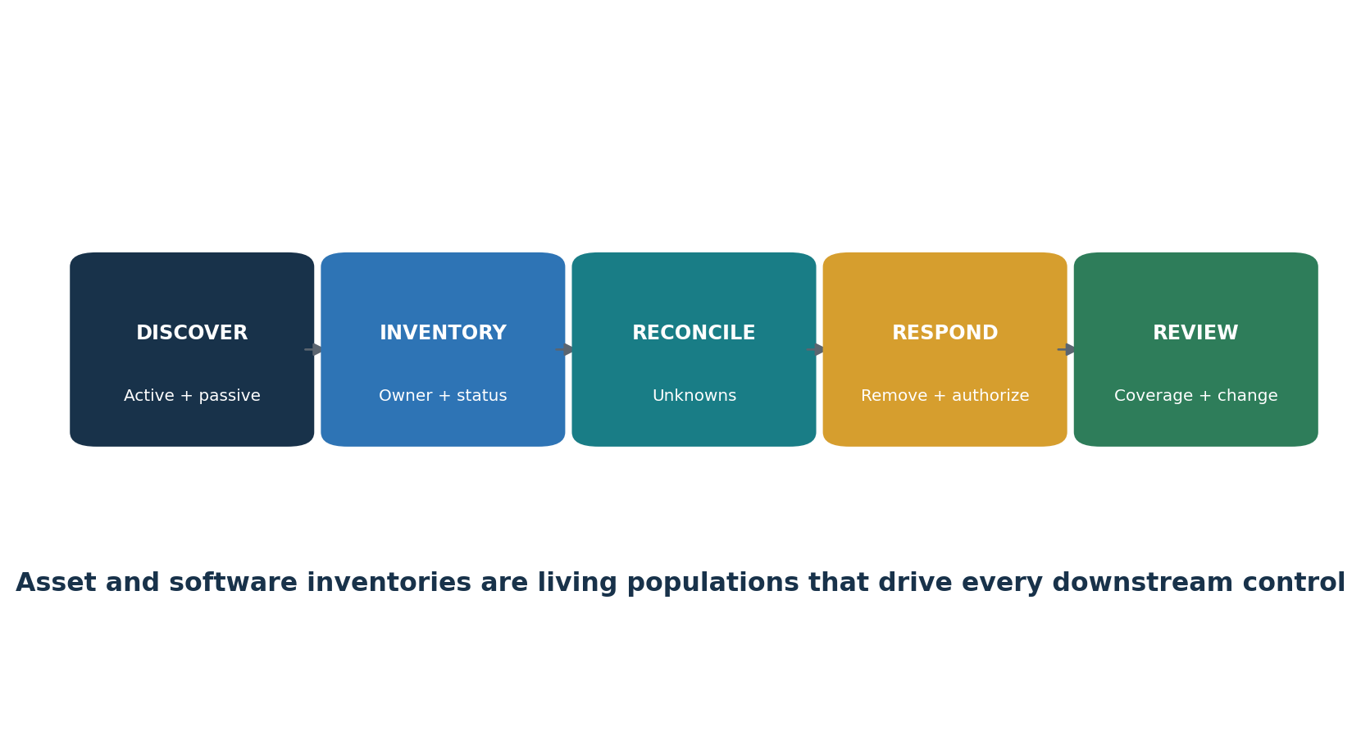
Figure 4. Asset and software inventory cycle
Control purpose: Strengthen the enterprise by implementing and measuring safeguards for inventory and control of enterprise assets.

ID | Safeguard | Plain meaning | Verification focus | Example evidence
1.1 | Establish and Maintain Detailed Enterprise Asset Inventory | Put a repeatable, owned process or technical control in place to establish and Maintain Detailed Enterprise Asset Inventory, then verify coverage and exceptions. | Confirm defined scope, population, ownership, implementation, frequency, coverage, exceptions, correction, and retest. | asset inventory, owners, approval status, active/passive discovery, DHCP/IPAM logs, unauthorized-asset tickets
1.2 | Address Unauthorized Assets | Put a repeatable, owned process or technical control in place to address Unauthorized Assets, then verify coverage and exceptions. | Confirm defined scope, population, ownership, implementation, frequency, coverage, exceptions, correction, and retest. | asset inventory, owners, approval status, active/passive discovery, DHCP/IPAM logs, unauthorized-asset tickets
1.3 | Utilize an Active Discovery Tool | Put a repeatable, owned process or technical control in place to utilize an Active Discovery Tool, then verify coverage and exceptions. | Confirm defined scope, population, ownership, implementation, frequency, coverage, exceptions, correction, and retest. | asset inventory, owners, approval status, active/passive discovery, DHCP/IPAM logs, unauthorized-asset tickets
1.4 | Use DHCP Logging to Update Enterprise Asset Inventory | Put a repeatable, owned process or technical control in place to use DHCP Logging to Update Enterprise Asset Inventory, then verify coverage and exceptions. | Confirm defined scope, population, ownership, implementation, frequency, coverage, exceptions, correction, and retest. | asset inventory, owners, approval status, active/passive discovery, DHCP/IPAM logs, unauthorized-asset tickets
1.5 | Use a Passive Asset Discovery Tool | Put a repeatable, owned process or technical control in place to use a Passive Asset Discovery Tool, then verify coverage and exceptions. | Confirm defined scope, population, ownership, implementation, frequency, coverage, exceptions, correction, and retest. | asset inventory, owners, approval status, active/passive discovery, DHCP/IPAM logs, unauthorized-asset tickets

Use the official CIS Controls v8.1 guide and Controls Assessment Specification for exact Safeguard language, asset class, security function, Implementation Group, dependencies, inputs, operations, measures, metrics, and procedural review.

7. Control 2 — Inventory and Control of Software Assets
All 7 Safeguards, plain meaning, verification focus, and example evidence.
Control purpose: Strengthen the enterprise by implementing and measuring safeguards for inventory and control of software assets.

ID | Safeguard | Plain meaning | Verification focus | Example evidence
2.1 | Establish and Maintain a Software Inventory | Put a repeatable, owned process or technical control in place to establish and Maintain a Software Inventory, then verify coverage and exceptions. | Confirm defined scope, population, ownership, implementation, frequency, coverage, exceptions, correction, and retest. | software inventory, support status, approved list, discovery results, exceptions, allowlisting policy and events
2.2 | Ensure Authorized Software is Currently Supported | Put a repeatable, owned process or technical control in place to ensure Authorized Software is Currently Supported, then verify coverage and exceptions. | Confirm defined scope, population, ownership, implementation, frequency, coverage, exceptions, correction, and retest. | software inventory, support status, approved list, discovery results, exceptions, allowlisting policy and events
2.3 | Address Unauthorized Software | Put a repeatable, owned process or technical control in place to address Unauthorized Software, then verify coverage and exceptions. | Confirm defined scope, population, ownership, implementation, frequency, coverage, exceptions, correction, and retest. | software inventory, support status, approved list, discovery results, exceptions, allowlisting policy and events
2.4 | Utilize Automated Software Inventory Tools | Put a repeatable, owned process or technical control in place to utilize Automated Software Inventory Tools, then verify coverage and exceptions. | Confirm defined scope, population, ownership, implementation, frequency, coverage, exceptions, correction, and retest. | software inventory, support status, approved list, discovery results, exceptions, allowlisting policy and events
2.5 | Allowlist Authorized Software | Put a repeatable, owned process or technical control in place to allowlist Authorized Software, then verify coverage and exceptions. | Confirm defined scope, population, ownership, implementation, frequency, coverage, exceptions, correction, and retest. | software inventory, support status, approved list, discovery results, exceptions, allowlisting policy and events
2.6 | Allowlist Authorized Libraries | Put a repeatable, owned process or technical control in place to allowlist Authorized Libraries, then verify coverage and exceptions. | Confirm defined scope, population, ownership, implementation, frequency, coverage, exceptions, correction, and retest. | software inventory, support status, approved list, discovery results, exceptions, allowlisting policy and events
2.7 | Allowlist Authorized Scripts | Put a repeatable, owned process or technical control in place to allowlist Authorized Scripts, then verify coverage and exceptions. | Confirm defined scope, population, ownership, implementation, frequency, coverage, exceptions, correction, and retest. | software inventory, support status, approved list, discovery results, exceptions, allowlisting policy and events

Use the official CIS Controls v8.1 guide and Controls Assessment Specification for exact Safeguard language, asset class, security function, Implementation Group, dependencies, inputs, operations, measures, metrics, and procedural review.

8. Control 3 — Data Protection
All 14 Safeguards, plain meaning, verification focus, and example evidence.
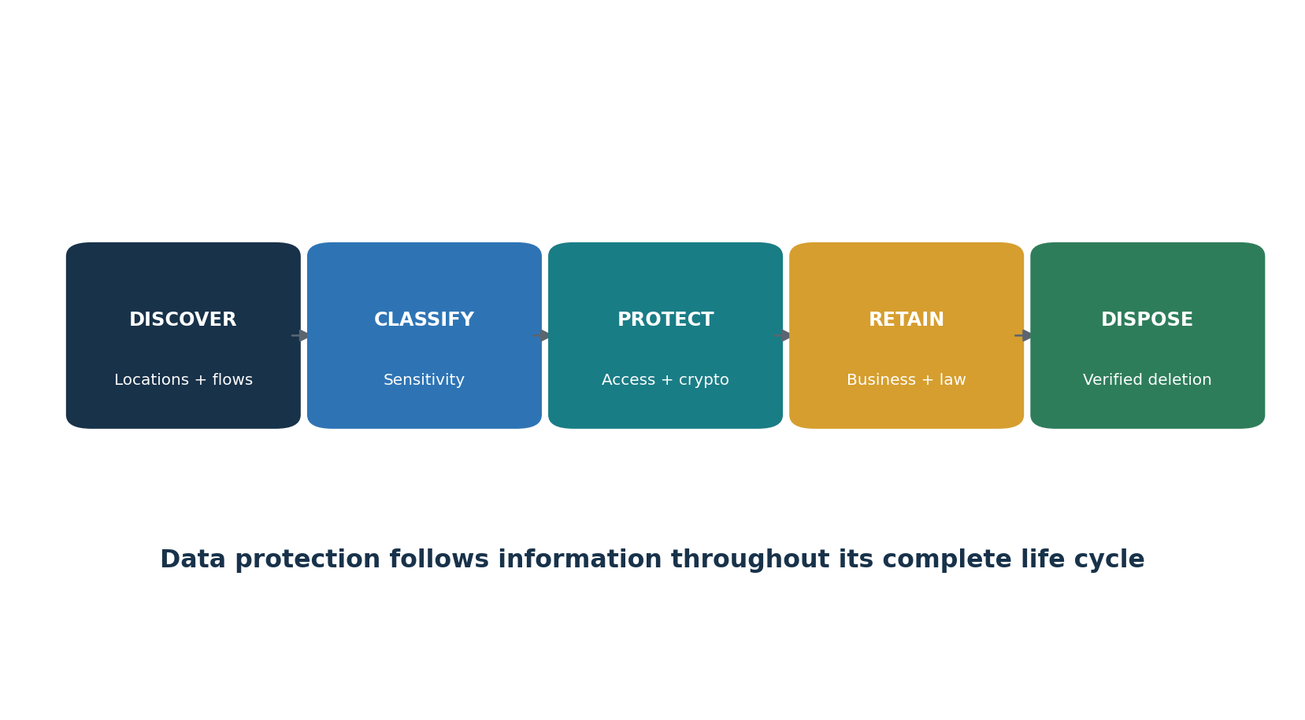
Figure 5. Data protection life cycle
Control purpose: Strengthen the enterprise by implementing and measuring safeguards for data protection.

ID | Safeguard | Plain meaning | Verification focus | Example evidence
3.1 | Establish and Maintain a Data Management Process | Put a repeatable, owned process or technical control in place to establish and Maintain a Data Management Process, then verify coverage and exceptions. | Confirm defined scope, population, ownership, implementation, frequency, coverage, exceptions, correction, and retest. | data inventory, classification, flows, ACLs, retention, disposal, encryption, DLP and access logs
3.2 | Establish and Maintain a Data Inventory | Put a repeatable, owned process or technical control in place to establish and Maintain a Data Inventory, then verify coverage and exceptions. | Confirm defined scope, population, ownership, implementation, frequency, coverage, exceptions, correction, and retest. | data inventory, classification, flows, ACLs, retention, disposal, encryption, DLP and access logs
3.3 | Configure Data Access Control Lists | Put a repeatable, owned process or technical control in place to configure Data Access Control Lists, then verify coverage and exceptions. | Confirm defined scope, population, ownership, implementation, frequency, coverage, exceptions, correction, and retest. | data inventory, classification, flows, ACLs, retention, disposal, encryption, DLP and access logs
3.4 | Enforce Data Retention | Put a repeatable, owned process or technical control in place to enforce Data Retention, then verify coverage and exceptions. | Confirm defined scope, population, ownership, implementation, frequency, coverage, exceptions, correction, and retest. | data inventory, classification, flows, ACLs, retention, disposal, encryption, DLP and access logs
3.5 | Securely Dispose of Data | Put a repeatable, owned process or technical control in place to securely Dispose of Data, then verify coverage and exceptions. | Confirm defined scope, population, ownership, implementation, frequency, coverage, exceptions, correction, and retest. | data inventory, classification, flows, ACLs, retention, disposal, encryption, DLP and access logs
3.6 | Encrypt Data on End-User Devices | Put a repeatable, owned process or technical control in place to encrypt Data on End-User Devices, then verify coverage and exceptions. | Confirm defined scope, population, ownership, implementation, frequency, coverage, exceptions, correction, and retest. | data inventory, classification, flows, ACLs, retention, disposal, encryption, DLP and access logs
3.7 | Establish and Maintain a Data Classification Scheme | Put a repeatable, owned process or technical control in place to establish and Maintain a Data Classification Scheme, then verify coverage and exceptions. | Confirm defined scope, population, ownership, implementation, frequency, coverage, exceptions, correction, and retest. | data inventory, classification, flows, ACLs, retention, disposal, encryption, DLP and access logs
3.8 | Document Data Flows | Put a repeatable, owned process or technical control in place to document Data Flows, then verify coverage and exceptions. | Confirm defined scope, population, ownership, implementation, frequency, coverage, exceptions, correction, and retest. | data inventory, classification, flows, ACLs, retention, disposal, encryption, DLP and access logs
3.9 | Encrypt Data on Removable Media | Put a repeatable, owned process or technical control in place to encrypt Data on Removable Media, then verify coverage and exceptions. | Confirm defined scope, population, ownership, implementation, frequency, coverage, exceptions, correction, and retest. | data inventory, classification, flows, ACLs, retention, disposal, encryption, DLP and access logs
3.10 | Encrypt Sensitive Data in Transit | Put a repeatable, owned process or technical control in place to encrypt Sensitive Data in Transit, then verify coverage and exceptions. | Confirm defined scope, population, ownership, implementation, frequency, coverage, exceptions, correction, and retest. | data inventory, classification, flows, ACLs, retention, disposal, encryption, DLP and access logs
3.11 | Encrypt Sensitive Data At Rest | Put a repeatable, owned process or technical control in place to encrypt Sensitive Data At Rest, then verify coverage and exceptions. | Confirm defined scope, population, ownership, implementation, frequency, coverage, exceptions, correction, and retest. | data inventory, classification, flows, ACLs, retention, disposal, encryption, DLP and access logs
3.12 | Segment Data Processing and Storage Based on Sensitivity | Put a repeatable, owned process or technical control in place to segment Data Processing and Storage Based on Sensitivity, then verify coverage and exceptions. | Confirm defined scope, population, ownership, implementation, frequency, coverage, exceptions, correction, and retest. | data inventory, classification, flows, ACLs, retention, disposal, encryption, DLP and access logs
3.13 | Deploy a Data Loss Prevention Solution | Put a repeatable, owned process or technical control in place to deploy a Data Loss Prevention Solution, then verify coverage and exceptions. | Confirm defined scope, population, ownership, implementation, frequency, coverage, exceptions, correction, and retest. | data inventory, classification, flows, ACLs, retention, disposal, encryption, DLP and access logs
3.14 | Log Sensitive Data Access | Put a repeatable, owned process or technical control in place to log Sensitive Data Access, then verify coverage and exceptions. | Confirm defined scope, population, ownership, implementation, frequency, coverage, exceptions, correction, and retest. | data inventory, classification, flows, ACLs, retention, disposal, encryption, DLP and access logs

Use the official CIS Controls v8.1 guide and Controls Assessment Specification for exact Safeguard language, asset class, security function, Implementation Group, dependencies, inputs, operations, measures, metrics, and procedural review.

9. Control 4 — Secure Configuration of Enterprise Assets and Software
All 12 Safeguards, plain meaning, verification focus, and example evidence.
Control purpose: Strengthen the enterprise by implementing and measuring safeguards for secure configuration of enterprise assets and software.

ID | Safeguard | Plain meaning | Verification focus | Example evidence
4.1 | Establish and Maintain a Secure Configuration Process | Put a repeatable, owned process or technical control in place to establish and Maintain a Secure Configuration Process, then verify coverage and exceptions. | Confirm defined scope, population, ownership, implementation, frequency, coverage, exceptions, correction, and retest. | configuration standards, benchmark results, firewalls, session locks, admin protocols, defaults, services and mobile settings
4.2 | Establish and Maintain a Secure Configuration Process for Network Infrastructure | Put a repeatable, owned process or technical control in place to establish and Maintain a Secure Configuration Process for Network Infrastructure, then verify coverage and exceptions. | Confirm defined scope, population, ownership, implementation, frequency, coverage, exceptions, correction, and retest. | configuration standards, benchmark results, firewalls, session locks, admin protocols, defaults, services and mobile settings
4.3 | Configure Automatic Session Locking on Enterprise Assets | Put a repeatable, owned process or technical control in place to configure Automatic Session Locking on Enterprise Assets, then verify coverage and exceptions. | Confirm defined scope, population, ownership, implementation, frequency, coverage, exceptions, correction, and retest. | configuration standards, benchmark results, firewalls, session locks, admin protocols, defaults, services and mobile settings
4.4 | Implement and Manage a Firewall on Servers | Put a repeatable, owned process or technical control in place to implement and Manage a Firewall on Servers, then verify coverage and exceptions. | Confirm defined scope, population, ownership, implementation, frequency, coverage, exceptions, correction, and retest. | configuration standards, benchmark results, firewalls, session locks, admin protocols, defaults, services and mobile settings
4.5 | Implement and Manage a Firewall on End-User Devices | Put a repeatable, owned process or technical control in place to implement and Manage a Firewall on End-User Devices, then verify coverage and exceptions. | Confirm defined scope, population, ownership, implementation, frequency, coverage, exceptions, correction, and retest. | configuration standards, benchmark results, firewalls, session locks, admin protocols, defaults, services and mobile settings
4.6 | Securely Manage Enterprise Assets and Software | Put a repeatable, owned process or technical control in place to securely Manage Enterprise Assets and Software, then verify coverage and exceptions. | Confirm defined scope, population, ownership, implementation, frequency, coverage, exceptions, correction, and retest. | configuration standards, benchmark results, firewalls, session locks, admin protocols, defaults, services and mobile settings
4.7 | Manage Default Accounts on Enterprise Assets and Software | Put a repeatable, owned process or technical control in place to manage Default Accounts on Enterprise Assets and Software, then verify coverage and exceptions. | Confirm defined scope, population, ownership, implementation, frequency, coverage, exceptions, correction, and retest. | configuration standards, benchmark results, firewalls, session locks, admin protocols, defaults, services and mobile settings
4.8 | Uninstall or Disable Unnecessary Services on Enterprise Assets and Software | Put a repeatable, owned process or technical control in place to uninstall or Disable Unnecessary Services on Enterprise Assets and Software, then verify coverage and exceptions. | Confirm defined scope, population, ownership, implementation, frequency, coverage, exceptions, correction, and retest. | configuration standards, benchmark results, firewalls, session locks, admin protocols, defaults, services and mobile settings
4.9 | Configure Trusted DNS Servers on Enterprise Assets | Put a repeatable, owned process or technical control in place to configure Trusted DNS Servers on Enterprise Assets, then verify coverage and exceptions. | Confirm defined scope, population, ownership, implementation, frequency, coverage, exceptions, correction, and retest. | configuration standards, benchmark results, firewalls, session locks, admin protocols, defaults, services and mobile settings
4.10 | Enforce Automatic Device Lockout on Portable End-User Devices | Put a repeatable, owned process or technical control in place to enforce Automatic Device Lockout on Portable End-User Devices, then verify coverage and exceptions. | Confirm defined scope, population, ownership, implementation, frequency, coverage, exceptions, correction, and retest. | configuration standards, benchmark results, firewalls, session locks, admin protocols, defaults, services and mobile settings
4.11 | Enforce Remote Wipe Capability on Portable End-User Devices | Put a repeatable, owned process or technical control in place to enforce Remote Wipe Capability on Portable End-User Devices, then verify coverage and exceptions. | Confirm defined scope, population, ownership, implementation, frequency, coverage, exceptions, correction, and retest. | configuration standards, benchmark results, firewalls, session locks, admin protocols, defaults, services and mobile settings
4.12 | Separate Enterprise Workspaces on Mobile End-User Devices | Put a repeatable, owned process or technical control in place to separate Enterprise Workspaces on Mobile End-User Devices, then verify coverage and exceptions. | Confirm defined scope, population, ownership, implementation, frequency, coverage, exceptions, correction, and retest. | configuration standards, benchmark results, firewalls, session locks, admin protocols, defaults, services and mobile settings

Use the official CIS Controls v8.1 guide and Controls Assessment Specification for exact Safeguard language, asset class, security function, Implementation Group, dependencies, inputs, operations, measures, metrics, and procedural review.

10. Control 5 — Account Management
All 6 Safeguards, plain meaning, verification focus, and example evidence.
Control purpose: Strengthen the enterprise by implementing and measuring safeguards for account management.

ID | Safeguard | Plain meaning | Verification focus | Example evidence
5.1 | Establish and Maintain an Inventory of Accounts | Put a repeatable, owned process or technical control in place to establish and Maintain an Inventory of Accounts, then verify coverage and exceptions. | Confirm defined scope, population, ownership, implementation, frequency, coverage, exceptions, correction, and retest. | account populations, owners, dates, password policy, dormant-account actions, admin and service-account inventories
5.2 | Use Unique Passwords | Put a repeatable, owned process or technical control in place to use Unique Passwords, then verify coverage and exceptions. | Confirm defined scope, population, ownership, implementation, frequency, coverage, exceptions, correction, and retest. | account populations, owners, dates, password policy, dormant-account actions, admin and service-account inventories
5.3 | Disable Dormant Accounts | Put a repeatable, owned process or technical control in place to disable Dormant Accounts, then verify coverage and exceptions. | Confirm defined scope, population, ownership, implementation, frequency, coverage, exceptions, correction, and retest. | account populations, owners, dates, password policy, dormant-account actions, admin and service-account inventories
5.4 | Restrict Administrator Privileges to Dedicated Administrator Accounts | Put a repeatable, owned process or technical control in place to restrict Administrator Privileges to Dedicated Administrator Accounts, then verify coverage and exceptions. | Confirm defined scope, population, ownership, implementation, frequency, coverage, exceptions, correction, and retest. | account populations, owners, dates, password policy, dormant-account actions, admin and service-account inventories
5.5 | Establish and Maintain an Inventory of Service Accounts | Put a repeatable, owned process or technical control in place to establish and Maintain an Inventory of Service Accounts, then verify coverage and exceptions. | Confirm defined scope, population, ownership, implementation, frequency, coverage, exceptions, correction, and retest. | account populations, owners, dates, password policy, dormant-account actions, admin and service-account inventories
5.6 | Centralize Account Management | Put a repeatable, owned process or technical control in place to centralize Account Management, then verify coverage and exceptions. | Confirm defined scope, population, ownership, implementation, frequency, coverage, exceptions, correction, and retest. | account populations, owners, dates, password policy, dormant-account actions, admin and service-account inventories

Use the official CIS Controls v8.1 guide and Controls Assessment Specification for exact Safeguard language, asset class, security function, Implementation Group, dependencies, inputs, operations, measures, metrics, and procedural review.

11. Control 6 — Access Control Management
All 8 Safeguards, plain meaning, verification focus, and example evidence.
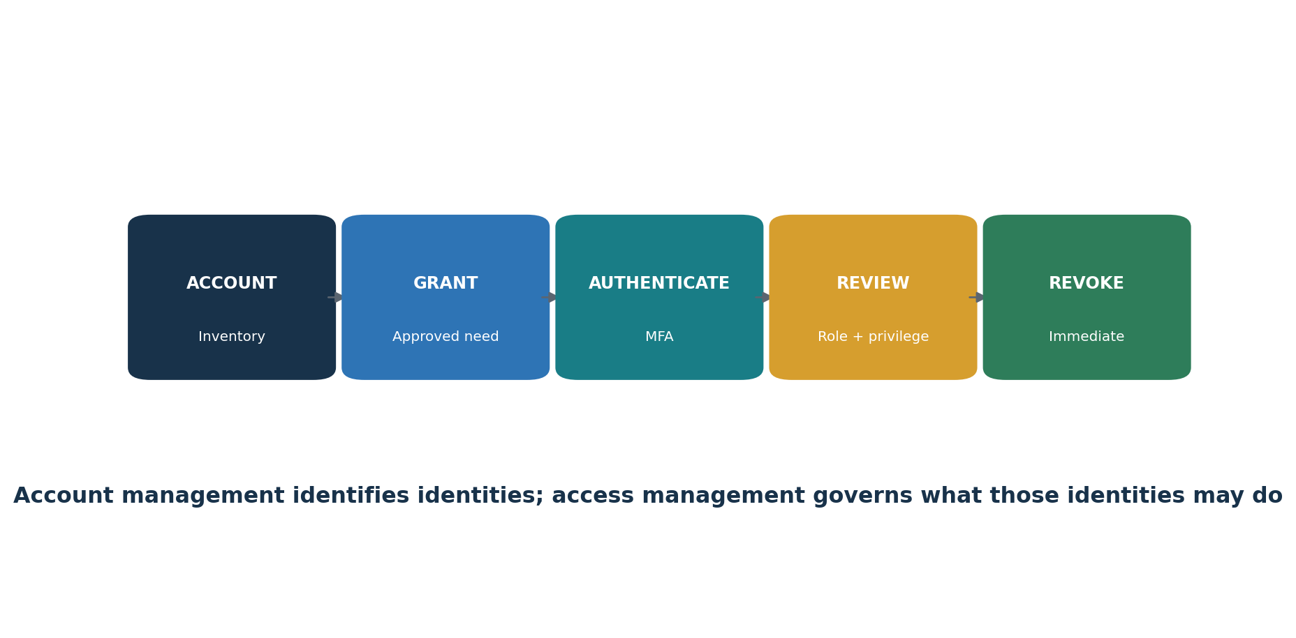
Figure 6. Identity and access life cycle
Control purpose: Strengthen the enterprise by implementing and measuring safeguards for access control management.

ID | Safeguard | Plain meaning | Verification focus | Example evidence
6.1 | Establish an Access Granting Process | Put a repeatable, owned process or technical control in place to establish an Access Granting Process, then verify coverage and exceptions. | Confirm defined scope, population, ownership, implementation, frequency, coverage, exceptions, correction, and retest. | grant/revoke tickets, MFA coverage, authentication-system inventory, roles, entitlements and access reviews
6.2 | Establish an Access Revoking Process | Put a repeatable, owned process or technical control in place to establish an Access Revoking Process, then verify coverage and exceptions. | Confirm defined scope, population, ownership, implementation, frequency, coverage, exceptions, correction, and retest. | grant/revoke tickets, MFA coverage, authentication-system inventory, roles, entitlements and access reviews
6.3 | Require MFA for Externally-Exposed Applications | Put a repeatable, owned process or technical control in place to require MFA for Externally-Exposed Applications, then verify coverage and exceptions. | Confirm defined scope, population, ownership, implementation, frequency, coverage, exceptions, correction, and retest. | grant/revoke tickets, MFA coverage, authentication-system inventory, roles, entitlements and access reviews
6.4 | Require MFA for Remote Network Access | Put a repeatable, owned process or technical control in place to require MFA for Remote Network Access, then verify coverage and exceptions. | Confirm defined scope, population, ownership, implementation, frequency, coverage, exceptions, correction, and retest. | grant/revoke tickets, MFA coverage, authentication-system inventory, roles, entitlements and access reviews
6.5 | Require MFA for Administrative Access | Put a repeatable, owned process or technical control in place to require MFA for Administrative Access, then verify coverage and exceptions. | Confirm defined scope, population, ownership, implementation, frequency, coverage, exceptions, correction, and retest. | grant/revoke tickets, MFA coverage, authentication-system inventory, roles, entitlements and access reviews
6.6 | Establish and Maintain an Inventory of Authentication and Authorization Systems | Put a repeatable, owned process or technical control in place to establish and Maintain an Inventory of Authentication and Authorization Systems, then verify coverage and exceptions. | Confirm defined scope, population, ownership, implementation, frequency, coverage, exceptions, correction, and retest. | grant/revoke tickets, MFA coverage, authentication-system inventory, roles, entitlements and access reviews
6.7 | Centralize Access Control | Put a repeatable, owned process or technical control in place to centralize Access Control, then verify coverage and exceptions. | Confirm defined scope, population, ownership, implementation, frequency, coverage, exceptions, correction, and retest. | grant/revoke tickets, MFA coverage, authentication-system inventory, roles, entitlements and access reviews
6.8 | Define and Maintain Role-Based Access Control | Put a repeatable, owned process or technical control in place to define and Maintain Role-Based Access Control, then verify coverage and exceptions. | Confirm defined scope, population, ownership, implementation, frequency, coverage, exceptions, correction, and retest. | grant/revoke tickets, MFA coverage, authentication-system inventory, roles, entitlements and access reviews

Use the official CIS Controls v8.1 guide and Controls Assessment Specification for exact Safeguard language, asset class, security function, Implementation Group, dependencies, inputs, operations, measures, metrics, and procedural review.

12. Control 7 — Continuous Vulnerability Management
All 7 Safeguards, plain meaning, verification focus, and example evidence.
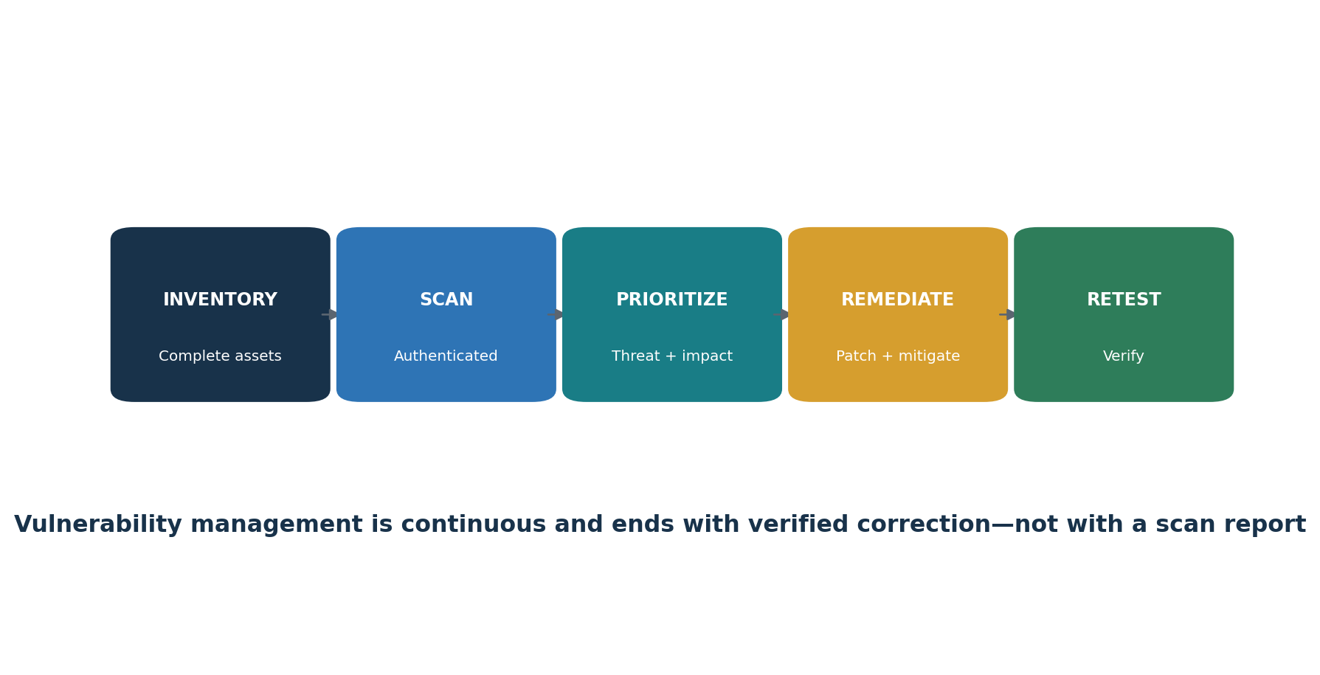
Figure 7. Continuous vulnerability management
Control purpose: Strengthen the enterprise by implementing and measuring safeguards for continuous vulnerability management.

ID | Safeguard | Plain meaning | Verification focus | Example evidence
7.1 | Establish and Maintain a Vulnerability Management Process | Put a repeatable, owned process or technical control in place to establish and Maintain a Vulnerability Management Process, then verify coverage and exceptions. | Confirm defined scope, population, ownership, implementation, frequency, coverage, exceptions, correction, and retest. | processes, feeds, asset coverage, authenticated scans, patch results, exceptions, remediation tickets and rescans
7.2 | Establish and Maintain a Remediation Process | Put a repeatable, owned process or technical control in place to establish and Maintain a Remediation Process, then verify coverage and exceptions. | Confirm defined scope, population, ownership, implementation, frequency, coverage, exceptions, correction, and retest. | processes, feeds, asset coverage, authenticated scans, patch results, exceptions, remediation tickets and rescans
7.3 | Perform Automated Operating System Patch Management | Put a repeatable, owned process or technical control in place to perform Automated Operating System Patch Management, then verify coverage and exceptions. | Confirm defined scope, population, ownership, implementation, frequency, coverage, exceptions, correction, and retest. | processes, feeds, asset coverage, authenticated scans, patch results, exceptions, remediation tickets and rescans
7.4 | Perform Automated Application Patch Management | Put a repeatable, owned process or technical control in place to perform Automated Application Patch Management, then verify coverage and exceptions. | Confirm defined scope, population, ownership, implementation, frequency, coverage, exceptions, correction, and retest. | processes, feeds, asset coverage, authenticated scans, patch results, exceptions, remediation tickets and rescans
7.5 | Perform Automated Vulnerability Scans of Internal Enterprise Assets | Put a repeatable, owned process or technical control in place to perform Automated Vulnerability Scans of Internal Enterprise Assets, then verify coverage and exceptions. | Confirm defined scope, population, ownership, implementation, frequency, coverage, exceptions, correction, and retest. | processes, feeds, asset coverage, authenticated scans, patch results, exceptions, remediation tickets and rescans
7.6 | Perform Automated Vulnerability Scans of Externally-Exposed Enterprise Assets | Put a repeatable, owned process or technical control in place to perform Automated Vulnerability Scans of Externally-Exposed Enterprise Assets, then verify coverage and exceptions. | Confirm defined scope, population, ownership, implementation, frequency, coverage, exceptions, correction, and retest. | processes, feeds, asset coverage, authenticated scans, patch results, exceptions, remediation tickets and rescans
7.7 | Remediate Detected Vulnerabilities | Put a repeatable, owned process or technical control in place to remediate Detected Vulnerabilities, then verify coverage and exceptions. | Confirm defined scope, population, ownership, implementation, frequency, coverage, exceptions, correction, and retest. | processes, feeds, asset coverage, authenticated scans, patch results, exceptions, remediation tickets and rescans

Use the official CIS Controls v8.1 guide and Controls Assessment Specification for exact Safeguard language, asset class, security function, Implementation Group, dependencies, inputs, operations, measures, metrics, and procedural review.

13. Control 8 — Audit Log Management
All 12 Safeguards, plain meaning, verification focus, and example evidence.
Control purpose: Strengthen the enterprise by implementing and measuring safeguards for audit log management.

ID | Safeguard | Plain meaning | Verification focus | Example evidence
8.1 | Establish and Maintain an Audit Log Management Process | Put a repeatable, owned process or technical control in place to establish and Maintain an Audit Log Management Process, then verify coverage and exceptions. | Confirm defined scope, population, ownership, implementation, frequency, coverage, exceptions, correction, and retest. | logging requirements, source inventory, storage, time settings, detailed logs, central platform, reviews and retention
8.2 | Collect Audit Logs | Put a repeatable, owned process or technical control in place to collect Audit Logs, then verify coverage and exceptions. | Confirm defined scope, population, ownership, implementation, frequency, coverage, exceptions, correction, and retest. | logging requirements, source inventory, storage, time settings, detailed logs, central platform, reviews and retention
8.3 | Ensure Adequate Audit Log Storage | Put a repeatable, owned process or technical control in place to ensure Adequate Audit Log Storage, then verify coverage and exceptions. | Confirm defined scope, population, ownership, implementation, frequency, coverage, exceptions, correction, and retest. | logging requirements, source inventory, storage, time settings, detailed logs, central platform, reviews and retention
8.4 | Standardize Time Synchronization | Put a repeatable, owned process or technical control in place to standardize Time Synchronization, then verify coverage and exceptions. | Confirm defined scope, population, ownership, implementation, frequency, coverage, exceptions, correction, and retest. | logging requirements, source inventory, storage, time settings, detailed logs, central platform, reviews and retention
8.5 | Collect Detailed Audit Logs | Put a repeatable, owned process or technical control in place to collect Detailed Audit Logs, then verify coverage and exceptions. | Confirm defined scope, population, ownership, implementation, frequency, coverage, exceptions, correction, and retest. | logging requirements, source inventory, storage, time settings, detailed logs, central platform, reviews and retention
8.6 | Collect DNS Query Audit Logs | Put a repeatable, owned process or technical control in place to collect DNS Query Audit Logs, then verify coverage and exceptions. | Confirm defined scope, population, ownership, implementation, frequency, coverage, exceptions, correction, and retest. | logging requirements, source inventory, storage, time settings, detailed logs, central platform, reviews and retention
8.7 | Collect URL Request Audit Logs | Put a repeatable, owned process or technical control in place to collect URL Request Audit Logs, then verify coverage and exceptions. | Confirm defined scope, population, ownership, implementation, frequency, coverage, exceptions, correction, and retest. | logging requirements, source inventory, storage, time settings, detailed logs, central platform, reviews and retention
8.8 | Collect Command-Line Audit Logs | Put a repeatable, owned process or technical control in place to collect Command-Line Audit Logs, then verify coverage and exceptions. | Confirm defined scope, population, ownership, implementation, frequency, coverage, exceptions, correction, and retest. | logging requirements, source inventory, storage, time settings, detailed logs, central platform, reviews and retention
8.9 | Centralize Audit Logs | Put a repeatable, owned process or technical control in place to centralize Audit Logs, then verify coverage and exceptions. | Confirm defined scope, population, ownership, implementation, frequency, coverage, exceptions, correction, and retest. | logging requirements, source inventory, storage, time settings, detailed logs, central platform, reviews and retention
8.10 | Retain Audit Logs | Put a repeatable, owned process or technical control in place to retain Audit Logs, then verify coverage and exceptions. | Confirm defined scope, population, ownership, implementation, frequency, coverage, exceptions, correction, and retest. | logging requirements, source inventory, storage, time settings, detailed logs, central platform, reviews and retention
8.11 | Conduct Audit Log Reviews | Put a repeatable, owned process or technical control in place to conduct Audit Log Reviews, then verify coverage and exceptions. | Confirm defined scope, population, ownership, implementation, frequency, coverage, exceptions, correction, and retest. | logging requirements, source inventory, storage, time settings, detailed logs, central platform, reviews and retention
8.12 | Collect Service Provider Logs | Put a repeatable, owned process or technical control in place to collect Service Provider Logs, then verify coverage and exceptions. | Confirm defined scope, population, ownership, implementation, frequency, coverage, exceptions, correction, and retest. | logging requirements, source inventory, storage, time settings, detailed logs, central platform, reviews and retention

Use the official CIS Controls v8.1 guide and Controls Assessment Specification for exact Safeguard language, asset class, security function, Implementation Group, dependencies, inputs, operations, measures, metrics, and procedural review.

14. Control 9 — Email and Web Browser Protections
All 7 Safeguards, plain meaning, verification focus, and example evidence.
Control purpose: Strengthen the enterprise by implementing and measuring safeguards for email and web browser protections.

ID | Safeguard | Plain meaning | Verification focus | Example evidence
9.1 | Ensure Use of Only Fully Supported Browsers and Email Clients | Put a repeatable, owned process or technical control in place to ensure Use of Only Fully Supported Browsers and Email Clients, then verify coverage and exceptions. | Confirm defined scope, population, ownership, implementation, frequency, coverage, exceptions, correction, and retest. | browser and email inventories, support status, DNS/URL filtering, extension policy, DMARC and attachment controls
9.2 | Use DNS Filtering Services | Put a repeatable, owned process or technical control in place to use DNS Filtering Services, then verify coverage and exceptions. | Confirm defined scope, population, ownership, implementation, frequency, coverage, exceptions, correction, and retest. | browser and email inventories, support status, DNS/URL filtering, extension policy, DMARC and attachment controls
9.3 | Maintain and Enforce Network-Based URL Filters | Put a repeatable, owned process or technical control in place to maintain and Enforce Network-Based URL Filters, then verify coverage and exceptions. | Confirm defined scope, population, ownership, implementation, frequency, coverage, exceptions, correction, and retest. | browser and email inventories, support status, DNS/URL filtering, extension policy, DMARC and attachment controls
9.4 | Restrict Unnecessary or Unauthorized Browser and Email Client Extensions | Put a repeatable, owned process or technical control in place to restrict Unnecessary or Unauthorized Browser and Email Client Extensions, then verify coverage and exceptions. | Confirm defined scope, population, ownership, implementation, frequency, coverage, exceptions, correction, and retest. | browser and email inventories, support status, DNS/URL filtering, extension policy, DMARC and attachment controls
9.5 | Implement DMARC | Put a repeatable, owned process or technical control in place to implement DMARC, then verify coverage and exceptions. | Confirm defined scope, population, ownership, implementation, frequency, coverage, exceptions, correction, and retest. | browser and email inventories, support status, DNS/URL filtering, extension policy, DMARC and attachment controls
9.6 | Block Unnecessary File Types | Put a repeatable, owned process or technical control in place to block Unnecessary File Types, then verify coverage and exceptions. | Confirm defined scope, population, ownership, implementation, frequency, coverage, exceptions, correction, and retest. | browser and email inventories, support status, DNS/URL filtering, extension policy, DMARC and attachment controls
9.7 | Deploy and Maintain Email Server Anti-Malware Protections | Put a repeatable, owned process or technical control in place to deploy and Maintain Email Server Anti-Malware Protections, then verify coverage and exceptions. | Confirm defined scope, population, ownership, implementation, frequency, coverage, exceptions, correction, and retest. | browser and email inventories, support status, DNS/URL filtering, extension policy, DMARC and attachment controls

Use the official CIS Controls v8.1 guide and Controls Assessment Specification for exact Safeguard language, asset class, security function, Implementation Group, dependencies, inputs, operations, measures, metrics, and procedural review.

15. Control 10 — Malware Defenses
All 7 Safeguards, plain meaning, verification focus, and example evidence.
Control purpose: Strengthen the enterprise by implementing and measuring safeguards for malware defenses.

ID | Safeguard | Plain meaning | Verification focus | Example evidence
10.1 | Deploy and Maintain Anti-Malware Software | Put a repeatable, owned process or technical control in place to deploy and Maintain Anti-Malware Software, then verify coverage and exceptions. | Confirm defined scope, population, ownership, implementation, frequency, coverage, exceptions, correction, and retest. | endpoint coverage, anti-malware configuration, updates, removable-media controls, behavior alerts and response tickets
10.2 | Configure Automatic Anti-Malware Signature Updates | Put a repeatable, owned process or technical control in place to configure Automatic Anti-Malware Signature Updates, then verify coverage and exceptions. | Confirm defined scope, population, ownership, implementation, frequency, coverage, exceptions, correction, and retest. | endpoint coverage, anti-malware configuration, updates, removable-media controls, behavior alerts and response tickets
10.3 | Disable Autorun and Autoplay for Removable Media | Put a repeatable, owned process or technical control in place to disable Autorun and Autoplay for Removable Media, then verify coverage and exceptions. | Confirm defined scope, population, ownership, implementation, frequency, coverage, exceptions, correction, and retest. | endpoint coverage, anti-malware configuration, updates, removable-media controls, behavior alerts and response tickets
10.4 | Configure Automatic Anti-Malware Scanning of Removable Media | Put a repeatable, owned process or technical control in place to configure Automatic Anti-Malware Scanning of Removable Media, then verify coverage and exceptions. | Confirm defined scope, population, ownership, implementation, frequency, coverage, exceptions, correction, and retest. | endpoint coverage, anti-malware configuration, updates, removable-media controls, behavior alerts and response tickets
10.5 | Enable Anti-Exploitation Features | Put a repeatable, owned process or technical control in place to enable Anti-Exploitation Features, then verify coverage and exceptions. | Confirm defined scope, population, ownership, implementation, frequency, coverage, exceptions, correction, and retest. | endpoint coverage, anti-malware configuration, updates, removable-media controls, behavior alerts and response tickets
10.6 | Centrally Manage Anti-Malware Software | Put a repeatable, owned process or technical control in place to centrally Manage Anti-Malware Software, then verify coverage and exceptions. | Confirm defined scope, population, ownership, implementation, frequency, coverage, exceptions, correction, and retest. | endpoint coverage, anti-malware configuration, updates, removable-media controls, behavior alerts and response tickets
10.7 | Use Behavior-Based Anti-Malware Software | Put a repeatable, owned process or technical control in place to use Behavior-Based Anti-Malware Software, then verify coverage and exceptions. | Confirm defined scope, population, ownership, implementation, frequency, coverage, exceptions, correction, and retest. | endpoint coverage, anti-malware configuration, updates, removable-media controls, behavior alerts and response tickets

Use the official CIS Controls v8.1 guide and Controls Assessment Specification for exact Safeguard language, asset class, security function, Implementation Group, dependencies, inputs, operations, measures, metrics, and procedural review.

16. Control 11 — Data Recovery
All 5 Safeguards, plain meaning, verification focus, and example evidence.
Control purpose: Strengthen the enterprise by implementing and measuring safeguards for data recovery.

ID | Safeguard | Plain meaning | Verification focus | Example evidence
11.1 | Establish and Maintain a Data Recovery Process | Put a repeatable, owned process or technical control in place to establish and Maintain a Data Recovery Process, then verify coverage and exceptions. | Confirm defined scope, population, ownership, implementation, frequency, coverage, exceptions, correction, and retest. | recovery plan, backup coverage, protected and isolated copies, restore tests, results, gaps and retests
11.2 | Perform Automated Backups | Put a repeatable, owned process or technical control in place to perform Automated Backups, then verify coverage and exceptions. | Confirm defined scope, population, ownership, implementation, frequency, coverage, exceptions, correction, and retest. | recovery plan, backup coverage, protected and isolated copies, restore tests, results, gaps and retests
11.3 | Protect Recovery Data | Put a repeatable, owned process or technical control in place to protect Recovery Data, then verify coverage and exceptions. | Confirm defined scope, population, ownership, implementation, frequency, coverage, exceptions, correction, and retest. | recovery plan, backup coverage, protected and isolated copies, restore tests, results, gaps and retests
11.4 | Establish and Maintain an Isolated Instance of Recovery Data | Put a repeatable, owned process or technical control in place to establish and Maintain an Isolated Instance of Recovery Data, then verify coverage and exceptions. | Confirm defined scope, population, ownership, implementation, frequency, coverage, exceptions, correction, and retest. | recovery plan, backup coverage, protected and isolated copies, restore tests, results, gaps and retests
11.5 | Test Data Recovery | Put a repeatable, owned process or technical control in place to test Data Recovery, then verify coverage and exceptions. | Confirm defined scope, population, ownership, implementation, frequency, coverage, exceptions, correction, and retest. | recovery plan, backup coverage, protected and isolated copies, restore tests, results, gaps and retests

Use the official CIS Controls v8.1 guide and Controls Assessment Specification for exact Safeguard language, asset class, security function, Implementation Group, dependencies, inputs, operations, measures, metrics, and procedural review.

17. Control 12 — Network Infrastructure Management
All 8 Safeguards, plain meaning, verification focus, and example evidence.
Control purpose: Strengthen the enterprise by implementing and measuring safeguards for network infrastructure management.

ID | Safeguard | Plain meaning | Verification focus | Example evidence
12.1 | Ensure Network Infrastructure is Up-to-Date | Put a repeatable, owned process or technical control in place to ensure Network Infrastructure is Up-to-Date, then verify coverage and exceptions. | Confirm defined scope, population, ownership, implementation, frequency, coverage, exceptions, correction, and retest. | network inventory, versions, architecture, diagrams, admin paths, AAA, secure protocols, VPN and admin workstations
12.2 | Establish and Maintain a Secure Network Architecture | Put a repeatable, owned process or technical control in place to establish and Maintain a Secure Network Architecture, then verify coverage and exceptions. | Confirm defined scope, population, ownership, implementation, frequency, coverage, exceptions, correction, and retest. | network inventory, versions, architecture, diagrams, admin paths, AAA, secure protocols, VPN and admin workstations
12.3 | Securely Manage Network Infrastructure | Put a repeatable, owned process or technical control in place to securely Manage Network Infrastructure, then verify coverage and exceptions. | Confirm defined scope, population, ownership, implementation, frequency, coverage, exceptions, correction, and retest. | network inventory, versions, architecture, diagrams, admin paths, AAA, secure protocols, VPN and admin workstations
12.4 | Establish and Maintain Architecture Diagrams | Put a repeatable, owned process or technical control in place to establish and Maintain Architecture Diagrams, then verify coverage and exceptions. | Confirm defined scope, population, ownership, implementation, frequency, coverage, exceptions, correction, and retest. | network inventory, versions, architecture, diagrams, admin paths, AAA, secure protocols, VPN and admin workstations
12.5 | Centralize Network Authentication, Authorization, and Auditing | Put a repeatable, owned process or technical control in place to centralize Network Authentication, Authorization, and Auditing, then verify coverage and exceptions. | Confirm defined scope, population, ownership, implementation, frequency, coverage, exceptions, correction, and retest. | network inventory, versions, architecture, diagrams, admin paths, AAA, secure protocols, VPN and admin workstations
12.6 | Use Secure Network Management and Communication Protocols | Put a repeatable, owned process or technical control in place to use Secure Network Management and Communication Protocols, then verify coverage and exceptions. | Confirm defined scope, population, ownership, implementation, frequency, coverage, exceptions, correction, and retest. | network inventory, versions, architecture, diagrams, admin paths, AAA, secure protocols, VPN and admin workstations
12.7 | Ensure Remote Devices Use a VPN and Enterprise AAA | Put a repeatable, owned process or technical control in place to ensure Remote Devices Use a VPN and Enterprise AAA, then verify coverage and exceptions. | Confirm defined scope, population, ownership, implementation, frequency, coverage, exceptions, correction, and retest. | network inventory, versions, architecture, diagrams, admin paths, AAA, secure protocols, VPN and admin workstations
12.8 | Maintain Dedicated Computing Resources for Administrative Work | Put a repeatable, owned process or technical control in place to maintain Dedicated Computing Resources for Administrative Work, then verify coverage and exceptions. | Confirm defined scope, population, ownership, implementation, frequency, coverage, exceptions, correction, and retest. | network inventory, versions, architecture, diagrams, admin paths, AAA, secure protocols, VPN and admin workstations

Use the official CIS Controls v8.1 guide and Controls Assessment Specification for exact Safeguard language, asset class, security function, Implementation Group, dependencies, inputs, operations, measures, metrics, and procedural review.

18. Control 13 — Network Monitoring and Defense
All 11 Safeguards, plain meaning, verification focus, and example evidence.
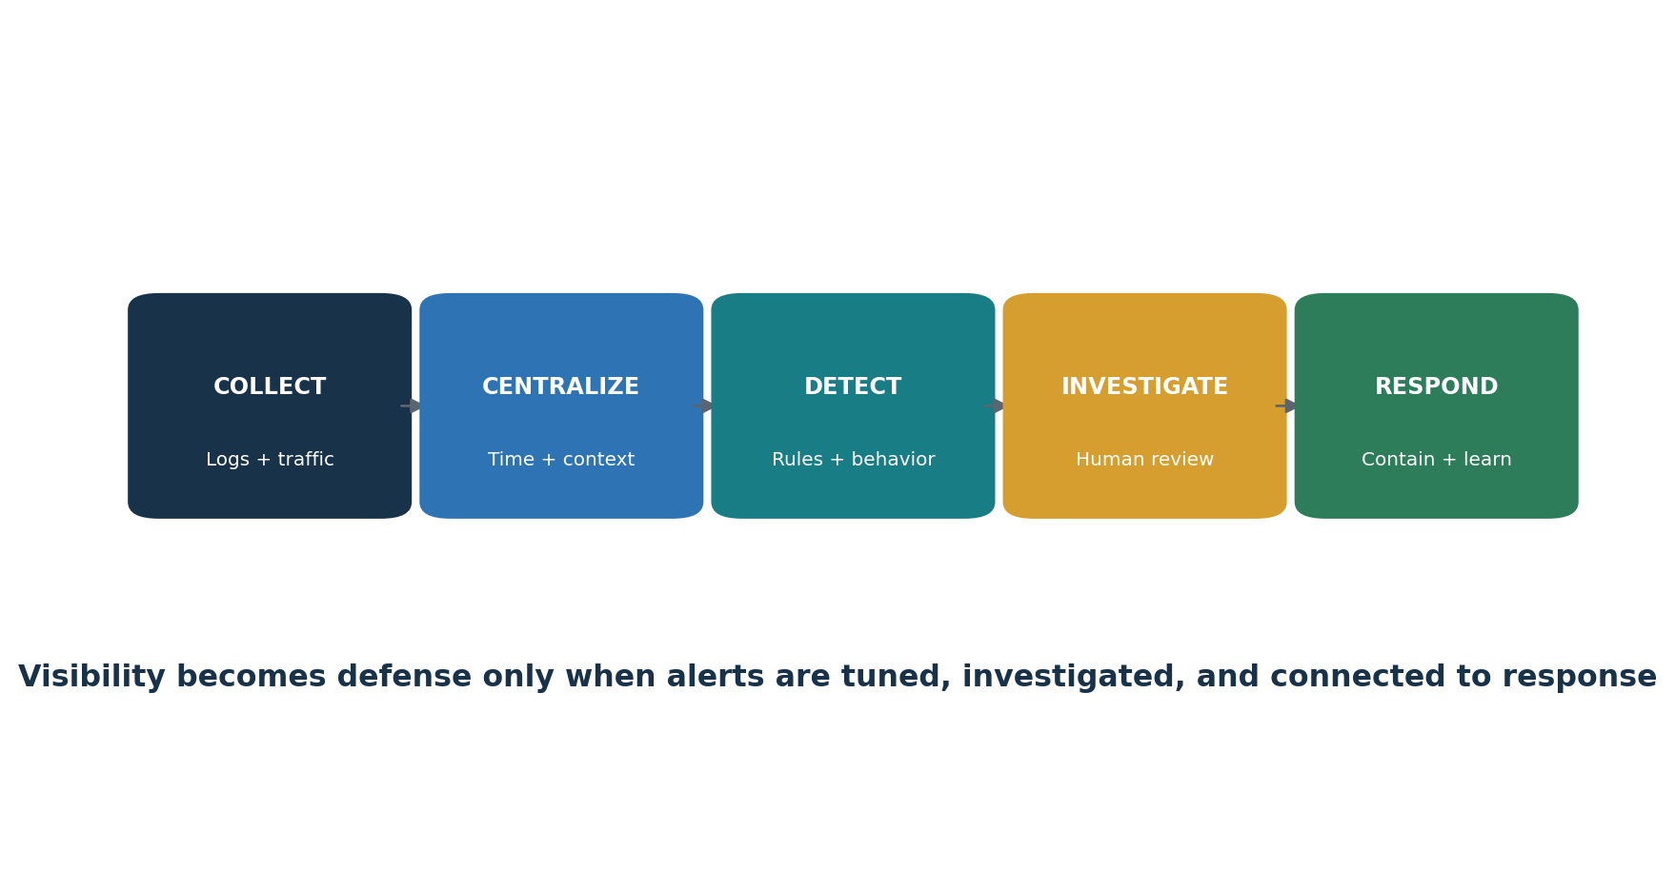
Figure 8. Monitoring-to-response workflow
Control purpose: Strengthen the enterprise by implementing and measuring safeguards for network monitoring and defense.

ID | Safeguard | Plain meaning | Verification focus | Example evidence
13.1 | Centralize Security Event Alerting | Put a repeatable, owned process or technical control in place to centralize Security Event Alerting, then verify coverage and exceptions. | Confirm defined scope, population, ownership, implementation, frequency, coverage, exceptions, correction, and retest. | SIEM coverage, host/network detection, segmentation, remote controls, flow logs, prevention systems and alert tuning
13.2 | Deploy a Host-Based Intrusion Detection Solution | Put a repeatable, owned process or technical control in place to deploy a Host-Based Intrusion Detection Solution, then verify coverage and exceptions. | Confirm defined scope, population, ownership, implementation, frequency, coverage, exceptions, correction, and retest. | SIEM coverage, host/network detection, segmentation, remote controls, flow logs, prevention systems and alert tuning
13.3 | Deploy a Network Intrusion Detection Solution | Put a repeatable, owned process or technical control in place to deploy a Network Intrusion Detection Solution, then verify coverage and exceptions. | Confirm defined scope, population, ownership, implementation, frequency, coverage, exceptions, correction, and retest. | SIEM coverage, host/network detection, segmentation, remote controls, flow logs, prevention systems and alert tuning
13.4 | Perform Traffic Filtering Between Network Segments | Put a repeatable, owned process or technical control in place to perform Traffic Filtering Between Network Segments, then verify coverage and exceptions. | Confirm defined scope, population, ownership, implementation, frequency, coverage, exceptions, correction, and retest. | SIEM coverage, host/network detection, segmentation, remote controls, flow logs, prevention systems and alert tuning
13.5 | Manage Access Control for Remote Assets | Put a repeatable, owned process or technical control in place to manage Access Control for Remote Assets, then verify coverage and exceptions. | Confirm defined scope, population, ownership, implementation, frequency, coverage, exceptions, correction, and retest. | SIEM coverage, host/network detection, segmentation, remote controls, flow logs, prevention systems and alert tuning
13.6 | Collect Network Traffic Flow Logs | Put a repeatable, owned process or technical control in place to collect Network Traffic Flow Logs, then verify coverage and exceptions. | Confirm defined scope, population, ownership, implementation, frequency, coverage, exceptions, correction, and retest. | SIEM coverage, host/network detection, segmentation, remote controls, flow logs, prevention systems and alert tuning
13.7 | Deploy a Host-Based Intrusion Prevention Solution | Put a repeatable, owned process or technical control in place to deploy a Host-Based Intrusion Prevention Solution, then verify coverage and exceptions. | Confirm defined scope, population, ownership, implementation, frequency, coverage, exceptions, correction, and retest. | SIEM coverage, host/network detection, segmentation, remote controls, flow logs, prevention systems and alert tuning
13.8 | Deploy a Network Intrusion Prevention Solution | Put a repeatable, owned process or technical control in place to deploy a Network Intrusion Prevention Solution, then verify coverage and exceptions. | Confirm defined scope, population, ownership, implementation, frequency, coverage, exceptions, correction, and retest. | SIEM coverage, host/network detection, segmentation, remote controls, flow logs, prevention systems and alert tuning
13.9 | Deploy Port-Level Access Control | Put a repeatable, owned process or technical control in place to deploy Port-Level Access Control, then verify coverage and exceptions. | Confirm defined scope, population, ownership, implementation, frequency, coverage, exceptions, correction, and retest. | SIEM coverage, host/network detection, segmentation, remote controls, flow logs, prevention systems and alert tuning
13.10 | Perform Application Layer Filtering | Put a repeatable, owned process or technical control in place to perform Application Layer Filtering, then verify coverage and exceptions. | Confirm defined scope, population, ownership, implementation, frequency, coverage, exceptions, correction, and retest. | SIEM coverage, host/network detection, segmentation, remote controls, flow logs, prevention systems and alert tuning
13.11 | Tune Security Event Alerting Thresholds | Put a repeatable, owned process or technical control in place to tune Security Event Alerting Thresholds, then verify coverage and exceptions. | Confirm defined scope, population, ownership, implementation, frequency, coverage, exceptions, correction, and retest. | SIEM coverage, host/network detection, segmentation, remote controls, flow logs, prevention systems and alert tuning

Use the official CIS Controls v8.1 guide and Controls Assessment Specification for exact Safeguard language, asset class, security function, Implementation Group, dependencies, inputs, operations, measures, metrics, and procedural review.

19. Control 14 — Security Awareness and Skills Training
All 9 Safeguards, plain meaning, verification focus, and example evidence.
Control purpose: Strengthen the enterprise by implementing and measuring safeguards for security awareness and skills training.

ID | Safeguard | Plain meaning | Verification focus | Example evidence
14.1 | Establish and Maintain a Security Awareness Program | Put a repeatable, owned process or technical control in place to establish and Maintain a Security Awareness Program, then verify coverage and exceptions. | Confirm defined scope, population, ownership, implementation, frequency, coverage, exceptions, correction, and retest. | program, workforce population, role curriculum, completion, simulations, evaluation, exceptions and follow-up
14.2 | Train Workforce Members to Recognize Social Engineering Attacks | Put a repeatable, owned process or technical control in place to train Workforce Members to Recognize Social Engineering Attacks, then verify coverage and exceptions. | Confirm defined scope, population, ownership, implementation, frequency, coverage, exceptions, correction, and retest. | program, workforce population, role curriculum, completion, simulations, evaluation, exceptions and follow-up
14.3 | Train Workforce Members on Authentication Best Practices | Put a repeatable, owned process or technical control in place to train Workforce Members on Authentication Best Practices, then verify coverage and exceptions. | Confirm defined scope, population, ownership, implementation, frequency, coverage, exceptions, correction, and retest. | program, workforce population, role curriculum, completion, simulations, evaluation, exceptions and follow-up
14.4 | Train Workforce on Data Handling Best Practices | Put a repeatable, owned process or technical control in place to train Workforce on Data Handling Best Practices, then verify coverage and exceptions. | Confirm defined scope, population, ownership, implementation, frequency, coverage, exceptions, correction, and retest. | program, workforce population, role curriculum, completion, simulations, evaluation, exceptions and follow-up
14.5 | Train Workforce Members on Causes of Unintentional Data Exposure | Put a repeatable, owned process or technical control in place to train Workforce Members on Causes of Unintentional Data Exposure, then verify coverage and exceptions. | Confirm defined scope, population, ownership, implementation, frequency, coverage, exceptions, correction, and retest. | program, workforce population, role curriculum, completion, simulations, evaluation, exceptions and follow-up
14.6 | Train Workforce Members on Recognizing and Reporting Security Incidents | Put a repeatable, owned process or technical control in place to train Workforce Members on Recognizing and Reporting Security Incidents, then verify coverage and exceptions. | Confirm defined scope, population, ownership, implementation, frequency, coverage, exceptions, correction, and retest. | program, workforce population, role curriculum, completion, simulations, evaluation, exceptions and follow-up
14.7 | Train Workforce to Identify and Report Missing Security Updates | Put a repeatable, owned process or technical control in place to train Workforce to Identify and Report Missing Security Updates, then verify coverage and exceptions. | Confirm defined scope, population, ownership, implementation, frequency, coverage, exceptions, correction, and retest. | program, workforce population, role curriculum, completion, simulations, evaluation, exceptions and follow-up
14.8 | Train Workforce on Risks of Insecure Networks | Put a repeatable, owned process or technical control in place to train Workforce on Risks of Insecure Networks, then verify coverage and exceptions. | Confirm defined scope, population, ownership, implementation, frequency, coverage, exceptions, correction, and retest. | program, workforce population, role curriculum, completion, simulations, evaluation, exceptions and follow-up
14.9 | Conduct Role-Specific Security Awareness and Skills Training | Put a repeatable, owned process or technical control in place to conduct Role-Specific Security Awareness and Skills Training, then verify coverage and exceptions. | Confirm defined scope, population, ownership, implementation, frequency, coverage, exceptions, correction, and retest. | program, workforce population, role curriculum, completion, simulations, evaluation, exceptions and follow-up

Use the official CIS Controls v8.1 guide and Controls Assessment Specification for exact Safeguard language, asset class, security function, Implementation Group, dependencies, inputs, operations, measures, metrics, and procedural review.

20. Control 15 — Service Provider Management
All 7 Safeguards, plain meaning, verification focus, and example evidence.
Control purpose: Strengthen the enterprise by implementing and measuring safeguards for service provider management.

ID | Safeguard | Plain meaning | Verification focus | Example evidence
15.1 | Establish and Maintain an Inventory of Service Providers | Put a repeatable, owned process or technical control in place to establish and Maintain an Inventory of Service Providers, then verify coverage and exceptions. | Confirm defined scope, population, ownership, implementation, frequency, coverage, exceptions, correction, and retest. | provider inventory, classifications, policy, contracts, assessments, monitoring, incidents and decommission evidence
15.2 | Establish and Maintain a Service Provider Management Policy | Put a repeatable, owned process or technical control in place to establish and Maintain a Service Provider Management Policy, then verify coverage and exceptions. | Confirm defined scope, population, ownership, implementation, frequency, coverage, exceptions, correction, and retest. | provider inventory, classifications, policy, contracts, assessments, monitoring, incidents and decommission evidence
15.3 | Classify Service Providers | Put a repeatable, owned process or technical control in place to classify Service Providers, then verify coverage and exceptions. | Confirm defined scope, population, ownership, implementation, frequency, coverage, exceptions, correction, and retest. | provider inventory, classifications, policy, contracts, assessments, monitoring, incidents and decommission evidence
15.4 | Ensure Service Provider Contracts Include Security Requirements | Put a repeatable, owned process or technical control in place to ensure Service Provider Contracts Include Security Requirements, then verify coverage and exceptions. | Confirm defined scope, population, ownership, implementation, frequency, coverage, exceptions, correction, and retest. | provider inventory, classifications, policy, contracts, assessments, monitoring, incidents and decommission evidence
15.5 | Assess Service Providers | Put a repeatable, owned process or technical control in place to assess Service Providers, then verify coverage and exceptions. | Confirm defined scope, population, ownership, implementation, frequency, coverage, exceptions, correction, and retest. | provider inventory, classifications, policy, contracts, assessments, monitoring, incidents and decommission evidence
15.6 | Monitor Service Providers | Put a repeatable, owned process or technical control in place to monitor Service Providers, then verify coverage and exceptions. | Confirm defined scope, population, ownership, implementation, frequency, coverage, exceptions, correction, and retest. | provider inventory, classifications, policy, contracts, assessments, monitoring, incidents and decommission evidence
15.7 | Securely Decommission Service Providers | Put a repeatable, owned process or technical control in place to securely Decommission Service Providers, then verify coverage and exceptions. | Confirm defined scope, population, ownership, implementation, frequency, coverage, exceptions, correction, and retest. | provider inventory, classifications, policy, contracts, assessments, monitoring, incidents and decommission evidence

Use the official CIS Controls v8.1 guide and Controls Assessment Specification for exact Safeguard language, asset class, security function, Implementation Group, dependencies, inputs, operations, measures, metrics, and procedural review.

21. Control 16 — Application Software Security
All 14 Safeguards, plain meaning, verification focus, and example evidence.
Control purpose: Strengthen the enterprise by implementing and measuring safeguards for application software security.

ID | Safeguard | Plain meaning | Verification focus | Example evidence
16.1 | Establish and Maintain a Secure Application Development Process | Put a repeatable, owned process or technical control in place to establish and Maintain a Secure Application Development Process, then verify coverage and exceptions. | Confirm defined scope, population, ownership, implementation, frequency, coverage, exceptions, correction, and retest. | secure SDLC, disclosure process, root cause, component inventory, severity, hardening, training, testing and threat models
16.2 | Establish and Maintain a Process to Accept and Address Software Vulnerabilities | Put a repeatable, owned process or technical control in place to establish and Maintain a Process to Accept and Address Software Vulnerabilities, then verify coverage and exceptions. | Confirm defined scope, population, ownership, implementation, frequency, coverage, exceptions, correction, and retest. | secure SDLC, disclosure process, root cause, component inventory, severity, hardening, training, testing and threat models
16.3 | Perform Root Cause Analysis on Security Vulnerabilities | Put a repeatable, owned process or technical control in place to perform Root Cause Analysis on Security Vulnerabilities, then verify coverage and exceptions. | Confirm defined scope, population, ownership, implementation, frequency, coverage, exceptions, correction, and retest. | secure SDLC, disclosure process, root cause, component inventory, severity, hardening, training, testing and threat models
16.4 | Establish and Manage an Inventory of Third-Party Software Components | Put a repeatable, owned process or technical control in place to establish and Manage an Inventory of Third-Party Software Components, then verify coverage and exceptions. | Confirm defined scope, population, ownership, implementation, frequency, coverage, exceptions, correction, and retest. | secure SDLC, disclosure process, root cause, component inventory, severity, hardening, training, testing and threat models
16.5 | Use Up-to-Date and Trusted Third-Party Software Components | Put a repeatable, owned process or technical control in place to use Up-to-Date and Trusted Third-Party Software Components, then verify coverage and exceptions. | Confirm defined scope, population, ownership, implementation, frequency, coverage, exceptions, correction, and retest. | secure SDLC, disclosure process, root cause, component inventory, severity, hardening, training, testing and threat models
16.6 | Establish a Severity Rating System and Process for Application Vulnerabilities | Put a repeatable, owned process or technical control in place to establish a Severity Rating System and Process for Application Vulnerabilities, then verify coverage and exceptions. | Confirm defined scope, population, ownership, implementation, frequency, coverage, exceptions, correction, and retest. | secure SDLC, disclosure process, root cause, component inventory, severity, hardening, training, testing and threat models
16.7 | Use Standard Hardening Templates for Application Infrastructure | Put a repeatable, owned process or technical control in place to use Standard Hardening Templates for Application Infrastructure, then verify coverage and exceptions. | Confirm defined scope, population, ownership, implementation, frequency, coverage, exceptions, correction, and retest. | secure SDLC, disclosure process, root cause, component inventory, severity, hardening, training, testing and threat models
16.8 | Separate Production and Non-Production Systems | Put a repeatable, owned process or technical control in place to separate Production and Non-Production Systems, then verify coverage and exceptions. | Confirm defined scope, population, ownership, implementation, frequency, coverage, exceptions, correction, and retest. | secure SDLC, disclosure process, root cause, component inventory, severity, hardening, training, testing and threat models
16.9 | Train Developers in Application Security and Secure Coding | Put a repeatable, owned process or technical control in place to train Developers in Application Security and Secure Coding, then verify coverage and exceptions. | Confirm defined scope, population, ownership, implementation, frequency, coverage, exceptions, correction, and retest. | secure SDLC, disclosure process, root cause, component inventory, severity, hardening, training, testing and threat models
16.10 | Apply Secure Design Principles in Application Architectures | Put a repeatable, owned process or technical control in place to apply Secure Design Principles in Application Architectures, then verify coverage and exceptions. | Confirm defined scope, population, ownership, implementation, frequency, coverage, exceptions, correction, and retest. | secure SDLC, disclosure process, root cause, component inventory, severity, hardening, training, testing and threat models
16.11 | Use Vetted Modules or Services for Application Security Components | Put a repeatable, owned process or technical control in place to use Vetted Modules or Services for Application Security Components, then verify coverage and exceptions. | Confirm defined scope, population, ownership, implementation, frequency, coverage, exceptions, correction, and retest. | secure SDLC, disclosure process, root cause, component inventory, severity, hardening, training, testing and threat models
16.12 | Implement Code-Level Security Checks | Put a repeatable, owned process or technical control in place to implement Code-Level Security Checks, then verify coverage and exceptions. | Confirm defined scope, population, ownership, implementation, frequency, coverage, exceptions, correction, and retest. | secure SDLC, disclosure process, root cause, component inventory, severity, hardening, training, testing and threat models
16.13 | Conduct Application Penetration Testing | Put a repeatable, owned process or technical control in place to conduct Application Penetration Testing, then verify coverage and exceptions. | Confirm defined scope, population, ownership, implementation, frequency, coverage, exceptions, correction, and retest. | secure SDLC, disclosure process, root cause, component inventory, severity, hardening, training, testing and threat models
16.14 | Conduct Threat Modeling | Put a repeatable, owned process or technical control in place to conduct Threat Modeling, then verify coverage and exceptions. | Confirm defined scope, population, ownership, implementation, frequency, coverage, exceptions, correction, and retest. | secure SDLC, disclosure process, root cause, component inventory, severity, hardening, training, testing and threat models

Use the official CIS Controls v8.1 guide and Controls Assessment Specification for exact Safeguard language, asset class, security function, Implementation Group, dependencies, inputs, operations, measures, metrics, and procedural review.

22. Control 17 — Incident Response Management
All 9 Safeguards, plain meaning, verification focus, and example evidence.
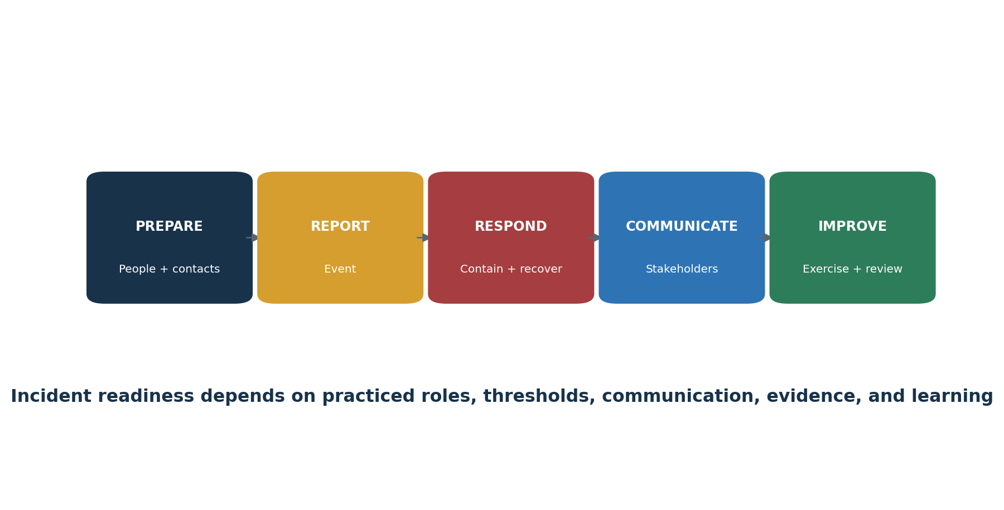
Figure 9. Incident-response readiness
Control purpose: Strengthen the enterprise by implementing and measuring safeguards for incident response management.

ID | Safeguard | Plain meaning | Verification focus | Example evidence
17.1 | Designate Personnel to Manage Incident Handling | Put a repeatable, owned process or technical control in place to designate Personnel to Manage Incident Handling, then verify coverage and exceptions. | Confirm defined scope, population, ownership, implementation, frequency, coverage, exceptions, correction, and retest. | incident leaders, contacts, reporting, plan, roles, communications, exercises, reviews and thresholds
17.2 | Maintain Contact Information for Reporting Security Incidents | Put a repeatable, owned process or technical control in place to maintain Contact Information for Reporting Security Incidents, then verify coverage and exceptions. | Confirm defined scope, population, ownership, implementation, frequency, coverage, exceptions, correction, and retest. | incident leaders, contacts, reporting, plan, roles, communications, exercises, reviews and thresholds
17.3 | Maintain an Enterprise Process for Reporting Incidents | Put a repeatable, owned process or technical control in place to maintain an Enterprise Process for Reporting Incidents, then verify coverage and exceptions. | Confirm defined scope, population, ownership, implementation, frequency, coverage, exceptions, correction, and retest. | incident leaders, contacts, reporting, plan, roles, communications, exercises, reviews and thresholds
17.4 | Establish and Maintain an Incident Response Process | Put a repeatable, owned process or technical control in place to establish and Maintain an Incident Response Process, then verify coverage and exceptions. | Confirm defined scope, population, ownership, implementation, frequency, coverage, exceptions, correction, and retest. | incident leaders, contacts, reporting, plan, roles, communications, exercises, reviews and thresholds
17.5 | Assign Key Roles and Responsibilities | Put a repeatable, owned process or technical control in place to assign Key Roles and Responsibilities, then verify coverage and exceptions. | Confirm defined scope, population, ownership, implementation, frequency, coverage, exceptions, correction, and retest. | incident leaders, contacts, reporting, plan, roles, communications, exercises, reviews and thresholds
17.6 | Define Mechanisms for Communicating During Incident Response | Put a repeatable, owned process or technical control in place to define Mechanisms for Communicating During Incident Response, then verify coverage and exceptions. | Confirm defined scope, population, ownership, implementation, frequency, coverage, exceptions, correction, and retest. | incident leaders, contacts, reporting, plan, roles, communications, exercises, reviews and thresholds
17.7 | Conduct Routine Incident Response Exercises | Put a repeatable, owned process or technical control in place to conduct Routine Incident Response Exercises, then verify coverage and exceptions. | Confirm defined scope, population, ownership, implementation, frequency, coverage, exceptions, correction, and retest. | incident leaders, contacts, reporting, plan, roles, communications, exercises, reviews and thresholds
17.8 | Conduct Post-Incident Reviews | Put a repeatable, owned process or technical control in place to conduct Post-Incident Reviews, then verify coverage and exceptions. | Confirm defined scope, population, ownership, implementation, frequency, coverage, exceptions, correction, and retest. | incident leaders, contacts, reporting, plan, roles, communications, exercises, reviews and thresholds
17.9 | Establish and Maintain Security Incident Thresholds | Put a repeatable, owned process or technical control in place to establish and Maintain Security Incident Thresholds, then verify coverage and exceptions. | Confirm defined scope, population, ownership, implementation, frequency, coverage, exceptions, correction, and retest. | incident leaders, contacts, reporting, plan, roles, communications, exercises, reviews and thresholds

Use the official CIS Controls v8.1 guide and Controls Assessment Specification for exact Safeguard language, asset class, security function, Implementation Group, dependencies, inputs, operations, measures, metrics, and procedural review.

23. Control 18 — Penetration Testing
All 5 Safeguards, plain meaning, verification focus, and example evidence.
Control purpose: Strengthen the enterprise by implementing and measuring safeguards for penetration testing.

ID | Safeguard | Plain meaning | Verification focus | Example evidence
18.1 | Establish and Maintain a Penetration Testing Program | Put a repeatable, owned process or technical control in place to establish and Maintain a Penetration Testing Program, then verify coverage and exceptions. | Confirm defined scope, population, ownership, implementation, frequency, coverage, exceptions, correction, and retest. | approved rules of engagement, scope, qualified testers, reports, remediation, retest and validation evidence
18.2 | Perform Periodic External Penetration Tests | Put a repeatable, owned process or technical control in place to perform Periodic External Penetration Tests, then verify coverage and exceptions. | Confirm defined scope, population, ownership, implementation, frequency, coverage, exceptions, correction, and retest. | approved rules of engagement, scope, qualified testers, reports, remediation, retest and validation evidence
18.3 | Remediate Penetration Test Findings | Put a repeatable, owned process or technical control in place to remediate Penetration Test Findings, then verify coverage and exceptions. | Confirm defined scope, population, ownership, implementation, frequency, coverage, exceptions, correction, and retest. | approved rules of engagement, scope, qualified testers, reports, remediation, retest and validation evidence
18.4 | Validate Security Measures | Put a repeatable, owned process or technical control in place to validate Security Measures, then verify coverage and exceptions. | Confirm defined scope, population, ownership, implementation, frequency, coverage, exceptions, correction, and retest. | approved rules of engagement, scope, qualified testers, reports, remediation, retest and validation evidence
18.5 | Perform Periodic Internal Penetration Tests | Put a repeatable, owned process or technical control in place to perform Periodic Internal Penetration Tests, then verify coverage and exceptions. | Confirm defined scope, population, ownership, implementation, frequency, coverage, exceptions, correction, and retest. | approved rules of engagement, scope, qualified testers, reports, remediation, retest and validation evidence

Use the official CIS Controls v8.1 guide and Controls Assessment Specification for exact Safeguard language, asset class, security function, Implementation Group, dependencies, inputs, operations, measures, metrics, and procedural review.

24. Open-Source Tools
Official links, safe quick starts, evidence, and limitations.
Tool | Purpose | Possible Controls
CIS Controls Navigator | Select IGs and explore official mappings | All
CIS Controls Assessment Specification | Official measurement guidance | All
CIS-CAT Lite | Selected CIS Benchmark assessment | 4
CISO Assistant | Controls, risks, evidence, and findings | All
Wazuh | Endpoint monitoring, SIEM, FIM, and alerts | 1, 4, 8, 10, 13, 17
osquery | Asset, software, account, and configuration queries | 1, 2, 4, 5, 8
OpenSCAP | Linux secure-configuration assessment | 4, 7
Lynis | Linux security auditing | 4, 7
Nmap | Authorized asset and service discovery | 1, 12
Greenbone Community Edition | Vulnerability assessment | 7
Trivy | Repositories, images, dependencies, secrets, and IaC | 2, 4, 7, 16
OWASP ZAP | Authorized web security testing | 16, 18
Suricata | Network intrusion detection and traffic visibility | 8, 13, 17
Keycloak | Identity, roles, MFA, sessions, and events | 5, 6, 8
DefectDojo | Finding intake, deduplication, remediation, and retest | 7, 16, 18
Velociraptor | Endpoint visibility and incident response | 1, 8, 13, 17

Critical limitation: A tool can support one or more Safeguards, but it cannot choose the organization’s IG, define risk tolerance, guarantee complete coverage, replace procedure and human review, authorize penetration testing, or prove another framework’s compliance by itself.

24.1 CIS Controls Navigator
Purpose: Select IGs and explore official mappings. Official project: CIS Controls Navigator
Safe quick start: Choose v8.1, select an Implementation Group and mapping, review Safeguards, then export the authorized selection.
Evidence: approved scope, version, configuration, coverage, source data, results, human review, exception, remediation, and retest. Protect administrative access and collected data.

24.2 CIS Controls Assessment Specification
Purpose: Official measurement guidance. Official project: CIS Controls Assessment Specification
Safe quick start: Open a Safeguard, identify inputs and assumptions, follow operations, calculate measures, and document procedure review.
Evidence: approved scope, version, configuration, coverage, source data, results, human review, exception, remediation, and retest. Protect administrative access and collected data.

24.3 CIS-CAT Lite
Purpose: Selected CIS Benchmark assessment. Official project: CIS-CAT Lite
Safe quick start: Run only on authorized systems, choose an available benchmark and profile, preserve the report, validate findings, correct, and reassess.
Evidence: approved scope, version, configuration, coverage, source data, results, human review, exception, remediation, and retest. Protect administrative access and collected data.

24.4 CISO Assistant
Purpose: Controls, risks, evidence, and findings. Official project: CISO Assistant
Safe quick start: Create a scoped project, load an applicable framework, assign owners, attach evidence, track findings, and review permissions.
Evidence: approved scope, version, configuration, coverage, source data, results, human review, exception, remediation, and retest. Protect administrative access and collected data.

24.5 Wazuh
Purpose: Endpoint monitoring, SIEM, FIM, and alerts. Official project: Wazuh
Safe quick start: Enroll a lab endpoint, trigger a safe event, confirm collection and alerting, investigate, and retain coverage and response evidence.
Evidence: approved scope, version, configuration, coverage, source data, results, human review, exception, remediation, and retest. Protect administrative access and collected data.

24.6 osquery
Purpose: Asset, software, account, and configuration queries. Official project: osquery
Safe quick start: Run read-only queries in a lab, schedule approved queries, compare results to inventories, and document platform and coverage limits.
Evidence: approved scope, version, configuration, coverage, source data, results, human review, exception, remediation, and retest. Protect administrative access and collected data.

24.7 OpenSCAP
Purpose: Linux secure-configuration assessment. Official project: OpenSCAP
Safe quick start: Choose an appropriate profile, scan a lab system, validate results, document exceptions, remediate, and rescan.
Evidence: approved scope, version, configuration, coverage, source data, results, human review, exception, remediation, and retest. Protect administrative access and collected data.

24.8 Lynis
Purpose: Linux security auditing. Official project: Lynis
Safe quick start: Audit a lab host, review findings against scope and standards, assign actions, correct selected items, and rerun.
Evidence: approved scope, version, configuration, coverage, source data, results, human review, exception, remediation, and retest. Protect administrative access and collected data.

24.9 Nmap
Purpose: Authorized asset and service discovery. Official project: Nmap
Safe quick start: Use a limited scan on written-authorized ranges, compare to inventory, investigate unknown services, and retain scope and command evidence.
Evidence: approved scope, version, configuration, coverage, source data, results, human review, exception, remediation, and retest. Protect administrative access and collected data.

24.10 Greenbone Community Edition
Purpose: Vulnerability assessment. Official project: Greenbone Community Edition
Safe quick start: Update feeds, use authorized targets and credentials, validate asset coverage, review findings, remediate, and rescan.
Evidence: approved scope, version, configuration, coverage, source data, results, human review, exception, remediation, and retest. Protect administrative access and collected data.

24.11 Trivy
Purpose: Repositories, images, dependencies, secrets, and IaC. Official project: Trivy
Safe quick start: Scan a test repository or image, validate findings, document justified exceptions, fix, and rescan in the pipeline.
Evidence: approved scope, version, configuration, coverage, source data, results, human review, exception, remediation, and retest. Protect administrative access and collected data.

24.12 OWASP ZAP
Purpose: Authorized web security testing. Official project: OWASP ZAP
Safe quick start: Proxy a training application, crawl passively, use active scanning only with approval, validate findings, correct, and retest.
Evidence: approved scope, version, configuration, coverage, source data, results, human review, exception, remediation, and retest. Protect administrative access and collected data.

24.13 Suricata
Purpose: Network intrusion detection and traffic visibility. Official project: Suricata
Safe quick start: Use a lab sensor, confirm interface and rules, generate approved test traffic, validate alerts, tune carefully, and preserve change history.
Evidence: approved scope, version, configuration, coverage, source data, results, human review, exception, remediation, and retest. Protect administrative access and collected data.

24.14 Keycloak
Purpose: Identity, roles, MFA, sessions, and events. Official project: Keycloak
Safe quick start: Create a lab realm, roles and MFA, test joiner-mover-leaver cases, review events, and document configuration and results.
Evidence: approved scope, version, configuration, coverage, source data, results, human review, exception, remediation, and retest. Protect administrative access and collected data.

24.15 DefectDojo
Purpose: Finding intake, deduplication, remediation, and retest. Official project: DefectDojo
Safe quick start: Import safe results, validate deduplication, assign owners and dates, attach proof, and close only after verified retest.
Evidence: approved scope, version, configuration, coverage, source data, results, human review, exception, remediation, and retest. Protect administrative access and collected data.

24.16 Velociraptor
Purpose: Endpoint visibility and incident response. Official project: Velociraptor
Safe quick start: Deploy only in an isolated authorized lab, collect a narrow artifact, document scope and access, investigate results, and remove lab data safely.
Evidence: approved scope, version, configuration, coverage, source data, results, human review, exception, remediation, and retest. Protect administrative access and collected data.

25. Manager’s CIS Controls Playbook
Questions, dashboard, ownership, and decisions managers must control.
- Is the chosen IG still appropriate for sensitive data, critical services, threat exposure, obligations, scale, and skills?
- Are the core populations complete, current, owned, and reconciled to independent discovery?
- Which IG1 Safeguards have incomplete coverage, overdue review, unreliable input data, or repeat exceptions?
- Are administrative access, externally exposed systems, unsupported software, critical vulnerabilities, and recovery failures escalated?
- Do alerts result in investigation and response, or only dashboard volume?
- Are service-provider responsibilities, evidence, incident obligations, subcontractors, and exit plans understood?
- Are penetration tests and exercises safely authorized, appropriately scoped, independently performed where needed, and followed through retest?
- What funding, staff, engineering time, or business decision is blocking correction?
Area | Manager question | Status
IG and scope | Are prioritization, additions, exclusions, and obligations documented? | Green / Yellow / Red
Inventories | Are assets, software, data, accounts, suppliers, applications, and logs complete? | Green / Yellow / Red
Protection | Are configuration, access, patching, email, malware, and data controls operating? | Green / Yellow / Red
Detection | Are log and network coverage complete and alerts reviewed? | Green / Yellow / Red
Recovery | Are protected backups and restores tested against business needs? | Green / Yellow / Red
Response | Are roles, contacts, thresholds, exercises, and reviews current? | Green / Yellow / Red
Measurement | Are inputs reliable and exception populations corrected? | Green / Yellow / Red
Assurance | Are testing, limitations, findings, and retests supportable? | Green / Yellow / Red

26. Junior Analyst Career Guide
A practical route into controls, vulnerability, assurance, GRC, and security operations work.
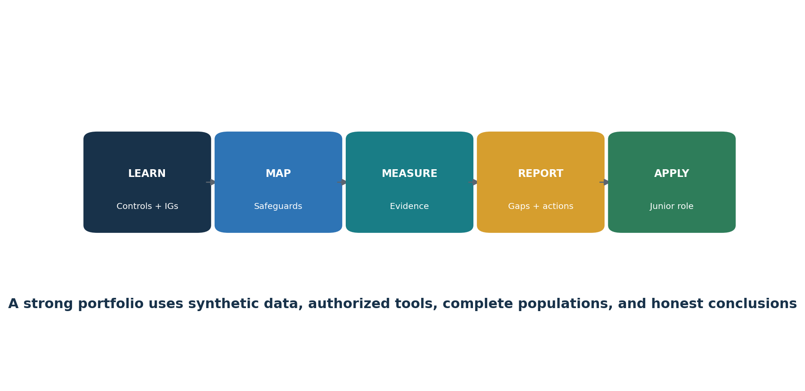
Figure 10. Junior CIS Controls analyst pathway
Junior Security Controls Analyst
GRC Analyst
Vulnerability Management Analyst
Security Assurance Analyst
Security Operations Analyst
IT Compliance Analyst
Third-Party Risk Analyst
Cybersecurity Program Analyst

26.1 Typical junior work
- Maintain inventories for assets, software, data, accounts, network systems, suppliers, applications, findings, and evidence.
- Gather evidence without changing source records and validate population completeness.
- Map Safeguards to owners, systems, procedures, configuration, evidence, metrics, exceptions, and actions.
- Run authorized discovery, configuration, vulnerability, logging, or application-security tools under approved procedures.
- Calculate coverage and exception metrics using the official assessment structure.
- Track unsupported software, unauthorized assets, access issues, vulnerabilities, failed backups, alert gaps, and supplier findings through retest.
- Write clear conclusions without claiming authority or certainty beyond the evidence.
Skill | Portfolio proof
Framework | Explain the 18 Controls, IGs, asset classes, and functions
Inventory | Reconcile two independent sources and explain differences
Measurement | Show inputs, operations, measures, metric, exception list, and conclusion
Technical literacy | Interpret configuration, identity, scan, log, recovery, and application evidence
Remediation | Trace finding to owner, due date, correction, and verified retest
Communication | Write a one-page manager summary and a detailed workpaper
Ethics | Use synthetic data, authorization, scope limits, and honest claims

27. Fictional Laboratory and Portfolio
A safe practice environment using synthetic data and authorized lab systems.
Lab rule: Use fictional organizations, synthetic data, isolated systems, and written authorization. Never attack public targets, use real credentials, or publish sensitive tool output.

- Create a fictional 50-person company with laptops, servers, cloud services, a web application, remote staff, and five suppliers.
- Select IG1 and document three risk-based additions from IG2 or IG3.
- Build enterprise-asset, software, data, account, authentication-system, network, supplier, application, and log-source inventories.
- Use Nmap and osquery in an isolated lab to reconcile asset and software inventories.
- Use OpenSCAP or Lynis on a lab host; document configuration findings, exceptions, corrections, and reassessment.
- Use Greenbone on approved lab targets; validate coverage, findings, remediation, and rescan.
- Use Wazuh or Suricata to generate and investigate a safe test alert.
- Use Trivy or ZAP on a training repository or application and record correction and retest.
- Write a backup-restore test and incident tabletop record.
- Create five CIS Assessment Specification workpapers with inputs, operations, measures, metrics, exception lists, and conclusions.
- Publish only sanitized artifacts and state clearly that the project is fictional and not a formal CIS assessment.
Artifact | What it proves
IG selection memo | Prioritization and risk reasoning
Inventory reconciliation | Population completeness and analytical skill
Safeguard workpaper | Official measurement structure and evidence
Configuration reassessment | Technical finding, correction, and retest
Vulnerability report | Coverage, prioritization, exception, and remediation
Detection case | Alert validation, investigation, and response
Restore test | Availability and recovery evidence
Manager dashboard | Clear risk and action communication

28. Thirty-Day Learning Plan
A focused schedule for useful junior-level capability.
Days | Focus | Deliverable
1–4 | Framework, 18 Controls, 153 Safeguards, IGs, asset classes, functions | Framework concept map and IG memo
5–8 | Assets, software, data, accounts, access | Four reconciled inventories
9–12 | Configuration, vulnerability, email, malware | Lab configuration and vulnerability workpaper
13–16 | Logs, monitoring, network defense | Log-source map and safe alert case
17–19 | Recovery and incident response | Restore test and tabletop record
20–22 | Suppliers and application security | Provider assessment and secure-development checklist
23–25 | Assessment Specification | Five complete Safeguard measurements
26–28 | Authorized tool labs and remediation | Two correction and retest memos
29–30 | Portfolio and interviews | Sanitized portfolio and five STAR stories

29. Interview Preparation
Clear answers, practical scenarios, and questions for the employer.

29.1 What are the CIS Controls?
A prioritized set of defensive best practices organized into 18 Controls and 153 focused Safeguards.

29.2 What is IG1?
The 56-Safeguard essential cyber hygiene starting point that CIS recommends every enterprise begin with.

29.3 Does IG1 fit every requirement?
It is a prioritization baseline. Material risk, contracts, laws, customers, or critical services may require additional Safeguards.

29.4 How do you measure a Safeguard?
Use official criteria, dependencies, assumptions, complete inputs, defined operations, measures, metrics, procedure review, exceptions, and retesting.

29.5 Why are inventories important?
They define the populations that configuration, vulnerability, logging, recovery, and response controls must cover.

29.6 Vulnerability scan versus penetration test?
A scan mainly identifies known weaknesses; penetration testing uses skilled human analysis and controlled exploitation to evaluate impact and resilience.

29.7 Does a framework mapping prove compliance?
No. It identifies relationships, but the organization must test the exact applicable requirement and evidence.

29.8 What can a junior analyst conclude?
Only what the defined scope and reliable evidence support, with sampling and limitations clearly disclosed.

29.9 Questions to ask the employer
Which Implementation Group and additions are in scope?
How are inventory populations created and reconciled?
Which Safeguards have the most incomplete coverage?
How are measurement data and exceptions reviewed?
Which open-source and commercial tools are approved?
How are findings prioritized, funded, and retested?
How will senior staff review junior work?

30. Templates, Glossary, Index, and References
Reusable work structures, important terms, and authoritative starting points.

30.1 Safeguard measurement workpaper
Field | Entry
Safeguard and IG | ____________________________
Scope and asset class | ____________________________
Owner and systems | ____________________________
Dependencies and assumptions | ____________________________
Inputs and validation | ____________________________
Operations performed | ____________________________
Measures | ____________________________
Metric and interpretation | ____________________________
Exceptions and limitation | ____________________________
Action, owner, date, and retest | ____________________________

30.2 Finding and retest record
Field | Entry
Criteria | ____________________________
Condition and evidence | ____________________________
Affected population | ____________________________
Risk and impact | ____________________________
Cause | ____________________________
Interim protection | ____________________________
Correction and owner | ____________________________
Due date | ____________________________
Retest procedure | ____________________________
Final result | ____________________________

30.3 Glossary
Term | Meaning
Asset class | Category affected by a Safeguard, such as devices, software, data, network, users, or documentation.
CIS Benchmark | Secure-configuration recommendations for a specific technology.
CIS Control | One of 18 broad defensive areas.
CIS Safeguard | A focused, implementable action within a Control.
Coverage | Share of the applicable population on which the Safeguard is properly implemented.
IG1 | 56 essential cyber hygiene Safeguards.
IG2 | IG1 plus 74 additional Safeguards.
IG3 | IG1 and IG2 plus 23 additional Safeguards; all 153.
Measure | A count, list, date, setting, or result produced by assessment operations.
Metric | Calculation or interpretation built from measures.
Population | Complete set of applicable records, assets, people, systems, or events.
Procedure review | Manual evaluation of whether a required process exists and contains needed elements.
Security function | Govern, Identify, Protect, Detect, Respond, or Recover mapping.

30.4 Subject index
Subject | Chapter
Accounts | 9–10
Application security | 21
Asset inventory | 6
Audit logs | 13
Data protection | 8
Evidence and measurement | 4
Implementation Groups | 2
Incident response | 22
Junior analyst | 26–29
Malware | 15
Manager | 25
Network | 17–18
Open-source tools | 24
Penetration testing | 23
Recovery | 16
Service providers | 20
Software inventory | 7
Training | 19
Vulnerability management | 12

30.5 Official references
CIS Controls v8.1
18 CIS Controls list
Implementation Groups
Controls Assessment Specification
Assessment Specification documentation
CIS Controls Navigator
CIS Controls mappings and compliance
Final reminder: Frameworks, mappings, tools, products, threats, laws, contracts, and organizational risks change. Confirm official current resources and applicable obligations before a real implementation or assessment.

