ISO/IEC 42001:2023
AI MANAGEMENT SYSTEM
Practical AIMS Manager and Junior Analyst Manual

What this manual does: Explains how to establish, implement, operate, audit, certify, and improve an AI management system. It breaks down Clauses 4–10, all nine Annex A control groups, risk and impact assessment, the Statement of Applicability, certification, evidence, tools, manager decisions, and junior analyst work.

Alberto (Al) Leiva
First Edition • July 2026

Preface
ISO/IEC 42001 helps organizations govern AI through an organization-wide management system. It does not certify that every output is correct or that every AI system is safe. It requires leadership, context, risk-based planning, resources, operational controls, performance evaluation, corrective action, and continual improvement around the responsible development, provision, or use of AI systems.
This manual explains concepts in the original language and does not reproduce the copyrighted standard. Obtain an authorized copy of ISO/IEC 42001:2023 and any standards used for implementation or audit. Certifications, laws, sector-specific duties, contracts, and technical risks must be evaluated against the organization’s actual scope and facts.
Current-information note: Verified July 14, 2026. ISO/IEC 42001:2023 remains the published AIMS requirements standard. ISO/IEC 42005:2025 provides AI system impact-assessment guidance. ISO/IEC 42006:2025 adds requirements for bodies auditing and certifying AIMS. ISO 19011:2026 is the current management-system audit guideline. ISO/IEC 42003 and 42007 remain under development and are not treated as requirements here.

How to use this manual
- AIMS leaders and managers: start with Chapters 1–10, 16–20, and 29–31.
- Implementers and GRC teams: study in order and use every template in Chapter 32.
- AI, data, product, security, privacy, and legal teams: focus on Chapters 6–15 and 20–28.
- Internal auditors: focus on Chapters 16–20 and 29, then practice the lab in Chapter 31.
- Junior analysts: learn the clause intent, produce evidence, write findings, and never claim certification or auditor authority you do not hold.

Table of Contents
This file contains a true native Word table of contents plus a permanent page-numbered chapter guide.
Preface 2
How to use this manual 2
Table of Contents 3
Chapter Guide 7
1. ISO/IEC 42001 and the AI Management System 8
1.1 What certification does not prove 8
2. AIMS Architecture and the Plan-Do-Check-Act Cycle 9
2.1 Integrating with existing systems 9
3. Applicability, Organizational Roles, and Implementation Roadmap 10
3.1 Implementation roadmap 10
4. Clause 4: Context of the Organization 12
4.1 Internal and external issues 12
4.2 Interested parties and requirements 12
4.3 Scope statement 12
4.4 AIMS processes 12
5. Clause 5: Leadership 13
5.1 Demonstrating leadership 13
5.2 AI policy 13
5.3 Roles, responsibilities, authorities 13
6. Clause 6.1: Actions to Address Risks and Opportunities 14
6.1 Planning inputs 14
6.1.1 Risk and opportunity actions 14
7. Clause 6.1.2: AI Risk Assessment 15
7.1 Risk method 15
8. Clause 6.1.3: AI Risk Treatment and the Statement of Applicability 16
8.1 Treatment process 16
8.2 Statement of Applicability fields 16
9. Clause 6.1.4: AI System Impact Assessment 17
9.1 Impact-assessment process 17
9.2 Risk assessment versus impact assessment 17
10. Clause 6.2 and 6.3: Objectives and Planning Changes 19
10.1 Objective record 19
10.2 Planning AIMS changes 19
11. Clause 7.1: Resources 20
11.1 Resource decisions 20
12. Clauses 7.2–7.4: Competence, Awareness, and Communication 21
12.1 Competence 21
12.2 Awareness 21
12.3 Communication plan 21
13. Clause 7.5: Documented Information 22
13.1 Document-control lifecycle 22
14. Clause 8.1: Operational Planning and Control 23
14.1 Operational control 23
15. Clauses 8.2–8.4: Operational Risk, Treatment, and Impact Assessment 24
15.1 Operational triggers 24
15.2 Operational evidence 24
16. Clause 9.1: Monitoring, Measurement, Analysis, and Evaluation 25
16.1 Measurement design 25
17. Clause 9.2: Internal Audit 26
17.1 Audit program 26
17.2 Audit workpaper 26
18. Clause 9.3: Management Review 27
18.1 Inputs 27
18.2 Outputs 27
19. Clause 10: Nonconformity, Corrective Action, and Continual Improvement 28
19.1 Corrective-action method 28
20. Annexes A–D and the Statement of Applicability 29
20.1 How the annexes work 29
21. Annex A.2: Policies Related to AI 30
21.1 Control implementation 30
22. Annex A.3: Internal Organization 31
22.1 Roles and responsibilities 31
22.2 Reporting concerns 31
23. Annex A.4: Resources for AI Systems 32
23.1 Resource documentation workflow 32
24. Annex A.5 and ISO/IEC 42005: AI System Impact Assessment 33
24.1 Four control outcomes 33
24.2 Assessment quality checks 33
25. Annex A.6: AI System Life Cycle 34
25.1 Change and retirement 34
26. Annex A.7: Data for AI Systems 35
26.1 Data controls 35
27. Annex A.8: Information for Interested Parties 36
27.1 Information package 36
27.2 External reporting and incidents 36
28. Annex A.9 and A.10: Responsible Use, Suppliers, and Customers 38
28.1 Responsible use 38
28.2 Third parties and customers 38
29. Certification, ISO/IEC 42006:2025, and Audit Readiness 40
29.1 Certification path 40
29.2 ISO/IEC 42006:2025 significance 40
29.3 Audit readiness without theater 40
30. Open-Source AIMS Evidence and AI Assurance Tools 41
30.1 MLflow 41
30.2 DVC 41
30.3 OpenLineage 42
30.4 OpenMetadata 42
30.5 Great Expectations 42
30.6 Evidently 42
30.7 Deepchecks 42
30.8 Giskard 43
30.9 Promptfoo 43
30.10 Garak 43
30.11 PyRIT 43
30.12 Inspect AI 43
30.13 Presidio 44
30.14 ModelScan 44
30.15 CycloneDX 44
30.16 Open Policy Agent 44
30.17 DefectDojo 45
30.18 Langfuse 45
31. Manager and Junior Analyst Playbook, Laboratory, and Interviews 46
31.1 Manager questions 46
31.2 Junior analyst work 46
31.3 Fictional laboratory 47
31.4 Thirty-day plan 47
31.5 What is ISO/IEC 42001? 47
31.6 What is an AIMS? 47
31.7 Are all Annex A controls mandatory? 48
31.8 Risk versus impact assessment? 48
31.9 What is the Statement of Applicability? 48
31.10 Stage 1 versus Stage 2? 48
31.11 What is a nonconformity? 48
31.12 How do tools prove conformity? 48
31.13 How do you test a corrective action? 48
31.14 What makes a strong junior analyst? 48
32. Templates, Glossary, Index, and Official References 49
32.1 AIMS scope and context record 49
32.2 AI risk and treatment record 49
32.3 Statement of Applicability 49
32.4 AI system impact assessment 49
32.5 Internal audit workpaper 50
32.6 Management review record 50
32.7 Glossary 50
32.8 Subject index 51
32.9 Official references 51

Chapter Guide
Chapter | Title | Starts on page
1 | ISO/IEC 42001 and the AI Management System | 5
2 | AIMS Architecture and the Plan-Do-Check-Act Cycle | 6
3 | Applicability, Organizational Roles, and Implementation Roadmap | 7
4 | Clause 4: Context of the Organization | 9
5 | Clause 5: Leadership | 10
6 | Clause 6.1: Actions to Address Risks and Opportunities | 11
7 | Clause 6.1.2: AI Risk Assessment | 12
8 | Clause 6.1.3: AI Risk Treatment and the Statement of Applicability | 14
9 | Clause 6.1.4: AI System Impact Assessment | 15
10 | Clause 6.2 and 6.3: Objectives and Planning Changes | 17
11 | Clause 7.1: Resources | 18
12 | Clauses 7.2–7.4: Competence, Awareness, and Communication | 19
13 | Clause 7.5: Documented Information | 20
14 | Clause 8.1: Operational Planning and Control | 21
15 | Clauses 8.2–8.4: Operational Risk, Treatment, and Impact Assessment | 22
16 | Clause 9.1: Monitoring, Measurement, Analysis, and Evaluation | 23
17 | Clause 9.2: Internal Audit | 24
18 | Clause 9.3: Management Review | 26
19 | Clause 10: Nonconformity, Corrective Action, and Continual Improvement | 27
20 | Annexes A–D and the Statement of Applicability | 28
21 | Annex A.2: Policies Related to AI | 29
22 | Annex A.3: Internal Organization | 30
23 | Annex A.4: Resources for AI Systems | 31
24 | Annex A.5 and ISO/IEC 42005: AI System Impact Assessment | 32
25 | Annex A.6: AI System Life Cycle | 33
26 | Annex A.7: Data for AI Systems | 34
27 | Annex A.8: Information for Interested Parties | 36
28 | Annex A.9 and A.10: Responsible Use, Suppliers, and Customers | 38
29 | Certification, ISO/IEC 42006:2025, and Audit Readiness | 40
30 | Open-Source AIMS Evidence and AI Assurance Tools | 42
31 | Manager and Junior Analyst Playbook, Laboratory, and Interviews | 47
32 | Templates, Glossary, Index, and Official References | 51

1. ISO/IEC 42001 and the AI Management System
ISO/IEC 42001 specifies requirements for an organization to establish, implement, maintain, and continually improve an AI management system.
Concept | Plain meaning | Evidence question
AIMS | Interrelated policies, objectives, processes, roles, controls, and records for responsible AI | Does the system operate across the defined scope?
Organization role | Developer/provider, deployer/user, supplier, customer, or several roles | Which responsibilities are controlled?
AI system | People, data, models, software, infrastructure, processes, and interfaces used for an AI outcome | What is the complete boundary?
Conformity | Requirements are fulfilled within the certified scope | What clause, implementation, evidence, and result support the claim?
Certification | Independent third-party assessment of the AIMS against ISO/IEC 42001 | What entity, scope, standard, body, dates, and status are certified?

1.1 What certification does not prove
- It does not guarantee every AI output is accurate, unbiased, secure, lawful, safe, or explainable.
- It does not certify AI products individually unless the certificate’s AIMS scope and scheme explicitly support that claim.
- It does not replace product testing, legal analysis, impact assessment, privacy/security controls, domain validation, or human oversight.
- It does not transfer accountability from the organization to the certification body or supplier.

2. AIMS Architecture and the Plan-Do-Check-Act Cycle
The AIMS follows the harmonized management-system structure and a continual Plan-Do-Check-Act cycle.
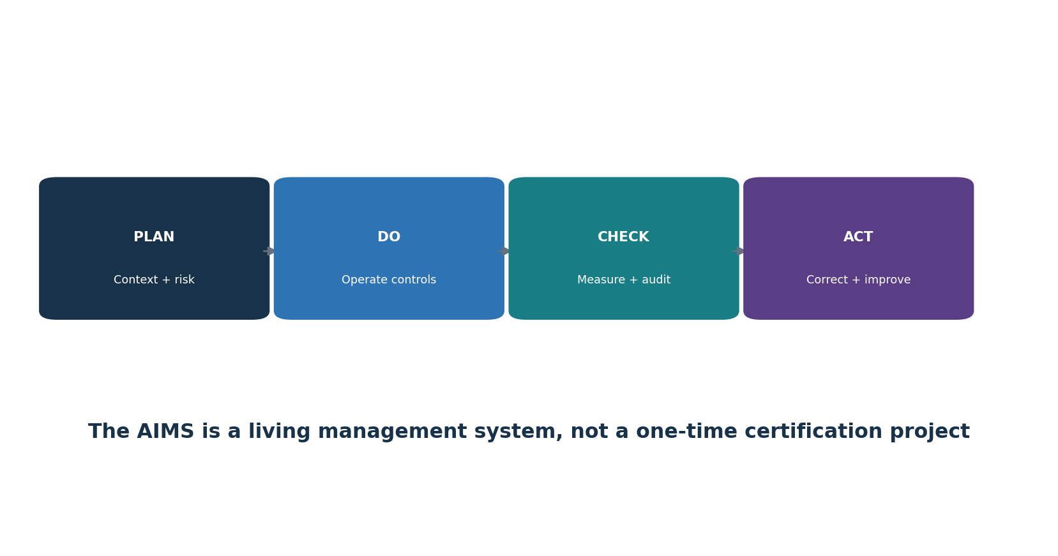
Figure 1. AIMS Plan-Do-Check-Act cycle
PDCA stage | ISO/IEC 42001 work | Typical output
Plan | Context, leadership, risk/opportunity assessment, treatment, objectives, resources | Scope, policy, methods, risk register, impact process, SoA, objectives
Do | Competence, communication, documentation, operational controls, assessments | Procedures, system records, approvals, supplier and life-cycle evidence
Check | Monitoring, measurement, analysis, internal audit, management review | Metrics, evaluation, audit report, review decisions
Act | Nonconformity, correction, root cause, corrective action, improvement | Action records, effectiveness tests, updated risks/controls/objectives

2.1 Integrating with existing systems
- Reuse governance, document control, risk, audit, corrective action, supplier, security, privacy, quality, and continuity processes when their scope and controls fit AI risk.
- Create AI-specific additions for impact assessment, model/data lifecycle, responsible use, transparency, human oversight, and value-chain responsibilities.
- Keep one source of truth and map it to ISO 27001, ISO 9001, privacy, legal, NIST AI RMF, and sector obligations rather than duplicating records.

3. Applicability, Organizational Roles, and Implementation Roadmap
A useful implementation begins with organizational control, an accurate AI inventory, accountable roles, and a staged roadmap.
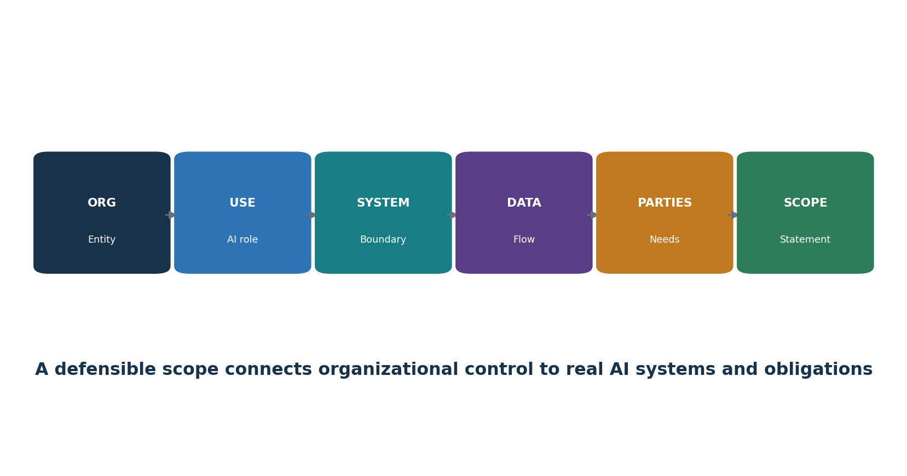
Figure 2. Scope-building chain
Role | Core responsibility
Governing body / executives | Oversight, direction, resources, risk appetite, material decisions
AIMS leader | Coordinate management system, performance, audits, improvement
Business/AI system owner | Purpose, outcome, affected process, risk, approval, monitoring
Model/data/product/engineering | Requirements, design, data, evaluation, deployment, change
Security/privacy/legal/compliance/safety | Specialist requirements, review, challenge, incidents
Procurement/supplier manager | Due diligence, allocation, contracts, evidence, monitoring, exit
Internal audit | Independent, objective assessment without owning the controls

3.1 Implementation roadmap
- Authorize the program and obtain the standards; define purpose, sponsor, resources, and governance.
- Inventory AI systems and roles; conduct context and interested-party analysis; draft scope and policy.
- Define risk, impact, treatment, SoA, objectives, document, competence, communication, and operational processes.
- Implement Annex A and additional controls according to risk; collect evidence during real operation.
- Measure performance; complete internal audit and management review; correct nonconformities and verify effectiveness.
- Select a competent certification body; complete Stage 1 and Stage 2; maintain surveillance and improvement.

4. Clause 4: Context of the Organization
Clause 4 establishes why the AIMS exists, who matters, what it covers, and how its processes interact.

4.1 Internal and external issues
- Strategy, culture, governance, risk appetite, resources, competence, data maturity, technology architecture, existing management systems, and organizational change.
- Law, regulation, sector expectations, contracts, customer requirements, standards, public trust, societal concerns, markets, suppliers, threats, technology/model change, and climate-related issues where relevant to intended AIMS outcomes.
- Record why each issue is relevant, owner, effect on the AIMS, response, and review trigger.

4.2 Interested parties and requirements
- Identify people and groups affected by AI, even if they are not direct users or customers.
- Include regulators, customers, workers, users, data subjects, suppliers, partners, communities, shareholders, auditors, insurers, and the public as relevant.
- Separate needs/expectations from binding compliance obligations; record authority/source, system/process, owner, evidence, and change monitoring.
- Determine which requirements the organization will address through the AIMS.

4.3 Scope statement
Scope element | Required clarity
Organization | Legal entities, business units, locations, functions
AI role | Developer/provider, deployer/user, service/supplier, combination
Products/services/processes | AI-enabled offerings and internal uses
Technology and data | Systems, models, environments, interfaces, key datasets
Boundaries/dependencies | Shared services, suppliers, customers, exclusions
Justification | Why boundaries are valid and do not avoid applicable requirements

4.4 AIMS processes
- Define process purpose, inputs, outputs, sequence, interaction, owner, criteria, controls, resources, records, measures, risks, and improvement.
- A process map should connect inventory, risk, impact, treatment, objectives, lifecycle, data, supplier, use, monitoring, incidents, audit, review, and corrective action.

5. Clause 5: Leadership
Leadership must own the AIMS, policy, integration, resources, communication, performance, and accountable roles.

5.1 Demonstrating leadership
- Make AIMS objectives compatible with strategy and responsible-AI commitments.
- Integrate AIMS requirements into business, product, procurement, data, technology, people, risk, and change processes.
- Provide competent people, time, tools, data, infrastructure, budget, independent challenge, and authority.
- Communicate that effective AI management and conformity matter, including when delivery pressure conflicts with controls.
- Review performance and support people who contribute to improvement or raise concerns.
- Ensure intended results are achieved rather than treating certification as the only outcome.

5.2 AI policy
- State purpose, principles, commitments to applicable requirements, risk-based responsible AI, objectives, and continual improvement.
- Match the organization’s AI roles, context, culture, impact, law, products, and risk appetite.
- Align security, privacy, quality, data, ethics, HR, procurement, product, records, safety, and incident policies.
- Approve at the right level, communicate it to relevant people, make it available as appropriate, and review it after planned intervals and material change.

5.3 Roles, responsibilities, authorities
- Define accountability for the AIMS and for reporting performance to top management.
- Assign owners for every AI system, risk, impact, data source, model, supplier, control, metric, incident, change, and corrective action.
- Define approval and escalation authority; prevent conflicts where the same team creates, validates, accepts, and audits high-impact risk without adequate challenge.

6. Clause 6.1: Actions to Address Risks and Opportunities
Planning turns context into managed risks, opportunities, controls, objectives, and controlled change.

6.1 Planning inputs
- Context and interested-party requirements; AIMS scope and processes.
- AI inventory, system roles, life-cycle stage, affected people, data, models, suppliers, integrations, and use conditions.
- Strategic benefits and opportunities, along with threats, failures, harms, uncertainty, and reasonably foreseeable misuse.
- Applicable legal, regulatory, contractual, security, privacy, safety, quality, records, accessibility, employment, IP, consumer, and sector obligations.

6.1.1 Risk and opportunity actions
- Plan actions proportionate to the effect on AIMS outcomes; integrate them into processes rather than keeping a separate register only.
- Define action, owner, resource, date, measure, evidence, dependency, residual decision, and effectiveness evaluation.
- Opportunities may include improved oversight, data quality, transparency, evaluation, competence, efficiency, stakeholder trust, and innovation.
- Prevent intended controls from creating new risks, such as excessive monitoring, inaccessible notices, or review overload.

7. Clause 6.1.2: AI Risk Assessment
The AI risk-assessment process must use defined, repeatable criteria to identify, analyze, evaluate, and prioritize risk.
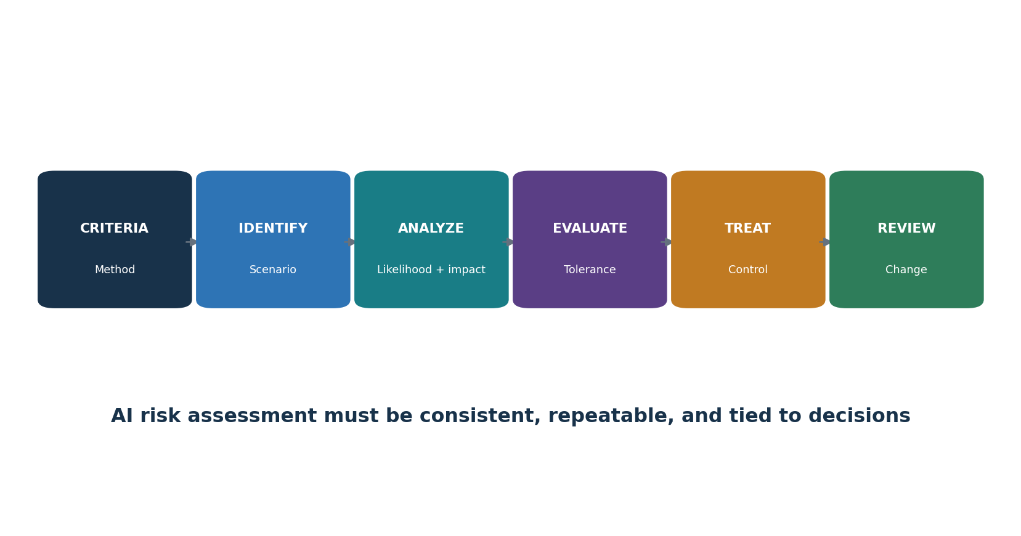
Figure 3. AI risk-assessment workflow

7.1 Risk method
- Define scope, unit of analysis, risk categories, impact dimensions, likelihood, severity, scale, duration, reversibility, affected groups, uncertainty, aggregation, tolerance, and decision authority.
- Identify risk scenarios across intended use, foreseeable misuse, failure, attack, data, model, human behavior, suppliers, environment, law, and societal effect.
- Analyze inherent risk and existing controls with evidence; distinguish current, target, and residual risk.
- Evaluate against criteria; prioritize treatment based on people and business consequence, not a single technical score.
- Ensure consistent, valid, and comparable results and preserve the assessment as documented information.
- Reassess at planned intervals and after material changes, incidents, new affected groups, model/provider updates, drift, legal change, or control failure.
Risk record | Minimum detail
Scenario | Cause/actor, vulnerable condition, event/action, system behavior, affected party, consequence
Context | Use, people, geography, scale, data, model/version, tools, supplier, assumptions
Analysis | Likelihood, impact dimensions, uncertainty, evidence, existing control effectiveness
Treatment | Avoid/reduce/share/accept, controls, owner, date, measure, residual risk
Decision | Authorized approver, rationale, conditions, expiry, monitoring, review trigger

8. Clause 6.1.3: AI Risk Treatment and the Statement of Applicability
Risk treatment selects controls, compares them to Annex A, produces the Statement of Applicability, and obtains residual-risk approval.

8.1 Treatment process
- Choose treatment options: avoid, change/reduce, share/transfer, accept within authority, or conduct a tightly limited pilot to reduce uncertainty.
- Determine necessary controls from legal and contractual requirements, AI risk and impact results, architecture, stakeholders, and objectives.
- Compare selected controls with Annex A to check that no relevant reference control was overlooked.
- Add controls beyond Annex A when needed for security, privacy, safety, quality, technical evaluation, accessibility, resilience, or sector obligations.
- Create and approve a treatment plan and obtain authorization for residual risk.
- Preserve treatment results and changes as controlled documented information.

8.2 Statement of Applicability fields
Field | Purpose
Control reference/title | Annex A or additional control identity
Applicable? | Included or excluded for the defined AIMS scope
Justification | Risk, obligation, objective, architecture, or reason for exclusion
Implementation | Policy/process/system and accountable owner
Status | Implemented, partial, planned, not applicable
Evidence/test | Current proof and operating-effectiveness result
Dependencies/gaps | Supplier/customer/shared controls and findings
Review | Last/next review and change triggers

SoA warning: The Statement of Applicability is not a copied checklist. It must agree with the current scope, risk and impact assessments, treatment plan, real implementation, evidence, and risk decisions.

9. Clause 6.1.4: AI System Impact Assessment
AI system impact assessment examines how an AI system may affect individuals, groups, and society throughout its life cycle.
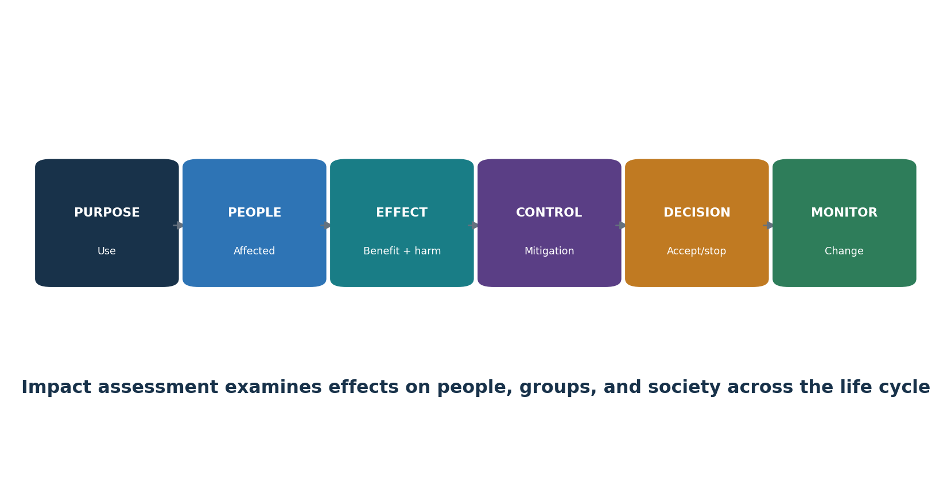
Figure 4. AI system impact assessment

9.1 Impact-assessment process
- Define triggers, scope, roles, independence, methods, affected-party engagement, approval, retention, review, and relationship to risk treatment and decisions.
- Describe purpose, users, affected people, decisions/content, degree of automation, alternatives, data, model, suppliers, geography, scale, duration, and prohibited/foreseeable uses.
- Identify intended benefits and adverse impacts on rights, fairness, privacy, safety, security, health, accessibility, employment, finance, children/vulnerable groups, environment, culture, public services, democracy, and social/economic conditions as relevant.
- Consider direct, indirect, cumulative, delayed, reversible/irreversible, individual, group, and societal impacts.
- Evaluate likelihood, severity, scale, duration, reversibility, distribution, uncertainty, and affected-party views.
- Select mitigations, human oversight, notices, choices, redress, monitoring, thresholds, and stop criteria; obtain accountable approval.
- Update before major change and after incidents, complaints, new evidence, drift, or expansion of use.

9.2 Risk assessment versus impact assessment
Risk assessment | Impact assessment
Manages uncertainty affecting objectives, including organization, people, and society | Focuses specifically on potential effects of an AI system on individuals, groups, and society
Can aggregate portfolio and process risk | Must stay connected to the particular system/use and affected context
Feeds treatment, controls, and residual acceptance | Feeds design, deployment, use, transparency, oversight, redress, and monitoring
Both must exchange findings and remain consistent | Both require documented methods, evidence, decisions, and review

10. Clause 6.2 and 6.3: Objectives and Planning Changes
Objectives translate policy and risk decisions into measurable results; changes must be planned and controlled.

10.1 Objective record
- Objective and intended result, connected policy/risk/requirement and scope.
- Measure, calculation, data source, population, baseline, target, threshold, frequency, owner, reporting, and limitation.
- Actions, resources, responsibilities, schedule, dependencies, evidence, and evaluation method.
- Response when performance misses the target; reassessment when the metric creates harmful incentives.
Objective example | Better measure
Complete AI inventory | Active systems with validated owner, use, data/model/provider, risk tier, assessment and status ÷ reconciled active systems
Improve assessment timeliness | Median and overdue days from intake/material change to approved risk and impact decision by tier
Strengthen evaluation | High-impact systems meeting defined production-like acceptance thresholds, including subgroup and severe-failure views
Improve supplier control | Critical AI suppliers with current scoped review, contract duties, evidence and closed material gaps ÷ critical suppliers
Improve remediation | Findings corrected and effectiveness-retested within risk-based target, with exception age and impact

10.2 Planning AIMS changes
- Define purpose, consequences, integrity of the AIMS, resources, responsibilities, timeline, transition, communication, evidence, and rollback.
- Triggers include scope, entity, product, use, model, data, supplier, law, certification, process, organization, tooling, audit method, and objectives.

11. Clause 7.1: Resources
The organization must determine and provide resources needed to establish, operate, evaluate, and improve the AIMS.
Resource | Examples | Evidence
People | AIMS, domain, data, ML, product, security, privacy, legal, safety, audit, human factors | Capacity plan, roles, competence, independence, workload
Data | Training/validation/test/production, labels, metadata, rights, reference sets | Inventory, lineage, quality, access, retention, provenance
Tools | Development, annotation, evaluation, monitoring, security, documentation | Approved inventory, versions, validation, access, support
Compute/system | Cloud/on-prem/edge, storage, network, registry, logging, sandbox | Architecture, ownership, capacity, resilience, environmental impact
Finance/time | Budget, evaluation cost, supplier review, stakeholder engagement, remediation | Plans, approvals, actuals, constraints, decisions

11.1 Resource decisions
- Match resource depth to scope, risk, system complexity, scale, legal duties, and affected people.
- Separate development, validation, approval, and audit enough to manage conflicts of interest.
- Monitor reviewer overload, evaluation coverage, data gaps, supplier limits, expiring licenses, model deprecation, and technical debt.
- Document accepted constraints and their effect on objectives and residual risk.

12. Clauses 7.2–7.4: Competence, Awareness, and Communication
Competence, awareness, and communication make policies and controls usable in real decisions.

12.1 Competence
- Define required education, training, skill, experience, independence, behavior, and authority by role and risk tier.
- Evaluate current competence; provide training, mentoring, supervised practice, specialist support, or reassignment.
- Assess effectiveness through observation, work-product review, scenario exercise, test, and outcomes—not attendance alone.
- Retain evidence and reassess after role, system, risk, law, method, or incident change.

12.2 Awareness
- People understand policy, their contribution, benefits of improved performance, consequences of nonconformity, concerns channel, and escalation.
- Users understand approved/prohibited use, data restrictions, verification, human oversight, limitations, incident/complaint handling, and stop conditions.

12.3 Communication plan
Field | Question
What | Policy, system/use, limits, impacts, incidents, results, changes, duties
Why/audience | Decision maker, worker, user, affected person, customer, supplier, regulator, public
When | Lifecycle gate, planned interval, incident, complaint, change, legal trigger
How | Training, notice, system card, report, contract, dashboard, meeting, alert
Owner/approval | Who prepares, validates, approves, delivers, and records?
Feedback | How are questions, accessibility, understanding, concerns, and correction handled?

13. Clause 7.5: Documented Information
Documented information must be controlled enough to be trustworthy, findable, protected, current, retained, and usable.

13.1 Document-control lifecycle
- Create/identify: title, owner, ID, version, date, format, classification, scope, related system/model/data, and approval.
- Review/approve: competent reviewer, conflicts, criteria, comments, disposition, and authorization.
- Publish/use: correct audience, access, training, effective date, point-of-use availability, and withdrawal of obsolete versions.
- Change: reason, affected requirements/processes/systems, approvals, version history, transition, and rollback.
- Protect: confidentiality, integrity, availability, privacy, security, backup, recovery, and evidence preservation.
- Retain/dispose: legal/business period, holds, archive, deletion, supplier copies, derived data, and verification.
Required/important records | Example
AIMS foundation | Context, interested parties, scope, policy, process map, roles
Planning | Risk method/assessment, treatment, SoA, impact process/records, objectives, changes
Operations | AI inventory, resources, lifecycle, data, supplier/use, communication, incidents
Evaluation | Metrics, analysis, internal audit, management review
Improvement | Nonconformity, correction, root cause, corrective action, effectiveness
System traceability | Model/data/prompt/tool/configuration versions, approvals, evaluations, logs, decisions

14. Clause 8.1: Operational Planning and Control
Operational planning translates AIMS requirements into repeatable controls for AI intake, design, acquisition, deployment, use, change, incident management, and retirement.

14.1 Operational control
- Define criteria and controls for processes; operate them as planned; retain enough evidence to prove performance.
- Control planned changes and review unintended changes; reduce adverse effects.
- Control externally provided processes, products, and services according to risk and responsibility.
- Use risk tiers and lifecycle gates to match review, independence, testing, approval, monitoring, and escalation to impact.
Gate | Required decision evidence
Intake | Purpose, owner, AI role, affected people, data, supplier, preliminary risk, prohibited-use check
Design/acquire | Requirements, risk/impact, architecture, resources, data, supplier duties, controls, tests
Build/configure | Versions, lineage, secure development, documentation, evaluation readiness
Validate | Representative tests, thresholds, failures, independent challenge, limitations, corrective action
Deploy | Approval, conditions, user information, oversight, monitoring, incident, rollback, support
Operate/change | Performance, drift, complaints, incidents, provider changes, regression, reassessment
Retire | Replacement, user/party communication, access, integrations, data, models, records, deletion

15. Clauses 8.2–8.4: Operational Risk, Treatment, and Impact Assessment
The organization must execute risk assessment, risk treatment, and impact assessment at planned intervals and when significant change occurs.

15.1 Operational triggers
- New or changed AI system, intended use, affected population, geography, scale, automation, decision authority, model, data, prompt, tool, integration, supplier, or infrastructure.
- New law, contract, incident, complaint, audit finding, vulnerability, threat intelligence, safety concern, drift, evaluation failure, unexpected impact, or supplier notice.
- Changes to risk criteria, objectives, controls, monitoring, organizational ownership, certification scope, or resource capacity.

15.2 Operational evidence
- Current approved assessment linked to exact system/model/data/configuration/use version.
- Treatment plan and SoA agree with implemented controls, gaps, exceptions, residual approval, and monitoring.
- Impact assessment includes affected parties, direct/indirect and societal effects, mitigations, redress, and review triggers.
- Actions are integrated into product, data, security, privacy, supplier, user, incident, and change workflows.
- Results and changes are retained as controlled documented information.

16. Clause 9.1: Monitoring, Measurement, Analysis, and Evaluation
Performance evaluation determines whether the AIMS and its controls achieve intended results.

16.1 Measurement design
- Decide what to monitor/measure, methods, timing, responsibility, acceptance criteria, analysis, evaluation, reporting, and retention.
- Verify data sources, definitions, populations, completeness, accuracy, time, access, transformations, and limitations.
- Use leading and lagging indicators across governance, risk, impact, lifecycle, data, supplier, use, complaints, incidents, audit, and improvement.
- Avoid averages that hide severe failures or subgroup effects; combine quantitative and qualitative evidence.
- Evaluate trends and causes, compare to objectives, and create decisions/actions when thresholds are missed.
AIMS measure | Decision enabled
Inventory/control coverage | Unknown or unowned AI use and assessment gaps
Risk/impact age and change coverage | Whether decisions remain current after system/context change
Evaluation results | Release, restriction, redesign, rollback, or added oversight
Complaints/incidents/redress | People impact, recurrence, communication and corrective action
Supplier changes/evidence | Reassessment, contract action, alternative, or exit
Audit/nonconformity aging | Control weakness, root cause, resource and management attention

17. Clause 9.2: Internal Audit
Internal audit provides independent, risk-based evidence that the AIMS conforms and operates effectively.
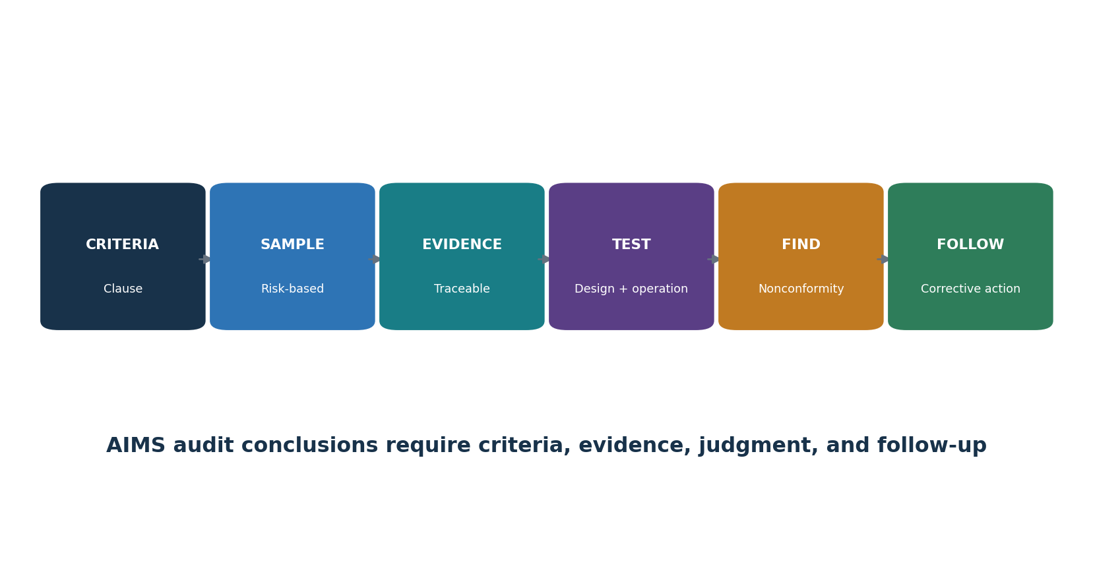
Figure 5. AIMS audit chain

17.1 Audit program
- Define objectives, scope, frequency, methods, responsibilities, planning, criteria, reporting, follow-up, resources, risks, and records.
- Prioritize high-impact systems, new models/use, weak controls, incidents, complaints, changes, suppliers, prior findings, and stale evidence.
- Select auditors for management-system and AI-domain competence, objectivity, confidentiality, communication, and independence.
- Use interviews, document review, observation, trace-through, data analysis, sampling, reperformance, and safe technical demonstration.
- Report results to relevant management and ensure correction/corrective action and effectiveness follow-up.

17.2 Audit workpaper
Field | Example
Criteria | Exact clause/control, internal procedure, law/contract as applicable
Scope/sample | Process, AI system/version, period, population, selection rationale
Evidence | Source, owner, date, version, query, observation, reliability
Test/result | Design and operation, expected versus observed, exceptions
Conclusion | Conforms, opportunity, observation, or nonconformity with objective basis
Follow-up | Correction, root cause, corrective action, owner/date, effectiveness

18. Clause 9.3: Management Review
Management review ensures top management evaluates suitability, adequacy, effectiveness, direction, resources, and improvement.

18.1 Inputs
- Status of actions from prior reviews and changes in internal/external issues or interested-party requirements.
- AIMS performance and trends: objectives, nonconformities/corrective actions, monitoring/measurement, internal audits, and relevant external assurance.
- Risk and impact assessment results, treatment status, SoA changes, incidents, complaints, concerns, redress, supplier and legal changes.
- Adequacy of resources, competence, independence, infrastructure, data, tools, and budget.
- Opportunities for continual improvement and strategic alignment.

18.2 Outputs
- Decisions and actions about improvement, changes to AIMS scope/policy/objectives/processes/controls, resource needs, risk decisions, and strategic direction.
- For each action: rationale, owner, due date, resources, expected result, measure, dependency, escalation, and follow-up.
- Retain agenda, materials, attendees/authority, discussion, decisions, dissent/concerns, actions, and closure evidence.
Avoid the slide-deck review: Management review is a decision process. A dashboard presentation without challenges, risk decisions, resource commitments, actions, and follow-up are weak evidence.

19. Clause 10: Nonconformity, Corrective Action, and Continual Improvement
Improvement corrects problems, removes causes, checks effectiveness, and strengthens the AIMS as risk and technology change.

19.1 Corrective-action method
- React to nonconformity; control/correct it; address consequences, affected people, decisions, data, systems, and communications.
- Evaluate cause and recurrence: review evidence, determine why controls failed or were bypassed, and find similar conditions elsewhere.
- Implement proportionate action with owner, date, resources, interim protection, change control, and risk/impact reassessment.
- Review effectiveness using defined evidence after enough operation; do not close based only on a new document.
- Update risks, impacts, controls, objectives, competence, supplier terms, monitoring, audit program, and documented information as needed.
- Retain nature of nonconformity, actions, and effectiveness results.
Weak response | Stronger response
Retrain the employee | Examine unclear process, workload, incentives, interface, access, approval and monitoring; fix system causes
Update policy | Change workflow/control, communicate, train, test operation, monitor recurrence
Supplier will fix | Track contract, mitigation, customer control, deadline, test, residual risk, alternative/exit
Finding closed | Evidence correction plus root-cause action and effectiveness review across similar scope

20. Annexes A–D and the Statement of Applicability
Annex A is a reference set of 38 controls in nine groups; Annex B gives guidance, Annex C provides AI objective/risk-source ideas, and Annex D supports sector/domain use.
Group | Theme | Controls | Implementation focus
A.2 | Policies related to AI | 3 | Policy, alignment with other policies, and planned/event-driven review.
A.3 | Internal organization | 2 | AI roles and responsibilities plus a protected concern-reporting process.
A.4 | Resources for AI systems | 5 | Document data, tools, system/compute, and human resources across the life cycle.
A.5 | Assessing impacts of AI systems | 4 | A repeatable process, records, impacts on people/groups, and societal impacts.
A.6 | AI system life cycle | 9 | Responsible-development objectives and processes, requirements, design records, V&V, deployment, operation, technical documentation, and logs.
A.7 | Data for AI systems | 5 | Data management, acquisition, quality, provenance, and preparation.
A.8 | Information for interested parties | 4 | User information, external reporting, incident communication, and other stakeholder information.
A.9 | Use of AI systems | 3 | Responsible-use process and objectives plus adherence to intended use.
A.10 | Third-party and customer relationships | 3 | Responsibility allocation, supplier governance, and customer obligations.

20.1 How the annexes work
- Clauses 4–10 contain the certifiable management-system requirements.
- Annex A supplies reference control objectives and controls to consider during risk treatment; it is not a universal checklist.
- Annex B provides implementation guidance for the Annex A controls without adding requirements.
- Annex C offers examples of AI objectives and risk sources that can support planning and assessment.
- Annex D explains how the AIMS can be used across domains and sectors.
- The organization may select additional controls; the SoA explains applicability and implementation.

21. Annex A.2: Policies Related to AI
Annex A.2 establishes a coherent AI policy framework that is aligned, approved, communicated, and reviewed.

21.1 Control implementation
- Create an AI policy appropriate to the organization’s roles, purpose, context, risk, impact, and responsible-AI commitments.
- Align it with security, privacy, data, quality, product, HR, procurement, legal, records, safety, accessibility, incident, and communication policies.
- Resolve contradictions such as an innovation goal that encourages unapproved tools or a retention policy that conflicts with traceability.
- Approve at appropriate management level; communicate to relevant people and parties; connect to objectives, procedures, controls, training, and enforcement.
- Review on schedule and after law, technology, business, scope, incident, audit, complaint, supplier, or material system change.
Evidence | Test
Approved AI policy | Verify scope, commitments, authority, effective date, availability and owner
Policy map | Trace AI requirements to related policies and resolved conflicts
Communication/training | Sample roles; verify understanding and practical workflow
Review record | Check inputs, changes, decision, approval and follow-through

22. Annex A.3: Internal Organization
Annex A.3 assigns AI responsibilities and creates a protected way to report concerns.

22.1 Roles and responsibilities
- Define lifecycle and management-system accountability for each AI system and shared service.
- Assign business outcome, AI/model, data, product, security, privacy, legal, impact, human oversight, supplier, incident, audit, and residual-risk roles.
- Define approval and escalation authority, deputies, conflicts, segregation, and emergency decisions.
- Update roles after organization, employment, supplier, system, scope, or risk change; remove access promptly.

22.2 Reporting concerns
- Provide accessible internal and external channels, confidentiality/anonymity where appropriate, non-retaliation, triage, investigation, protection, escalation, feedback, and records.
- Accept concerns about unsafe use, bias, rights, privacy, security, data, misleading output, hidden AI, supplier behavior, pressure to bypass controls, or retaliation.
- Measure awareness, accessibility, response, recurrence, overdue cases, and corrective action without exposing reporters.
Concern channels are controls: A channel is ineffective if people do not know it exists, fear retaliation, cannot report externally affected harm, or never receive evidence that concerns are investigated and corrected.

23. Annex A.4: Resources for AI Systems
Annex A.4 requires visibility into the data, tools, system/compute, and people needed across the AI life cycle.
Resource record | Details
Data | Source, owner, purpose, rights, sensitivity, people, quality, bias, version, lineage, retention, location
Tooling | Algorithms, frameworks, packages, models, prompts, evaluation, annotation, orchestration, versions, support
System/compute | Cloud/on-prem/edge, accounts, environments, storage, network, GPUs, capacity, resilience, energy/environment
Human | Role, organization/supplier, competence, independence, access, workload, decision authority
Dependencies | Provider, subprocessor, API, identity, monitoring, content filter, vector store, business process

23.1 Resource documentation workflow
- Connect resources to exact AI systems, lifecycle stages, owners, risk/impact assessments, supplier records, versions, and change history.
- Reconcile resource inventories to code, model registries, data catalogs, cloud/API billing, identity, network, procurement, and interviews.
- Identify unapproved/shadow resources, unsupported components, missing competence, capacity limits, common dependencies, and environmental effects.
- Use the record for reproducibility, incident response, change assessment, recovery, supplier exit, and retirement.

24. Annex A.5 and ISO/IEC 42005: AI System Impact Assessment
Annex A.5 operationalizes impact assessment; ISO/IEC 42005:2025 supplies complementary current guidance.

24.1 Four control outcomes
- A defined, repeatable AI system impact-assessment process with triggers, roles, methods, lifecycle integration, approval, and review.
- Controlled documentation of assessments, assumptions, evidence, affected parties, impacts, mitigations, decisions, and changes.
- Specific evaluation of impacts on individuals and groups, including fairness, rights, privacy, safety, health, accessibility, financial/employment effects, vulnerable people, human oversight, and redress as relevant.
- Evaluation of broader societal effects such as public safety, environment, economy, culture, democratic processes, misinformation, labor, market concentration, and deliberate misuse as relevant.

24.2 Assessment quality checks
- Affected people/groups are identified beyond direct users and customers.
- Benefits and harms are both evaluated, including distribution and alternatives.
- The method considers scale, duration, reversibility, cumulative and indirect effects, uncertainty, and foreseeable misuse.
- Stakeholder engagement is meaningful, accessible, documented, and protected.
- Mitigations become owned requirements, tests, notices, oversight, monitoring, redress, and stop criteria.
- Assessment version matches the deployed system/use and is updated after material change.

25. Annex A.6: AI System Life Cycle
Annex A.6 connects responsible-development objectives to requirements, design, testing, deployment, operation, documentation, and event logging.
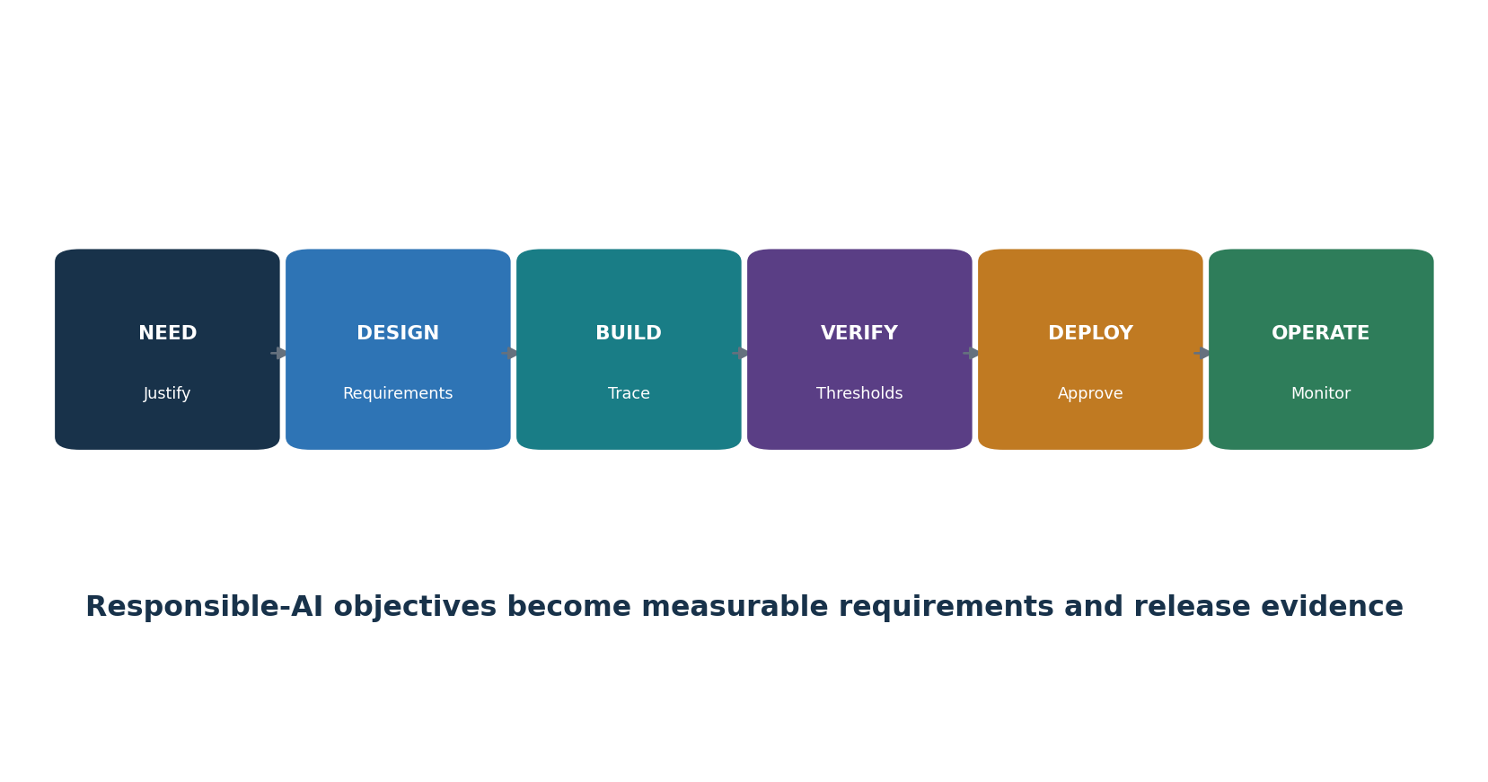
Figure 6. Responsible AI system life cycle
Life-cycle area | Implementation evidence
Responsible objectives/process | Fairness, safety, privacy, transparency, security, robustness and other relevant measurable goals; lifecycle procedure
Requirements/specification | Purpose, functional and nonfunctional criteria, affected people, data, model, human oversight, limits, obligations
Design/development records | Architecture, decisions, alternatives, assumptions, components, threats, interfaces, provenance, reviews
Verification/validation | Methods, evaluation data, scorers, thresholds, severe failures, subgroup/edge/adversarial tests, limitations
Deployment | Release approval, environment, configuration, user information, migration, monitoring, rollback
Operation/monitoring | Performance, drift, security, safety, impact, complaints, changes, support, repair, updates
Technical documentation/logs | Audience-appropriate instructions plus traceable events for audit, incidents, decisions, and improvement

25.1 Change and retirement
- Version model, data, prompts, retrieval, tools, code, infrastructure, policies, evaluation, approvals, and monitoring.
- Define material-change triggers and regression scope; deploy gradually with rollback.
- Retire users, identities, integrations, endpoints, models, datasets, indexes, logs, documentation, contracts, and provider copies according to obligations; preserve required records.

26. Annex A.7: Data for AI Systems
Annex A.7 requires governed data acquisition, quality, provenance, and preparation for AI development, enhancement, and operation.
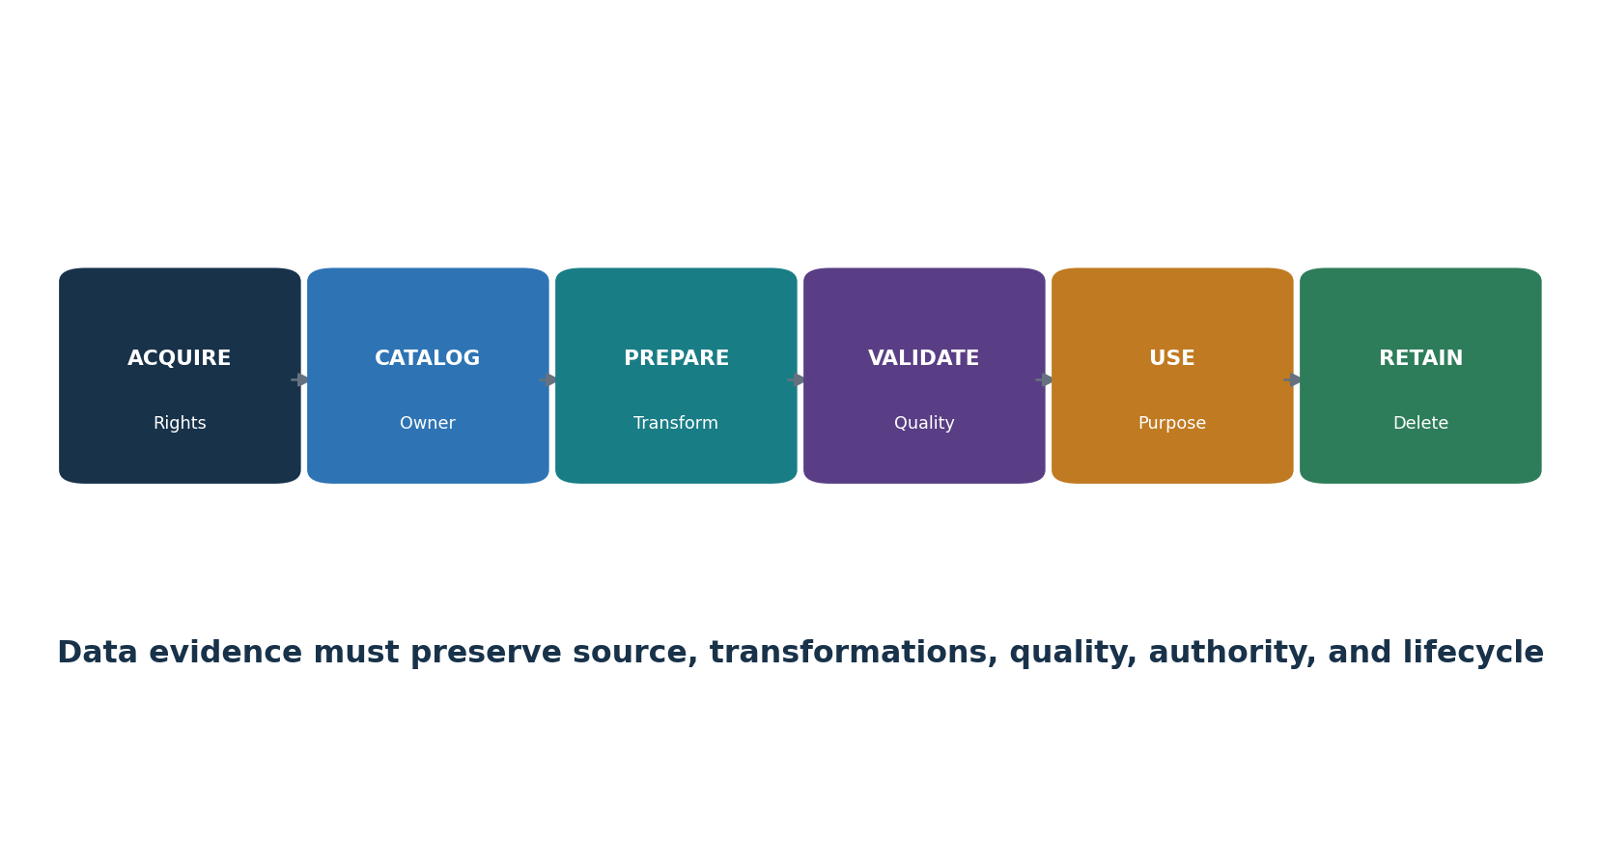
Figure 7. AI data evidence chain

26.1 Data controls
- Define data-management requirements for privacy, security, representativeness, explainability, provenance, accuracy, integrity, availability, retention, and deletion as relevant.
- Document acquisition/selection: source, method, people/population, rights/license, prior purpose, consent/authority where applicable, metadata, date, restrictions, and known bias.
- Set use-specific quality criteria and thresholds for accuracy, completeness, consistency, currency, uniqueness, validity, representativeness, labels, and subgroup coverage.
- Preserve provenance through creation, acquisition, transfer, transformation, labeling, augmentation, filtering, versioning, validation, use, sharing, correction, and deletion.
- Document preparation methods, code/tool/version, parameters, people, quality checks, rationale, outputs, and reproducibility.
- Separate and protect training, validation, test, production, monitoring, and incident datasets; prevent evaluation-set leakage.
Data evidence | Test
Dataset/data card | Trace purpose, population, fields, source, rights, quality, limitations, owner
Lineage | Reproduce source-to-feature transformations and version
Quality result | Verify full population/sample, rules, failures, correction and approval
Access/retention | Sample grants, reviews, removals, use, copies, deletion
Bias/representation | Check relevant groups, history, proxies, labels, gaps and mitigation

27. Annex A.8: Information for Interested Parties
Annex A.8 requires useful information for users and interested parties, plus reporting and incident communication.
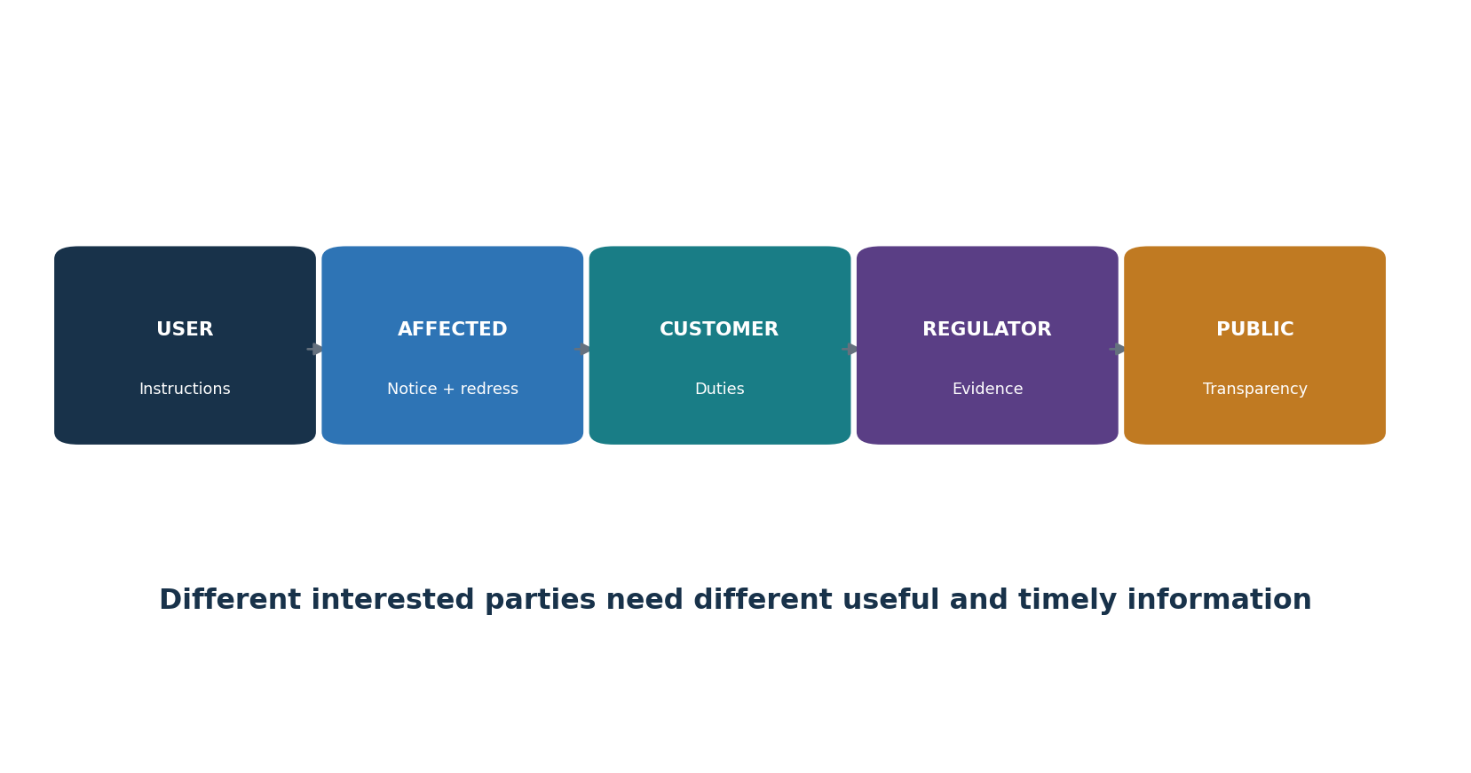
Figure 8. Interested-party information

27.1 Information package
- Users: intended purpose, capabilities, limitations, expected input/output, prohibited use, verification, human oversight, monitoring, escalation, and support.
- Affected people: that AI is used where appropriate, role in the decision, important factors/limitations, data and rights, human review, correction, appeal, complaint, and redress.
- Customers/partners: responsibilities, configuration, data, control dependencies, evidence, incidents, changes, support, and exit.
- Regulators/auditors: controlled documentation, scope, assessments, controls, test results, incidents, changes, findings, and corrective action as required.
- Public: proportionate transparency, significant impacts, governance, safety information, contact, and reports where appropriate.

27.2 External reporting and incidents
- Provide accessible channels to report errors, harm, bias, security/privacy concerns, misuse, accessibility problems, or unexpected effects.
- Define triage, severity, investigation, protection, feedback, correction, redress, escalation, retention, and trend analysis.
- Predefine incident audiences, content, owner/spokesperson, legal review, timing, channel, accessibility, coordination, updates, and closure.
- Do not over-disclose security-sensitive or personal information; do not hide material limitations behind confidentiality.

28. Annex A.9 and A.10: Responsible Use, Suppliers, and Customers
Annex A.9 governs responsible use and intended purpose; Annex A.10 allocates duties across suppliers, customers, and the AI value chain.
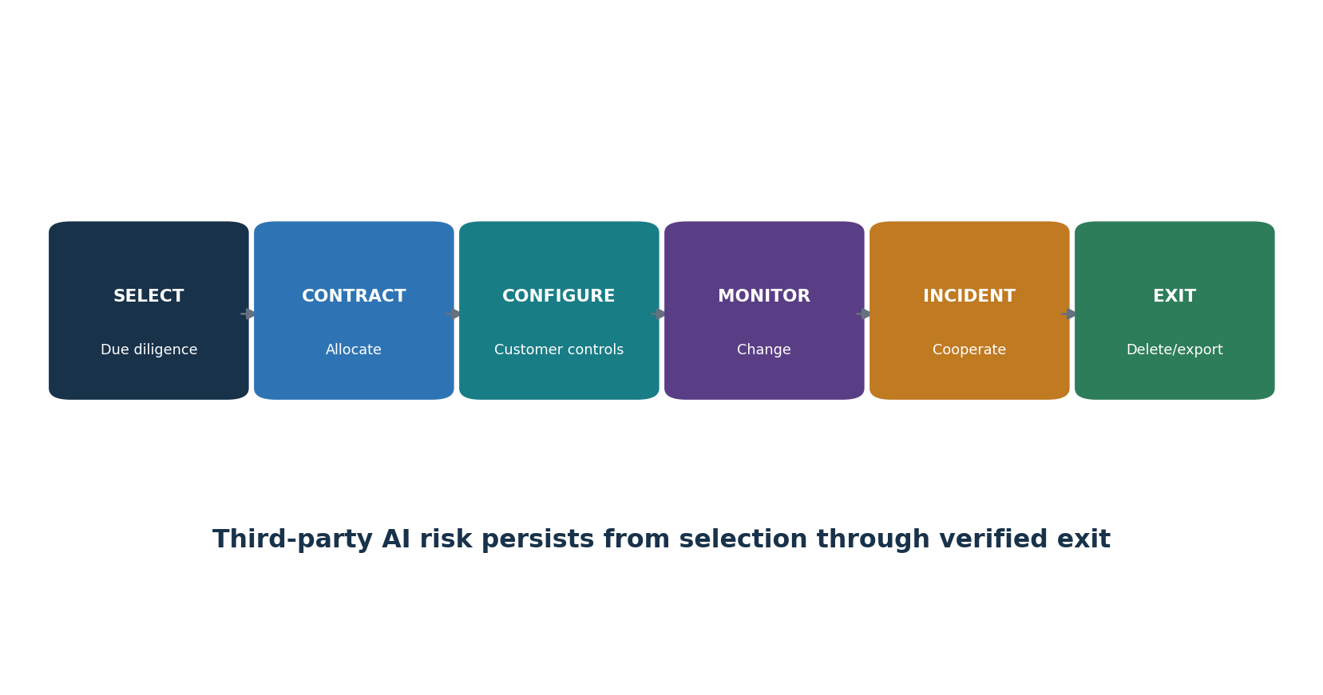
Figure 9. Third-party AI life cycle

28.1 Responsible use
- Define approved and prohibited uses, users, data, outputs, decisions, autonomy, verification, human oversight, logging, support, incident, and stop conditions.
- Set measurable responsible-use objectives tied to relevant impacts and risk.
- Train users and supervisors; enforce through identity, configuration, interfaces, policy, monitoring, review, and consequences.
- Detect scope creep and require reassessment before repurposing, expansion, new populations, higher impact, or new integrations/tools.

28.2 Third parties and customers
- Map developer/provider/deployer, data/model/tool/cloud suppliers, integrators, human services, customers, users, and affected parties.
- Allocate responsibility for data, requirements, testing, configuration, transparency, human oversight, security, incidents, monitoring, change, evidence, rights, deletion, and exit.
- Perform risk-based due diligence and contracting; verify model/system documentation, evaluation, security/privacy assurance, data terms, IP, support, vulnerabilities, changes, subprocessors, resilience, and portability.
- Monitor provider model/terms/training/retention/subprocessor/incidents/deprecation changes and reassess promptly.
- Define customer obligations and support; do not use customer responsibility as a vague transfer of provider duties.

29. Certification, ISO/IEC 42006:2025, and Audit Readiness
Certification evaluates the AIMS against ISO/IEC 42001 within a defined scope; ISO/IEC 42006:2025 strengthens requirements for certification bodies.

29.1 Certification path
- Select a competent certification body and verify its accreditation/status, scheme, geography, competence, impartiality, scope capability, and contract.
- Application and planning: organization, AIMS scope, roles, sites, people, systems, complexity, outsourced processes, standards, and audit time.
- Stage 1: readiness, scope, documented system, context, risk/impact methods, SoA, internal audit, management review, and Stage 2 preparedness.
- Stage 2: implementation and operating effectiveness through interviews, samples, records, observation, and trace-through.
- Resolve nonconformities with correction, cause, corrective action, and effectiveness evidence under scheme rules.
- Certification decision, certificate, surveillance, scope changes, recertification, suspension/withdrawal, and ongoing improvement.

29.2 ISO/IEC 42006:2025 significance
- It adds AIMS-specific requirements for bodies that audit and certify against ISO/IEC 42001 and builds on ISO/IEC 17021-1.
- It supports appropriate competence, consistent audit processes, impartiality, audit time, and rigor for organizations that develop, provide, or use AI systems.
- The organization should verify that a claimed certification is issued under a relevant accredited scheme and that certificate scope and status match the claim.
Audit evidence pack | Examples
Foundation | Scope, context, parties, policy, process map, roles, inventory
Planning | Risk method/results, treatment, SoA, impact process/results, objectives, changes
Support/operation | Resources, competence, communication, documents, lifecycle, data, use, suppliers, incidents
Evaluation/improvement | Metrics, internal audit, management review, findings, corrective actions, effectiveness
Trace samples | End-to-end records for representative high/medium/low-risk AI systems and material changes

29.3 Audit readiness without theater
- Operate controls long enough to produce honest evidence; do not create records after the fact.
- Reconcile scope, inventory, risk, impact, SoA, supplier, system versions, metrics, audit, and management review.
- Train interviewees to explain their real work and show evidence, not memorize answers.
- Disclose gaps, accepted risk, limitations, incidents, and corrective action accurately.

30. Open-Source AIMS Evidence and AI Assurance Tools
Open-source tools can support traceability, evaluation, monitoring, policy, privacy, and findings, but they do not decide ISO conformity.
Tool | Purpose
MLflow | Experiment tracking, model registry, lineage, approval, and deployment records
DVC | Version control for data, models, and pipelines
OpenLineage | Open standard and tooling for data/job lineage events
OpenMetadata | Data catalog, lineage, ownership, glossary, and quality metadata
Great Expectations | Automated data-quality expectations and validation results
Evidently | Data quality, drift, model performance, and monitoring reports
Deepchecks | Testing for data, ML models, and LLM applications
Giskard | AI testing and vulnerability scanning
Promptfoo | Prompt, model, RAG, and red-team evaluations
Garak | LLM vulnerability scanning and probes
PyRIT | Risk identification and red-team orchestration for generative AI
Inspect AI | Reproducible AI evaluations
Presidio | Detection and de-identification of personal information
ModelScan | Static scanning of serialized model files
CycloneDX | Software, ML, and AI bill-of-materials formats and tools
Open Policy Agent | Policy-as-code decisions
DefectDojo | Finding intake, deduplication, ownership, remediation, and retest
Langfuse | Open-source LLM tracing, prompt management, and evaluation

Tool governance: Use only authorized systems, models, accounts, repositories, and data. Start with isolated environments and synthetic data. Protect credentials, prompts, outputs, traces, personal information, and findings. Record versions and validate automated results.

30.1 MLflow
Purpose: Experiment tracking, model registry, lineage, approval, and deployment records. Official project: MLflow
Safe quick start: Create a local project; log parameters, dataset reference, metrics, artifacts, owner, and approval; register only a tested model; restrict registry changes.
AIMS evidence: authority/scope, system/model/data versions, identity, tool/version/configuration, criteria/thresholds, date, source population, result, human validation, limitations, finding, owner/action, approval, and retest.

30.2 DVC
Purpose: Version control for data, models, and pipelines. Official project: DVC
Safe quick start: Use a synthetic dataset in a training repository; version data and pipeline stages; reproduce a run; protect remote storage and credentials.
AIMS evidence: authority/scope, system/model/data versions, identity, tool/version/configuration, criteria/thresholds, date, source population, result, human validation, limitations, finding, owner/action, approval, and retest.

30.3 OpenLineage
Purpose: Open standard and tooling for data/job lineage events. Official project: OpenLineage
Safe quick start: Instrument a small lab pipeline; record dataset and job relationships; check event completeness; protect sensitive metadata.
AIMS evidence: authority/scope, system/model/data versions, identity, tool/version/configuration, criteria/thresholds, date, source population, result, human validation, limitations, finding, owner/action, approval, and retest.

30.4 OpenMetadata
Purpose: Data catalog, lineage, ownership, glossary, and quality metadata. Official project: OpenMetadata
Safe quick start: Deploy a lab instance; catalog synthetic datasets; assign owners/classification; document lineage and retention; restrict connectors.
AIMS evidence: authority/scope, system/model/data versions, identity, tool/version/configuration, criteria/thresholds, date, source population, result, human validation, limitations, finding, owner/action, approval, and retest.

30.5 Great Expectations
Purpose: Automated data-quality expectations and validation results. Official project: Great Expectations
Safe quick start: Define accuracy, completeness, range, and null expectations for synthetic data; run validation; preserve suite/version/results and exceptions.
AIMS evidence: authority/scope, system/model/data versions, identity, tool/version/configuration, criteria/thresholds, date, source population, result, human validation, limitations, finding, owner/action, approval, and retest.

30.6 Evidently
Purpose: Data quality, drift, model performance, and monitoring reports. Official project: Evidently
Safe quick start: Create reference and current synthetic datasets; run a report; define action thresholds; investigate before retraining or rollback.
AIMS evidence: authority/scope, system/model/data versions, identity, tool/version/configuration, criteria/thresholds, date, source population, result, human validation, limitations, finding, owner/action, approval, and retest.

30.7 Deepchecks
Purpose: Testing for data, ML models, and LLM applications. Official project: Deepchecks
Safe quick start: Run a focused suite on approved lab data; review relevance and false positives; record exceptions; rerun after correction.
AIMS evidence: authority/scope, system/model/data versions, identity, tool/version/configuration, criteria/thresholds, date, source population, result, human validation, limitations, finding, owner/action, approval, and retest.

30.8 Giskard
Purpose: AI testing and vulnerability scanning. Official project: Giskard
Safe quick start: Connect only an approved test model and dataset; select relevant tests; validate failures manually; keep the report and remediation retest.
AIMS evidence: authority/scope, system/model/data versions, identity, tool/version/configuration, criteria/thresholds, date, source population, result, human validation, limitations, finding, owner/action, approval, and retest.

30.9 Promptfoo
Purpose: Prompt, model, RAG, and red-team evaluations. Official project: Promptfoo
Safe quick start: Create a versioned YAML suite with synthetic cases and expected behavior; run locally; review failures; retain configuration and results.
AIMS evidence: authority/scope, system/model/data versions, identity, tool/version/configuration, criteria/thresholds, date, source population, result, human validation, limitations, finding, owner/action, approval, and retest.

30.10 Garak
Purpose: LLM vulnerability scanning and probes. Official project: Garak
Safe quick start: Use an isolated lab model and a limited approved probe set; cap requests and cost; protect outputs; validate each finding.
AIMS evidence: authority/scope, system/model/data versions, identity, tool/version/configuration, criteria/thresholds, date, source population, result, human validation, limitations, finding, owner/action, approval, and retest.

30.11 PyRIT
Purpose: Risk identification and red-team orchestration for generative AI. Official project: PyRIT
Safe quick start: Define written lab rules; use harmless objectives and synthetic data; set request/time/cost limits; protect transcripts and findings.
AIMS evidence: authority/scope, system/model/data versions, identity, tool/version/configuration, criteria/thresholds, date, source population, result, human validation, limitations, finding, owner/action, approval, and retest.

30.12 Inspect AI
Purpose: Reproducible AI evaluations. Official project: Inspect AI
Safe quick start: Define a task, dataset, solver, scorer, and acceptance rule; pin versions; run an approved model; retain logs and limitations.
AIMS evidence: authority/scope, system/model/data versions, identity, tool/version/configuration, criteria/thresholds, date, source population, result, human validation, limitations, finding, owner/action, approval, and retest.

30.13 Presidio
Purpose: Detection and de-identification of personal information. Official project: Presidio
Safe quick start: Test on synthetic examples; configure recognizers for language/context; inspect false positives and misses; protect analyzer output.
AIMS evidence: authority/scope, system/model/data versions, identity, tool/version/configuration, criteria/thresholds, date, source population, result, human validation, limitations, finding, owner/action, approval, and retest.

30.14 ModelScan
Purpose: Static scanning of serialized model files. Official project: ModelScan
Safe quick start: Scan an artifact in quarantine; verify source and hash; investigate warnings; never load an untrusted model merely to test it.
AIMS evidence: authority/scope, system/model/data versions, identity, tool/version/configuration, criteria/thresholds, date, source population, result, human validation, limitations, finding, owner/action, approval, and retest.

30.15 CycloneDX
Purpose: Software, ML, and AI bill-of-materials formats and tools. Official project: CycloneDX
Safe quick start: Generate a bill of materials for a lab repository; validate components and versions; link findings to owners and supplier records.
AIMS evidence: authority/scope, system/model/data versions, identity, tool/version/configuration, criteria/thresholds, date, source population, result, human validation, limitations, finding, owner/action, approval, and retest.

30.16 Open Policy Agent
Purpose: Policy-as-code decisions. Official project: Open Policy Agent
Safe quick start: Write a small lab rule for approved model/data/use; test allow, deny, and missing-data cases; peer-review changes; keep human exception authority.
AIMS evidence: authority/scope, system/model/data versions, identity, tool/version/configuration, criteria/thresholds, date, source population, result, human validation, limitations, finding, owner/action, approval, and retest.

30.17 DefectDojo
Purpose: Finding intake, deduplication, ownership, remediation, and retest. Official project: DefectDojo
Safe quick start: Import safe lab results; validate duplicates and severity; assign owner/date; attach evidence; close only after retest.
AIMS evidence: authority/scope, system/model/data versions, identity, tool/version/configuration, criteria/thresholds, date, source population, result, human validation, limitations, finding, owner/action, approval, and retest.

30.18 Langfuse
Purpose: Open-source LLM tracing, prompt management, and evaluation. Official project: Langfuse
Safe quick start: Use an approved lab; redact sensitive fields; trace a workflow; restrict access/retention; connect traces to evaluation and incident records.
AIMS evidence: authority/scope, system/model/data versions, identity, tool/version/configuration, criteria/thresholds, date, source population, result, human validation, limitations, finding, owner/action, approval, and retest.

31. Manager and Junior Analyst Playbook, Laboratory, and Interviews
Managers keep the AIMS tied to real outcomes; junior analysts create reliable inventories, workpapers, findings, and improvement evidence.
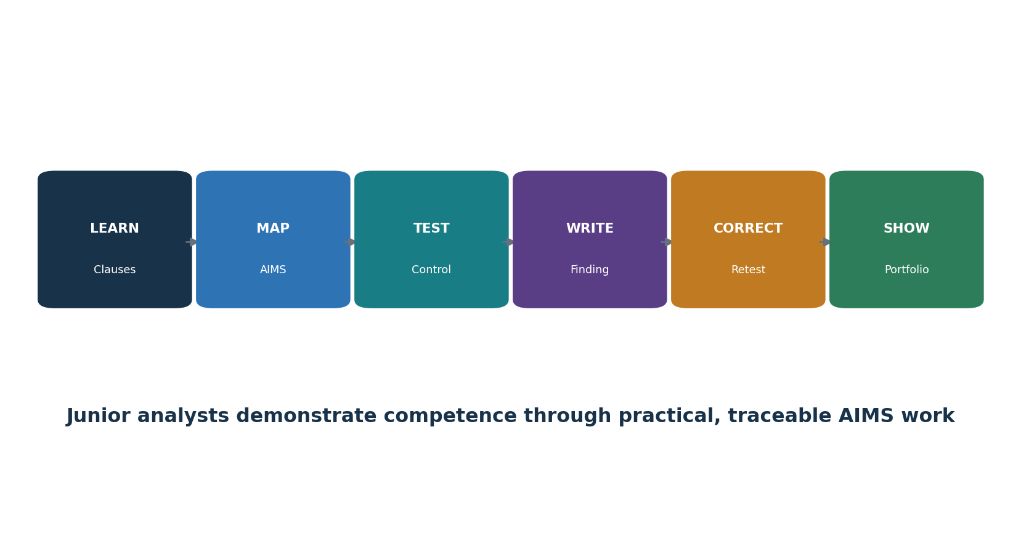
Figure 10. Junior AIMS analyst pathway

31.1 Manager questions
Question | Strong evidence | Red flag
What is in scope? | Reconciled AI inventory, organization/role/system/data/supplier boundaries | Marketing scope broader than certificate
Who may decide? | Named business, system, data, impact, risk, supplier, incident and audit authority | AI team accepts business/legal risk alone
What harms are possible? | Current risk and impact assessments with affected people and alternatives | Only model accuracy considered
What proves readiness? | Versioned production-like evaluation, thresholds, failures, oversight, rollback | Vendor demo or policy only
What changes risk? | Trigger list, monitoring, provider notice, regression, reassessment | Automatic updates without review
Is the AIMS improving? | Objectives, audit, complaints/incidents, root causes, effective actions | Certificate is the only success measure

31.2 Junior analyst work
- Maintain AI inventory, scope, interested parties, obligations, risk/impact registers, SoA, supplier records, objectives, evidence, and actions.
- Map clauses/controls to processes and real system evidence; reconcile populations and versions.
- Test document control, competence, lifecycle gates, data lineage/quality, evaluation, responsible use, supplier change, monitoring, incident, and corrective action.
- Write objective findings and manager summaries; track correction and effectiveness retest.
- Support internal audits and management review without making decisions reserved for owners or auditors.
Portfolio lab rule: Use a fictional organization, synthetic data, and local or approved test models. Never claim the project is certified, audited by an accredited body, or based on confidential employer evidence.

31.3 Fictional laboratory
- Create a fictional 100-person company that develops a customer-support RAG assistant and uses a purchased HR drafting assistant that cannot make employment decisions.
- Define AIMS context, interested parties, roles, scope, policy, process map, AI inventory, obligations, and implementation roadmap.
- Create a risk method, six risk scenarios, treatment plan, 38-control SoA, and two impact assessments using ISO/IEC 42005 concepts.
- Build resource, dataset, model/system, supplier, user-information, communication, competence, and document-control records.
- Run synthetic evaluations using two open-source tools; retain versions, thresholds, failures, correction, and retest.
- Create objectives/dashboard, internal audit plan and five workpapers, two findings, corrective actions, management-review pack, and certification readiness report.
- Publish only sanitized fictional evidence and an honest limitations statement.

31.4 Thirty-day plan
Days | Focus | Deliverable
1–3 | Standard, AIMS, PDCA | Clause map and glossary
4–6 | Context, parties, scope | Scope and interested-party register
7–9 | Leadership and planning | Policy, RACI, objectives
10–12 | Risk and treatment | Method, register, plan, SoA
13–15 | Impact assessment | Two impact workpapers
16–18 | Support and documents | Competence, communication, document controls
19–21 | Lifecycle, data, use, suppliers | Five control workpapers
22–24 | Measurement and tools | Dashboard and evaluation evidence
25–27 | Audit and corrective action | Audit report, findings, effectiveness plan
28–30 | Management review and interview | Review pack, readiness memo, STAR stories

31.5 What is ISO/IEC 42001?
A certifiable management-system standard for organizations that develop, provide, or use AI systems. It establishes requirements for responsible governance, risk, impact, operation, evaluation, and improvement.

31.6 What is an AIMS?
The organization’s interrelated policies, objectives, processes, roles, controls, and records for managing AI responsibly within a defined scope.

31.7 Are all Annex A controls mandatory?
They are reference controls considered through risk treatment. The organization documents applicability and implementation in the Statement of Applicability and may add other controls.

31.8 Risk versus impact assessment?
Risk assessment manages uncertainty affecting objectives. AI system impact assessment focuses on effects on individuals, groups, and society. They exchange findings but are not identical.

31.9 What is the Statement of Applicability?
A controlled record explaining which Annex A and additional controls apply, why, how they are implemented, their status, evidence, gaps, and review.

31.10 Stage 1 versus Stage 2?
Stage 1 evaluates scope, documented system, readiness and planning. Stage 2 evaluates implementation and operating effectiveness through evidence and sampling.

31.11 What is a nonconformity?
A requirement is not fulfilled. The finding must identify criteria, objective evidence, and the gap without prescribing the auditee’s solution.

31.12 How do tools prove conformity?
They do not. Tools produce evidence that must be scoped, validated, interpreted against requirements, connected to controls, and reviewed by competent people.

31.13 How do you test a corrective action?
Verify correction, root-cause action, application to similar conditions, and evidence that recurrence risk was reduced after sufficient operation.

31.14 What makes a strong junior analyst?
Accurate scope, careful evidence, clause understanding, clear writing, respect for affected people, honest uncertainty, safe tool use, and reliable follow-through.

32. Templates, Glossary, Index, and Official References
Reusable work structures and authoritative references support consistent AIMS implementation and audit.

32.1 AIMS scope and context record
Field | Entry
Organizations/business units/locations | ________________________________________
AI role, products/services/processes | ________________________________________
AI systems/models/data/environments | ________________________________________
Internal/external issues | ________________________________________
Interested parties and requirements | ________________________________________
Legal/contractual obligations | ________________________________________
Boundaries, interfaces, dependencies | ________________________________________
Outsourced/shared processes | ________________________________________
Exclusions and justification | ________________________________________
Scope approval and review triggers | ________________________________________

32.2 AI risk and treatment record
Field | Entry
System/use/version/owner | ________________________________________
Scenario, affected party, consequence | ________________________________________
Likelihood/impact/uncertainty/evidence | ________________________________________
Existing controls and effectiveness | ________________________________________
Risk evaluation/tolerance | ________________________________________
Treatment option/control | ________________________________________
Annex A/additional control mapping | ________________________________________
Owner/resource/date/measure | ________________________________________
Residual risk/approver/conditions | ________________________________________
Monitoring/review/retest | ________________________________________

32.3 Statement of Applicability
Field | Entry
Control reference/title | ________________________________________
Applicability and justification | ________________________________________
Related risk/impact/obligation | ________________________________________
Implementation and owner | ________________________________________
Status and target date | ________________________________________
Evidence and test result | ________________________________________
Supplier/customer dependencies | ________________________________________
Gap/exception/residual risk | ________________________________________
Last/next review | ________________________________________
Change history/approval | ________________________________________

32.4 AI system impact assessment
Field | Entry
Purpose, use, affected people, alternatives | ________________________________________
System/data/model/supplier/context | ________________________________________
Benefits and adverse impacts | ________________________________________
Individual/group/societal effects | ________________________________________
Likelihood/severity/scale/duration | ________________________________________
Reversibility/distribution/uncertainty | ________________________________________
Stakeholder engagement | ________________________________________
Mitigation/oversight/transparency/redress | ________________________________________
Decision/authority/conditions | ________________________________________
Monitoring/triggers/review | ________________________________________

32.5 Internal audit workpaper
Field | Entry
Criteria/scope/objective | ________________________________________
Process/system/version/period | ________________________________________
Population/sample/rationale | ________________________________________
Evidence/source/reliability | ________________________________________
Test/expected result | ________________________________________
Observed result/exceptions | ________________________________________
Conclusion/nonconformity | ________________________________________
Risk/impact/cause indication | ________________________________________
Correction/corrective action | ________________________________________
Effectiveness/follow-up/closure | ________________________________________

32.6 Management review record
Field | Entry
Prior action status | ________________________________________
Context/party changes | ________________________________________
Objectives/performance trends | ________________________________________
Risk/impact/treatment/SoA | ________________________________________
Audit/nonconformity/corrective action | ________________________________________
Incidents/complaints/concerns/redress | ________________________________________
Supplier/legal/system changes | ________________________________________
Resources/competence | ________________________________________
Decisions/actions/owners/dates | ________________________________________
Effectiveness/follow-up | ________________________________________

32.7 Glossary
Term | Meaning
AIMS | Artificial intelligence management system.
AI system impact assessment | Structured evaluation of potential effects on individuals, groups, and society.
Annex A | ISO/IEC 42001 reference control objectives and controls.
Annex B | Implementation guidance for Annex A controls.
Certification | Third-party attestation that the scoped AIMS conforms to specified requirements.
Conformity | Fulfillment of a requirement.
Control | Measure that maintains or modifies risk.
Correction | Action to eliminate a detected nonconformity.
Corrective action | Action to eliminate cause and prevent recurrence.
Documented information | Information the organization controls and maintains, plus its medium.
Interested party | Person or organization that can affect, be affected by, or perceive itself affected by a decision/activity.
Internal audit | Independent and objective systematic process for evaluating evidence against criteria.
Nonconformity | Non-fulfillment of a requirement.
Objective | Result to be achieved.
Residual risk | Risk remaining after treatment.
Risk owner | Person/entity with accountability and authority to manage risk.
SoA | Statement of Applicability.
Stage 1 | Certification readiness and documented-system audit stage.
Stage 2 | Certification implementation and operating-effectiveness audit stage.
Top management | Person/group directing and controlling the organization at the highest level within scope.

32.8 Subject index
Subject | Chapter
Annex A controls | 20–28
Audit | 17, 29
Certification | 29
Context/scope | 3–4
Corrective action | 19
Data | 23, 26
Documents | 13
Impact assessment | 9, 24
Interested parties | 4, 27
Leadership/policy | 5, 21
Lifecycle | 14–15, 25
Manager/junior analyst | 31
Measurement/review | 16–18
Objectives/change | 10
Resources/competence | 11–12, 23
Risk/treatment/SoA | 6–8
Suppliers/use | 28
Tools | 30

32.9 Official references
- ISO/IEC 42001:2023 official page
- ISO 42001 explained
- ISO/IEC 42001 Online Browsing Platform
- ISO/IEC 42005:2025 AI system impact assessment
- ISO/IEC 42006:2025 certification bodies
- ISO 19011:2026 audit guidelines
- ISO/IEC 23894:2023 AI risk management
- ISO/IEC 22989:2022 AI concepts and terminology
- ISO/IEC 23053:2022 ML system framework
- ISO/IEC 38507:2022 governance implications of AI
- ISO/IEC JTC 1/SC 42 catalogue
- ISO management-system standards
- IAF CertSearch
- NIST AI Risk Management Framework
- OECD AI Principles
- EU AI Act official policy page
Final reminder: Use an authorized copy of the standard. ISO standards, certification schemes, accreditation, laws, AI systems, providers, risks, tools, and official guidance change. Verify the current source, exact edition, certificate scope/status, system version, and organizational facts before implementation, audit, certification, or public claims.

