KALI LINUX
AI, Security Testing & Digital Forensics
A Beginner-Friendly Practical Manual for Understanding
When, Why, and How to Use Essential Tools
Prepared by Alberto (Al) Leiva
Final English Edition v1.0 - July 2026
Reviewed for Kali Linux 2026.2
English Master Edition
FREE EDUCATIONAL RESOURCE
An independent guide. Not sponsored, endorsed, or officially affiliated with Kali Linux, OffSec, or Hack The Box.

Preface

Passing Knowledge Forward
I created this manual because I wanted beginners to have the kind of guide I would have valued when I first entered the technology and cybersecurity field. Powerful tools are easier to find than patient explanations. My goal is to explain not only what a tool does, but why it matters, when it should be used, and what responsibilities come with using it.
After many years in the industry, I believe experience has the greatest value when it is shared. Technology changes constantly, but the need for curiosity, discipline, ethics, and sound judgment does not. This book is my way of passing those lessons forward to students, career changers, and young people who may one day protect systems and information that the rest of us depend on.
I also understand that learning does not look the same for everyone. I have dysgraphia, a learning disability that can make writing, spelling, and organizing written information difficult. The ideas and experience were mine, but turning them into a clear, structured book would have been extremely difficult for me without the support of an AI writing and editing assistant.
That assistance did not replace professional experience, judgment, or responsibility. It helped me organize my thoughts, improve the language, check consistency, and present the material in a form that other people can use. Every technology should be approached in the same way: as a tool that can extend human ability when it is used carefully, honestly, and responsibly.
This manual is offered freely because opportunity should not depend entirely on a person’s income, location, language, or learning differences. I hope it gives someone the confidence to begin, the patience to keep learning, and a lifelong interest in the changing and challenging world of cybersecurity, artificial intelligence, and digital forensics.
Most of all, I hope readers remember that technical skill is only part of becoming a security professional. Character, permission, respect for others, and the willingness to use knowledge for good are just as important.
— Alberto (Al) Leiva

About this manual
This manual was created to help beginners take their first steps into Kali Linux, artificial intelligence tools, ethical hacking, security testing, and digital forensics. You do not need to be an expert to begin. You need curiosity, patience, and a willingness to learn responsibly.
Cybersecurity is constantly changing. New technologies appear, new vulnerabilities are discovered, and new defenses are developed every day. That is part of what makes this field challenging, but it is also what makes it exciting. The purpose of this free manual is not simply to teach commands. It is to help readers understand why a tool is used, when it should be used, what the results mean, and what responsibilities come with technical skill.
The rule that guides every chapter
Technical ability does not create permission. Ethical hacking requires clear authorization, a defined scope, care for other people's information, and honest reporting.

License
Unless a section states otherwise, the original text in this manual is shared under the Creative Commons Attribution-Noncommercial-Share Alike 4.0 International license (CC BY-NC-SA 4.0). You may share and adapt the material for noncommercial purposes when you provide attribution and distribute adaptations under the same license. Third-party names, trademarks, screenshots, documentation, and code remain the property of their respective owners.
Creative Commons CC BY-NC-SA 4.0

Important disclaimer
This publication is educational and is not legal advice. Laws differ by country and circumstances. Perform exercises only in authorized labs or on systems you own and control. The author and contributors do not authorize or encourage unauthorized access, disruption, credential theft, privacy violations, or other harmful activity.

How to use this first edition
• Read the ethics and lab-safety chapters before using security tools.
• Start with a virtual machine unless you have a strong reason to install Kali directly on hardware.
• Use Hack The Box Starting Point or your own intentionally vulnerable lab for practice.
• Type commands yourself and understand the target before pressing Enter.
• Keep notes. Every practical chapter includes an interpretation-and-reporting mindset.
• Check official documentation because Kali and its tools change frequently.

Index and Table of Contents
Preface 2
Passing Knowledge Forward 2
About this manual 2
License 2
Important disclaimer 3
How to use this first edition 3
Index and Table of Contents 3
1. AI Security Foundations, Careers, and Professional Skills 7
1.1 AI Security Foundations and Career Skills 7
1.2 Semgrep for secure AI application code 7
1.3 Continue for AI-assisted development 8
1.4 Hugging Face 8
1.5 A beginner AI red-team workflow 8
2. Learning Roadmap, Ethics, and Responsible Practice 9
2.1 How to use this manual and learning roadmap 9
2.2 Ethical Hacking, Authorization, and Consequences 9
3. Choosing and Installing Kali Linux 11
3.1 Which image should a beginner choose? 11
3.2 Recommended hardware 11
3.3 VMware on Windows - recommended for many beginners 12
3.4 Practical checklist 12
3.5 Hyper-V on Windows 11 Pro 12
3.6 Practical checklist 12
3.7 VirtualBox 13
3.8 Practical checklist 13
3.9 Separate partition and dual boot 13
3.10 Practical checklist 13
3.11 Mac computers 13
3.12 Practical checklist 13
3.13 First boot, updates, and safe defaults 14
3.14 Essential Linux commands 14
3.15 Detailed Installation Walkthroughs 14
3.16 Before you download anything 14
3.17 Choose the correct Kali image 15
3.18 VMware Workstation on Windows - easiest choice for many beginners 15
3.19 Hyper-V on Windows 11 Pro, Enterprise, or Education 15
3.20 Oracle VirtualBox on Windows, Linux, or Intel Mac 16
3.21 Kali on Apple Silicon Mac - M1, M2, M3, and newer 16
3.22 Intel-based Mac 17
3.23 Separate partition or dual boot with Windows 17
3.24 Dedicated computer installation 18
3.25 First boot checklist for every installation 18
3.26 Virtualization links at a glance 18
4. Building a Safe Practice Lab 20
4.1 Hack The Box as the primary practice area 20
4.2 Safe HTB workflow 20
5. AI Tools for Cybersecurity Learning 22
5.1 Ollama 22
5.2 Open WebUI 23
5.3 Promptfoo 24
5.4 Giskard 25
5.5 LangChain 26
5.6 LlamaIndex 27
5.7 Aider 27
5.8 Open Interpreter 28
6. MCP, RAG, and AI Agents 30
6.1 RAG in plain language 30
6.2 Vector databases in plain language 30
6.3 Agents and tool use 30
6.4 Model Context Protocol (MCP): a core AI security principle 30
6.5 Why MCP matters to employers 30
6.6 The security principles behind MCP 31
6.7 A beginner MCP review checklist 31
6.8 AI agents: the basic idea 31
6.9 The risks every employer should understand 31
6.10 Microsoft Azure and Microsoft Foundry: security basics 31
6.11 AWS and Amazon Bedrock: security basics 32
6.12 OpenAI API and ChatGPT-connected workflows: security basics 32
6.13 A minimum employer checklist for AI agents 32
6.14 Official starting references 32
6.15 A simple AI security checklist 33
7. GRC and AI Governance 34
7.1 Governance 34
7.2 Risk 34
7.3 Compliance 34
7.4 Important beginner documents 34
7.5 AI governance questions 35
7.6 Frameworks to recognize 35
8. Essential Kali Security Tools 36
8.1 Choosing the right Kali tool 36
8.2 Twenty Essential Kali Security Tools 36
8.3 Nmap 36
8.4 Wireshark 37
8.5 Burp Suite Community Edition 38
8.6 Metasploit Framework 39
8.7 Gobuster 40
8.8 FFUF 40
8.9 Nikto 41
8.10 sqlmap 42
8.11 OWASP ZAP 43
8.12 Hydra 43
8.13 John the Ripper 44
8.14 Hashcat 45
8.15 Aircrack-ng 46
8.16 Bettercap 46
8.17 Responder 47
8.18 NetExec 48
8.19 enum4linux-ng 49
8.20 Searchsploit 49
8.21 Autopsy 50
8.22 Maltego 51
9. Digital Forensics Fundamentals and Tools 53
9.1 Digital Forensics Fundamentals 53
9.2 Sleuth Kit 53
9.3 Guymager 54
9.4 ExifTool 55
9.5 Binwalk 56
9.6 Volatility 3 57
9.7 Foremost 58
9.8 bulk_extractor 59
9.9 Plaso/log2timeline 60
9.10 YARA 60
9.11 Ghidra 61
10. Reporting What You Learn 62
10.1 Simple finding template 62
10.2 Avoid these reporting mistakes 63
11. Your First 30 Days with Kali Linux 64
11.1 Week 1 - Build safe foundations 64
11.2 Week 2 - Learn to observe 64
11.3 Week 3 - Begin web and HTB practice 64
11.4 Week 4 - Connect the skills 64
12. English for Technology Careers 65
12.1 Where English appears 65
12.2 A realistic goal 65
12.3 Free English Learning Resources Available Worldwide 65
12.4 A simple weekly English plan 65
13. Career Paths and Continued Learning 67
Lab folder pattern 67
Verification notes for this edition 69
Planned GitHub repository structure 70

1. AI Security Foundations, Careers, and Professional Skills

1.1 AI Security Foundations and Career Skills
AI security is more than using a chatbot. It combines software security, data protection, model testing, governance, privacy, and clear communication. This section shows where the jobs are developing and what a beginner can learn first.
Why AI security is a growing career area
Organizations are integrating generative AI, copilots, retrieval systems, and automated agents into their business processes. These systems create new questions: What data can the model see? Can a user manipulate its instructions? Can the model call tools it should not use? Can sensitive information appear in an answer? AI security professionals help answer those questions before a system causes harm.
- AI security analyst - reviews risks, tests safeguards, and documents findings.
- AI governance analyst - helps create policies, inventories, approvals, and evidence.
- LLM security tester or AI red-team tester - evaluates prompt injection, data leakage, unsafe tool use, and other failure modes.
- Secure AI engineer - adds authentication, authorization, filtering, logging, and monitoring to AI applications.
- RAG security specialist - protects document retrieval, vector databases, source permissions, and citations.
- AI risk and compliance specialist - connects technical controls to NIST, ISO, privacy, and contractual requirements.
- AI incident-response analyst - investigates misuse, leaked data, harmful outputs, and compromised AI workflows.
A beginner does not need to master every role. Start with Linux, networking, Python basics, safe testing, and the ability to explain a finding clearly.

1.2 Semgrep for secure AI application code
What it is and why to use it
Semgrep is a source-code scanning tool. It searches code for patterns that may indicate security mistakes, such as hard-coded secrets, unsafe input handling, or insecure API use. It is valuable for AI applications because many AI failures stem from the surrounding code rather than the model itself.
When to use it
- Reviewing your own Python or JavaScript AI project.
- Checking whether API keys were accidentally placed in source code.
- Finding risky functions before a code review.
Install and check
Use a Python virtual environment when possible. Then install Semgrep with pip and confirm it starts with semgrep --version. Kali may also provide a packaged version, but the official documentation should be checked for the current method.
First safe exercise
- Create a small practice file that contains a fake test password.
- Run Semgrep only against that local practice folder.
- Read the rule name and file location.
- Remove the fake password and run the scan again.
- Write one sentence explaining why secrets should be stored outside source code.
Official Semgrep documentation

1.3 Continue for AI-assisted development
Continue is an AI coding assistant that can work inside supported development environments. It can explain code, suggest changes, and connect to local or hosted models. Use it as a helper, not as an authority. Every suggested change must be reviewed and tested.
Beginner safety rules
- Use a practice repository, not a production system.
- Do not send private client code to a public model without approval.
- Review the exact files and commands the assistant proposes.
- Use Git so unwanted changes can be reversed.
Official Continue documentation

1.4 Hugging Face
Hugging Face is a large ecosystem for models, datasets, demonstrations, and development libraries. It helps learners understand that models have licenses, intended uses, limitations, file sizes, and security considerations. A model page should be read before a model is downloaded or used.
What a beginner should check
- The model license and allowed uses.
- The model card and known limitations.
- Whether code must be trusted or executed.
- The download size and hardware requirements.
- Whether the repository is maintained by a recognized organization or an unknown account.
Hugging Face documentation

1.5 A beginner AI red-team workflow
AI red teaming means testing an AI system for harmful or unexpected behavior with permission. It is not an excuse to attack a public chatbot or bypass another organization's controls.
- Write down the authorized application, users, data, model, and test period.
- List the behaviors that must be protected, such as confidential data, system instructions, and tool permissions.
- Create normal test prompts first so you understand expected behavior.
- Test one risk category at a time, such as prompt injection or unsafe tool use.
- Save the prompt, response, model version, settings, and time.
- Repeat the test to determine whether the behavior is consistent.
- Explain the impact without exaggeration.
- Recommend a control and retest after the control is applied.
OWASP GenAI Security Project
MITRE ATLAS
NIST AI Risk Management Framework

2. Learning Roadmap, Ethics, and Responsible Practice

2.1 How to use this manual and learning roadmap
Section | What you will learn
Part I | Ethics, consequences, and the professional mindset
Part II | Choosing, installing, and maintaining Kali Linux
Part III | Building a safe practice lab and using Hack The Box
Part IV | AI tools for learning, testing, and analysis
Part V | Twenty essential Kali security tools
Part VI | Digital forensics fundamentals and tools
Part VII | Reporting, career paths, and your first 30 days
Appendices | Checklists, glossary, official links, and source notes
Suggested learning order
- Read Parts I-III before running tools.
- Install Kali in a virtual machine and create a clean snapshot.
- Learn basic Linux navigation and networking.
- Use the AI section to support understanding, not to replace it.
- Practice reconnaissance and traffic analysis before exploitation.
- Complete the forensics section using sample evidence, never original evidence.
- Write a short report after every lab.

2.2 Ethical Hacking, Authorization, and Consequences
Ethical hacking is the authorized use of security methods to identify weaknesses and help improve defenses. The same command can be ethical in a lab and unlawful on an unapproved system. The difference is permission, scope, purpose, and conduct.
Permission is specific, not assumed
Permission should identify the systems, dates, allowed techniques, contacts, and stop conditions. Permission to use a website is not permission to test it. Employment at an organization is not automatically permission to scan its network. A friend saying “try my Wi-Fi” may not be enough if the router, service, or data is someone else's.
Scope keeps good intentions from causing harm
Scope defines the boundaries of a test. It may include specific IP addresses, applications, accounts, hours, and prohibited actions. If a result points to a system outside the scope, stop and ask. Do not follow the trail simply because it is technically possible.
Consequences of unauthorized behavior
Unauthorized security activity can cause account suspension, school discipline, job loss, civil claims, criminal investigation, financial damage, loss of certifications, and long-term reputational harm. It can also hurt innocent people by exposing private messages, medical records, photographs, financial data, or business operations.
Responsible behavior when you discover a problem
Do not download more information than needed to demonstrate the issue. Do not publicly identify affected people. Record the minimum evidence necessary, protect it, and report through the organization’s published security channel or an appropriate responsible-disclosure process.
Stop conditions
Stop immediately if you reach personal data, obtain unexpected administrative access, cause instability, identify the wrong target, lose authorization, or become unsure whether the next action is permitted.

Practice scenarios
Scenario | Professional response
A student scans the school network to “see what is open.” | Not ethical without explicit authorization. Curiosity does not replace permission.
A learner scans a Hack The Box machine assigned to their account. | Appropriate when the action follows the lab rules and stays within the assigned target.
A friend gives a Wi-Fi password and asks for a security check. | Pause. Clarify ownership, written permission, allowed actions, and whether other users or provider equipment may be affected.
A researcher finds a public login page and tries common passwords. | Unauthorized credential testing. Public access does not permit password attacks.
A learner analyzes a downloadable forensic practice image. | Appropriate when the evidence was provided for training and is handled according to the exercise instructions.

3. Choosing and Installing Kali Linux
Choosing and Installing Kali Linux
Kali Linux is a specialized Linux distribution for penetration testing, security assessment, digital forensics, and related work. It contains many powerful tools, but it is still a Linux operating system. Beginners should first learn safe installation, updates, files, users, permissions, networking, and recovery.
Current version note
This first edition was reviewed against the official Kali Linux 2026.2 point release available in July 2026. Kali is rolling, and its official point-release images are refreshed quarterly. Always verify the current release on the official download page.

Official Kali Linux downloads
Official Kali Linux documentation

3.1 Which image should a beginner choose?
- Windows or Linux computer with Intel/AMD processor: use the official x86_64/AMD64 point-release image.
- Apple Silicon Mac: use an ARM64 image designed for Apple Silicon virtualization.
- VMware, VirtualBox, or Hyper-V: prefer an official prebuilt virtual-machine image when available.
- Direct installation or dual boot: use the official Installer image, not an unofficial repackaged ISO.
- Avoid weekly images as a first choice unless you specifically need a recent fix and understand that they receive less point-release testing.

3.2 Recommended hardware
The diagrams in this manual are instructional. Each one summarizes the surrounding text so that a beginner can see the relationship between choices, systems, and security controls before reading the details.
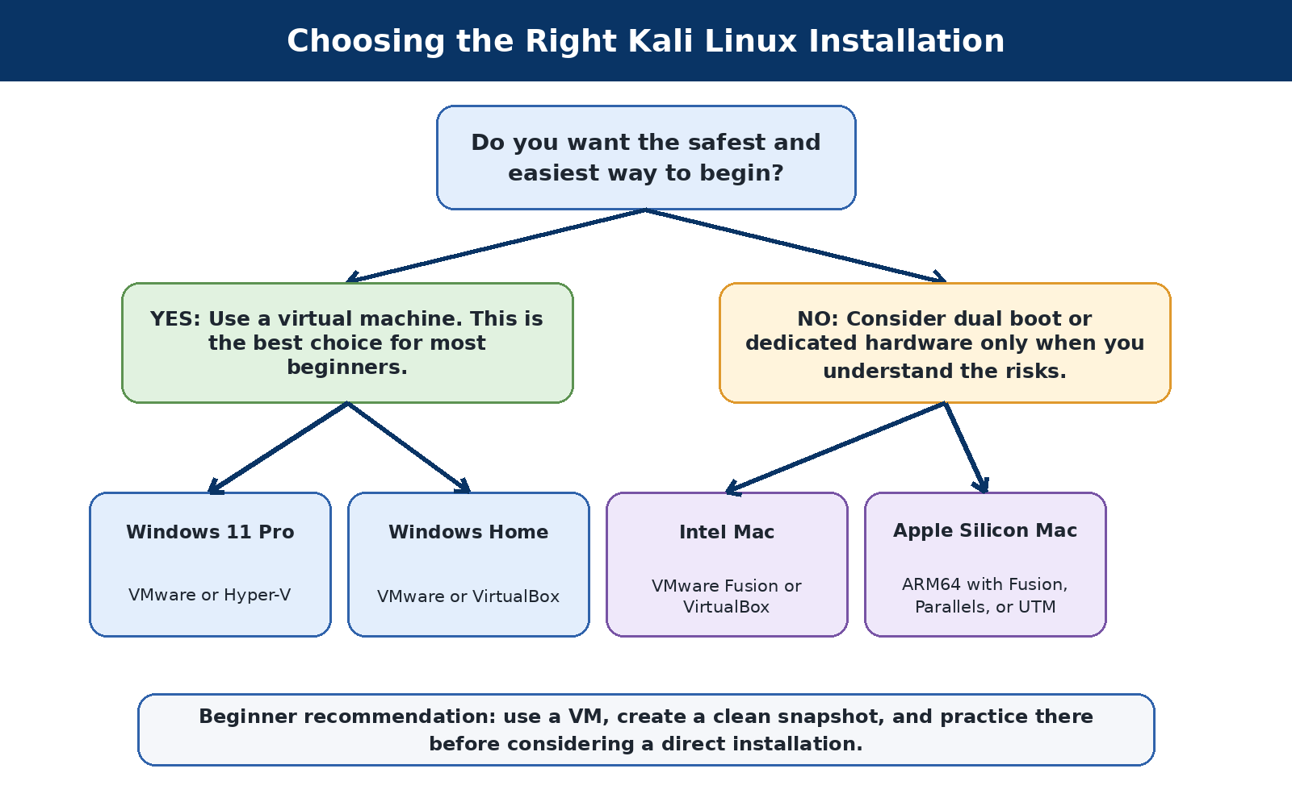
Figure 1. A beginner-friendly guide to choosing a Kali installation method.
Use | Reasonable starting point | Comfortable recommendation
Basic Kali VM | 2 CPU cores, 4 GB RAM, 60 GB disk | 4 CPU cores, 8 GB RAM, 80-100 GB disk
Kali plus local AI | 4 CPU cores, 8-12 GB RAM, 100 GB disk | 6-8 CPU cores, 16 GB RAM, 150 GB disk
Forensics practice | 4 CPU cores, 8 GB RAM, 120 GB disk | 6 CPU cores, 16 GB RAM, separate evidence storage
Low-resource path
A learner with limited hardware can use a smaller Kali VM for basic tools and use Hack The Box Pwnbox for browser-based lab access. Local large language models may be impractical on older machines; cloud AI tools can be used with privacy precautions.

3.3 VMware on Windows - recommended for many beginners
VMware provides strong desktop integration, snapshots, and straightforward USB-device handling. Download the official prebuilt Kali VMware image when possible.
Confirm that virtualization is enabled in the computer firmware. Install VMware Workstation, download the official Kali VMware archive, verify the download, extract it, open the virtual machine, and change the default password.
Begin with NAT networking. NAT allows Kali to reach the Internet through the host while reducing accidental exposure to the local network. Use bridged mode only when the lab requires it and you understand the effect.

3.4 Practical checklist
• Create a snapshot named Clean Install before adding tools.
• Do not store VPN files or secrets in a public shared folder.
• Use host-only networking for isolated multi-VM labs.
Beginner recommendation
Use a virtual machine, create a clean snapshot, and practice there before considering a direct installation.

3.5 Hyper-V on Windows 11 Pro
Kali now provides an official prebuilt Hyper-V image. Extract the official archive and run its installation script with administrative approval, or create a Generation 2 VM from the installer ISO.
Hyper-V Enhanced Session Mode can provide clipboard and file-sharing features. USB passthrough is less direct than in some desktop hypervisors, which matters for wireless adapters and certain forensic devices.

3.6 Practical checklist
- Use the official prebuilt Hyper-V image for the simplest setup.
- Keep the virtual disk in a location with enough free space.
- Create a checkpoint after the first update.
Beginner recommendation
Use a virtual machine, create a clean snapshot, and practice there before considering a direct installation.

3.7 VirtualBox
VirtualBox is widely available and works well for isolated practice labs. Kali provides both installation guidance and prebuilt VirtualBox images.
Import the official appliance or create a VM from the installer. Install guest additions if needed, and use snapshots before major tool or configuration changes.

3.8 Practical checklist
For safer lab work, disable the shared clipboard and shared folders when handling untrusted samples. Use NAT for normal learning and host-only networking for isolated local labs.
Beginner recommendation
Use a virtual machine, create a clean snapshot, and practice there before considering a direct installation.

3.9 Separate partition and dual boot
Dual boot provides direct hardware access and better performance, but it is riskier for beginners because partitioning and bootloader mistakes can make the existing operating system unavailable.
Back up important files, save the BitLocker recovery key, disable Fast Startup, shrink the Windows partition from Windows Disk Management, and leave the new space unallocated. Boot the official Kali installer in the same UEFI mode as Windows.
Never select an entire-disk option if you intend to keep the existing operating system. Read every partitioning screen slowly.

3.10 Practical checklist
- Use a VM first unless direct hardware access is genuinely required.
- Keep recovery media available.
- Do not repartition a computer containing irreplaceable data without a tested backup.
Beginner recommendation
Use a virtual machine, create a clean snapshot, and practice there before considering a direct installation.

3.11 Mac computers
There is no separate “Mac edition” of Kali. Intel Macs use AMD64 images, while Apple Silicon Macs require ARM64 images.
On Apple Silicon, VMware Fusion, Parallels, and UTM are common choices. Many tools work normally, but some x86-only packages, drivers, and hardware workflows may differ.
Direct installation on Mac hardware can be model-specific. A VM is the safer beginning for most learners.

3.12 Practical checklist
- Verify whether the Mac is Intel or Apple Silicon before downloading.
- Use an ARM64 Kali image on M-series Macs.
- Expect external Wi-Fi adapters to require compatible hardware and VM USB access.
Beginner recommendation
Use a virtual machine, create a clean snapshot, and practice there before considering a direct installation.

3.13 First boot, updates, and safe defaults
- Change any default or temporary password.
- Confirm the date, time zone, keyboard layout, and network connection.
- Update package information and apply normal upgrades.
- Restart when the kernel or core system components are updated.
- Create a clean snapshot after the system is stable.
- Create a dedicated folder for each lab and keep notes separate from tool output.
sudo apt update
sudo apt full-upgrade -y
sudo reboot
Why full-upgrade?
Kali is a rolling distribution. The official documentation commonly recommends full-upgrade so package relationships can be handled correctly. Review proposed removals before accepting unexpected changes.

3.14 Essential Linux commands
Command | Purpose
pwd | Show the current directory.
ls -la | List files, including hidden files.
cd folder | Move into a folder.
mkdir lab-name | Create a directory.
cp / mv | Copy or move files.
cat / less | Read text output.
grep | Search text.
ip addr | View network interfaces and addresses.
ss -tulpn | View listening network sockets.
man tool | Open a manual page.
tool --help | Show command help.

3.15 Detailed Installation Walkthroughs
This section explains each installation choice slowly and in plain language. A virtual machine is the safest starting point for most new learners because it keeps Kali separate from the main operating system and makes it easy to undo mistakes with a snapshot.

3.16 Before you download anything
- Use only the official Kali Linux website and the official virtualization vendor website.
- Check whether your computer uses an Intel/AMD processor or an Apple Silicon processor. Apple Silicon Macs use ARM64 images.
- Make sure important files are backed up before changing partitions, firmware settings, or virtualization features.
- For a normal Kali security lab, plan for at least 8 GB of host memory, although 16 GB is much more comfortable.
- Keep at least 80 GB of free storage for a virtual machine. Local AI models may require much more space.
Official Kali downloads
How to verify an official Kali image

3.17 Choose the correct Kali image
Open the official Kali download page before choosing an image.
- For VMware, VirtualBox, or Hyper-V on an Intel or AMD Windows computer, choose the 64-bit AMD64 image.
- For an Apple Silicon Mac, such as an M1, M2, M3, or newer model, choose the ARM64 installer image.
- For VMware and VirtualBox, the official prebuilt virtual-machine image is usually easiest because Kali has already been installed.
- For Hyper-V, a separate partition, or a dedicated computer, use the official Installer image unless Kali provides a current prebuilt image that matches your exact platform.
- Record where the downloaded file is saved. Most browsers place it in the Downloads folder.

3.18 VMware Workstation on Windows - easiest choice for many beginners
Use this method when you want strong desktop integration, snapshots, and straightforward USB device support. The names of buttons can vary slightly by VMware version.
Download VMware Workstation
Download the official Kali VMware image
Kali guide for importing the prebuilt VMware image
- Check that hardware virtualization is enabled. In Windows, open Task Manager, choose Performance, and select CPU. Look for “Virtualization: Enabled.”
- Install VMware Workstation from the official VMware website. Restart Windows if the installer asks you to do so.
- Download the official Kali VMware AMD64 archive. Do not download a file from an unknown mirror or video description.
- Use 7-Zip to extract the downloaded .7z archive. On Windows 11, right-click the file and choose Show more options if the 7-Zip menu is hidden.
- Open VMware Workstation. Choose Open a Virtual Machine, then select the .vmx file inside the extracted Kali folder.
- Before starting Kali, open the virtual-machine settings. A good beginner configuration is 4 processor cores, 8 GB of memory, and the disk size supplied by the image.
- Keep the network adapter set to NAT for the first lessons. NAT allows Kali to reach the Internet through the host while reducing direct exposure to the local network.
- Start the virtual machine. The official prebuilt image may initially use kali as both the username and password. Change the password immediately.
- Run system updates, shut down Kali cleanly, and create a snapshot named Clean Install. This gives you a safe recovery point.
- Do not enable shared folders or drag-and-drop until you understand the privacy risk. Shared features can expose host files to the guest system.

3.19 Hyper-V on Windows 11 Pro, Enterprise, or Education
Use Hyper-V when it is already part of your Windows environment. Windows Home normally does not include the full Hyper-V feature. Hyper-V can also affect how some other virtualization products work, so use one main platform at a time when possible.
Microsoft Hyper-V requirements and setup
Official Kali Hyper-V installation guide
Official Kali prebuilt Hyper-V import guide
Kali Enhanced Session Mode guide
- Open Windows Search and type Turn Windows features on or off.
- Select Hyper-V, including Hyper-V Management Tools and Hyper-V Platform. Choose OK and restart the computer.
- Open Hyper-V Manager from the Start menu.
- Choose New, then Virtual Machine. Give the VM a clear name such as Kali-Lab.
- Choose Generation 2 unless the current Kali documentation specifically directs you to another choice.
- Assign startup memory. Eight GB is a comfortable beginner value when the host has at least 16 GB. Dynamic Memory can be enabled if the host needs flexibility.
- Connect the VM to the Default Switch for a simple NAT-style Internet connection.
- Create a virtual hard disk of at least 80 GB. Choose a larger disk if you plan to install local AI models.
- Attach the official Kali Installer ISO, or follow Kali’s current prebuilt Hyper-V import guide.
- If the VM will not boot, review the Secure Boot setting. Kali documentation may instruct you to disable Secure Boot for that VM or select a compatible certificate template.
- Complete the graphical Kali installer. Use the guided option that uses the entire virtual disk. This virtual disk is only a file; it is not the physical Windows drive.
- After the first successful update, create a Hyper-V checkpoint named Clean Install.
- For improved resizing and clipboard behavior, follow the official Enhanced Session Mode guide and use kali-tweaks inside Kali.

3.20 Oracle VirtualBox on Windows, Linux, or Intel Mac
VirtualBox is free and widely used. It is a good option when VMware or Hyper-V is unavailable, although USB and graphics behavior may require more setup.
Download Oracle VirtualBox
Download the official Kali VirtualBox image
Kali guide for importing the prebuilt VirtualBox image
Kali VirtualBox guest installation guide
- Download and install VirtualBox from Oracle’s official website.
- Download the official Kali VirtualBox archive and extract it with 7-Zip or another trusted archive tool.
- Open VirtualBox and choose Add. Browse to the extracted Kali folder and select the .vbox file.
- Open Settings for the VM. Assign about 4 processor cores and 8 GB of memory when the host has enough resources.
- Use NAT networking for the first lessons.
- Start Kali and sign in. Change the default password if the image uses one.
- Update Kali, shut it down, and create a snapshot named Clean Install.
- If the screen does not resize correctly, confirm that the VirtualBox guest packages are installed. Kali normally installs them automatically in supported VM setups.
- Install the Oracle Extension Pack only when you need its features and only when its version exactly matches the installed VirtualBox version.

3.21 Kali on Apple Silicon Mac - M1, M2, M3, and newer
Apple Silicon Macs use ARM64 processors. An AMD64 Kali image is not the correct choice for normal virtualization on these Macs.
Kali ARM64 installer downloads
VMware Fusion for Mac
Kali VMware Fusion guide for Apple Silicon
Parallels Desktop
Kali in Parallels guide
UTM for Mac
Kali in UTM guide
- Open the Apple menu, choose About This Mac, and confirm that the computer lists an Apple M-series chip.
- Choose one virtualization product: VMware Fusion, Parallels Desktop, or UTM. Install it from the official vendor website.
- Download the Kali ARM64 Installer ISO. Do not choose AMD64 for an Apple Silicon VM.
- Create a new virtual machine and select Linux or Other Linux ARM64 when prompted for the operating system type.
- Assign at least 4 processor cores, 8 GB of memory, and 80 GB of storage when the Mac has enough capacity.
- Attach the ARM64 ISO and start the VM.
- Use the graphical installer and install Kali onto the virtual disk created for the VM.
- After the first update, install the guest integration tools recommended by the chosen virtualization product.
- Create a snapshot before adding security tools or changing important settings.
- Remember that a few security tools or drivers may behave differently on ARM64. Check the official tool documentation when a package is unavailable.

3.22 Intel-based Mac
Intel Macs normally use the AMD64 Kali image. VMware Fusion, VirtualBox, or Parallels may be used depending on current vendor support for the macOS version.
Kali virtualization documentation
- Confirm that About This Mac identifies an Intel processor.
- Install a supported virtualization program from its official website.
- Download the official Kali AMD64 image or installer ISO.
- Create or import the VM, then assign reasonable memory, processor, and disk resources.
- Use NAT networking first, update Kali, and create a clean snapshot.

3.23 Separate partition or dual boot with Windows
This method gives Kali direct hardware access, but it carries more risk than a VM. A partitioning mistake can make Windows or personal files unavailable. New learners should normally practice in a VM first.
Official Kali dual-boot guide
Official Kali hard-disk installation guide
- Back up all important files to a separate drive or trusted cloud service.
- Save the Windows BitLocker recovery key. Do not continue until you know where that key is stored.
- Create a Windows recovery drive and confirm that Windows starts normally.
- Disable Windows Fast Startup. Fast Startup can leave Windows partitions in a state that Linux should not modify.
- Open Windows Disk Management and shrink the Windows partition. Leave the new space unallocated; do not format it in Windows.
- Download the official Kali Installer ISO and verify its checksum.
- Create a bootable USB drive using a trusted imaging program. Be certain you select the USB drive, not the computer’s main disk.
- Restart the computer and open the UEFI boot menu. Choose the USB device in UEFI mode.
- Start the graphical installer. When partitioning appears, choose the option that uses the largest continuous free space, or manually select only the unallocated space.
- Never choose Use entire disk when Windows and personal files must remain on the computer.
- Allow the installer to configure the GRUB boot menu. After installation, test both Kali and Windows.
- If Windows requests the BitLocker recovery key after the boot configuration changes, enter the saved key.
- Update Kali and keep the recovery USB available. Do not remove the Windows backup after only one successful boot.

3.24 Dedicated computer installation
A dedicated computer is a strong long-term choice for wireless adapters, USB devices, GPU work, and full hardware access. The computer should contain no important data before installation.
- Back up anything that must be kept. The installation can erase the entire drive.
- Download and verify the official Kali Installer ISO.
- Create the bootable USB and start the computer from it.
- Choose Graphical install.
- Select the language, location, keyboard, user account, and time-zone information.
- When partitioning appears, use Guided - use entire disk only when the computer is truly dedicated to Kali and contains no needed operating system or files.
- Use encrypted LVM when the computer may store sensitive notes or evidence and you can safely manage the encryption passphrase.
- Complete the installation, remove the USB when prompted, and restart.
Update Kali before installing additional tools.

3.25 First boot checklist for every installation
- Open a terminal.
- Run sudo apt update to refresh the package lists.
- Run sudo apt full-upgrade -y to install current updates. Read prompts before accepting unusual changes.
- Restart Kali after a major kernel or system update.
- Confirm the date, time, keyboard, network, and screen resolution.
- Create a snapshot or checkpoint if Kali is running as a VM.
- Create a folder for labs and notes. Keep client or personal data out of beginner exercises.
- Use NAT networking until a lesson explains why another network mode is needed.
- Never connect a security tool to a real target merely to see what happens.

3.26 Virtualization links at a glance
Platform or resource | Official link
Kali downloads | Official resource - kali.org
VMware Workstation/Fusion | Official resource - vmware.com
Oracle VirtualBox | Official resource - virtualbox.org
Microsoft Hyper-V | Official resource - learn.microsoft.com
Parallels Desktop | Official resource - parallels.com
UTM for Mac | Official resource - mac.getutm.app
Kali virtualization guides | Official resource - kali.org

4. Building a Safe Practice Lab
Building a Safe Practice Lab
A safe lab gives you permission to make mistakes. It separates practice targets from real systems and makes recovery possible. The simplest lab is one Kali VM plus an assigned Hack The Box target. A local lab may add intentionally vulnerable virtual machines or containers on an isolated host-only network.
Never use a public target as a substitute
A tutorial showing TARGET_IP does not authorize you to replace it with a school, employer, public website, neighbor, or random Internet address.

4.1 Hack The Box as the primary practice area
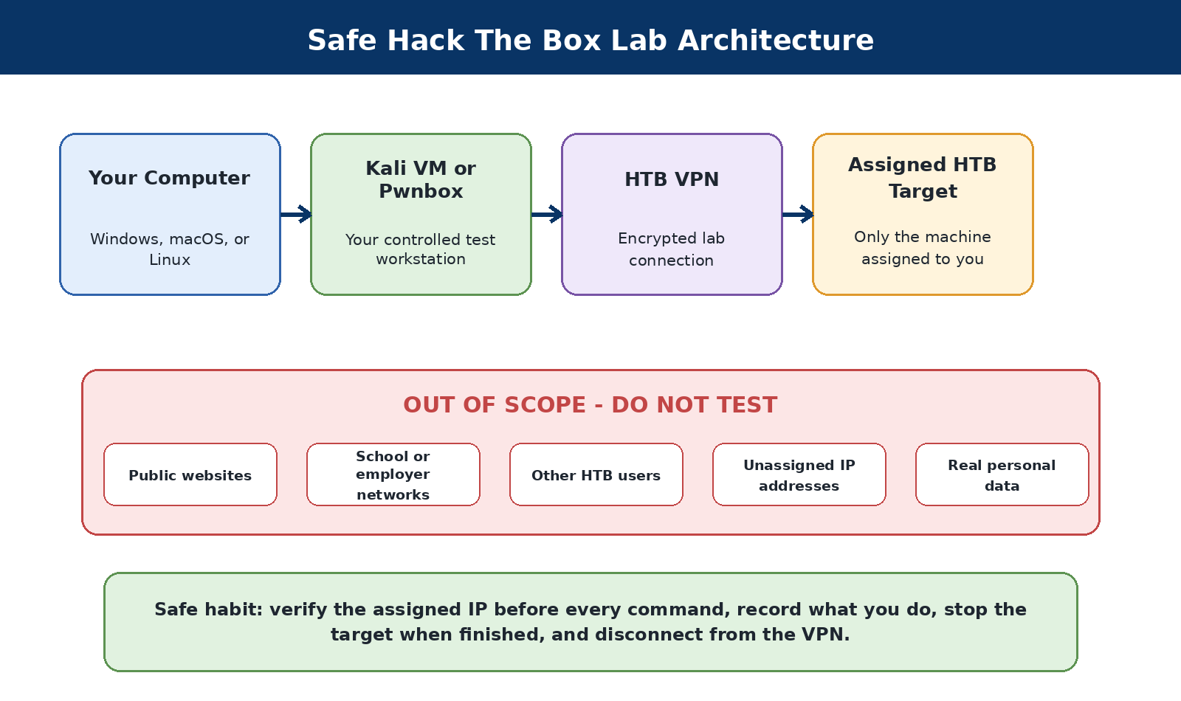
Figure 2. The safe path from the learner’s computer to an assigned Hack The Box target.
Hack The Box Starting Point is designed for absolute beginners and provides guided machines with explanations. Learners can connect through OpenVPN from Kali or use Pwnbox, a browser-based environment. Follow the current platform rules and never publish restricted active-machine solutions, flags, credentials, or spoilers.
Hack The Box Starting Point
HTB Getting Started
HTB Academy
HTB Platform Rules
Introduction to Pwnbox

4.2 Safe HTB workflow
Follow this sequence for each authorized Hack The Box lab session:
- Sign in and choose a Starting Point machine or another lab you are permitted to use.
- Start or spawn the target and record the assigned IP address.
- Download your VPN configuration or launch Pwnbox.
- Create a local evidence folder named for the lab.
- Connect to the VPN and confirm the connection.
- Verify the target IP again before every command.
- Begin with low-impact discovery.
- Record findings and reasons for each next step.
- Stop the target and disconnect when finished.
mkdir -p ~/labs/starting-point/example/{notes,scans,evidence}
cd ~/labs/starting-point/example
sudo openvpn /path/to/your-lab.ovpn
Protect the VPN file
Your .ovpn file may contain account-specific access information. Do not upload it to GitHub, paste it into public AI tools, or share it with another person.

5. AI Tools for Cybersecurity Learning
AI Tools for Cybersecurity Learning
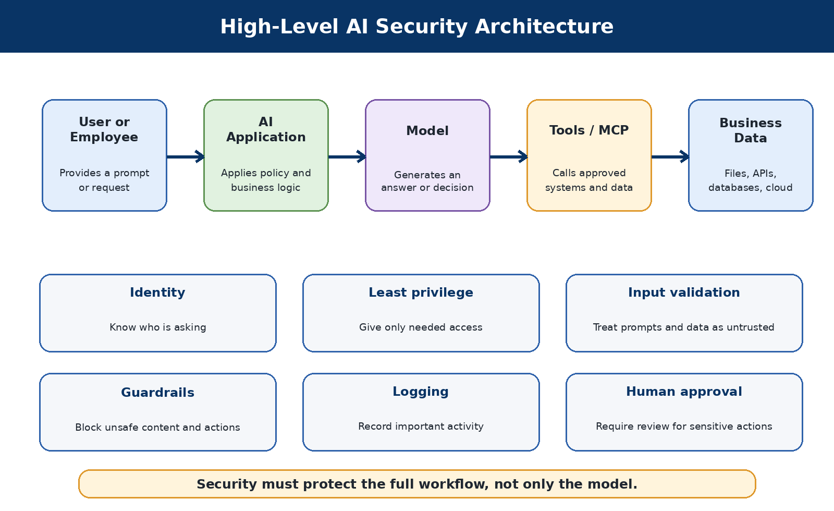
Figure 3. Security controls must protect the complete AI workflow.
AI can help a beginner interpret output, organize notes, generate study questions, and compare documentation. It can also be wrong, overconfident, unsafe, or unaware of your authorization. Treat it as a study assistant, not as an authority or permission system.
AI safety rule
Never paste real credentials, VPN files, tokens, client data, malware from an unknown source, private forensic evidence, or confidential scan results into a public AI service.

5.1 Ollama
LOCAL MODEL RUNNER
What it is and why it matters
Runs supported language models on the learner’s own computer. Useful when privacy or offline access matters and the computer has enough memory.
When to use it
• Explaining sanitized command output locally.
• Creating study questions from your own notes.
• Drafting a remediation summary without uploading data.
When not to use it
Do not assume local means perfectly secure. Large models may overwhelm an older computer.
Authorization checkpoint
Use this tool only on a system you own, a lab specifically assigned to you, or a system covered by clear written authorization. Publicly reachable does not mean publicly testable.
Check that it is available
ollama --version
ollama list
First safe exercise
Install from the official Ollama source, start the service, download a small model, and ask it to explain a harmless command such as `ip addr`.
What to look for
Does the answer distinguish an IP address, interface, and loopback device? Can you confirm its explanation with `man ip` or official documentation?
Common beginner mistakes
Downloading a model that is too large. Treating a plausible answer as verified fact.
Risk level
Low operational risk when used with non-sensitive data. Resource use can be high.

Using AI responsibly with this tool
Ask AI to explain the result, then verify the explanation with the tool’s help output, manual page, or official documentation. Remove IP addresses, usernames, secrets, and unique client details before sharing output externally.
Official resources
Ollama

5.2 Open WebUI
BROWSER INTERFACE FOR LOCAL OR CONNECTED AI MODELS
What it is and why it matters
Provides a familiar chat interface and can connect to Ollama and other supported back ends. Useful for learners who prefer a browser interface and want organized conversations.
When to use it
Keeping separate study chats for networking, web security, and forensics. Using a local model through a graphical interface.
When not to use it
Do not expose Open WebUI to the Internet without strong security. Do not upload secrets or evidence without understanding storage.
Authorization checkpoint
Use this tool only on a system you own, a lab specifically assigned to you, or a system covered by clear written authorization. Publicly reachable does not mean publicly testable.
Check that it is available
docker --version
docker ps
First safe exercise
Run Open WebUI in a local Docker container, connect it to Ollama, and create a study conversation that contains only fictional data.
What to look for
- Can the interface reach the selected model?
- Where are conversations stored?
- Can another user on the host access them?
Common beginner mistakes
Publishing the service on all interfaces. Using an untrusted container command without review.
Risk level
Medium configuration risk. A poorly exposed service can create privacy and access-control problems.

Using AI responsibly with this tool
Ask AI to explain the result, then verify the explanation with the tool’s help output, manual page, or official documentation. Remove IP addresses, usernames, secrets, and unique client details before sharing output externally.
Official resources
Open WebUI documentation

5.3 Promptfoo
LLM EVALUATION AND RED-TEAM FRAMEWORK
What it is and why it matters
Runs repeatable tests against prompts, models, and AI applications. Useful when testing whether an AI system handles unsafe or adversarial prompts consistently.
When to use it
- Comparing model responses to the same test set.
- Testing prompt-injection defenses in your own application.
- Documenting pass/fail criteria.
When not to use it
Do not target an AI service you are not authorized to test. Do not send confidential prompts to external providers.
Authorization checkpoint
Use this tool only on a system you own, a lab specifically assigned to you, or a system covered by clear written authorization. Publicly reachable does not mean publicly testable.
Check that it is available
promptfoo --version
promptfoo init
First safe exercise
Create a small local evaluation with harmless prompts: one normal question, one instruction-conflict test, and one request for a secret that does not exist.
What to look for
- Did the model follow the intended system instruction?
- Are the test criteria measurable?
- Can another learner reproduce the result?
Common beginner mistakes
Confusing a demonstration with a complete security assessment. Using vague assertions that always pass.
Risk level
Medium risk. Tests can send large numbers of requests or sensitive text to providers.

Using AI responsibly with this tool
Ask AI to explain the result, then verify the explanation with the tool’s help output, manual page, or official documentation. Remove IP addresses, usernames, secrets, and unique client details before sharing output externally.
Official resources
Promptfoo documentation

5.4 Giskard
AI TESTING AND EVALUATION TOOLKIT
What it is and why it matters
Helps evaluate machine-learning and generative-AI systems for quality and security issues. Useful when a project needs structured tests, reports, and repeatable checks.
When to use it
Testing a model or agent you own. Building quality and security checks into the development process.
When not to use it
Do not install packages globally when a virtual environment is more appropriate. Do not assume every scanner result is a confirmed vulnerability.
Authorization checkpoint
Use this tool only on a system you own, a lab specifically assigned to you, or a system covered by clear written authorization. Publicly reachable does not mean publicly testable.
Check that it is available
python3 -m venv .venv
source .venv/bin/activate
python -m pip show giskard
First safe exercise
Create a virtual environment, install only the needed package set, and run a documented example against non-sensitive sample data.
What to look for
• Which test failed?
• What evidence supports the failure?
• Can it be reproduced manually?
Common beginner mistakes
Mixing incompatible Python environments. Publishing test data containing private information.
Risk level
Medium risk, mainly related to dependencies, data handling, and external model calls.

Using AI responsibly with this tool
Ask AI to explain the result, then verify the explanation with the tool’s help output, manual page, or official documentation. Remove IP addresses, usernames, secrets, and unique client details before sharing output externally.
Official resources
Giskard documentation

5.5 LangChain
FRAMEWORK FOR MODEL-POWERED APPLICATIONS
What it is and why it matters
Provides components for prompts, tools, retrieval, memory, and agents. Useful for building a controlled learning project that connects a model to documents or functions.
When to use it
Creating a small RAG demonstration from public notes. Learning how agents select tools.
When not to use it
Do not give an experimental agent unrestricted shell access. Do not use it as a security boundary.
Authorization checkpoint
Use this tool only on a system you own, a lab specifically assigned to you, or a system covered by clear written authorization. Publicly reachable does not mean publicly testable.
Check that it is available
python -m pip show langchain
First safe exercise
Build a minimal application that answers questions from a short public text file. Keep tools disabled during the first exercise.
What to look for
• Does the answer cite the supplied text?
• What happens when the answer is absent?
• Can the model invent a source?
Common beginner mistakes
Starting with a complex autonomous agent. Ignoring dependency and version changes.
Risk level
Medium to high risk when agents can invoke tools or access sensitive data.

Using AI responsibly with this tool
Ask AI to explain the result, then verify the explanation with the tool’s help output, manual page, or official documentation. Remove IP addresses, usernames, secrets, and unique client details before sharing output externally.
Official resources
LangChain documentation

5.6 LlamaIndex
DATA AND RETRIEVAL FRAMEWORK
What it is and why it matters
Helps connect language models to documents, indexes, and retrieval workflows. Useful for learning RAG and the security implications of untrusted knowledge sources.
When to use it
Indexing public course notes. Testing whether retrieved passages support an answer.
When not to use it
Do not ingest private evidence into an external model path. Do not trust retrieved text as instructions.
Authorization checkpoint
Use this tool only on a system you own, a lab specifically assigned to you, or a system covered by clear written authorization. Publicly reachable does not mean publicly testable.
Check that it is available
python -m pip show llama-index
First safe exercise
Index a small set of public text files and ask questions with answers that quote or cite the retrieved passages.
What to look for
- Was the correct passage retrieved?
- Did an embedded instruction change model behavior?
- How is source access controlled?
Common beginner mistakes
Confusing retrieval relevance with truth. Failing to separate data from instructions.
Risk level
Medium risk. RAG can leak indexed data or carry prompt injection from documents.

Using AI responsibly with this tool
Ask AI to explain the result, then verify the explanation with the tool’s help output, manual page, or official documentation. Remove IP addresses, usernames, secrets, and unique client details before sharing output externally.
Official resources
LlamaIndex documentation

5.7 Aider
TERMINAL-BASED AI PAIR PROGRAMMER
What it is and why it matters
Helps edit code in a Git repository using supported AI models. Useful for understanding code changes, creating tests, and learning secure review habits.
When to use it
- Improving a small lab script.
- Adding error handling and comments.
- Reviewing a proposed patch before accepting it.
When not to use it
Do not run it in a repository containing secrets. Do not accept changes without reading the diff.
Authorization checkpoint
Use this tool only on a system you own, a lab specifically assigned to you, or a system covered by clear written authorization. Publicly reachable does not mean publicly testable.
Check that it is available
aider --version
git status
First safe exercise
Create a disposable Git repository containing a harmless Python script, ask Aider to add input validation, and review the diff.
What to look for
- What files changed?
- Did the change add dependencies?
- Do tests still pass?
Common beginner mistakes
Letting the tool edit the wrong repository. Committing generated secrets or unsafe code.
Risk level
Medium risk. It can modify many files and may send code to a model provider.

Using AI responsibly with this tool
Ask AI to explain the result, then verify the explanation with the tool’s help output, manual page, or official documentation. Remove IP addresses, usernames, secrets, and unique client details before sharing output externally.
Official resources
Aider documentation

5.8 Open Interpreter
NATURAL-LANGUAGE INTERFACE THAT CAN EXECUTE LOCAL CODE
What it is and why it matters
Allows a model-assisted session to run code and interact with the local computer. Useful only in a disposable, well-scoped environment when the learner understands that generated commands may execute.
When to use it
Performing harmless data transformation in a lab folder. Learning to review proposed commands before execution.
When not to use it
Do not use it on a primary computer with valuable files. Do not grant broad access to credentials, browser profiles, or private evidence.
Authorization checkpoint
Use this tool only on a system you own, a lab specifically assigned to you, or a system covered by clear written authorization. Publicly reachable does not mean publicly testable.
Check that it is available
interpreter --version
First safe exercise
Use a disposable VM snapshot and a folder containing fictional CSV data. Ask for a summary and approve only commands you understand.
What to look for
- Which command will run?
- Which files can it access?
- Can the task be done without elevated privileges?
Common beginner mistakes
- Approving commands automatically.
- Running as root.
- Assuming a natural-language request cannot delete files.
Risk level
High risk compared with a normal chatbot because it may execute code and change files.

Using AI responsibly with this tool
Ask AI to explain the result, then verify the explanation with the tool’s help output, manual page, or official documentation. Remove IP addresses, usernames, secrets, and unique client details before sharing output externally.
Official resources
Open Interpreter documentation

6. MCP, RAG, and AI Agents

6.1 RAG in plain language
Retrieval-augmented generation, commonly called RAG, allows an application to search approved documents and include relevant passages in a model prompt. The model then uses those passages while creating an answer. RAG can improve accuracy, but it can also expose documents to the wrong user if permissions are poorly designed.

6.2 Vector databases in plain language
A vector database stores numerical representations of text so an application can find content with a similar meaning. Examples include Chroma, FAISS, and Qdrant. The security question is not only whether the database is encrypted. The application must also check whether the current user is allowed to retrieve each source document.

6.3 Agents and tool use
An AI agent can choose actions, call APIs, search files, or run tools. This makes the system useful, but it also increases risk. An agent should have the minimum necessary permissions, require approval for high-impact actions, and maintain reliable logs.

6.4 Model Context Protocol (MCP): a core AI security principle
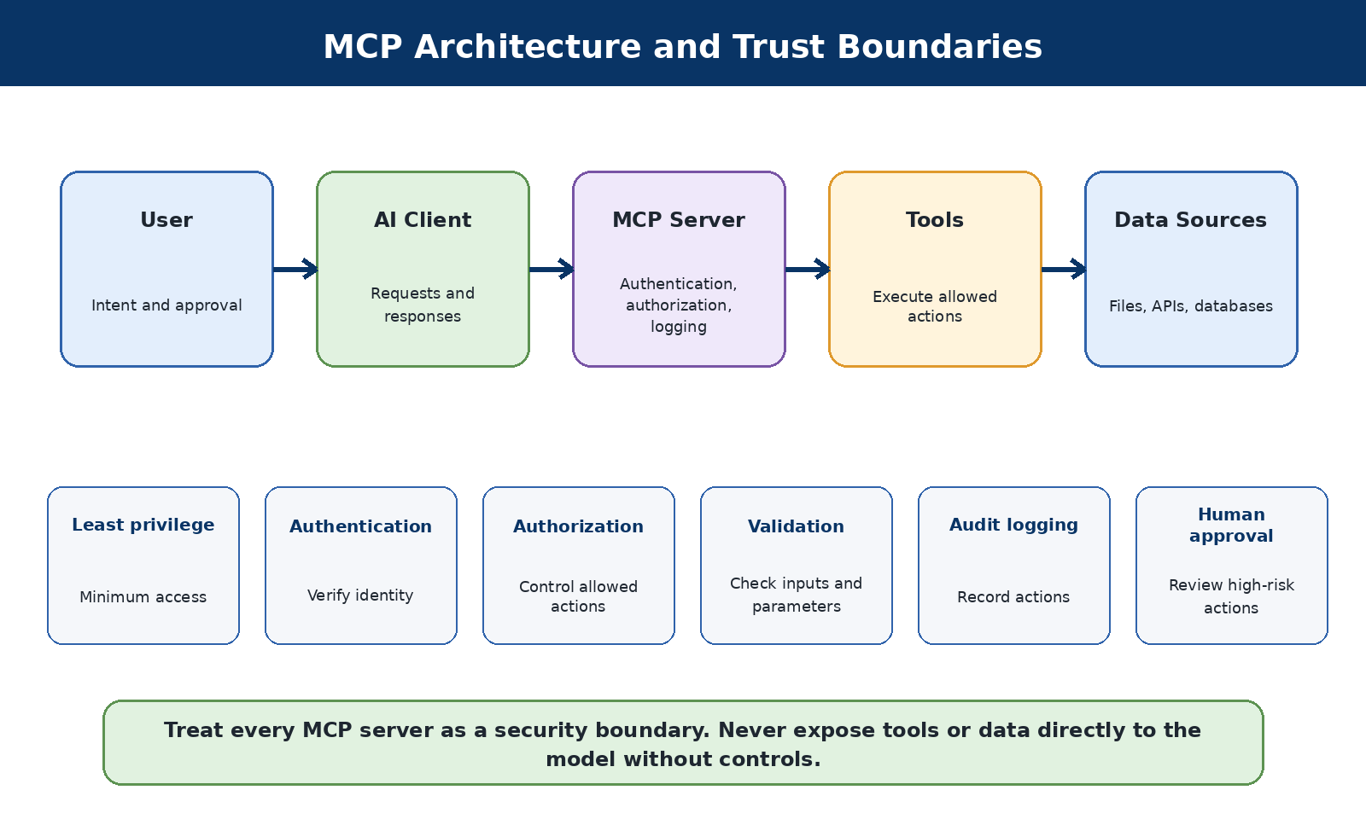
Figure 4. MCP components and the controls required at each trust boundary.
Model Context Protocol, or MCP, is a way for AI applications to connect to tools and data sources through a consistent interface. Treat every MCP server as a software integration requiring authentication, authorization, logging, input validation, and careful review of the data and actions it exposes.

6.5 Why MCP matters to employers
Modern AI systems increasingly need controlled access to tools, files, databases, cloud services, and business applications. MCP provides a common way for an AI application to discover and use those capabilities. Employers need people who understand not only how to connect an MCP server, but also how to decide which tools the AI should be allowed to use, what data it may access, and how every action will be recorded and reviewed.

6.6 The security principles behind MCP
Treat every MCP server as a security boundary. Give it the smallest set of permissions needed for its purpose. Authenticate users and services, validate all inputs, protect secrets, restrict file and network access, keep audit logs, and require human approval for actions that could change data, send messages, run code, or affect production systems. A useful MCP connection is not automatically a safe MCP connection.

6.7 A beginner MCP review checklist
- What business problem does this MCP server solve?
- Which tools and data sources can it reach?
- How are users, applications, and servers authenticated?
- Are permissions limited to the minimum required?
- Could untrusted prompts or documents trigger a dangerous tool call?
- Which actions require a person to approve them?
- Are tool calls, errors, and data access recorded in audit logs?
- How can the connection be disabled quickly during an incident?

6.8 AI agents: the basic idea
An AI agent is software that uses an AI model to work toward a goal. A chatbot usually answers a question. An agent may go further by choosing a next step, reading information, calling a tool, creating a ticket, sending a message, or changing a cloud resource. The model provides reasoning and language; the tools provide the ability to act.
The most important security idea is simple: an agent can make mistakes, misunderstand instructions, or follow malicious instructions hidden in a document, webpage, email, or tool response. For that reason, an agent must never be trusted simply because it sounds confident.

6.9 The risks every employer should understand
- Prompt injection: malicious text may try to change the agent's instructions.
- Excessive permissions: an agent may be able to read, change, or delete more than its job requires.
- Data leakage: sensitive information may be placed in prompts, logs, memory, tool calls, or model responses.
- Unsafe tool use: the agent may send email, run code, approve a transaction, or change a system incorrectly.
- Untrusted knowledge: documents or websites used by the agent may contain false information or hidden instructions.
- Weak monitoring: an organization may not know what the agent accessed, decided, or changed.
- Cost and availability: loops, repeated tool calls, or very large requests can create unexpected cost or service disruption.

6.10 Microsoft Azure and Microsoft Foundry: security basics
In Azure, an employer may build agents with Microsoft Foundry Agent Service and connect them to Azure data, applications, and tools. The basic protections are the same ones used for other enterprise systems: give the agent its own managed identity, apply least privilege with Azure role-based access control, store secrets in a protected service such as Azure Key Vault, restrict network access, and log activity.
Use content-safety controls and Prompt Shields where appropriate to help detect harmful content, jailbreak attempts, and prompt-injection attacks. Require human approval before an agent changes production data, sends external communications, runs code, or performs another high-impact action. Send relevant logs and alerts to the organization's monitoring and incident-response systems.

6.11 AWS and Amazon Bedrock: security basics
In AWS, agents may use Amazon Bedrock and connect to knowledge bases, Lambda functions, APIs, databases, and other services. Give each agent a narrowly scoped IAM role instead of broad administrator access. Use separate environments for development and production, protect data with encryption, and restrict network paths to the systems the agent actually needs.
Amazon Bedrock Guardrails can help filter unsafe content and detect prompt attacks, but guardrails are only one layer. Validate tool inputs and outputs, limit how many actions an agent can take, set time and spending limits, log prompts and tool calls according to privacy rules, and require approval for actions with financial, legal, security, or operational impact.

6.12 OpenAI API and ChatGPT-connected workflows: security basics
When an employer uses OpenAI models, the main risk is usually not the model alone. The greater risk appears when the model is connected to company files, email, browsers, databases, code, or external tools. Treat every connector and tool as a security boundary. Allow only the data and actions needed for the approved business purpose.
Keep system instructions and credentials out of user-visible content, validate tool arguments on the server, and do not let the model make final authorization decisions. Add confirmation before sensitive actions, protect against data exfiltration through links or tool calls, separate trusted instructions from untrusted content, and retain enough audit information to investigate what happened.

6.13 A minimum employer checklist for AI agents
- Maintain an inventory of every agent, owner, model, tool, data source, and business purpose.
- Assign a separate identity to the agent and use least privilege.
- Classify the data the agent may read, create, store, or transmit.
- Treat prompts, documents, webpages, emails, and tool responses as potentially untrusted input.
- Allow-list approved tools and validate every tool request outside the model.
- Require human approval for destructive, external, financial, legal, or production actions.
- Record prompts, tool calls, approvals, results, and errors while respecting privacy requirements.
- Test for prompt injection, data leakage, excessive agency, broken authorization, and unsafe output handling.
- Set rate limits, cost limits, timeouts, and emergency shutoff procedures.
- Review the agent after model, prompt, tool, permission, or data-source changes.
Beginner takeaway: secure the agent like a new employee who can work very quickly but still needs a clear job description, limited access, supervision, and a record of important actions.

6.14 Official starting references
Microsoft Foundry Agent Service
Azure AI security best practices
AWS Security for agentic AI
AWS Generative AI security and least privilege
OpenAI agent link safety
Career connection: MCP knowledge is becoming useful in AI security engineering, AI platform engineering, agent security, application security, cloud security, and AI governance roles. Beginners should learn the architecture and security questions first; production deployment comes later.

6.15 A simple AI security checklist
- Know what data enters the model.
- Know where prompts and outputs are stored.
- Separate trusted instructions from untrusted user content.
- Apply normal authentication and authorization outside the model.
- Limit tools and agent permissions.
- Test prompt injection and data-leakage scenarios.
- Keep human approval for important or irreversible actions.
- Monitor failures and create an incident-response process.

7. GRC and AI Governance
GRC means governance, risk, and compliance. It helps an organization decide who is responsible, what could go wrong, what controls are needed, and how the organization proves that it is meeting its obligations.
The diagram below shows GRC as a continuous cycle. Governance sets direction, risk management identifies and treats uncertainty, compliance and assurance confirm that controls work, and improvement feeds lessons back into the next cycle.
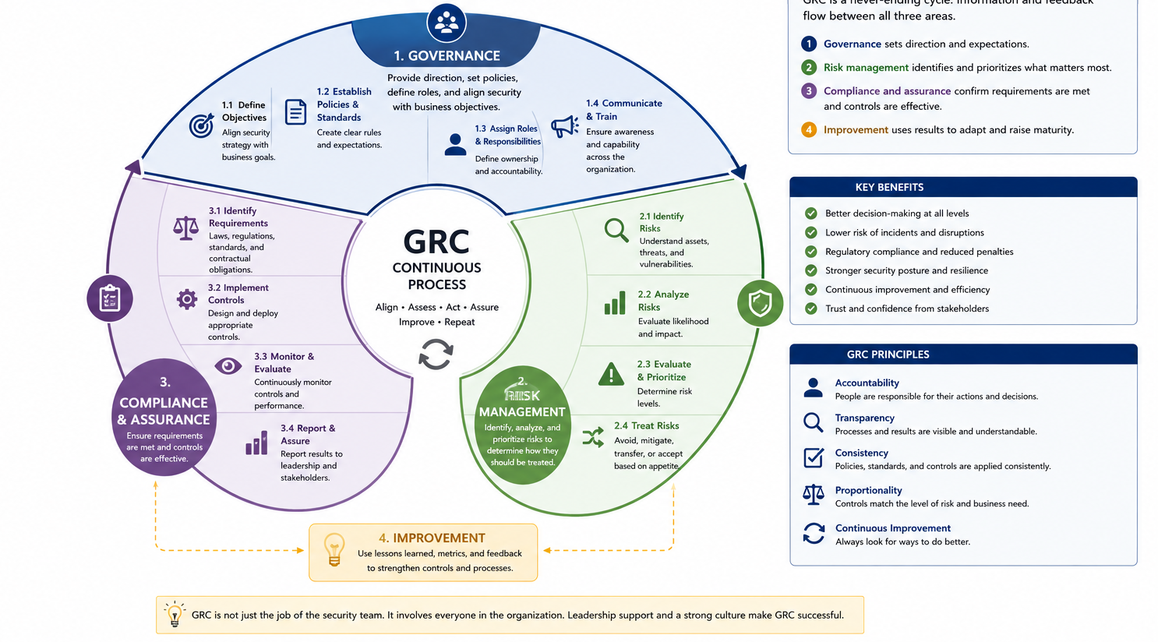
Figure 7.1 - GRC is a continuous process, not a one-time project.

7.1 Governance
Governance defines decision-making. It includes policies, roles, approvals, ownership, and oversight. In AI, governance may determine which tools are approved, what data may be used, and who can accept risk.

7.2 Risk
Risk considers what could happen, how likely it is, and how serious the result could be. A good risk statement connects a threat, a weakness, and a business impact.

7.3 Compliance
Compliance means meeting requirements from laws, regulations, contracts, standards, or internal policies. Passing an audit does not automatically mean a system is secure, but evidence and control testing can reveal whether expected safeguards are working.

7.4 Important beginner documents
- Policy - states what the organization requires.
- Standard - defines a mandatory technical or operational rule.
- Procedure - gives the steps for completing a task.
- Guideline - provides recommended practices.
- Risk register - records risks, owners, decisions, and treatment plans.
- Control evidence - shows that a control operated, such as a report, ticket, log, or approval.

7.5 AI governance questions
- Do we have an inventory of AI systems and vendors?
- What data is used for training, retrieval, prompts, and monitoring?
- Who approves a new AI use case?
- How is human oversight provided?
- How are bias, privacy, security, and intellectual-property risks evaluated?
- How are incidents reported and investigated?
- What evidence shows that controls are working?

7.6 Frameworks to recognize
- NIST Cybersecurity Framework
- NIST AI Risk Management Framework
- ISO/IEC 27001 for information-security management
- ISO/IEC 42001 for AI management systems
- SOC 2 trust services criteria
- OWASP guidance for generative AI and LLM applications
- MITRE ATLAS for adversarial threats to AI systems
Do not try to memorize every framework. Learn the purpose of each framework and how controls, evidence, ownership, and risk decisions fit together.

8. Essential Kali Security Tools

8.1 Choosing the right Kali tool
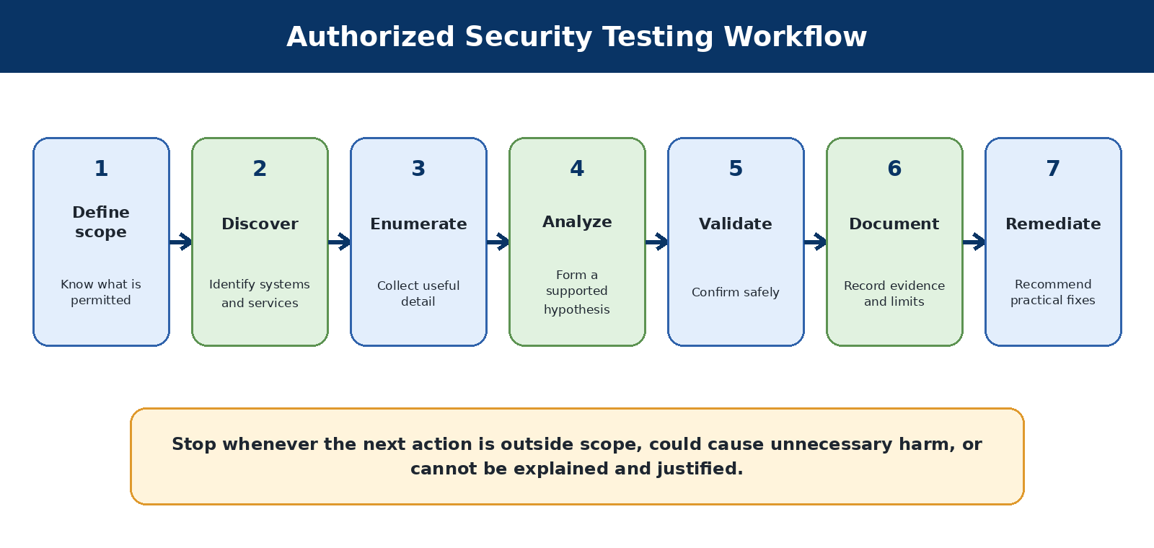
Figure 5. A safe and explainable security-testing workflow.
Kali includes many tools, but professionals do not run every tool against every target. They choose a tool because it answers a specific question. A simple workflow is: discover, enumerate, analyze, validate, document, and recommend remediation.
- Discover: What systems and services are present?
- Enumerate: What details can be learned from an authorized service?
- Analyze: What does the evidence suggest?
- Validate: Can the suspected weakness be confirmed safely?
- Document: What happened, what proves it, and what are the limitations?
- Remediate: What practical change would reduce the risk?
- Part V - Twenty Essential Kali Security Tools
- Part VI - Digital Forensics Fundamentals
- Part VII - Reporting What You Learn
- Your First 30 Days with Kali Linux

8.2 Twenty Essential Kali Security Tools
This list is a practical learning selection, not a claim that one ranking fits every professional. It covers discovery, traffic analysis, web testing, authentication, wireless work, Windows environments, exploit research, forensics, and open-source intelligence.

8.3 Nmap
NETWORK DISCOVERY AND SERVICE IDENTIFICATION
What it is and why it matters
Nmap discovers hosts, open ports, services, and selected system details. It gives a structured first view of an authorized target and helps you decide what to investigate next.
When to use it
Confirming which services an assigned lab machine exposes. Checking your own systems and lab network.
When not to use it
Do not scan networks you do not own or have permission to assess. Avoid aggressive options until you understand their traffic and impact.
Authorization checkpoint
Use this tool only on a system you own, a lab specifically assigned to you, or a system covered by clear written authorization. Publicly reachable does not mean publicly testable.
Check that it is available
nmap --version
First safe exercise
Against an assigned HTB target, begin with a small TCP scan and save the output: `nmap -sV -oN scans/initial.txt TARGET_IP`.
What to look for
• Open ports and service names.
• Service versions that may need manual confirmation.
• Filtered ports that may indicate a firewall.
Common beginner mistakes
• Scanning the wrong IP.
• Assuming a version string proves a vulnerability.
• Running every NSE script at once.
Risk level
Low to medium, depending on options. Scanning can trigger alerts and aggressive scripts may affect services.
Official resources
Nmap on Kali
Nmap reference guide

8.4 Wireshark
NETWORK TRAFFIC ANALYSIS
What it is and why it matters
Wireshark captures and analyzes packets and protocols. It lets learners see what systems actually exchange on a network.
When to use it
Troubleshooting your lab connection. Learning DNS, TCP, TLS, and HTTP behavior.
When not to use it
Do not capture traffic where you lack authorization. Do not collect other people’s credentials or private communications.
Authorization checkpoint
Use this tool only on a system you own, a lab specifically assigned to you, or a system covered by clear written authorization. Publicly reachable does not mean publicly testable.
Check that it is available
wireshark --version
First safe exercise
Capture only your own lab interface while you run `ping` and a DNS lookup. Stop quickly and apply display filters such as `icmp` and `dns`.
What to look for
• Source and destination addresses.
• Protocol fields and request/response relationships.
• Encrypted versus unencrypted content.
Common beginner mistakes
• Capturing on the wrong interface.
• Leaving a capture running too long.
• Sharing packet files containing secrets.
Risk level
Medium privacy risk. Packet captures can contain credentials, tokens, and personal data.
Official resources
Wireshark on Kali
Wireshark documentation

8.5 Burp Suite Community Edition
WEB APPLICATION TESTING PROXY
What it is and why it matters
Burp intercepts and examines browser requests and application responses. It teaches how web applications communicate and supports careful manual testing.
When to use it
Testing an assigned web lab. Understanding cookies, headers, forms, and API requests.
When not to use it
Do not intercept another person’s traffic. Do not use automated attacks against unapproved applications.
Authorization checkpoint
Use this tool only on a system you own, a lab specifically assigned to you, or a system covered by clear written authorization. Publicly reachable does not mean publicly testable.
Check that it is available
burpsuite --help
First safe exercise
Configure a lab browser to use Burp, visit an assigned training application, and inspect one harmless GET request in HTTP history.
What to look for
• Method, path, parameters, headers, and cookies.
• Response status and content type.
• Which fields are controlled by the user.
Common beginner mistakes
• Installing Burp’s CA certificate in a primary browser profile.
• Leaving the proxy enabled after the lab.
• Treating a scanner result as proven.
Risk level
Medium risk. Modified requests can change data or trigger application actions.
Official resources
Burp Suite on Kali
PortSwigger Web Security Academy

8.6 Metasploit Framework
VULNERABILITY RESEARCH AND VALIDATION FRAMEWORK
What it is and why it matters
Metasploit provides modules for research, validation, payloads, and controlled post-exploitation. It helps demonstrate the impact of known weaknesses in a lab.
When to use it
Validating a specific, confirmed lab vulnerability. Learning how exploit modules require options and target context.
When not to use it
Do not “try modules” on random services. Do not use persistence or destructive payloads outside an explicitly designed lab.
Authorization checkpoint
Use this tool only on a system you own, a lab specifically assigned to you, or a system covered by clear written authorization. Publicly reachable does not mean publicly testable.
Check that it is available
msfconsole --version
First safe exercise
Open `msfconsole`, use `search` to research a module mentioned by a retired or Starting Point lab, and read `info` before setting a target. Do not launch it until the lab explicitly calls for that action.
What to look for
- Required options.
- Supported targets.
- Module references and side effects.
Common beginner mistakes
- Selecting a module based only on a product name.
- Ignoring target architecture.
- Running as root without need.
Risk level
High risk. Exploitation can crash services, create sessions, or alter a target.
Official resources
Metasploit on Kali
Metasploit documentation

8.7 Gobuster
WEB CONTENT AND NAME DISCOVERY
What it is and why it matters
Gobuster uses wordlists to discover directories, files, DNS names, or virtual hosts. It finds content that may exist but is not linked from the visible website.
When to use it
Enumerating an assigned lab website. Comparing server responses to candidate paths.
When not to use it
Do not use large wordlists against unapproved or fragile systems. Do not interpret every response as sensitive content.
Authorization checkpoint
Use this tool only on a system you own, a lab specifically assigned to you, or a system covered by clear written authorization. Publicly reachable does not mean publicly testable.
Check that it is available
gobuster version
First safe exercise
Run a small directory enumeration against an assigned lab URL using a modest wordlist and a conservative thread count.
What to look for
- Status codes.
- Response sizes.
- Redirects and false-positive patterns.
Common beginner mistakes
  - Using the wrong mode.
  - Ignoring extensions.
  - Overloading the target with too many threads.
Risk level
Medium traffic risk. Wordlist enumeration can produce many requests.
Official resources
Gobuster on Kali

8.8 FFUF
FLEXIBLE WEB FUZZER
What it is and why it matters
FFUF places a FUZZ marker in a request and substitutes values from a wordlist. It supports directory, parameter, header, and virtual-host discovery with flexible filtering.
When to use it
Testing a specific input location on an assigned lab. Filtering responses by code, words, lines, or size.
When not to use it
Do not start with huge wordlists or high rates. Do not fuzz state-changing requests without understanding the consequences.
Authorization checkpoint
Use this tool only on a system you own, a lab specifically assigned to you, or a system covered by clear written authorization. Publicly reachable does not mean publicly testable.
Check that it is available
ffuf -V
First safe exercise
Use a small wordlist against a lab directory path and first observe the baseline response for a nonexistent value.
What to look for
  - Consistent response-size patterns.
  - Distinct status codes.
  - Whether a finding is reproducible in the browser.
Common beginner mistakes
  - Failing to filter wildcard responses.
  - Using too many threads.
  - Fuzzing the wrong part of a URL.
Risk level
Medium traffic risk, potentially high with aggressive rates.
Official resources
FFUF on Kali
FFUF project

8.9 Nikto
WEB SERVER REVIEW SCANNER
What it is and why it matters
Nikto checks web servers for known files, outdated signatures, and common configuration concerns. It provides a quick, explainable introduction to automated web server checks.
When to use it
Early review of an assigned training server. Generating items for manual verification.
When not to use it
Do not treat output as a final vulnerability report. Do not run against production without approved timing and rate considerations.
Authorization checkpoint
Use this tool only on a system you own, a lab specifically assigned to you, or a system covered by clear written authorization. Publicly reachable does not mean publicly testable.
Check that it is available
nikto -Version
First safe exercise
Run Nikto only against a designated training web server and save the report. Manually confirm one low-risk informational item.
What to look for
  - Server headers.
  - Potential files or configuration issues.
  - False positives and outdated signatures.
Common beginner mistakes
  - Reporting every item as critical.
  - Ignoring redirects or virtual hosts.
  - Running without permission because it is “only a scan.”
Risk level
Medium. It generates recognizable scanning traffic and may trigger defenses.
Official resources
Nikto on Kali

8.10 sqlmap
SQL INJECTION TESTING AUTOMATION
What it is and why it matters
sqlmap helps detect and validate SQL injection in web parameters. It demonstrates the serious impact of unsafe database queries when used in a purpose-built lab.
When to use it
A lab explicitly designed for SQL injection. Confirming a manually suspected injectable parameter.
When not to use it
Do not test arbitrary public forms. Do not dump data simply because the tool offers the option.
Authorization checkpoint
Use this tool only on a system you own, a lab specifically assigned to you, or a system covered by clear written authorization. Publicly reachable does not mean publicly testable.
Check that it is available
sqlmap --version
First safe exercise
Use sqlmap only in a dedicated SQL-injection lesson and begin with detection-oriented settings. Stop before data extraction unless the lab specifically requires it.
What to look for
- Tested parameter and injection technique.
- Database fingerprint confidence.
- Requests that produced the result.
Common beginner mistakes
- Using maximum risk and level immediately.
- Sending state-changing requests.
- Collecting unnecessary data.
Risk level
High. It can generate many requests, modify data, or retrieve sensitive records.
Official resources
sqlmap on Kali
sqlmap project

8.11 OWASP ZAP
WEB PROXY AND SCANNER
What it is and why it matters
ZAP provides interception, crawling, passive analysis, and active scanning features. Its graphical workflow is approachable for learning web testing and distinguishing passive from active actions.
When to use it
Passive review of your own training application. Guided scanning in an isolated lab.
When not to use it
Do not active-scan systems without explicit approval. Do not assume all alerts are exploitable.
Authorization checkpoint
Use this tool only on a system you own, a lab specifically assigned to you, or a system covered by clear written authorization. Publicly reachable does not mean publicly testable.
Check that it is available
zaproxy -version
First safe exercise
Proxy a local OWASP Juice Shop session through ZAP and review passive alerts before enabling any active scan.
What to look for
  - Alert confidence and evidence.
  - Difference between passive and active checks.
  - Affected URL and parameter.
Common beginner mistakes
Starting an active scan accidentally. Reporting informational headers as severe findings.
Risk level
Medium to high depending on scanner use.
Official resources
ZAP on Kali
ZAP documentation

8.12 Hydra
ONLINE AUTHENTICATION TESTING
What it is and why it matters
Hydra tests username and password combinations against supported services. It can demonstrate weak credentials and missing account protections in a controlled lab.
When to use it
A lab that explicitly teaches credential auditing. Testing a small approved account list with known lockout rules.
When not to use it
Never test real accounts without authorization. Do not run when lockout, rate limits, or service stability are unknown.
Authorization checkpoint
Use this tool only on a system you own, a lab specifically assigned to you, or a system covered by clear written authorization. Publicly reachable does not mean publicly testable.
Check that it is available
hydra -h
First safe exercise
Use only a purpose-built lab account and a tiny wordlist. Confirm the expected authentication protocol and stop after the lab objective.
What to look for
  - Successful credential indication.
  - Connection errors and false positives.
  - Rate-limit or lockout behavior.
Common beginner mistakes
  - Using the wrong service module.
  - Testing a large list immediately.
  - Causing account lockouts.
Risk level
High. It can lock accounts, overload authentication, and trigger incident response.
Official resources
Hydra on Kali

8.13 John the Ripper
OFFLINE PASSWORD-HASH AUDITING
What it is and why it matters
John tests password hashes against candidate passwords and rules. Offline auditing helps demonstrate password strength without repeatedly contacting a login service.
When to use it
Hashes provided by a training lab. Auditing hashes obtained through an approved process.
When not to use it
Do not use stolen password databases. Do not upload hashes to public cracking services without permission.
Authorization checkpoint
Use this tool only on a system you own, a lab specifically assigned to you, or a system covered by clear written authorization. Publicly reachable does not mean publicly testable.
Check that it is available
john --list=build-info
First safe exercise
Create hashes from fictional passwords in a lab and use a small wordlist to observe why predictable passwords fail.
What to look for
  - Hash format.
  - Recovered password and time required.
  - Which password patterns were weak.
Common beginner mistakes
  - Failing to identify the hash type.
  - Exposing recovered passwords.
  - Assuming unrecovered means strong.
Risk level
Medium confidentiality risk. Recovered credentials must be protected.
Official resources
John on Kali

8.14 Hashcat
HIGH-PERFORMANCE HASH AUDITING
What it is and why it matters
Hashcat uses CPUs or GPUs and supports many hash formats and attack modes. It teaches how password length, uniqueness, and predictability affect resistance to offline attacks.
When to use it
Controlled password-strength demonstrations. Authorized hash audits with suitable hardware.
When not to use it
Do not use hashes from breaches without lawful authority. Avoid overheating or destabilizing hardware.
Authorization checkpoint
Use this tool only on a system you own, a lab specifically assigned to you, or a system covered by clear written authorization. Publicly reachable does not mean publicly testable.
Check that it is available
hashcat --version
First safe exercise
Use a small set of fictional hashes and a short wordlist. Monitor temperature and compare results with John.
What to look for
  - Correct hash mode.
  - Recovered candidates.
  - Performance and hardware limits.
Common beginner mistakes
  - Choosing the wrong mode.
  - Running an unrealistic mask indefinitely.
  - Ignoring thermal limits.
Risk level
Medium to high resource and confidentiality risk.
Official resources
Hashcat on Kali
Hashcat wiki

8.15 Aircrack-ng
WIRELESS SECURITY TOOLKIT
What it is and why it matters
Aircrack-ng supports wireless capture, analysis, and approved security testing. It helps explain Wi-Fi channels, frames, authentication, and why wireless assessments need specialized hardware.
When to use it
Your own isolated access point and clients. A formal wireless assessment with explicit scope.
When not to use it
Do not test nearby networks. Do not disrupt other users or send deauthentication frames without explicit authorization.
Authorization checkpoint
Use this tool only on a system you own, a lab specifically assigned to you, or a system covered by clear written authorization. Publicly reachable does not mean publicly testable.
Check that it is available
aircrack-ng --help
First safe exercise
Begin by identifying whether your external adapter supports monitor mode. Use only your own isolated test access point.
What to look for
Adapter mode, channel, BSSID, client, and capture quality.
Common beginner mistakes
• Assuming the built-in adapter supports monitor mode.
• Selecting the wrong network.
• Causing service disruption.
Risk level
High. Wireless actions can affect people beyond the intended target.
Official resources
Aircrack-ng on Kali

8.16 Bettercap
NETWORK RECONNAISSANCE AND TRAFFIC-MANIPULATION FRAMEWORK
What it is and why it matters
Bettercap supports discovery, inspection, and controlled network testing. It demonstrates how local-network trust can be abused and why encryption and segmentation matter.
When to use it
An isolated network built for the exercise. Observing hosts and protocols in your own lab.
When not to use it
Do not perform interception on shared, public, school, or workplace networks. Do not enable spoofing modules casually.
Authorization checkpoint
Use this tool only on a system you own, a lab specifically assigned to you, or a system covered by clear written authorization. Publicly reachable does not mean publicly testable.
Check that it is available
bettercap -version
First safe exercise
Use a host-only lab network and begin with passive host discovery. Do not enable interception or spoofing in the first exercise.
What to look for
  - Discovered hosts.
  - Interfaces and network range.
  - Which modules are active.
Common beginner mistakes
Starting on the wrong interface. Enabling active modules without reading their effect.
Risk level
High. Incorrect use can intercept traffic or disrupt connectivity.
Official resources
Bettercap on Kali
Bettercap documentation

8.17 Responder
WINDOWS NAME-RESOLUTION ASSESSMENT TOOL
What it is and why it matters
Responder tests weaknesses in local Windows name-resolution and authentication behavior. It shows how insecure fallback protocols may expose authentication material.
When to use it
A dedicated Windows/Active Directory lab. An authorized internal assessment with strict handling requirements.
When not to use it
Never run on an ordinary corporate, school, public, or home network with uninvolved users. Do not collect or crack real user credentials outside explicit scope.
Authorization checkpoint
Use this tool only on a system you own, a lab specifically assigned to you, or a system covered by clear written authorization. Publicly reachable does not mean publicly testable.
Check that it is available
responder -h
First safe exercise
In a purpose-built AD lab, first read the configuration and learn what listeners would start. Use analysis mode before any active poisoning where supported.
What to look for
- Protocols observed.
- Whether a response would be sent.
- What sensitive artifacts could be captured.
Common beginner mistakes
- Running on the primary network interface.
- Collecting unrelated user hashes.
- Leaving the tool running.
Risk level
Very high. It can capture authentication material and interfere with name resolution.
Official resources
Responder on Kali

8.18 NetExec
WINDOWS AND ACTIVE DIRECTORY ASSESSMENT FRAMEWORK
What it is and why it matters
NetExec checks SMB, WinRM, LDAP, and other enterprise services using authorized credentials and enumeration. It provides a consistent way to assess large Windows environments and understand permissions.
When to use it
A controlled AD lab after learning SMB, LDAP, Kerberos, and credential handling. Authorized internal assessment.
When not to use it
Do not spray passwords or enumerate real domains without approval. Do not use privileged actions before confirming scope.
Authorization checkpoint
Use this tool only on a system you own, a lab specifically assigned to you, or a system covered by clear written authorization. Publicly reachable does not mean publicly testable.
Check that it is available
nxc --version
First safe exercise
In an AD lab, query one assigned host with known lab credentials and use a read-only information option. Record exactly what permission was required.
What to look for
- Authentication result.
- Host and domain information.
- Read-only versus modifying modules.
Common beginner mistakes
- Using production credentials in a training command.
- Targeting an entire subnet accidentally.
- Confusing authentication with authorization.
Risk level
High. It can test credentials at scale and invoke remote actions.
Official resources
NetExec documentation

8.19 enum4linux-ng
SMB AND WINDOWS ENUMERATION
What it is and why it matters
enum4linux-ng gathers accessible information from SMB/Samba systems. It helps beginners organize users, groups, shares, policies, and domain information.
When to use it
After Nmap identifies SMB on an assigned target. A controlled Windows or Samba lab.
When not to use it
Do not enumerate systems outside scope. Do not assume anonymous access is harmless.
Authorization checkpoint
Use this tool only on a system you own, a lab specifically assigned to you, or a system covered by clear written authorization. Publicly reachable does not mean publicly testable.
Check that it is available
enum4linux-ng -h
First safe exercise
Run against one assigned SMB lab target and export results to a file. Compare the output with manual `smbclient` observations.
What to look for
Shares, users, groups, policies, and domain names. Access-denied versus anonymous results.
Common beginner mistakes
Ignoring false or duplicate entries. Copying sensitive user lists into public notes.
Risk level
Medium. Enumeration can expose sensitive organizational details.
Official resources
enum4linux-ng on Kali

8.20 Searchsploit
LOCAL EXPLOIT DATABASE SEARCH
What it is and why it matters
Searchsploit searches a local catalog of public exploit and proof-of-concept references. It connects exact product versions to security research while keeping the search local.
When to use it
Research after identifying a precise product and version. Reading exploit code to understand prerequisites.
When not to use it
Do not run proof-of-concept code without review. Do not assume a search match proves vulnerability.
Authorization checkpoint
Use this tool only on a system you own, a lab specifically assigned to you, or a system covered by clear written authorization. Publicly reachable does not mean publicly testable.
Check that it is available
searchsploit -h
First safe exercise
Search for a product used in a retired lab. Open the reference and identify affected versions, prerequisites, and whether the code modifies the target.
What to look for
- Version range.
- Exploit type and reliability.
- Required privileges and target platform.
Common beginner mistakes
- Matching only on a broad product name.
- Compiling unknown code as root.
- Skipping manual review.
Risk level
Research is low risk; executing unreviewed exploit code is high risk.
Official resources
Searchsploit on Kali
Exploit Database

8.21 Autopsy
GRAPHICAL DIGITAL FORENSICS PLATFORM
What it is and why it matters
Autopsy helps examine disk images, files, metadata, browser artifacts, and timelines. It gives beginners a structured interface for forensic analysis.
When to use it
Sample forensic images. Authorized incident investigations using forensic copies.
When not to use it
Do not open original read-write evidence. Do not expose case data or recovered personal files.
Authorization checkpoint
Use this tool only on a system you own, a lab specifically assigned to you, or a system covered by clear written authorization. Publicly reachable does not mean publicly testable.
Check that it is available
autopsy --help
First safe exercise
Create a case using a publicly available training image, calculate or verify its hash, and locate basic file system metadata.
What to look for
- Evidence source and hash.
- Time-zone settings.
- Recovered files and timeline context.
Common beginner mistakes
- Using the original device as working evidence.
- Misinterpreting timestamps.
- Exporting private artifacts carelessly.
Risk level
Medium privacy and evidence-integrity risk.
Official resources
Autopsy on Kali
Autopsy documentation

8.22 Maltego
RELATIONSHIP VISUALIZATION AND OSINT PLATFORM
What it is and why it matters
Maltego maps relationships among public entities, infrastructure, and information sources. It helps learners see how small public clues can combine into a larger picture.
When to use it
Researching fictional or authorized organizations. Mapping your own public exposure.
When not to use it
Do not stalk, harass, or build invasive profiles of private individuals. Do not treat a visual connection as proof.
Authorization checkpoint
Use this tool only on a system you own, a lab specifically assigned to you, or a system covered by clear written authorization. Publicly reachable does not mean publicly testable.
Check that it is available
maltego --help
First safe exercise
Use a fictional company or your own domain and a limited set of public transforms. Record source quality for every relationship.
What to look for
  - Source of each entity.
  - Confidence and possible alternative explanations.
  - Data that should not be published.
Common beginner mistakes
Collecting more personal information than needed. Treating correlation as identity confirmation.
Risk level
Medium privacy and ethical risk.
Official resources
Maltego on Kali
Maltego documentation

9. Digital Forensics Fundamentals and Tools

9.1 Digital Forensics Fundamentals
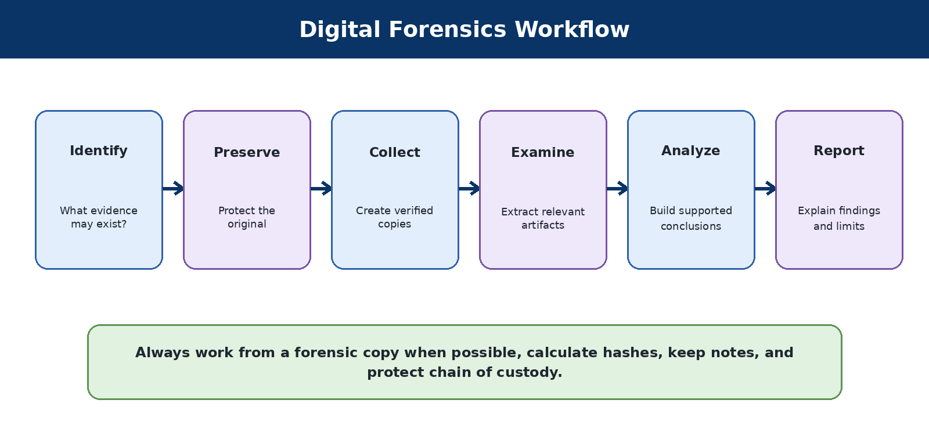
Figure 6. A basic digital-forensics workflow that protects original evidence.
Digital forensics is the disciplined identification, preservation, examination, analysis, and reporting of digital evidence. The goal is not simply to find interesting files. The goal is to produce accurate, repeatable conclusions while preserving integrity and respecting privacy.
Work from copies
When evidence matters, preserve the original, create a verified forensic image, record hashes, and conduct analysis on a working copy. A learner should use public training images rather than real personal devices.

Core concepts
- Chain of custody: a record of who handled evidence, when, why, and how.
- Hash: a reproducible digital fingerprint used to verify that evidence has not changed.
- Write blocker: hardware or software controls intended to prevent modification of source media.
- Timeline: an ordered view of events derived from file systems, logs, applications, and other artifacts.
- Artifact: a piece of data that may support an investigation, such as browser history, registry information, logs, or metadata.
- Finding versus conclusion: an observed artifact is not automatically proof of intent or identity.

9.2 Sleuth Kit
COMMAND-LINE FILE-SYSTEM FORENSICS
What it is and why it matters
Provides tools for examining disk images and file-system structures. Useful for learning repeatable, scriptable analysis beneath graphical interfaces.
When to use it
  - Authorized incident response.
  - Public training evidence.
  - Your own deliberately prepared sample data.
When not to use it
Do not analyze someone else’s device or account without lawful authority. Do not work from original evidence when preservation matters.
Authorization checkpoint
Use this tool only on a system you own, a lab specifically assigned to you, or a system covered by clear written authorization. Publicly reachable does not mean publicly testable.
Check that it is available
fls -V
First safe exercise
List files from a public training image and compare allocated and deleted entries.
What to look for
  - Record the source and hash.
  - Separate observation from interpretation.
  - Document time zone, tool version, and export location.
Common beginner mistakes
  - Selecting the wrong device or image.
  - Changing evidence.
  - Overstating what an artifact proves.
Risk level
Medium evidence-integrity risk if the wrong device is selected.

Using AI responsibly with this tool
AI can help summarize sanitized timelines or explain file formats, but do not upload real evidence to a public model. Confirm every conclusion from the underlying artifact and tool output.
Official resources
Sleuth Kit

9.3 Guymager
FORENSIC IMAGING
What it is and why it matters
Creates forensic images and calculates hashes. Useful when learning acquisition, evidence copies, and verification.
When to use it
- Authorized incident response.
- Public training evidence.
- Your own deliberately prepared sample data.
When not to use it
Do not analyze someone else’s device or account without lawful authority. Do not work from original evidence when preservation matters.
Authorization checkpoint
Use this tool only on a system you own, a lab specifically assigned to you, or a system covered by clear written authorization. Publicly reachable does not mean publicly testable.
Check that it is available
guymager
First safe exercise
Image a disposable USB device containing fictional files, never a device with real personal data.
What to look for
- Record the source and hash.
- Separate observation from interpretation.
- Document time zone, tool version, and export location.
Common beginner mistakes
  - Selecting the wrong device or image.
  - Changing evidence.
  - Overstating what an artifact proves.
Risk level
High risk if source and destination are confused.

Using AI responsibly with this tool
AI can help summarize sanitized timelines or explain file formats, but do not upload real evidence to a public model. Confirm every conclusion from the underlying artifact and tool output.
Official resources
Guymager on Kali

9.4 ExifTool
METADATA EXAMINATION
What it is and why it matters
Reads and writes metadata from many file formats. Useful for understanding timestamps, camera information, document properties, and hidden metadata.
When to use it
- Authorized incident response.
- Public training evidence.
- Your own deliberately prepared sample data.
When not to use it
Do not analyze someone else’s device or account without lawful authority. Do not work from original evidence when preservation matters.
Authorization checkpoint
Use this tool only on a system you own, a lab specifically assigned to you, or a system covered by clear written authorization. Publicly reachable does not mean publicly testable.
Check that it is available
exiftool -ver
First safe exercise
Run ExifTool on your own sample images and documents. Compare file-system times with embedded metadata.
What to look for
- Record the source and hash.
- Separate observation from interpretation.
- Document time zone, tool version, and export location.
Common beginner mistakes
- Selecting the wrong device or image.
- Changing evidence.
- Overstating what an artifact proves.
Risk level
Low when reading copies; writing metadata can alter evidence.

Using AI responsibly with this tool
AI can help summarize sanitized timelines or explain file formats, but do not upload real evidence to a public model. Confirm every conclusion from the underlying artifact and tool output.
Official resources
ExifTool on Kali
ExifTool

9.5 Binwalk
EMBEDDED DATA AND FIRMWARE ANALYSIS
What it is and why it matters
Identifies signatures and embedded objects inside binary files. Useful for introductory concepts in firmware and file carving.
When to use it
• Authorized incident response.
• Public training evidence.
• Your own deliberately prepared sample data.
When not to use it
Do not analyze someone else’s device or account without lawful authority. Do not work from original evidence when preservation matters.
Authorization checkpoint
Use this tool only on a system you own, a lab specifically assigned to you, or a system covered by clear written authorization. Publicly reachable does not mean publicly testable.
Check that it is available
binwalk --help
First safe exercise
Analyze a publicly available sample firmware image and identify signatures without automatically executing the extracted content.
What to look for
  - Record the source and hash.
  - Separate observation from interpretation.
  - Document time zone, tool version, and export location.
Common beginner mistakes
  - Selecting the wrong device or image.
  - Changing evidence.
  - Overstating what an artifact proves.
Risk level
Medium. Extracted files may be untrusted.

Using AI responsibly with this tool
AI can help summarize sanitized timelines or explain file formats, but do not upload real evidence to a public model. Confirm every conclusion from the underlying artifact and tool output.
Official resources
Binwalk on Kali

9.6 Volatility 3
MEMORY FORENSICS
What it is and why it matters
Analyzes supported memory images to recover process, network, and operating-system artifacts. Useful for incident response and understanding what existed in memory at capture time.
When to use it
- Authorized incident response.
- Public training evidence.
- Your own deliberately prepared sample data.
When not to use it
Do not analyze someone else’s device or account without lawful authority. Do not work from original evidence when preservation matters.
Authorization checkpoint
Use this tool only on a system you own, a lab specifically assigned to you, or a system covered by clear written authorization. Publicly reachable does not mean publicly testable.
Check that it is available
vol -h
First safe exercise
Use a public Windows memory image and list basic process information. Verify plugin requirements and image compatibility.
What to look for
- Record the source and hash.
- Separate observation from interpretation.
- Document time zone, tool version, and export location.
Common beginner mistakes
- Selecting the wrong device or image.
- Changing evidence.
- Overstating what an artifact proves.
Risk level
High privacy risk; memory can contain credentials and private data.

Using AI responsibly with this tool
AI can help summarize sanitized timelines or explain file formats, but do not upload real evidence to a public model. Confirm every conclusion from the underlying artifact and tool output.
Official resources
Volatility 3 documentation

9.7 Foremost
FILE CARVING
What it is and why it matters
Recovers file-like content from raw data based on headers and signatures. Useful for understanding recovery when directory information is missing.
When to use it
- Authorized incident response.
- Public training evidence.
- Your own deliberately prepared sample data.
When not to use it
Do not analyze someone else’s device or account without lawful authority. Do not work from original evidence when preservation matters.
Authorization checkpoint
Use this tool only on a system you own, a lab specifically assigned to you, or a system covered by clear written authorization. Publicly reachable does not mean publicly testable.
Check that it is available
foremost -V
First safe exercise
Carve a small public practice image into a dedicated output directory and review false positives.
What to look for
- Record the source and hash.
- Separate observation from interpretation.
- Document time zone, tool version, and export location.
Common beginner mistakes
- Selecting the wrong device or image.
- Changing evidence.
- Overstating what an artifact proves.
Risk level
Medium storage and privacy risk.

Using AI responsibly with this tool
AI can help summarize sanitized timelines or explain file formats, but do not upload real evidence to a public model. Confirm every conclusion from the underlying artifact and tool output.
Official resources
Foremost on Kali

9.8 bulk_extractor
FEATURE EXTRACTION
What it is and why it matters
Scans images for features such as email addresses, URLs, and other patterns without parsing every file system. Useful for triage and understanding why extracted indicators require context.
When to use it
- Authorized incident response.
- Public training evidence.
- Your own deliberately prepared sample data.
When not to use it
Do not analyze someone else’s device or account without lawful authority. Do not work from original evidence when preservation matters.
Authorization checkpoint
Use this tool only on a system you own, a lab specifically assigned to you, or a system covered by clear written authorization. Publicly reachable does not mean publicly testable.
Check that it is available
bulk_extractor -V
First safe exercise
Run against a public practice image and examine reports without assuming every string belongs to a user.
What to look for
- Record the source and hash.
- Separate observation from interpretation.
- Document time zone, tool version, and export location.
Common beginner mistakes
- Selecting the wrong device or image.
- Changing evidence.
- Overstating what an artifact proves.
Risk level
High privacy risk on real evidence.

Using AI responsibly with this tool
AI can help summarize sanitized timelines or explain file formats, but do not upload real evidence to a public model. Confirm every conclusion from the underlying artifact and tool output.
Official resources
bulk_extractor project

9.9 Plaso/log2timeline
TIMELINE GENERATION
What it is and why it matters
Collects timestamps and artifacts from many sources to create forensic timelines. Useful for reconstructing sequences of activity.
When to use it
  - Authorized incident response.
  - Public training evidence.
  - Your own deliberately prepared sample data.
When not to use it
Do not analyze someone else’s device or account without lawful authority. Do not work from original evidence when preservation matters.
Authorization checkpoint
Use this tool only on a system you own, a lab specifically assigned to you, or a system covered by clear written authorization. Publicly reachable does not mean publicly testable.
Check that it is available
log2timeline.py --help
First safe exercise
Build a timeline from a small training image and filter it to a narrow time range.
What to look for
- Record the source and hash.
- Separate observation from interpretation.
- Document time zone, tool version, and export location.
Common beginner mistakes
- Selecting the wrong device or image.
- Changing evidence.
- Overstating what an artifact proves.
Risk level
Medium; wrong time-zone assumptions can mislead analysis.

Using AI responsibly with this tool
AI can help summarize sanitized timelines or explain file formats, but do not upload real evidence to a public model. Confirm every conclusion from the underlying artifact and tool output.
Official resources
Plaso documentation

9.10 YARA
PATTERN-BASED CLASSIFICATION
What it is and why it matters
Uses rules to identify files or memory matching defined byte and text patterns. Useful for malware triage and repeatable classification when rules are carefully written.
When to use it
- Authorized incident response.
- Public training evidence.
- Your own deliberately prepared sample data.
When not to use it
Do not analyze someone else’s device or account without lawful authority. Do not work from original evidence when preservation matters.
Authorization checkpoint
Use this tool only on a system you own, a lab specifically assigned to you, or a system covered by clear written authorization. Publicly reachable does not mean publicly testable.
Check that it is available
yara --version
First safe exercise
Write a harmless rule that identifies a fictional text marker in a sample directory.
What to look for
- Record the source and hash.
- Separate observation from interpretation.
- Document time zone, tool version, and export location.
Common beginner mistakes
- Selecting the wrong device or image.
- Changing evidence.
- Overstating what an artifact proves.
Risk level
Medium. Poor rules create false positives; untrusted samples remain dangerous.

Using AI responsibly with this tool
AI can help summarize sanitized timelines or explain file formats, but do not upload real evidence to a public model. Confirm every conclusion from the underlying artifact and tool output.
Official resources
YARA documentation

9.11 Ghidra
REVERSE ENGINEERING SUITE
What it is and why it matters
Disassembles and decompiles executable code for analysis. Useful for advanced learning about programs, malware, and vulnerabilities.
When to use it
- Authorized incident response.
- Public training evidence.
- Your own deliberately prepared sample data.
When not to use it
Do not analyze someone else’s device or account without lawful authority. Do not work from original evidence when preservation matters.
Authorization checkpoint
Use this tool only on a system you own, a lab specifically assigned to you, or a system covered by clear written authorization. Publicly reachable does not mean publicly testable.
Check that it is available
ghidraRun
First safe exercise
Open a harmless compiled “hello world” program and identify strings and functions. Do not begin with live malware.
What to look for
- Record the source and hash.
- Separate observation from interpretation.
- Document time zone, tool version, and export location.
Common beginner mistakes
- Selecting the wrong device or image.
- Changing evidence.
- Overstating what an artifact proves.
Risk level
High when analyzing malicious samples; isolation is essential.

Using AI responsibly with this tool
AI can help summarize sanitized timelines or explain file formats, but do not upload real evidence to a public model. Confirm every conclusion from the underlying artifact and tool output.
Official resources
Ghidra

10. Reporting What You Learn
Reporting What You Learn
A security professional is judged not only by what they can discover, but by how clearly, accurately, and responsibly they communicate it. Begin reporting in your first lab.

10.1 Simple finding template
Field | What to write
Title | A clear description of the issue.
Scope | The exact authorized target.
Observation | What you directly saw.
Evidence | Relevant command, timestamp, and sanitized output.
Risk | What could happen and under what conditions.
Recommendation | A practical corrective action.
Limitations | What you did not test or could not confirm.

10.2 Avoid these reporting mistakes
- Calling a version number a confirmed vulnerability without validation.
- Copying raw scanner output without explaining significance.
- Using dramatic words such as “catastrophic” without evidence.
- Including passwords, tokens, flags, or personal data in a public report.
- Hiding uncertainty. A professional report clearly distinguishes confirmed facts, reasonable inferences, and open questions.

11. Your First 30 Days with Kali Linux
Your First 30 Days with Kali Linux

11.1 Week 1 - Build safe foundations
- Read the ethics section.
- Install Kali in a VM.
- Update it and create a snapshot.
- Learn files, directories, permissions, processes, and basic networking.
- Create a lab notebook.

11.2 Week 2 - Learn to observe
- Use Nmap on one assigned lab target.
- Capture your own traffic with Wireshark.
- Learn DNS, TCP, HTTP, and TLS at an introductory level.
- Write one short finding.

11.3 Week 3 - Begin web and HTB practice
  - Complete beginner Starting Point machines.
  - Learn Burp HTTP history and basic Gobuster or FFUF use.
  - Use AI only to explain sanitized output, then verify it.
  - Review the HTB rules.

11.4 Week 4 - Connect the skills
  - Complete a small lab from discovery to reporting.
  - Use one forensic training image to learn hashing and metadata.
  - Review what actions were low impact, intrusive, or prohibited.
  - Choose the next learning path: penetration testing, SOC/incident response, forensics, cloud, GRC, or AI security.
What success looks like after 30 days
You can safely operate a Kali VM, identify an authorized target, run basic discovery, explain the difference between observation and exploitation, protect lab data, and write a simple evidence-based report. You are not expected to know every tool.

12. English for Technology Careers
A person does not need perfect English to begin a technology career. Many excellent professionals use English as a second or third language. However, practical English opens access to more documentation, training, communities, and international jobs.

12.1 Where English appears
  - Programming keywords and command-line options
  - Error messages and troubleshooting results
  - Official documentation and release notes
  - GitHub issues, pull requests, and security advisories
  - Team meetings, tickets, reports, and interviews
  - Research papers and early reports about new threats

12.2 A realistic goal
The goal is not to sound like a native speaker. The goal is to read instructions, understand an error, search for a solution, explain a problem, write a clear update, and describe your work during an interview. Technical English improves through daily use.
Beginners should start in the language they understand best and use English as an additional professional tool. Do not wait for perfect English before beginning cybersecurity or software development.

12.3 Free English Learning Resources Available Worldwide
Most of these resources provide free self-paced lessons. Some organizations also sell optional tutoring or live classes, so read the pricing page before enrolling in anything paid.
Resource | Best use | Official link
British Council LearnEnglish | Free videos, reading, listening, grammar, vocabulary, and level-based activities. | Official resource - learnenglish.britishcouncil.org
British Council free level test | An approximate starting-level check. | Official resource - learnenglish.britishcouncil.org
USA Learns | Structured adult English courses with free registration and progress tracking. | Official resource - usalearns.org
VOA Learning English | American English lessons, slower news, audio, vocabulary, and beginner courses. | Official resource - learningenglish.voanews.com
Cisco Skills for All | Free technology and cybersecurity learning that also builds technical English. Search the catalog for English for IT and Ethical Hacker. | Official resource - skillsforall.com
OpenLearn | Free courses from The Open University, including everyday and study English. | Official resource - open.edu
BBC Learning English | Free videos, pronunciation, grammar, vocabulary, and live lessons. | Official resource - bbc.co.uk
Duolingo | Free daily practice for vocabulary and basic grammar; best used with other speaking and listening resources. | Official resource - duolingo.com
EF SET | Free English-level tests and a shareable result; an assessment rather than a full course. | Official resource - efset.org

12.4 A simple weekly English plan
  - Study one structured lesson three times a week.
  - Listen to ten minutes of English every day.
  - Write down five technical words and use each in a sentence.
  - Keep error messages in their original English when searching for solutions.
  - Explain one Kali or AI concept aloud in simple English.
  - Measure progress every three to six months rather than every day.

13. Career Paths and Continued Learning
Path | Focus
SOC and incident response | Monitoring, triage, investigation, containment, and communication.
Penetration testing | Authorized assessment, validation, reporting, and remediation guidance.
Digital forensics | Evidence preservation, artifact analysis, timelines, and defensible conclusions.
Security engineering | Designing, configuring, and operating security controls.
Cloud security | Identity, data protection, configuration, logging, and workload security.
GRC | Governance, risk, compliance, policy, control design, and business communication.
AI security | Model evaluation, prompt injection, RAG security, data protection, and AI governance.
Kali is a useful laboratory, not a complete career. Employers value networking, operating systems, scripting, cloud, identity, communication, documentation, and ethical judgment. Build depth gradually and create a portfolio that contains sanitized lab reports rather than copied flags or unexplained screenshots.

- I own the target or have explicit authorization.
- The IP address, hostname, account, and time window are inside scope.
- I understand whether the action is passive, active, intrusive, or modifying.
- I know the expected output and stop condition.
- I am saving output in the correct lab folder.
- I am not exposing credentials, VPN files, client data, or flags.
- I can explain why this command is necessary.

Lab folder pattern
~/labs/<platform>/<lab-name>/
├── notes/
├── scans/
├── evidence/
└── report/

Term | Entry-level meaning
Active Directory (AD) | Microsoft directory services used to manage users, computers, permissions, and policies in many organizations.
AI model | A computer system trained to recognize patterns or generate outputs such as text, images, or predictions.
Attack surface | The systems, services, applications, identities, devices, and paths that could be targeted.
Authentication | The process of proving who or what you are, commonly with a password, token, or biometric factor.
Authorization | The rules that determine what an authenticated person or system is allowed to do.
Brute-force attack | Repeatedly trying many possible passwords or keys. This can lock accounts or disrupt systems and requires explicit authorization.
Chain of custody | A documented record of who collected, handled, transferred, and examined digital evidence.
Checksum | A calculated value used to check whether a downloaded file changed or became corrupted.
Command-line interface (CLI) | A text-based way to control a computer by entering commands.
Common Vulnerabilities and Exposures (CVE) | A public identifier assigned to a known cybersecurity vulnerability.
Credential | Information used to prove identity, such as a username, password, API key, certificate, or token.
Digital evidence | Data that may help explain an event, incident, or activity and must be handled carefully.
Enumeration | Collecting detailed information about systems, accounts, shares, services, or applications after initial discovery.
Exploit | Code or a technique that uses a vulnerability to cause an unintended result.
False positive | A result that appears to identify a problem but is incorrect after validation.
Forensic image | A bit-for-bit copy of storage media created for examination while preserving the original.
Hash | A calculated digital fingerprint used to identify data, verify integrity, or support password auditing.
Host | A computer, server, phone, virtual machine, or other device connected to a network.
HTTP proxy | A tool that sits between a browser and a web application so requests and responses can be inspected.
Incident response | The organized process of preparing for, detecting, investigating, containing, and recovering from security incidents.
IP address | A numerical address used to identify and communicate with a device on a network.
Jailbreak | An attempt to make an AI system ignore its intended rules or safeguards.
Least privilege | Giving users and systems only the minimum access needed to perform their tasks.
Log | A record of events generated by an operating system, application, network device, or security tool.
Malware | Software designed to disrupt, damage, spy on, or gain unauthorized access to systems or data.
Network service | A program that listens for connections and provides a function such as web, email, file sharing, or remote access.
Open-source intelligence (OSINT) | Information collected lawfully from publicly available sources.
Packet | A small unit of data transmitted across a network.
Payload | The action or code delivered after a vulnerability is used.
Penetration test | An authorized, scoped assessment that safely attempts to identify and validate security weaknesses.
Port | A numbered logical endpoint used by network services.
Privilege escalation | Gaining permissions beyond those assigned to the current user or process.
Prompt injection | Instructions placed in input or retrieved content that try to manipulate an AI system into ignoring its intended rules.
RAG | Retrieval-augmented generation: a method that supplies retrieved information to a language model before it answers.
Reconnaissance | The early process of gathering information about an authorized target.
Responsible disclosure | Privately reporting a security weakness to the affected organization and allowing reasonable time for correction.
Risk | The possibility that a threat will exploit a weakness and cause harm, considered together with likelihood and impact.
Scope | The approved boundaries of a security activity, including targets, dates, accounts, and permitted techniques.
Service | A program that offers a network or system function.
Shell | A command environment used to interact with an operating system.
Snapshot | A saved state of a virtual machine that can be restored after a mistake or failed change.
Social engineering | Manipulating people into revealing information or taking unsafe actions.
Threat | A person, event, action, or condition capable of causing harm.
Token | A value used to represent identity, authorization, or a session. Tokens must be protected like passwords.
Virtual machine (VM) | A software-based computer that runs inside a physical host computer.
VPN | A virtual private network that creates an encrypted connection to another network or lab environment.
Vulnerability | A weakness that may be exploited or otherwise create risk.
Wordlist | A file containing words or possible values used by authorized discovery or password-auditing tools.
Write blocker | A hardware or software control used to reduce the chance of modifying original evidence media.
Zero-day vulnerability | A vulnerability that is newly discovered and may not yet have an available fix.

This manual prefers primary and official sources. Tool behavior, packages, screenshots, and platform rules can change. Follow the links below and verify current instructions before acting.
Kali Linux
Get Kali
Kali documentation
Kali tool documentation
Kali virtualization documentation
Hack The Box
HTB Starting Point
HTB Academy
HTB Getting Started
OWASP
NIST Cybersecurity
MITRE ATT&CK
MITRE ATLAS
Creative Commons license

This is a living educational project. Readers are encouraged to report broken links, unclear explanations, grammar problems, accessibility concerns, and technical errors. Do not submit credentials, flags, active-machine solutions, personal information, client data, or unverified exploit claims.

Planned GitHub repository structure
kali-learning-manual/
├── README.md
├── LICENSE
├── CODE_OF_CONDUCT.md
├── CONTRIBUTING.md
├── CHANGELOG.md
├── docs/en/
├── docs/es/
├── docs/pt-br/
├── companion-guides/
├── assets/
└── references/
The public repository link will be added to the next revision after the repository is created. The source edition will be maintained in English, with properly localized Latin American Spanish and Brazilian Portuguese editions.

Keep learning. Stay curious. Use your skills to protect people.
Every experienced cybersecurity professional was once a beginner.
First Public Edition - English Master - July 2026
Free for noncommercial educational sharing under CC BY-NC-SA 4.0

