Χρήστος Σιάσιος christossiasios@gmail.com 6988192449 1088618
Σωτήριος Κασσίδης sotiris.cassidis@gmail.com 6980263717 1084498
AIoT Course - Project 2+ (Human Activity Recognition Project)
1. Dataset, activities and ingestion
We used the PAMAP2 dataset: 9 subjects, 3 IMUs (hand, chest, ankle) at 100 Hz, with an accelerometer and a gyroscope per IMU (6 channels each). We focused on the Protocol split with 12 activities done by every subject, and dropped heart-rate, orientation, and the transient periods (activity_id = 0). The Optional split was left out because some activities have only one subject. We parsed each .dat file, split it into contiguous (subject, activity) segments, and stored each segment as one MongoDB document per IMU.
2. Preprocessing
We filled NaN values with linear interpolation, since IMU signals are continuous and a line between two known samples is a good guess; no NaN are left after this. Each segment is then split into windows of 256 samples (2.56 s) with 50% overlap, and each window is filtered with a 4th-order Butterworth low-pass at 10 Hz to remove high-frequency noise. The window count per class is uneven, mainly because some subjects did not do every activity (e.g. subject 109 only did rope jumping).
3. Data preparation
Subjects 101-105 and 107 train the model, subjects 106, 108, 109 are kept for testing. No subject appears in both sets. We used a StandardScaler fit only on the training subjects, so no information leaks into the test set.
4. The two ML solutions and tuning
We built two ML solutions. (1) Time-series flattens every filtered window into a 1,536-value vector (256 samples x 6 channels). (2) Feature engineering computes 105 features per window: time-domain statistics per channel (mean, std, min, max, RMS, skewness, kurtosis), FFT features (dominant frequency, spectral energy, entropy), and the pairwise channel correlations. We used Random Forest importance to pick the top-30 features, and PCA (45 components for 95% variance) for visualisation. Both solutions train a Random Forest and an SVM (RBF kernel), tuned with GridSearchCV.
5. Results and interpretation
Solution / model (hand IMU) | Accuracy | Macro-F1
Time series – Random Forest | 0.642 | 0.612
Time series – SVM (RBF) | 0.572 | 0.548
Features – Random Forest (full) | 0.767 | 0.760
Features – SVM (default) | 0.634 | 0.605
Features – SVM (tuned, GridSearch) | 0.711 | 0.706
Feature engineering works much better than the raw signal: Random Forest macro-F1 goes from 0.61 to 0.76, and SVM from 0.55 to 0.71 once tuned. GridSearch alone pushes SVM accuracy from 0.634 to 0.711. Keeping only the top-30 features matches the full 105 - a smaller, simpler model. The most useful features are accelerometer-based (mean, energy, RMS), which describe how the body is posed and how strongly it moves.
The model recognises fast or repetitive activities (running, walking, cycling) very well, with F1 above 0.85. It gets confused mostly with similar or low-motion ones (sitting, standing, ironing, going up vs down stairs).
6. Sensor configuration comparison
Starting from the wrist baseline, we added the chest and/or the ankle and re-ran the full feature pipeline on the combined channels. Adding the chest macro-F1 goes from 0.71 (wrist) to 0.79 (wrist and chest). Adding only the ankle barely changes anything (0.71), so it carries little extra information for these upper-body activities. The full wrist, chest and ankle is actually a bit worse than wrist and chest. So the chest does most of the work, and the ankle is not needed.
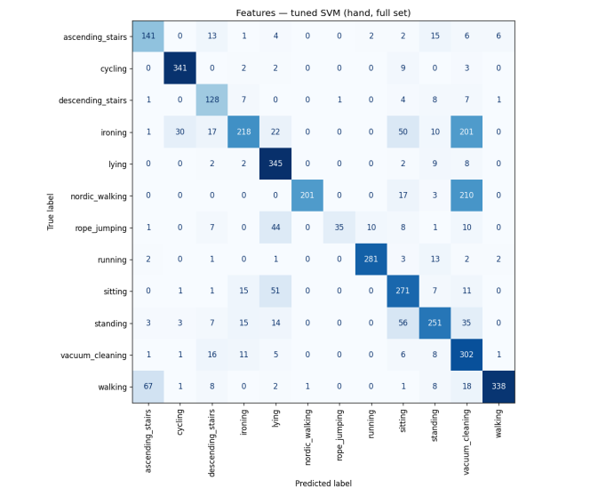 | 