TvHeadendCli – How to

Setup with TV-Browser and Aufnahmesteuerung

Inhalt

1 Requirements 1

2 TvHeadend 2

2.1 Configure Web Interface with Authentication (Recommended) 2

2.2 Configure Web Interface without Authentication 2

3 TvHeadendGui.exe 3

3.1 Settings 3

3.2 Channels 3

3.3 Recordings 3

4 TvHeadendCli.exe 4

4.1 Download and installation 4

4.2 Get Channel names from Tv-Headend 4

5 Aufnahmesteuerung 5

5.1 Install and Update the Plugin with TV-Browser 5

5.2 Setup the Plugin 5

5.2.1 Add a new „Device“ 5

5.2.2 Setup the Device 5

5.2.3 Assign Channel Names 7

5.2.4 Further Settings 7

# Requirements

* Windows, tested with Windows 10
* .Net-Framework 4.7.2 or above
* TV-Browser, tested with Version 4.01
* Plugin Aufnahmesteuerung, tested with 3.1.4.14, 3.1.4.21
* TV-Headend Server, tested with 4.2.4 on Raspberry Pi
* You can find the binaries [here](https://github.com/ChrWieg/TvHeadendCli/tree/master/Binaries). No installation is necessary, just download the zip file and extract the files to a folder of your choice.

# TvHeadend

## Configure Web Interface with Authentication (Recommended)

Make sure you have a user with a password and sufficient rights. You can manage this at the web interface here:

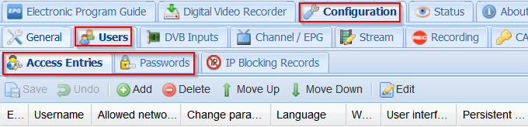

Create a user and set at least the following rights. Then go to the password tab and create a password for the new user.

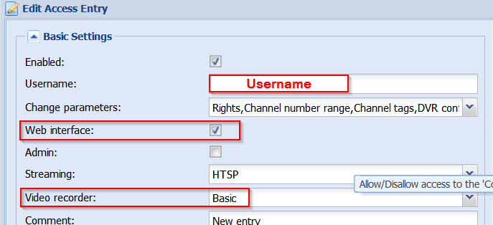

## Configure Web Interface without Authentication

Make sure you have a user with name *. Give * Permissions as shown here:

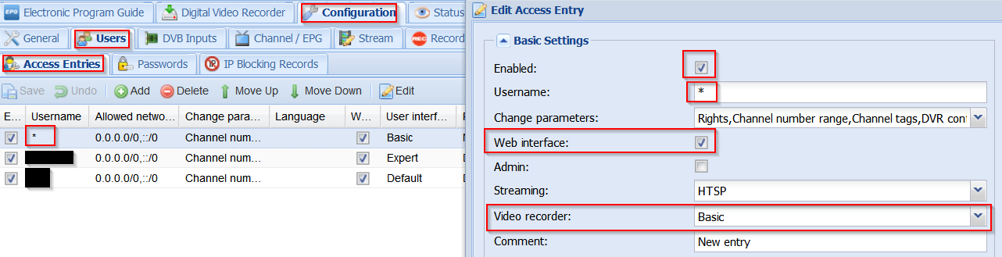

Make sure you have a password for User *

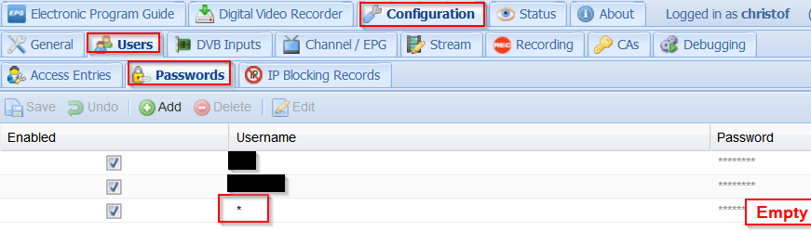

# TvHeadendGui.exe

Not required for the recording control function, but useful for creating data for the Plug-In Aufnahmesteuerung as the parameter list and the channel names list (for the assignment of the channels). Download the zip-archive [here](https://github.com/ChrWieg/TvHeadendCli/blob/master/Binaries/TvHeadendGui.zip) and extract all files to a folder of your choice.

## Settings

Enter the data for your TV-Headend installation here. With the thumb-button, you can check if the server accepts the data. When setting up the Plug-In Aufgabensteuerung later on, you can copy the parameter list here.

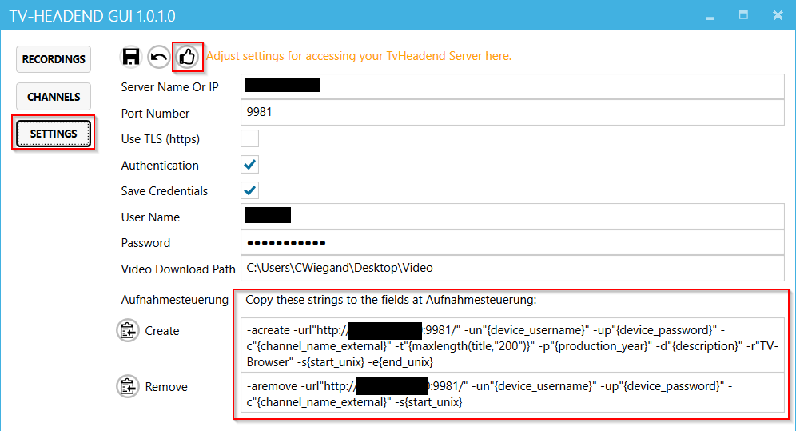

## Channels

This window shows a list of all channels available on your TV-Headend-Server. You can use it later for the channel assignment of the Plug-In Aufgabensteuerung. You can open the list as a text file by the marked button to get the correct channel names by copy & paste.

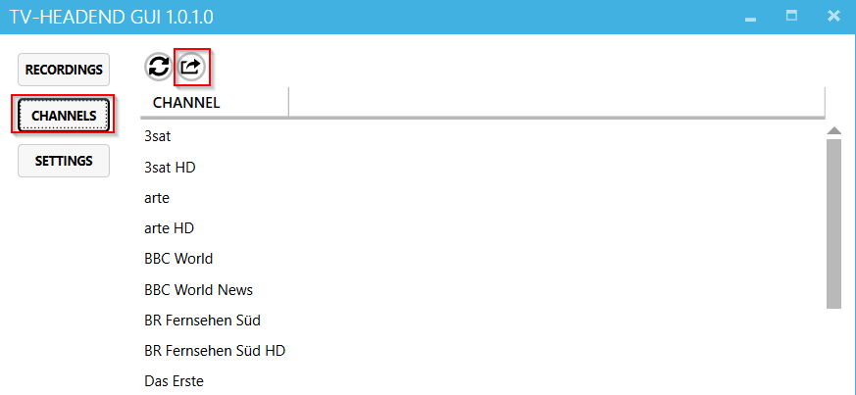

## Recordings

You can use this window to further control the recordings. Completed recordings can be downloaded from the TV headend server and deleted from the server as required.

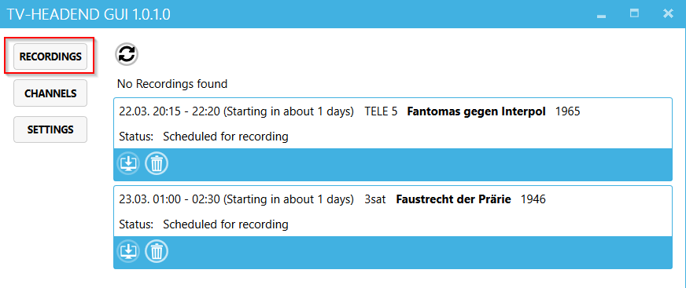

# TvHeadendCli.exe

This is the command line tool. It is a command line program for windows, written in C#. After setting up everything, you will not see it anymore and can forget about it.

## Download and installation

Download the zip-archive [here](https://github.com/ChrWieg/TvHeadendCli/blob/master/Binaries/TvHeadendCli.zip) and extract all files to a folder of your choice. Remember the path to the file **TvHeadendCli.exe**, you will need it later to configure the plug-in Aufnahmesteuerung.

You can Check the tool by opening a command prompt or PowerShell window and change to the folder where TvHeadendCli.exe is located. Try the following command:

TvHeadendCli.exe -help

## Get Channel names from Tv-Headend

The following steps are only necessary for troubleshooting. For the channel list the tool TvHeadend-Gui.exe is recommend.

Later on, you need to match channel names between TV-Browser and TvHeadend. For this task, you need to know the channel names used by TvHeadend. The following command queries the channel names from TvHeadend and writes it to a text file.

Open a command prompt or Powershell windows and change to the folder where TvHeadendCli.exe is located.

Replace url, my_username and password with your values and post the command like this:

Attention: if you do not use authentication and if you have a user *, you need to leave off the parameters  
**-un"my_username" -up"my_password"!**

TvHeadendCli.exe -channels -url"http://tvheadend:9981" -un"my_username" -up"my_password" > channels.txt

Note: the url (and the port) you can find in the address bar of your browser after opening the TvHeadend Site.

# Aufnahmesteuerung

## Install and Update the Plugin with TV-Browser

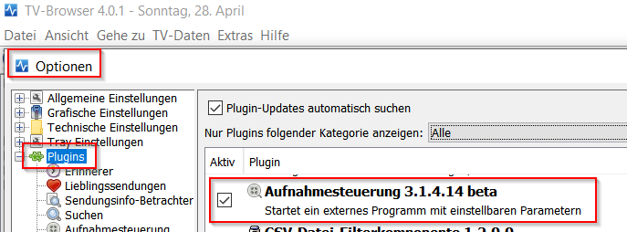

## Setup the Plugin

### Add a new „Device“

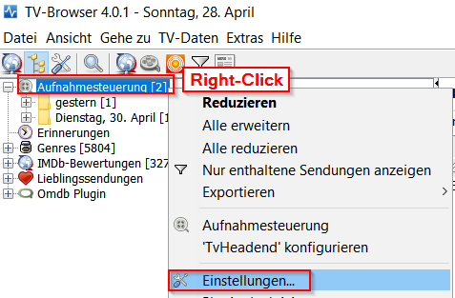

Chose a name for the Device and click okay:

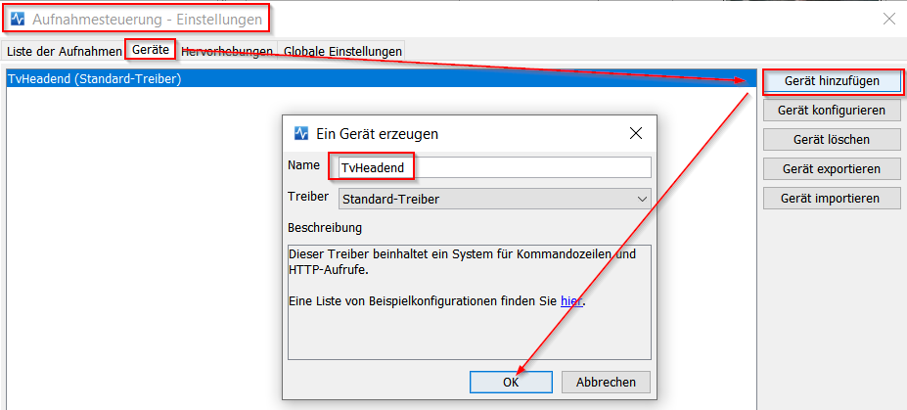

### Setup the Device

Fill in the path to TvHeadendCli.exe:

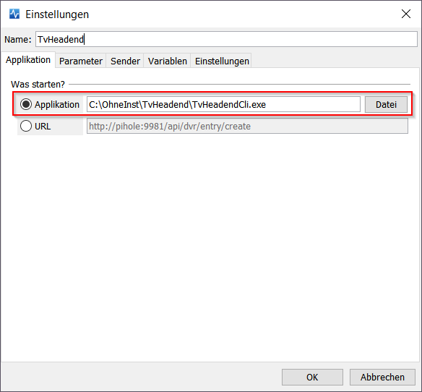

Setup parameters:

The parameters in curly brackets will be provided by TV-Browser at runtime. You might adjust them to your needs. Replace red marked string by your url. Remove all line breaks after copy and paste!

Attention: if you do not use authentication and if you have a user *, you need to leave off the parameters  
**-un"{device_username}" -up"{device_password}"!**

**For this parameter lists use the tool TvHeadendGui.exe as described in chapter 3.1**

1. 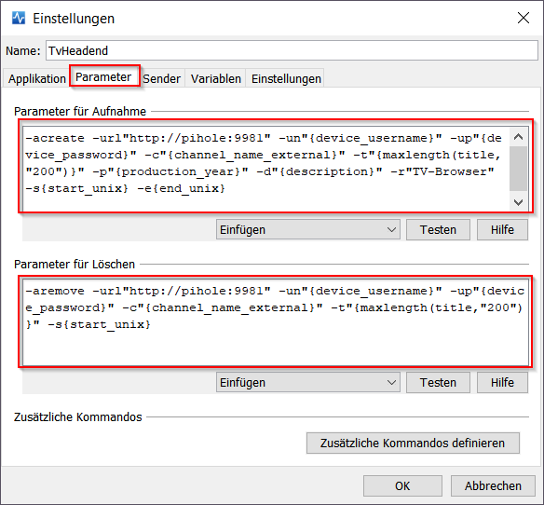Command to schedule recordings:

-acreate -url"http://TvHeadend:9981" -un"{device_username}" -up"{device_password}" -c"{channel_name_external}" -t"{maxlength(title,"200")}" -p"{isset({production_year},'')}" -d"{description}" -r"TV-Browser" -s{start_unix} -e{end_unix}

1. Command to remove scheduled recordings:

-aremove -url"http:// TvHeadend:9981" -un"{device_username}" -up"{device_password}" -c"{channel_name_external}" -t"{maxlength(title,"200")}" -s{start_unix}

### Assign Channel Names

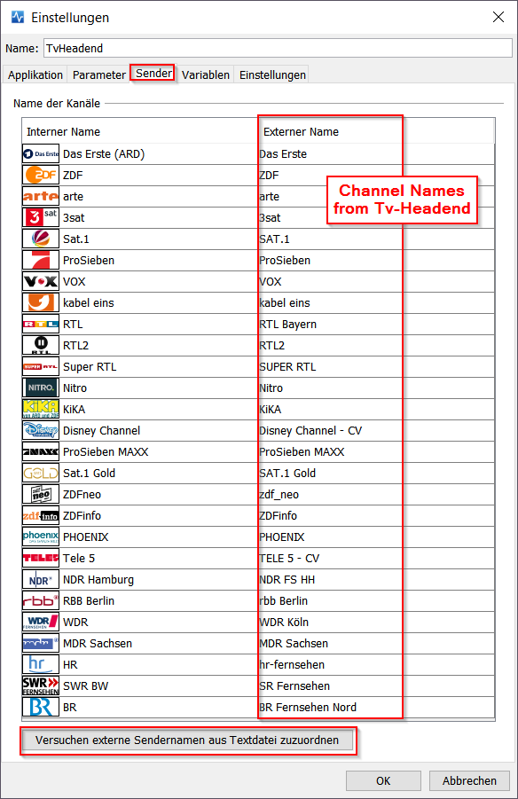As TV-Browser doesn’t know the channel names used by TvHeadend, you need to assign them at tab “Sender”:

Start with the build-in function “Versuche externe Sendernamen aus Textdatei zuzuordnen” (button at the end). The function is not working perfectly, so proof every assignment.

**For a list of all channel names provided by your TV-Headend-Server use the tool TvHeadendGui.exe as described in chapter 3.2.** Compare the assigned names with the names at the generated text file or transfer them by copy & paste.

### Further Settings

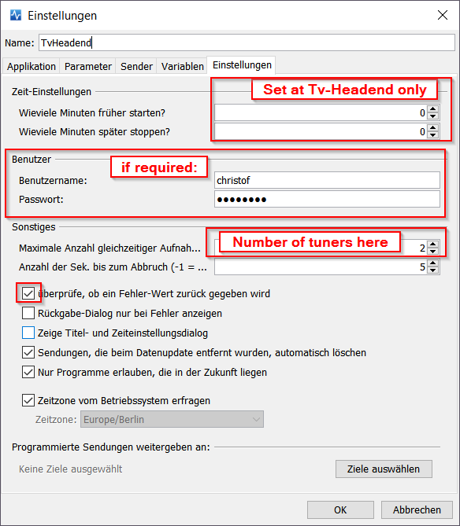Goto tab “Einstellungen” and provide the following settings. Do not set the pre- or post-recording time here; you should do this at TvHeadend. Provide username and password if required.