PROJECT REPORT
Incident Lifecycle Automation in ServiceNow

Date | ________________________________________
Team ID | ________________________________________
Project Name | Incident Lifecycle Automation in ServiceNow
Platform | ServiceNow

1. INTRODUCTION
1.1 Project Overview
Incident Lifecycle Automation in ServiceNow is an academic project focused on standardizing and structuring the Incident Management lifecycle using ServiceNow capabilities. It addresses incidents reported through email, phone, or informal communication that may otherwise result in inconsistent recording, classification, ownership, escalation, SLA visibility, and related-record tracking.
The documented lifecycle covers service and service offering setup, incident creation, classification, Knowledge and Agent Assist, assignment and reassignment, Level 2 investigation, emergency change handling, child incident creation, incident resolution, Knowledge article creation, SLA tracking, and final validation.
1.2 Purpose
The purpose is to standardize the Incident Management lifecycle in ServiceNow so incidents can be created, classified, assigned, investigated, resolved, and documented in a structured manner, with traceability across changes, child incidents, Knowledge records, and SLA information.

2. IDEATION PHASE
2.1 Problem Statement
Incidents are often reported through different channels such as email, phone, or informal communication. This can result in inconsistent incident recording and classification, unclear ownership, delayed escalation and resolution, limited SLA visibility, manual coordination, and difficulty tracking related records such as change requests and child incidents.
2.2 Empathy Map Canvas
Stakeholder | Needs | Concerns | Expected Outcome
End Users | Report IT issues | Quick resolution and visibility | Faster resolution and tracking
Service Desk Agents | Easy logging and classification | Consistent intake and escalation | Standardized incident handling
Level 2 Support | Complete incident data | Clear ownership and related records | Better diagnosis and resolution
Change Management | Structured emergency changes | Controlled change process | Traceable change handling
ServiceNow Administrator | Maintain configuration | Scalable and controlled process | Consistent process management
2.3 Brainstorming
• Standardized incident creation and classification.
• Knowledge and Agent Assist for troubleshooting.
• Assignment and Level 2 escalation.
• Emergency change linkage.
• Child incident tracking.
• Cause, resolution and Knowledge creation.
• SLA and related-record validation.

3. REQUIREMENT ANALYSIS
3.1 Customer Journey map
Stage | Actor | ServiceNow Activity | Need | Outcome
Issue Reporting | End User | Incident creation | Easy reporting | Trackable incident
Initial Handling | Service Desk | Classification and assignment | Correct routing | Clear ownership
Assisted Resolution | Service Desk | Knowledge / Agent Assist | Troubleshooting support | Faster assisted handling
Escalation | Level 2 | Investigation | Complete information | Technical resolution
Change Handling | Change Team | Emergency change | Controlled change | Traceability
Related Incidents | Service Desk | Child incident | Track common issue | Parent-child visibility
Closure | Level 2 | Cause and resolution | Complete documentation | Resolved incident
Validation | Admin | Knowledge, SLA and related records | Verify lifecycle | Validated process
3.2 Solution Requirement
• Incident creation in Service Operations Workspace.
• Capture category, subcategory, urgency, service, service offering and CI.
• Knowledge and Agent Assist integration.
• Assignment and reassignment.
• Level 2 investigation and resolution.
• Emergency change creation and linkage.
• Child incident creation.
• Cause and resolution documentation.
• Knowledge article creation.
• SLA and related-record tracking.
• Final lifecycle validation.
3.3 Data Flow Diagram
Figure 1 represents the major actors, the ServiceNow incident lifecycle process, and the related incident, Knowledge, change, child-incident and SLA information.
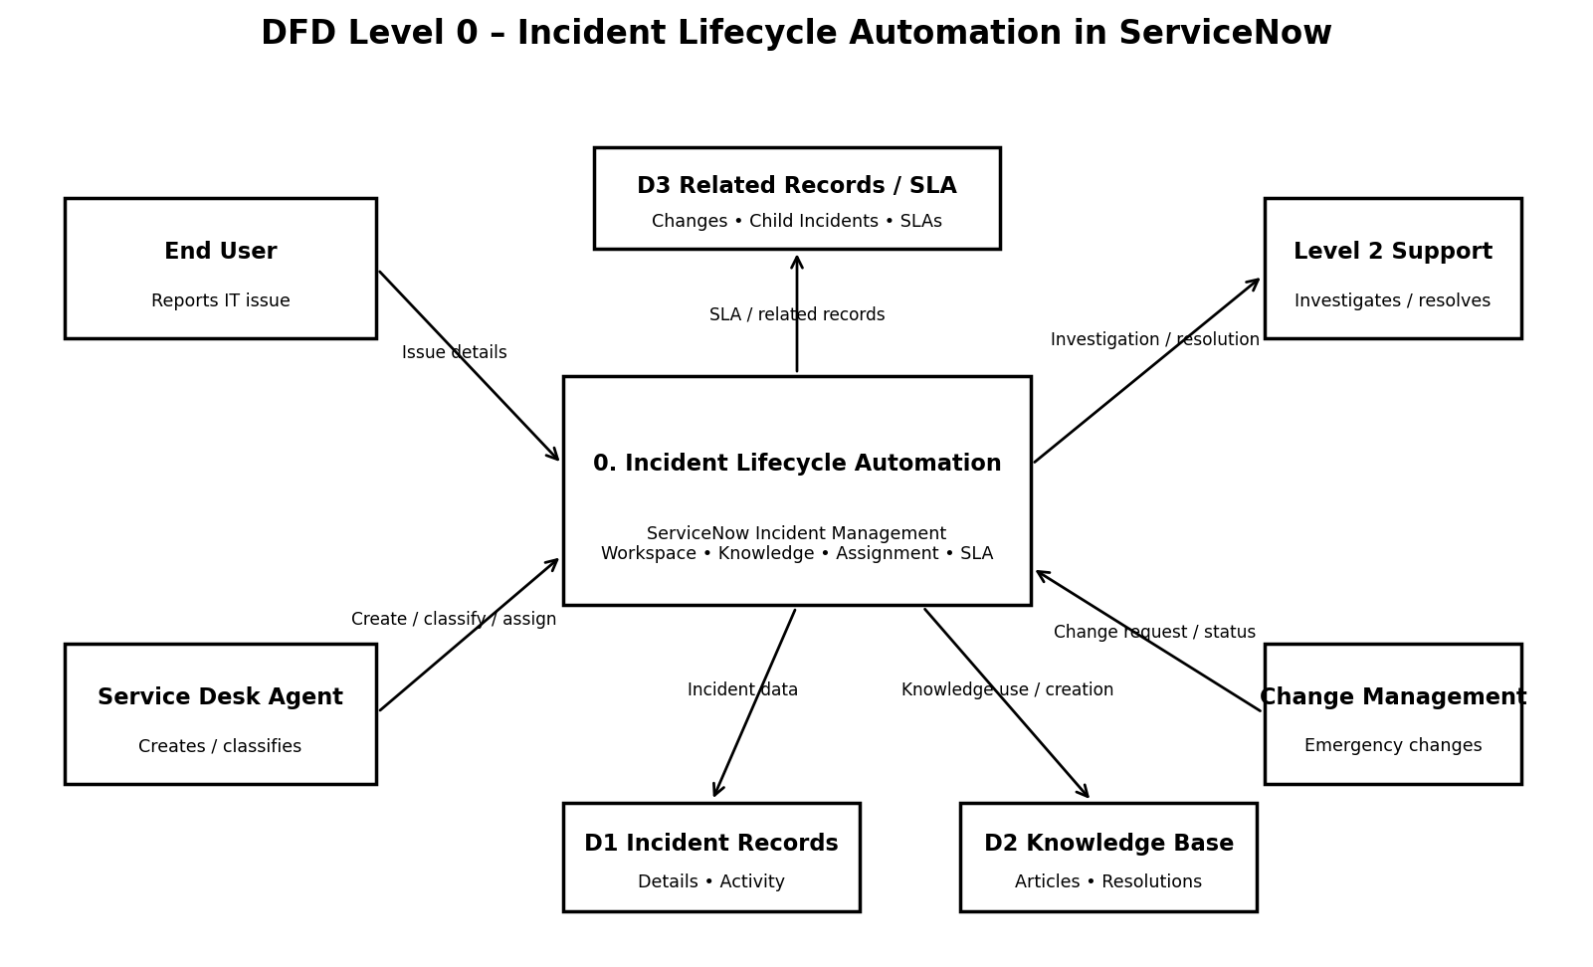
Figure 1: DFD Level 0 – Incident Lifecycle Automation in ServiceNow
3.4 Technology Stack
Component | Use
ServiceNow | Primary platform
Incident Management | Incident creation, classification, assignment and resolution
Service Operations Workspace | Incident record handling
Knowledge Management | Knowledge access and article creation
Agent Assist | Knowledge-assisted incident support
SLAs | SLA visibility and tracking
Change Management | Emergency change handling
Service / Service Offering / CI | Service and configuration context
Related Records / Activity | Changes, child incidents, Knowledge and activity tracking

4. PROJECT DESIGN
4.1 Problem Solution Fit
Problem | Project Feature | Fit
Inconsistent recording | Structured incident creation | Standardized intake
Poor classification | Category, subcategory, urgency, service, CI | Consistent classification
Delayed resolution | Knowledge / Agent Assist | Assisted troubleshooting
Unclear ownership | Assignment / reassignment | Clear responsibility
Escalation | Level 2 support | Structured escalation
Urgent changes | Emergency change linkage | Controlled change
Multiple affected users | Child incidents | Parent-child tracking
Poor closure documentation | Cause and resolution | Structured closure
Repeated issues | Knowledge creation | Reusable knowledge
Limited visibility | SLA and related records | Traceability
4.2 Proposed Solution
The proposed solution is a ServiceNow Incident Management lifecycle in which an incident is created and classified, supported by Knowledge and Agent Assist, assigned to the appropriate team, escalated to Level 2 when required, linked to an emergency change or child incident where applicable, resolved with documented cause and resolution information, and followed by Knowledge creation and SLA/related-record validation.
4.3 Solution Architecture
Layer | Components | Responsibility
Users | End User, Service Desk, Level 2 | Report, create, classify, investigate, resolve
Process | Service Operations Workspace, Incident Management | Manage incident lifecycle
Knowledge | Knowledge Management, Agent Assist | Provide and create troubleshooting knowledge
Change | Change Management | Handle emergency changes
Related Records | Child Incidents, Change Requests, Task SLAs, Activity | Maintain traceability
Service Context | Service, Service Offering, CI | Provide service and configuration context

5. PROJECT PLANNING & SCHEDULING
5.1 Project Planning
The project is planned across four six-day sprints. The project planning values are 51 total story points and an average velocity of 12.75 story points per sprint.
Sprint | Points | Duration | Start | Planned End | Completed | Release
Sprint-1 | 13 | 6 Days | 20 Aug 2026 | 25 Aug 2026 | 13 | 25 Aug 2026
Sprint-2 | 13 | 6 Days | 26 Aug 2026 | 31 Aug 2026 | 13 | 31 Aug 2026
Sprint-3 | 13 | 6 Days | 01 Sep 2026 | 06 Sep 2026 | 13 | 06 Sep 2026
Sprint-4 | 12 | 6 Days | 07 Sep 2026 | 12 Sep 2026 | 12 | 12 Sep 2026

Total Story Points = 51 | Velocity = 12.75 points/sprint | Average Velocity/Day = 2.125 points/day

6. FUNCTIONAL AND PERFORMANCE TESTING
6.1 Performance Testing
The project documentation specifies functional validation and SLA visibility. No quantitative response-time, throughput, load, or resource-utilization measurements were supplied; therefore, no numerical performance results are invented.
• Incident record handling through Service Operations Workspace.
• Knowledge / Agent Assist availability and attachment.
• Assignment and Level 2 investigation.
• Task SLA visibility in Related Records.
• Change and child-incident linkage.
• Resolution and Knowledge creation.
• End-to-end lifecycle validation.

7. RESULTS
7.1 Output Screenshots

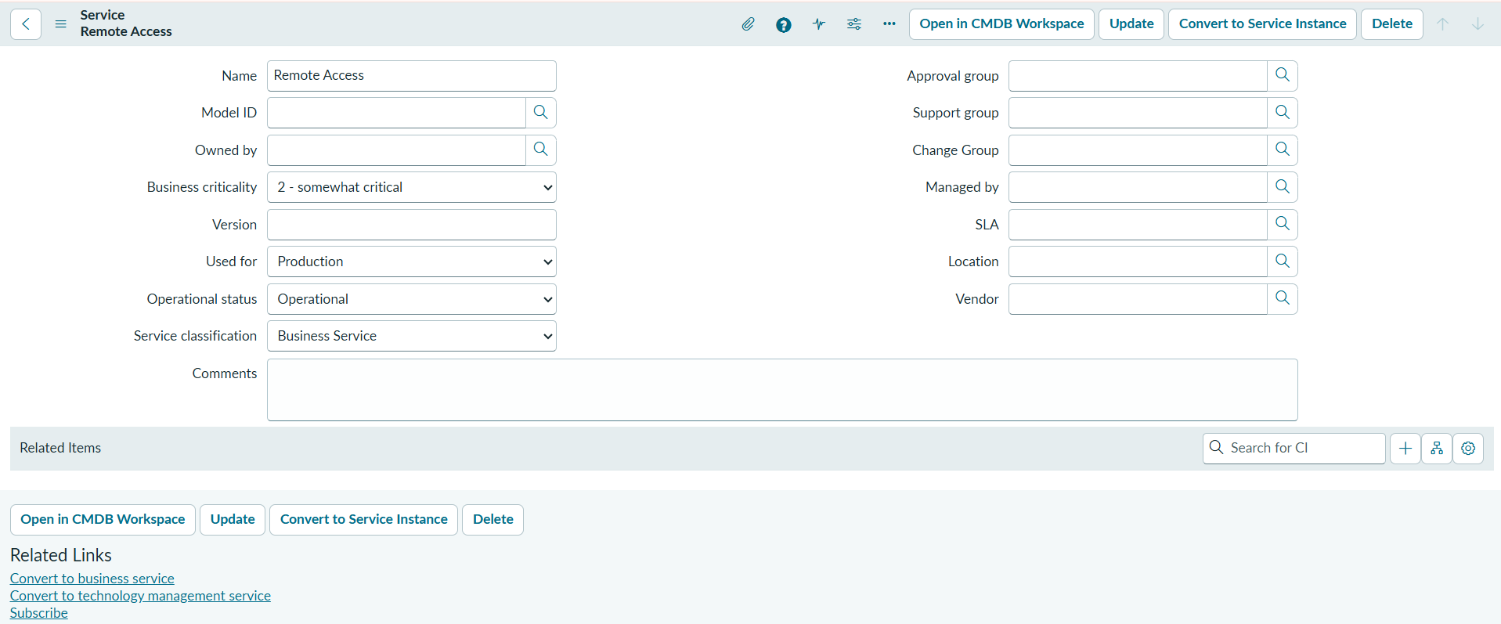

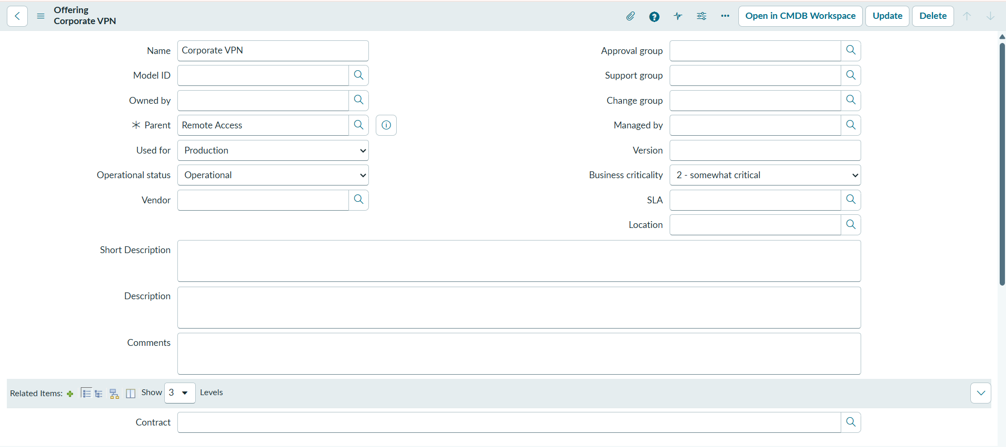

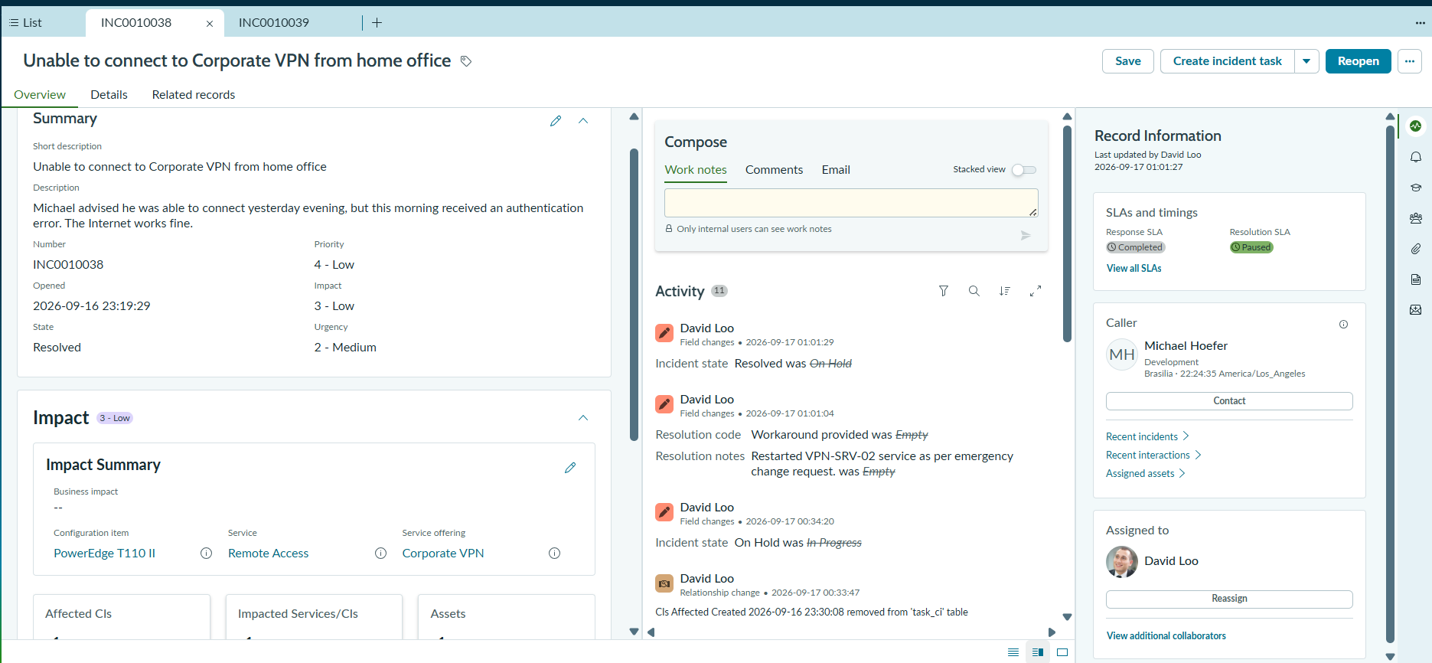

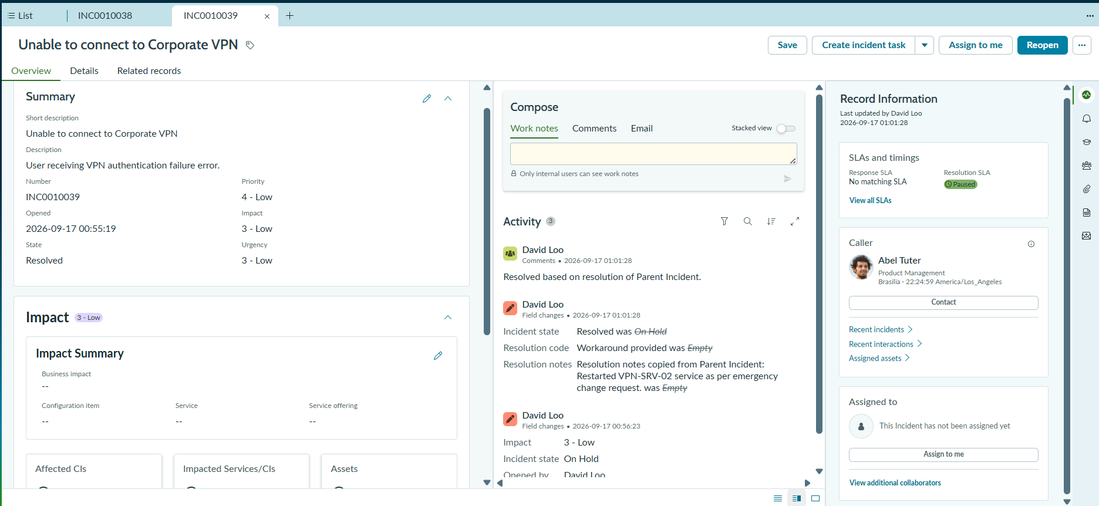

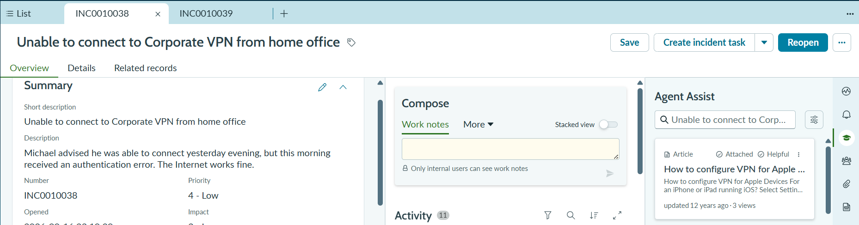
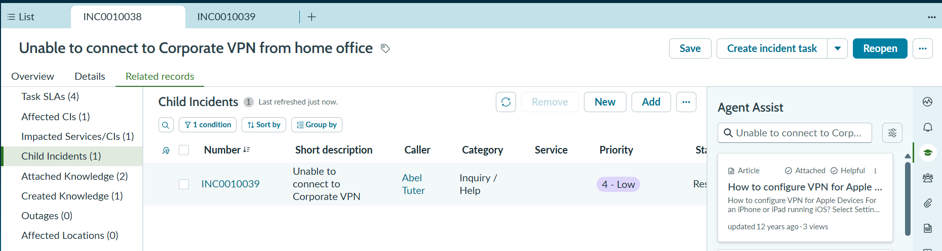

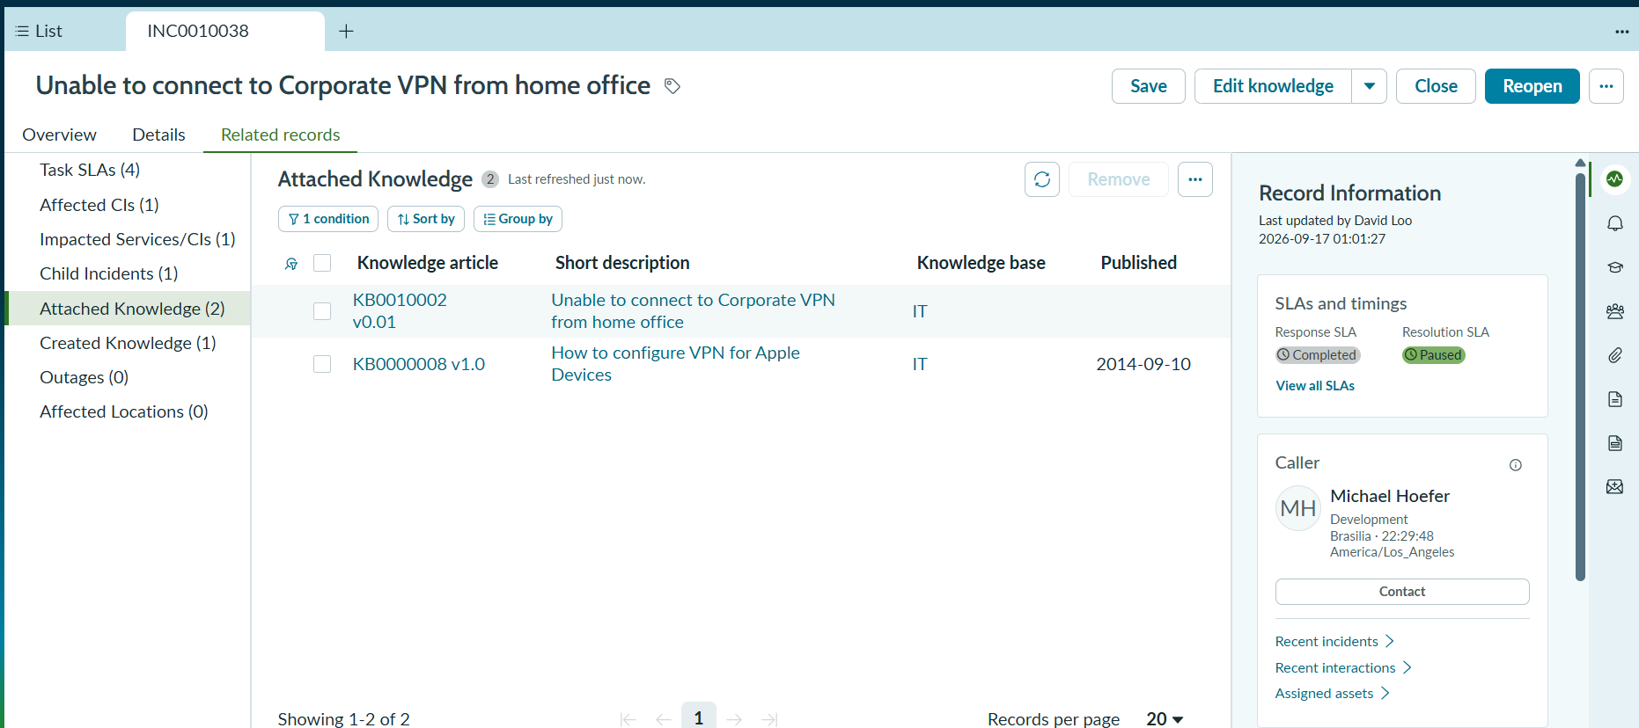

8. ADVANTAGES & DISADVANTAGES
Advantages | Disadvantages / Limitations
Standardized incident handling. | Depends on correct ServiceNow configuration.
Clear ownership and escalation. | Knowledge usefulness depends on relevant articles.
Knowledge-assisted troubleshooting. | No quantitative performance benchmarks were supplied.
SLA and related-record visibility. | Actual UAT evidence/screenshots must be maintained.
Traceable changes and child incidents. | Roles and support groups must be correctly configured.
Structured resolution documentation.
Reusable Knowledge from resolved incidents.

9. CONCLUSION
Incident Lifecycle Automation in ServiceNow demonstrates a structured Incident Management lifecycle connecting incident creation, classification, Knowledge support, assignment, Level 2 investigation, emergency change handling, child incident management, resolution, Knowledge creation, SLA tracking and final validation. The project supports consistency, visibility, ownership, coordination and documentation in incident management.

10. FUTURE SCOPE
• Extend automation and notification rules where required.
• Expand Knowledge coverage based on recurring incidents.
• Add operational dashboards for incident and SLA trends.
• Perform quantitative response-time and load testing.
• Extend automated validation for escalation and related records.

11.APPENDIX
Project Demo Link : https://drive.google.com/file/d/10ZzaL2sG5d7Zdr1Ib6E7jWCOpy4ATPN0/view?usp=sharing

