Project Design Phase
Solution Architecture
Date | ________________________________________
Team ID | ________________________________________
Project Name | Incident Lifecycle Automation in ServiceNow
Maximum Marks | 4 Marks

Solution Architecture: Solution architecture bridges the gap between the business problem and the technology solution. For this project, the architecture defines how ServiceNow capabilities work together to support the complete Incident Management lifecycle.
• Provide a structured ServiceNow solution for incident creation, classification, assignment, investigation, and resolution.
• Describe the interaction between End Users, Service Desk Agents, Level 2 Support, Change Management, and the ServiceNow platform.
• Define the major ServiceNow capabilities and related records required by the project.
• Provide a clear architecture that supports the project's functional scope and validation activities.

Project Solution Architecture Diagram:
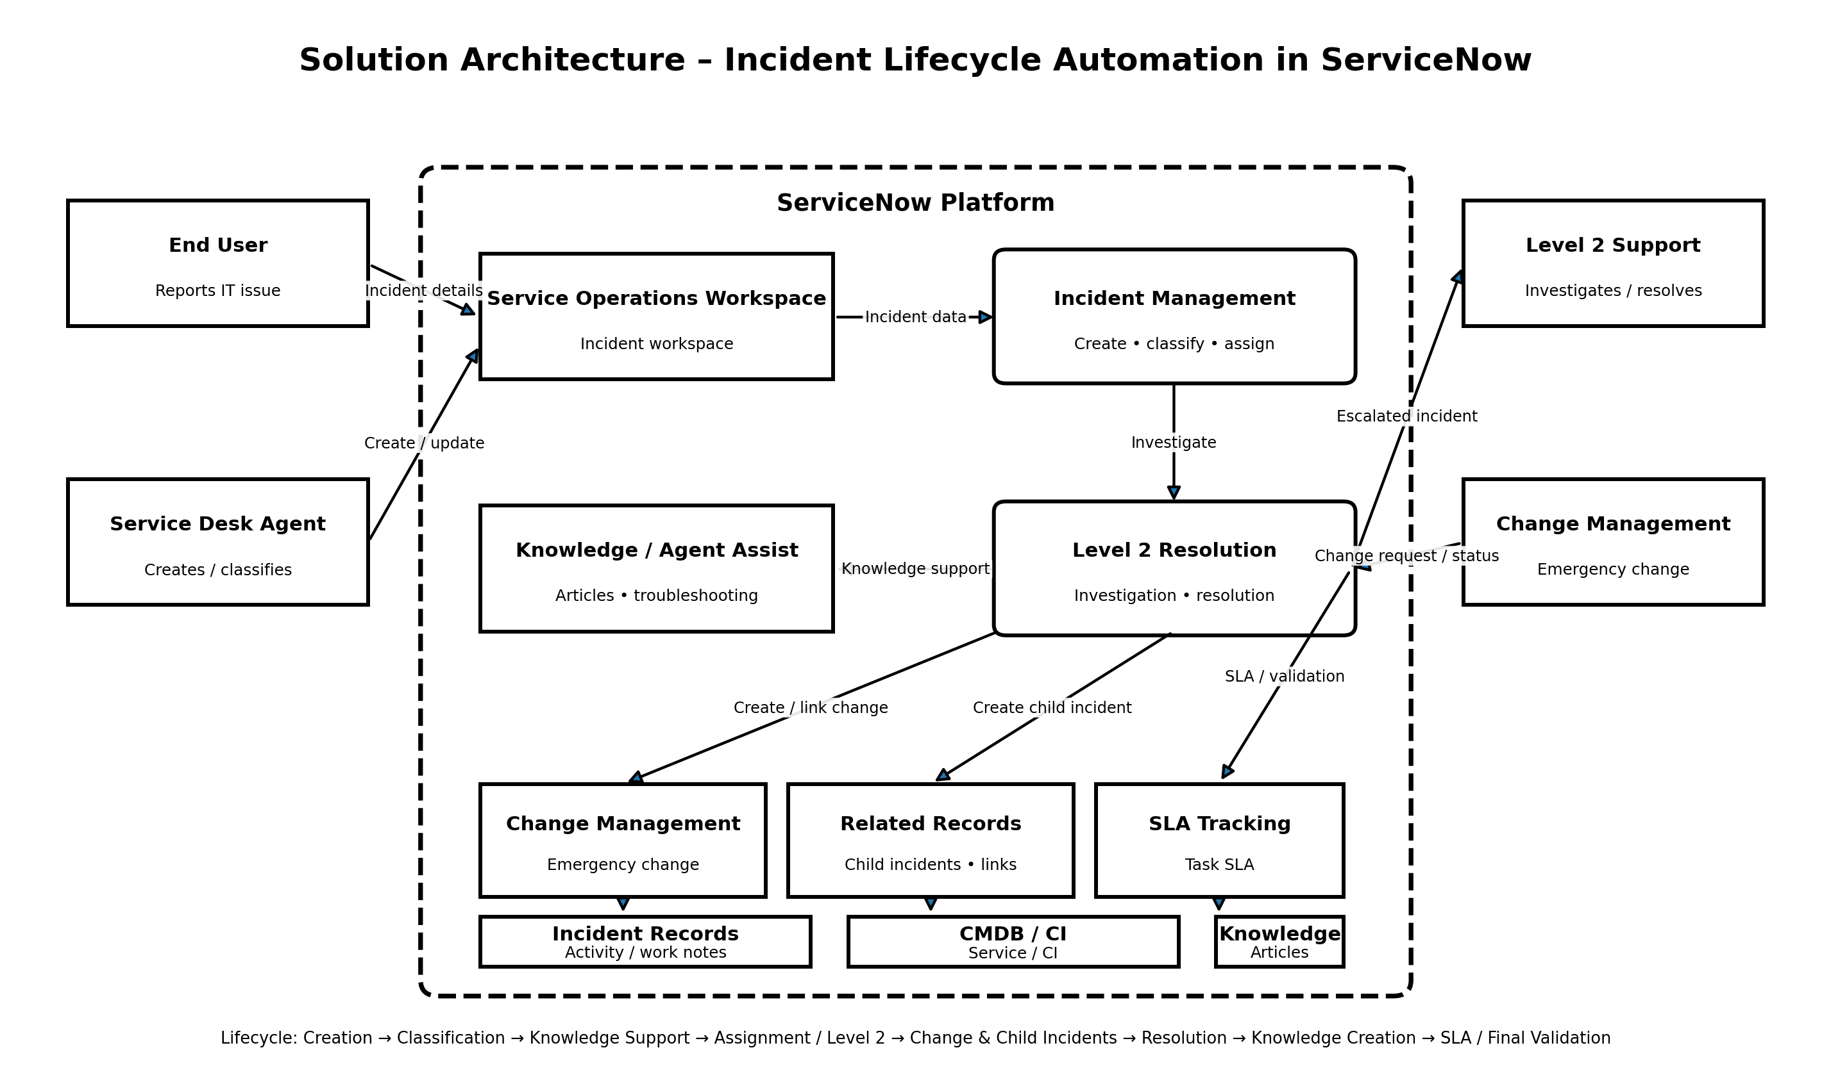
Figure 1: Solution architecture and data flow of Incident Lifecycle Automation in ServiceNow

Architecture Explanation: End Users report incidents and Service Desk Agents use Service Operations Workspace to create, classify, and assign incident records. Incident Management coordinates the lifecycle. Knowledge Management and Agent Assist support troubleshooting. Level 2 Support performs advanced investigation and resolution. When required, Change Management handles emergency changes and related records support child incidents. SLA tracking, incident activity, service/CI information, and Knowledge records support lifecycle visibility and final validation.
Project Scope Alignment: The architecture directly represents the supplied project scope: Service and Service Offering setup, incident creation, classification, Knowledge/Agent Assist, assignment and reassignment, Level 2 investigation, emergency change creation, child incident creation, incident resolution, Knowledge article creation, SLA tracking, related-record validation, and testing.

