Project Planning Phase
Project Planning Template (Product Backlog, Sprint Planning, Stories, Story points)
Date | ________________________________________
Team ID | ________________________________________
Project Name | Incident Lifecycle Automation in ServiceNow
Maximum Marks | 5 Marks

Product Backlog, Sprint Schedule, and Estimation (4 Marks)
Sprint | Functional  Requirement (Epic) | User Story  Number | User Story / Task | Story  Points | Priority | Team  Members
Sprint-1 | Service & Service Offering Setup | USN-1 | As a ServiceNow Administrator, I can create the Remote Access service and Corporate VPN service offering so that incidents can be associated with the correct service hierarchy. | 5 | High | Reshma Chowdary Chilakapati
Sprint-1 | Incident Management | USN-2 | As a Service Desk Agent, I can create an incident in Service Operations Workspace so that an IT issue is formally recorded and tracked. | 5 | High | Reshma Chowdary Chilakapati
Sprint-1 | Incident Classification | USN-3 | As a Service Desk Agent, I can classify an incident using category, subcategory, urgency, service, service offering, and CI so that the incident is correctly prioritized and routed. | 3 | High | Reshma Chowdary Chilakapati
Sprint-2 | Knowledge & Agent Assist | USN-4 | As a Service Desk Agent, I can use Agent Assist and attach a relevant Knowledge article so that troubleshooting information is available during incident resolution. | 5 | High | Reshma Chowdary Chilakapati
Sprint-2 | Assignment & Reassignment | USN-5 | As a Service Desk Agent, I can assign or reassign an incident to the appropriate support group so that ownership is clear and escalation is controlled. | 5 | High | Reshma Chowdary Chilakapati
Sprint-2 | Level 2 Incident Tracking | USN-6 | As a Level 2 support technician, I can investigate an escalated incident and view its description, Knowledge articles, and SLA information so that I can work toward resolution. | 3 | High | Reshma Chowdary Chilakapati
Sprint-3 | Emergency Change | USN-7 | As a Change Management team member, I can handle an emergency change related to an incident so that a required change can be controlled and linked to the incident. | 5 | High | Reshma Chowdary Chilakapati
Sprint-3 | Child Incident Management | USN-8 | As a Service Desk Agent, I can create a child incident for another user affected by the same issue so that related incidents can be tracked under the parent incident. | 5 | Medium | Reshma Chowdary Chilakapati
Sprint-3 | Incident Resolution | USN-9 | As a Level 2 support technician, I can document the probable cause and resolution notes and resolve the incident so that the completed resolution is properly recorded. | 3 | High | Reshma Chowdary Chilakapati
Sprint-4 | Knowledge Creation | USN-10 | As a Service Desk Agent, I can create a Knowledge article from a resolved incident so that the documented solution can support future incident resolution. | 5 | Medium | Reshma Chowdary Chilakapati
Sprint-4 | SLA & Related Record Validation | USN-11 | As a ServiceNow Administrator, I can validate SLA information and related records so that the incident lifecycle is traceable and correctly linked. | 5 | High | Reshma Chowdary Chilakapati
Sprint-4 | Testing & Final Validation | USN-12 | As a ServiceNow Administrator, I can validate the complete incident lifecycle so that incident creation, escalation, change integration, child incidents, Knowledge creation, and SLA tracking are verified. | 2 | High | Reshma Chowdary Chilakapati

Project Tracker, Velocity & Burndown Chart (4 Marks)

Sprint | Total Story  Points | Duration | Sprint Start Date | Sprint End Date  (Planned) | Story Points  Completed (as on  Planned End Date) | Sprint Release Date  (Actual)
Sprint-1 | 13 | 6 Days | 20 Aug 2026 | 25 Aug 2026 | 13 | 25 Aug 2026
Sprint-2 | 13 | 6 Days | 26 Aug 2026 | 31 Aug 2026 | 13 | 31 Aug 2026
Sprint-3 | 13 | 6 Days | 01 Sep 2026 | 06 Sep 2026 | 13 | 06 Sep 2026
Sprint-4 | 12 | 6 Days | 07 Sep 2026 | 12 Sep 2026 | 12 | 12 Sep 2026

Velocity: The project backlog contains 51 story points across four sprints. Using the planned allocation of 13, 13, 13, and 12 story points, the average planned velocity is 51 ÷ 4 = 12.75 story points per sprint.
Average Velocity (AV): AV = Total Story Points / Number of Sprints = 51 / 4 = 12.75 story points per sprint.
Planned Burndown Chart: The chart shows planned remaining story points after each sprint based on the project backlog allocation.

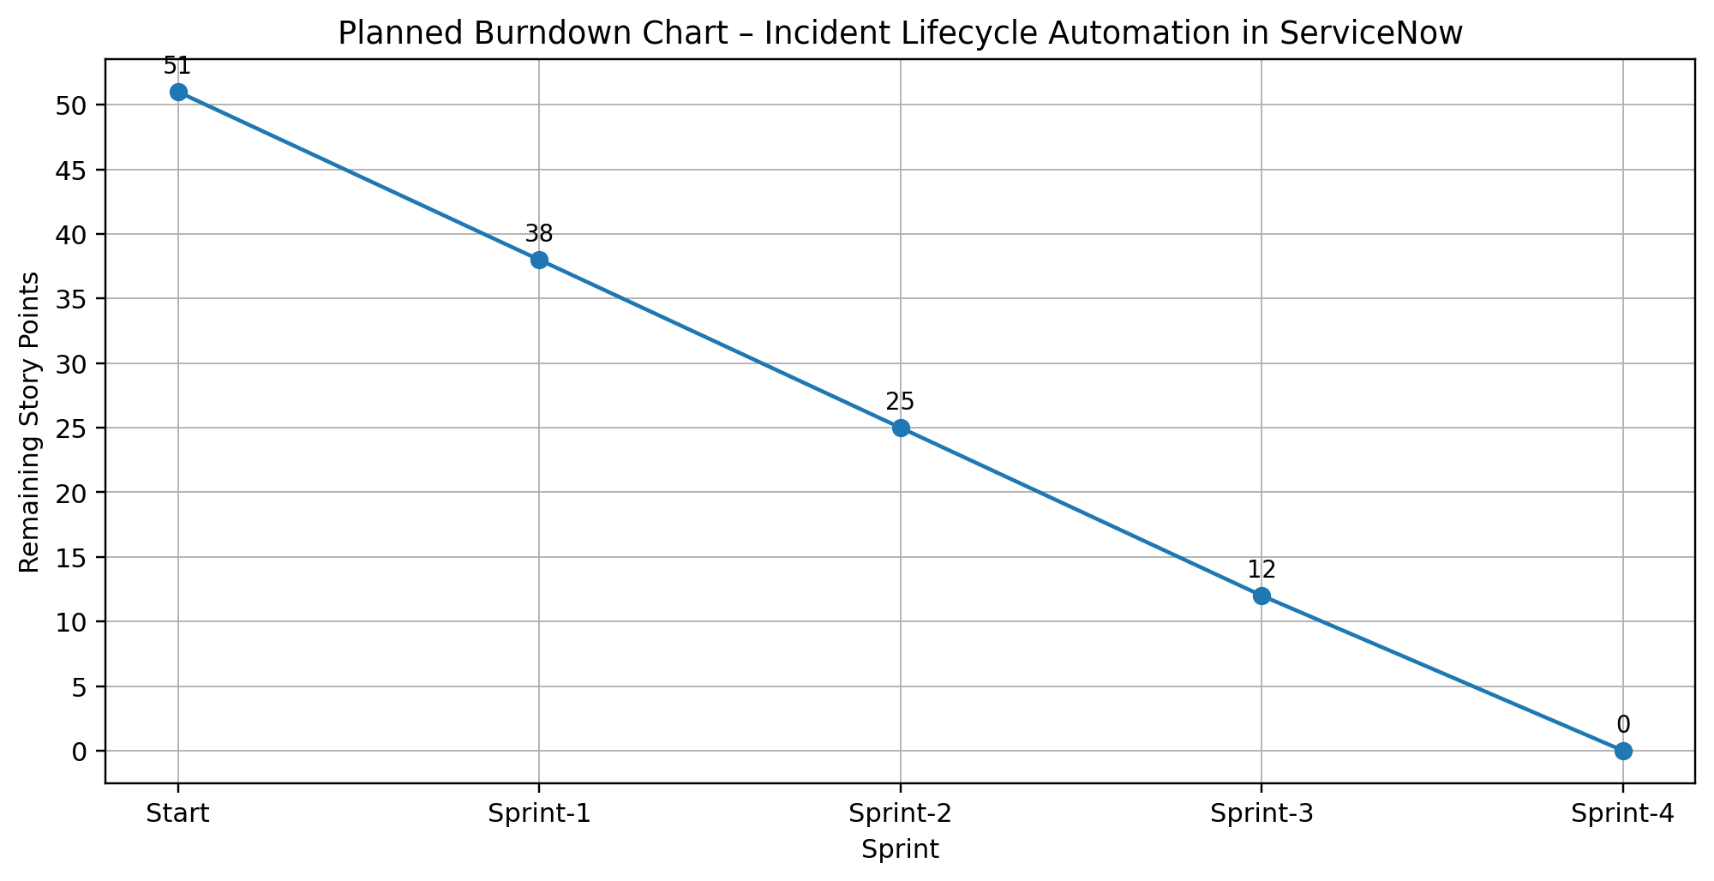

Burndown Chart: A burn down chart is a graphical representation of work left to do versus time. It is often used in agile software development methodologies such as Scrum and can be applied to projects containing measurable progress over time.

