Project Design Phase-II
Data Flow Diagram & User Stories
Date | ________________________________________
Team ID | ________________________________________
Project Name | Incident Lifecycle Automation in ServiceNow
Maximum Marks | 4 Marks

Data Flow Diagrams: A Data Flow Diagram (DFD) is a traditional visual representation of the information flows within a system. The DFD below represents how incident information enters ServiceNow, is processed through Incident Management, and is stored or exchanged with related ServiceNow records.

Figure 1: DFD Level 0 – Incident Lifecycle Automation in ServiceNow
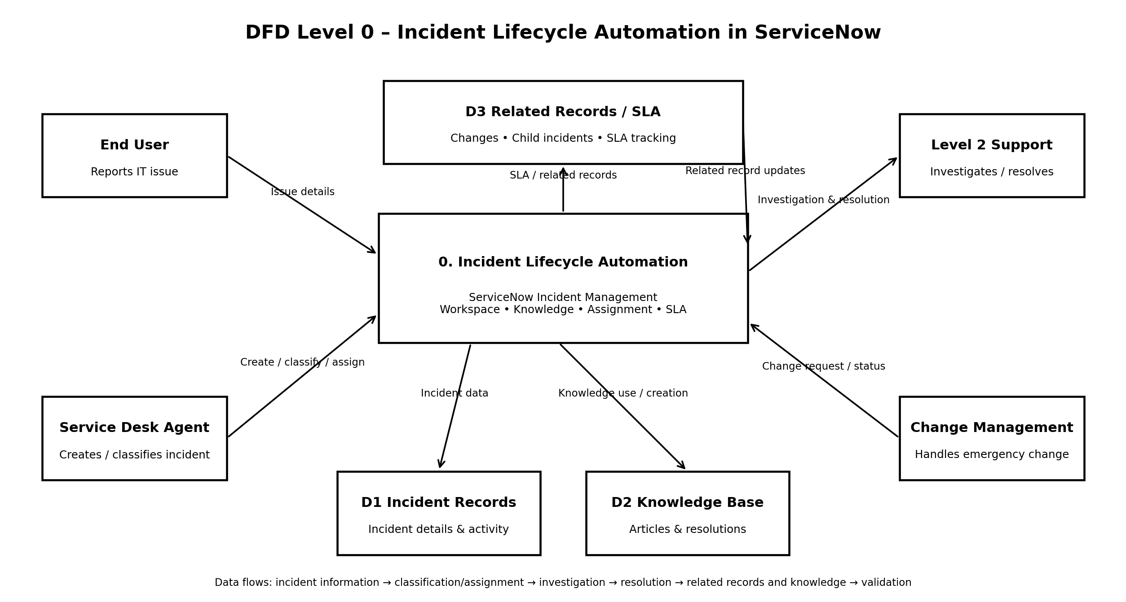

DFD Explanation: End Users report incidents and Service Desk Agents create, classify, and assign incident records. Level 2 Support investigates and resolves incidents. When required, Change Management handles an emergency change. ServiceNow maintains incident records, knowledge information, related records such as child incidents and changes, and SLA tracking throughout the lifecycle.

User Stories
The following user stories are defined for Incident Lifecycle Automation in ServiceNow using the prescribed user-story table structure. The stories cover the functional scope of the project.
User Type | Functional  Requirement (Epic) | User Story  Number | User Story / Task | Acceptance criteria | Priority | Release
End User | Incident Management | USN-1 | As an end user, I can report an IT incident so that the issue is formally recorded for support.  Story Points: 5 | An incident record is created with the reported issue and caller information. | High | Sprint-1
Service Desk Agent | Incident Creation | USN-2 | As a Service Desk Agent, I can create an incident in Service Operations Workspace with the required incident details.  Story Points: 5 | The incident is saved and can be opened and tracked in Service Operations Workspace. | High | Sprint-1
Service Desk Agent | Incident Classification | USN-3 | As a Service Desk Agent, I can classify an incident using category, subcategory, urgency, service, service offering, and CI.  Story Points: 3 | The selected classification and service information are stored on the incident. | High | Sprint-1
Service Desk Agent | Knowledge Management | USN-4 | As a Service Desk Agent, I can use Agent Assist and Knowledge articles while working on an incident.  Story Points: 5 | Relevant Knowledge articles can be viewed, attached to the incident, and marked helpful. | High | Sprint-2
Service Desk Agent | Assignment & Reassignment | USN-5 | As a Service Desk Agent, I can assign or reassign an incident to the appropriate support group.  Story Points: 5 | The incident is assigned to the selected support group and the assigned-to information is updated appropriately. | High | Sprint-2
Level 2 Support | Incident Investigation | USN-6 | As a Level 2 support technician, I can investigate an escalated incident and review its description, Knowledge articles, and SLA information.  Story Points: 3 | The Level 2 technician can access the incident details, related Knowledge, and Task SLA information. | High | Sprint-2

User Stories (Continued)
User Type | Functional  Requirement (Epic) | User Story  Number | User Story / Task | Acceptance criteria | Priority | Release
Change Management Team | Emergency Change | USN-7 | As a Change Management team member, I can handle an emergency change related to an incident when a change is required for resolution.  Story Points: 5 | The emergency change is linked to the incident and the incident can be placed on hold awaiting change. | High | Sprint-3
Service Desk Agent | Child Incident Management | USN-8 | As a Service Desk Agent, I can create a child incident for another user affected by the same issue.  Story Points: 5 | The child incident is created and is listed under the parent incident's related records. | Medium | Sprint-3
Level 2 Support | Incident Resolution | USN-9 | As a Level 2 support technician, I can document the probable cause and resolution notes and resolve the incident.  Story Points: 3 | Cause and resolution details are saved and the incident state changes to Resolved. | High | Sprint-3
Service Desk Agent | Knowledge Creation | USN-10 | As a Service Desk Agent, I can create a Knowledge article from a resolved incident.  Story Points: 5 | A Knowledge article is created using the selected Knowledge Base and template and is visible in related records. | Medium | Sprint-4
ServiceNow Administrator | SLA & Related Records | USN-11 | As a ServiceNow Administrator, I can validate SLA information and related records across the incident lifecycle.  Story Points: 5 | SLA tracking and related change, child incident, and Knowledge records are visible and linked correctly. | High | Sprint-4
ServiceNow Administrator | Testing & Validation | USN-12 | As a ServiceNow Administrator, I can validate the complete incident lifecycle from creation through resolution and knowledge creation.  Story Points: 2 | The end-to-end scenario, escalation, change integration, child incident, Knowledge creation, and SLA tracking are validated. | High | Sprint-4
Sprint / Velocity Consistency: Sprint-1 = 13 points, Sprint-2 = 13 points, Sprint-3 = 13 points, Sprint-4 = 12 points. Total = 51 story points; Velocity = 51 ÷ 4 = 12.75 points/sprint.
Project Coverage: The user stories cover incident creation, classification, Knowledge/Agent Assist, assignment and reassignment, Level 2 investigation, emergency change creation, child incidents, incident resolution, Knowledge creation, SLA/related-record validation, and final testing.

