Project Design Phase-II
Technology Stack (Architecture & Stack)
Date | ________________________________________
Team ID | ________________________________________
Project Name | Incident Lifecycle Automation in ServiceNow
Maximum Marks | 4 Marks

Technical Architecture: The Deliverable shall include the architectural diagram and the information as per Table-1 and Table-2.
Project Architecture: The architecture below is specific to the Incident Lifecycle Automation in ServiceNow project.

Figure 1: Technical Architecture – Incident Lifecycle Automation in ServiceNow
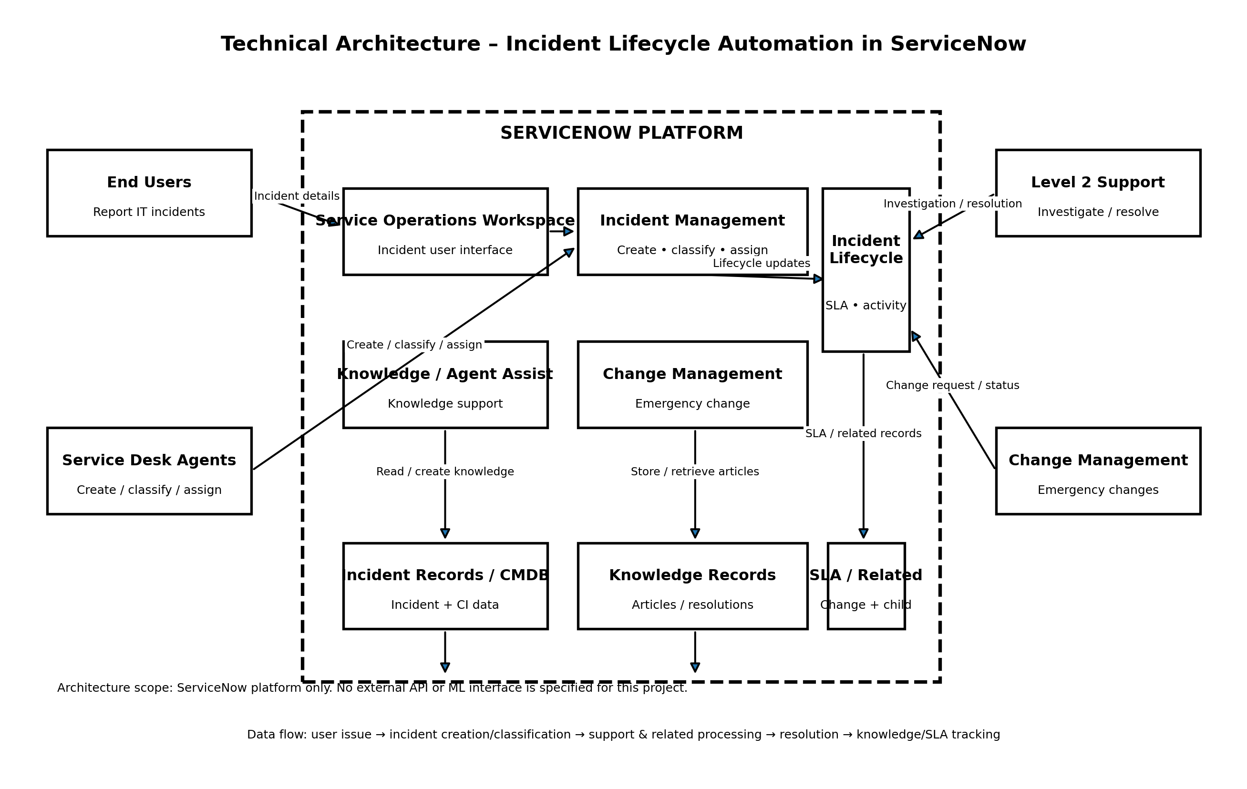

Architecture Note: The project information supplied identifies ServiceNow and its related capabilities. No external API, machine-learning model, or separate local/cloud infrastructure configuration was specified; therefore these items are marked as not specified/not applicable rather than being invented.

Table-1 : Components & Technologies

S.No | Component | Description | Technology
1 | User Interface | How the user interacts with the application. | Service Operations Workspace
2 | Application Logic-1 | Logic for incident creation, classification, assignment, reassignment, investigation, and resolution. | ServiceNow Incident Management
3 | Application Logic-2 | Logic for knowledge-supported incident resolution and Agent Assist. | Knowledge Management / Agent Assist
4 | Application Logic-3 | Logic for emergency change handling and related-record processing. | Change Management / Related Records
5 | Database | Data records required for incident lifecycle tracking, including incident details, activity, and configuration item information. | ServiceNow Incident records / CMDB
6 | Cloud Database | Database service on cloud. | Not separately specified in the project information; ServiceNow platform data storage is used.
7 | File Storage | File storage requirements. | Not specified / not required in the supplied project scope.
8 | External API-1 | Purpose of external API used in the application. | None specified.
9 | External API-2 | Purpose of external API used in the application. | None specified.
10 | Machine Learning Model | Purpose of machine learning model. | Not applicable; no machine-learning model is specified for this project.
11 | Infrastructure (Server / Cloud) | Application deployment on local system / cloud. | ServiceNow Platform. Specific local/cloud server configuration is not separately specified.

Guideline coverage: The architecture includes the application/process blocks, ServiceNow platform boundary, data storage/record components, and external stakeholder interfaces. External APIs and ML interfaces are explicitly marked as none/not applicable because they were not provided as part of the project.

Table-2: Application Characteristics

S.No | Characteristics | Description | Technology
1 | Open-Source Frameworks | List the open-source frameworks used. | No open-source framework was specified in the supplied ServiceNow project details.
2 | Security Implementations | List all security/access controls implemented. | The project information identifies role-based stakeholder participation, but specific security controls, encryption, firewall, or access-control configurations were not provided.
3 | Scalable Architecture | Justify the scalability of architecture. | The project is documented around ServiceNow Incident Management and related capabilities. Specific 3-tier or microservices implementation was not specified.
4 | Availability | Justify the availability of the application. | The project uses ServiceNow capabilities for incident lifecycle operations. Specific load balancer or distributed-server configuration was not provided.
5 | Performance | Design consideration for performance of the application. | The project emphasizes structured incident processing, Knowledge/Agent Assist, SLA tracking, and related-record visibility. Specific request-rate, caching, or CDN configuration was not provided.

