
Sociology and Demography (MA)
Labor Market and Occupation Policies, A.Y. 2024/2025

Joli Christian u255226 christian.joli01@estudiant.upf.edu

Regional Context, Net Migration Rate, and GDP Per Capita. What Is Their Relationship in Italy?
Abstract
This study investigates the macro-level relationship between regional context, net immigration rate, and GDP per capita in Italy from 2000 to 2023. Using data from the ESS survey at the NUTS-2 regional level, panel linear regression modelling is employed. The findings highlight a significant overall positive relationship between the net immigration rate and GDP per capita across Italy. However, when considering the moderating effect of the net immigration rate at the regional level, distinct patterns emerge. Specifically, two regions (Lazio and Marche) exhibit a positive relationship, while two others (Emilia-Romagna and Toscana) show a negative relationship. The analysis further emphasizes a significant negative association in certain contexts. Although these results underscore the importance of adopting a regional approach when studying immigration, caution is advised when generalizing these findings, as potential endogeneity and methodological limitations may affect their robustness.
Word count: 3,599 words (excluding abstract, tables, references and appendix)

1. Introduction
Italy represents an intriguing and distinctive context for analyzing the interplay between immigration and regional economic performance. Over the past two decades, Italy has emerged as a major destination for immigrants, reaching unprecedented levels in terms of foreign-born residents, who now exceed 5 million people, accounting for approximately 8% of the total population (Bonatti, 2019).
Prior research and economic theory suggest that immigration can positively affect the economies of both host and origin countries (Kahanec & Pytlikova 2017, Koczan et al. 2021). Immigrants contribute to the labor force, aggregate demand, and may introduce skills or entrepreneurial activities that enhance productivity and innovation (Borjas 2019). Borjas (2019, p. 2) specifically describes immigration as a <<key contributor to economic growth>>. Cross-country evidence consistently indicates that migration supports economic growth and productivity in advanced economies (Brunow et al. 2015, Dustman & Preston 2019, IMF 2020). For instance, IMF (2020) finds that immigration positively impacts per capita output in the short and medium term by increasing both labor supply and efficiency.
Simultaneously, the Italian economy remains characterized by significant regional disparities. The historical geographical and economic divide between Northern and Southern Italy has shown minimal improvement over recent decades. For example, in 2017, GDP per capita in Southern Italy was 45% lower than in the rest of the nation, a gap similar to that recorded in the early 1970s (Bonatti 2019). Furthermore, in 2022, this disparity persisted, with per capita GDP in the northwest nearly double that of the Southern regions (€40,900 compared to €21,700, ANSA). Consequently, the regional economic gap underscores the continued relevance of geographical location in analyzing economic outcomes. The historically more industrialized Northern and Central regions consistently outperform Southern regions in terms of wealth and productivity (Bonatti 2019). Structural factors—including infrastructure quality, human capital, and historical investment patterns—contribute to persistent regional inequality. Official statistics reinforce that Southern Italy's GDP per capita remains roughly half that of Northern Italy (Bonatti 2019, ANSA).
Additionally, immigration has been credited with sustaining economic growth in Italy during periods of declining native labor force. Bugamelli et al. (2018) estimate that Italy's modest GDP growth over recent decades was entirely driven by immigration-driven population growth, given the absence of productivity gains (Bonatti 2019).
This study investigates the relationship between regional contexts in Italy, net immigration rates, and regional economic performance (expressed through GDP per capita) from 2000 to 2023. Using data from ESS (2023), this research addresses two central questions: Does immigration foster regional economic growth in Italy, and can it contribute to reducing (or exacerbating) regional economic disparities? Addressing these questions is not only academically significant but crucial for policy, especially considering Italy's demographic aging, labor shortages, and entrenched regional inequalities.
It is important to note that this paper exclusively focuses on international immigration into Italy, excluding internal migration (e.g., from Southern to Northern regions).
2. Theoretical Framework, Previous Studies, and Hypotheses
2.1 Push-Pull Theory
When discussing immigration, the Push-Pull Theory provides a useful analytical framework (European Commission). According to this theory, migration decisions are driven by factors that either attract individuals to another country (pull factors) or compel them to leave their home countries (push factors) (European Commission).
Push factors are contextual variables that encourage people to emigrate (Siyal et al. 2019). Examples include reduced agricultural yields due to climate change (Federal Ministry for Economic Cooperation and Development 2023, Dritsaki & Dritsaki 2024), low educational attainment, discrimination, inadequate healthcare systems, limited industrialization (Lee 1966, Khan 2021), and lack of economic and political freedom (Ashby 2010).
Conversely, pull factors are incentives attracting individuals to another country, such as improved living conditions, higher wages, better healthcare and education, favorable climate, and lower crime rates (Urbanski 2022). Extensive literature identifies economic opportunities as a primary pull factor, particularly for migrants from developing countries like India (Khalid & Urbanski 2021, Mandal et al. 2018, Carbajal & De Miguel Calvo 2021).
2.2 Immigration, Mobility, and Economic Growth
Literature broadly acknowledges that mobility and international relations foster knowledge exchange, enhancing regional knowledge bases and consequently stimulating economic growth (Peri 2012, Huber & Tondl 2012, Boubtane et al. 2013, IMF 2020). Frankel and Romer (1999) and Keller (2004), for instance, highlight international trade and foreign direct investment (FDI) as critical mechanisms facilitating cross-national ties and economic openness, thereby positively affecting GDP per capita.
Migration constitutes another essential channel of knowledge transfer, impacting a country's ability to assimilate advanced technologies (Andersen & Dalgaard 2011). Migration movements facilitate not only the physical transfer of individuals but also the flow of ideas, which supports economic growth in both sending and receiving regions (Bodvarsson & Van den Berg 2013). Indeed, migration flows function as "information brokers" that connect home and host regions, acting as transnational knowledge conduits (D'Ambrosio et al. 2019, p. 8).
Furthermore, globalization processes have intensified, significantly enhancing economic growth globally, a trend partly attributable to the substantial immigrant workforce contributing directly to GDP per capita (OECD 2007, Borjas 2019, Bernardino et al. 2021). Immigration also stimulates skill mobility and labor market efficiency, positively influencing wage structures and job allocation (Dolado et al. 1994, Angrist & Kugler 2003, Borjas 2003, Boubtane et al. 2013).
Another positive impact is found in Niebuhr (2010) work, where he states:
“Knowledge and capabilities of workers from diverse cultural backgrounds enhance[s] performance of regional R&D sectors. As regards innovation, the benefits of diversity seem to outweigh the costs caused, for example, by communication barriers.” (p. 563).
However, the magnitude of immigration's impact depends on the host regions' developmental status and absorptive capacity (Aghion et al. 2005, 2009, Acemoglu et al., 2006).
Immigration also drives entrepreneurship and innovation, as evidenced by immigrant-founded businesses and innovation contributions across Italian regions (Kerr & Lincoln, 2010).
Hypothesis 1: Higher immigration rates positively correlate with higher GDP per capita.
2.3 The Italian Context
Cumulative causation theories (Myrdal, 1957) suggest richer regions attract more investment and talent, reinforcing advantages, while poorer regions face persistent challenges. Northern Italy historically attracted capital, leading to better job opportunities and infrastructure, whereas Southern Italy suffered from outward migration and economic stagnation (Vedovato 1990, Paci & Pigliaru 1998, Dunford & Greco 2008, Iuzzolino et al. 2011, Marinelli 2011, Mulino et al. 2017, Ramazzotti 2023, Scarpino et al. 2023, Mauro & Pigliaru 2024, Colacchio & Forges Davanzati 2025). Differences in institutional quality and governance further exacerbate regional disparities (Putnam 1993a, 1993b). Empirical analyses confirm persistent regional income variations, indicating slow convergence among Italian regions (Cellini & Scorcu 2000, OECD 2019, European Commission 2023).
2.4 Italy and Immigration
In 2023, Italy’s principal immigrant origins include Ukraine (32.9%), Albania (28.9%), Bangladesh (24.9%), and Romania (21.9%) (ANPAL, 2023). Given Italy's declining native birth rates and aging population, the country relies increasingly on immigrant labor to sustain economic growth. Immigrants contribute significantly to Italy’s GDP, employment rates, and welfare sustainability (OECD 2019, IOM 2017).
Nonetheless, the specific economic contribution of immigration varies based on immigrants' skill levels and labor market conditions. As a consequence, the magnitude of the immigration effect depends on context. Factors such as the skill composition of immigrants, the flexibility of the labor market, and the capacity of the economy to absorb new workers will inevitably differ, influencing the possible outcomes. In Italy, many immigrants are employed in temporary occupations (OECD 2014), which has a twofold implication. On one hand, it means that immigrants occupy jobs that would otherwise remain vacant. On the other hand, economic growth in terms of GDP per capita generated by immigrants occupying precarious employment positions will not be very high, given their limited contribution. Nonetheless, even low-skilled immigration can indirectly raise native productivity by enabling locals to transition into higher-skilled roles or by preventing losses in sectors that would contract without immigrant labor (Foged & Peri, 2015).
2.5 Italian regional disparities and immigration
Neoclassical growth theory suggests that labor mobility functions as a mechanism for convergence: workers move to regions with labor shortages—often those offering higher wages—thereby equalizing the marginal productivity of labor across regions over time (Solow, 1999). In the Italian case, however, labor mobility has historically taken the form of internal migration from the South to the North, arguably exacerbating the South’s depopulation and economic decline. International immigration introduces a different dynamic: rather than redistributing Italians within the country, it brings additional people from abroad. If some of these newcomers settle in the South or in economically disadvantaged areas, they may contribute to local economies in ways that help reduce the persistent North–South divide. For instance, foreign workers have become essential to Southern Italy’s agriculture and caregiving sectors, supporting productivity in areas that might otherwise face even more severe economic contractions. Some rural towns have even leveraged immigration to counteract population decline and revitalize local businesses—such as small-scale manufacturing and artisan enterprises—illustrating immigration’s potential to stimulate lagging regions (ISTAT 2021, Del Giudice 2023).
Empirical evidence on whether immigration reduces or exacerbates regional disparities remains mixed. As previously discussed, studies such as Berardino et al. (2021) indicate that regions receiving a larger number of immigrants experienced a greater economic boost than those receiving fewer. In Centre-North regions, both the scale and diversity of immigration positively influenced per capita GDP growth. In the South, however, only the scale of immigration had a positive effect, and that effect was significantly smaller (Berardino et al. 2021). These findings suggest that wealthier regions were better positioned to transform immigration into economic gains, while poorer regions benefited less—possibly even widening the existing economic gap.
In the context of a regression model, regional fixed effects or dummy variables are expected to be jointly significant, indicating that the “region of reference” contributes meaningfully to the model’s explanatory power.
Furthermore, Berardino et al. (2021) found that an increased share of immigration significantly fostered output per capita between 2003 and 2017, with provinces that experienced higher immigration rates also registering higher income per resident. This positive association supports the rationale that when regions attract more immigrants, they often reap economic benefits in terms of both output and income.
However, these findings also highlight an important caveat: immigration alone does not necessarily act as an equalizer of regional disparities. In fact, it may exacerbate inequality if the distribution of immigrants is uneven or if infrastructure and labor market access—both for natives and immigrants—remain inadequate.
Nevertheless, immigrants have helped maintain economic activity in Southern regions. As aging and out-migration have reduced the native labor force, immigrants have partially compensated for this loss, sustaining local employment levels (Bonatti 2019).
Moreover, the immigration rate may serve as a moderating variable in the relationship between regional context and GDP per capita. It is reasonable to expect that regions with higher immigration rates might experience a reduction in the strength of the “region effect” on income. The influx of new workers and consumers can stimulate growth regardless of initial regional disadvantages. In this sense, immigration could function as an external shock capable of triggering economic development in multiple regions. This, in turn, could offer insights into how immigration might reduce the preexisting economic gap between regions, with those experiencing larger inflows of immigrants potentially benefiting more in terms of economic growth.
H2: The higher the immigration rate, the lower the effect of regional context on GDP per capita.
3. Data and Variables
3.1 Data
The European Social Survey is a large-scale, cross-national, and repeated cross-sectional survey research program. For this analysis, panel multilevel data from Italy is used, covering the period from 2000 to 2023, and focusing exclusively on macro-level observations categorized at the NUTS2 (regional) level.
The final analytical sample consists of 205 observations.
3.2 Variables
The dependent variable (Y), ”GDP per capita” is a continuous variable useful as it is commonly used in the literature as an indicator of national economic performance, reflecting average living standards or economic well-being (OECD 2013). Figure 1 reports the GDP per capita trend over the years for each region.
Figure 1. GDP per capita trend for regions from 2000 to 2023
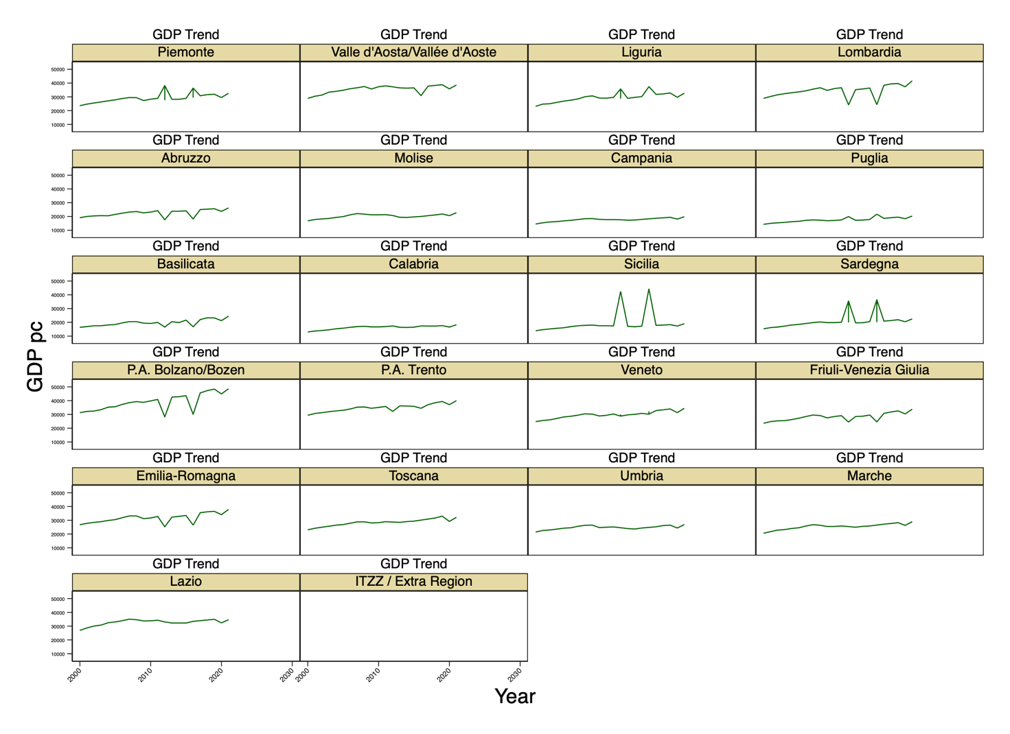
The main independent variable (X) is “Region”, a categorical variable representing each region of Italy at the NUTS2 level, accounting also for the two autonomous provinces and an “extra region”, which takes into account possible residuals. The values correspond to the Italian territorial units (1 = “Piemonte”; 2 = “Valle d’Aosta/Vallée d’Aoste”; 3 = “Liguria”; 4 = “Lombardia”; 5 = “Abruzzo”; 6 = “Molise”; 7 = “Campania”; 8 = “Puglia”; 9 = “Basilicata”; 10 = “Calabria”; 11 = “Sicilia”; 12 = “Sardegna”; 13 = “P.A. Bolzano/Bozen”; 14 = “P.A. Trento”; 15 = “Veneto”; 16 = “Friuli-Venezia Giulia”; 17 = “Emilia-Romagna”; 18 = “Toscana”; 19 = “Umbria”; 20 = “Marche”; 21 = “Lazio”; 22 = “ITZZ / Extra Region”).
Moreover, the variable “Net Migration Rate” is included as a moderator (Z), while also being examined for its direct effect on Y. This continuous variable is suitable for this analysis since not only gives the number of immigrants in a region over the years but gives the result of the difference between the number of immigrants and the number of emigrants per year divided by the population (Raymer & Wiśniowski 2018), giving a clearer rate net of the real new population of a nation. As Figure 2 suggests, for a lot of regions, the variability registered over the years for the Net Migration Rate is low. As a consequence, in order to not inflate the regression outcomes, those regions are dropped.
Figure 2. Net migration rate trend for regions from 2000 to 2023
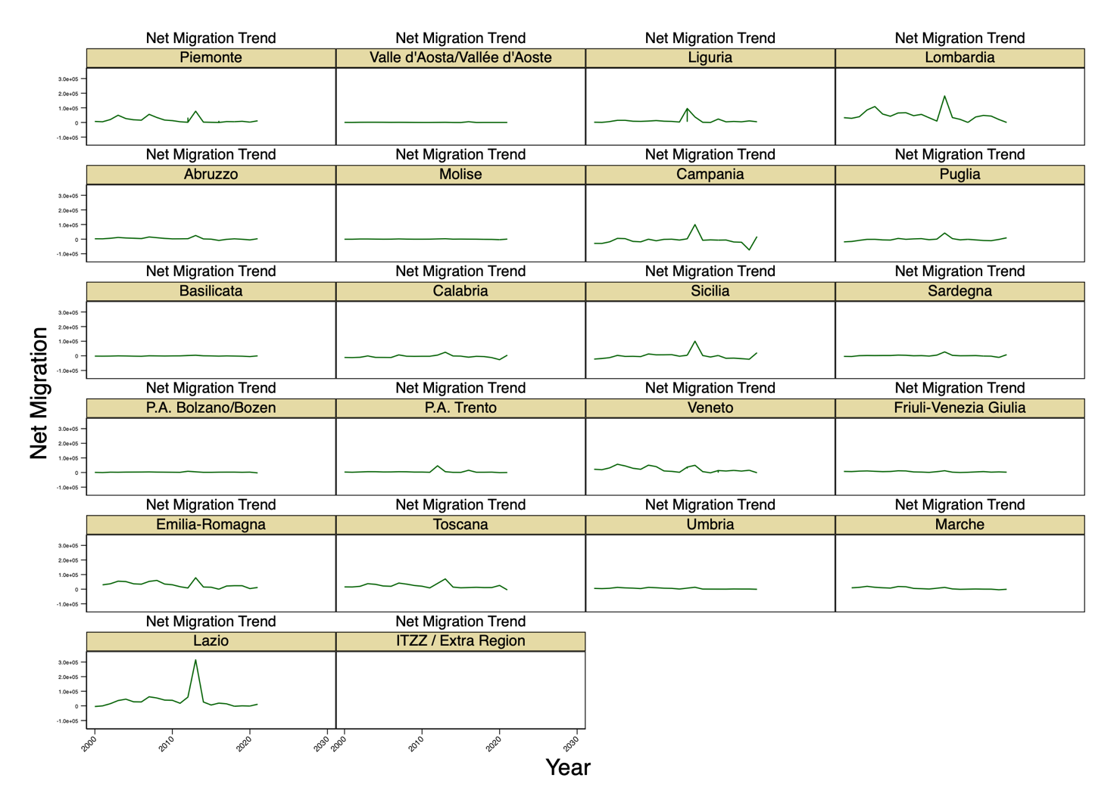

Finally, several control variables, as continuous variables are included: ”Unemployment Rate”; ”Density of the Population”; “Long-Term Unemployment”; “Fertility Rate”; “Infant-Mortality Rate”; “Life Expectancy”; and “Year”.

Table 1. Descriptive statistics of the variables
 | Mean | Sd | Min | Max
gdp_pc | 26377.27 | 7056.195 | 13000 | 41600
netmig_rate | 18177.05 | 34471.14 | -74027 | 315302
unrate | 10.45619 | 6.248091 | 2.8 | 27.3
popdens | 246.8702 | 105.0338 | 123.7 | 439.2
ltu_rate | 50.92905 | 11.87202 | 25.3 | 76.2
fert | 1.344285 | .0993646 | 1.12 | 1.57
infantmr | 3.122936 | .9966426 | 1.2 | 6.7
lifeexp | 81.98349 | 1.352486 | 78.2 | 84.4
year | 2010.5 | 6.358757 | 2000 | 2021
Observations | 220

4.Analytical Strategy
To test the hypotheses, stepwise panel linear regression models are employed. In the first model, the effect of Region on GDP per capita is examined while controlling for the Net Migration Rate. The second model introduces an interaction term between Region and the Net Migration Rate, without including any control variables, in order to assess the gross effect of this interaction on GDP per capita. Finally, the third model includes relevant control variables to evaluate how the relationship between the main predictor, considered with the moderator, and GDP per capita may change once these additional factors are accounted for.
5.Results
Figure 3. Scatter plot illustrating the relationship between Region as the independent variable, Net Migration Rate as a moderator and GDP per capita as the dependent variable (with outliers).
As shown in Figure 3, the analysis reveals that several regions are affected by the presence of outliers, which may inflate the effects of the variables and bias the overall results. To address this issue and improve the clarity of the output, the mean and standard deviation of the Met Migration Rate were calculated for each region. Following standard econometric practice, observations exceeding three standard deviations from the regional mean were identified and removed as outliers (e.g., Barnett & Lewis 1994, Gujarati & Porter 2009, Wooldridge 2012). Notably, the identified outlier value occurred simultaneously across all regions in the year 2013.
Table 2. Regression table for three models.
GDP per capita | Model 1 | Model 2 | Model 3
netmig_rate | -0.020 | -0.014 | 0.006**
 | (0.014) | (.) | (0.002)
Lombardia#c.netmig_rate |  | -0.021 | -0.005
 |  | (.) | (0.005)
Campania#c.netmig_rate |  | 0.029 | 0.004
 |  | (.) | (0.003)
Calabria#c.netmig_rate |  | 0.053 | 0.004
 |  | (.) | (0.007)
Sicialia#c.netmig_rate |  | 0.058 | 0.011
 |  | (.) | (0.010)
Veneto#c.netmig_rate |  | -0.051 | -0.003
 |  | (.) | (0.006)
Emilia-Romagna#c.netmig_rate |  | -0.048 | -0.013**
 |  | (.) | (0.005)
Toscana#c.netmig_rate |  | -0.066 | -0.020***
 |  | (.) | (0.005)
Marche#c.netmig_rate |  | -0.121 | 0.037**
 |  | (.) | (0.013)
Lazio#c.netmig_rate |  | 0.051 | 0.050***
 |  | (.) | (0.009)
unrate |  |  | -228.496**
 |  |  | (80.187)
popdens |  |  | 36.380
 |  |  | (28.699)
ltu_rate |  |  | 15.406
 |  |  | (19.613)
fert |  |  | 2,748.438*
 |  |  | (1,397.282)
infantmr |  |  | 532.276**
 |  |  | (169.598)
lifeexp |  |  | 157.384
 |  |  | (166.201)
year |  |  | 289.634***
 |  |  | (28.836)
Constant | 26,711.782*** | 27,169.158 | -581,804.263***
 | (207.773) | (.) | (59,370.759)
Observations | 213 | 213 | 205
R-squared | 0.025 | 0.138 | 0.801
Number of region_num | 10 | 10 | 10
Robust standard errors in parentheses
*** p<0.01, ** p<0.05, * p<0.1

In the first model, the impact of the Net Migration Rate on GDP per capita is examined without including control variables. In this specification, the Net Migration Rate does not exhibit a statistically significant effect on GDP per capita.

In the second model, the interaction term between Region and Net Migration Rate is introduced, still without controlling for additional variables. Here too, neither the Net Migration Rate nor the interaction terms with Region show any statistically significant effects.

In the third model, all relevant control variables are included. This model reveals that several predictors—including some of the interaction terms—become statistically significant. Specifically, the Net Migration Rate is shown to have a significant and positive effect on GDP per capita, with a coefficient of 0.006**. As a result, the first hypothesis cannot be rejected.

However, the interaction terms exhibit a more complex pattern. Statistically significant effects are found only for Emilia-Romagna, Toscana, Marche, and Lazio. For Emilia-Romagna and Toscana, the interaction between the Net Migration Rate and GDP per capita is negative and significant (-0.013** and -0.020***, respectively). In contrast, for Marche and Lazio, the interaction is positive and significant (0.037** and 0.050**, respectively). These results highlight not only regional differences but also positive and negative regional outcomes associated with immigration’s effect on GDP per capita. Therefore, the second hypothesis is rejected.

Figure 4 provides a graphical representation of the model’s results using a scatter plot, visually illustrating the linear relationship between the Net Migration Rate and GDP per capita across the regions included in the analysis.

With regard to the control variables, the unemployment rate has a negative and statistically significant effect on GDP per capita (-228.496**), while the fertility rate shows a positive and significant effect (2,748.438*). Similarly, the infant mortality rate is positively and significantly associated with GDP per capita (532.276**), and the year variable also displays a significant positive effect (289.634***).

Figure 4. Scatter plot illustrating the relationship between Region as the independent variable, Net Migration Rate as a moderator and GDP per capita as the dependent variable (without outliers).
6. Conclusions and Discussion
The academic field of migration studies offers an extensive body of literature on the topic. Some contributions have explored the interplay between macro-level immigration flows and micro-level outcomes such as wages (Borjas, 2017). In contrast, the present study focuses exclusively on macro-regional effects within the Italian context. Specifically, the aim was to assess the magnitude of immigration’s impact on the relationship between regional context and GDP per capita in Italy. This was achieved through a panel data analysis covering the period from 2000 to 2023.
The theoretical framework is grounded in the “Push-Pull” theory of migration (European Commission) and the Neoclassical growth theory (Solow, 1999). Based on this foundation, the first hypothesis proposed a positive association between higher net immigration rates and higher regional GDP per capita. Previous studies have supported this relationship, identifying positive links between mobility—whether of knowledge or capital—and economic growth (Peri, 2012; Huber & Tondl, 2012; Boubtane et al., 2013; IMF, 2020). The findings of this analysis are consistent with this trend, and as such, the first hypothesis cannot be rejected.
An interaction term was then introduced to capture the macro-level interplay between the regional context and the Net Migration Rate. Accordingly, the second hypothesis proposed that the effect of regional context on GDP per capita would vary depending on the level of net immigration. Existing literature highlights significant regional disparities in Italy, particularly in relation to the North-South divide (Vedovato 1990, Paci & Pigliaru 1998, Dunford & Greco 2008, Iuzzolino et al. 2011, Marinelli 2011, Mulino et al. 2017, Ramazzotti 2023, Scarpino et al. 2023, Mauro & Pigliaru 2024, Colacchio & Forges Davanzati 2025). While immigration may offer opportunities for disadvantaged regions, structural constraints—such as historically rooted infrastructural deficiencies (Myrdal 1957)—may limit their capacity to accommodate large migrant populations.
The empirical findings point to a more nuanced pattern: Emilia-Romagna and Toscana show a negative interaction effect, whereas Lazio and Marche display a positive one. These results underscore the importance of considering regional context when examining the economic impacts of immigration in Italy. Moreover, the findings suggest that regional disparities may not always align neatly with the North-South divide. In this case, all significant interaction effects were observed in regions located in the central part of the country, with divergent outcomes—two negative, and two positive.
This pattern may be explained by differences in regional infrastructure or by the varying distribution of net migration rates. For example, Marche—despite showing a relatively low net migration rate over the years—was associated with positive economic outcomes. This could indicate that limited but manageable migration flows may be beneficial, whereas larger inflows might yield different results for certain regions. These dynamics highlight the need for region-specific approaches when assessing the broader economic consequences of immigration.
Following the results obtained, this study provides meaningful insights and contributes to the existing body of literature. As previously discussed, many prior studies have focused on micro-level outcomes, whereas this analysis adopts a macro-level perspective. This approach allows for a deeper exploration of regional dynamics within a complex Southern European country such as Italy, by examining how immigration flows interact with local contexts over time through panel data analysis. By capturing temporal trends, the study addresses a notable gap in migration research, particularly in the Italian case.
From a policy perspective, these findings highlight the importance of adopting region-specific strategies when assessing the effects of immigration. Tailored approaches that consider institutional frameworks, infrastructure quality, social cohesion, labor market conditions, and the capacity for integration can help ensure that immigration contributes positively to economic growth. Such strategies are essential not only to mitigate potential negative impacts, but also to leverage immigration as a driver of development and innovation.
Lastly, this study is subject to several limitations. First, the risk of endogeneity and multicollinearity is present. Without establishing a clear causal chain, it is not possible to draw definitive conclusions about causality, which weakens the robustness of the analysis. Moreover, the methodology employed may not be the most appropriate for addressing the complexity of this topic. Previous research—such as Borjas (2017)—has often relied on more advanced econometric techniques, including difference-in-differences approaches and instrumental variable methods, to better account for endogeneity.
Additionally, this study does not include information on the composition of the immigrant population arriving in Italy. As a result, important factors such as nationality, political attitudes, religion, and skill levels are not captured, preventing an assessment of within-group heterogeneity among immigrants. The analysis also lacks consideration of the institutional structure of the various regions, failing to examine in depth the public-private divide or differences in governance capacity across the country.
Future research should address these limitations to offer a more comprehensive understanding of the potential benefits of immigration for host countries—particularly in fragmented national contexts like Italy, where regional disparities are deeply entrenched and highly relevant to the migration-development nexus.
Appendix
Figure 5. Fertility trend for regions from 2000 to 2023.
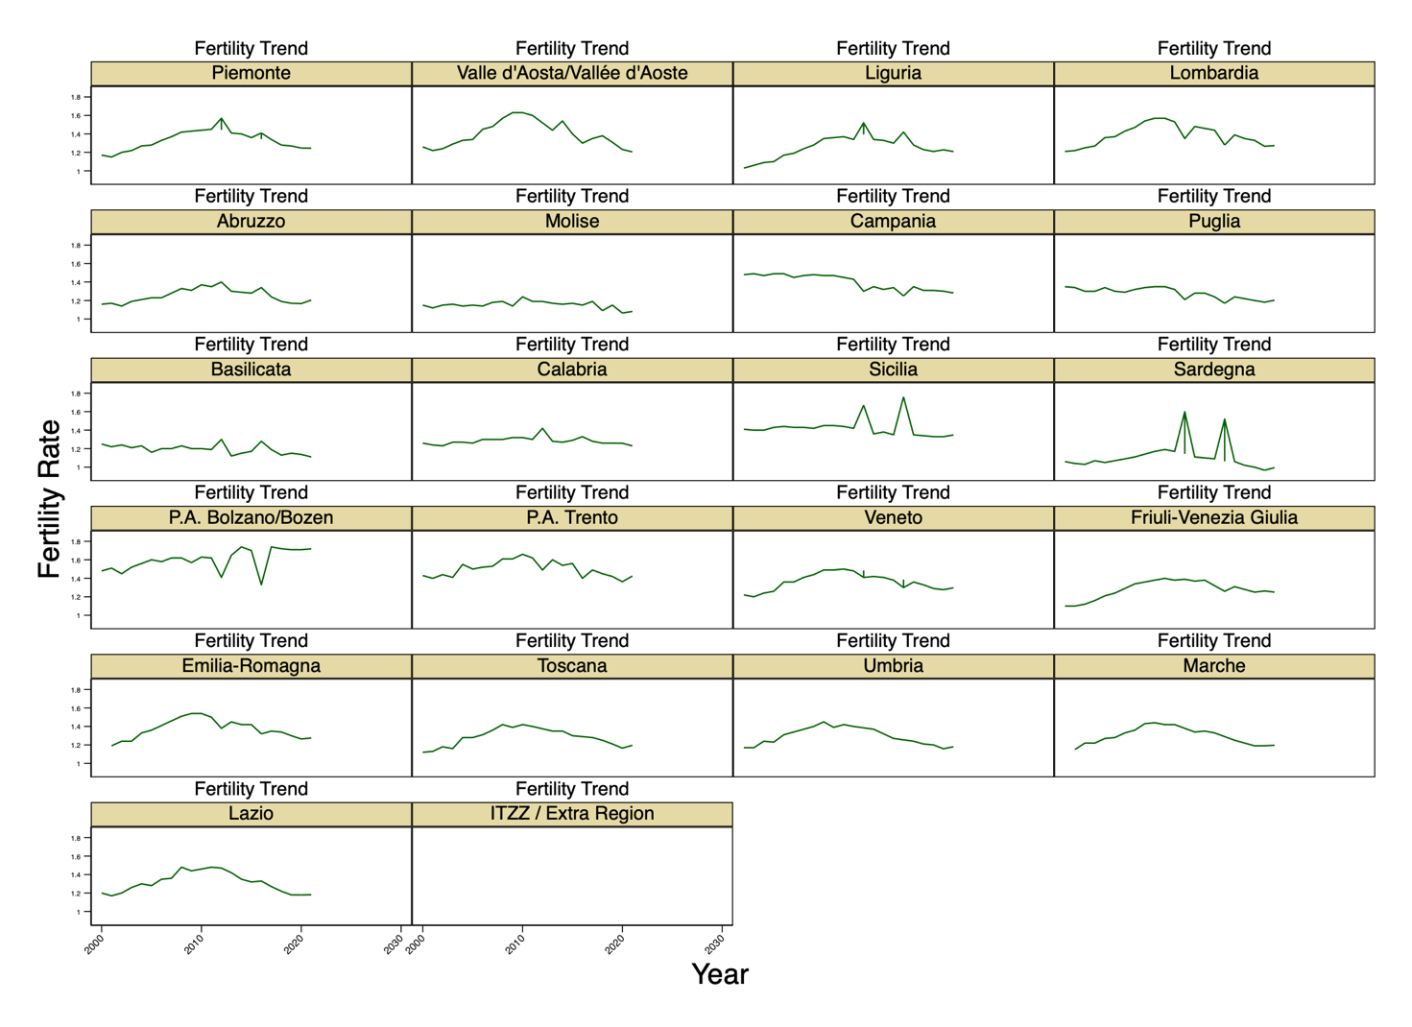

Figure 6. Fertility trend for regions from 2000 to 2023.
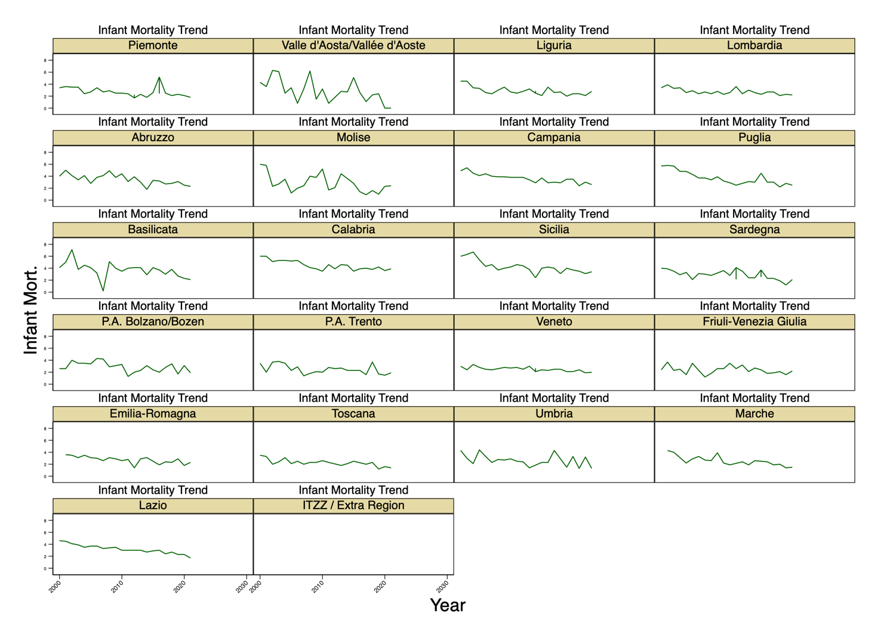
Figure 7. Life expectancy trend for regions from 2000 to 2023.

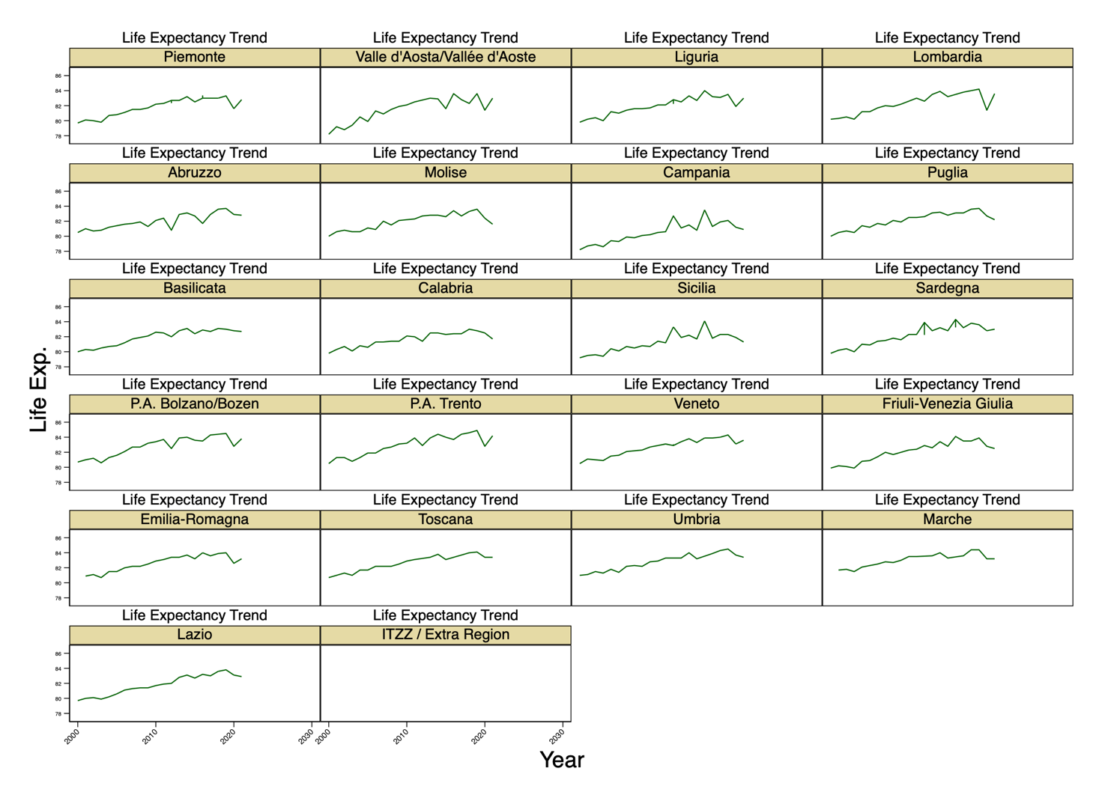

Figure 8. Unemployment trend for regions from 2000 to 2023.
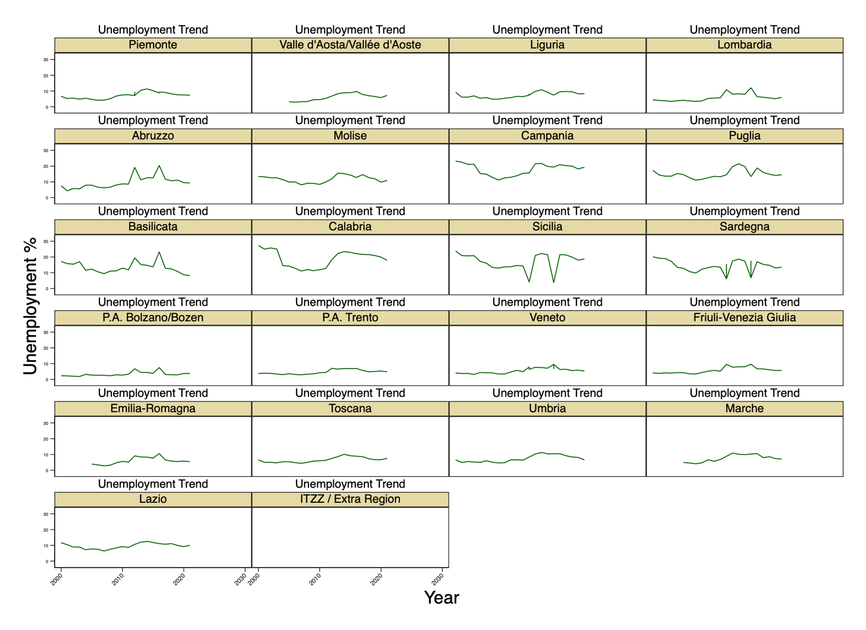
Figure 9. Long-Term Unemployment trend for regions from 2000 to 2023

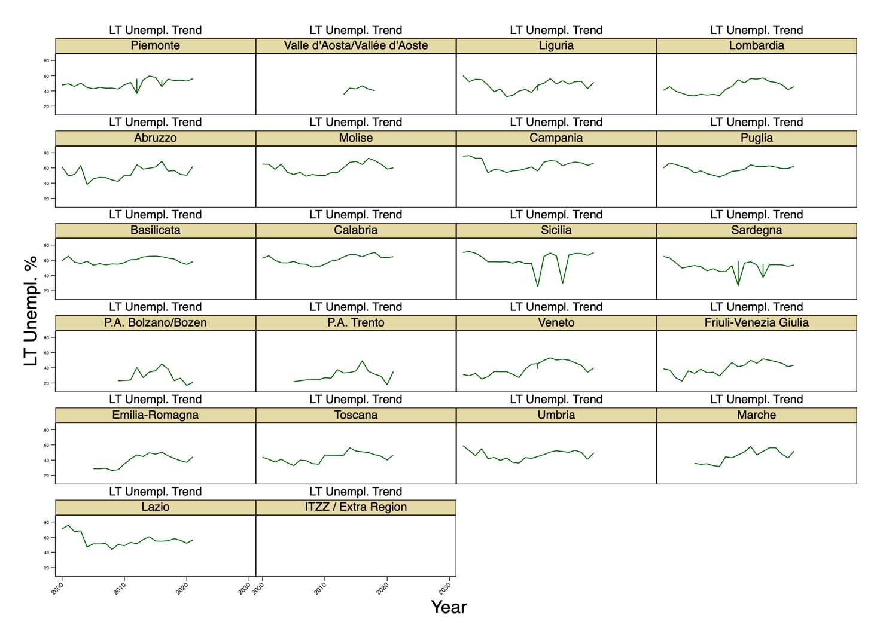

Figure 10. Density of the Population trend for regions from 2000 to 2023.
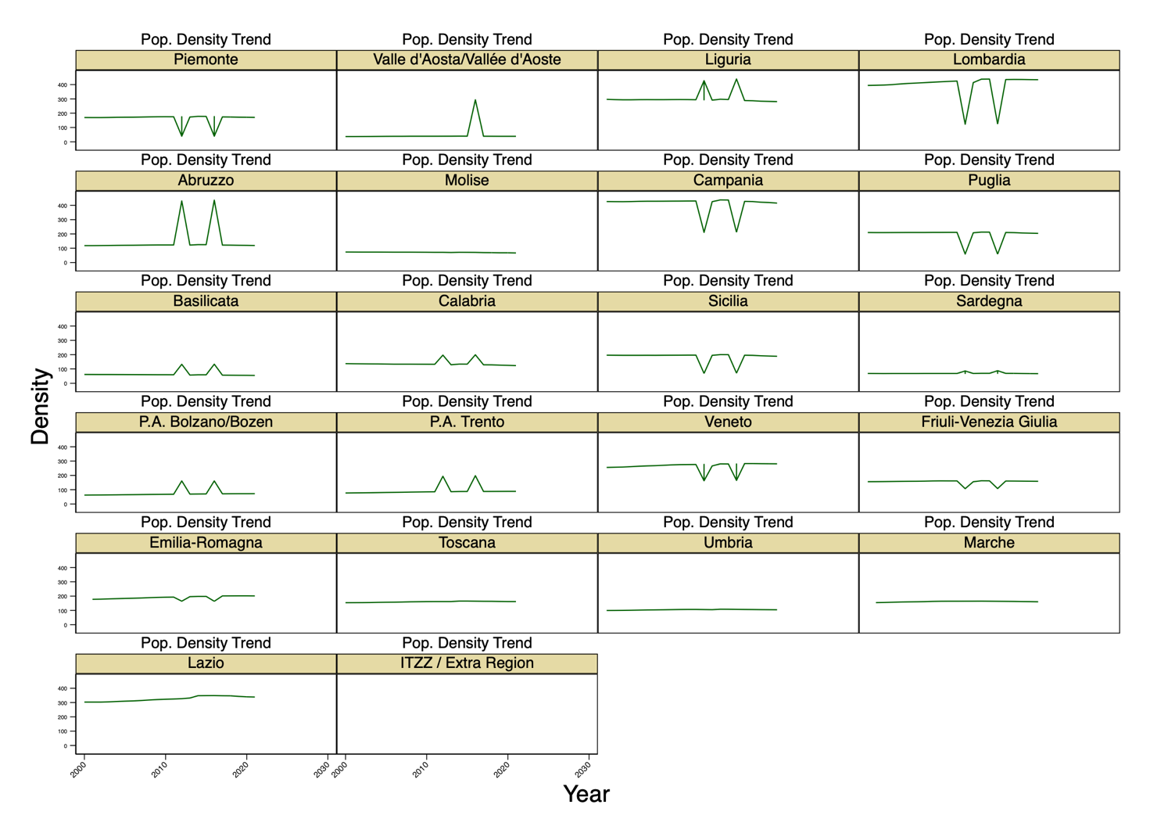

Bibliography

Acemoglu, D., Aghion, P., & Zilibotti, F. (2006). Distance to frontier, selection, and economic growth. Journal of the European Economic Association, 4(1), 37–74.
Aghion, P., Boustan, L., Hoxby, C., & Vadenbussche, J. (2005). Exploiting states’ mistakes to identify the causal impact of higher education on growth [NBER Working Paper].
Aghion, P., Boustan, L., Hoxby, C., & Vandenbussche, J. (2009). The causal impact of education on economic growth: Evidence from US. Harvard University, 1–73.
Andersen, T. B., & Dalgaard, C.-J. (2011). Flows of people, flows of ideas, and the inequality of nations. Journal of Economic Growth, 16(1), 1–32. https://doi.org/10.1007/s10887-011-9060-7
Angrist, J. D., & Kugler, A. D. (2003). Protective or counter-productive? European labor market institutions and the effect of immigrants on EU natives. The Economic Journal, 113(488), F302–F331. https://doi.org/10.1111/1468-0297.00136
ANPAL. (2023). https://www.lavoro.gov.it/temi-e-priorita-immigrazione/focus/sintesi-xiii-rapporto-mdl-stranieri-2023
ANSA. (2024). https://www.ansa.it/sito/notizie/economia/2024/06/26/istat-pil-pro-capite-del-nordovest-doppio-rispetto-al-sud_d3d33b08-3dc9-4a3f-b30a-aebd7f65f06a.html#:~:text=Nel%202022%2C%20ultimo%20anno%20per,Se
Ashby, N. J. (2010). Freedom and international migration. Southern Economic Journal, 77(1), 49–62.
Barnett, V., & Lewis, T. (1994). Outliers in statistical data (3rd ed.). Chichester, UK: John Wiley & Sons.
Berardino, C., D’Ingiullo, D., Furia, D., & Cartone, A. (2021). Immigration diversity and regional economic growth. Economia Politica, 38(3), 863–886. https://doi.org/10.1007/s40888-021-00226-8
Bodvarsson, Ö. B., & Van den Berg, H. (2013). The economics of immigration. https://doi.org/10.1007/978-1-4614-2116-0
Borjas, G. J. (2003). The labor demand curve. Quarterly Journal of Economics, 118(4), 1335–1374. https://doi.org/10.1162/003355303322552810
Borjas, G. J. (2017). The wage impact of the Marielitos: A reappraisal.
Borjas, G. J. (2019). Immigration and economic growth. NBER Working Paper No. 25836. National Bureau of Economic Research.
Brunow, S., Nijkamp, P., & Poot, J. (2015). The impact of international migration on economic growth in the global economy. In B. R. Chiswick & P. W. Miller (Eds.), Handbook of the economics of international migration (Cap. 19). Publisher Name.
Bugamelli, M., et al. (2018). Quale può essere il contributo degli immigrati alla crescita economica in Italia? Banca d’Italia Annual Report [as cited in Bonatti (2019)].
Boubtane, E., Coulibaly, D., & Rault, C. (2013). Immigration, unemployment, and GDP in the host country: Bootstrap panel Granger causality analysis on OECD countries. Economic Modelling, 33, 261–269.
Carbajal, M., & de Miguel Calvo, J. (2021). Factors that influence immigration to OECD member states. Cuadernos de Trabajo Social, 34, 417–430.
Cellini, R., & Scorcu, A. E. (2000). Segmented stochastic convergence across the G-7 countries. Empirical Economics, 25, 463–474.
Colacchio, G., & Forges Davanzati, G. (2025). Augusto Graziani on Italian economic development (1950–1970). Review of Political Economy.
Del Giudice, T. (2023, January 26). L’emorragia demografica delle aree rurali [The demographic hemorrhage of rural areas]. Lavoce.info. https://lavoce.info/archives/99769/lemorragia-demografica-delle-aree-rurali/
Dolado, J., Goria, A., & Ichino, A. (1994). Immigration, human capital and growth in the host country: Evidence from pooled country data. Journal of Population Economics, 7(2), 193–215.
D’Ambrosio, A., Montresor, S., Parrilli, M. D., & Quatraro, F. (2019). Migration, communities on the move and international innovation networks: An empirical analysis of Spanish regions. Regional Studies, 53(1), 6–16. https://doi.org/10.1080/00343404.2018.1426850
Dunford, M., & Greco, L. (2008). After the three Italies: Wealth, inequality and industrial change. Wiley-Blackwell.
Dustmann, C., & Preston, I. (2019). Free Movement, Open Borders, and the Global Gains from Labor Mobility. Annual Review of Economics, 11, 783–808. https://doi.org/10.1146/annurev-economics-080218-030215
Dritsaki, M., & Dritsaki, C. (2024). Immigration, growth and unemployment: Panel VAR evidence from E.U. countries. Journal of the Knowledge Economy.
European Commission. (n.d.). Push–pull factor. Retrieved from https://home-affairs.ec.europa.eu/networks/european-migration-network-emn/emn-asylum-and-migration-glossary/glossary/push-pull-factor_en
European Commission. (2023). Country report Italy 2023. Publications Office of the European Union. https://economy-finance.ec.europa.eu/system/files/2023-06/ip236_en.pdf
European Social Survey. (2023). ESS 2023 NUTS 2 level [Data set]. Retrieved from https://www.europeansocialsurvey.org
Federal Ministry for Economic Cooperation and Development. (2023). Available at: https://www.bmz.de/en
Foged, M., & Peri, G. (2015). Immigrants’ effect on native workers: New analysis on longitudinal data. American Economic Journal: Applied Economics, 8(2), 1–34.
Frankel, J. A., & Romer, D. (1999). Does trade cause growth? American Economic Review, 89(3), 379–399. https://doi.org/10.1257/aer.89.3.379
Gujarati, D. N., & Porter, D. C. (2009). Basic econometrics (5th ed.). New York, NY: McGraw-Hill Education.
Huber, P., & Tondl, G. (2012). Migration and regional convergence in the European Union. Empirica, 39(4), 439–460. https://doi.org/10.1007/s10663-011-9175-0
International Monetary Fund. (2020). World economic outlook, April 2020: Chapter 4 – The macroeconomic effects of migration. Washington, DC: IMF.
IOM. (2017). Retrieved from https://italy.iom.int/sites/g/files/tmzbdl1096/files/IOM_Italy_Briefing_02_Oct2017_Migrants’%20contributions.pdf
Istat – Istituto Nazionale di Statistica. (2024). Conti economici territoriali 2021–2023 (Regional economic accounts). Rome: ISTAT.
Istituto Nazionale di Statistica. (2021). Previsioni demografiche per il periodo 2021–2070 [Demographic forecasts for the period 2021–2070]. https://www.istat.it/it/files/2022/09/REPORT-PREVISIONI-DEMOGRAFICHE-2021.pdf
Iuzzolino, G., Pellegrini, G., & Viesti, G. (2011). Convergence among Italian regions, 1861–2011. Bank of Italy Economic History Working Paper.
Kahanec, M., & Pytlikova, M. (2017). The economic impact of east–west migration on the European Union. Empirica, 44(3), 407–434.
Keller, W. (2004). International technology diffusion. Journal of Economic Literature, 42(3), 752–782. https://doi.org/10.2753/EEE0012-8775510202
Khan, M. I., Alharthi, M., Haque, A., & Illiyan, A. (2023). Statistical analysis of push and pull factors of migration: A case study of India. Department of Economics, College of Economics and Business Administration, University of Technology and Applied Sciences, Ibri, Oman.
Khalid, & Urbanski, M. (2021). Approaches to understanding migration: A multi-country analysis of the push and pull migration trend. Economics and Sociology, 14, 249–274.
Kerr, W., & Lincoln, W. (2010). The supply side of innovation: H-1B visa reforms and U.S. ethnic invention. Journal of Labor Economics, 28(3), 473–508.
Koczan, Z., Peri, G., Pinat, M., & Rozhkov, D. (2021). The impact of international migration on inclusive growth: A review. IMF Working Paper No. 2021/088.
Lee, E. S. (1966). A theory of migration. Demography, 3(1), 47–57. Retrieved from Duke University Press
Mandal, T., Das, J., & Poddar, D. (2018). Nature and determinates of labour migration: A case study of Koch Bihar district.
Marinelli, E. (2011). Graduates on the move: Knowledge flows and Italian regional disparities (Doctoral dissertation, LSE).
Mauro, L., & Pigliaru, F. (2024). Italy’s national recovery and resilience plan: Will it narrow the north–south productivity gap? Italian Economic Journal.
Mulino, M., Giallonardo, L., & Iapadre, L. P. (2017). The European Economic Community and Italian regional disparities, 1951–1987. Economic History Working Paper.
Myrdal, G. (1957). Economic theory and underdeveloped regions. London: Duckworth.
OECD. (2007). International Migration Outlook 2007. OECD Publishing. https://doi.org/10.1787/migr_outlook-2007-en
OECD. (2019). OECD economic surveys: Italy 2019. Paris: OECD Publishing.
OECD. (2022). The contribution of migration to regional development. Paris: OECD Publishing.
OECD. (2022). [Data explorer]. Retrieved from https://data-explorer.oecd.org/vis?tm=elderly&pg=0&snb=14&df[ds]=dsDisseminateFinalDMZ&df[id]=DSD_POPULATION%40DF_POP_HIST&df[ag]=OECD.ELS.SAE&df[vs]=1.0&dq=AUS..PS._T..&pd=2010%2C2022&to[TIME_PERIOD]=false
OECD. (2013). GDP per capita. In National accounts at a glance 2013. OECD Publishing. https://doi.org/10.1787/na_glance-2013-5-en
OECD. (2014). Jobs for immigrants (Vol. 4): Labour market integration in Italy. OECD. https://doi.org/10.1787/9789264214712-en
Peri, G. (2012). The effect of immigration on productivity: Evidence from U.S. states. Review of Economics and Statistics, 94, 348–358.
Pierce, J., & Lawhon, M. (2015). Walking as method: Toward methodological forthrightness and comparability in urban geographical research. The Professional Geographer, 67(4), 655–662. https://doi.org/10.1080/00330124.2015.1059401
Paci, R., & Pigliaru, F. (1998). Growth and sectoral dynamics in the Italian regions.
Putnam, R. (1993a). Making democracy work: Civic traditions in modern Italy. Princeton University Press.
Putnam, R. (1993b). The prosperous community: Social capital and public life. The American Prospect, 13(Spring), 4. Retrieved from http://www.prospect.org/print/vol/13
Ramazzotti, A. (2023). The legacy of 1969? Human capital, internal migration and manufacturing firms, 1960s–2000s (Doctoral dissertation, LSE). Retrieved from http://etheses.lse.ac.uk/4534/
Raymer, J., & Wiśniowski, A. (2018). Applying and testing a forecasting model for age and sex patterns of immigration and emigration. Population Studies, 72(3), 339–355.
Solow, R. M. (1999). Neoclassical growth theory. In J. B. Taylor & M. Woodford (Eds.), Handbook of Macroeconomics (Vol. 1, pp. 637–667). Elsevier.
Siyal, G. E. A., Khalid, I. S., & Qaisrani, A. (2019). Internal migration and urbanisation: A case study from semi-arid regions of Pakistan. Sustainable Development Policy Institute.
Scarpino, A., Steigleder, K., & Kalkschmied, K. (2023). Public services as a predictor of economic wellbeing: A historical comparison (1945–1975) of Italy and Germany.
Urbański, M. (2022). Comparing push and pull factors affecting migration. Economies, 10(1), 21.
Vedovato, C. (1990). Economic stagnation and easy “exit”: The Italian South from unification to the 1950s. Scandinavian Economic History Review, 38(1), 28–42.
Wooldridge, J. M. (2012). Introductory econometrics: A modern approach (5th ed.). Mason, OH: South-Western Cengage Learning.

For further clarification check the website: https://home-affairs.ec.europa.eu/networks/european-migration-network-emn/emn-asylum-and-migration-glossary/glossary/push-pull-factor_en
Look at the appendix to see the different trends for the control variables.

