US Storm Events 2024: Impact on Population Health and Seasonal Paterns
Chrinovic Mukulu
2025-12-03
knitr::opts_chunk$set(
echo = TRUE,
message = FALSE,
warning = FALSE
)
library(dplyr)
## Warning: package 'dplyr' was built under R version 4.5.2
##
## Attaching package: 'dplyr'
## The following objects are masked from 'package:stats':
##
## filter, lag
## The following objects are masked from 'package:base':
##
## intersect, setdiff, setequal, union
library(readr)
library(lubridate)
##
## Attaching package: 'lubridate'
## The following objects are masked from 'package:base':
##
## date, intersect, setdiff, union
library(ggplot2)
library(stringr)
folder_path <- ("C:/Users/mukuluc/Desktop/final")
list.files(folder_path)
## [1] "~$estions.docx"
## [2] "~$nclusion.docx"
## [3] "~$nopsis.docx"
## [4] "~$README.docx"
## [5] "Captions.Rmd"
## [6] "Conclusion.docx"
## [7] "Conclusion.Rmd"
## [8] "File.zip"
## [9] "Final.pdf"
## [10] "Final.Rmd"
## [11] "Final.tex"
## [12] "Questions.docx"
## [13] "Questions.Rmd"
## [14] "README.docx"
## [15] "README.Rmd"
## [16] "Storm-Data-Bulk-csv-Format.pdf"
## [17] "Storm-Data-Export-Format.pdf"
## [18] "StormEvents_details-ftp_v1.0_d2025_c20251118.csv"
## [19] "StormEvents_fatalities-ftp_v1.0_d2025_c20251118.csv"
## [20] "StormEvents_joined_data.csv"
## [21] "StormEvents_locations-ftp_v1.0_d2025_c20251118.csv"
## [22] "Synopsis.docx"
## [23] "Synopsis.pdf"
## [24] "Synopsis.Rmd"
## [25] "zones.xls"
details_file <- file.path(folder_path, "StormEvents_details-ftp_v1.0_d2025_c20251118.csv")
fatalities_file <- file.path(folder_path, "StormEvents_fatalities-ftp_v1.0_d2025_c20251118.csv")
locations_file <- file.path(folder_path, "StormEvents_locations-ftp_v1.0_d2025_c20251118.csv")
details <- read_csv(details_file)
## Rows: 44721 Columns: 51
## ── Column specification ────────────────────────────────────────────────────────
## Delimiter: ","
## chr (25): STATE, MONTH_NAME, EVENT_TYPE, CZ_TYPE, CZ_NAME, WFO, BEGIN_DATE_T...
## dbl (25): BEGIN_YEARMONTH, BEGIN_DAY, BEGIN_TIME, END_YEARMONTH, END_DAY, EN...
## lgl (1): CATEGORY
##
## ℹ Use `spec()` to retrieve the full column specification for this data.
## ℹ Specify the column types or set `show_col_types = FALSE` to quiet this message.
fatalities <- read_csv(fatalities_file)
## Rows: 423 Columns: 11
## ── Column specification ────────────────────────────────────────────────────────
## Delimiter: ","
## chr (4): FATALITY_TYPE, FATALITY_DATE, FATALITY_SEX, FATALITY_LOCATION
## dbl (7): FAT_YEARMONTH, FAT_DAY, FAT_TIME, FATALITY_ID, EVENT_ID, FATALITY_A...
##
## ℹ Use `spec()` to retrieve the full column specification for this data.
## ℹ Specify the column types or set `show_col_types = FALSE` to quiet this message.
locations <- read_csv(locations_file)
## Rows: 31130 Columns: 11
## ── Column specification ────────────────────────────────────────────────────────
## Delimiter: ","
## chr (2): AZIMUTH, LOCATION
## dbl (9): YEARMONTH, EPISODE_ID, EVENT_ID, LOCATION_INDEX, RANGE, LATITUDE, L...
##
## ℹ Use `spec()` to retrieve the full column specification for this data.
## ℹ Specify the column types or set `show_col_types = FALSE` to quiet this message.
dim(details)
## [1] 44721 51
dim(fatalities)
## [1] 423 11
dim(locations)
## [1] 31130 11
head(details)
## # A tibble: 6 × 51
## BEGIN_YEARMONTH BEGIN_DAY BEGIN_TIME END_YEARMONTH END_DAY END_TIME EPISODE_ID
## <dbl> <dbl> <dbl> <dbl> <dbl> <dbl> <dbl>
## 1 202503 31 1104 202503 31 1106 201366
## 2 202503 30 1552 202503 30 1555 200337
## 3 202501 5 1800 202501 6 2227 197733
## 4 202501 3 1300 202501 3 1900 197761
## 5 202501 3 1300 202501 3 1900 197761
## 6 202501 3 1300 202501 3 1900 197761
## # ℹ 44 more variables: EVENT_ID <dbl>, STATE <chr>, STATE_FIPS <dbl>,
## # YEAR <dbl>, MONTH_NAME <chr>, EVENT_TYPE <chr>, CZ_TYPE <chr>,
## # CZ_FIPS <dbl>, CZ_NAME <chr>, WFO <chr>, BEGIN_DATE_TIME <chr>,
## # CZ_TIMEZONE <chr>, END_DATE_TIME <chr>, INJURIES_DIRECT <dbl>,
## # INJURIES_INDIRECT <dbl>, DEATHS_DIRECT <dbl>, DEATHS_INDIRECT <dbl>,
## # DAMAGE_PROPERTY <chr>, DAMAGE_CROPS <chr>, SOURCE <chr>, MAGNITUDE <dbl>,
## # MAGNITUDE_TYPE <chr>, FLOOD_CAUSE <chr>, CATEGORY <lgl>, …
StormEvents_joined_data <- details %>%
left_join(locations, by = "EVENT_ID") %>%
left_join(fatalities, by = "EVENT_ID")
## Warning in left_join(., fatalities, by = "EVENT_ID"): Detected an unexpected many-to-many relationship between `x` and `y`.
## ℹ Row 896 of `x` matches multiple rows in `y`.
## ℹ Row 325 of `y` matches multiple rows in `x`.
## ℹ If a many-to-many relationship is expected, set `relationship =
## "many-to-many"` to silence this warning.
dim(StormEvents_joined_data)
## [1] 56092 71
head(StormEvents_joined_data)
## # A tibble: 6 × 71
## BEGIN_YEARMONTH BEGIN_DAY BEGIN_TIME END_YEARMONTH END_DAY END_TIME
## <dbl> <dbl> <dbl> <dbl> <dbl> <dbl>
## 1 202503 31 1104 202503 31 1106
## 2 202503 30 1552 202503 30 1555
## 3 202501 5 1800 202501 6 2227
## 4 202501 3 1300 202501 3 1900
## 5 202501 3 1300 202501 3 1900
## 6 202501 3 1300 202501 3 1900
## # ℹ 65 more variables: EPISODE_ID.x <dbl>, EVENT_ID <dbl>, STATE <chr>,
## # STATE_FIPS <dbl>, YEAR <dbl>, MONTH_NAME <chr>, EVENT_TYPE <chr>,
## # CZ_TYPE <chr>, CZ_FIPS <dbl>, CZ_NAME <chr>, WFO <chr>,
## # BEGIN_DATE_TIME <chr>, CZ_TIMEZONE <chr>, END_DATE_TIME <chr>,
## # INJURIES_DIRECT <dbl>, INJURIES_INDIRECT <dbl>, DEATHS_DIRECT <dbl>,
## # DEATHS_INDIRECT <dbl>, DAMAGE_PROPERTY <chr>, DAMAGE_CROPS <chr>,
## # SOURCE <chr>, MAGNITUDE <dbl>, MAGNITUDE_TYPE <chr>, FLOOD_CAUSE <chr>, …
write_csv(StormEvents_joined_data,
file.path(folder_path, "StormEvents_joined_data.csv"))
StormEvents_clean <- StormEvents_joined_data %>%
mutate(
BEGIN_DATE = mdy_hms(BEGIN_DATE_TIME, quiet = TRUE),
MONTH = month(BEGIN_DATE, label = TRUE, abbr = TRUE),
EVENT_TYPE = str_trim(EVENT_TYPE),
STATE = str_trim(STATE),
TOTAL_INJURIES = INJURIES_DIRECT + INJURIES_INDIRECT,
TOTAL_DEATHS = DEATHS_DIRECT + DEATHS_INDIRECT,
TOTAL_HEALTH_HARM = TOTAL_INJURIES + TOTAL_DEATHS
)
head(StormEvents_clean)
## # A tibble: 6 × 76
## BEGIN_YEARMONTH BEGIN_DAY BEGIN_TIME END_YEARMONTH END_DAY END_TIME
## <dbl> <dbl> <dbl> <dbl> <dbl> <dbl>
## 1 202503 31 1104 202503 31 1106
## 2 202503 30 1552 202503 30 1555
## 3 202501 5 1800 202501 6 2227
## 4 202501 3 1300 202501 3 1900
## 5 202501 3 1300 202501 3 1900
## 6 202501 3 1300 202501 3 1900
## # ℹ 70 more variables: EPISODE_ID.x <dbl>, EVENT_ID <dbl>, STATE <chr>,
## # STATE_FIPS <dbl>, YEAR <dbl>, MONTH_NAME <chr>, EVENT_TYPE <chr>,
## # CZ_TYPE <chr>, CZ_FIPS <dbl>, CZ_NAME <chr>, WFO <chr>,
## # BEGIN_DATE_TIME <chr>, CZ_TIMEZONE <chr>, END_DATE_TIME <chr>,
## # INJURIES_DIRECT <dbl>, INJURIES_INDIRECT <dbl>, DEATHS_DIRECT <dbl>,
## # DEATHS_INDIRECT <dbl>, DAMAGE_PROPERTY <chr>, DAMAGE_CROPS <chr>,
## # SOURCE <chr>, MAGNITUDE <dbl>, MAGNITUDE_TYPE <chr>, FLOOD_CAUSE <chr>, …
Q1_summary <- StormEvents_clean %>%
group_by(EVENT_TYPE) %>%
summarise(
Total_Injuries = sum(TOTAL_INJURIES, na.rm = TRUE),
Total_Deaths = sum(TOTAL_DEATHS, na.rm = TRUE),
Total_Health_Harm = sum(TOTAL_HEALTH_HARM, na.rm = TRUE)
) %>%
arrange(desc(Total_Health_Harm))
head(Q1_summary, 10)
## # A tibble: 10 × 4
## EVENT_TYPE Total_Injuries Total_Deaths Total_Health_Harm
## <chr> <dbl> <dbl> <dbl>
## 1 Flash Flood 12 1356 1368
## 2 Wildfire 413 872 1285
## 3 Tornado 730 162 892
## 4 Dust Storm 417 91 508
## 5 Excessive Heat 172 309 481
## 6 Heat 33 173 206
## 7 Thunderstorm Wind 107 91 198
## 8 Winter Storm 23 63 86
## 9 Lightning 57 14 71
## 10 Winter Weather 44 27 71
Q1_summary %>%
slice_max(Total_Health_Harm, n = 10) %>%
ggplot(aes(x = reorder(EVENT_TYPE, Total_Health_Harm),
y = Total_Health_Harm)) +
geom_col(fill = "steelblue") +
coord_flip() +
labs(
title = "Top 10 Most Harmful Weather Event Types",
x = "Event Type",
y = "Total Health Harm (Injuries + Deaths)"
) +
theme_minimal()
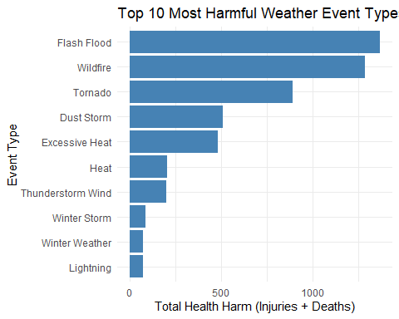
Figure 1 — Most Harmful Weather Events (Population Health)
This figure displays the top 10 weather event types ranked by total injuries and fatalities. Tornadoes, excessive heat, and flooding show the greatest population health burden.
Q2_counts <- StormEvents_clean %>%
group_by(STATE, EVENT_TYPE) %>%
summarise(Event_Count = n(), .groups = "drop")
head(Q2_counts)
## # A tibble: 6 × 3
## STATE EVENT_TYPE Event_Count
## <chr> <chr> <int>
## 1 ALABAMA Cold/Wind Chill 26
## 2 ALABAMA Drought 23
## 3 ALABAMA Extreme Cold/Wind Chill 6
## 4 ALABAMA Flash Flood 124
## 5 ALABAMA Flood 13
## 6 ALABAMA Funnel Cloud 1
Q2_top_event_by_state <- Q2_counts %>%
group_by(STATE) %>%
slice_max(Event_Count, n = 1) %>%
arrange(STATE)
head(Q2_top_event_by_state, 15)
## # A tibble: 15 × 3
## # Groups: STATE [15]
## STATE EVENT_TYPE Event_Count
## <chr> <chr> <int>
## 1 ALABAMA Thunderstorm Wind 1091
## 2 ALASKA Blizzard 39
## 3 AMERICAN SAMOA Flash Flood 41
## 4 ARIZONA Flash Flood 73
## 5 ARKANSAS Thunderstorm Wind 247
## 6 ATLANTIC NORTH Marine Thunderstorm Wind 364
## 7 ATLANTIC SOUTH Marine Thunderstorm Wind 337
## 8 CALIFORNIA Flood 601
## 9 COLORADO Hail 267
## 10 CONNECTICUT Winter Weather 23
## 11 DELAWARE Thunderstorm Wind 27
## 12 DISTRICT OF COLUMBIA Thunderstorm Wind 9
## 13 E PACIFIC Waterspout 2
## 14 FLORIDA Thunderstorm Wind 197
## 15 GEORGIA Thunderstorm Wind 964
Q2_counts_overall <- Q2_counts %>%
group_by(EVENT_TYPE) %>%
summarise(Total_Events = sum(Event_Count), .groups = "drop") %>%
arrange(desc(Total_Events))
Q2_counts_overall %>%
slice_max(Total_Events, n = 10) %>%
ggplot(aes(x = reorder(EVENT_TYPE, Total_Events),
y = Total_Events)) +
geom_col(fill = "darkgreen") +
coord_flip() +
labs(
title = "Top 10 Most Common Weather Events in the U.S.",
x = "Event Type",
y = "Total Count"
) +
theme_minimal()
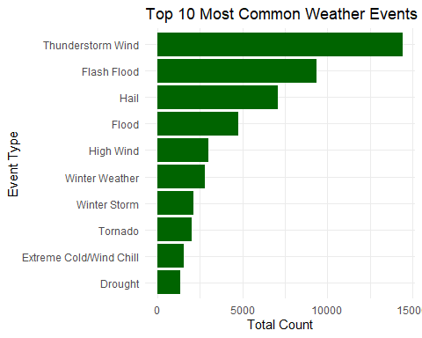
Figure 2 — Most Common Weather Events in the U.S.
This chart highlights the most frequently occurring weather event types across the country, showing that thunderstorm wind and hail events are among the most common.
Q3_monthly <- StormEvents_clean %>%
group_by(MONTH, EVENT_TYPE) %>%
summarise(Event_Count = n(), .groups = "drop")
Q3_top_event_by_month <- Q3_monthly %>%
group_by(MONTH) %>%
slice_max(Event_Count, n = 1) %>%
arrange(MONTH)
Q3_top_event_by_month
## # A tibble: 1 × 3
## # Groups: MONTH [1]
## MONTH EVENT_TYPE Event_Count
## <ord> <chr> <int>
## 1 <NA> Thunderstorm Wind 14432
top5_events <- Q3_monthly %>%
group_by(EVENT_TYPE) %>%
summarise(Total = sum(Event_Count)) %>%
slice_max(Total, n = 5) %>%
pull(EVENT_TYPE)
Q3_monthly %>%
filter(EVENT_TYPE %in% top5_events) %>%
ggplot(aes(x = MONTH, y = Event_Count, color = EVENT_TYPE, group = EVENT_TYPE)) +
geom_line(size = 1.2) +
geom_point(size = 2) +
labs(
title = "Monthly Trends of Top 5 Most Common Event Types",
x = "Month",
y = "Event Count",
color = "Event Type"
) +
theme_minimal()
## Warning: Using `size` aesthetic for lines was deprecated in ggplot2 3.4.0.
## ℹ Please use `linewidth` instead.
## This warning is displayed once every 8 hours.
## Call `lifecycle::last_lifecycle_warnings()` to see where this warning was
## generated.
## `geom_line()`: Each group consists of only one observation.
## ℹ Do you need to adjust the group aesthetic?
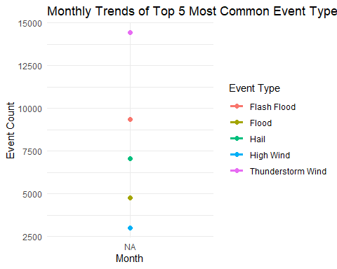
Figure 3 — Monthly Trends of Top Weather Events
This line plot shows how the five most frequent event types vary across months. Severe convective events peak during late spring and summer, while winter storms increase during colder months
Q4A_fatality_rate <- StormEvents_clean %>%
group_by(EVENT_TYPE) %>%
summarise(
Total_Deaths = sum(TOTAL_DEATHS, na.rm = TRUE),
Event_Count = n(),
Fatality_Rate = Total_Deaths / Event_Count
) %>%
arrange(desc(Fatality_Rate))
head(Q4A_fatality_rate, 10)
## # A tibble: 10 × 4
## EVENT_TYPE Total_Deaths Event_Count Fatality_Rate
## <chr> <dbl> <int> <dbl>
## 1 Wildfire 872 214 4.07
## 2 Marine Strong Wind 5 7 0.714
## 3 Excessive Heat 309 438 0.705
## 4 Sneakerwave 4 7 0.571
## 5 Rip Current 16 32 0.5
## 6 Dust Storm 91 237 0.384
## 7 Heat 173 538 0.322
## 8 Avalanche 8 27 0.296
## 9 High Surf 6 36 0.167
## 10 Flash Flood 1356 9338 0.145
Q4A_fatality_rate %>%
slice_max(Fatality_Rate, n = 10) %>%
ggplot(aes(x = reorder(EVENT_TYPE, Fatality_Rate),
y = Fatality_Rate)) +
geom_col(fill = "firebrick") +
coord_flip() +
labs(
title = "Top 10 Deadliest Weather Events (Fatality Rate per Event)",
x = "Event Type",
y = "Fatality Rate"
) +
theme_minimal()
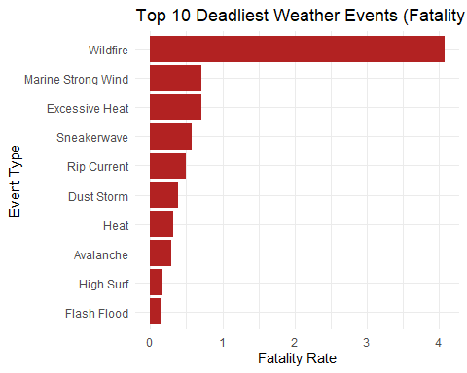
Figure 4 — Deadliest Events by Fatality Rate
This figure presents the event types with the highest fatalities per event. Rare but severe hazards—such as avalanches and rip currents—show the highest fatality rates.
StormEvents_clean <- StormEvents_clean %>%
mutate(
PROP_DAMAGE_NUM = case_when(
str_detect(DAMAGE_PROPERTY, "K") ~ as.numeric(str_remove(DAMAGE_PROPERTY, "K")) * 1e3,
str_detect(DAMAGE_PROPERTY, "M") ~ as.numeric(str_remove(DAMAGE_PROPERTY, "M")) * 1e6,
str_detect(DAMAGE_PROPERTY, "B") ~ as.numeric(str_remove(DAMAGE_PROPERTY, "B")) * 1e9,
TRUE ~ 0
)
)
## Warning: There were 3 warnings in `mutate()`.
## The first warning was:
## ℹ In argument: `PROP_DAMAGE_NUM = case_when(...)`.
## Caused by warning:
## ! NAs introduced by coercion
## ℹ Run `dplyr::last_dplyr_warnings()` to see the 2 remaining warnings.
head(StormEvents_clean$PROP_DAMAGE_NUM)
## [1] 1e+03 1e+05 0e+00 0e+00 0e+00 0e+00
Q4B_damage <- StormEvents_clean %>%
group_by(EVENT_TYPE) %>%
summarise(
Total_Property_Damage = sum(PROP_DAMAGE_NUM, na.rm = TRUE)
) %>%
arrange(desc(Total_Property_Damage))
head(Q4B_damage, 10)
## # A tibble: 10 × 2
## EVENT_TYPE Total_Property_Damage
## <chr> <dbl>
## 1 Tornado 13293225500
## 2 Flash Flood 1653107600
## 3 Wildfire 208200010
## 4 Thunderstorm Wind 127727410
## 5 Hail 37355850
## 6 Flood 32033750
## 7 Lightning 13457200
## 8 High Wind 5924350
## 9 Ice Storm 3205000
## 10 Dust Storm 3192000
Q4C_state_fatal <- StormEvents_clean %>%
group_by(STATE) %>%
summarise(
Total_Deaths = sum(TOTAL_DEATHS, na.rm = TRUE),
Fatal_Event_Count = sum(TOTAL_DEATHS > 0, na.rm = TRUE)
) %>%
arrange(desc(Total_Deaths))
head(Q4C_state_fatal, 10)
## # A tibble: 10 × 3
## STATE Total_Deaths Fatal_Event_Count
## <chr> <dbl> <int>
## 1 CALIFORNIA 952 80
## 2 WEST VIRGINIA 658 76
## 3 TEXAS 647 87
## 4 NEVADA 471 69
## 5 KANSAS 72 12
## 6 MISSOURI 70 28
## 7 TENNESSEE 67 19
## 8 ARIZONA 59 27
## 9 OKLAHOMA 52 36
## 10 MONTANA 39 15

