Firmware Programming

Initial power ON
Updating firmware

Sign Configuration

Image Updating

Firmware Programming

This is the first thing that needs to be done before the controller can be used. It only needs to be done once.

Initial power ON:

- The board should NOT be connected to the internal signs power supply

- Temporary add a jumper to J11, marked Use USB Power.
The board should NOT be powered by USB and main power supply at same time. The USB can be used with the main power connected only when the J11 is removed.

- Plug in USB.

- On PC navigate to the new USB drive.
Normally this will be D:\RPI-RP2\
If the drive does not appear see Firmware Updating.

- Copy the ‘xxxxx.uf2’ to this new drive.
This will cause the new drive letter to disipear and the board will be programmed with the firmware.
The LED will raridaly flash every ½ second until the tile configeration is loaded.

- Remove the temporary jumper added in step 2

Firmware Updating:

- If the board is installed and being powered by the sign then make sure J11 has been removed.
If power is not connected then J11 should be installed to provide USB power the board.

- Plug in USB.

- Press and Hold the button Marked ‘FIRM’(sw1).

- Press and release the button marked RESET, keeping FIRM pressed.

- Release the FIRM button.

- On PC navigate to the new USB drive,
Normally this will be D:\RPI-RP2\

- Copy the ‘xxxxx.uf2’ to this new drive.
This will cause the new drive letter to disipear and the board will be programmed with the firmware.

The LED will raridaly flash every ½ second if configeration has NOT been programmed.
If the configuration has been programmed the board LED will rapidly.

- If the jumper was used it should be removed.
Sign Configuration Loading

The board need to be setup work with spasific tiles.
Each tile will have it’s own configeration file.
The SD card need’s to be formmted with FAT-32
The configeration file should be named ‘config.ini’

Copy the ‘config.ini’ file to the root directory of the SD card
Insert SD card.
Set the positions of all switches 1-4 to the ON positions.
Press and Hold the button Marked ‘SELECT’
Press and release the button marked RESET, keeping SELECT pressed.
The LED will raridaly flash 3 times every ½ second.
Release the ‘ SELECT’ button.
Pressing the ‘SELECT’ button again will disply the teting mode.
The test mode has a cyan border around the full display.
The LED will flash once per ½ second when configeded and in test mode.
Set the positions of all switches 1-4 to the OFF positions.

The configeration file will now be installed on the board.

Sign Image Loading

Images are stored in the board flash memory. When operating the SD is not required.

Set switch 1 = OFF 2 = OFF 3 = ON 4 = OFF

1 | 2 | 3 | 4
OFF | OFF | ON | OFF

Press the ‘SELECT’ button

This wil show the test screen with ‘LOAD’

Press the ‘SELECT’ button again

Will read inages from the SD card and store in on board memory.

Set switch 3 = OFF , all other switched should still be OFF.
The test screen will display ‘EXIT’

1 | 2 | 3 | 4
OFF | OFF | OFF | OFF

Press the ‘SELECT’ button again to go back to normal mode.

Image format

Images need to be ‘BMP’ 24bit format.
The image size needs to match the screen size set in config.ini

User inputs

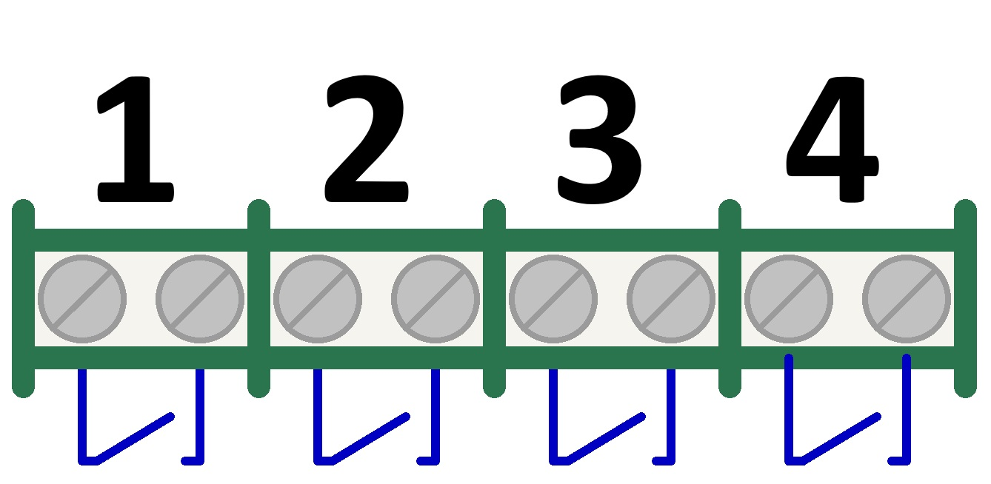

Image  File Name | Inputs |  |  |  | Example  Image
Image  File Name | 1 | 2 | 3 | 4 | Example  Image
0.BMP | CLOSED | CLOSED | CLOSED | CLOSED | Blank Image
1.BMP | OPEN | CLOSED | CLOSED | CLOSED | Arrow up
2.BMP | CLOSED | OPEN | CLOSED | CLOSED | Arrow Left
3.BMP | OPEN | OPEN | CLOSED | CLOSED | Blank Image
4.BMP | CLOSED | CLOSED | OPEN | CLOSED | Arrow Right
5.BMP | OPEN | CLOSED | OPEN | CLOSED | Blank Image
6.BMP | CLOSED | OPEN | OPEN | CLOSED | Blank Image
7.BMP | OPEN | OPEN | OPEN | CLOSED | Blank Image
8.BMP | CLOSED | CLOSED | CLOSED | OPEN | Blank Image
9.BMP | OPEN | CLOSED | CLOSED | OPEN | Red Cross
10.BMP | CLOSED | OPEN | CLOSED | OPEN | Blank Image
11.BMP | OPEN | OPEN | CLOSED | OPEN | Blank Image
12.BMP | CLOSED | CLOSED | OPEN | OPEN | Blank Image
13.BMP | OPEN | CLOSED | OPEN | OPEN | Blank Image
14.BMP | CLOSED | OPEN | OPEN | OPEN | Blank Image
15.BMP | OPEN | OPEN | OPEN | OPEN | Blank Image

