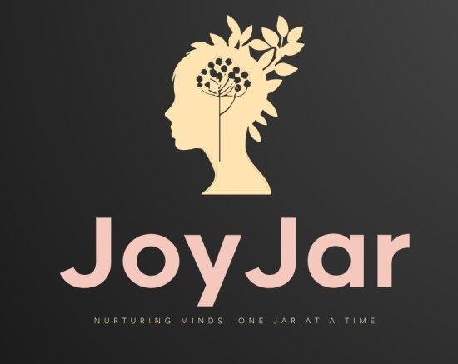

**JOYJAR: A Digital Intervention for Mental Wellbeing Enhancement**

**Abstract:**

In the fast-paced and often stressful world we live in today, mental health has become an increasingly important topic that deserves attention and proactive care. The rise of digital platforms has led to the development of innovative tools to support mental well-being. This project focuses on the creation of an AI-powered Mental Health Chatbot designed to provide accessible, empathetic, and immediate mental health support. Using natural language processing and machine learning, the chatbot is capable of conversing with users, offering emotional support, providing stress management tips, and directing users to professional resources when needed. This AI tool aims to bridge the gap between traditional mental health services and the need for immediate assistance, offering a safe and anonymous space for individuals to discuss their concerns. Additionally, the accompanying website serves as a resource hub, offering educational content on mental health awareness, including articles, coping strategies, and self-care techniques. Together, the AI-powered chatbot and website aim to reduce the stigma surrounding mental health and promote proactive self-care in an increasingly digital world.

|  |  |
| --- | --- |
| Submitted By: | **Chrispa Daniel** |
|  | **AM.SC.P2ARI24005** |