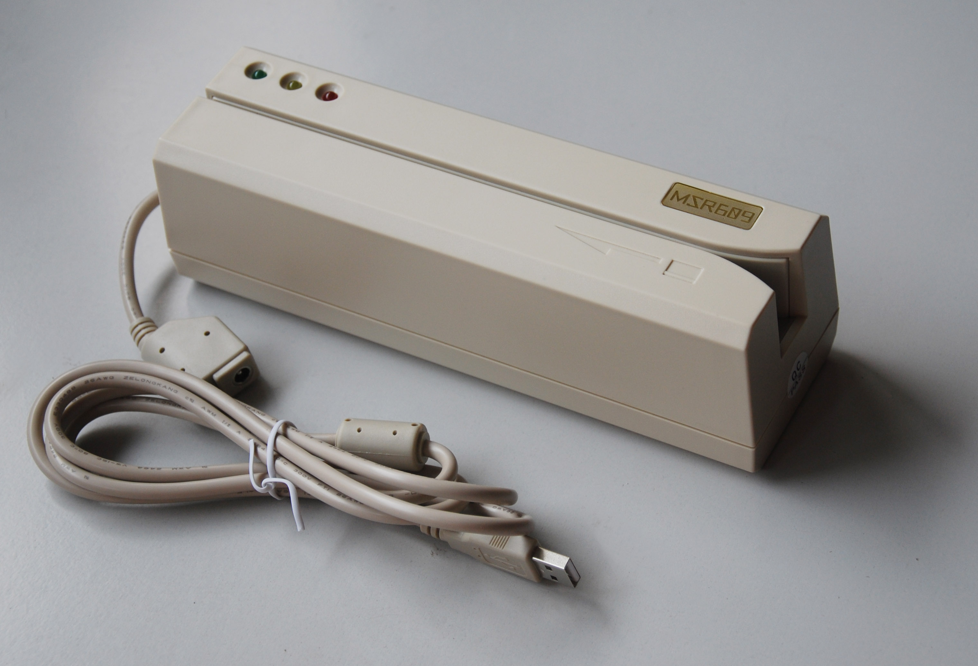 NEW!
MSR609 High-speed USB Magnetic Strip Card Reader / Writer
Plug and play, not need usb driver,easy to use

Why choose MSR609?
Answer 1: MSR609 is the easiest encoder in the world!
MSR609 coming with direct USB cable, plug and play,not need install USB driver ,easy to use, All the people are experts.
Answer 2: MSR609 is the fast encoder in the world!
MSR609 have a truly High-speed USB interface,fast computer communications,not the USB emulation serial writers in the market.
Answer 3: MSR609 is the compatible encoder in the world!
MSR609 can working with mini readers directly with our free software,you can easy transfer card data to pc and write to new cards quickly with MSR609.
Answer 4: MSR609 is the strongest encoder in the world!
MSR609 coming with Free software, Easy read,write,copy,erase cards.
Read and Write High & Low Coercive force of magnetic stripe (300~4000Oe)
All 3 tracks can set to 75 or 210 BPI
Sequential write function, partial or full track data(0~104 digits).
Windows 98/me/2000/xp/vista/windows 7(32&64 bit) ok!
... ...
Answer 5: MSR609 is the Best encoder in the world!
Msr609 manufactured at ISO9001 certified factoy,Production of all products adopts imported advanced equipments and materials and strict quality control system is implemented.MSR609 composed of Durable hard plastic casing,high capability&long life magnetic read/write head, exact encoder,fast datacom chip, exact encoding chip... ... etc. All parts of msr609 are the best.
Now! Enjoy swiping card! So Easy!

Product Information

Magnetic stripe card reader/writer MSR609 is designed to offer a card reading/writing solution for ISO/ANSI formats. It reads and writes up to 3 tracks of data,decoding/encoding and verifying up to 3 tracks of data simultaneously.MSR609 magnetic stripe card reader/writer provides a high-speed USB interface to communicate with host system or other terminal computers and no need install USB driver,plug and play. Durable hard plastic casing and metal pad for sliding card keep this machine form wear and tear from extended use. It comes with all full version of the software and instruction manuals. MSR609 is the best USB Hi-co magnetic card reader/writer available in the market today for small and medium size businesses which require magnetic stripe card customizations.It is ideal for access control, time keeping, banking, ID recognition & credit verification and related applications. In fact, wherever a magnetic stripe ID or transaction card is used, one can find a related use for the versatile, user-friendly MSR609 reader/writer.
Application:
Financial Banking: Credit Card, Debit Card, Bank Card
Retail: Gift Card, Customer ID, Store ID
Government: Driver Licence, Health Card, Government ID
Any movable data collection Trade shows, Racing events
Employee's Time / Attendance data collection
Exhibition visitors' data collection
Conference attendants data collection
Card Verification: Age verification
Point of Sales: Payment collection, Credit card data collection
Law Enforcement: DMV card
Attendance: Student ID, Membership Card, Club ID
Features
- Reading/Writing magnetic stripe card complied with ISO formats
- Program software for Windows XP/Vista 32 or 64 bit systems
- Programming software for various read/write performance
- Sequential write function, partial or full track data(0~104 digits)
- All 3 tracks can set to 75/210 BPI
- Manual Swipe to read and/or write card with USB output
- Writing and verifying data on single, dual, or triple track in one swipe
- Comes with high-speed USB connection to computer and laptops without USB driver
- Read and Write High & Low Coercive force of magnetic stripe (300~4000Oe)
- High/Low Coercivity encoding circuitry selectable on screen
- Programmable leading bit, raw data, DMV/AAMVA, and user defined format
- Works with DOS/Linux and Windows 95/98/Me/2000/NT/XP/VISTA/Windows 7
- DC+24V, 2.5A Max external power adapter attached
- dimensions of 212(L) x 64(W) x 63(H) mm
- CE, FCC, UL, cUL,ROHS certified
- One year warrenty

Performance
Read card Track1 Track2 Track3
Bit per density 210 bpi 75/210bpi 210 bpi
Coercive force Read/write 300-4000 oe Mag.card
Card thickness 0.76-1.2mm
Read speed STD card Jitter +/-15% Amp. 60%
5-55ips 5-50ips 5-50ips
Write speed 5-30ips
Write jitter Interval < +/- 10%, Sub-interval < +/- 12%
Error rate Read < 0.5% Write < 0.8%
Head life Min. 1000K swipes for both read/write head
Box Contents:
1 MSR609 USB
1 maghead clear card
1 Power Cord with Adapter
1 MSR609 Software CD
1 Instruction Manual PDF Format

