Download https://repo.anaconda.com/archive/Anaconda3-2023.03-0-Windows-x86_64.exe and install it.

Run Anaconda Prompt and input the following command.

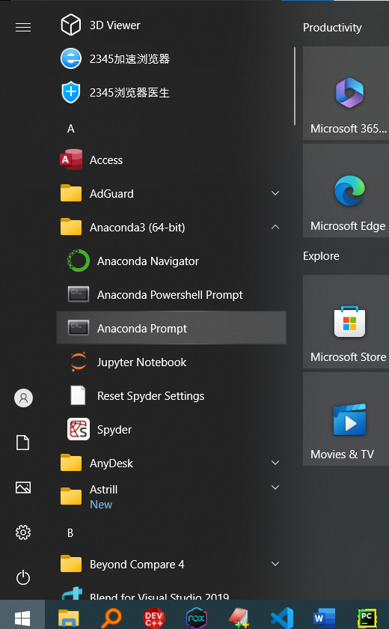

pip install -r [yourpath of requirement.txt] 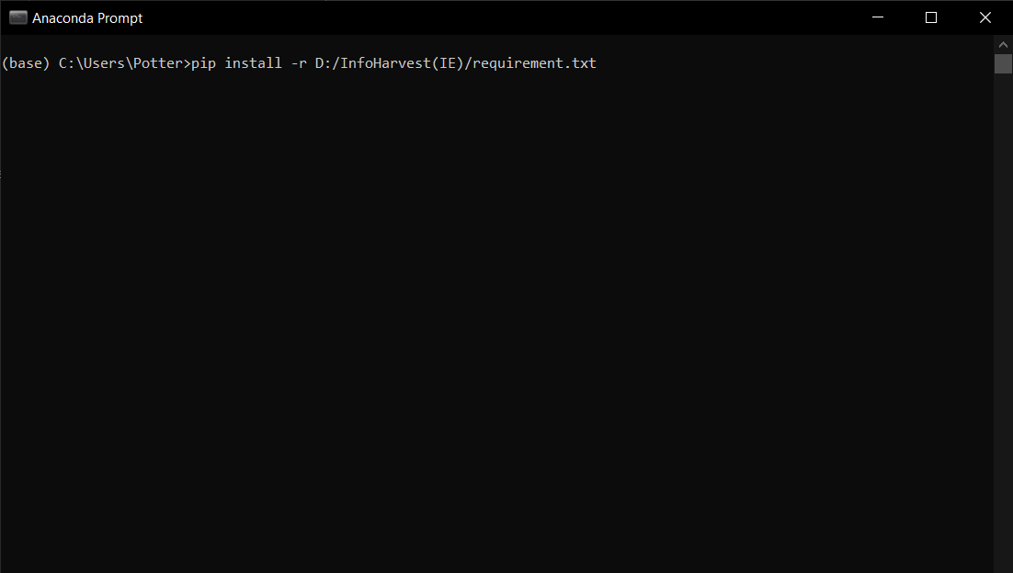

Example:

pip install -r D:/InfoHarvest(IE)/requirement.txt

Then Run the code.

python [your path of main.pyc] [pdf path]

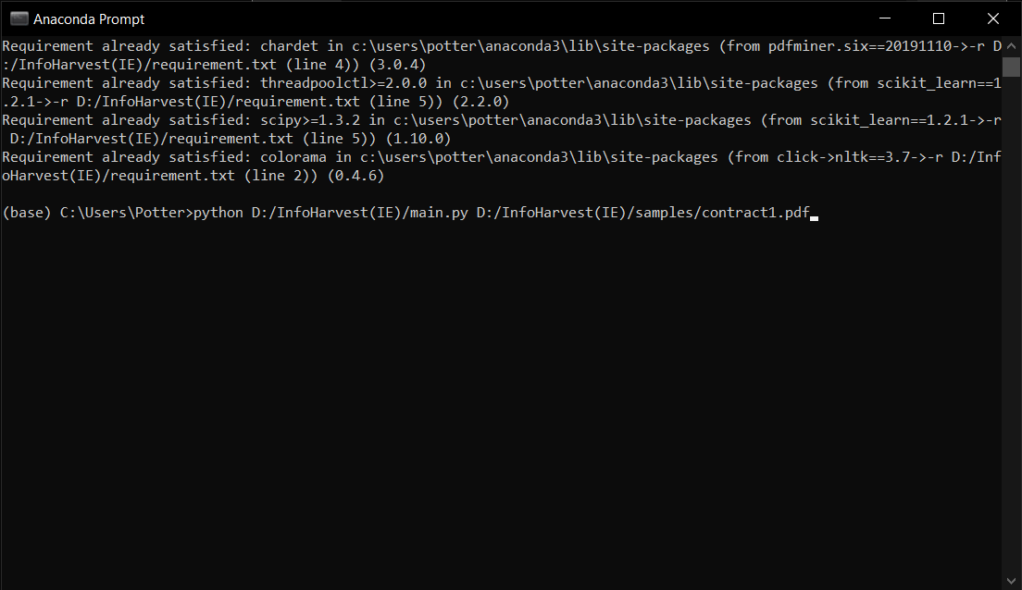

Example:

python D:/InfoHarvest(IE)/main.pyc D:/InfoHarvest(IE)/samples/contract1.pdf

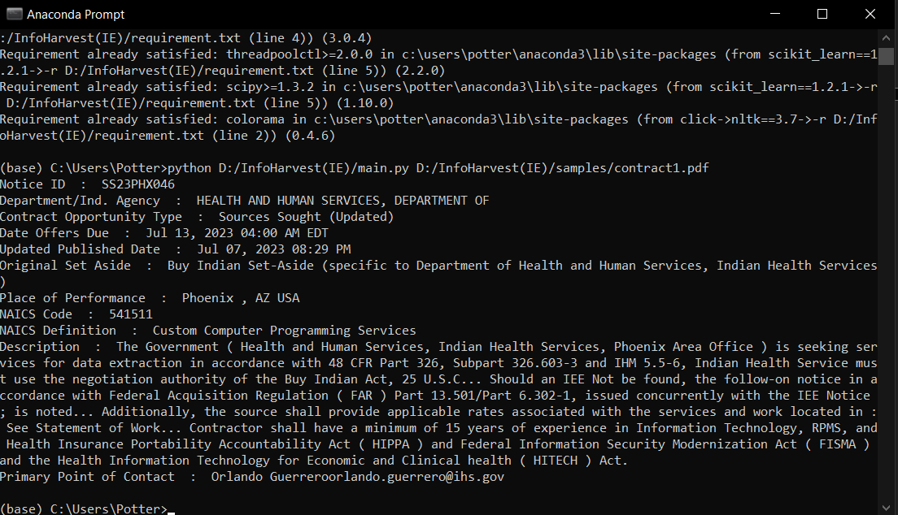

Then go to the D:/InfoHarvest(IE)/samples and you can see the contract1.txt file.

